Find Data on environmental impacts of feces and chemicals rejection for Salmon farming

**Chopper des noms d’organismes et des liens pour aller voir comment sont traités les produits chimiques et les fécès, et quels organismes surveillent les fonds marins…**

Rapport OECD_2017 sur Salmo Salar.

Natural habitat

Antibiotics and hydrogen peroxide against fngus en milieu naturel ou autre = page 52 :

Farming

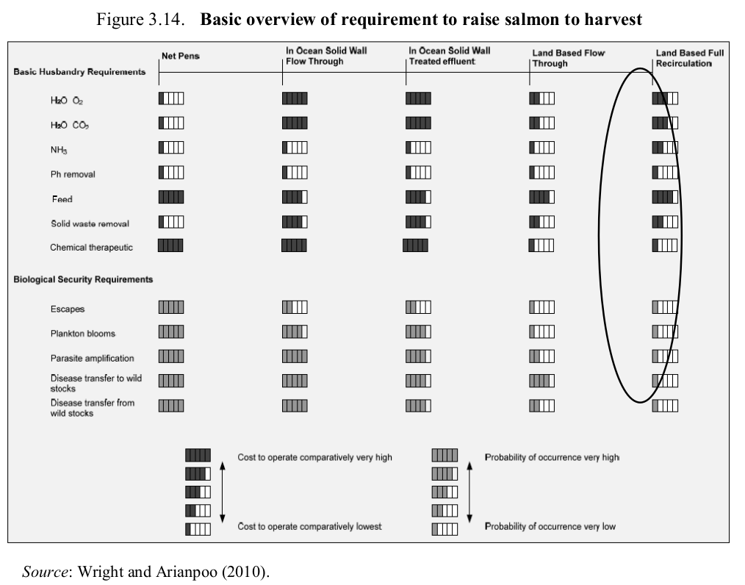

Pour le farming in waters = page 67/79 :
Atlantic salmon globally are typically vaccinated in fresh water before entry to sea cages so they are protected in the marine environment. There is also extensive use of different pharmaceuticals and antiseptics (e.g. hydrogen peroxide) against sea lice infestations.
Antibiotics are rarely used on salmon with typically less than 1% of the production each year being treated. In addition, there is some use of pharmaceuticals against tapeworm (Praziquantel). All vaccines and pharmaceuticals must be approved by the appropriate government agencies in the jurisdiction of use.
Salmon lice infestations have been treated with antiseptics, organic phosphates, pyrethrines and pyrethroids, avermectins and chitin synthesis inhibitors. The avermectins and chitin synthesis inhibitors are administered through the feed, while the other treatments are given as baths. Bath treatment typically involves placing a closed or semi-closed tarpaulin around the cage and adding the treatment chemical. Treatment of fish sometimes also occurs in well-boats subsequent to transfer of fish from the sea cage. Labrids (wrasse) (Bjordal, 1990) have been used as an alternative to chemical treatment for more than 15 years, primarily in Norway, with lumpfish receiving attention as a cleaner fish in more recent years. These cleaner fish remove individual sea lice from Atlantic salmon

Disposition of waste and carcasses
Scuba divers are used to collect dead fish from cages. Dead fish are transported to land and disposed of similarly to land-based disposal. The open-system technology (e.g. net pens and cages) used for most Atlantic salmon grow-out in marine environments results in release of all inputs to the cages to the surrounding water, except what is harvested as fish. These emissions consist of nutrients and dissolved organic substances, surplus (uneaten) feeds and faeces, antifouling devices and chemicals, including medicines and disinfectants. Some of these effluents may be reduced by improvements in husbandry and technology (e.g. underwater video systems to monitor feeding and reduce the amounts of uneaten feed) while others are inevitable in aquaculture and increase with increasing production.
p.79 ?:
Drugs and chemicals
Drugs and chemicals that are used on salmon farms will typically be released directly into the surrounding marine environment, usually without any prior treatment or removal. For this reason most countries have strict requirements on how and when the chemicals and drugs are used, and they undergo an extensive evaluation prior to approval to ensure that their use will not result in significant environmental impacts outside of the immediate farm area.
Feed and faeces
Waste feed and faeces pass through cages and into the benthic environment. Countries with salmon aquaculture have benthic monitoring programmes that track changes to the benthic environment to prevent negative effects. Atlantic salmon cages are often attractants to
benthic or other organisms for these reasons (presence of feed and faeces).

Pour le Land-based farmingin enclosed systems – page 65 / 72 :
p. 72 :
Diseases, pathogens and parasites
The advantage of the closed system is the ability to filter and sterilise incoming and
recirculated water to assist in the removal of pathogens. This advantage was evident from
a trial run in an intensive recirculation system in West Virginia, where there were no drugs or
chemicals used to treat the salmon. Additionally, the salmon had not been vaccinated.
Salt was used to treat any low level fungus outbreaks and weak fish were removed from
the system to keep the population strong (Summerfelt et al., 2013). This same advantage
becomes a significant disadvantage should a pathogen ever get introduced into the system.
Evidence suggests that fish present may be treated to alleviate fish health concerns from
many diseases; however, the prospect of fully removing many pathogens following
introduction into a system is very low.

Drug treatments, vaccines, and usage of chemicals for cleaning and disinfection
Land-based closed-containment systems must be treated with vigilance for biosecurity.
If a problem occurs then the tanks should be able to be isolated or operated as a quarantined
area. If a fish health problem occurs with a facility using a high level of recirculation,
then all salmon could be rapidly exposed. It is important that all technicians are trained to
notice any abnormal behaviour or conditions within the fish stock and are able to deal
with these issues quickly. All equipment and tanks should have cleaning and regular
maintenance schedules to reduce organic loading.

Disposition of waste and carcasses
Phosphorus removal is one of the largest environmental concerns for a land-based
aquaculture facility. Aquaponics can be integrated to help remove high nitrite levels from
the system as the phosphorus will be absorbed as nutrients by the plants. If this cannot be
used then the phosphorus will need to be removed using different effective methods.
Each kilogram of feed averages 0.25 kg of solids in the water, and recirculation systems
provide an opportunity to remove much of the phosphorus levels through solid waste
removal using mechanical filtration. A combination of equipment types and methods can be
used, including drum filters, swirl separators, foam fractionators and settling ponds.

