**Lab-1**

**Lab-2**

**Lab-3**

**Lab-4**

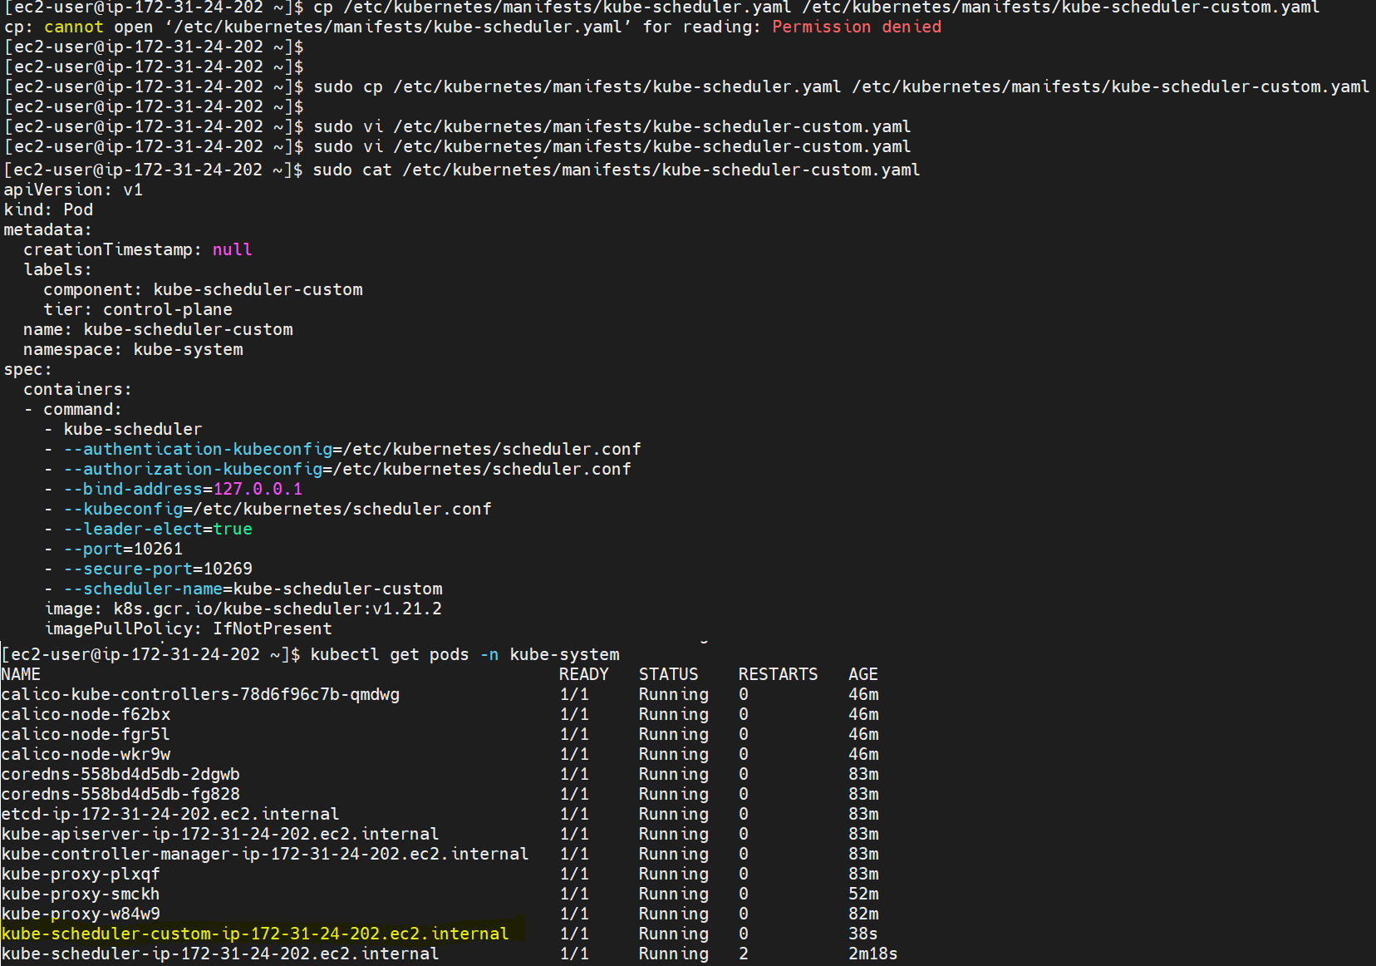

**Lab-5**



**Lab-6**

**Lab-7**

