**Lab-1**

**Lab-2**

**Lab-3**

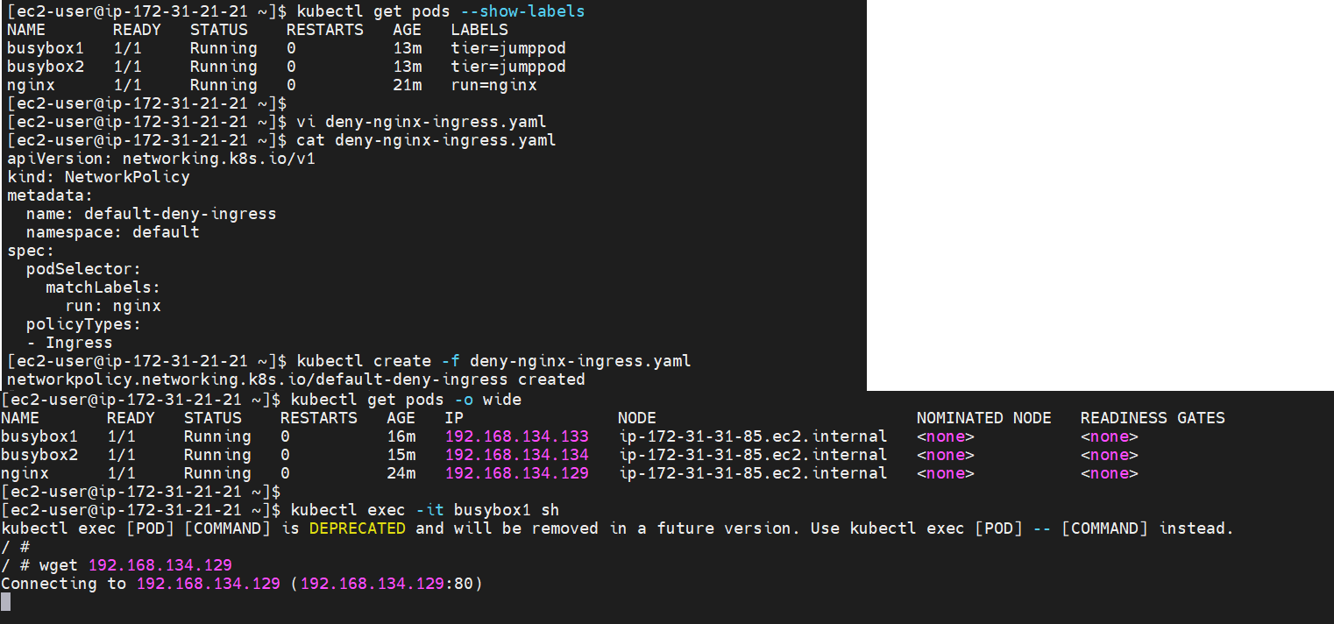

**Lab-4**

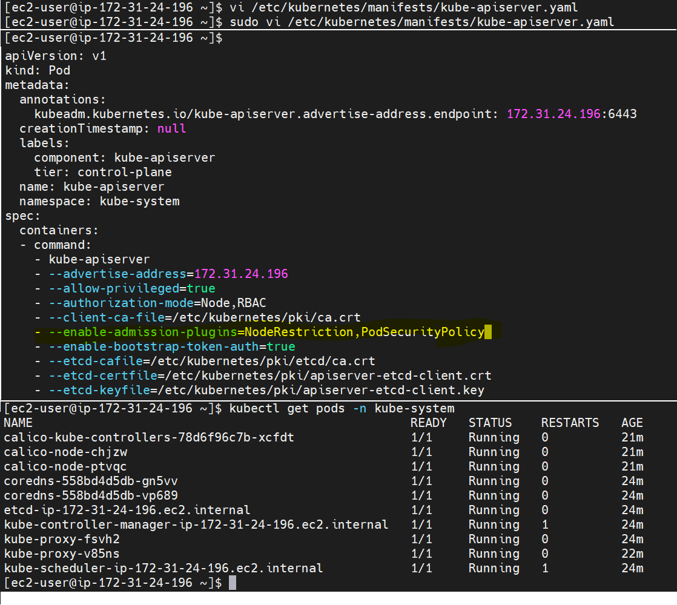



**Lab-5**

**'Privileged' policy with no restrictions**

**'Restrictive' policy with**

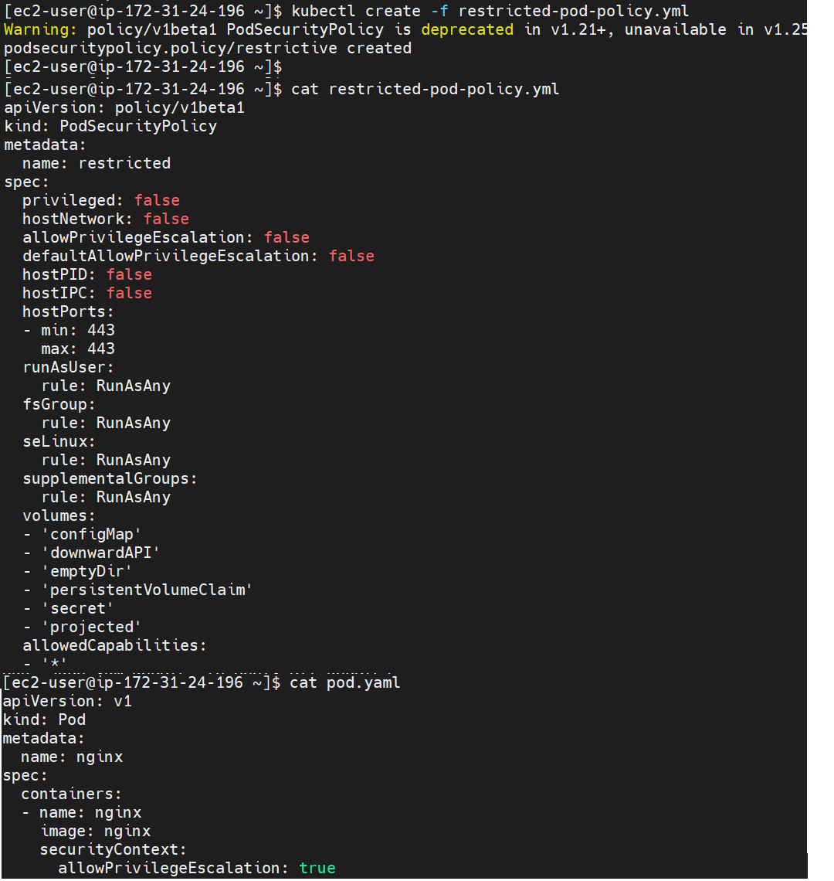



**Lab-6**

**Lab-7**



