**Building the Application**

1. Download the project ZIP archive from github ( <https://github.com/kumsan-wong/KSCognixusDemo> )
2. Unzip and import the project into Eclipse as ‘Existing Maven Project’.
3. Edit the file ‘application.properties’ and replace the two <placeholderText> with the appropriate values from your Google OAuth2 Client ID
4. Run the project as maven build with goals, ‘clean install’. This will create a jar file in the target folder located in the application root directory.

**Running the Application**

1. Run the application via ‘docker compose up’. The docker-compose.yml file is located in the application root directory.

**Testing the Application**

1. Retrieve a Google Account token using the client id and secret as configured in application.properties.
2. Apply the given token to the request Authorization header

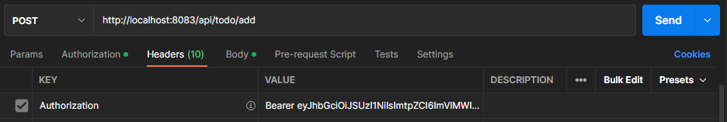

Figure 1: Sample Bearer token on request header via Postman.

1. Execute the HTTP call.

**API Interface**

API Base URL: <http://localhost:8083>

1. **Add Todo Entry**

Method: POST

Path: /api/todo/add

JSON Request Parameters:

|  |  |  |
| --- | --- | --- |
| **Name** | **Type** | **Description** |
| name | String |  |
| description | String |  |
| status | Enum | COMPLETE, INCOMPLETE |
| performDate | DateTime | Format: YYYY-MM-DDTHH:MM:SS  E.g. “2022-10-28T14:30:00” |

JSON Response Parameters:

|  |  |  |
| --- | --- | --- |
| **Name** | **Type** | **Description** |
| id | Long |  |
| name | String |  |
| description | String |  |
| status | Enum | COMPLETE, INCOMPLETE |
| performDate | DateTime | Format: YYYY-MM-DDTHH:MM:SS  E.g. “2022-10-28T14:30:00” |
| insertDate | DateTime |  |

1. **List Todo Entries**

Method: GET

Path: /api/todo/add

JSON Request Parameters: N/A

1. **Mark Complete**

Method: PUT

Path: /api/todo/mark/complete/{id}

JSON Request Parameters: N/A

1. **Delete Entry**

Method: DEL

Path: /api/todo/del/{id}

**{id} to be substituted with a valid entry ID

JSON Request Parameters: N/A