INTERNAL PRODUCT DOCUMENT
AI-Powered Pricing Strategy Assistant
Product Requirements Document (PRD)
A personalized, SQL-driven pricing recommendation system for a simulated EdTech subscription platform

Field | Value
Document Owner | Kumud Jalori — Product Manager (Author)
Product Area | Pricing & Monetization
Status | Draft v1.0 — Internal Prototype
Platform | Simulated EdTech subscription platform (internally referred to as “LearnSphere” for this document)
Distribution | Product, Pricing, Growth, Marketing, Customer Success, Leadership
Last Updated | This document

Scope note: This PRD documents an internal prototype built to demonstrate product thinking, SQL-based product analytics, and pricing-strategy design on a simulated dataset. It is not a live production system, and figures cited throughout should be read as outputs of a sandboxed analysis rather than live business results.

Table of Contents
1. Executive Summary 3
2. Product Problem Statement 3
3. Product Vision 4
4. Stakeholders 5
5. Dataset Overview 5
6. User Research & Business Discovery 7
7. SQL Analysis 9
8. Learner Segmentation 9
9. Product Insights 10
10. Pricing Recommendation Framework 11
11. Business Rules 13
12. Pricing Parameters 14
13. Functional Requirements 15
14. Non-Functional Requirements 15
15. Product Success Metrics 16
16. Dashboard Overview 17
17. Roadmap 18
18. Risks 18
19. Future Improvements 19
20. Key Product Learnings 19

1. Executive Summary
What is a PRD? A Product Requirements Document is the artifact a Product Manager writes to align engineering, design, analytics, and business stakeholders on what a product should do, why it should exist, who it serves, and how success will be measured. It is not a spec for a single feature — it is the source of truth that connects a business problem to a shippable solution. This PRD follows that same discipline for an internal pricing-recommendation prototype.
The AI-Powered Pricing Strategy Assistant is an internal, rule-based pricing and renewal recommendation system built for LearnSphere, a simulated EdTech subscription platform. It analyzes learner behavior — engagement, course completion, support activity, and renewal history — and recommends a personalized subscription plan, discount action, or renewal offer for each learner. Every recommendation is generated by an auditable SQL business-rules engine, and a large language model (Google Gemini) is used only to translate the SQL decision into a warm, natural-language message for the learner.

Why It Exists
LearnSphere currently applies the same pricing and discounting logic to every learner regardless of behavior. This has produced renewal rates that range from 19.6% to 86.7% across learner segments with no systematic explanation, discounting that is not gated by behavior, and no mechanism to flag at-risk or upgrade-ready learners before the moment is lost. This product exists to close that gap using data the platform already collects, without requiring a machine-learning pipeline or historical A/B outcome data that a new product does not yet have.

Who Uses It
The system is designed for five internal consumers: the Product team (roadmap prioritization), the Pricing team (discount governance), the Growth team (re-engagement targeting), the Marketing team (acquisition spend allocation), and Customer Success (churn-risk triage). Section 4 details what each stakeholder needs from the system.

Expected Business Value
- Replace one-size-fits-all pricing with behavior-driven, per-learner recommendations.
- Reduce discount leakage by gating offers behind engagement signals instead of blanket segment rules.
- Give Customer Success an early, rule-based churn-risk flag before a learner lapses.
- Provide Product and Pricing leadership with an auditable set of success metrics — conversion, renewal, upgrade, and discount redemption — to evaluate whether personalized pricing is working.
- Establish a transparent v1 (SQL rules) that can be extended with machine learning once real longitudinal outcome data exists.
This document intentionally avoids projecting business impact in absolute revenue terms. Because the underlying dataset is simulated and a single-point-in-time snapshot rather than a before/after funnel log, this PRD reports what the analysis found and what the system is designed to do — not a forecast of real-world lift.

2. Product Problem Statement
LearnSphere sells four subscription tiers to a diverse learner base, but pricing and discount decisions are not personalized to learner behavior. This section lays out the specific gaps the data analysis surfaced.
Problem | Description
Static pricing | The same four fixed price points (Basic, Standard, Pro, Premium) are offered to every learner in a segment, regardless of individual engagement or outcome signals.
Generic discounts | Coupons and discounts are issued without a behavioral gate. Learners who redeem a discount but disengage still receive it, while behaviorally similar full-price learners renew at higher rates.
Low renewal rates in specific segments | Renewal rates range from 19.6% (Casual Learner) to 86.7% (Power Learner) — a spread that plan tier alone does not explain.
Poor upgrade conversion | Learners who are clearly ready for a higher tier (high completion, high weekly hours) are not proactively identified or offered an upgrade path.
One-size-fits-all subscription offers | All six learner segments — from College Student to Working Professional — see the same generic renewal and upsell messaging.
Lack of personalized pricing | There is currently no system that combines a learner's plan, engagement, tenure, and support history into a single, explainable pricing action.

Why These Problems Matter
Left unaddressed, these gaps compound in two directions: the business over-discounts to low-intent learners who would have churned anyway, and under-serves high-intent learners who are ready to pay more but are never asked. Both failure modes are visible directly in the data — for example, discount-redeeming learners complete meaningfully less coursework than full-price learners, while a measurable share of the base already shows upgrade-ready behavior with no corresponding recommendation ever surfaced to them. A personalized, rule-based pricing layer directly targets both failure modes.

3. Product Vision

Mission
To make every pricing, discount, and renewal decision on LearnSphere explainable, personalized, and grounded in actual learner behavior — not a fixed, one-size-fits-all rate card.

Vision
A pricing layer that any team at LearnSphere — Product, Pricing, Growth, or Customer Success — can trust and audit, because every recommendation traces back to a named business rule rather than an opaque model.

Value Proposition
- For learners: a subscription experience that reflects how they actually use the platform, not a generic segment average.
- For the business: fewer wasted discounts, earlier churn-risk visibility, and a clear, defensible rationale behind every pricing action.
- For the product organization: a v1 recommendation engine that ships without a machine-learning pipeline, and can be upgraded to one later with confidence.

Business Goals
- Improve renewal rates in low-renewal segments through earlier, targeted intervention rather than blanket discounting.
- Reduce discount redemption among learners unlikely to convert into retained, paying subscribers.
- Increase the share of upgrade-ready learners who are proactively shown an upgrade recommendation.
- Establish a metrics framework (Section 15) that lets Pricing and Product leadership evaluate personalization effectiveness on an ongoing basis.

Success Criteria
For this v1 prototype, success is defined as: (1) a working, auditable recommendation engine covering 20+ business rules and 10+ pricing parameters; (2) a defined set of product success metrics with documented, honest formulas; (3) a reporting dashboard that surfaces those metrics and the underlying charts to non-technical stakeholders; and (4) a clear, credible roadmap for how the system would be validated with real user data (Section 17).

4. Stakeholders
The recommendation engine and its dashboard are built as an internal, cross-functional tool. Each stakeholder group consumes it differently:
Stakeholder | What They Need
Product Manager | Owns the rule logic and prioritization; uses the metrics dashboard to decide which segments or rules need iteration next.
Pricing Team | Needs visibility into discount redemption and pricing-sensitivity findings to set guardrails on how much and to whom discounts are offered.
Growth Team | Uses segment-level renewal and engagement data to target re-engagement campaigns at the learners most likely to respond.
Marketing Team | Uses revenue-by-segment findings to prioritize acquisition spend toward the segments that retain and monetize best.
Business Analysts | Consume the underlying SQL views and dataset to validate findings, extend the rule set, and build additional ad hoc reporting.
Leadership | Reviews the six core product metrics (MRR, ARPU, Renewal, Discount Redemption, Conversion, Upgrade Rate) as a standing pricing health check.

5. Dataset Overview
The analysis is built on a simulated dataset of 1,600 learners (exceeding the 1,500+ target), each represented as a single snapshot row summarizing 12 months of engagement history, across 4 subscription plans and 6 learner segments. The dataset is generated with deliberate, segment-driven correlations rather than random values, so that SQL analysis surfaces a coherent, explainable story instead of noise.

Subscription Plans
Plan | Monthly Fee
Basic | ₹299
Standard | ₹599
Pro | ₹999
Premium | ₹1,499

Learner Segments (Renewal Rate, Avg. Completion, Avg. Weekly Hours)
Segment | Renewal Rate | Avg. Completion Rate | Avg. Weekly Hours
Power Learner | 86.7% | 0.88 | 15.32
Certification Seeker | 78.8% | 0.77 | 5.38
Career Switcher | 74.5% | 0.67 | 8.31
Working Professional | 74.4% | 0.71 | 6.91
College Student | 62.7% | 0.55 | 5.39
Casual Learner | 19.6% | 0.27 | 2.23

Dataset Schema — 19 Fields
The Learners fact table joins to two lookup tables (Subscription_Plans and Learner_Segments) via foreign keys. Field-level detail:
Field | Description | Why It Matters
Learner_ID | Primary key identifying each learner | Row-level join key for all analysis and recommendation output.
Age | Learner age | Used as an eligibility check for student-discount and age-gated offers (Rule 20).
Profession | Self-reported occupation | Contextualizes segment assignment (e.g., Working Professional, Career Switcher).
Region | Learner's geographic region | Supports regional pricing-sensitivity analysis if extended later.
Learner_Segment | One of 6 behavioral personas | Primary driver of persona-based pricing sensitivity and rule matching.
Subscription_Plan | Current plan (Basic/Standard/Pro/Premium) | Anchors all upgrade/downgrade logic.
Monthly_Fee | Price currently paid | Feeds MRR and ARPU calculations directly.
Months_Active | Tenure on the platform | Distinguishes new-user onboarding cases from loyal, long-tenure renewers.
Courses_Enrolled | Total courses started | Denominator for completion-rate calculation.
Courses_Completed | Total courses finished | Absolute output signal, independent of enrollment volume (Rule 13).
Completion_Rate | Courses_Completed / Courses_Enrolled | The single strongest engagement and outcome signal used across the rule set.
Weekly_Hours | Average hours per week on-platform | Time-investment signal used for upgrade and Pro/Premium eligibility rules.
Login_Frequency | Logins per month | Platform-habit strength; distinguishes casual browsing from consistent use.
Last_Login_Days | Days since last login | Primary recency signal for churn-risk and renewal-reminder rules.
Coupon_Used | Whether a coupon was applied (Y/N) | Flags discount-dependent learners for pricing-sensitivity analysis.
Discount_Availed | Magnitude of discount received (%) | Measures how much margin has already been given up on this learner.
Payment_Mode | Payment method used | Operational field; supports payment-friction analysis.
Support_Tickets | Count of support tickets raised | Leading indicator of friction and disengagement; highest-priority rule trigger.
Renewed_Last_Cycle | Whether the learner renewed (Y/N) | Primary outcome variable for renewal-rate analysis and win-back targeting.

Data honesty note: this is a single-point-in-time snapshot per learner, not an event-level funnel log. That distinction directly shapes how Conversion Rate and Upgrade Rate are defined in Section 15 — both are documented as proxy metrics rather than presented as directly-measured funnel conversions.

6. User Research & Business Discovery
This prototype does not include live customer interviews. In place of traditional user research, discovery was conducted through business-side analysis: understanding how the current pricing workflow behaves, stating the assumptions behind it, and testing those assumptions against the dataset using SQL.

Current Pricing Workflow (As-Is)
- Learners are assigned to one of four plans at signup, with no dynamic repricing afterward.
- Discounts are issued on a segment or promotional basis, not gated by individual behavior.
- Renewal and churn are only visible after the fact — there is no forward-looking risk flag.
- There is no mechanism today that connects engagement data to a pricing or renewal action.

Pain Points Identified
- Support and Customer Success teams have no systematic early-warning signal for at-risk learners.
- Pricing cannot currently answer “which segments are over-discounted?” with data.
- Growth has no ranked list of upgrade-ready learners to target.

Business Assumptions Going In
- Assumption: engagement (completion, hours, logins) is a better renewal predictor than plan tier. Confirmed — see Section 9.
- Assumption: discounting has a ceiling effect on quality of engagement. Confirmed — coupon-using learners complete meaningfully less coursework than full-price learners.
- Assumption: a small number of segments account for a disproportionate share of revenue. Confirmed — Working Professionals generate the highest revenue per learner despite not being the largest segment.

Key Findings from Exploratory Analysis
- Pro plan outperforms Standard on total revenue despite having fewer subscribers — price point beats volume at this tier.
- Coupon-using learners renew roughly 9 points lower than full-price learners.
- Power Learners renew at 86.7% versus 19.6% for Casual Learners — a 3x gap that dwarfs the spread between any two plan tiers.
- Support ticket volume falls steadily as completion rate rises (2.8 tickets on average below 40% completion, down to 0.5 above 70%), making ticket volume a usable leading indicator of disengagement.
- College Students over-index on discount usage, with a redemption rate around 57% — the highest of any segment.
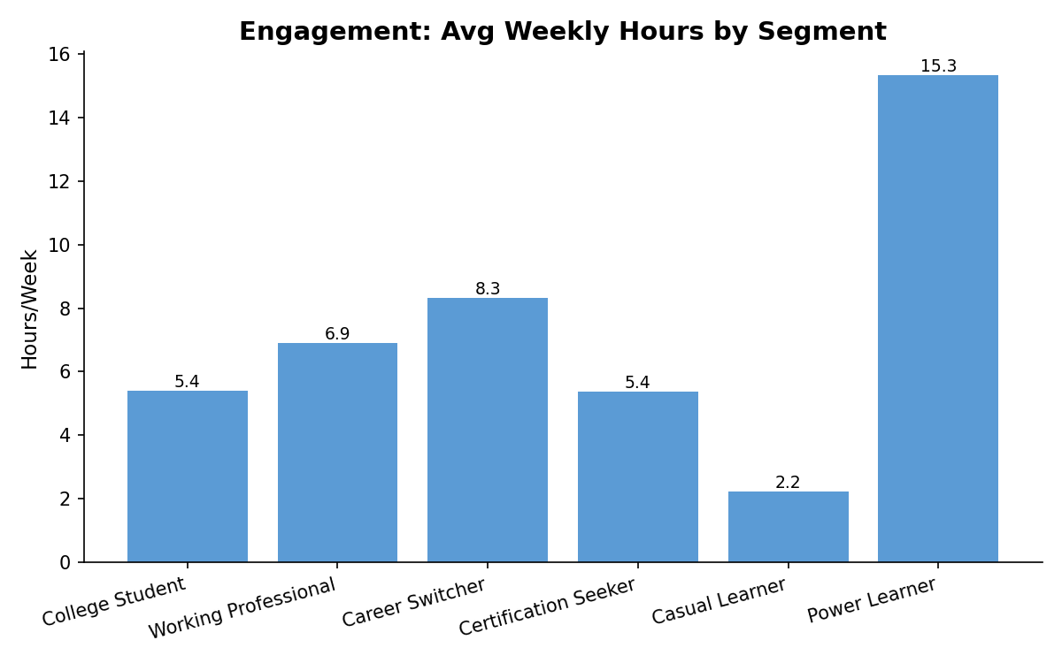
Figure 1. Engagement distribution across the learner base, generated from the SQL/Excel analysis referenced above.

7. SQL Analysis
All analysis is performed with 22 SQL queries against a normalized, three-table schema (a Learners fact table plus Subscription_Plans and Learner_Segments lookup tables), chosen deliberately over a single flat table to demonstrate basic normalization without over-engineering a small dataset.

Techniques Used
Technique | How It Was Applied
Aggregation | SUM, AVG, and COUNT across plan, segment, and cohort dimensions to compute revenue, ARPU, and renewal rate.
Joins | Learners joined to Subscription_Plans and Learner_Segments lookup tables to enrich analysis with plan pricing and segment metadata.
Filtering | WHERE and CASE-based filtering to isolate specific cohorts, e.g., learners inactive 60+ days who did not renew.
Window Functions | Ranking and cohort comparisons (e.g., ranking segments by revenue-per-learner) to surface relative, not just absolute, performance.
Trend Analysis | Tenure-bucketed revenue analysis (1–3, 4–6, 7–9, 10–12 months) used as a proxy for revenue trend given the snapshot dataset.
Segmentation | GROUP BY Learner_Segment across renewal, completion, and revenue metrics to build the segment profile in Section 8.
Renewal Analysis | Renewed_Last_Cycle compared against engagement fields to isolate what actually predicts renewal.
Revenue Analysis | Monthly_Fee aggregated by plan and by segment to identify which tiers and personas drive the most revenue.
Conversion Analysis | Coupon_Used compared against Renewed_Last_Cycle to build the proxy Conversion Rate metric (Section 15).

What the Analysis Found
Rather than reproduce the query text here, this section summarizes findings by category. Revenue analysis showed the Pro plan generating more total revenue than Standard despite fewer subscribers. Renewal analysis showed a far larger gap by learner segment than by plan tier. Pricing-sensitivity analysis showed a measurable completion-rate penalty among discount users. Engagement analysis showed support-ticket volume as a reliable, low-noise leading indicator of disengagement. Every one of these findings feeds directly into the business rules defined in Section 11.

8. Learner Segmentation
Six behavioral segments anchor both the analysis and the recommendation engine. Each is described below with its dominant behavior, pricing sensitivity, renewal likelihood, and the pricing strategy the engine applies to it.
Segment | Behavior | Pricing Sensitivity | Renewal Likelihood | Recommended Strategy
Power Learner | Highest engagement (15.3 hrs/week, 88% completion) | Low — values depth of content over price | Very High (86.7%) | Recommend Premium or Annual Plan; candidate for referral programs.
Certification Seeker | High completion, moderate hours, goal-driven | Medium — will pay for credential value | High (78.8%) | Recommend Pro for certification-relevant content depth.
Career Switcher | High weekly hours, transitional intent | Medium | High (74.5%) | Recommend Pro when weekly hours are high.
Working Professional | Consistent, moderate engagement; highest revenue per learner | Low — time-constrained but willing to pay | High (74.4%) | Recommend Premium for high engagers; loyalty rewards for long-tenure renewers.
College Student | Moderate completion, price-sensitive | High — highest discount redemption in the base | Medium (62.7%) | Student discount (15%) gated by a minimum completion threshold.
Casual Learner | Lowest engagement (2.2 hrs/week, 27% completion) | High but discounting doesn't fix disengagement | Very Low (19.6%) | Engagement nudges before any pricing action; hold on Basic.
The core segmentation insight: engagement predicts renewal far more strongly than plan tier does. Pricing alone will not fix a Casual Learner's churn risk, which is why the recommendation engine checks engagement and satisfaction signals before any pricing or upsell action for every segment.

9. Product Insights
Translating the SQL and segmentation analysis into insight categories a pricing or growth team would act on:
Category | What the Data Shows
High-engagement users | Power Learners and Certification Seekers with 80%+ completion — primary upgrade and annual-plan candidates.
Low-engagement users | Casual Learners and any learner under ~30% completion — pricing changes alone will not retain them; needs an engagement intervention first.
Discount-sensitive users | College Students and Casual Learners, who together account for the highest coupon redemption rates in the base.
Upgrade candidates | Basic/Standard learners with high completion and weekly hours, and any learner who has completed 10+ courses regardless of current plan.
Churn-risk users | Learners inactive 45+ days, with 60+ days plus a non-renewal treated as high risk and routed to a win-back offer.
Revenue opportunities | Working Professionals (highest revenue per learner) and the Pro tier (highest plan revenue despite fewer subscribers than Standard) represent the clearest expansion opportunities.
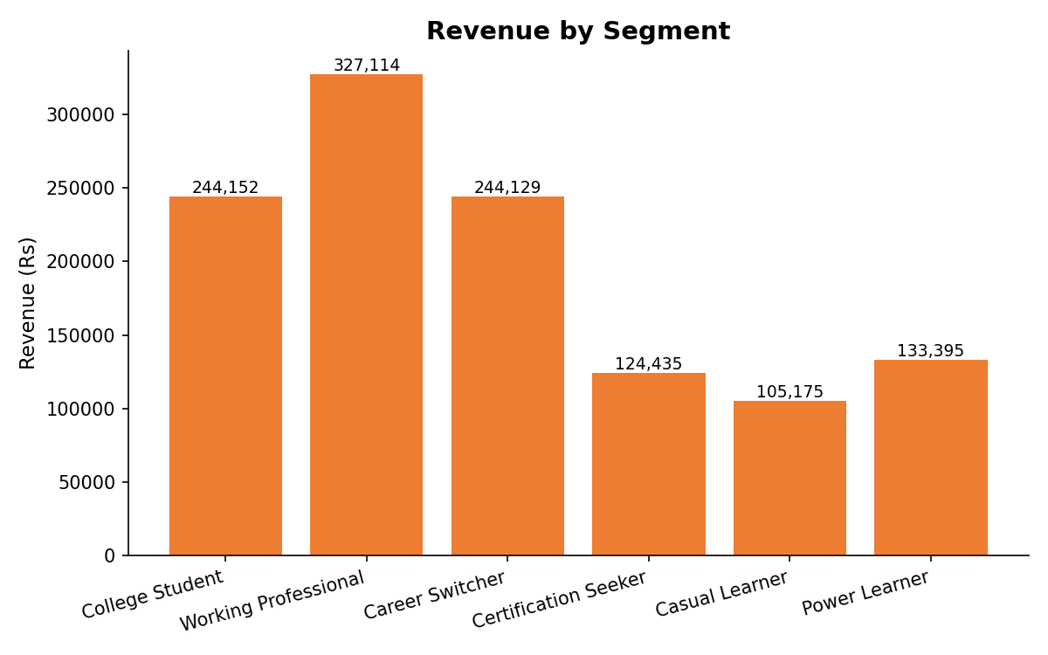
Figure 2. Revenue by learner segment — Working Professionals lead on revenue per learner despite a mid-sized segment population.

10. Pricing Recommendation Framework
The recommendation engine is a deterministic, priority-ordered SQL rules engine. It takes learner-level data as input, evaluates it against a fixed, ranked set of business rules, and outputs a single recommended action per learner — a plan change, a discount, a renewal offer, or a non-pricing action such as a support outreach or engagement nudge.

Inputs
All 19 dataset fields described in Section 5, most directly the 14 fields formalized as pricing parameters in Section 12.

Decision Engine
Implemented as a single, priority-ordered SQL CASE statement. Each learner is evaluated top-to-bottom against the 22 rules in Section 11; the first matching rule wins and becomes that learner's recommended action for the cycle. This ordering is itself a product decision, not just SQL syntax — satisfaction and churn-risk rules are checked before any upsell rule, so a struggling learner is never pitched an upgrade before their underlying issue is addressed.

Business Rules
See Section 11 for the complete, ranked rule set.

Recommendation Logic — Priority Tiers
- Priority 1 — Friction override: unresolved support issues are addressed before any pricing conversation.
- Priority 2 — Churn risk: inactivity and non-renewal trigger a win-back or renewal reminder.
- Priority 3 — Value mismatch: high-tier, low-usage learners are flagged for a downgrade review rather than upsold further.
- Priority 4–5 — Upgrade signals: segment- and behavior-specific upsell paths (Premium, Pro, Annual Plan).
- Priority 6–9 — Renewal, entry-tier upgrade, and loyalty logic for engaged but not-yet-converted learners.
- Priority 10–13 — Discount hygiene, onboarding, disengagement, and advocacy/referral flags.

Outputs
- Recommended_Action: the single, prioritized SQL decision (e.g., “Recommend Upgrade to Pro,” “High Churn Risk – Win-Back Offer”).
- A learner-facing natural-language explanation, generated by the LLM layer described below, that never alters the underlying SQL decision.

System Flow Diagram
Step | Component | Description
1 | Learner Data | 19-field snapshot per learner (Section 5).
2 | SQL Analysis | Exploratory queries surface segment- and behavior-level patterns (Section 7).
3 | 22 Business Rules / 14 Parameters | Priority-ordered CASE logic evaluates every learner (Section 11–12).
4 | Recommendation Engine | First matching rule becomes the learner's recommended action.
5 | LLM Phrasing Layer | Gemini rewrites the SQL decision into a personalized, second-person message — it cannot change the decision.
6 | Output | Recommended plan, discount, or renewal offer, delivered with a plain-language explanation.

AI Explains — It Never Decides
The LLM layer (Google Gemini, gemini-1.5-flash) is used exclusively to phrase the SQL engine's decision in natural language. It is explicitly instructed not to alter the recommendation, its output is capped at 60 words, written in second person, and never references the fact that the message was automated. A per-row error-handling design ensures one failed API call never breaks the batch. Example:
Layer | Output
SQL (decision) | Current plan: Basic. Recommendation: Upgrade to Pro. Reason: 82% completion, 7.4 hrs/week.
Gemini (phrasing) | “You're putting in real effort — 82% course completion and multiple hours a week. Pro would unlock more advanced content that matches how seriously you're taking this.”

11. Business Rules
22 rules govern the recommendation engine (exceeding the 20+ target in scope). Rules are listed in priority order — the order in which they are evaluated in the underlying SQL CASE statement. Higher-priority rules intentionally override lower-priority upsell rules.
Rule | Condition (IF) | Recommended Action (THEN)
R12 | Support_Tickets ≥ 3 | CS outreach before any upsell
R8 | Last_Login_Days > 60 AND Renewed_Last_Cycle = 'N' | High churn risk — 20% win-back offer
R7 | Last_Login_Days > 45 | Renewal reminder
R16 | Subscription_Plan = Premium AND Completion_Rate < 0.3 | Downgrade review (value mismatch)
R1 | Learner_Segment = Power Learner AND Completion_Rate > 0.8 | Recommend Premium
R13 | Courses_Completed ≥ 10 AND Subscription_Plan ≠ Premium | Recommend Premium (power usage signal)
R2 | Working Professional AND Weekly_Hours > 6 AND Completion_Rate > 0.7 | Recommend Premium
R11 | Power Learner AND Months_Active ≥ 6 | Recommend Annual Plan
R14 | Certification Seeker AND Completion_Rate > 0.8 | Recommend Pro (certification value)
R15 | Career Switcher AND Weekly_Hours > 8 | Recommend Pro
R3 | Subscription_Plan in (Basic, Standard) AND Completion_Rate > 0.75 AND Weekly_Hours > 6 | Recommend upgrade to Pro
R9 | Renewed_Last_Cycle = 'N' AND Completion_Rate > 0.7 | Loyalty discount (10%) — price objection case
R4 | Subscription_Plan = Basic AND Completion_Rate > 0.6 AND Login_Frequency > 10 | Recommend upgrade to Standard
R5 | College Student AND Completion_Rate > 0.7 | Student discount (15%)
R19 | Working Professional AND Renewed_Last_Cycle = 'Y' AND Months_Active ≥ 9 | Loyalty reward — free month or 10% off renewal
R17 | Discount_Availed > 20 AND Completion_Rate < 0.5 | Do not extend discount next cycle
R10 | Coupon_Used = 'Y' AND Completion_Rate < 0.4 | Flag low-intent discount user — no further discount
R18 | Months_Active ≤ 2 AND Login_Frequency < 3 | Onboarding nudge — no discount
R6 | Casual Learner AND Completion_Rate < 0.3 | Engagement nudge — remain on Basic
R22 | Last_Login_Days ≤ 7 AND Completion_Rate > 0.85 | Referral-program candidate
R20 | Age < 21 AND Subscription_Plan in (Pro, Premium) | Verify extended student eligibility
R21 | Mid-range completion and hours (no other rule matched) | Maintain current plan — monitor
Why priority order matters: this ordering is a deliberate product decision. Friction (support tickets) and churn-risk signals are always evaluated before any upsell rule, so the engine never pitches an upgrade to a learner who is actively struggling or at risk of leaving.

12. Pricing Parameters
14 parameters feed the rules engine (exceeding the 10+ target in scope), each mapped to a specific dataset field:
Parameter | Why It Influences Pricing Decisions
Subscription_Plan | Anchors all upgrade/downgrade logic — every rule about “upgrade to X” depends on knowing the current plan.
Monthly_Fee | Current price point paid; feeds MRR/ARPU and price-objection logic.
Completion_Rate | The single strongest engagement and outcome signal in the dataset; used across most rules.
Weekly_Hours | Time-investment signal, distinct from completion — captures effort even before a course is finished.
Login_Frequency | Platform-habit strength; separates consistent users from one-off logins.
Months_Active | Tenure/loyalty signal; distinguishes new-user onboarding from long-tenure loyalty cases.
Learner_Segment | Persona-driven pricing sensitivity; determines which segment-specific rule branch applies.
Coupon_Used | Discount-dependency signal; flags learners whose engagement may be price-driven rather than product-driven.
Discount_Availed | Magnitude of past discounting; used to cap further discount exposure.
Renewed_Last_Cycle | Most recent renewal outcome; the primary variable for renewal and win-back logic.
Last_Login_Days | Recency/churn-risk signal; the primary trigger for renewal reminders and win-back offers.
Courses_Completed | Absolute output, independent of completion rate — rewards high-volume learners even mid-course.
Support_Tickets | Friction/satisfaction proxy; the single highest-priority signal in the entire rule set.
Age | Eligibility check for age-gated student and youth offers.

13. Functional Requirements
ID | Requirement
FR-1 | Generate a recommended action (plan, discount, or renewal offer) for every learner in the dataset.
FR-2 | Calculate a renewal-likelihood signal per learner using tenure, engagement, and prior renewal history.
FR-3 | Recommend discounts gated by behavior (completion, engagement) rather than segment alone.
FR-4 | Suggest plan upgrades based on usage thresholds specific to each segment.
FR-5 | Flag churn-risk learners based on inactivity and non-renewal, before the renewal date is missed.
FR-6 | Generate a personalized, natural-language explanation for each recommendation via the LLM phrasing layer.
FR-7 | Create and refresh a reporting dashboard summarizing the six core product metrics (Section 15).
FR-8 | Track KPI trends by segment and by plan to support ongoing pricing-strategy review.
FR-9 | Export the full set of learner-level recommendations to a structured file (CSV) for downstream use by Growth or Marketing.
FR-10 | Preserve a fully auditable trail from each recommendation back to the specific rule that produced it.

14. Non-Functional Requirements
Category | Requirement
Performance | The rule engine must evaluate the full learner base (1,600+ rows) in a single batch query with no per-row latency, since recommendations are generated in bulk, not real-time, in this v1.
Scalability | The schema and rule design (CASE-based SQL, indexed on Learner_ID) should scale linearly to a substantially larger learner base without redesign.
Reliability | LLM phrasing failures must be isolated per learner — a single failed API call must never block or corrupt the batch of recommendations.
Security | Learner-level data (support tickets, payment mode, discount history) is treated as internal-only; no learner-identifiable data should leave the recommendation pipeline.
Data Privacy | The dataset used here is fully simulated; a production version would require the same field-level access controls applied to any real subscriber PII.
Usability | Dashboard output must be interpretable by non-technical stakeholders (Pricing, Marketing, Leadership) without needing to read the underlying SQL.
Auditability | Every recommendation must be traceable to exactly one named rule (Section 11) — no unexplained or black-box outputs.

15. Product Success Metrics
Six metrics define success for this system — the numbers a PM would report to leadership on a pricing review.
Metric | Formula | Current Value | Why It Matters
Monthly Recurring Revenue (MRR) | Sum of Monthly_Fee across all active learners | ₹11.78L | The north-star subscription-health metric; every other metric here ultimately ladders up to it.
Average Revenue Per User (ARPU) | MRR / total learner count | ₹736.50 | Reveals whether growth would come from adding users or better monetizing existing ones.
Renewal Rate | % of learners with Renewed_Last_Cycle = 'Y' | 64.7% | The clearest signal of product-market fit and pricing fairness for a subscription product.
Discount Redemption Rate | % of learners with Coupon_Used = 'Y' | 34.3% | Shows how dependent revenue is on discounting, and whether it's concentrated in the right segments.
Conversion Rate* | % of coupon users who went on to renew (proxy) | 58.8% | Measures whether discounting is actually converting learners into retained subscribers, not just subsidizing churn.
Upgrade Rate* | % of the base flagged by the engine for an upgrade action (proxy) | 29.9% | Sizes the upsell opportunity currently sitting in the base, directly actionable by Growth.
*Conversion Rate and Upgrade Rate are explicitly-labeled proxy definitions, documented in product_metrics.sql. Because the dataset is a snapshot rather than a before/after funnel log, these two metrics are defined against the closest available signals (coupon-to-renewal and recommendation-flagged share of the base) rather than a true funnel measurement. In a production system, both would instead be measured as Recommendation-Shown → Action-Taken within a defined window.

16. Dashboard Overview
A supporting analytics dashboard, built in Excel with formula-driven charts (no hardcoded values, sourced from SUMIF / AVERAGEIF / COUNTIFS), gives non-technical stakeholders a single view of pricing health without needing to query SQL directly.
Dashboard Element | What It Shows
Monthly Revenue | Total Monthly_Fee across the active base — the MRR view leadership checks first.
Renewal Trend | Renewal rate broken out by segment, surfacing the 19.6%–86.7% spread directly.
Revenue by Segment | Segment-level revenue contribution — identifies Working Professionals as the top revenue-per-learner segment.
Subscription Distribution | Share of the base on each plan — shows Standard as the modal choice, with Pro and Premium as the growth opportunity.
Engagement Distribution | Distribution of completion rate and weekly hours across the base — the input signal for most business rules.
Conversion Funnel | Coupon-user cohort broken into renewed vs. not-renewed, underlying the proxy Conversion Rate metric.
Upgrade Funnel | Share of the base flagged “Recommend Premium / Pro / Upgrade” by the engine, underlying the proxy Upgrade Rate metric.
Recommendation Distribution | Count of learners landing on each of the 22 rule outcomes — shows which interventions are most common in the current base.
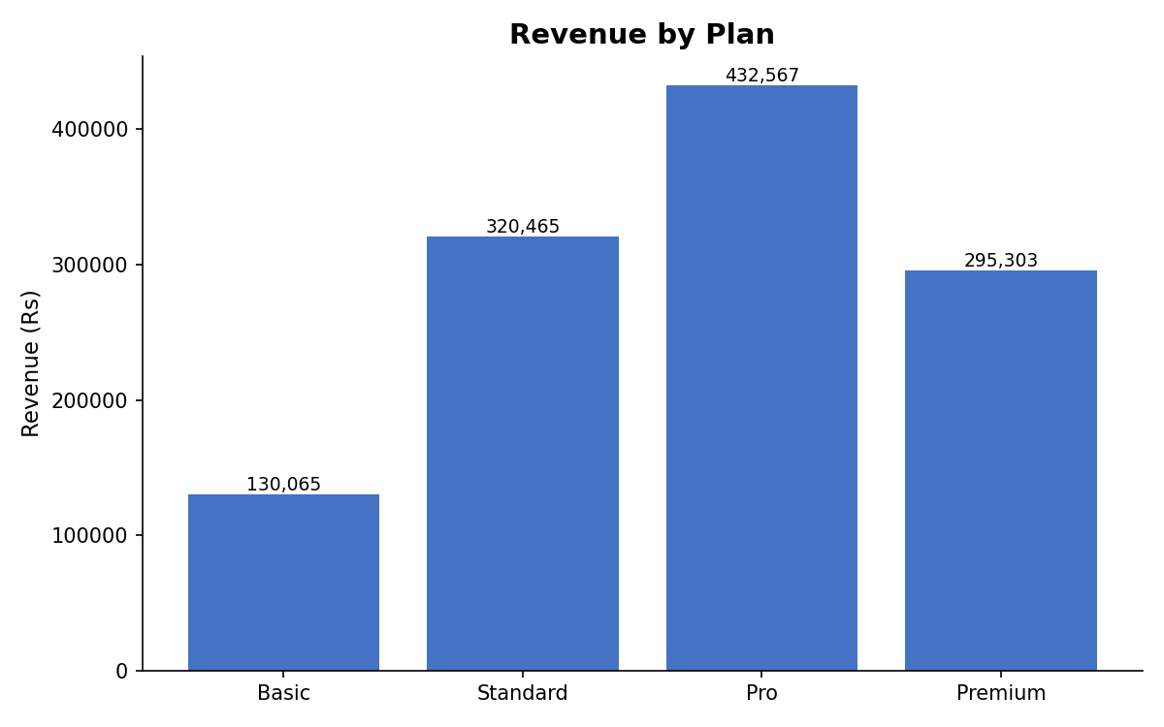
Figure 3. Revenue by subscription plan — Pro outperforms Standard on total revenue despite fewer subscribers.
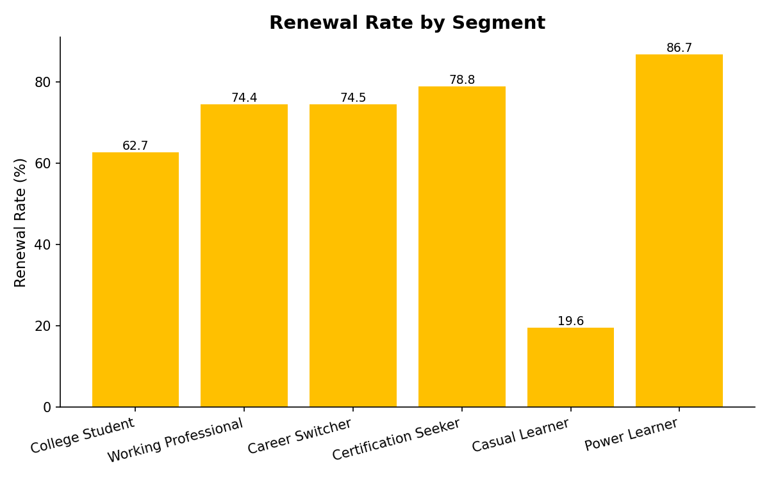
Figure 4. Renewal rate by learner segment — the 3x gap between Power Learners and Casual Learners.

17. Roadmap
Phase | Scope | Status
Phase 1 — Data Analysis | Build the simulated dataset, normalize the schema, and run 22 SQL queries to establish segment, revenue, and renewal patterns. | Complete
Phase 2 — Recommendation Engine | Design and implement the 22-rule, 14-parameter priority-ordered SQL engine and the Gemini phrasing layer. | Complete
Phase 3 — Dashboard | Build the Excel-based reporting dashboard covering the six core product metrics and supporting charts. | Complete
Phase 4 — Future AI Enhancements | Introduce machine learning for edge cases the rules can't resolve, once real, longitudinal outcome data exists (Section 19). | Planned

18. Risks
Risk | Description | Mitigation
Incorrect recommendations | A rule may misfire on an edge case not anticipated during design. | Priority-ordered rules plus a documented “maintain current plan — monitor” fallback rule prevent any learner from being left without a defined, safe outcome.
Data quality | Simulated data may not fully reflect real learner behavior distributions. | Rules are designed against clearly-documented, seeded generation logic; a production rollout would require re-validation against real data before launch.
Cold start | New learners (≤2 months tenure) have too little history for confident recommendations. | A dedicated onboarding-nudge rule (R18) explicitly avoids discounting or upselling new users until sufficient signal exists.
Pricing fairness | Behavior-based pricing could be perceived as penalizing struggling learners. | Friction and churn-risk rules always take priority over upsell rules, so the system never pressures an already-struggling learner.
User trust | Learners may distrust an AI-generated message if it feels automated or impersonal. | Gemini output is explicitly instructed to avoid referencing automation and stays within a natural, second-person tone; SQL — not the LLM — always owns the decision.
Business adoption | Internal teams may not trust a rules-based system without a track record. | Full auditability (every recommendation traces to one named rule) is designed specifically to build stakeholder trust ahead of a pilot rollout.

19. Future Improvements
- Dynamic pricing — move from fixed plan tiers toward usage- or value-based pricing once elasticity data exists.
- Machine learning models — layer in ML for edge cases the rules can't resolve, once real outcome data validates which signals actually predict renewal and upgrade.
- A/B testing — test the SQL engine's discount and upgrade offers against a control group to measure true causal lift, not just correlation.
- LLM explanation feedback loop — measure whether Gemini-personalized messages outperform raw SQL text on renewal and upgrade response.
- Real-time recommendations — move from batch scoring to event-triggered recommendations as learner behavior changes.
- Predictive churn scoring — once sufficient longitudinal data exists, complement the rule-based churn flag with a probabilistic churn score.
SQL was chosen deliberately for v1: for a new product with no historical A/B outcome data, every rule can be justified individually in a business review, and a trained model cannot. Machine learning earns its place once that outcome data exists — not before.

20. Key Product Learnings

Product Thinking
Framing pricing as a product problem — not just a finance decision — meant starting from learner behavior rather than a target margin, and designing the rule-priority order (friction and churn risk before upsell) as a deliberate product and trust decision.

SQL Insights
22 targeted queries were enough to move from raw data to a defensible, segment-level narrative — revenue, renewal, and engagement patterns were all directly queryable without needing a modeling layer.

Business Impact
The clearest actionable finding was that engagement, not plan tier, predicts renewal. That single insight reshapes how discounting and upsell should be targeted across the base.

Pricing Strategy
Personalization does not require discounting more — it requires discounting more precisely, and gating discounts behind actual behavior rather than blanket segment rules.

Data-Driven Decisions
Every rule in this engine is traceable to a specific, named finding from the SQL analysis, not an assumption — which is what makes the system auditable to non-technical stakeholders.

Recommendation Systems
A transparent, rule-based system is a legitimate and often preferable v1 architecture for a new product with no historical outcome data — explainability was treated as a feature, not a limitation.

Metrics
Defining metrics honestly — including labeling Conversion Rate and Upgrade Rate as proxies rather than overstating what a snapshot dataset can measure — is itself a core product-analytics skill.

End of Document — AI-Powered Pricing Strategy Assistant PRD, v1.0

