**Overview:**

Administrator should be able to create all base data including semester, candidate, course and lecture, lecture should have the ability to create internal result, dean, who is one of the lecture, should be the only one with the ability to update internal results revaluation can be initialized by candidate for all internal results.

**Purpose:**

In the world of human resources, talent acquisition and recruiting, CRM stands for candidate relationship management.CRM is often confused with its close relative which also goes by thus CRM acronym and is commonly utilized by the sales and marketing teams.

**Problem definition and Design thinking**

**Empathy map**

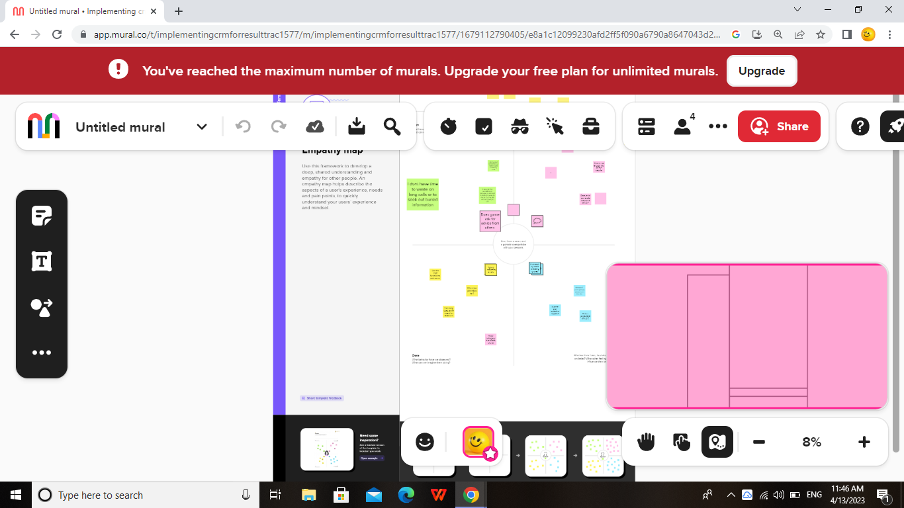

Ideationand Brainstorming map screenhot

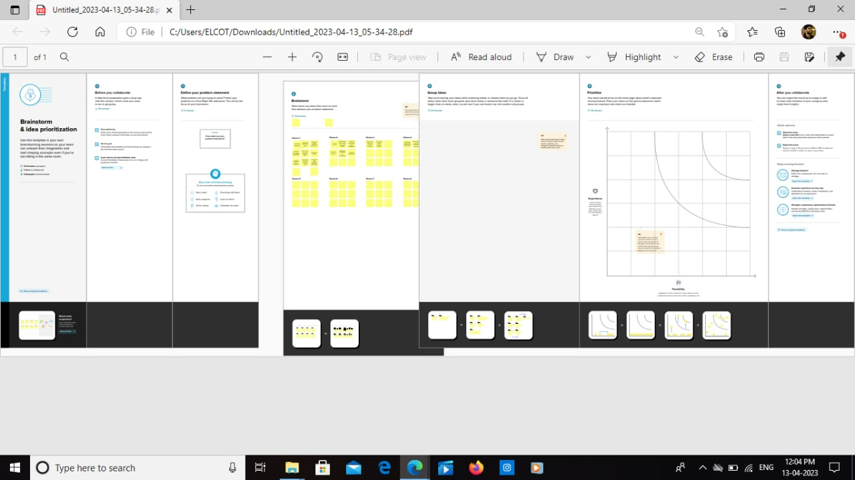

Result:

Data model:

|  |  |
| --- | --- |
| Object name | Fields in the object |
| Object-1 | Field Label: Semester  Data type: Text |
| Object-2 | Field name: clean status  Data type: Pick list |
| Object-3 | Field name: Account owner  Data type:Lookup(User) |

**Activity and Screenshot:**

**Create Salesforce Org-creating Developer Account**

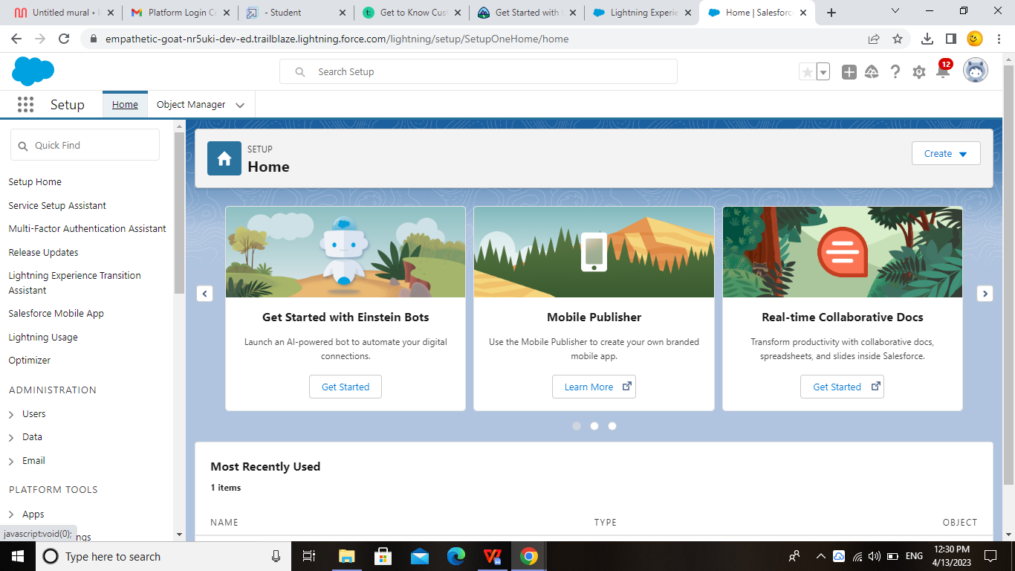

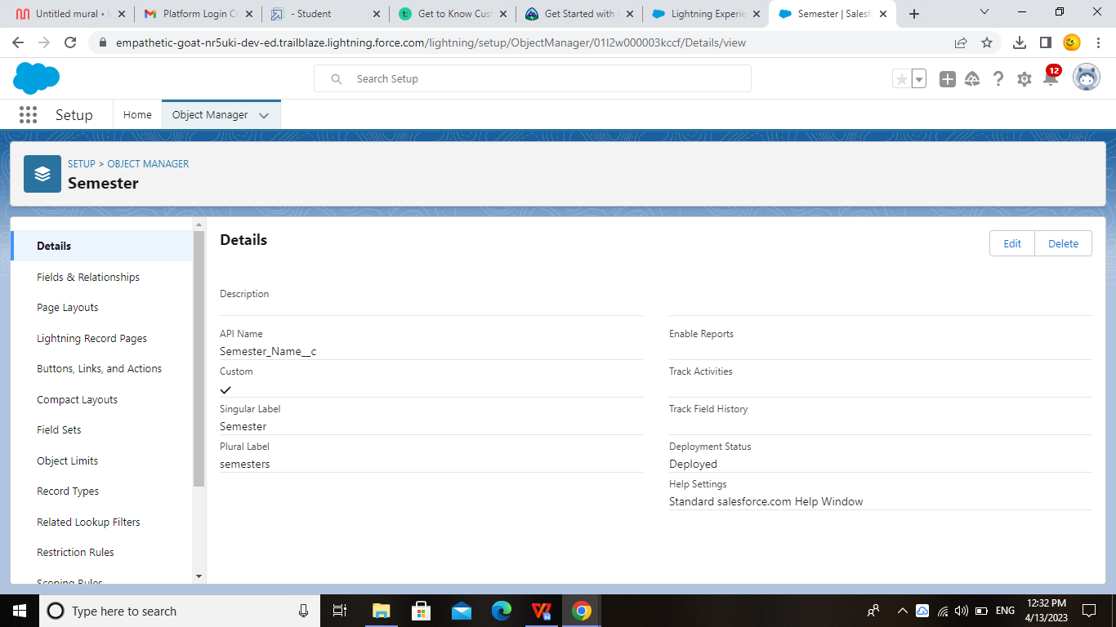

1. **Trailhead profile public URL:-**

**Team lead:-  [https: //trailblazer.me/id/dhard170]( https: /trailblazer.me/id/dhard170)**

**Team Member 1: <https://trailblazer.me/id/vpaem>**

**Team Member 2: <https://trailblazer.me/id/nmathsdepttmshift2>**

**Team member 3:  [https://trailblazer.me/id/pavtm](")**

Advantages and disadvantages of CRM

The advantages of a business using a CRM system greatly outweigh the disadvantages. However, there are pitfalls. For a CRM system to work, there needs to be buy-in across the organisation and the processes in place to support it. Otherwise, your CRM may end up being an expensive waste of time. Here, we take a look at the strategic pros, cons, and importance of CRM.

|  |  |
| --- | --- |
| Pros | Cons |
| It allows for the consolidation of customer data and the basis for deep insights.  It speeds up the sales conversion process.  It increases staff productivity, lowering time-cost.  It allows geographically dispersed teams to collaborate effectively.  Improves customer experience by allowing personalisation and improved query resolution. | Customer experience may worsen due to staff over-reliance on the system.  Security and data protection issues with centralised data.  The excess initial time and productivity cost at the implementation.  Requires a process-driven sales organisation.  CRM may not suit all businesses. |

Advantages of CRM



 It allows for more effective sales and marketing.

Having huge amounts of data on customer interactions enables an organisation to build up a clearer picture of its customers. It allows for deep insights to identify what the company is doing right as well as where it’s weak when it comes to managing its customers. With a CRM system, the most profitable customers can be identified, with the view to more time being spent targeting them. The CRM software also lets a business tailor its marketing communications to achieve more effective results and, hence, a greater return on investment in sales and marketing.

It can speed up the sales conversion process.

A CRM system integrated within a marketing campaign allows insights into the interests of prospective customers. Once the client enters the sales funnel, qualification and conversion can be full or partly automated making it much faster. This, whilst enhancing the sales experience, also frees up the sales team’s time, enabling them to focus on closing high probability and/or high-value deals.

It increases staff productivity, lowers time costs and boosts morale.

Quaint as it may seem, paperwork is still a significant part of many businesses’ day-to-day operations. A lot of that paperwork could be eliminated with a CRM system. Cutting down on wasted time increases the ability of the employee to get on with the kind of work that brings real value to the organisation. Slashing busy-work means that profit per employee rises, all the while increasing morale as staff feels that their work is more essential and rewarding. All of this fits neatly in with the kind of lean management practices that high-performing businesses utilize.

### ****It enables widely dispersed teams to work closely.****

Companies often have parts of their operations away from their home base for a multitude of reasons—cheaper operating costs, proximity to clients, or greater ease in providing on-site technical support. A remotely accessible CRM software allows a company to exploit the efficiencies and benefits of multiple geographical locations. This is a huge advantage for sales teams in the field as it gives them the facility to spend more time with prospects and clients. Most importantly though, an organisation fully integrated by means of a CRM system can respond far more effectively to customer queries and issues.

### ****Can improve customer loyalty through exceptional experience.****

The hallmark of excellent ****customer service**** is being able to intelligently and quickly address queries and problems. This can only be achieved by being able to efficiently access customers’ data and transactional history allowing for instant familiarization with their context and needs. A CRM system helps speed up processes, enabling employees to deal with more queries and providing a generally better customer experience. An investment in a CRM system is an investment in customer loyalty and the return on that investment comes in the form of an increase in customers’ lifetime value and word-of-mouth referrals.

## ****Disadvantages of CRM****

We’ve looked at the pros—the advantages—of initiating a ****CRM system****, so now it’s time to examine some of the cons—the disadvantages—of a CRM system. Whilst ultimately these are fewer in number than the advantages, for some businesses, the short-term pain of a cultural and technological shift can be a lot to bear and may not generate a return.

### ****Staff over-reliance on CRM may diminish customer loyalty through a bad experience.****

If staff come to rely too heavily on ****CRM software****, it reduces their flexibility in dealing with customer queries. They often become helpless in the face of questions from clients where the information isn’t on the system and which requires lateral thinking to solve the problem. This has obvious implications for the customer experience and clients may become frustrated, taking their business to a competitor.

### ****Security concerns associated with centralised data.****

There are risks associated with keeping a lot of data in one place. With stringent regulations surrounding data (GDPR, for example), businesses face severe penalties in the event of security breaches. When it comes to CRM software, it is vital that security processes are put in place to protect clients’ personal information. This can be a significant expense for a business, but the costs associated with not having such safeguards in place are far higher.

### ****The excess initial time and productivity cost of implementation****

There will be a steep learning curve for staff with any new system. It will take some time for employees to find their feet with the CRM system and mistakes will be made. It’s for the management team to ensure that there’s adequate buy-in and support in the process of transitioning. This can be expensive as it distracts manpower from their core tasks. The benefits when the CRM system *is*in place, however, will far outweigh the initial time and productivity costs.

### ****It requires a process-driven sales organisation.****

To maximize the return on investment (ROI) in a CRM system, it is necessary to have a process-driven sales regime. A CRM can be used simply as a data store that can be mined for insights, assuming that that data is updated consistently. However, the real value comes from using it to manage the sales pipeline, flagging issues early and holding people to account. This reduces lost deals, increases upsell rates and provides much-improved revenue forecasting. Where no formal sales process exists, introducing one can be a massive change for some companies—one which may require extensive investment in people, retraining, a whole philosophical shift in the business’ sales approach and quite a lot of short-term expense and pain.

**APPLICATIONS:**

A good CRM helps you understand your market and the needs of your customers.has you attract more customers, CRM makes two things clear :

Who is interested in what you have to offer, and what is most important to them.

When it comes to winning more customers a CRM helps you make smarter decisions then your competition and offer people what they truly want.

And if customers leave or your sales stagnat you can see common threads and change the process accordingly better meet they needs and retain them.

**CONCLUSION:**

Customer Relationship Management enables a company to align its stragety with the needs of the customers in order to best meet those needs and thus ensure long term customer loyalty.

However, in order to be successful in these aims, the different company departments have to work together and use measure in a coordinated fashions.

This purpose is achieved via a customer data base which is analysed and updated using CRM software.

**FUTURE SCOPE:**

Customers will become a company’s best sales reps through superior product and services as well as customer oriented messaging.

The future of CRM is more than just the future of Customer Relationship Management software.

It is really the future of buissness.