# 系统基本信息

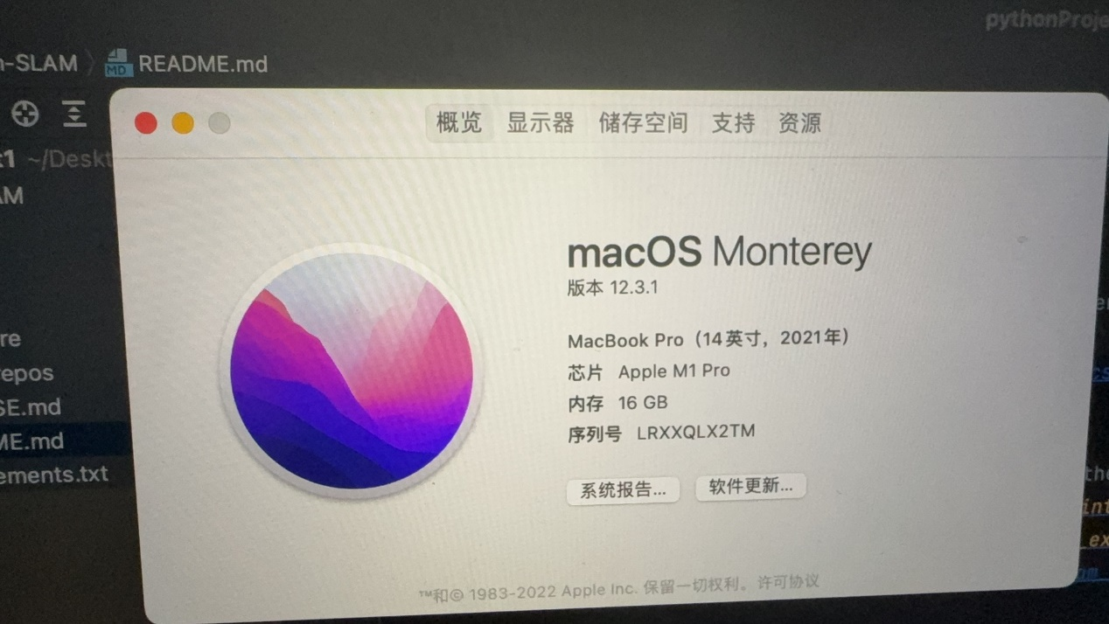

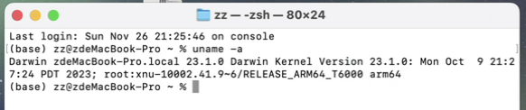

# 安装ROS2

文档：[macOS (source) — ROS 2 Documentation: Foxy documentation --- macOS （源代码） — ROS 2 Documentation： Foxy 文档](https://docs.ros.org/en/foxy/Installation/Alternatives/macOS-Development-Setup.html#system-requirements)

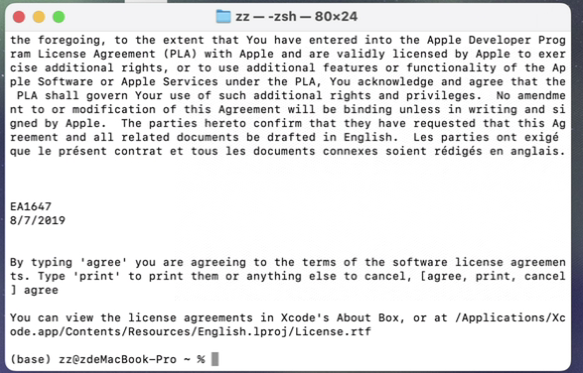

.

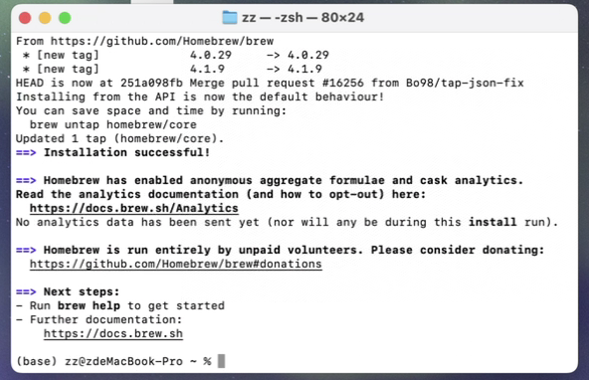

报错：

Running setup.py install for pygraphviz ... error

ERROR: Command errored out with exit status 1:

command: /usr/local/bin/python3 -u -c 'import io, os, sys, setuptools, tokenize; sys.argv[0] = '"'"'/private/var/folders/1z/lj64_w8n1x341xxj_0d4tsq00000gn/T/pip-install-qzz_kfiy/pygraphviz_81f2fe9030254edda698e47cb83e5706/setup.py'"'"'; __file__='"'"'/private/var/folders/1z/lj64_w8n1x341xxj_0d4tsq00000gn/T/pip-install-qzz_kfiy/pygraphviz_81f2fe9030254edda698e47cb83e5706/setup.py'"'"';f = getattr(tokenize, '"'"'open'"'"', open)(__file__) if os.path.exists(__file__) else io.StringIO('"'"'from setuptools import setup; setup()'"'"');code = f.read().replace('"'"'\r\n'"'"', '"'"'\n'"'"');f.close();exec(compile(code, __file__, '"'"'exec'"'"'))' install --record /private/var/folders/1z/lj64_w8n1x341xxj_0d4tsq00000gn/T/pip-record-27fsdtoc/install-record.txt --single-version-externally-managed --compile --install-headers /Library/Frameworks/Python.framework/Versions/3.9/include/python3.9/pygraphviz

cwd: /private/var/folders/1z/lj64_w8n1x341xxj_0d4tsq00000gn/T/pip-install-qzz_kfiy/pygraphviz_81f2fe9030254edda698e47cb83e5706/

Complete output (68 lines):

running install

/Library/Frameworks/Python.framework/Versions/3.9/lib/python3.9/site-packages/setuptools/_distutils/cmd.py:66: SetuptoolsDeprecationWarning: setup.py install is deprecated.

!!

********************************************************************************

Please avoid running ``setup.py`` directly.

Instead, use pypa/build, pypa/installer or other

standards-based tools.

See https://blog.ganssle.io/articles/2021/10/setup-py-deprecated.html for details.

********************************************************************************

!!

self.initialize_options()

running build

running build_py

creating build

creating build/lib.macosx-10.9-x86_64-cpython-39

creating build/lib.macosx-10.9-x86_64-cpython-39/pygraphviz

copying pygraphviz/scraper.py -> build/lib.macosx-10.9-x86_64-cpython-39/pygraphviz

copying pygraphviz/graphviz.py -> build/lib.macosx-10.9-x86_64-cpython-39/pygraphviz

copying pygraphviz/__init__.py -> build/lib.macosx-10.9-x86_64-cpython-39/pygraphviz

copying pygraphviz/agraph.py -> build/lib.macosx-10.9-x86_64-cpython-39/pygraphviz

copying pygraphviz/testing.py -> build/lib.macosx-10.9-x86_64-cpython-39/pygraphviz

creating build/lib.macosx-10.9-x86_64-cpython-39/pygraphviz/tests

copying pygraphviz/tests/test_unicode.py -> build/lib.macosx-10.9-x86_64-cpython-39/pygraphviz/tests

copying pygraphviz/tests/test_scraper.py -> build/lib.macosx-10.9-x86_64-cpython-39/pygraphviz/tests

copying pygraphviz/tests/test_readwrite.py -> build/lib.macosx-10.9-x86_64-cpython-39/pygraphviz/tests

copying pygraphviz/tests/test_string.py -> build/lib.macosx-10.9-x86_64-cpython-39/pygraphviz/tests

copying pygraphviz/tests/__init__.py -> build/lib.macosx-10.9-x86_64-cpython-39/pygraphviz/tests

copying pygraphviz/tests/test_html.py -> build/lib.macosx-10.9-x86_64-cpython-39/pygraphviz/tests

copying pygraphviz/tests/test_node_attributes.py -> build/lib.macosx-10.9-x86_64-cpython-39/pygraphviz/tests

copying pygraphviz/tests/test_drawing.py -> build/lib.macosx-10.9-x86_64-cpython-39/pygraphviz/tests

copying pygraphviz/tests/test_repr_mimebundle.py -> build/lib.macosx-10.9-x86_64-cpython-39/pygraphviz/tests

copying pygraphviz/tests/test_subgraph.py -> build/lib.macosx-10.9-x86_64-cpython-39/pygraphviz/tests

copying pygraphviz/tests/test_close.py -> build/lib.macosx-10.9-x86_64-cpython-39/pygraphviz/tests

copying pygraphviz/tests/test_edge_attributes.py -> build/lib.macosx-10.9-x86_64-cpython-39/pygraphviz/tests

copying pygraphviz/tests/test_clear.py -> build/lib.macosx-10.9-x86_64-cpython-39/pygraphviz/tests

copying pygraphviz/tests/test_layout.py -> build/lib.macosx-10.9-x86_64-cpython-39/pygraphviz/tests

copying pygraphviz/tests/test_attribute_defaults.py -> build/lib.macosx-10.9-x86_64-cpython-39/pygraphviz/tests

copying pygraphviz/tests/test_graph.py -> build/lib.macosx-10.9-x86_64-cpython-39/pygraphviz/tests

running egg_info

writing pygraphviz.egg-info/PKG-INFO

writing dependency_links to pygraphviz.egg-info/dependency_links.txt

writing top-level names to pygraphviz.egg-info/top_level.txt

reading manifest file 'pygraphviz.egg-info/SOURCES.txt'

reading manifest template 'MANIFEST.in'

warning: no files found matching '*.png' under directory 'doc'

warning: no files found matching '*.txt' under directory 'doc'

warning: no files found matching '*.css' under directory 'doc'

warning: no previously-included files matching '*~' found anywhere in distribution

warning: no previously-included files matching '*.pyc' found anywhere in distribution

warning: no previously-included files matching '.svn' found anywhere in distribution

no previously-included directories found matching 'doc/build'

adding license file 'LICENSE'

writing manifest file 'pygraphviz.egg-info/SOURCES.txt'

copying pygraphviz/graphviz.i -> build/lib.macosx-10.9-x86_64-cpython-39/pygraphviz

copying pygraphviz/graphviz_wrap.c -> build/lib.macosx-10.9-x86_64-cpython-39/pygraphviz

running build_ext

building 'pygraphviz._graphviz' extension

creating build/temp.macosx-10.9-x86_64-cpython-39

creating build/temp.macosx-10.9-x86_64-cpython-39/pygraphviz

gcc -Wno-unused-result -Wsign-compare -Wunreachable-code -fno-common -dynamic -DNDEBUG -g -fwrapv -O3 -Wall -arch x86_64 -g -DSWIG_PYTHON_STRICT_BYTE_CHAR -Iopt/homebrew/Cellar/portaudio/19.7.0/include/ -I/Library/Frameworks/Python.framework/Versions/3.9/include/python3.9 -c pygraphviz/graphviz_wrap.c -o build/temp.macosx-10.9-x86_64-cpython-39/pygraphviz/graphviz_wrap.o

pygraphviz/graphviz_wrap.c:3020:10: fatal error: 'graphviz/cgraph.h' file not found

#include "graphviz/cgraph.h"

^~~~~~~~~~~~~~~~~~~

1 error generated.

error: command '/usr/bin/gcc' failed with exit code 1

----------------------------------------

ERROR: Command errored out with exit status 1: /usr/local/bin/python3 -u -c 'import io, os, sys, setuptools, tokenize; sys.argv[0] = '"'"'/private/var/folders/1z/lj64_w8n1x341xxj_0d4tsq00000gn/T/pip-install-qzz_kfiy/pygraphviz_81f2fe9030254edda698e47cb83e5706/setup.py'"'"'; __file__='"'"'/private/var/folders/1z/lj64_w8n1x341xxj_0d4tsq00000gn/T/pip-install-qzz_kfiy/pygraphviz_81f2fe9030254edda698e47cb83e5706/setup.py'"'"';f = getattr(tokenize, '"'"'open'"'"', open)(__file__) if os.path.exists(__file__) else io.StringIO('"'"'from setuptools import setup; setup()'"'"');code = f.read().replace('"'"'\r\n'"'"', '"'"'\n'"'"');f.close();exec(compile(code, __file__, '"'"'exec'"'"'))' install --record /private/var/folders/1z/lj64_w8n1x341xxj_0d4tsq00000gn/T/pip-record-27fsdtoc/install-record.txt --single-version-externally-managed --compile --install-headers /Library/Frameworks/Python.framework/Versions/3.9/include/python3.9/pygraphviz Check the logs for full command output.

[MAC 安装 pygraphviz 找不到头文件 - 君君姐 - 博客园 (cnblogs.com)](https://www.cnblogs.com/WMT-Azura/p/9086246.html)

[完美解决：ERROR: the following packages/stacks could not have their rosdep keys resolvedto system depend_我就是菜的博客-CSDN博客](https://blog.csdn.net/weixin_50518868/article/details/119717777)

