项目地址：[real-stanford/cloth-funnels: [ICRA 2023] This repository contains code for training and evaluating Cloth Funnels in simulation for Ubuntu 18.04. --- 真实斯坦福/布料漏斗：[ICRA 2023] 此存储库包含用于在 Ubuntu 18.04 模拟中训练和评估布料漏斗的代码。 (github.com)](https://github.com/real-stanford/cloth-funnels)

参考地址：[My Research Workflow: Conda, Deep Learning, CUDA, Storage, and SSH --- 我的研究工作流程：Conda、深度学习、CUDA、存储和 SSH (danieltakeshi.github.io)](https://danieltakeshi.github.io/2021/09/05/workflow/)

PyfleX地址：[PyFleX/extensions at master · YunzhuLi/PyFleX --- PyFleX/扩展在 master 上 ·YunzhuLi/PyFleX (github.com)](https://github.com/YunzhuLi/PyFleX)

[Previous PyTorch Versions | PyTorch --- 以前的 PyTorch 版本 |Py火炬](https://pytorch.org/get-started/previous-versions/)

[PyPI · The Python Package Index --- 皮皮 ·Python 包索引](https://pypi.org/)

第一步基础环境：

安装显卡驱动，cuda

检查显卡型号：

[Linux(Ubuntu)系统查看显卡型号-腾讯云开发者社区-腾讯云 (tencent.com)](https://cloud.tencent.com/developer/article/2109897)  
 [怎样在ubuntu中查看自己的显卡型号及其对应驱动的安装_linux下ubuntu查看电脑cpu和显卡型号信息_universe_R的博客-CSDN博客](https://blog.csdn.net/universe_R/article/details/122115135)

下载驱动显卡驱动： [NVIDIA GeForce 驱动程序 - N 卡驱动 | NVIDIA](https://www.nvidia.cn/geforce/drivers/)

教程：[Ubuntu + nvidia驱动+ cuda安装教程以及重装问题_ubuntu nvidia cuda-CSDN博客](https://blog.csdn.net/qq_37041791/article/details/126932883" \l ":~:text=%E9%80%9A%E8%BF%87ctrl%2Balt%2BF1%E8%BF%9B%E5%85%A5%E5%91%BD%E4%BB%A4%E8%A1%8C%E7%95%8C%E9%9D%A2%EF%BC%8C%E5%85%B3%E9%97%AD%E6%89%80%E6%9C%89%E4%BD%BF%E7%94%A8GPU%E7%9A%84%E8%BF%9B%E7%A8%8B%E3%80%82%20sudo%20systemctl,isolate%20multi-user.target%20%E4%B9%8B%E5%90%8E%E5%8D%B8%E8%BD%BD%E7%B3%BB%E7%BB%9F%E7%9A%84nvidia%E9%A9%B1%E5%8A%A8%EF%BC%8C%E9%80%89%E6%8B%A9%E6%96%B0%E7%9A%84%E6%98%BE%E5%8D%A1%E9%A9%B1%E5%8A%A8%E9%87%8D%E6%96%B0%E5%AE%89%E8%A3%85%E3%80%82%20%E7%AD%89%E5%BE%85%E5%AE%89%E8%A3%85%E5%AE%8C%E6%88%90%E4%B9%8B%E5%90%8E%EF%BC%8C%E8%AE%BE%E7%BD%AE%E5%9B%BE%E5%BD%A2%E5%8C%96%E7%95%8C%E9%9D%A2%E5%B9%B6%E9%87%8D%E5%90%AF%E3%80%82) 注意：要安装OpenGL

下载cuda：[CUDA Toolkit Archive | NVIDIA Developer --- CUDA 工具包存档 |NVIDIA 开发者](https://developer.nvidia.com/cuda-toolkit-archive)

tb1228@tb1228:~$ lspci -vnn | grep VGA -A 12

sudo systemctl isolate multi-user.target

tb1228@tb1228:~/Downloads$ wget 'https://us.download.nvidia.com/XFree86/Linux-x86_64/470.223.02/NVIDIA-Linux-x86_64-470.223.02.run'

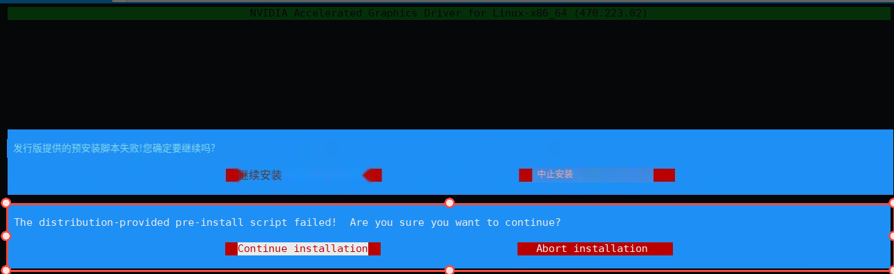

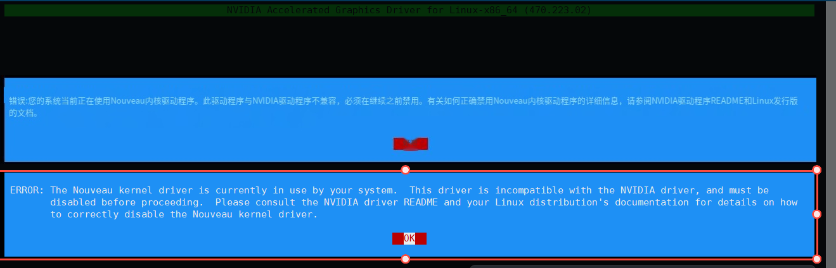 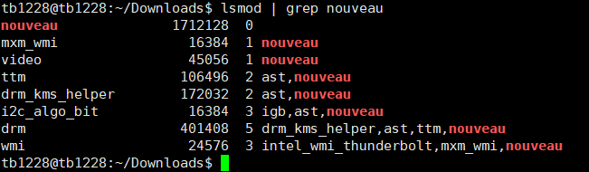

禁用：

创建文件

sudo vim /etc/modprobe.d/blacklist-nouveau.conf

插入以下内容进去：

blacklist nouveau

options nouveau modeset=0

执行禁用并重启：

sudo update-initramfs -u

sudo reboot

重启后再次输入：lsmod | grep nouveau 没有任何输出就是禁用成功了

tb1228@tb1228:~/Downloads$ sudo ./NVIDIA-Linux-x86_64-470.223.02.run 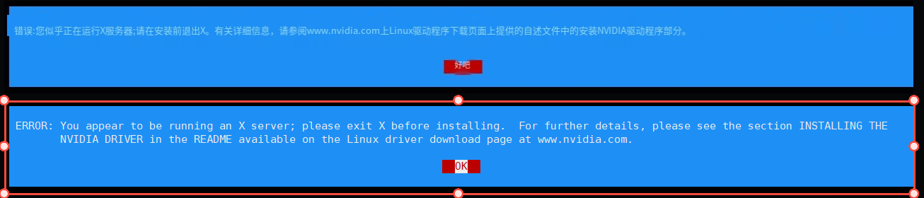

禁用X 服务器（也就是图形化GUI界面）

tb1228@tb1228:~/Downloads$ systemctl status lightdm.service

tb1228@tb1228:~/Downloads$ systemctl stop lightdm.service

按Ctrl-Alt-F1切换到文本控制台。这将关闭图形界面，以便进行后续的命令行操作。

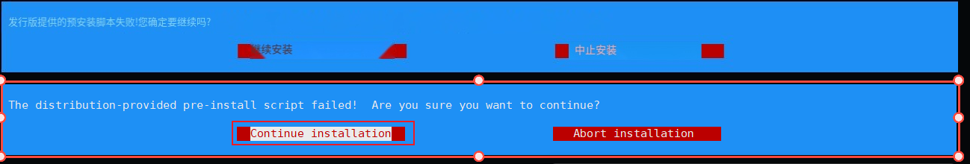

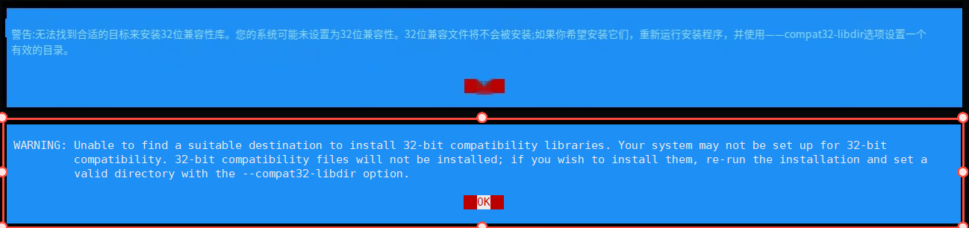

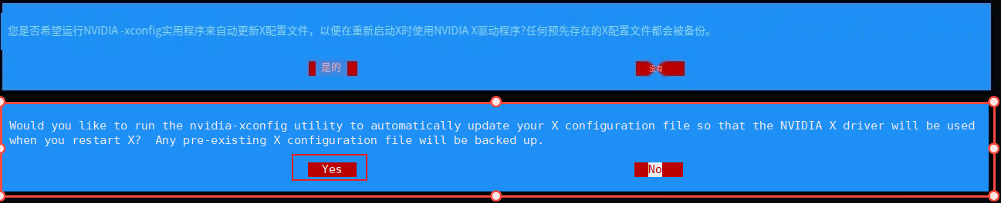

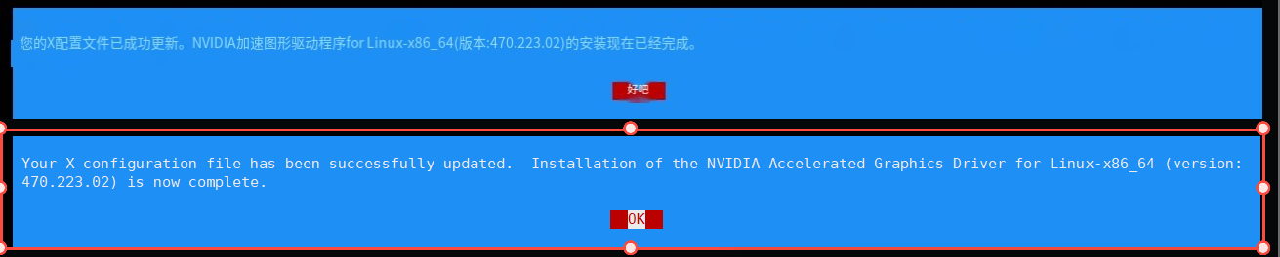

tb1228@tb1228:~/Downloads$ sudo ./cuda_9.2.148_396.37_linux.run

 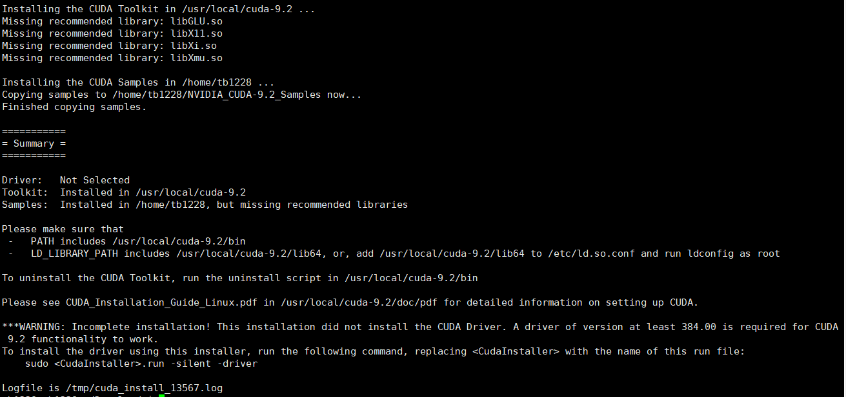

安装好了，要设置以下环境变量

tb1228@tb1228:~/Downloads$ sudo vim /etc/profile

export PATH=/usr/local/cuda-9.2/bin:$PATH

export LD_LIBRARY_PATH=/usr/local/cuda-9.2/lib64:$LD_LIBRARY_PATH

tb1228@tb1228:~/Downloads$ source /etc/profile

tb1228@tb1228:~/Downloads$ nvcc -V

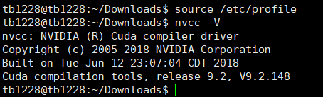

安装一下补丁：

tb1228@tb1228:~/Downloads$ sudo ./cuda_9.2.148.1_linux.run

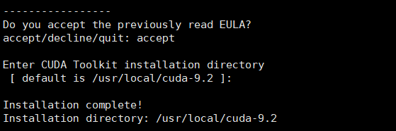

第二部：安装anaconda，记得随便设置conda的源，有助于加速[anaconda | 镜像站使用帮助 | 清华大学开源软件镜像站 | Tsinghua Open Source Mirror](https://mirrors.tuna.tsinghua.edu.cn/help/anaconda/)

wget <https://mirrors.tuna.tsinghua.edu.cn/anaconda/miniconda/Miniconda3-latest-Linux-x86_64.sh> --no-check-certificate

bash ./ Miniconda3-latest-Linux-x86_64.sh

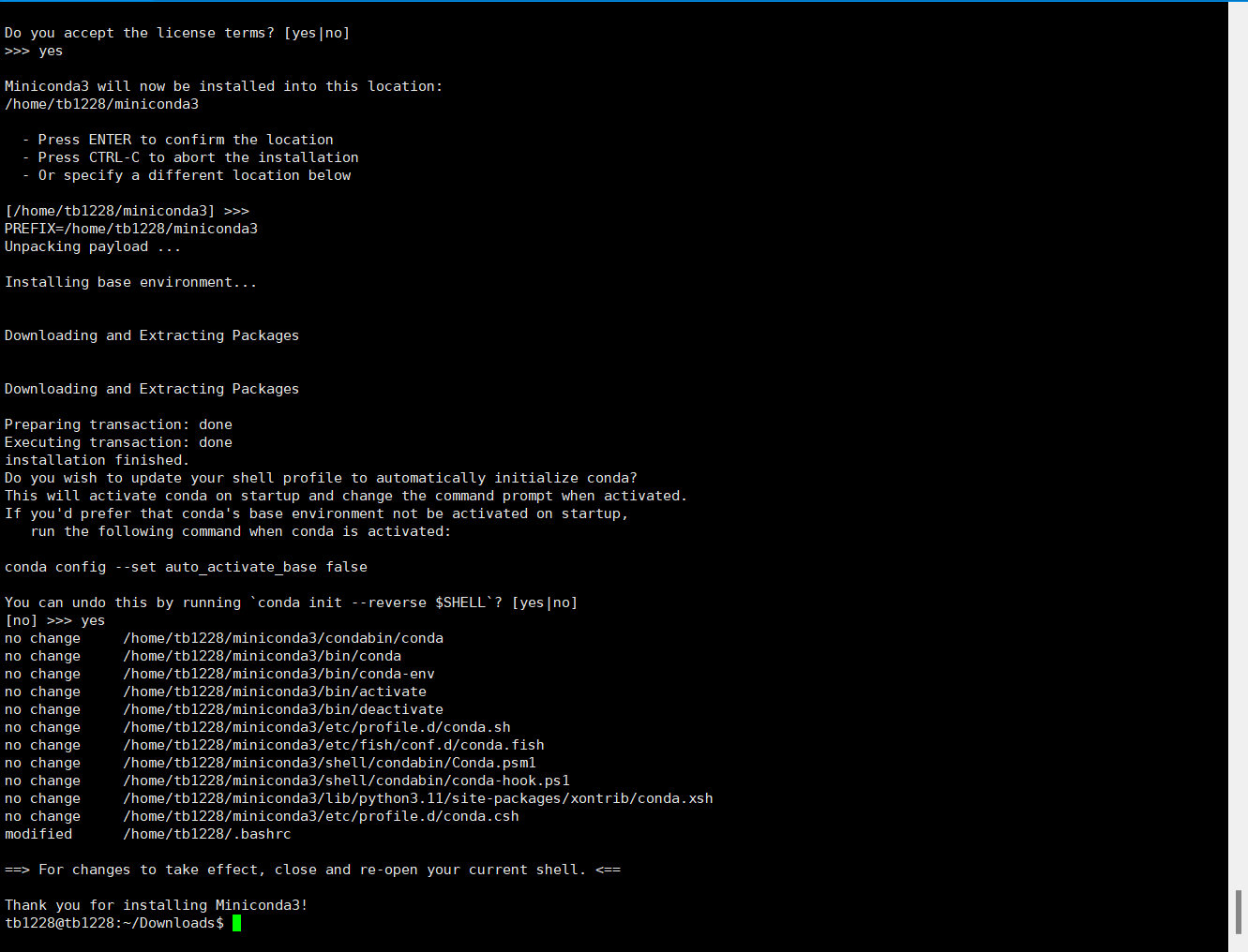

更换源：

conda config --set show_channel_urls yes

(base) tb1228@tb1228:~$ vim ~/.condarc

添加如下内容：

channels:

- defaults

show_channel_urls: true

default_channels:

- https://mirrors.tuna.tsinghua.edu.cn/anaconda/pkgs/main

- https://mirrors.tuna.tsinghua.edu.cn/anaconda/pkgs/r

- https://mirrors.tuna.tsinghua.edu.cn/anaconda/pkgs/msys2

custom_channels:

conda-forge: https://mirrors.tuna.tsinghua.edu.cn/anaconda/cloud

msys2: https://mirrors.tuna.tsinghua.edu.cn/anaconda/cloud

bioconda: https://mirrors.tuna.tsinghua.edu.cn/anaconda/cloud

menpo: https://mirrors.tuna.tsinghua.edu.cn/anaconda/cloud

pytorch: https://mirrors.tuna.tsinghua.edu.cn/anaconda/cloud

pytorch-lts: https://mirrors.tuna.tsinghua.edu.cn/anaconda/cloud

simpleitk: https://mirrors.tuna.tsinghua.edu.cn/anaconda/cloud

deepmodeling: https://mirrors.tuna.tsinghua.edu.cn/anaconda/cloud/

conda clean -i

其他：配置pip （清华源）

[pypi | 镜像站使用帮助 | 清华大学开源软件镜像站 | Tsinghua Open Source Mirror](https://mirrors.tuna.tsinghua.edu.cn/help/pypi/)

pip config set global.index-url https://pypi.tuna.tsinghua.edu.cn/simple



第三步：创建conda环境，以及安装依赖库

conda create -n cloth-funnels python=3.7.16

conda activate cloth-funnels

pip install -U torch==1.7.1+cu92 -f https://download.pytorch.org/whl/torch_stable.html pytorch-lightning==1.5

创建会很慢很慢，所以升级pip就可以解决这个问题

python -m pip install --upgrade pip

pip install opencv-python==4.5.5.64

pip install h5py==3.6.0

pip install filelock==3.6.0

pip install matplotlib==3.4.2

pip install imageio==2.19.5

pip install imageio-ffmpeg==0.4.5

pip install scipy

pip install ray==2.3.1

pip install torchvision==0.8.2

pip install torchaudio==0.7.2

ps：torchvision和torchaudi，是对torch的版本是有要求的，具体链接：[PyTorch中torch、torchvision、torchaudio、torchtext版本对应关系_torch与torchvision版本_Liekkas Kono的博客-CSDN博客](https://blog.csdn.net/shiwanghualuo/article/details/122860521)

pip install imutils==0.5.4

pip install libigl

使用igl找不到这个包，使用libigl==2.2.1没有这个版本

pip install pandas==1.3.1

pip install zarr==2.8.3

pip install trimesh==3.10.7

pip install scikit-image

pip install memory-profiler==0.60.0

pip install wandb==0.14.0

pip install hydra-core==1.2.0

pip install open3d==0.9.0

pip install imath OpenEXR

pip install cmake==3.27.5 pybind11==2.0.1 pybind11-global

附：官方的cloth-funnels环境文件：[cloth-funnels/environment.yml at main · real-stanford/cloth-funnels --- cloth-funnels/environment.yml 在主 ·真正的斯坦福/布料漏斗 (github.com)](https://github.com/real-stanford/cloth-funnels/blob/main/environment.yml)

克隆cloth-funnels项目以及PyfleX项目

sudo apt install git  
 git clone <https://github.com/real-stanford/cloth-funnels.git>

git clone <https://github.com/YunzhuLi/PyFleX.git>

这里有个坑：cloth-funnels项目提供的pyflex里面缺少了lib目录，所以：需要拷贝pyflex项目到cloth-funnels里面

rm -rf cloth-funnels/cloth_funnels/Pyflex

cp -R PyFleX cloth-funnels/cloth_funnels/

mv cloth-funnels/cloth_funnels/PyFleX/ cloth-funnels/cloth_funnels/PyFlex

安装pyflex编译需要的环境：

sudo apt-get install libgl1-mesa-dev libegl1-mesa-dev libc++-dev libc++abi-dev build-essential freeglut3-dev

编辑pyflex的编译参数：在cloth-funnels/cloth-funnels/compile.sh中的第9行：改为：

cmake -DPYBIND11_PYTHON_VERSION=3.7 -DCMAKE_BUILD_TYPE=Release ..

执行命令：开始安装

. ./prepare.sh && . ./compile.sh

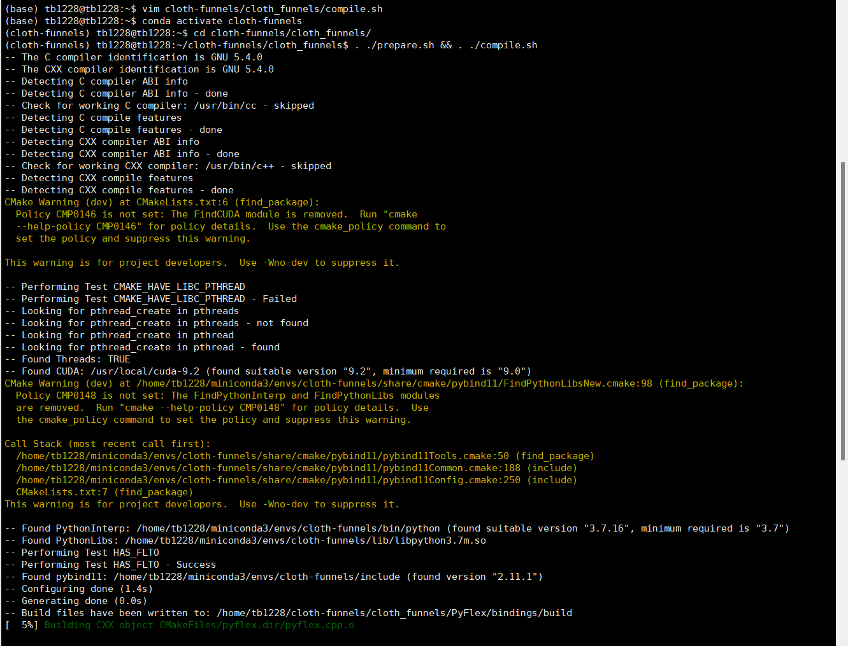

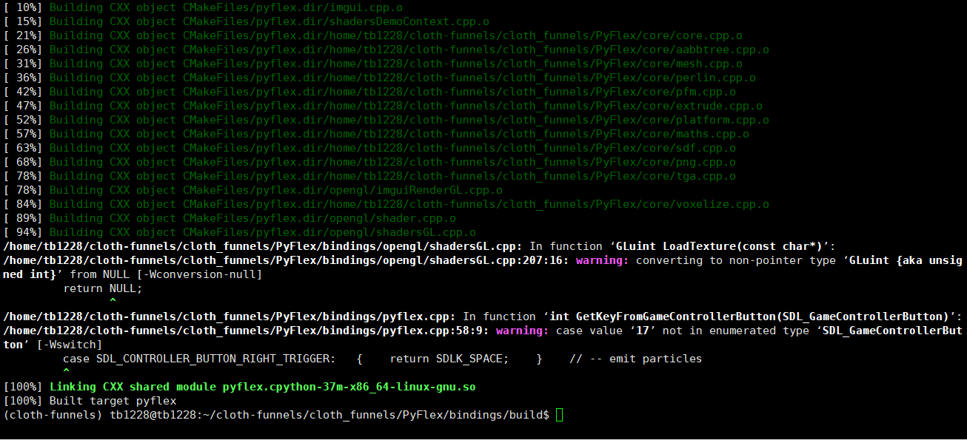

下载数据集

source download_models.sh

source download_tasks.sh

source download_sample.sh

source download_cloth_data.sh

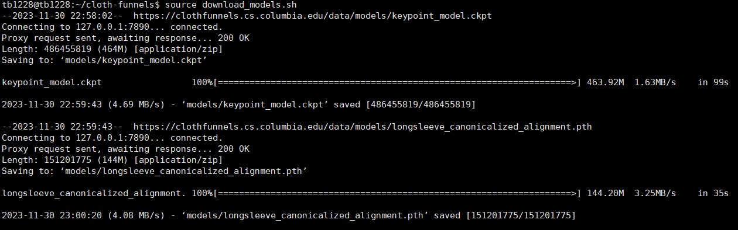

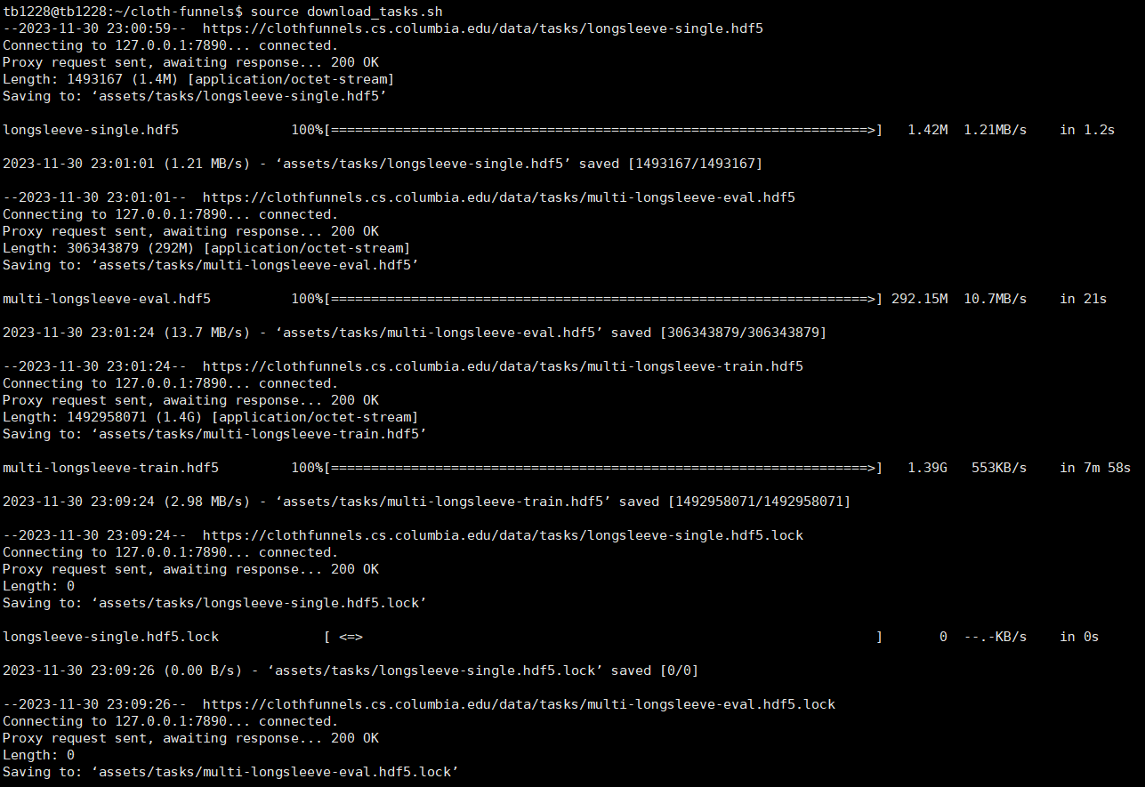

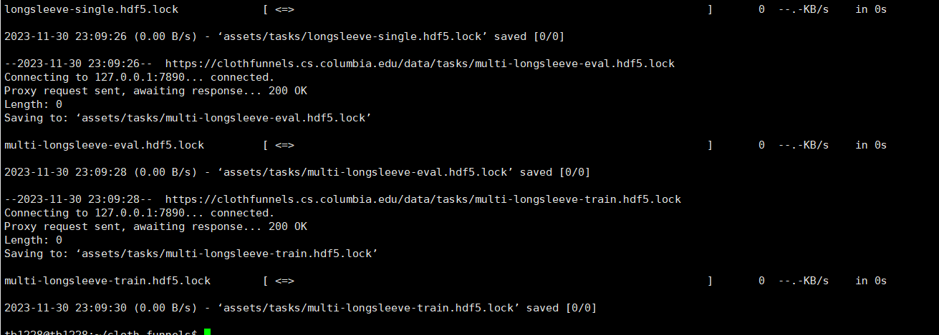

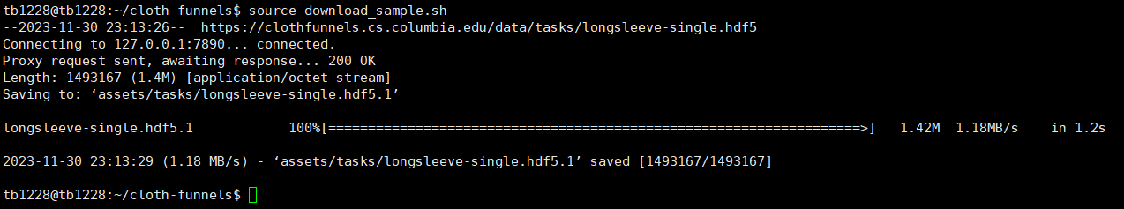

因为用的是：torch1.7.1的版本：需要修改：

第一步：在simEnv.py中1210行修改：vim cloth-funnels/cloth_funnels/environment/simEnv.py

rotation_idx = torch.div(x, num_scales, rounding_mode='floor') 要改为

rotation_idx = torch.floor_divide(x, num_scales)

第二步：在learning/utils.py中415行，修改：

img = transforms.functional.rotate(img, rotation,

interpolation=transforms.InterpolationMode.BILINEAR) 要改为 img =

transforms.functional.rotate(img, rotation, resample=Image.BILINEAR) （记得 from PIL import Image）

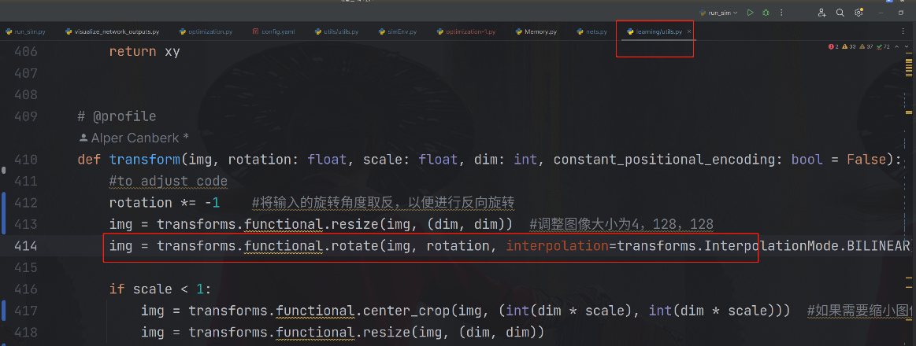

测试之前修改3给地方：

第一个：在utils/utils.py中58、59、60行注释

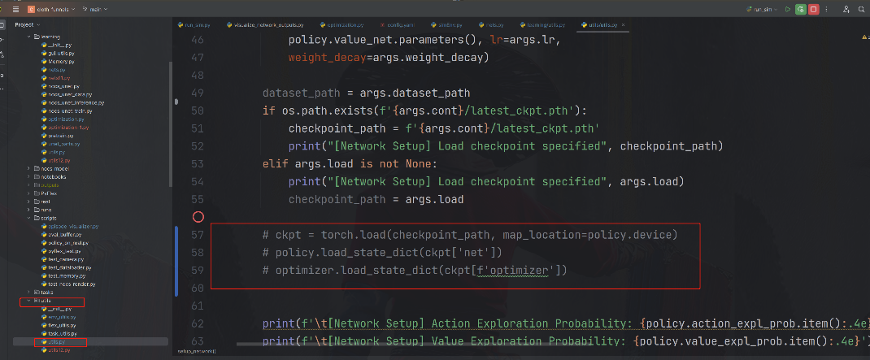

第二个：第二个在scripts/episode_visualizer.py中6行，添加为您当前的cloth-funnels的实际路径

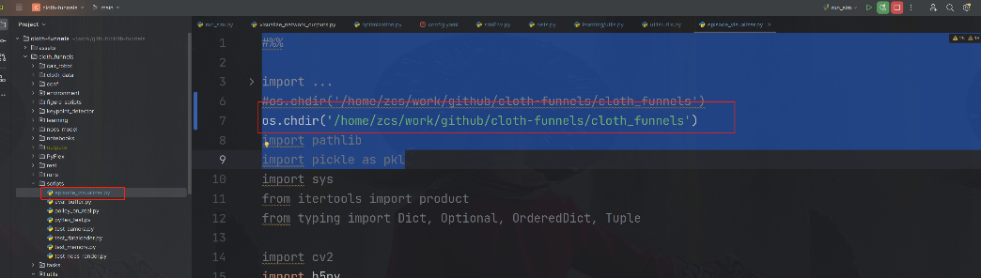

第三个：在conf/config.yaml中49行：修改为您的实际cloth-funnels实际路径

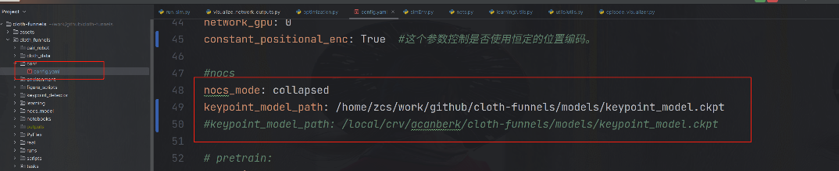

测试：

bash ./demo_single.sh

如果报错1：

Could not initialize GL extensions Segmentation fault (core dumped)

可能是安装显卡驱动的时候加了-no-opengl，导致没有安装OpneGL，重新安装显卡即可

报错2：

fatal error: EGL/eglplatform.h: No such file or directory

解决方法：sudo apt-get install libglfw3 libgles2-mesa-dev

报错3：.no module named 'cloth-funnels'

export PYTHONPATH=/home/tb1228/cloth-funnels报错4： File "/home/tb1228/miniconda3/envs/cloth-funnels/lib/python3.7/functools.py", line 490, in lru_cache

raise TypeError('Expected maxsize to be an integer or None')

TypeError: Expected maxsize to be an integer or None

这个错误信息表明，在你的代码中，有一个地方使用了functools.lru_cache()函数，但传递给它的参数maxsize不是整数或None。根据Python的functools模块，lru_cache接受一个可选的参数maxsize，它表示缓存的大小。这个参数应该是一个整数或者None。

错误可能出现在utils.py文件的generate_positional_encodings函数中，因为在这个函数中使用了functools.lru_cache。你需要检查这个函数的定义，确保maxsize参数是一个整数或None。

尝试安装pip install functools 看看能不能解决，如果不能，则执行下面操作：

打开/home/tb1228/cloth-funnels/cloth_funnels/learning/utils.py", line 443

@functools.lru cache(maxsize=100)# 缓存最近的100次调用

@functools.lru cache(maxsize=None) # 如果您不希望限制缓存大小，可以设置为“None

使用functools 需要import functools

如果还是不行的话，那就：@lru cache(maxsize=None)

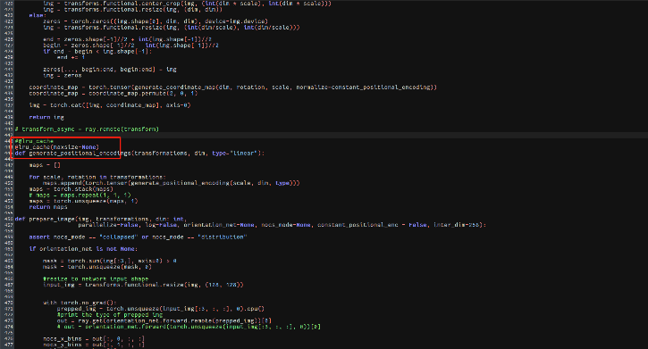

报错6：KeyError: 'CUDA_VISIBLE_DEVICES'

解决方法：export CUDA_VISIBLE_DEVICES=0

报错7：

Traceback (most recent call last):

File "cloth_funnels/run_sim.py", line 1, in <module>

from cloth_funnels.utils.utils import (

File "/home/tb1228/cloth-funnels/cloth_funnels/utils/utils.py", line 3, in <module>

from cloth_funnels.environment import SimEnv

File "/home/tb1228/cloth-funnels/cloth_funnels/environment/__init__.py", line 1, in <module>

from .simEnv import SimEnv

File "/home/tb1228/cloth-funnels/cloth_funnels/environment/simEnv.py", line 9, in <module>

from cloth_funnels.utils.env_utils import (

File "/home/tb1228/cloth-funnels/cloth_funnels/utils/env_utils.py", line 6, in <module>

from cloth_funnels.learning.utils import rewards_from_group

File "/home/tb1228/cloth-funnels/cloth_funnels/learning/__init__.py", line 2, in <module>

from .nets import MaximumValuePolicy

File "/home/tb1228/cloth-funnels/cloth_funnels/learning/nets.py", line 11, in <module>

from cloth_funnels.learning.utils import generate_positional_encoding, shift_tensor

File "/home/tb1228/cloth-funnels/cloth_funnels/learning/utils.py", line 443, in <module>

def generate_positional_encodings(transformations, dim, type="linear"):

File "/home/tb1228/miniconda3/envs/cloth-funnels/lib/python3.7/functools.py", line 490, in lru_cache

raise TypeError('Expected maxsize to be an integer or None')

TypeError: Expected maxsize to be an integer or None

报错：

Primary config directory not found.

Check that the config directory '/home/tb1228/cloth-funnels/cloth_funnels/cloth_funnels/conf' exists and readable

Set the environment variable HYDRA_FULL_ERROR=1 for a complete stack trace.

报错：

ray::SimEnv.__init__() (pid=39121, ip=192.168.10.8, actor_id=afdcb3e830186109578b2c3301000000, repr=<cloth_funnels.environment.simEnv.FunctionActorManager._create_fake_actor_class.<locals>.TemporaryActor object at 0x7f52eea38b90>)

ModuleNotFoundError: No module named 'cloth_funnels.environment'

解决方法：

cloth-funnels) tb1228@tb1228:~/cloth-funnels$ pip freeze | grep cloth_funnels

(cloth-funnels) tb1228@tb1228:~/cloth-funnels$ python -c "import cloth_funnels; print(cloth_funnels.__file__)"

/home/tb1228/cloth-funnels/cloth_funnels/__init__.py

(cloth-funnels) tb1228@tb1228:~/cloth-funnels$ echo $PYTHONPATH

/home/tb1228/cloth-funnels/cloth_funnels/PyFlex/bindings/build:

(cloth-funnels) tb1228@tb1228:~/cloth-funnels$ export PYTHONPATH=/home/tb1228/cloth-funnels:$PYTHONPATH

(cloth-funnels) tb1228@tb1228:~/cloth-funnels$ echo $PYTHONPATH

/home/tb1228/cloth-funnels:/home/tb1228/cloth-funnels/cloth_funnels/PyFlex/bindings/build:

报错：(cloth-funnels) tb1228@tb1228:~/cloth-funnels$ bash ./demo_single.sh

Primary config directory not found.

Check that the config directory '/home/tb1228/cloth-funnels/cloth_funnels/cloth_funnels/conf' exists and readable

Set the environment variable HYDRA_FULL_ERROR=1 for a complete stack trace.

解决方法：就是在cloth_funnels中创建一个cloth_funnels，然后把cloth_funnels中的conf拷贝过去

其他：flinbbot用的是blender这个渲染的，然后，cloth-funnels好像是opengl

如果需要安装：blender 可以执行：sudo snap install blender --channel=2.8/stable –classic

编译pyflex出现报错：

/usr/bin/ld: cannot find -lEGL

collect2: error: ld returned 1 exit status

CMakeFiles/pyflex.dir/build.make:374: recipe for target 'pyflex.cpython-37m-x86_64-linux-gnu.so' failed

make[2]: *** [pyflex.cpython-37m-x86_64-linux-gnu.so] Error 1

CMakeFiles/Makefile2:82: recipe for target 'CMakeFiles/pyflex.dir/all' failed

make[1]: *** [CMakeFiles/pyflex.dir/all] Error 2

Makefile:90: recipe for target 'all' failed

make: *** [all] Error 2

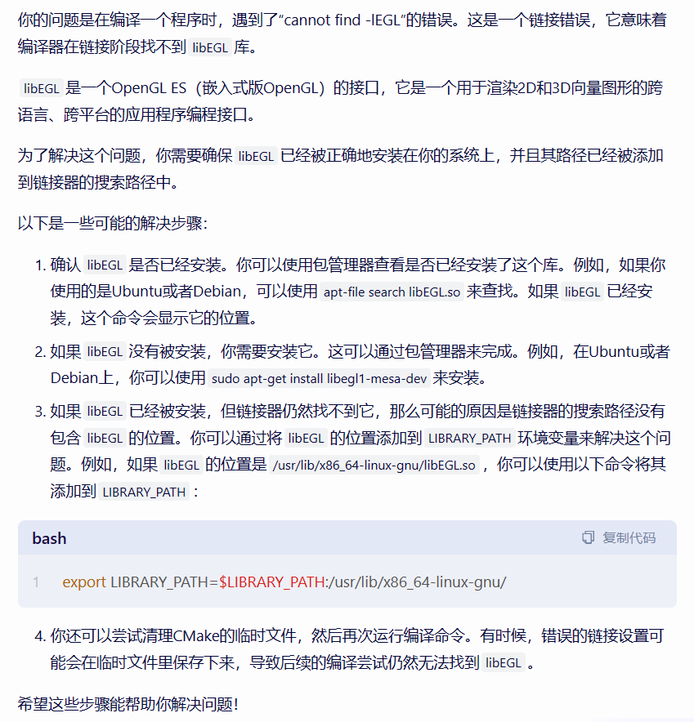

如果您已经安装了 `libegl1-mesa` 和 `libegl1-mesa-dev`，但链接器 (`ld`) 仍然报告找不到 `libEGL`，可能是以下几个原因：

### 1. 链接器配置问题

链接器可能没有查看包含 `libEGL` 的目录。您可以尝试以下步骤来诊断和解决问题：

- **检查库文件的实际位置**：使用 `locate libEGL.so` 命令找出 `libEGL.so` 的实际位置。如果 `locate` 命令不可用，您需要先安装它（在 Ubuntu 上使用 `sudo apt-get install mlocate`）并运行 `sudo updatedb`。

- **更新链接器配置**：如果 `libEGL.so` 不在链接器默认的搜索路径中，您可以将其路径添加到 `/etc/ld.so.conf` 或 `/etc/ld.so.conf.d/` 目录下的某个文件中。例如，如果 `libEGL.so` 位于 `/usr/lib/x86_64-linux-gnu/`，您可以添加这一行到 `/etc/ld.so.conf` 或创建一个新文件在 `/etc/ld.so.conf.d/`。

- **更新链接器缓存**：修改配置文件后，运行 `sudo ldconfig` 来更新缓存。

### 2. 环境变量问题

链接器可能没有检查 `LD_LIBRARY_PATH` 环境变量中指定的目录。您可以通过在命令行中运行 `export LD_LIBRARY_PATH=/path/to/lib:$LD_LIBRARY_PATH` 来添加库的路径到这个环境变量中，其中 `/path/to/lib` 是 `libEGL.so` 的目录路径。注意，这种方法对当前会话有效，如果想永久设置，需要添加到您的 shell 配置文件中，如 `.bashrc`。

### 3. 软件链接

如果 `libEGL.so` 位于系统的非标准库目录中，您可以创建一个软链接到 `/usr/lib` 或其他链接器查看的标准目录。例如：

```bash

sudo ln -s /path/to/libEGL.so /usr/lib/libEGL.so

```

### 4. 重新检查安装

有时，即使安装命令执行无误，包管理器也可能未能正确安装库文件。重新运行安装命令，并注意任何错误或警告信息。

```bash

sudo apt-get install --reinstall libegl1-mesa libegl1-mesa-dev

```

执行这些步骤后，再次运行 `ld -lEGL --verbose`。如果问题仍未解决，可能需要进一步检查您的系统配置或咨询您的 Linux 发行版的相关支持论坛。

pip freeze #可以输出整个环境的包

jhsignal@proton.me

密码：huiyi201566

SSH连接：

IP：223.109.239.14

端口：37090

主机：tb1228

密码：QwE123!@

base) tb1228@tb1228:~$ conda activate cloth-funnels

(cloth-funnels) tb1228@tb1228:~$ cd cloth-funnels/cloth_funnels/

(cloth-funnels) tb1228@tb1228:~/cloth-funnels/cloth_funnels$ . ./prepare.sh

(cloth-funnels) tb1228@tb1228:~/cloth-funnels/cloth_funnels$ cd ../

(cloth-funnels) tb1228@tb1228:~/cloth-funnels$ . ./demo_single.sh

conda activate cloth-funnels &&cd cloth-funnels/cloth_funnels/&&. ./prepare.sh&&cd ../&&. ./demo_single.sh

这里用小写：（大写的好像识别不到）

export http_proxy='http://127.0.0.1:7890'

export https_proxy='https://127.0.0.1:7890'

export HTTP_PROXY="http://127.0.0.1:7890/"

export HTTPS_PROXY="http://127.0.0.1:7890/"

取消代理：

unset http_proxy

unset https_proxy

查看代理  
env | grep -i porxy

pip install urllib3==1.26.6

其他错误  
2023-11-30 16:44:39,406 INFO worker.py:1553 -- Started a local Ray instance.

SEEDING WITH 0

[Network] Initializing with inputs: rgb_pos

[Network] Initializing factorized network

[Network] Giving deformable network positional encoding

[Network Setup] Load checkpoint specified ../models/longsleeve_canonicalized_alignment.pth

[Network Setup] Action Exploration Probability: 1.0000e+00

[Network Setup] Value Exploration Probability: 1.0000e+00

[Network Setup] Train Steps: 0

Replay Buffer path: ../experiments/11-30-1644-demo-single/replay_buffer.hdf5

CUDA_VISIBLE_DEVICES: 0

(TaskLoader pid=18957) [TaskLoader] Loading eval tasks

(TaskLoader pid=18957) 2023-11-30 16:44:47,870 ERROR worker.py:772 -- Exception raised in creation task: The actor died because of an error raised in its creation task, ray::TaskLoader.__init__() (pid=18957, ip=192.168.10.8, repr=<cloth_funnels.tasks.generate_tasks.TaskLoader object at 0x7f0aea75f890>)

(TaskLoader pid=18957) File "/home/tb1228/cloth-funnels/cloth_funnels/tasks/generate_tasks.py", line 551, in __init__

(TaskLoader pid=18957) with h5py.File(self.hdf5_path, 'r') as tasks:

(TaskLoader pid=18957) File "/home/tb1228/miniconda3/envs/cloth-funnels/lib/python3.7/site-packages/h5py/_hl/files.py", line 507, in __init__

(TaskLoader pid=18957) fid = make_fid(name, mode, userblock_size, fapl, fcpl, swmr=swmr)

(TaskLoader pid=18957) File "/home/tb1228/miniconda3/envs/cloth-funnels/lib/python3.7/site-packages/h5py/_hl/files.py", line 220, in make_fid

(TaskLoader pid=18957) fid = h5f.open(name, flags, fapl=fapl)

(TaskLoader pid=18957) File "h5py/_objects.pyx", line 54, in h5py._objects.with_phil.wrapper

(TaskLoader pid=18957) File "h5py/_objects.pyx", line 55, in h5py._objects.with_phil.wrapper

(TaskLoader pid=18957) File "h5py/h5f.pyx", line 106, in h5py.h5f.open

(TaskLoader pid=18957) FileNotFoundError: [Errno 2] Unable to open file (unable to open file: name = '../assets/tasks/longsleeve-single.hdf5', errno = 2, error message = 'No such file or directory', flags = 0, o_flags = 0)

Error executing job with overrides: ['name=demo-single', 'load=../models/longsleeve_canonicalized_alignment.pth', 'eval_tasks=../assets/tasks/longsleeve-single.hdf5', 'eval=True', 'num_processes=1', 'episode_length=10', 'wandb=disabled', 'fold_finish=True', 'dump_visualizations=True']

(SimEnv pid=18960) 2023-11-30 16:44:48,858 ERROR worker.py:772 -- Exception raised in creation task: The actor died because of an error raised in its creation task, ray::SimEnv.__init__() (pid=18960, ip=192.168.10.8, repr=<cloth_funnels.environment.simEnv.SimEnv object at 0x7f4e32ab2650>)

(SimEnv pid=18960) File "/home/tb1228/cloth-funnels/cloth_funnels/environment/simEnv.py", line 212, in __init__

(SimEnv pid=18960) self.setup_env()

(SimEnv pid=18960) File "/home/tb1228/cloth-funnels/cloth_funnels/environment/simEnv.py", line 267, in setup_env

(SimEnv pid=18960) 0 #msaa samples, hardcoded

(SimEnv pid=18960) TypeError: init(): incompatible function arguments. The following argument types are supported:

(SimEnv pid=18960) 1. () -> None

(SimEnv pid=18960)

(SimEnv pid=18960) Invoked with: True, True, 480, 480, 0

Traceback (most recent call last):

File "cloth_funnels/run_sim.py", line 114, in main

envs, _ = setup_envs(dataset=dataset_path, **args)

File "/home/tb1228/cloth-funnels/cloth_funnels/utils/utils.py", line 145, in setup_envs

ray.get([e.setup_ray.remote(e) for e in envs])

File "/home/tb1228/miniconda3/envs/cloth-funnels/lib/python3.7/site-packages/ray/_private/client_mode_hook.py", line 105, in wrapper

return func(*args, **kwargs)

File "/home/tb1228/miniconda3/envs/cloth-funnels/lib/python3.7/site-packages/ray/_private/worker.py", line 2382, in get

raise value

ray.exceptions.RayActorError: The actor died because of an error raised in its creation task, ray::SimEnv.__init__() (pid=18960, ip=192.168.10.8, repr=<cloth_funnels.environment.simEnv.SimEnv object at 0x7f4e32ab2650>)

File "/home/tb1228/cloth-funnels/cloth_funnels/environment/simEnv.py", line 212, in __init__

self.setup_env()

File "/home/tb1228/cloth-funnels/cloth_funnels/environment/simEnv.py", line 267, in setup_env

0 #msaa samples, hardcoded

TypeError: init(): incompatible function arguments. The following argument types are supported:

1. () -> None

Invoked with: True, True, 480, 480, 0

Set the environment variable HYDRA_FULL_ERROR=1 for a complete stack trace.

这个报错，我就去

