启动VMware Workstation的时候提示如图：

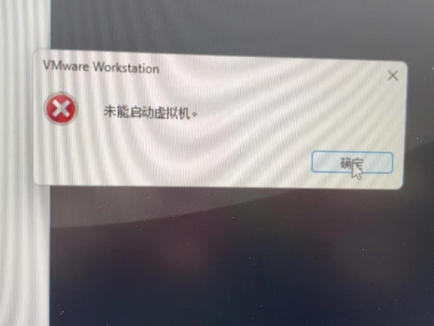

出现这个问题，检查windows里面的可选功能，是否启动了Hyper-V、Windos虚拟监控程序平台、虚拟机平台，等有虚拟化需求的软件，如果开启了则关闭

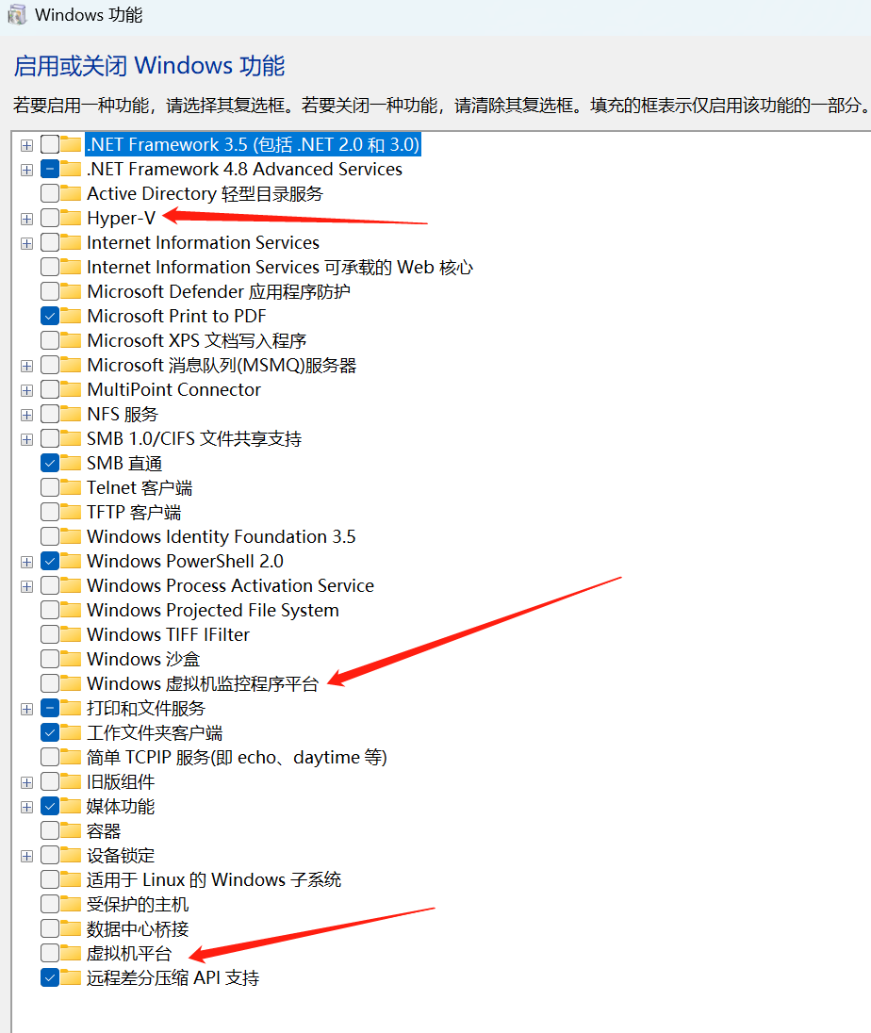

其他方法：[(22条消息) win11 vmware 显示 “未能启动虚拟机“ 解决办法_未能启动虚拟机。_PurrLi的博客-CSDN博客](https://blog.csdn.net/qq_43038348/article/details/131007595#:~:text=%E6%8C%89%E4%B8%8B%20%E2%80%9Cwin%2Br%E2%80%9D%20%E9%94%AE%EF%BC%8C%E8%BE%93%E5%85%A5%20%E2%80%9Cregedit%E2%80%9D%20%E6%89%93%E5%BC%80%E6%B3%A8%E5%86%8C%E8%A1%A8%EF%BC%8C%E9%80%9A%E8%BF%87%E5%B7%A6%E4%BE%A7%E5%AF%BC%E8%88%AA%E6%89%BE%E5%88%B0%E2%80%9CHKEY_LOCAL_MACHINE%2FSystemCurrentControlSetControlDeviceGuard%E2%80%9D%EF%BC%8C%E9%80%89%E4%B8%AD%E5%90%8E%E5%8F%8C%E5%87%BB%E2%80%9CEnableVirtualizationBasedSecurity%E2%80%9D%EF%BC%8C%E5%B0%86DWORD%E5%80%BC%E8%AE%BE%E7%BD%AE%E4%B8%BA0%EF%BC%8C%E9%87%8D%E5%90%AF%E7%94%B5%E8%84%91%205.,%E9%87%8D%E5%90%AF%E5%90%8E%E6%AD%A3%E5%B8%B8%E5%B0%B1%E5%8F%AF%E4%BB%A5%E4%BA%86%EF%BC%8C%E5%A6%82%E6%9E%9C%E5%A4%B1%E8%B4%A5%EF%BC%8C%E5%90%8C%E7%AC%AC2%E6%AD%A5%E6%A3%80%E6%9F%A5%E2%80%9C%E5%9F%BA%E4%BA%8E%E8%99%9A%E6%8B%9F%E5%8C%96%E7%9A%84%E5%AE%89%E5%85%A8%E6%80%A7%E2%80%9D%E6%98%AF%E5%90%A6%E6%88%90%E5%8A%9F%E5%85%B3%E9%97%AD%EF%BC%8C%E6%B2%A1%E6%9C%89%E5%85%B3%E9%97%AD%E6%88%90%E5%8A%9F%E7%9A%84%E8%AF%9D%EF%BC%8C%E4%BD%BF%E7%94%A8%E7%AE%A1%E7%90%86%E5%91%98%E8%BA%AB%E4%BB%BD%E6%89%93%E5%BC%80Windows%20Power%20Shell%EF%BC%8C%E6%89%A7%E8%A1%8Cbcdedit%20%2Fset%20hypervisorlaunchtype%20off%E5%91%BD%E4%BB%A4%EF%BC%8C%E5%86%8D%E6%AC%A1%E9%87%8D%E5%90%AF)

确保虚拟化开启，内核隔离的内核完整性是否关闭（先开启，然后在关闭，（有些的有兼容问题，卸载出现兼容的（模块，dll）就好了））