**PART A**

(Part A: TO BE REFERRED BY STUDENTS)

**Experiment No. 01**

**A.1 AIM:**

Observing a Website. Study about its content, structure.

**A.2 Pre requisite:**

Basic Knowledge of Internet, Web Browsers, Web Servers.

**A.3 Outcome:**

After successful completion of this experiment students will be able to:

1. Understand structure of web pages.
2. Understand content of web pages.
3. Features & shortcomings of the website.
4. Working of Web Browsers, Web Servers, Protocols & Client Server Architecture.

**A.4 Theory:**

Website or simply site, is a collection of related web pages, including multimedia content, typically identified with a common domain name, and published on at least one web server. A website may be accessible via a public Internet Protocol (IP) network, such as the Internet, or a private local area network (LAN), by referencing a uniform resource locator (URL) that identifies the site.

Websites have many functions and can be used in various fashions; a website can be a personal website, a commercial website for a company, a government website or a non-profit organization website. Websites are typically dedicated to a particular topic or purpose, ranging from entertainment and social networking to providing news and education. All publicly accessible websites collectively constitute the World Wide Web, while private websites, such as a company's website for its employees, are typically a part of an intranet.

**A.4 Tasks to be Performed:**

1. Browse a website of your choice
2. Note down the features & shortcomings of the website visited
3. Find if there is any broken link in the website
4. Explain the following terms:
   1. Internet
   2. WWW
   3. Web Server
   4. Client
   5. Browser
   6. Client Server Architecture
   7. URL
   8. Router
   9. Gateways
   10. DNS

**PART B**

(PART B: TO BE COMPLETED BY STUDENTS)

(Students must submit the soft copy as per following segments within two hours of the practical. The soft copy must be uploaded on the Blackboard or emailed to the concerned lab in charge faculties at the end of the practical in case the there is no Black board access available)

|  |  |
| --- | --- |
| Roll No.: E258 | Name: Kundan Patil |
| Class: B. Tech CS | Batch: A3 |
| Date of Experiment : 07/01/2025 | Date/Time of Submission: : 07/01/2025 |
| Grade : |  |

**B.1 Findings:**

* Explored <https://www.nasa.gov/> and analysed its features and shortcomings.
* Identified a mix of strengths like responsive design and shortcomings like broken links and outdated elements.
* Learned about the architecture and functioning of websites, including key terms like DNS, URL, and web servers

*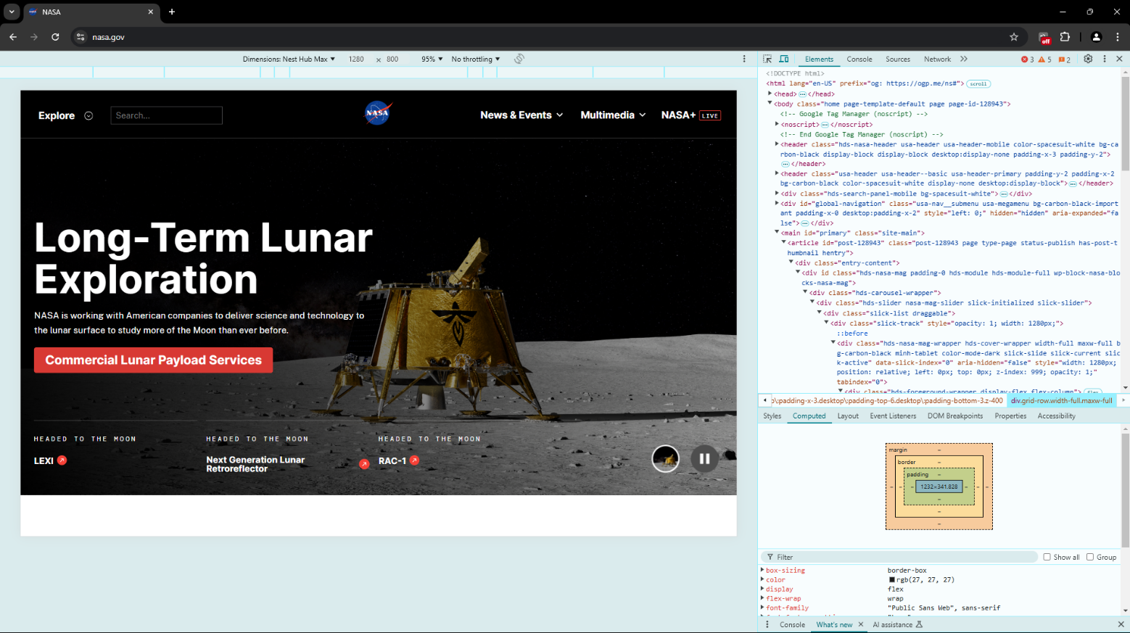***B.2 Output**

**B.3 Conclusion:**

The practical session provided insights into the structure and functionality of websites, highlighting key features, common shortcomings, and methods to evaluate their performance. It emphasized the importance of responsive design, proper navigation, and maintaining updated links and content for an optimal user experience. The session also reinforced the understanding of technical concepts related to web architecture and tools for website analysis.

**B.3 Observations and Learning:**

| **HTML Tag** | **Function** |
| --- | --- |
| <a> | Defines a hyperlink, allowing users to click and navigate to another page or resource. |
| <p> | Represents a paragraph of text, helping to separate content for better readability. |
| <h1> to <h6> | Used for headings, with <h1> being the highest level and <h6> the lowest, organizing content hierarchically. |
| <div> | A container element that groups together other HTML elements for styling or layout purposes. |
| <img> | Embeds an image into the document, requiring a src attribute to specify the image source. |
| <ul> | Creates an unordered list, typically displayed with bullet points. |
| <ol> | Creates an ordered list, displayed with numbers or letters. |
| <li> | Defines a list item within an ordered or unordered list. |
| <span> | An inline container for text that can be styled with CSS without breaking the flow of text. |
| <strong> | Indicates that the text is of strong importance, typically displayed in bold. |

* Observed that responsive design and proper navigation are essential for user satisfaction.
* Learned the importance of maintaining updated UI/UX and functional links.
* Gained clarity on technical terms related to web architecture like client-server architecture and DNS.
* There is a broken link, The embedded YouTube video link on this webpage appears to be broken. When attempting to access the video, users are unable to view the content. This could be due to a variety of reasons, such as the video being removed from YouTube, the URL being incorrect, or the video being set to private or restricted based on region. As a result, visitors are presented with an error message or a placeholder where the video should be, preventing them from watching the intended content. This issue affects the overall functionality of the page and disrupts the user experience.

**B.4 Question of Curiosity**

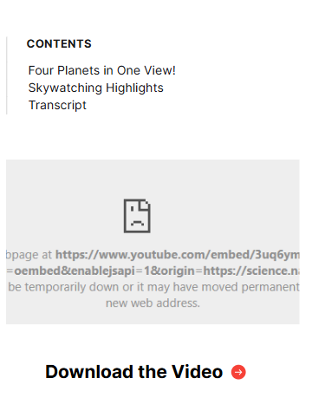*(To be answered by student based on the practical performed and learning/observations)*

Q.1. What were the shortcomings in the websites visited?

A.1. **The shortcomings in the websites visited are**

* Outdated UI design
* Missing alt-text for some images
* Slow loading on certain pages
* Identified a few broken links