**PART A**

(Part A: TO BE REFERRED BY STUDENTS)

**Experiment No. 03**

**A.1 AIM:**

Study of Basic HTML tags & create a web page or website using HTML tags.

**A.2 Pre requisite:**

Basic Knowledge of HTML and HTML tags.

**A.3 Outcome:**

After successful completion of this experiment students will be able to:

1. Design pages in HTML
2. Perform all formatting of text and images in HTML
3. Create tables and lists in HTML
4. Design interactive pages in HTML using Frames
5. Use various properties of Frames

**A.4 Theory:**

**What is HTML?**

HTML is a language for describing web pages. HTML stands for Hyper Text Markup Language. HTML is a markup language. A markup language is a set of markup tags. The tags describe document content. HTML documents contain HTML tags and plain text. HTML documents are also called web pages.

**HTML Tags**

HTML markup tags are usually called HTML tags. HTML tags are keywords (tag names) surrounded by angle brackets like <html>. HTML tags normally come in pairs like <p> and </p>. The first tag in a pair is the start tag, the second tag is the end tag. The end tag is written like the start tag, with a slash before the tag name. Start and end tags are also called opening tags and closing tags

**HTML Element Syntax**

An HTML element starts with a start tag / opening tag. An HTML element ends with an end tag / closing tag. The element content is everything between the start and the end tag. Some HTML elements have empty content. Empty elements are closed in the start tag. Most HTML elements can have attributes.

**HTML Attributes**

HTML elements can have attributes. Attributes provide additional information about an element. Attributes are always specified in the start tag. Attributes come in name/value pairs like: name="value".

Example :

<**html**>

<**head**>

<**title**>This is a title</**title**>

</**head**>

<**body**>

<**p**>Hello world!</**p**>

</**body**>

</**html**>

**List**

* **Unordered List**

An unordered list starts with the **<ul>** tag. Each list item starts with the **<li>** tag.

**Example:**

<ul>  
  <li>Cricket</li>  
  <li>Tennis</li>  
  <li>Hockey</li>  
</ul>

* **Ordered List**

An ordered list starts with the **<ol>** tag. Each list item starts with the **<li>** tag.

**Example:**

<ol>  
  <li>Cricket</li>  
  <li>Tennis</li>  
  <li>Hockey</li>  
</ol>

* **Description List**

**<dl>** tag defines the description list

**<dt>** tag defines the term (name)

**<dd>** tag describes each term

**Example:**

<dl>  
  <dt>Static Web Page</dt>  
  <dd>- Do not change frequently</dd>  
  <dt>Dynamic Web Page</dt>  
  <dd>- Created at run time</dd>  
</dl>

* Nesting of list is also possible.

**Tables**

* An HTML table is defined with the **<table>** tag.
* Each table row is defined with the **<tr>** tag.
* A table header is defined with the **<th>** tag.
* By default, table headings are bold and centered.
* A table data/cell is defined with the **<td>** tag.
* **Example:**

<table >  
  <tr>  
    <th>Firstname</th>  
    <th>Lastname</th>   
    <th>Age</th>  
  </tr>  
  <tr>  
    <td>Sachin</td>  
    <td>Tendulkar</td>   
    <td>40</td>  
  </tr>  
  <tr>  
    <td>Rahul</td>  
    <td>Dravid</td>   
    <td>42</td>  
  </tr>  
</table>

**Cell that Span Many rows (Rowspan)**

<table style="width:100%">  
  <tr>  
    <th>Name:</th>  
    <td>RAM Rao</td>  
  </tr>  
  <tr>  
    <th rowspan="2">Mobile:</th>  
    <td>123456</td>  
  </tr>  
  <tr>  
    <td>654321</td>  
  </tr>  
</table>

**Images**

* Images help to make web page look attractive.
* We should always use images in jpg, gif or png, as browser supports these format.
* HTML images are defined with the **<img>** tag.
* Example

<img src="flower.jpg" alt="W3Schools.com" width="104" height="142">

* The compulsory attribute for <img> tag is **src** to specify URL of the image
  + **alt** stands for Alternate Text – If the browser is not supporting Images it display the value of ALT .
  + **height** and **width** specify the height and width of the image.
* Img also has following attributes
  + Hspace – specifies the amount of space to left and right of image.
  + Vspace – Specifies the amount of space to top and bottom of an image.
  + Border – Specifies border around an image.
  + Align – Defines the alignment of image.
* **Example:-**

<img src="home.jpg" alt="Hill Climbing" hspace=250 vspace=250 border=10 align="right">

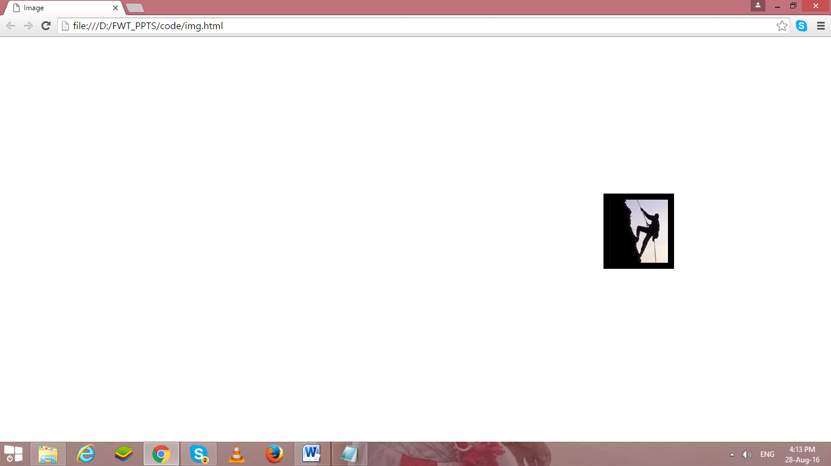

**Its good practice to follow following html format:-**

<!DOCTYPE html>  
<html lang="en-us">  
<head>

<meta charset="utf-8">  
  <title> Title</title>  
</head>  
<body>  
  
</body>  
</html>

**Anchors <a>**

**Types of link:-**

* Absolute (link to website )
* Relative (link to other files in same system(local file link), link to other section of page)
* Internal
* Graphical
* <a> </a>Tag defines a hyperlink
* Attribute is href…
* By default, links will appear as follows in all browsers:
  + An unvisited link is underlined and blue
  + A visited link is underlined and purple
  + An active link is underlined and red
* The **HTML <body> vlink Attribute**is used to specify a color of a visited link in a Document.
* The **HTML <body> alink Attribute** is used to specify the color of an active link in a document.
* The **HTML <body> link Attribute** is used to specify the default color for a unvisited link in a document.

**Target Attribute: -**

* The target attribute specifies where to open the linked document.
* Syntax:-

<a target="_blank|_self|_parent|_top|*framename*">

* **Attribute values:-**

|  |  |
| --- | --- |
| **Value** | **Description** |
| _blank | Opens the linked document in a new window or tab |
| _self | Opens the linked document in the same frame as it was clicked (this is default) |
| _parent | Opens the linked document in the parent frame |
| _top | Opens the linked document in the full body of the window |
| *framename* | Opens the linked document in the named iframe |

**HTML Form**

* Form is a container where user provides their information, this can be personal information or feedback.
* <form> </form> are used to create interactive GUI
* Form contains following form elements.
* Elements of forms are
  + Text Box.
  + Text Area.
  + Radio Button
  + Check Box
  + Drop Down List
  + Buttons
  + Files
  + Slider etc….
* Forms cannot be nested, but a web page can contain multiple form.
* The actual working of form involves the setting of action and method(GET & POST)attributes.
* Following elements can be used to create an HTML form
  + Form
    - Form elements defines form.& Form element support action attribute.

<form action= “confirm.html”>

* + - Confirm.html File will be opened when user submits the data of the form.
  + Input
    - It enables us to insert
      * Radio button
      * Check boxes
      * Text box
      * password
    - input elements are implemented by <input></input> container tag.
    - Following are the attributes of input
      * Name
      * Type
      * Value
      * MaxLength
      * Size
  + Select & option
    - Used to create a menu or drop down list.
  + Textarea
    - In textarea user can enter large amount of text.
    - Has following attributes
      * Rows
      * Cols
      * name

Note:- Here table tag is used to go give proper look to form

**TextBox & Password**

* Enables us to create text field.
* Values of input element is **“text”** for textbox.
* Values of input element is **“password”** for Password Field.

<form>

<tr>

<td align="right">user name</td>

<td><input type="text" name="usrnm” maxlenghth=15 size=10/></td>

</tr>

<tr>

<td align="right">Password</td>

<td><input type="Password" name="pw" maxlenghth=15 size=10/></td>

</tr>

</form>

**Output**

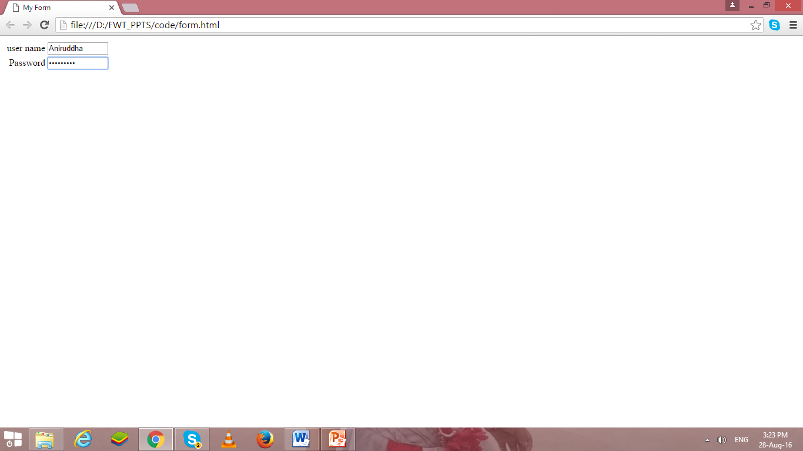

**Text Area**

* Text Area is require for large amount of text.
* Following are commonly used attributes for <textarea>
  + Rows
    - Sets the number of rows of text that visible without scrolling up or down in the fields.
  + Cols
    - Sets the number of rows of text that visible without scrolling left or right in the fields.
  + Name
    - Specifies name of text area.

<form>

<tr>

<td align="right">User Details</td>

<td><textarea rows=5 cols=40></textarea></td>

</tr>

</form>

**OutPut**

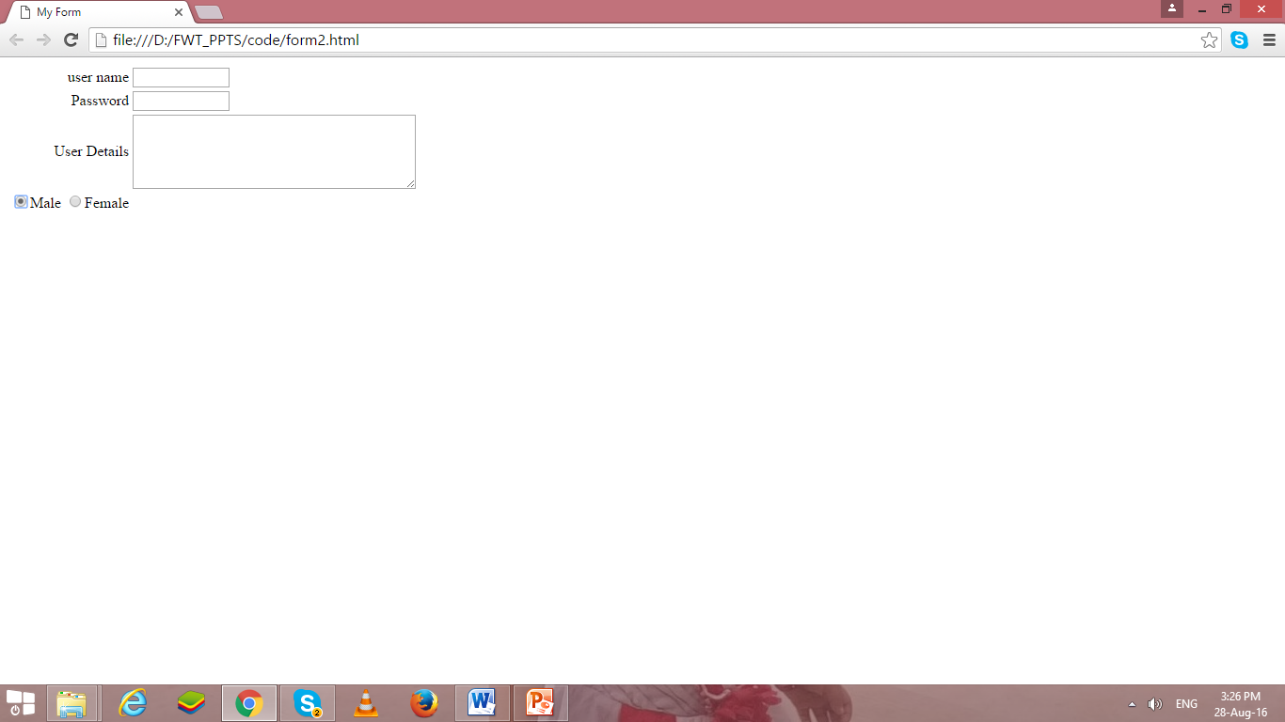

**Radio Button**

* Values of input element is **“radio”** for radio.
* Enables to create radio button.
* We can select only one radio button at a time from group of radio buttons.

<form>

<tr>

<td align="Right"> Gender:

<input type="radio" name="gen" value="m">Male

<input type="radio" name="gen" value="F">Female

</td>

</tr>

</form>

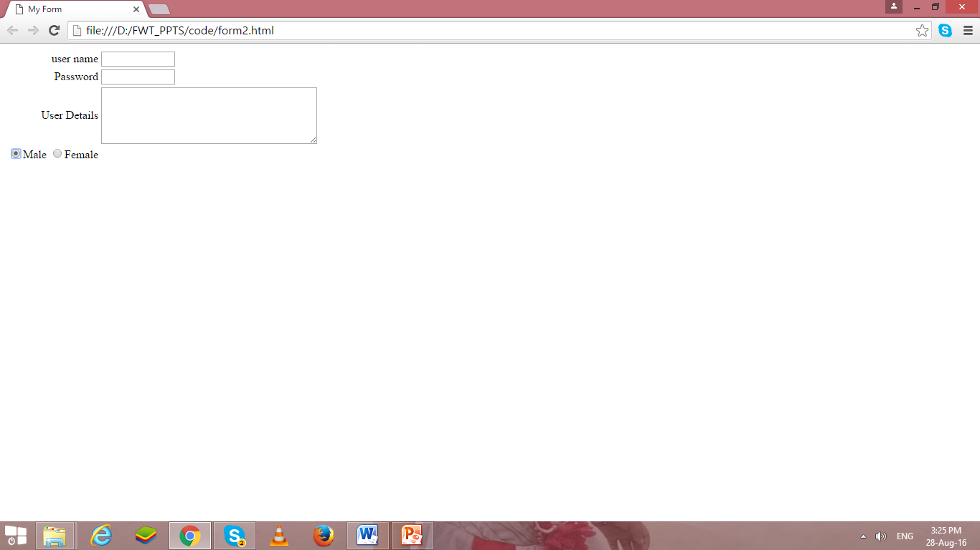

**Check Box**

* Values of input element is **“checkbox”** for enabling checkbox.
* We can select multiple check boxes.

<form>

<tr>

<td align="Right"> Sports Interest:

<input type="checkbox" name="sprt" value="h">Hockey

<input type="checkbox" name="sprt" value="ft">FootBall

</tr>

</form>

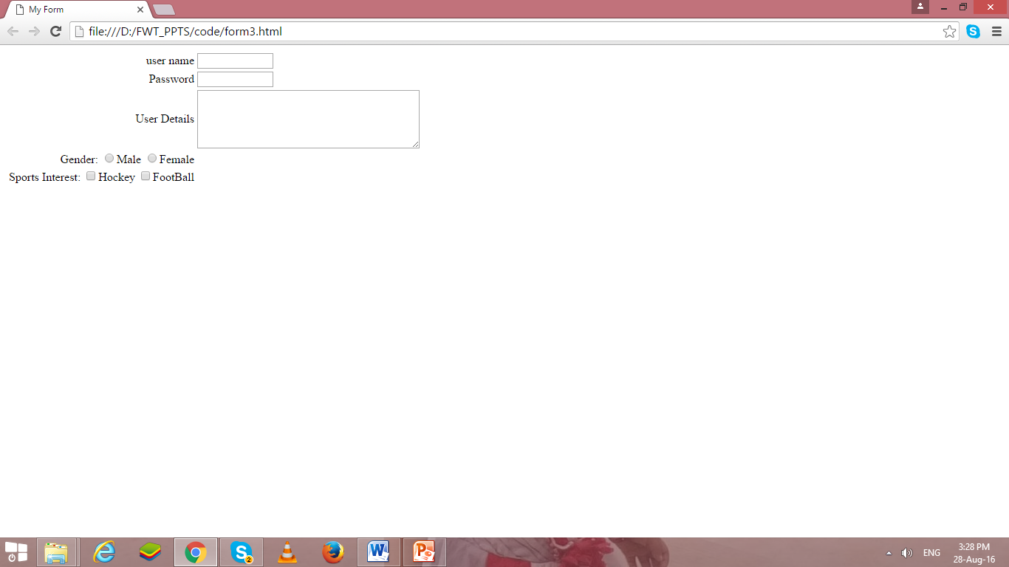

**Drop Down List**

* The select element enables us to create a menu or drop down list in a form, depending on the attribute specified.
* The Select element specifies that the text follows is a list.
* Select element is used with the option element.
* The option element enables us to specify the items of the list created using the select element.
* Functionality of select element is similar to that of unordered list(<ul> </ul>) and ordered list(<ol></ol>) element.
* The option element is similar to list item element (<li>)
* The select element is implemented by using <select> </select> tag
* The option element is implemented by using <option> </option> tag.

<td align="Right"> Branch:</td><td align="left">

<select name="Branch" size=“4”>

<option value="#">--Select--</option>

<option value="ce">Comp Engg</option>

<option value="cs">Comp Science</option>

<option value="cse">Comp Sci & Engg</option>

</select>

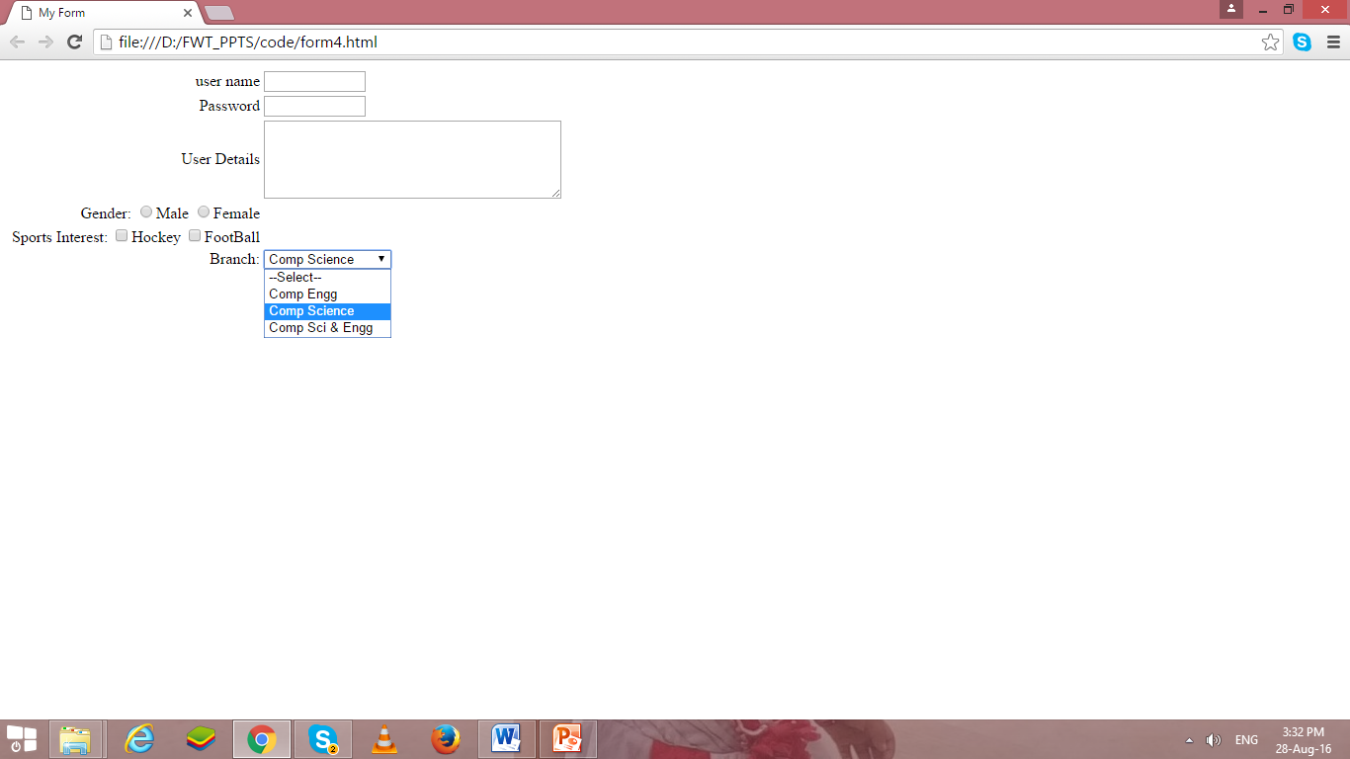

**Button**

* Values of input element is **“submit”** for submit button.
* Values of input element is **“reset”** for reset/clear button.
* Reset and Submit are buttons.
* “Submit” enables to create submit button, when we click submit button, the values of the from are submitted to the web page specified in the action attribute of the form.
* “reset” enables to create reset/clear button , when we click reset button, the values entered in the form are cleared automatically and set back to default values.

</tr>

< tr> <td colspan=2 align="center">

<input type="submit" value="Add to DB"/>

<input type="reset" value="Clear"/>

</tr>

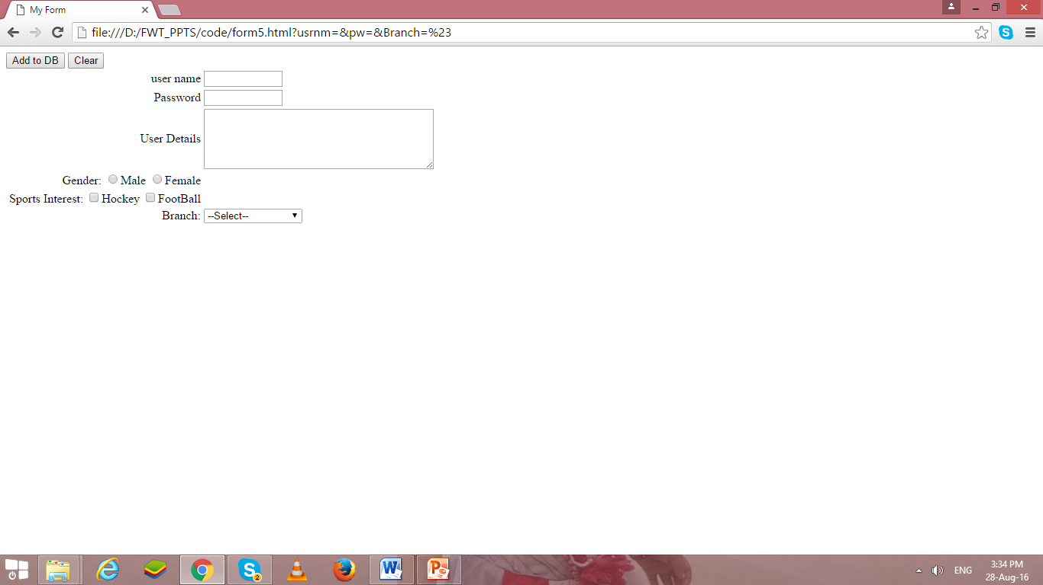

**File**

* Values of input element is **“file”** for uploading file.
* the file are submitted to the path/url specified in the action attribute of the form???

< tr>

<td align=“right"> Select Image to Upload

<input type=“file" value=“upload"/>

</tr>

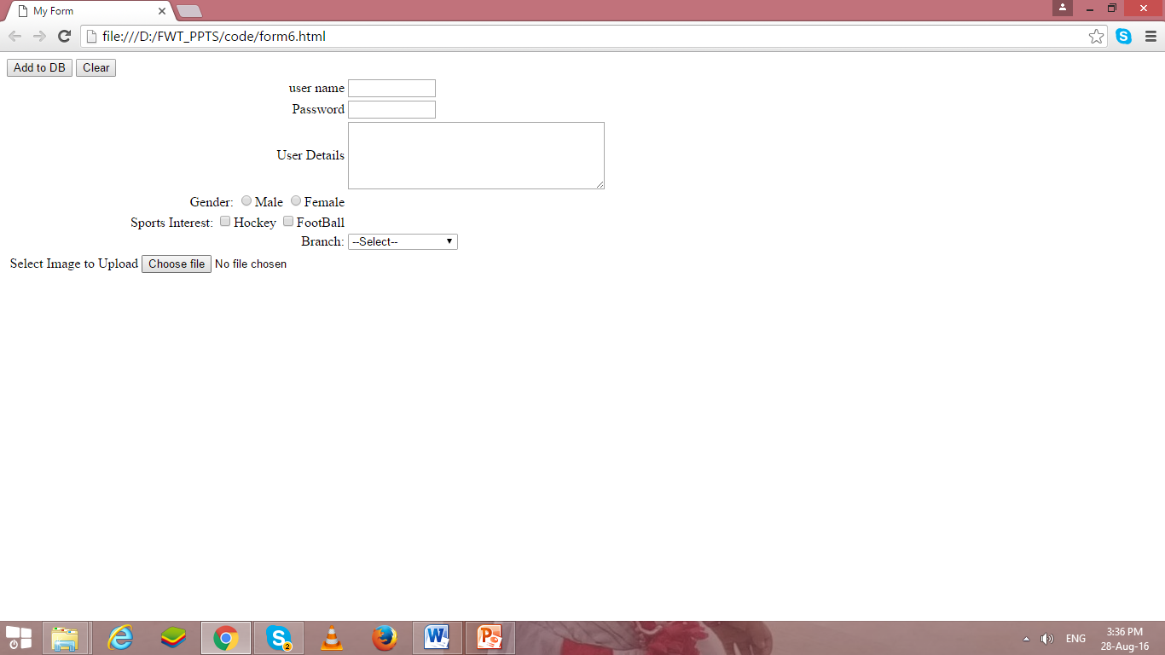

**Image Control**

* Values of input element is **“image”** for graphical submit button.
* If any error occur to open image, then alt values will be displayed.

< tr>

<td align=“right"> Select Image to Upload

<input type=“image" src=“ dj.jpg” alt=“submit”/>

</tr>

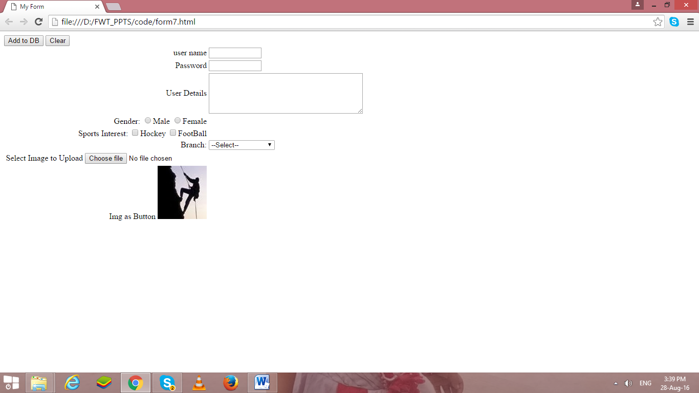

If we integrate above all code, it will generate following form as output.

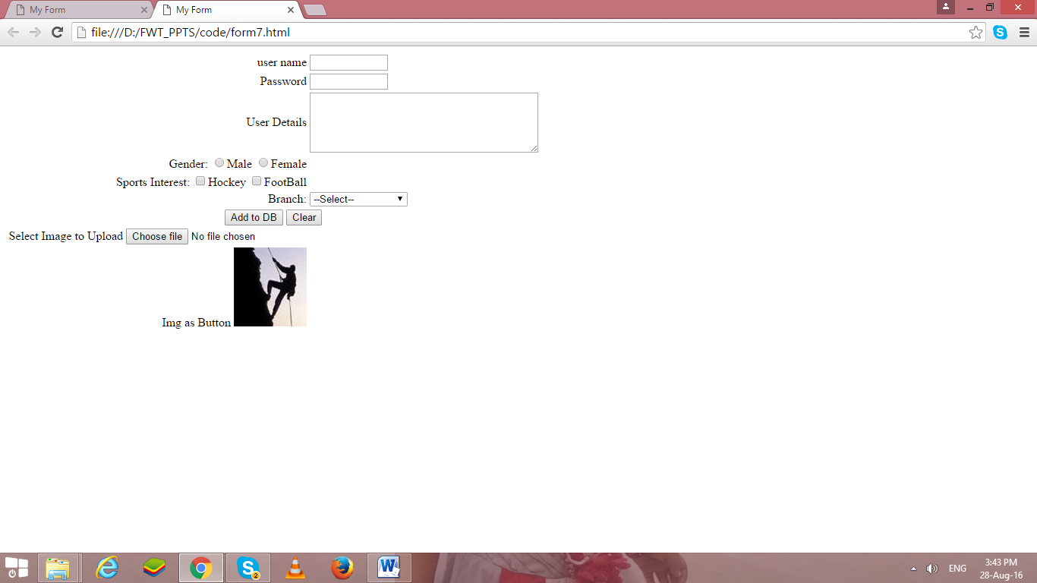

Because the attributes used with input elements varies so much depending on the type of input you want to use, we have provided several specific examples of using different types of input.

**Color:**-

<input type = "color"

value = "#001A57"

id = "clr"

">

* type is color picker
* value is default color value

**Slider/Range:**

<input type = "range"

min = "10"

max = "100"

value = "10"

">

* type is slider
* min is minimum value, max is maximum value
* value is default value
* id lets us refer to input element in JavaScript

**File:-**

<input type = "file"

multiple = "false"

accept = "image/*"

">

* type is file
* multiple = "false" indicates user cannot select multiple files
* accept = "image/*" indicates user can only select image files
* value is default value

**Frames**

* Frame allows us to divide browser window into one or more sub regions.
* Each sub region displaying different HTML documents.
* By using frame in this way, we can view the data of all documents simultaneously.
* Frames are useful when we want to compare data.
* We can also use frame to display an index of link in one sub region and corresponding document in another sub regions
* This way the index never goes out of sight while browsing through the documents.
* Frames divides the browser window horizontally or vertically.
* We can also nest frame with in a another frame.
* We can also display tables, links forms, and images through frame.
* A <frameset> tag is used to create frames in a web page.
* A standard frame has no body element and cannot contain tags normally placed in the body element.
* If they appears in frame, frameset tag ignores.
* With <frameset> tag we can use <frame> and <noframe> tag.
* The frameset tag has two attributes
  + Rows
  + cols
* <frame> tag is used to display different html pages in different frame.
* <frame> has no matching end tag.
* <frame> tag has following attributes
  + Src 🡪url of html file
  + Name 🡪 assign name to frame
  + Marginwidth 🡪can be used when user wants to control margin from frame
  + Marginheight 🡪top and bottom margin
  + Scrolling 🡪whether frame should have scroll bar or not..
  + Noresize 🡪has no value & which means that frame cannot be resized by user.
  + Frameboarder 🡪control the display of frame border.
  + Framespacing 🡪 to set extra space around the frame.
* Use the *name* attribute to name a frame, then target the frame name with hyperlinks
* The syntax for naming a frame is as follows:

<frame src="*url*" name="*framename*"/>

* Load a web page into a frame using **src** attribute

**Example:-**

<html>

<head >

<title> Image</title>

</head>

<frameset cols="25%,*,25%">

<frame src="base.html">

<frame src="form7.html">

<frame src="img.html">

</frameset>

</html>

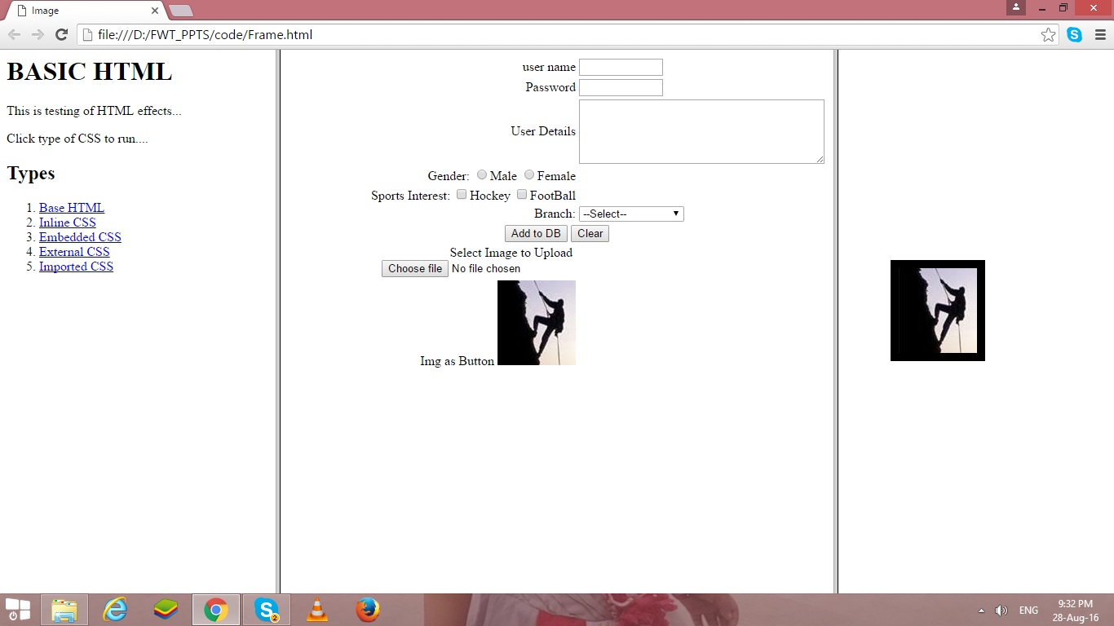

**Ex1:**

<frameset rows="40%,60%">  
<frame src="top.htm" name="top">  
<frame src="bottom.htm" name="bottom">  
</frameset>

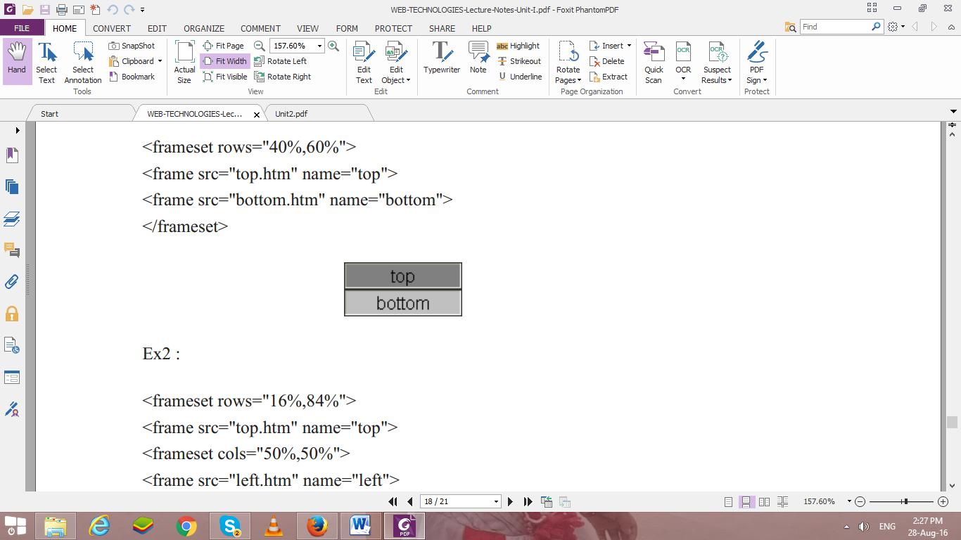  
**Ex2 :**  
<frameset rows="16%,84%">  
<frame src="top.htm" name="top">  
<frameset cols="50%,50%">  
<frame src="left.htm" name="left">  
<frame src="right.htm" name="right">  
</frameset></frameset>

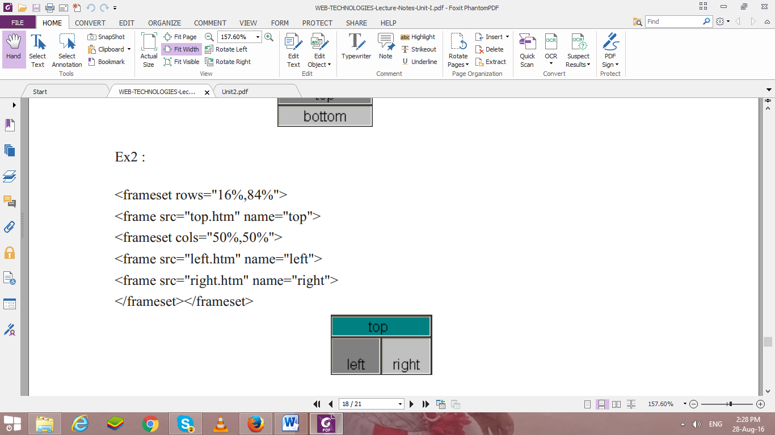

Create a static web pages using HTML

1. Create one HTML web page to interlink the webpages created in expt#2, use attributes link, alink and vlink for text hyperlinks and other tags.
2. Create link to section within same page (of your CV implemented in expt#2)
3. Create all the tables in given format of CV, use attributes colspan, rowspan, cellspacing, cellpadding and caption tag.
4. Use attribute type for lists in program 1 to change the type of sequence numbering & different symbols for unordered list.
5. Registration page (Now, implement it using form tag)
6. One web page with frames implemented (to display all three web pages implemented in expt #2) column-wise

**Note: - Don’t use any type of CSS in your code…**

1. **Your CV: - Do all entries with your personal details in following format…**

**Create a webpage to display your Curriculum vitae (CV) as per following format.**



**B. TECH. COMPUTER ENGINEERING**

**Name: - Your Name**

**OBJECTIVE:**

Write single line objective

**EDUCATION:**

|  |  |  |  |  |
| --- | --- | --- | --- | --- |
| **Degree** | **Institute** | **Board/University** | **CGPA/Percentage** | **Year** |
| B. Tech |  |  |  | Currently Pursuing |
| XII |  |  |  | 2018 |
| X |  |  |  | 2016 |

**Note: - if X & XII from same institute then use row span in institute column and If board is same for X & XII use row span in Board/University Column.**

**TECHNICAL SKILLS:**

|  |  |
| --- | --- |
| **Domain** | **Details** |
| Languages |  |
| Web Designing |  |
| Software |  |
| Database |  |
| Analytics |  |
| Operating Systems |  |

**KEY PROJECTS:**

|  |  |  |  |
| --- | --- | --- | --- |
| **Project Title** | **Duration** | **Platform Used** | **Brief Description** |
|  |  |  |  |
|  |  |  |  |
|  |  |  |  |

**TECHNICAL –PRESENTATION/WORKSHOPS/CERTIFICATION**

* Program 1
* Program 2

**TECHNICAL –WORK EXPERIENCE / INTERNSHIPS:**

1. Internship 1
2. Internship 2

**PART B**

(PART B: TO BE COMPLETED BY STUDENTS)

(Students must submit the soft copy as per following segments within two hours of the practical. The soft copy must be uploaded on the Blackboard or emailed to the concerned lab in charge faculties at the end of the practical in case the there is no Black board access available)

|  |  |
| --- | --- |
| Roll No. : E258 | Name: Kundan S. Patil |
| Class : BTech CS | Batch :A-3 |
| Date of Experiment :14/01/2025 | Date/Time of Submission :22/01/2025 |
| Grade : |  |

**B.1 Code:**

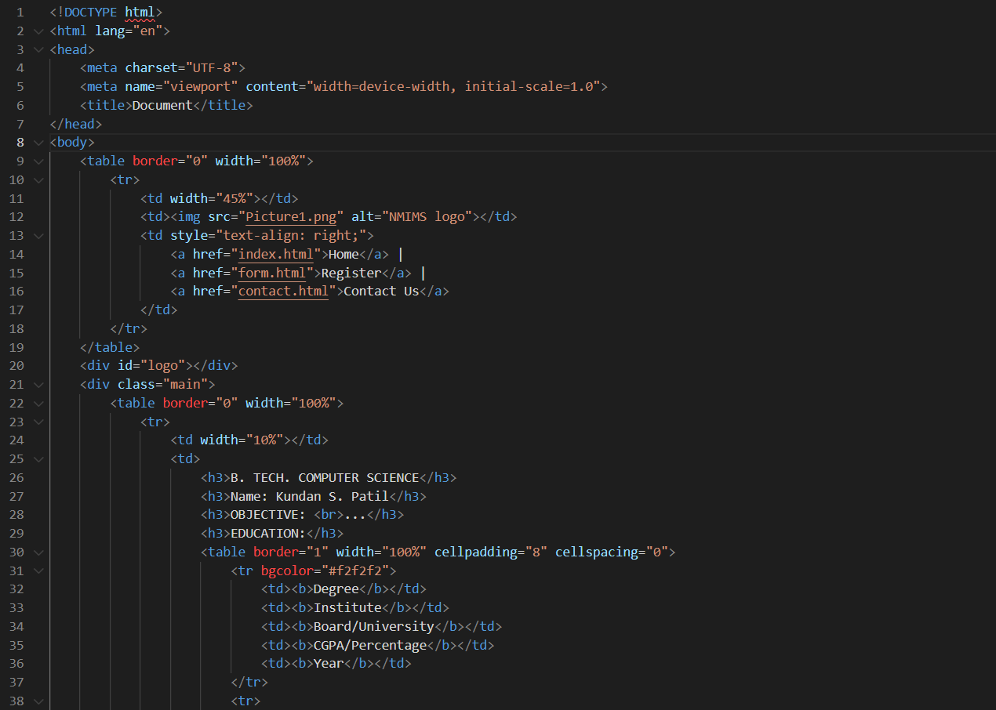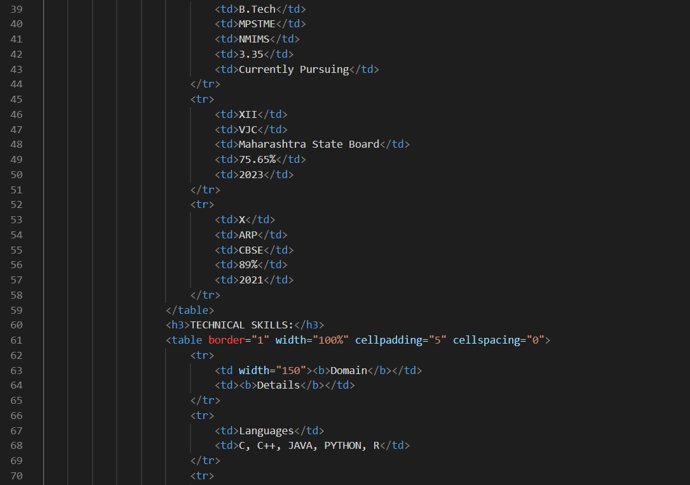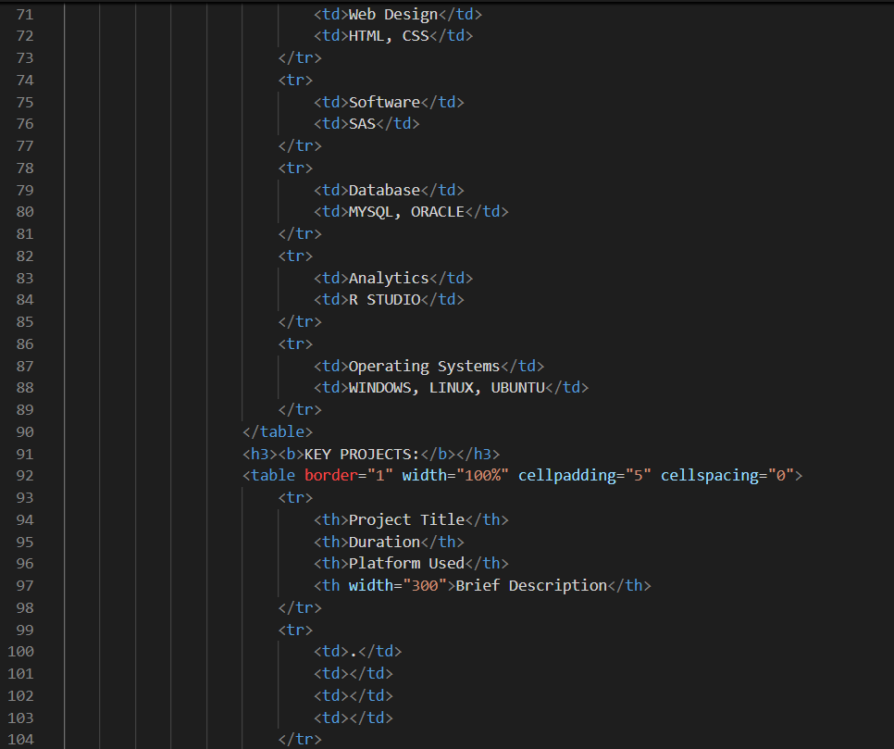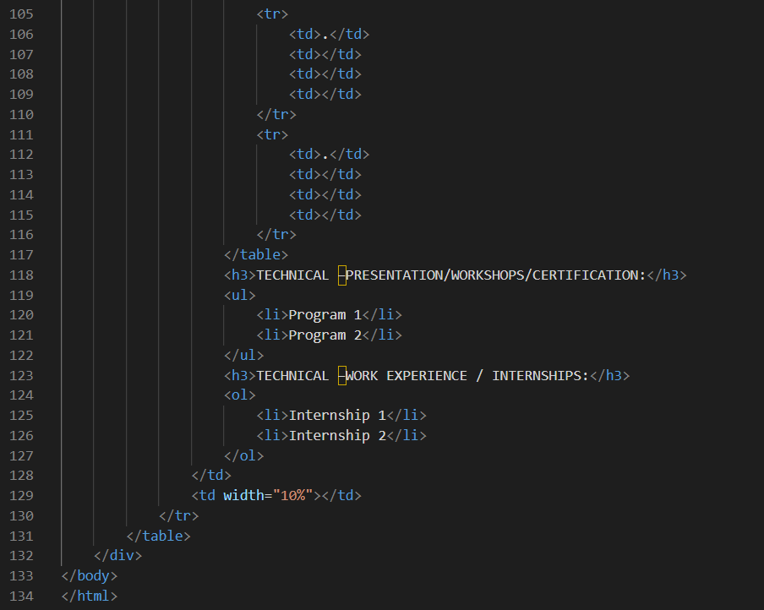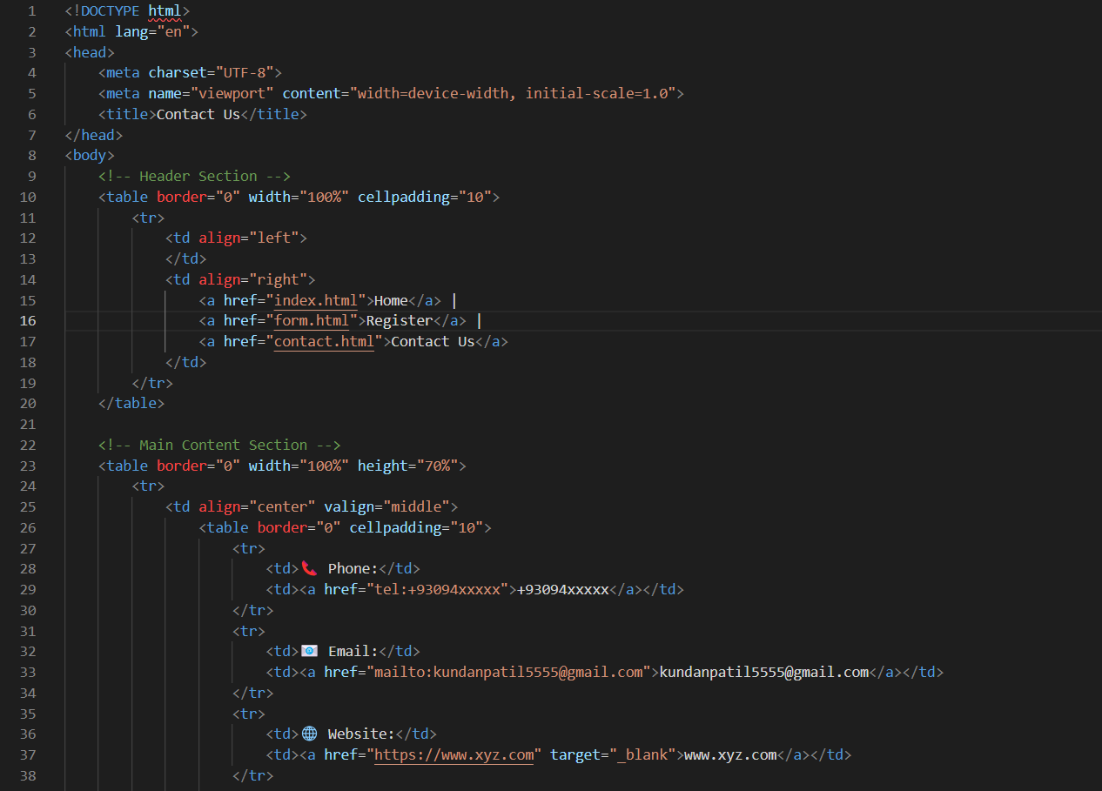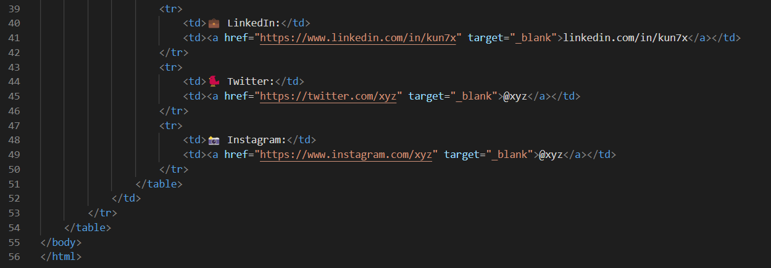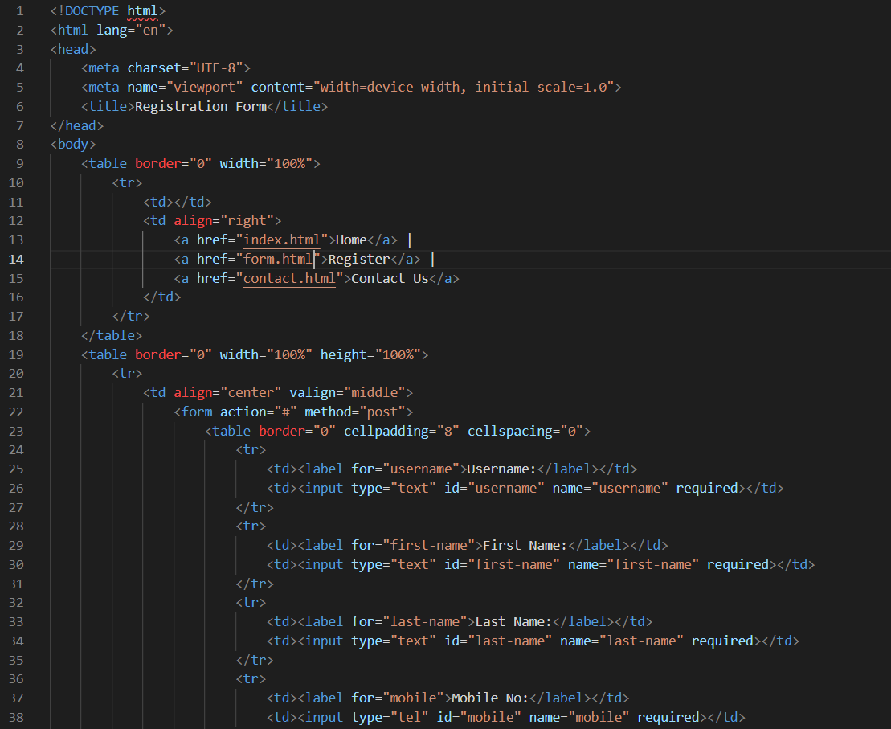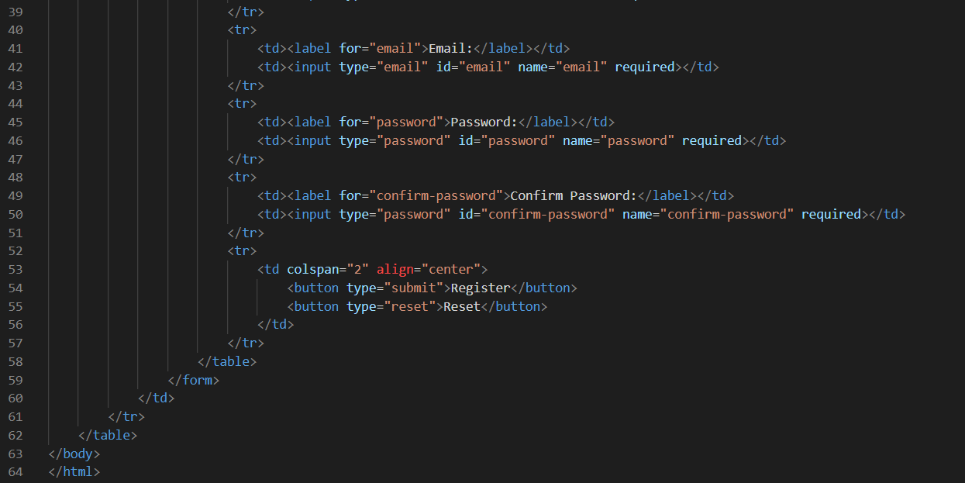

**B.2 Output**

**B.3 Conclusion:**

This experiment introduced fundamental HTML tags and their usage in creating static web pages. Students learned how to design basic web pages, format text and images, create tables and lists, and implement interactive features such as forms and hyperlinks. By using HTML elements like <img>, <table>, <form>, and <frameset>, students were able to develop their understanding of web development.

**B.3 Observations and Learning:**

• HTML tags form the backbone of web page structure and formatting.

• HTML elements can be nested, and attributes like href, src, and alt provide additional functionality.

• The use of forms, buttons, and input fields makes web pages interactive.

• Frames allow the display of multiple HTML documents in the same window.

• Understanding these basic elements is essential for building more advanced web pages and web applications.

**B.4 Question of Curiosity**

*(To be answered by student based on the practical performed and learning/observations)*

1. Validate html code of your CV code… using following link…. (validate by direct method )

<https://validator.w3.org/>

Input code to validator: -



Output of validator: -

