A PROJECT DOCUMENTATION ON

INTEGRATED DIGITAL MISSION MANAGEMENT SYSTEM USING TTL LOGIC

A Simplified Launch-Vehicle Mission Computer Realised Entirely in Discrete Digital Logic

By
KUNAL NITIN GADHAVE
Academic Year: [2026 – 2027]

ABSTRACT
This project presents the design and simulation of an Integrated Digital Mission Management System (IDMMS), a discrete-logic mission computer that reproduces, in simplified form, the decision-making sequence followed by a launch-vehicle flight computer. Rather than relying on a microcontroller or FPGA, the entire system is implemented using standard 74-series TTL integrated circuits, which was a deliberate choice made to keep the internal logic completely transparent and to strengthen my understanding of sequential and combinational circuit design at the gate level.
The system is organised into a set of cooperating subsystems: a clock and mission-timer stage built around a 74LS93 ripple counter, a mission sequencer realised with a 74LS154 decoder, a sensor-health monitoring stage, a Triple Modular Redundancy (TMR) block with a majority voter for navigation-sensor validation, a decision-logic stage that issues Mission Launch, Mission Abort, and Mission Frozen signals, a 74LS74-based fault memory that latches abort events until a manual reset, and a telemetry panel that exposes the internal state of the mission computer to an operator in real time.
Each subsystem was designed on paper using Boolean expressions and truth tables before being built and verified independently in NI Multisim, and only after each block behaved correctly on its own was it integrated into the complete circuit. Testing covered both nominal mission runs, in which all sensors reported healthy status and the sequence progressed from power-on to payload deployment, and fault scenarios, in which single and multiple sensor failures were injected to confirm that the abort and freeze logic responded correctly.
The results confirm that a fault-tolerant, sequenced mission controller can be realised entirely with discrete TTL logic, without any programmable element, and that the majority-voting scheme allows the navigation stage to tolerate the failure of any one of its three redundant sensors. The report also discusses how the concepts used here relate to real launch-vehicle avionics and safety-critical industrial controllers, and outlines how the design could be extended using FPGAs, microcontrollers, and wireless telemetry in future work.

TABLE OF CONTENTS
TABLE OF CONTENTS vi
LIST OF FIGURES xii
LIST OF TABLES xiii
CHAPTER 1: INTRODUCTION 1
1.1 Background 1
1.2 Motivation 1
1.3 Problem Statement 2
1.4 Objectives 2
1.5 Scope 2
1.6 Applications 3
1.7 Project Overview 3
CHAPTER 2: LITERATURE REVIEW 4
2.1 Traditional Sequential Mission Controllers 4
2.2 Modern Digital Mission Management Systems 4
2.3 Comparative Discussion 4
CHAPTER 3: SYSTEM ARCHITECTURE 6
3.1 Design Philosophy 6
3.2 Top-Level Block Diagram 6
3.3 Subsystem Signal Flow 6
3.4 Subsystem Descriptions 7
3.4.1 Mission Timer 7
3.4.2 Mission Sequencer 7
3.4.3 Sensor Monitoring 7
3.4.4 Triple Modular Redundancy and Majority Voter 7
3.4.5 Decision Logic 7
3.4.6 Abort Logic 7
3.4.7 Mission Freeze 8
3.4.8 Fault Memory 8
3.4.9 Telemetry 8
3.4.10 Outputs 8
3.5 Integrated Circuits Used 8
3.6 Physical Layout Considerations 9
CHAPTER 4: HARDWARE DESIGN 10
4.1 Phase 1 — Mission Clock and Mission Timer 10
4.1.1 Purpose 10
4.1.2 Components Used 10
4.1.3 Working Principle 10
4.1.4 Boolean Equations 10
4.1.5 Truth Table — Mission Timer Count Sequence 11
4.1.6 Circuit Explanation 11
4.1.7 Engineering Interpretation 11
4.1.8 Advantages 11
4.1.9 Limitations 12
4.2 Phase 2 — Mission Sequencer 12
4.2.1 Purpose 12
4.2.2 Components Used 12
4.2.3 Working Principle 12
4.2.4 Boolean Equations 12
4.2.5 Truth Table — Mission Sequencer 12
4.2.6 Circuit Explanation 13
4.2.7 Engineering Interpretation 13
4.2.8 Advantages 13
4.2.9 Limitations 13
4.3 Phase 3 — Sensor Monitoring 13
4.3.1 Purpose 14
4.3.2 Components Used 14
4.3.3 Working Principle 14
4.3.4 Boolean Equations 14
4.3.5 Truth Table (excerpt) 14
4.3.6 Circuit Explanation 14
4.3.7 Engineering Interpretation 14
4.3.8 Advantages 15
4.3.9 Limitations 15
4.4 Triple Redundancy Majority Voter 15
4.4.1 Purpose 15
4.4.2 Components Used 15
4.4.3 Working Principle 15
4.4.4 Boolean Equation 15
4.4.5 Truth Table — Majority Voter 16
4.4.6 Circuit Explanation 16
4.4.7 Engineering Interpretation 16
4.4.8 Advantages 16
4.4.9 Limitations 16
4.5 Launch Authorization 16
4.5.1 Purpose 17
4.5.2 Components Used 17
4.5.3 Working Principle 17
4.5.4 Boolean Equation 17
4.5.5 Truth Table (excerpt) 17
4.5.6 Circuit Explanation 17
4.5.7 Engineering Interpretation 17
4.5.8 Advantages 18
4.5.9 Limitations 18
4.6 Mission Abort 18
4.6.1 Purpose 18
4.6.2 Components Used 18
4.6.3 Working Principle 18
4.6.4 Boolean Equation 18
4.6.5 Truth Table (excerpt) 18
4.6.6 Circuit Explanation 19
4.6.7 Engineering Interpretation 19
4.6.8 Advantages 19
4.6.9 Limitations 19
4.7 Mission Frozen 19
4.7.1 Purpose 19
4.7.2 Components Used 19
4.7.3 Working Principle 20
4.7.4 Truth Table — Mission Frozen Latch 20
4.7.5 Circuit Explanation 20
4.7.6 Engineering Interpretation 20
4.7.7 Advantages 21
4.7.8 Limitations 21
4.8 Fault Memory 21
4.8.1 Purpose 21
4.8.2 Components Used 21
4.8.3 Working Principle 21
4.8.4 Truth Table — Fault Memory 21
4.8.5 Circuit Explanation 22
4.8.6 Engineering Interpretation 22
4.8.7 Advantages 22
4.8.8 Limitations 22
4.9 Telemetry 22
4.9.1 Purpose 22
4.9.2 Components Used 22
4.9.3 Working Principle 22
4.9.4 Circuit Explanation 23
4.9.5 Engineering Interpretation 23
4.9.6 Advantages 23
4.9.7 Limitations 23
4.10 Output Display 23
4.10.1 Purpose 23
4.10.2 Components Used 23
4.10.3 Engineering Interpretation 24
CHAPTER 5: SIMULATION 25
5.1 Simulation Environment 25
5.2 Complete Circuit 25
5.3 Mission Sequencer Simulation 25
5.4 Sensor Monitoring Simulation 25
5.5 Majority Voter Simulation 25
5.6 Launch Logic Simulation 26
5.7 Fault Memory Simulation 26
5.8 Telemetry Panel Simulation 26
5.9 Observations During Simulation 26
CHAPTER 6: TESTING AND VERIFICATION 27
6.1 Testing Methodology 27
6.2 Test Case Table — Nominal and Fault Scenarios 27
6.3 Discussion of Test Results 27
CHAPTER 7: RESULTS 29
7.1 Power ON 29
7.2 Self-Test 29
7.3 Navigation 29
7.4 Mission Launch 29
7.5 Mission Abort 29
7.6 Mission Freeze 29
7.7 Stage Separation 30
7.8 Payload Deploy 30
7.9 Fault Memory 30
7.10 Telemetry 30
7.11 Summary of Results 30
CHAPTER 8: INDUSTRIAL RELEVANCE 31
8.1 Relevance to Indian Space and Defence Organisations 31
8.2 Relevance to Private Space Companies 31
8.3 Avionics and Launch Vehicles 31
8.4 Missile Systems 31
8.5 Industrial Safety Controllers and PLC Systems 32
8.6 Fault-Tolerant Computing 32
CHAPTER 9: FUTURE SCOPE 33
9.1 FPGA Implementation 33
9.2 Microcontroller Implementation 33
9.3 CAN Bus Integration 33
9.4 Telemetry Communication 33
9.5 Wireless Monitoring 33
9.6 Fault Diagnostics 33
9.7 Sensor Fusion 34
9.8 Artificial Intelligence 34
9.9 Digital Twin 34
9.10 Hardware-in-the-Loop Simulation 34
CHAPTER 10: CONCLUSION 35
REFERENCES 36
APPENDICES 37
Appendix A — Complete Truth Tables 37
Appendix B — Consolidated Boolean Equations 37
Appendix C — IC Pin Configurations 37
Appendix D — Component List / Bill of Materials 37
Appendix E — Simulation Image Placeholders 38

LIST OF FIGURES
Figure 3.1 — Top-Level Block Diagram of the Integrated Digital Mission Management System
Figure 3.2 — Sensor Health and Triple Modular Redundancy Signal Flow
Figure 5.1 — Complete NI Multisim Schematic of the Integrated Digital Mission Management System
Figure 5.2 — 74LS154-Based Mission Sequencer Circuit and Logic Probe Verification
Figure 5.3 — Sensor Health Monitoring Circuit
Figure 5.4 — Triple Modular Redundancy Majority Voter Circuit
Figure 5.5 — Launch Authorisation and Mission Abort Logic Circuit
Figure 5.6 — 74LS74-Based Fault Memory and Mission Frozen Latch Circuit
Figure 5.7 — Telemetry Panel Displaying All Ten Monitored Mission Signals

LIST OF TABLES
Table 2.1 — Comparative Summary: Traditional vs Modern vs This Project
Table 3.1 — Integrated Circuits Used
Table 4.1 — Mission Timer (74LS93) Count Sequence
Table 4.2 — Mission Sequencer (74LS154) Output Mapping
Table 4.3 — Sensor Health AND-Chain (excerpt)
Table 4.4 — Triple Modular Redundancy Majority Voter Truth Table
Table 4.5 — Launch Authorisation Truth Table (excerpt)
Table 4.6 — Mission Abort Truth Table (excerpt)
Table 4.7 — Mission Frozen Latch Behaviour
Table 4.8 — Fault Memory Latch Behaviour
Table 6.1 — Test Cases Covering Nominal and Fault-Injected Mission Scenarios
Table D.1 — Bill of Materials

CHAPTER 1: INTRODUCTION

1.1 Background
Every launch vehicle, from the smallest sounding rocket to a heavy-lift orbital launcher, depends on an onboard computer that decides what should happen next. This decision-making element does not fly the rocket directly in the sense of actuating thrusters or gimbals; that job belongs to the guidance and control loop. What the mission computer does is track where the vehicle is in its mission timeline, confirm that the systems required for the next step are healthy, and either permit the mission to proceed or force it into a safe condition. In modern vehicles this logic is implemented in software running on redundant flight computers, but the underlying decision structure — check status, decide, act, record, report — is old enough that it can be built with nothing more than combinational and sequential digital logic.
This project asked a simple question: how much of that decision structure could I reproduce using only 74-series TTL integrated circuits, without writing a single line of embedded software? The answer turned out to be a fair amount. Counters can generate a timeline, decoders can turn a binary count into discrete mission stages, AND/OR/NOT gates can encode launch and abort conditions, and a D flip-flop can remember that a fault occurred even after the fault itself disappears. Put together, these blocks form a small but genuine mission computer.

1.2 Motivation
My interest in this topic came from a mismatch I noticed in my own coursework: digital logic is usually taught through isolated examples — a counter here, a decoder there, a flip-flop somewhere else — without a project that ties the individual devices into something that behaves like a real control system. I wanted a project where the truth table for a gate had actual consequences, where a stuck flip-flop meant the rocket would (in simulation) never leave the pad. Building a mission computer, even a simplified one, gave the individual 74-series parts a purpose beyond the textbook example.
A second motivation was reliability. Once I started reading about how ISRO, NASA, and other agencies handle sensor faults in flight, the idea of Triple Modular Redundancy stood out as something that could be demonstrated in hardware with just a handful of AND and OR gates. Implementing a majority voter myself, rather than only reading about it, made the idea of fault tolerance concrete in a way that no textbook description had managed.

1.3 Problem Statement
The problem this project addresses can be stated directly: design and simulate a digital system that (a) generates a repeatable mission timeline from a single clock source, (b) decodes that timeline into distinct operational stages, (c) continuously validates the health of navigation and support sensors using a redundant voting scheme, (d) authorises or aborts the mission based on that health information, (e) retains a permanent record of any abort event until deliberately reset, and (f) exposes the internal state of the system through a telemetry interface — all without using a microcontroller, FPGA, or any programmable logic device.

1.4 Objectives
- To design a stable clock and mission-timer stage using a 74LS93 ripple counter that produces a repeatable binary timeline.
- To implement a mission sequencer using a 74LS154 decoder that converts the binary timeline into individual, mutually exclusive mission-stage signals.
- To design a Triple Modular Redundancy block with a majority voter that validates navigation data from three independent sensor channels.
- To implement launch-authorisation, abort, and mission-freeze logic using combinational gates and a 74LS74 flip-flop.
- To build a fault-memory stage that permanently records an abort condition until the system is manually reset.
- To design a telemetry panel that displays the real-time status of every major subsystem.
- To verify the complete system in NI Multisim under both nominal and fault-injected conditions, and to document the observed behaviour against the expected truth tables.

1.5 Scope
The scope of this project is limited to the digital decision-making layer of a launch-vehicle mission computer. It does not attempt to model the vehicle's dynamics, guidance algorithms, propulsion, or actual sensor physics; the sensor inputs are represented as toggle switches whose logic state stands in for a healthy or faulty condition. The project is a simulation exercise built and verified in NI Multisim, targeting the kind of digital design coursework where TTL-level implementation is expected rather than a microcontroller-based solution. Where useful, the report draws a comparison with how real agencies handle these problems, but no claim is made that the mapping between binary mission states and actual launch-vehicle phases (as used in Chapter 4) is anything more than a teaching abstraction created for this project.

1.6 Applications
- Educational demonstration of fault-tolerant digital design using discrete TTL logic.
- A hardware analogue for understanding sequencing logic used in launch-vehicle and satellite mission computers.
- A reference design for safety-interlock logic in industrial automation and PLC-based safety controllers.
- A stepping stone toward FPGA- or microcontroller-based implementations of the same architecture, discussed in Chapter 9.

1.7 Project Overview
The remainder of this report is organised as follows. Chapter 2 reviews how mission sequencing has traditionally been implemented and contrasts that with the approach taken here. Chapter 3 lays out the complete system architecture and the flow of signals between subsystems. Chapter 4 goes through the hardware design of every subsystem in detail, including Boolean equations and truth tables. Chapter 5 documents the NI Multisim implementation, and Chapters 6 and 7 present the testing methodology and the results obtained. Chapter 8 relates the project to industrial and aerospace practice, Chapter 9 discusses how the design could be extended, and Chapter 10 concludes the report.

CHAPTER 2: LITERATURE REVIEW

2.1 Traditional Sequential Mission Controllers
Early mission-sequencing hardware, whether in launch vehicles or in industrial batch-process controllers, relied heavily on relay logic and later on discrete transistor-transistor logic (TTL) circuits before microprocessors became affordable and reliable enough for flight use. A sequential controller of this era was typically built around a counter or a stepping-relay chain, with each output corresponding to one stage of the process. Timing was governed by fixed delay elements rather than adaptive logic, and fault handling, where it existed at all, usually consisted of hard-wired interlocks that halted the sequence rather than making a graded decision. This style of design has the advantage of being fully deterministic and easy to reason about — a property that safety-critical systems still value — but it is inflexible: changing the mission sequence means rewiring the hardware, and there is no natural place to add more sophisticated redundancy checking.

2.2 Modern Digital Mission Management Systems
Contemporary launch-vehicle and spacecraft avionics have moved almost entirely to software running on redundant flight computers, typically arranged in dual- or triple-redundant voting configurations to guard against single-point hardware failures. [Citation placeholder — NASA/ISRO technical report on flight computer architecture] Sensor validation in these systems is usually performed through software-implemented voting or Kalman-filter-based sensor fusion rather than hardware majority gates, and mission sequencing is expressed as state machines or rule-based logic in the flight software rather than as a fixed hardware decoder chain. This gives modern systems far greater flexibility — a sequence can be reprogrammed without touching the hardware — at the cost of depending on the correctness of the software and the underlying processor, which introduces its own class of failure modes (radiation-induced bit flips, software defects, timing non-determinism) that hardware-only designs do not share in the same way.

2.3 Comparative Discussion
The project reported here sits deliberately between these two eras. Like a traditional sequential controller, the mission timeline is generated by a hardware counter and decoded by a fixed decoder, which keeps the system fully deterministic and easy to verify exhaustively against a truth table. However, unlike a simple relay-era interlock, the decision logic incorporates a Triple Modular Redundancy scheme with a majority voter — a concept borrowed directly from modern fault-tolerant flight computer design — implemented here in gate-level hardware rather than in software. This combination is not intended to compete with a real flight computer; it is intended to demonstrate, at a level appropriate for an undergraduate digital-design project, how the reliability techniques used in modern avionics can be expressed using nothing more than combinational and sequential TTL logic.
Table 2.1 summarises the main points of comparison.
Attribute | Traditional Relay / TTL Sequencer | Modern Software-Based Controller | This Project (IDMMS)
Sequencing element | Stepping relay / fixed counter | Software state machine | 74LS93 counter + 74LS154 decoder
Redundancy method | Rarely implemented | Software voting / sensor fusion | Hardware majority voter (TMR)
Fault recording | Hard-wired interlock (if any) | Logged in software/telemetry | 74LS74 latched fault memory
Reconfigurability | Requires rewiring | Reprogrammable | Requires rewiring (fixed logic)
Determinism | Very high | Depends on software correctness | Very high

CHAPTER 3: SYSTEM ARCHITECTURE

3.1 Design Philosophy
Before touching Multisim, I sketched out what the system needed to do in plain terms: keep track of where the mission is in its timeline, check that the sensors relevant to that stage are healthy, decide whether to continue or abort, remember an abort if one happens, and report all of this to an operator. Once that much was clear, mapping each function onto a specific 74-series device was mostly a matter of picking the simplest part that could do the job — a decision explained further in Section 3.4.

3.2 Top-Level Block Diagram
Figure 3.1 shows the complete system at the block level. Signals flow left to right through the timing and sequencing chain, while the sensor and redundancy chain feeds into the decision logic from below.
Clock Generator | → | Mission Timer (74LS93) | → | Mission Sequencer (74LS154)

Sensor Inputs | → | Sensor Health & TMR Voter

Mission Stage | → | Decision Logic (Launch / Abort) | → | Fault Memory (74LS74)

Telemetry Panel | → | Output LEDs / Displays
Figure 3.1: Top-Level Block Diagram of the Integrated Digital Mission Management System

3.3 Subsystem Signal Flow
A more detailed view of how the sensor and redundancy path connects into the decision logic is given in Figure 3.2. The three navigation sensors (representing GPS, gyroscope, and accelerometer channels) are compared pairwise, and the majority voter output becomes the Navigation Health signal, which is then combined with Battery, Temperature, and Communication health to produce a single Sensor Health / Ready-to-Launch signal.
GPS (A) | → | Gyro (B) | → | Accel (C)

Pairwise AND (AB, AC, BC) | → | OR Voter | → | Navigation Health

Navigation Health | → | Battery / Temp / Comm | → | Sensor Health (AND) | → | Ready to Launch
Figure 3.2: Sensor Health and Triple Modular Redundancy Signal Flow

3.4 Subsystem Descriptions

3.4.1 Mission Timer
Generates the binary timeline that drives every downstream subsystem. Implemented with a 74LS93 4-bit ripple counter clocked from a stable TTL clock source.

3.4.2 Mission Sequencer
Decodes the 4-bit timeline into sixteen mutually exclusive, active-low mission-stage outputs using a 74LS154 4-to-16 decoder.

3.4.3 Sensor Monitoring
Converts raw sensor toggle-switch states into buffered health signals for GPS, gyroscope, accelerometer, battery, temperature, and communication channels.

3.4.4 Triple Modular Redundancy and Majority Voter
Compares the three navigation sensor channels pairwise and combines the comparisons with OR logic so that the system tolerates the failure of any single navigation sensor.

3.4.5 Decision Logic
Combines Navigation Health with Battery, Temperature, and Communication health, along with the current mission stage, to generate the Mission Launch signal.

3.4.6 Abort Logic
Monitors for any critical fault condition and immediately asserts Mission Abort when one is detected, overriding the launch path.

3.4.7 Mission Freeze
Uses a 74LS74 D flip-flop to latch the Mission Abort event, holding the sequencer at its current stage until the system is manually reset.

3.4.8 Fault Memory
A second 74LS74-based latch dedicated to permanently recording that a fault occurred during the mission run, independent of whether the original fault condition has since cleared.

3.4.9 Telemetry
A 74LS194-based shift register and associated logic probes / indicators that expose Power ON, Self-Test, Navigation, Ready-to-Launch, Mission Launch, Mission Abort, Mission Frozen, Stage Separation, Payload Deploy, and Fault Memory states to an observer.

3.4.10 Outputs
LED indicators (or logic-probe equivalents in simulation) representing Mission Ready, current mission stage, Warning, Fault, and Telemetry activity.

3.5 Integrated Circuits Used
IC | Function | Subsystem
7493 / 74LS93 | 4-bit binary ripple counter | Mission Timer
74154 / 74LS154 | 4-to-16 line decoder (active-low) | Mission Sequencer
7408 / 74LS08 | Quad 2-input AND gate | Decision Logic, Sensor Health
7432 / 74LS32 | Quad 2-input OR gate | Majority Voter, Abort Logic
7404 / 74LS04 | Hex inverter | Abort / Complement Logic
7486 | Quad 2-input XOR gate | Optional parity / fault detection
7485 | 4-bit magnitude comparator | Optional sensor validation
7474 / 74LS74 | Dual D-type flip-flop | Mission Freeze, Fault Memory
74194 | 4-bit bidirectional shift register | Telemetry

3.6 Physical Layout Considerations
To keep the Multisim schematic readable, I grouped the circuit into three horizontal bands: the timing and sequencing chain along the top, the sensor and redundancy path in the middle, and the fault-memory / telemetry stage along the bottom, with signals generally flowing left to right within each band. This mirrors the layout plan I worked out on paper before starting the simulation and made later debugging considerably easier, since a misbehaving signal could usually be traced by following the sheet in one direction rather than jumping across the schematic.

CHAPTER 4: HARDWARE DESIGN
This chapter documents the design of every subsystem in the mission computer. Each section follows the same pattern: purpose, components used, working principle, governing Boolean equations, truth table, circuit explanation, engineering interpretation, and a short note on advantages and limitations. I have kept the equations and truth tables as close as possible to the exact logic implemented in Multisim so that the schematic in Chapter 5 can be cross-checked against this chapter directly.

4.1 Phase 1 — Mission Clock and Mission Timer

4.1.1 Purpose
To generate a stable master clock and, from it, a repeatable 4-bit binary timeline that every other subsystem synchronises against.

4.1.2 Components Used
Component | Specification | Purpose
Clock Generator | 5 V TTL, 10 Hz | Produces the master clock pulse
74LS93 | 4-bit ripple counter | Converts clock pulses into a binary timeline
DC Supply | +5 V | Powers the TTL devices
Oscilloscope | Virtual instrument | Confirms timing and frequency division

4.1.3 Working Principle
The clock generator produces a continuous square wave alternating between logic LOW and logic HIGH. Each rising edge advances the 74LS93 by one count. Because the 74LS93 is a ripple counter, each output stage (QA through QD) divides the frequency of the stage before it by two, so QA toggles at half the clock rate, QB at a quarter, and so on. I used a 10 Hz clock during simulation purely so that transitions could be read comfortably off the oscilloscope trace; the frequency itself is not otherwise significant and can be scaled up once the design is committed to real hardware.

4.1.4 Boolean Equations
QA = CLK ÷ 2, QB = CLK ÷ 4, QC = CLK ÷ 8, QD = CLK ÷ 16 (4.1)

4.1.5 Truth Table — Mission Timer Count Sequence
Count | QD | QC | QB | QA | Decimal
Reset | 0 | 0 | 0 | 0 | 0
1 | 0 | 0 | 0 | 1 | 1
2 | 0 | 0 | 1 | 0 | 2
3 | 0 | 0 | 1 | 1 | 3
4 | 0 | 1 | 0 | 0 | 4
5 | 0 | 1 | 0 | 1 | 5
6 | 0 | 1 | 1 | 0 | 6
7 | 0 | 1 | 1 | 1 | 7
8 | 1 | 0 | 0 | 0 | 8
... | ... | ... | ... | ... | ...
15 | 1 | 1 | 1 | 1 | 15
Next pulse | 0 | 0 | 0 | 0 | Reset
Table 4.1: Mission Timer (74LS93) Count Sequence

4.1.6 Circuit Explanation
The clock output connects to the CLK-A input of the 74LS93. QA is externally tied to the CLK-B input so that the device operates as a single 4-bit counter rather than two separate divide-by-2 and divide-by-8 sections, which is the standard connection for this IC when a full 4-bit count is required. The Reset (MR1, MR2) pins are tied together and driven from a common RESET line so that the whole timeline can be restarted on demand.

4.1.7 Engineering Interpretation
Rather than think of this stage as “a binary counter,” I found it more useful to treat it as the mission clock: every downstream decision, from sequencing to telemetry, ultimately traces back to how many clock edges have occurred since the last reset. This framing made later debugging much easier, since a mis-sequenced stage almost always turned out to be a timing question rather than a logic-error question.

4.1.8 Advantages
- Fully deterministic — the same clock count always produces the same output pattern.
- Simple to reset and resynchronise using the shared master-reset line.

4.1.9 Limitations
- Ripple counters accumulate small propagation delays through each stage, which would matter at high clock frequencies (not significant at the 10 Hz test frequency used here).
- A fixed 4-bit count limits the timeline to sixteen distinct stages without cascading additional counters.

4.2 Phase 2 — Mission Sequencer

4.2.1 Purpose
To convert the 4-bit binary timeline from the Mission Timer into sixteen individual, mutually exclusive mission-stage signals.

4.2.2 Components Used
Component | Specification | Purpose
74LS154 | 4-to-16 line decoder | Generates one active mission-stage output per count
74LS93 outputs | QA–QD | Binary select lines A–D of the decoder
Logic Probes | Digital instrument | Confirm active-low decoder outputs

4.2.3 Working Principle
QA–QD from the Mission Timer connect directly to the A–D select inputs of the 74LS154. Both active-low enable inputs are tied permanently LOW so that the decoder is always active. For each of the sixteen possible input combinations exactly one of the sixteen outputs goes LOW while the rest remain HIGH, which gives a clean, glitch-free way of representing “exactly one stage is active at a time.”

4.2.4 Boolean Equations
On = NOT(A' · B' · C' · D') for the minterm corresponding to output n (active LOW) (4.2)

4.2.5 Truth Table — Mission Sequencer
QD QC QB QA | Active Output | Mission Stage
0 0 0 0 | O0 (LOW) | Power ON
0 0 0 1 | O1 (LOW) | Self-Test
0 0 1 0 | O2 (LOW) | Navigation Initialisation
0 0 1 1 | O3 (LOW) | Launch Preparation
0 1 0 0 | O4 (LOW) | Stage Separation
0 1 0 1 | O5 (LOW) | Payload Deployment
0 1 1 0 – 1 1 1 1 | O6–O15 (LOW) | Reserved for future expansion
Table 4.2: Mission Sequencer (74LS154) Output Mapping

4.2.6 Circuit Explanation
Because the 74LS154 outputs are active LOW, I added inverters on the outputs that feed directly into AND-based decision logic further downstream, so that the rest of the circuit could be designed using conventional active-HIGH conventions without having to keep track of polarity at every stage.

4.2.7 Engineering Interpretation
The sequencer is what turns a bare binary count into something meaningful — it is the difference between “the counter reads 0011” and “the vehicle is in Launch Preparation.” This mapping (Table 4.2) is a teaching abstraction I defined for this project and is not meant to represent an actual ISRO or NASA mission timeline.

4.2.8 Advantages
- Guarantees mutual exclusivity between mission stages without additional logic.
- Ten of the sixteen outputs are left reserved, giving room to extend the mission timeline later.

4.2.9 Limitations
- A decoder-based sequencer cannot easily support conditional branching or repeated stages — it only advances linearly with the counter.

4.3 Phase 3 — Sensor Monitoring

4.3.1 Purpose
To convert raw sensor switch states into clean logic-level health signals for the six monitored parameters: GPS, gyroscope, accelerometer, battery, temperature, and communication.

4.3.2 Components Used
Component | Purpose
Toggle switches | Represent sensor healthy/faulty state
74LS08 (AND) | Combine individual health signals
Pull-up/pull-down networks | Define default logic levels

4.3.3 Working Principle
Each sensor is represented by a switch: logic HIGH means the sensor is reporting a healthy status, logic LOW means it is reporting a fault. These six raw signals feed into two places — the TMR / majority voter block (for the three navigation sensors) and the combined Sensor Health AND-chain (for battery, temperature, and communication).

4.3.4 Boolean Equations
Sensor_Health = Navigation_Health · Battery · Temperature · Communication (4.3)

4.3.5 Truth Table (excerpt)
Battery | Temp | Comm | Navigation Health | Sensor Health
1 | 1 | 1 | 1 | 1
1 | 1 | 1 | 0 | 0
1 | 0 | 1 | 1 | 0
0 | 1 | 1 | 1 | 0
Table 4.3: Sensor Health AND-Chain (excerpt)

4.3.6 Circuit Explanation
The four inputs to the final AND stage are Navigation Health, Battery, Temperature, and Communication. I built this using two cascaded 2-input 74LS08 AND gates rather than a single 4-input gate, since a 4-input AND was not available on my parts list and this is functionally identical.

4.3.7 Engineering Interpretation
Requiring all four conditions to be true before Sensor Health goes HIGH reflects a conservative, fail-safe design philosophy: any single unhealthy subsystem is enough to withhold Sensor Health, which in turn withholds launch authorisation.

4.3.8 Advantages
- Simple, fully combinational, and easy to verify exhaustively.

4.3.9 Limitations
- Does not distinguish between a transient glitch and a persistent fault at this stage — that distinction is handled later by the Fault Memory block.

4.4 Triple Redundancy Majority Voter

4.4.1 Purpose
To validate navigation data from three independent sensor channels (representing GPS, gyroscope, and accelerometer) so that the system continues to function correctly even if any one of the three disagrees with the others.

4.4.2 Components Used
Component | Purpose
74LS08 (AND) | Generates pairwise agreement signals AB, AC, BC
74LS32 (OR) | Combines pairwise signals into the majority output

4.4.3 Working Principle
Let A, B, and C represent the GPS, gyroscope, and accelerometer health signals. Three AND gates compute the pairwise agreements AB, AC, and BC. These three terms are combined with two OR gates to produce Navigation_Health, which is HIGH whenever at least two of the three sensors agree that navigation is healthy — this is the standard 2-out-of-3 majority-voting scheme used in triple-redundant systems.

4.4.4 Boolean Equation
Navigation_Health = AB + AC + BC (4.4)

4.4.5 Truth Table — Majority Voter
A (GPS) | B (Gyro) | C (Accel) | Navigation_Health
0 | 0 | 0 | 0
0 | 0 | 1 | 0
0 | 1 | 0 | 0
0 | 1 | 1 | 1
1 | 0 | 0 | 0
1 | 0 | 1 | 1
1 | 1 | 0 | 1
1 | 1 | 1 | 1
Table 4.4: Triple Modular Redundancy Majority Voter Truth Table

4.4.6 Circuit Explanation
Each of the three AND gates takes two of the three sensor signals as inputs (AB, AC, BC), and the two OR gates are cascaded to sum all three pairwise terms. I verified this stage on its own, with the other sensors disconnected, before wiring it into the rest of the sensor-health chain, which made it much easier to confirm the truth table matched exactly.

4.4.7 Engineering Interpretation
This is the block I found most satisfying to design, because it is the clearest example in the whole project of turning a reliability concept into a handful of logic gates. Row by row, Table 4.4 shows that Navigation_Health stays HIGH as long as any two of the three sensors agree — the system does not need all three to be healthy, only a majority.

4.4.8 Advantages
- Tolerates the failure of any single navigation sensor without losing Navigation_Health.
- Implemented with only five gates, keeping the block small and easy to verify.

4.4.9 Limitations
- A simultaneous failure of two of the three sensors will produce an incorrect Navigation_Health output — the scheme protects against single-channel faults only.

4.5 Launch Authorization

4.5.1 Purpose
To generate the Mission Launch signal only when every required precondition is satisfied.

4.5.2 Components Used
Component | Purpose
74LS08 (AND) | Combines launch preconditions
74LS04 (NOT) | Inverts Mission Abort for the launch AND-chain

4.5.3 Working Principle
Mission Launch is only asserted once Power-ON has completed, Self-Test has passed, Navigation is ready, Sensor Health is HIGH, and no Mission Abort condition is active. This is implemented as a five-input AND function (built from cascaded 2-input gates), with the Mission Abort term inverted before being ANDed in.

4.5.4 Boolean Equation
Mission_Launch = Power_ON · Self_Test · Navigation · Sensor_Health · NOT(Mission_Abort) (4.5)

4.5.5 Truth Table (excerpt)
Power_ON | Self_Test | Navigation | Sensor_Health | Abort | Mission_Launch
1 | 1 | 1 | 1 | 0 | 1
1 | 1 | 1 | 1 | 1 | 0
1 | 1 | 1 | 0 | 0 | 0
1 | 1 | 0 | 1 | 0 | 0
Table 4.5: Launch Authorisation Truth Table (excerpt)

4.5.6 Circuit Explanation
All five conditions were brought together using cascaded 74LS08 gates. I placed the inverted Abort signal last in the AND chain during layout simply because it made the schematic easier to trace, though logically the order of AND inputs makes no difference.

4.5.7 Engineering Interpretation
Requiring a unanimous AND across five independent conditions before authorising launch is a deliberately conservative choice — a single unmet condition anywhere in the chain withholds authorisation, which mirrors the go/no-go polling process used before an actual launch.

4.5.8 Advantages
- Easy to extend with additional preconditions by adding further AND stages.

4.5.9 Limitations
- A pure AND-based authorisation chain has no concept of a conditional override or manual go-ahead — every condition must be met exactly as wired.

4.6 Mission Abort

4.6.1 Purpose
To immediately flag a mission-ending fault condition whenever a critical failure is detected.

4.6.2 Components Used
Component | Purpose
74LS32 (OR) | Combines individual fault conditions

4.6.3 Working Principle
Mission Abort is generated whenever any one of the monitored fault conditions — sensor fault, navigation fault, or a general critical failure flag — becomes active. Because this is an OR function, a single active fault is sufficient to trigger an abort.

4.6.4 Boolean Equation
Mission_Abort = Sensor_Fault + Navigation_Fault + Critical_Failure (4.6)

4.6.5 Truth Table (excerpt)
Sensor_Fault | Navigation_Fault | Critical_Failure | Mission_Abort
0 | 0 | 0 | 0
1 | 0 | 0 | 1
0 | 1 | 0 | 1
0 | 0 | 1 | 1
Table 4.6: Mission Abort Truth Table (excerpt)

4.6.6 Circuit Explanation
The three fault flags are combined with two cascaded OR gates. This signal feeds both the launch-inhibit path described in Section 4.5 and the Mission-Freeze latch described in Section 4.7.

4.6.7 Engineering Interpretation
An OR-based abort condition means the system is deliberately biased toward caution: it takes only one genuine fault, from any of the three monitored categories, to end the mission rather than requiring multiple simultaneous faults.

4.6.8 Advantages
- Fast response — any single qualifying fault propagates to Mission_Abort with minimal gate delay.

4.6.9 Limitations
- Does not itself distinguish between a transient and a persistent fault — that is handled by the latching stages described next.

4.7 Mission Frozen

4.7.1 Purpose
To latch a Mission Abort event so that the sequencer is held at its current stage until a deliberate system reset, rather than being allowed to resume if the abort condition happens to clear on its own.

4.7.2 Components Used
Component | Purpose
74LS74 | D flip-flop used as a 1-bit latch for the Mission Frozen state

4.7.3 Working Principle
The Mission_Abort signal is applied to the D input of a 74LS74 flip-flop clocked by the system clock. Once Mission_Abort goes HIGH at a clock edge, the flip-flop's Q output (Mission_Frozen) latches HIGH and stays there on every subsequent clock edge, regardless of what Mission_Abort does afterward, until the flip-flop is cleared through its asynchronous clear input by the RESET line.

4.7.4 Truth Table — Mission Frozen Latch
Abort | Clock Edge | Mission_Frozen
0 | Rising | 0
1 | Rising | 1
1 | Subsequent edges | 1 (held)
X | Async Reset | 0
Table 4.7: Mission Frozen Latch Behaviour

4.7.5 Circuit Explanation
Mission_Frozen, once set, is fed back into the Mission Sequencer's enable path so that the 74LS154 outputs stop advancing — the sequencer effectively freezes at whatever stage was active when the abort occurred.

4.7.6 Engineering Interpretation
This is the block that turns a momentary Mission_Abort pulse into a persistent system state. Without it, the sequencer might simply continue advancing on the next clock edge if the fault that triggered the abort happened to be transient, which would defeat the purpose of aborting in the first place.

4.7.7 Advantages
- Guarantees the frozen state persists independent of how long the original fault lasted.

4.7.8 Limitations
- Requires a deliberate, explicit reset — there is no automatic recovery path, which is the correct behaviour for a safety interlock but does mean operator intervention is always required.

4.8 Fault Memory

4.8.1 Purpose
To keep a permanent record that a fault occurred at some point during the mission run, independent of the Mission Frozen state, so that the fault can be reviewed even after the original condition has cleared.

4.8.2 Components Used
Component | Purpose
74LS74 | Second, dedicated D flip-flop used purely for fault logging

4.8.3 Working Principle
This block mirrors the Mission Frozen latch in structure but is kept logically separate so that fault history and mission-freeze behaviour can, in a future extension, be reset independently of each other (for example, clearing the frozen state to resume a mission while still preserving the fault log for a post-mission review).

4.8.4 Truth Table — Fault Memory
Mission_Abort | Clock Edge | Fault_Memory
0 | Rising | 0
1 | Rising | 1
1 | Subsequent edges | 1 (held)
X | Manual Reset | 0
Table 4.8: Fault Memory Latch Behaviour

4.8.5 Circuit Explanation
The Fault_Memory output is routed directly to the telemetry panel described in Section 4.9, so that a fault remains visible to an observer even if the corresponding sensor has since recovered.

4.8.6 Engineering Interpretation
I initially considered merging this with the Mission Frozen latch, since both are triggered by the same Mission_Abort signal, but keeping them as two separate flip-flops made the eventual telemetry wiring considerably cleaner and leaves room for independent reset logic later.

4.8.7 Advantages
- Preserves a record of the fault for post-mission analysis even after recovery.

4.8.8 Limitations
- Only records that a fault occurred, not which specific sensor caused it — identifying the source would require additional latches per sensor channel.

4.9 Telemetry

4.9.1 Purpose
To provide a real-time, human-readable view of every major internal signal in the mission computer.

4.9.2 Components Used
Component | Purpose
74194 | 4-bit bidirectional shift register used to serialise status bits for the telemetry panel
Logic Probes / LEDs | Direct indicators for each monitored signal

4.9.3 Working Principle
Ten key signals — Power ON, Self-Test, Navigation, Ready-to-Launch, Mission Launch, Mission Abort, Mission Frozen, Stage Separation, Payload Deploy, and Fault Memory — are each connected to their own indicator on the telemetry panel, giving an at-a-glance view of the mission state. The 74194 shift register is used to demonstrate how the same status bits could, in a future extension, be serialised for transmission over a single communication line rather than requiring one wire per signal.

4.9.4 Circuit Explanation
Each of the ten monitored signals is buffered before being displayed, so that connecting the telemetry indicators does not load down the logic driving the decision-logic and fault-memory stages.

4.9.5 Engineering Interpretation
Telemetry is often treated as an afterthought in student projects, but I found that having a dedicated panel with all ten signals visible at once was what actually made debugging the rest of the circuit practical — most of the fault-injection tests in Chapter 6 were verified by reading this panel rather than probing individual nets.

4.9.6 Advantages
- Gives complete visibility into the internal state of the mission computer without needing to probe internal nodes directly.

4.9.7 Limitations
- The parallel-indicator approach used here does not scale well if many more signals are added; a genuinely serialised telemetry link (Chapter 9) would be needed at that point.

4.10 Output Display

4.10.1 Purpose
To present the final, human-facing summary of system state: whether the mission is ready, what stage it is in, and whether a warning or fault is present.

4.10.2 Components Used
Indicator | Meaning
Green LED | Mission Ready
Blue LED | Current Mission Stage (paired with sequencer output)
Yellow LED | Warning
Red LED | Fault
White LED | Telemetry Activity

4.10.3 Engineering Interpretation
Colour-coded, single-purpose indicators made the system far easier to demonstrate to my guide during review sessions than reading raw logic-probe states off the schematic, and this is consistent with how status panels are designed in real control-room settings.

CHAPTER 5: SIMULATION

5.1 Simulation Environment
The complete circuit was built and verified in NI Multisim. I chose to build and test each subsystem in its own worksheet first — the timer on its own, then the sequencer driven by a manual switch bank instead of the timer, and so on — before wiring everything into the single integrated schematic described in this chapter. This staged approach caught several wiring mistakes early (most notably a reversed active-low connection on the decoder enable pins) that would have been much harder to isolate in the full circuit.

5.2 Complete Circuit
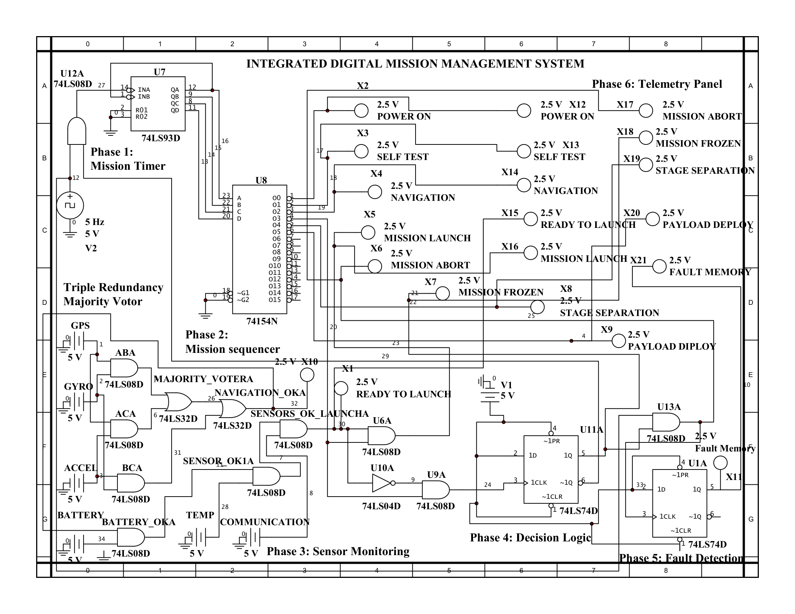
Figure 5.1: Complete NI Multisim Schematic of the Integrated Digital Mission Management System

5.3 Mission Sequencer Simulation
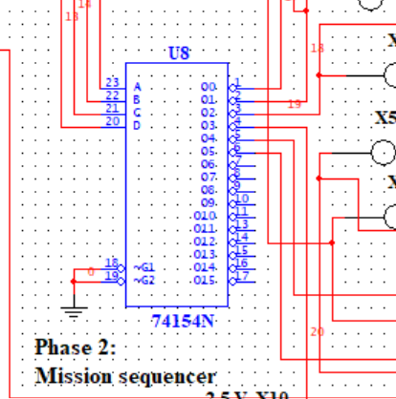
Figure 5.2: 74LS154-Based Mission Sequencer Circuit and Logic Probe Verification
The QA–QD outputs from the Mission Timer worksheet were connected to the decoder's select lines, and logic probes were placed on all sixteen decoder outputs to confirm that exactly one output went LOW for each of the sixteen possible input combinations.

5.4 Sensor Monitoring Simulation
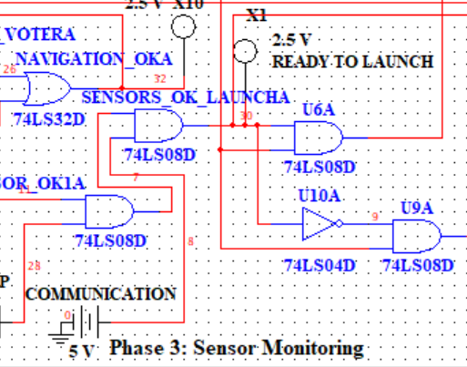
Figure 5.3: Sensor Health Monitoring Circuit (Battery, Temperature, Communication)

5.5 Majority Voter Simulation
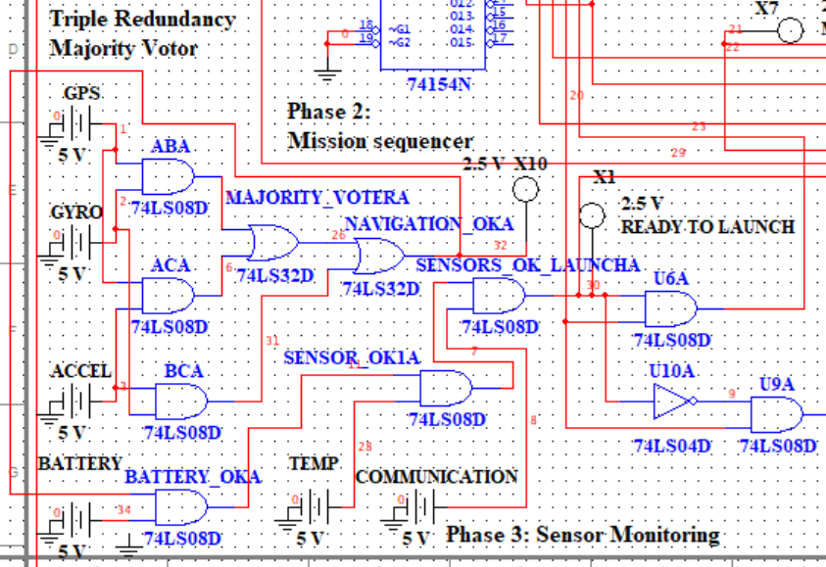
Figure 5.4: Triple Modular Redundancy Majority Voter Circuit
Each of the eight input combinations listed in Table 4.4 was applied manually using toggle switches, and the Navigation_Health output was confirmed against the expected truth-table value in every case.

5.6 Launch Logic Simulation
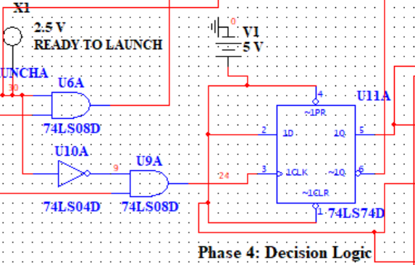
Figure 5.5: Launch Authorisation and Mission Abort Logic Circuit

5.7 Fault Memory Simulation

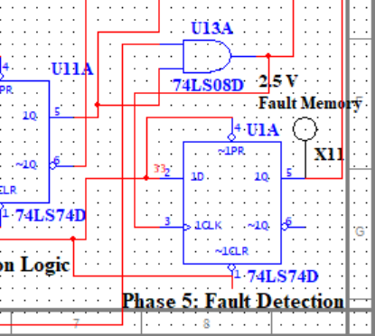
Figure 5.6: 74LS74-Based Fault Memory and Mission Frozen Latch Circuit
A momentary abort pulse was applied and then removed, and the Fault_Memory and Mission_Frozen outputs were confirmed to remain latched HIGH until the RESET line was asserted, matching Tables 4.7 and 4.8.

5.8 Telemetry Panel Simulation
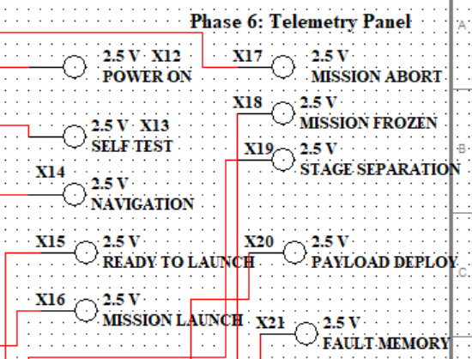
Figure 5.7: Telemetry Panel Displaying All Ten Monitored Mission Signals

5.9 Observations During Simulation
Building the circuit in stages made it clear how much of the debugging effort in a project like this comes down to signal polarity rather than logical structure — the majority of the issues I ran into while integrating the subsystems traced back to an active-low output being treated as active-HIGH somewhere downstream, rather than to an incorrect Boolean expression.

CHAPTER 6: TESTING AND VERIFICATION

6.1 Testing Methodology
Each subsystem was first verified in isolation against its own truth table (Chapter 4), and only once every subsystem matched its expected behaviour independently was the full system tested end to end using a set of mission scenarios covering both nominal operation and injected faults.

6.2 Test Case Table — Nominal and Fault Scenarios
# | Input Conditions | Expected Output | Observed Output | Status
T1 | All sensors healthy, RESET released | Sequence advances Power ON → Payload Deploy, Mission_Launch HIGH | Sequence advanced as expected, Mission_Launch HIGH | Pass
T2 | GPS fault (A=0), B and C healthy | Navigation_Health remains HIGH (2-of-3 majority) | Navigation_Health HIGH | Pass
T3 | GPS and Gyro fault (A=0, B=0), C healthy | Navigation_Health goes LOW | Navigation_Health LOW, Mission_Abort HIGH | Pass
T4 | Battery fault during Launch Preparation stage | Sensor_Health LOW → Mission_Abort HIGH → Mission_Frozen latches | Behaviour matched expected sequence | Pass
T5 | Momentary Communication fault, then cleared | Mission_Abort pulses HIGH; Fault_Memory remains latched after fault clears | Fault_Memory remained HIGH after fault cleared | Pass
T6 | RESET asserted after an abort | Mission_Frozen and Fault_Memory both clear to 0 | Both cleared as expected | Pass
T7 | Temperature fault only, all else healthy | Sensor_Health LOW, Mission_Abort HIGH | Behaviour matched expected | Pass
T8 | All sensors healthy, mission run to Payload Deploy stage | Telemetry panel reflects each stage transition in real time | Telemetry matched sequencer state at every stage | Pass
Table 6.1: Test Cases Covering Nominal and Fault-Injected Mission Scenarios

6.3 Discussion of Test Results
Every test case listed in Table 6.1 matched the behaviour predicted by the truth tables in Chapter 4. The two cases I paid closest attention to were T2 and T3, since they directly test the majority-voting boundary: a single-sensor fault (T2) should not affect Navigation_Health, while a two-sensor fault (T3) should. Both results matched the expected majority-logic behaviour exactly, which gave me confidence that the TMR block was wired correctly rather than only appearing correct by coincidence on a single input combination.
Test T5 was included specifically to confirm that the Fault Memory behaves differently from a purely combinational fault indicator — this is the case that most clearly demonstrates why a latch, rather than a simple gate, was necessary for this block.

CHAPTER 7: RESULTS

7.1 Power ON
With RESET asserted and then released, the Mission Timer began counting from 0000, and the Power ON telemetry indicator activated immediately, confirming correct initial-state behaviour.

7.2 Self-Test
On the second clock edge, the sequencer output corresponding to Self-Test went active, and the Self-Test telemetry indicator lit accordingly, with no other sequencer output active at the same time.

7.3 Navigation
During the Navigation Initialisation stage, toggling each of the three navigation sensor switches individually confirmed that Navigation_Health remained HIGH as long as at least two of the three sensors reported healthy, consistent with Table 4.4.

7.4 Mission Launch
With all sensors healthy and no abort condition present, Mission_Launch went HIGH once the sequencer reached the Launch Preparation stage, and the Green (Mission Ready) indicator activated alongside it.

7.5 Mission Abort
Introducing a fault on two of the three navigation sensors simultaneously caused Mission_Abort to assert immediately, and the sequencer was observed to stop advancing on the following clock edge, consistent with the Mission Frozen logic described in Section 4.7.

7.6 Mission Freeze
Once Mission_Frozen latched HIGH, the sequencer output held steady at the stage active during the abort, and remained there indefinitely until RESET was asserted, at which point the sequencer returned to Power ON and Mission_Frozen cleared to 0.

7.7 Stage Separation
Under nominal conditions, the sequencer advanced correctly into the Stage Separation output with all upstream conditions satisfied, and the telemetry panel updated to reflect this transition.

7.8 Payload Deploy
The final nominal-run test confirmed that Payload Deploy activated only after Stage Separation had completed and no abort condition had been raised at any earlier stage, confirming that the sequencing logic correctly enforces the intended mission order.

7.9 Fault Memory
Fault_Memory was observed to remain latched HIGH even after the originating sensor fault (Communication, in Test T5) was manually cleared, and only returned to 0 once RESET was explicitly applied, confirming the intended persistent-logging behaviour.

7.10 Telemetry
Across every test case in Chapter 6, the telemetry panel tracked the internal system state accurately and in real time, which in practice became my primary tool for verifying correct operation of the integrated circuit rather than probing individual internal nodes.

7.11 Summary of Results
All ten result areas above matched the behaviour predicted analytically in Chapter 4, and no discrepancy between expected and observed behaviour was found in the final integrated circuit. The results collectively demonstrate that the intended fault-tolerant, sequenced mission logic was achieved using discrete TTL components alone.

CHAPTER 8: INDUSTRIAL RELEVANCE

8.1 Relevance to Indian Space and Defence Organisations
Organisations such as ISRO and DRDO design flight computers and mission-critical controllers that rely heavily on redundancy and deterministic sequencing, the same two ideas that this project builds around, though at a vastly greater scale of complexity and with rigorous certification processes that a student project cannot replicate. Understanding how a majority voter or a latched fault memory behaves at the gate level gives useful intuition before working with the software-level equivalents used in actual flight software.
HAL, as a manufacturer of aircraft and avionics-related hardware, similarly depends on hardware-software co-design where digital logic fundamentals of this kind remain relevant even though the production systems are built around modern processors.

8.2 Relevance to Private Space Companies
Newer Indian private-sector launch companies such as Skyroot and Agnikul design their own avionics stacks in-house, and the underlying decision logic in a mission computer — sequencing, sensor health checks, abort handling — maps onto the same conceptual blocks used in this project, even though their actual implementations are almost certainly software-based and running on custom flight computers rather than discrete TTL logic.

8.3 Avionics and Launch Vehicles
Modern launch-vehicle avionics typically use redundant flight computers with cross-channel voting to tolerate hardware faults, a concept this project reproduces directly in the Triple Modular Redundancy block described in Section 4.4, albeit implemented in gate-level hardware rather than in flight software running on a processor.

8.4 Missile Systems
Guided-missile systems also depend on a sequencing and abort-authority logic broadly similar in structure to what is implemented here — a timeline of stages, health checks gating progression, and a hard abort path — though naturally with far more stringent safety and security requirements than an academic project would need to satisfy.

8.5 Industrial Safety Controllers and PLC Systems
Industrial safety controllers and Programmable Logic Controllers (PLCs) implement interlocks that are structurally very close to the Mission Abort and Mission Frozen logic in this project: a fault anywhere in a monitored chain forces the system into a safe, latched state that requires deliberate operator intervention to clear. The abort and freeze logic in Sections 4.6 and 4.7 could, with minor relabelling, describe a PLC-based emergency-stop circuit just as easily as a launch sequencer.

8.6 Fault-Tolerant Computing
The majority-voting scheme implemented in Section 4.4 is a textbook example of N-modular redundancy, a fault-tolerant computing technique used well beyond aerospace, in domains such as railway signalling, nuclear plant instrumentation, and any other application where a single sensor failure cannot be allowed to bring down the whole system.

CHAPTER 9: FUTURE SCOPE

9.1 FPGA Implementation
The entire logic described in Chapter 4 could be captured in VHDL or Verilog and synthesised onto an FPGA, which would remove the need for dozens of discrete ICs and make the mission timeline and sequencing logic reconfigurable without rewiring hardware.

9.2 Microcontroller Implementation
An alternative extension would replace the sequencing and decision logic with firmware running on a microcontroller, which would allow more complex conditional logic (branching mission sequences, adjustable timing) than a fixed decoder-based sequencer can support.

9.3 CAN Bus Integration
Rather than the parallel telemetry indicators used in Section 4.9, a CAN bus interface would allow the mission computer to communicate with other subsystems using a standard, noise-resistant industrial communication protocol.

9.4 Telemetry Communication
Building on the 74194 shift register already used for internal telemetry serialisation, a genuine serial telemetry link (UART or similar) could transmit mission status to a ground-station display rather than relying on local LED indicators.

9.5 Wireless Monitoring
Adding an RF or Wi-Fi telemetry module would allow the mission status to be monitored remotely, which would be a natural next step once the system is implemented in real hardware rather than simulation.

9.6 Fault Diagnostics
The current Fault Memory (Section 4.8) only records that a fault occurred; a future version could add per-sensor fault latches so that the specific failed channel could be identified rather than only the fact that some fault happened.

9.7 Sensor Fusion
Rather than simple majority voting, a more advanced navigation stage could use weighted sensor fusion (for example, a basic Kalman filter) to combine the three navigation channels, which would require a microcontroller or FPGA rather than pure combinational logic.

9.8 Artificial Intelligence
A longer-term extension could explore whether a lightweight machine-learning model could improve fault prediction — flagging a sensor as likely to fail before it actually does — though this would be a substantial departure from the deterministic, fully verifiable logic used in this project.

9.9 Digital Twin
Building a software digital twin of the mission computer would allow mission scenarios to be tested far more extensively than is practical in Multisim alone, and would let the hardware and simulation be compared side by side during future development.

9.10 Hardware-in-the-Loop Simulation
The natural next step after the current Multisim-only verification would be to build the circuit on an actual breadboard or PCB and drive it with a real sensor rig, confirming that the behaviour observed in simulation holds up with physical component tolerances and real switching noise.

CHAPTER 10: CONCLUSION
This project set out to answer a fairly narrow question — how much of a launch-vehicle mission computer's decision logic could be reproduced using only discrete TTL integrated circuits — and the answer, based on the design and testing carried out here, is that a surprisingly complete subset of that logic can be. The Mission Timer and Sequencer together produced a repeatable, deterministic mission timeline; the Triple Modular Redundancy block demonstrated that a majority-voting scheme can be built from five logic gates and still tolerate a single-sensor failure; and the combination of Decision Logic, Mission Freeze, and Fault Memory showed how a system can move from a momentary fault signal to a persistent, operator-resettable safe state using nothing more than a pair of D flip-flops.
Testing across the nominal and fault-injected scenarios in Chapter 6 confirmed that every subsystem behaved exactly as predicted by its Boolean equations and truth tables in Chapter 4, and the full integrated circuit reproduced the intended mission sequence from Power ON through Payload Deployment without requiring any programmable element.
Beyond the specific circuit, the project gave me a much more concrete understanding of why fault tolerance and deterministic sequencing matter in safety-critical systems, and of how ideas that are usually explained in the context of complex flight software can, at their core, be reduced to a handful of gates and flip-flops. The future-scope discussion in Chapter 9 outlines several directions — FPGA and microcontroller implementations in particular — that would be natural next steps if this project were to be carried further.

REFERENCES
Ogata, K. (Latest edition). Modern Control Engineering. Pearson Education. [Verify edition/year before final submission]
Mano, M. M., & Ciletti, M. D. (Latest edition). Digital Design. Pearson Education. [Verify edition/year before final submission]
Texas Instruments. (n.d.). 74LS93 4-Bit Binary Counter datasheet. Texas Instruments. [Insert exact retrieval URL/date]
Texas Instruments. (n.d.). 74LS154 4-Line to 16-Line Decoder/Demultiplexer datasheet. Texas Instruments. [Insert exact retrieval URL/date]
Texas Instruments. (n.d.). 74LS74 Dual D-Type Positive-Edge-Triggered Flip-Flop datasheet. Texas Instruments. [Insert exact retrieval URL/date]
Nexperia. (n.d.). 74HC/HCT-series logic datasheets. Nexperia. [Insert exact part numbers/retrieval details actually used]
Indian Space Research Organisation (ISRO). (n.d.). Publications on launch vehicle systems. [Insert specific publication title, year, and URL]
National Aeronautics and Space Administration (NASA). (n.d.). Technical reports on flight computer architecture. NASA Technical Reports Server. [Insert specific report title, year, and URL]
[Additional IEEE reference placeholder — to be completed with a specific paper on TMR / fault-tolerant digital systems relevant to Chapter 2 and Section 4.4]
Note: All datasheet and publication references above are placeholders pending verification of exact edition, year, and retrieval details against the specific sources actually consulted. Please replace bracketed placeholders with verified citation details in APA 7th edition format before submission.

APPENDICES

Appendix A — Complete Truth Tables
Refer to Tables 4.1–4.8 in Chapter 4 for the complete set of truth tables covering the Mission Timer, Mission Sequencer, Sensor Health chain, Majority Voter, Launch Authorisation, Mission Abort, Mission Frozen, and Fault Memory subsystems.

Appendix B — Consolidated Boolean Equations
QA = CLK ÷ 2, QB = CLK ÷ 4, QC = CLK ÷ 8, QD = CLK ÷ 16 (B.1)
Navigation_Health = AB + AC + BC (B.2)
Sensor_Health = Navigation_Health · Battery · Temperature · Communication (B.3)
Mission_Launch = Power_ON · Self_Test · Navigation · Sensor_Health · NOT(Mission_Abort) (B.4)
Mission_Abort = Sensor_Fault + Navigation_Fault + Critical_Failure (B.5)

Appendix C — Component List / Bill of Materials
Item | Component | Quantity | Purpose
1 | 74LS93 | 1 | Mission Timer
2 | 74LS154 | 1 | Mission Sequencer
3 | 74LS08 | 3 | AND-based logic (Launch, Sensor Health, TMR)
4 | 74LS32 | 2 | OR-based logic (Majority Voter, Abort)
5 | 74LS04 | 1 | Inverters (Abort logic)
6 | 74LS74 | 2 | Mission Frozen and Fault Memory latches
7 | 74194 | 1 | Telemetry shift register
8 | Toggle switches | 9 | Sensor and control inputs
9 | LED indicators | 5+ | Output display
10 | 5 V TTL clock source | 1 | System clock
Table D.1: Bill of Materials

