MATLAB OUTPUT:

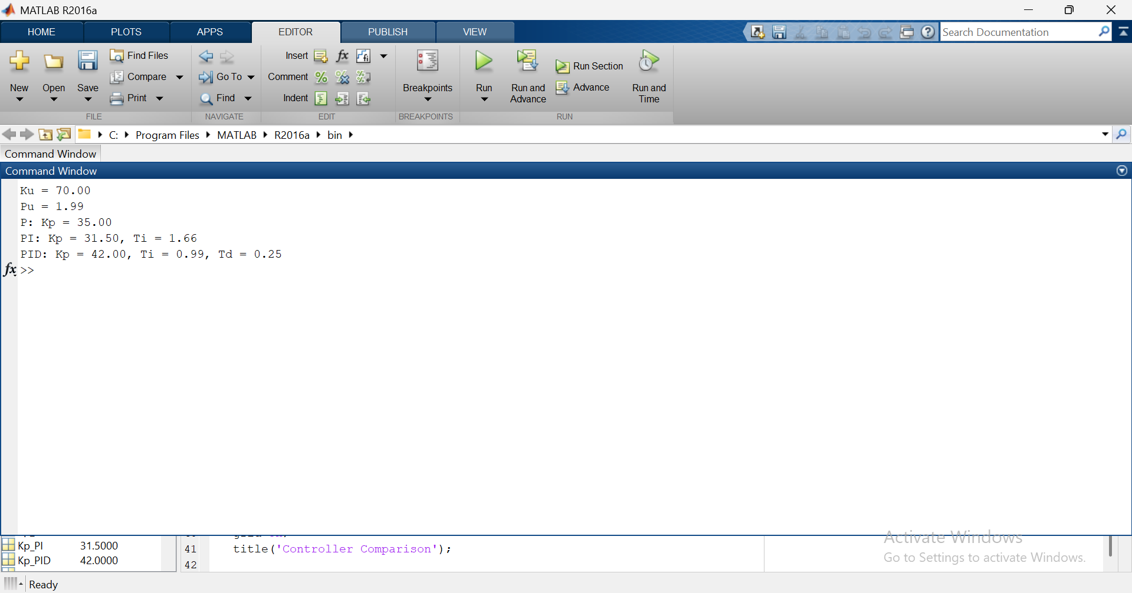

Comparison of Controllers P, PI, PID:

Simulink Model:

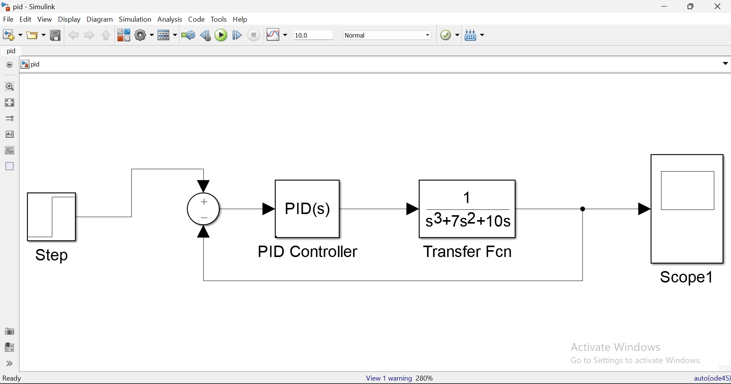

Observations & Analysis:

1. For P Controller:

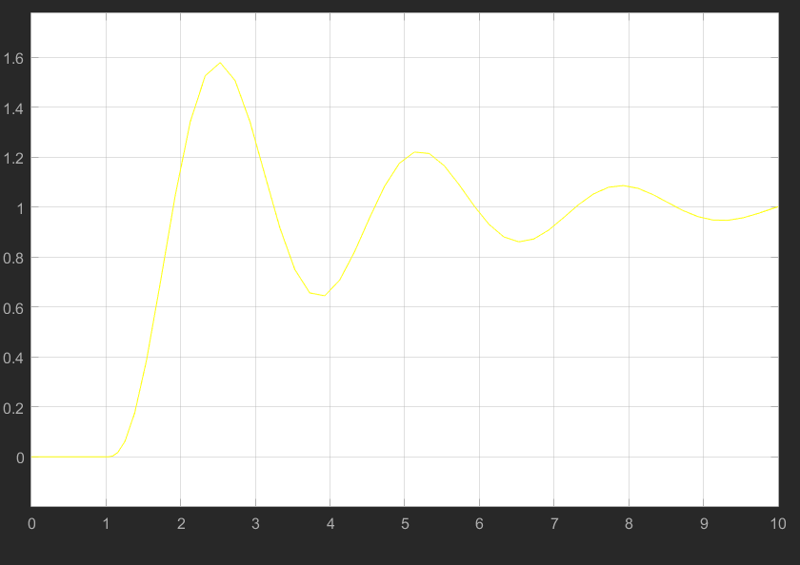
2. For PI Controller:

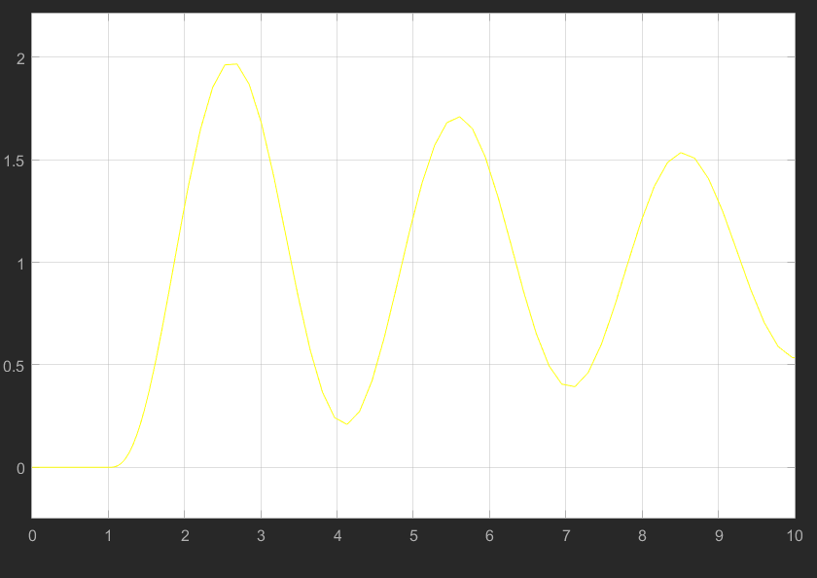

3. For PID Controller:

