6/26/2023

Kunal Ghosh

Pizza Sales Analysis using Microsoft excel and Microsoft SQL server

**PROBLEM STATEMENT**

* We want to find some insights for Pizza Sales Data for 2015. Creating an interactive Pizza Sales Dashboard to provide actionable insights and improve decision making for a Pizza Company. The company’s management recognizes the need to leverage data-driven strategies to optimise sales performance and enhance customer satisfaction, Goal is top develop a user friendly and visually appealing pizza sales dashboard. By leveraging data visualization techniques, the dashboard will enable stakeholders to track sales performance, identify popular pizza flavours and toppings, analyse customer preferences and identify opportunities for growth and improvement over the time for sales.
* My objective is to verify the accuracy and integrity of the pizza sales dashboard that I have made for the Pizza Company using SQL queries. It is crucial to ensure that the data is reliable and trustworthy to support informed decision making and analysis. However, there are concerns regarding potential data inconsistencies, errors, or discrepancies within the data base that may impact the validity of the sales data. I will import the pizza sales dataset in Microsoft SQL Server and verify if the values are correct or not so that the user should only get the correct insights.

**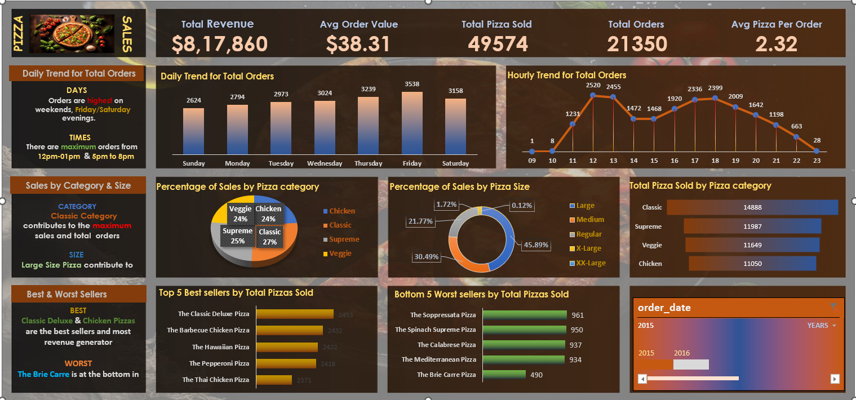  
  
  
PIZZA SALES DASHBOARD  
  
STEPS APPLIED:  
  
1. Problem Statement  
2. Data Cleaning  
3. Data Preprocessing  
4. Data Manipulation  
5. Data Analysis**

**KPI (Key Performance Indicator)**We needto analysekey indicators for our pizza sales data to gain insights into our business performance. Specially, we want to calculate the following metrices.1. Total Revenue: Sum of total price of all pizza orders

Query:  
Select SUM(total\_price) AS total\_revenue from pizza\_sales  
  
Output:  
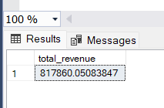

2. Average Order Value: The average amount spent per order, calculated by dividing the total revenue by the total number of orders.

Query:  
Select SUM(total\_price)/COUNT(Distinct order\_id) AS Avg\_Order\_Value from pizza\_sales

Output:  
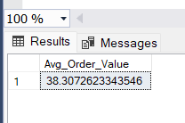

3. Total Pizzas Sold: The sum of all the quantities of all pizzas sold.

Query:  
Select SUM(quantity) AS Total\_Pizzas\_Sold from pizza\_sales

Output:  
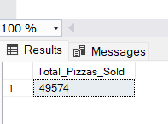  
4. Total Orders: The total number of orders placed.  
  
Query:  
Select COUNT(Distinct order\_id) AS Total\_Orders from pizza\_sales  
  
Output:  
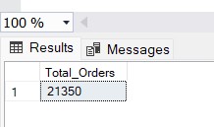  
  
5. Average Pizzas Per Order: The average number of pizzas sold per order, calculated by dividing the total number of pizzas sold by the total number of orders.  
  
Query:  
Select CAST(CAST(SUM(quantity) AS DECIMAL (10,2))/

CAST(COUNT(Distinct order\_id) AS DECIMAL (10,2)) AS DECIMAL (10,2)) AS Avg\_Pizzas\_Per\_Order from pizza\_sales  
  
Output:  
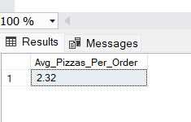  
  
**CHARTS REQUIREMENTS**We would like to visualize the various aspects of our pizza sales data to gain insights and understand key trends . We have identified the following requirements for creating charts.  
  
1. Daily Trend for Total Orders: Create a bar chart that displays the daily trend of total orders over a specific time period. This chart will help us identify any patterns or fluctuations in order volumes on a daily basis.

Query:  
--Daily Trend  
SELECT DATENAME(DW, order\_date) AS Order\_Day, COUNT(DISTINCT order\_id) AS Total\_Orders from pizza\_sales

GROUP BY DATENAME(DW, order\_date)  
  
DateName: It is an argument which is used to derive the date of the week.  
DW: It retrieves a day of the week, Character strings (i.e. Monday, Sunday etc)   
  
Insights: **Orders are highest on weekends, Friday/Saturday evenings**  
Output:  
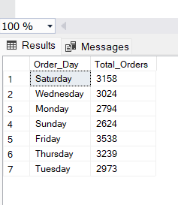  
  
2. Hourly Trend for Total Orders: Creating a line chart that illustrates the hourly trend of total orders through out the day. This chart will allow us to identify peak hours or periods of high order activity.  
  
Query:  
--Hourly Trend

SELECT DATEPART(HOUR, order\_time) AS Order\_Hours, COUNT(DISTINCT order\_id) AS Total\_Orders from pizza\_sales

GROUP BY DATEPART(HOUR, order\_time)   
ORDER BY DATEPART(HOUR, order\_time)  
  
Insights: **There are maximum orders from 12pm-01pm & 5pm to 8pm**

Output:  
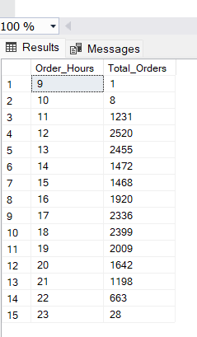  
  
3. Percentage of Sales by Pizza Category: Creating a pie chart that shows the distribution of sales across different pizza categories, This chart will provide insights into the popularity of various pizza categories and their contribution to overall sales.  
  
Query:  
Select pizza\_category, SUM(total\_price) AS total\_sales, SUM(total\_price)\*100 / (SELECT sum(total\_price) from pizza\_sales) AS PCT from pizza\_sales GROUP BY pizza\_category  
  
Insights: **Classic Category contributes to the maximum sales and total orders**  
  
Output:  
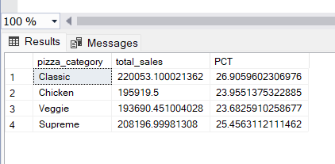  
  
4. Percentage of Sales by Pizza Size: Generate a pie chart that represents the percentage of sales attributed to different pizza sizes. This chart will help us understand customer preferences of pizza sizes and their impact on sales.

Query:  
Select pizza\_size, SUM(total\_price) AS total\_sales, SUM(total\_price)\*100 / (SELECT sum(total\_price) from pizza\_sales) AS PCT from pizza\_sales GROUP BY pizza\_size

ORDER BY PCT DESC  
  
Insights: **Large Size Pizza contribute to maximum sales**   
  
Output:  
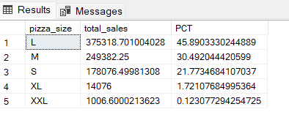  
  
5. Total Pizza Sold by Pizza category: Creating a funnel chart that presents the total number of pizzas sold for each pizza category. This chart will allow us to compare the sales performance of different pizza category.  
  
Query:  
Select pizza\_category , SUM(quantity) AS Total\_Pizza\_Sold from pizza\_sales GROUP BY pizza\_category  
  
Output:  
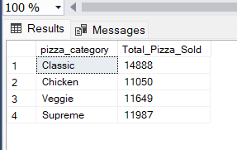  
  
6. Top 5 Best Sellers by Total Pizzas Sold: Creating a bar chart highlighting the top 5 best selling pizzas based on the total number of pizzas sold. This chart will help us identify the most popular pizzas option.

Query:  
Select TOP 5 pizza\_name, sum(quantity) as Total\_Pizzas\_Sold from pizza\_sales GROUP BY pizza\_name ORDER BY sum(quantity) DESC   
  
Insights: **Classic Deluxe & Chicken Pizzas are the best sellers and most revenue generator**

Output:  
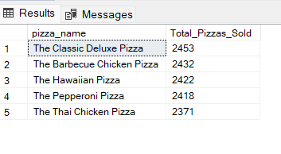  
  
7. Bottom 5 Worst Sellers by Total Pizzas Sold: Creating a bar chart showcasing the bottom 5 worst selling pizzas based on the total number of pizzas sold. This chart will enable us to identify underperforming or less popular pizza options.  
  
Query:  
Select TOP 5 pizza\_name, sum(quantity) as Total\_Pizzas\_Sold from pizza\_sales GROUP BY pizza\_name ORDER BY sum(quantity) ASC  
  
Insights: **The Brie Carre Pizza is at the bottom in both orders & revenue**  
  
Output:  
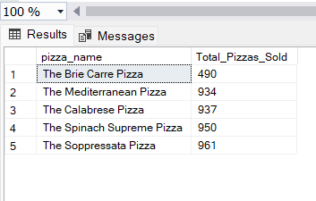

**THANK YOU FOR READING THIS**

Related Links  
Dashboard and Pivot Tables: <Excel.Pizza.xlsx>  
Dataset: <pizza_sales.csv>  
  
LinkedIn: <https://www.linkedin.com/in/kunal-ghosh-03294a219/>  
Portfolio: <https://www.datascienceportfol.io/Kunal>  
GitHub: <https://github.com/kunaal02>  
Email: <kunu.kunal02@gmail.com>

**FOLLOW FOR MORE CONTENTS**