



const myconst = 5;

console.log(myconst); // 5

myconst = 10;

console.log(myconst) //Uncaught TypeError: Assignment to constant variable.

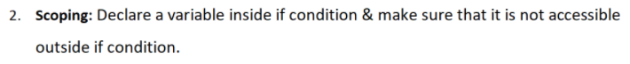

let a = 5;

if(a){

let b = 10;

console.log(b); // 10

}

console.log(a); // 5

console.log(b); // Uncaught ReferenceError: b is not defined

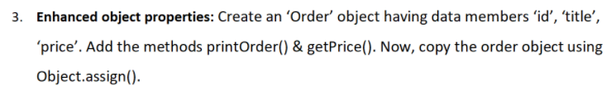

let order = {

id : 1234,

title:"pizza",

price : 300,

printOrder:()=>{

console.log(`id is ${order.id} name of item is ${order.title} and price is ${order.price}`)

},

getPrice:()=>{

console.log("price is "+order.price)

}

}

let neworder = Object.assign(order)

console.log(neworder.printOrder())

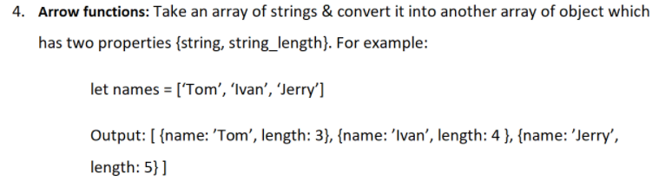

const string_convert = (arr)=>{

let myarr =[];

for (let i of arr){

a= {name:i,length:i.length};

myarr.push(a);

}

return myarr;

}

let result = string_convert(['Tom','Ivan','Jerry']);

console.log(result);

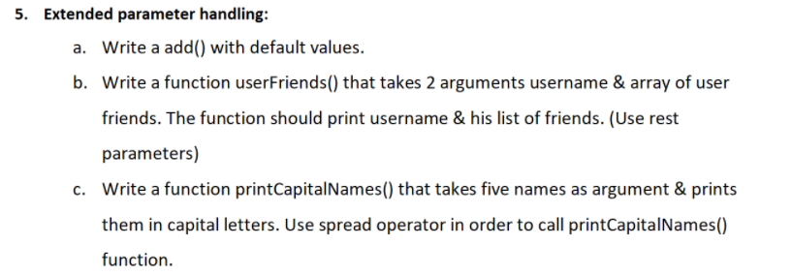

1. let add = function(a=5, b=10){

return a+b;

}

console.log("No Arrgument "+add());

console.log("One Arrgument "+add(2));

console.log("Two Arrgument "+add(1,2));

1. let userFriends=function(username, ...friends){

console.log("Username is : " + username);

console.log("List of Friends is : " );

for(let i of friends){

console.log(i);

}

}

userFriends("kunaalgupta","Kunal","Ram","Rahul")

1. const printCapitalNames = function(...names){

var myarr = [];

for (let i of names){

myarr.push(i.toUpperCase())

}

return myarr

}

let names = ['ram','rahul','ajay','vipul','deepanshu','bhavya']

var capital_names = printCapitalNames(...names);

console.log(capital_names)

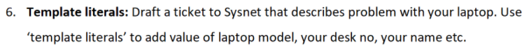

var laptop_model = "abc_123";

var desk_no = 22;

var name = "Kunal Gupta"

let draft = `To Sysnet

subject : Dispaly problem

Hi, i am Kunal Gupta, i purchase a laptop from your company

Its amonth ago i purchase Laptop from you. Now their is a problem in display

Please help with it.

Laptop Model : ${laptop_model}

desk Number : ${desk_no}

Name : ${name}`

console.log(draft);

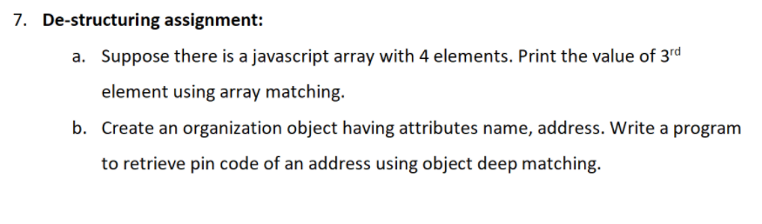

1. let myarr = ['abc','xyz','pqr','lmn'];

let [,,third_element,] = myarr;

console.log(third_element);

1. const org = {

name:"Kunal",

address:{

pincode:301001,

city:"Alwar",

state:"Rajasthan"

}

}

let {name:n,address:ad} = org;

console.log(ad.pincode);

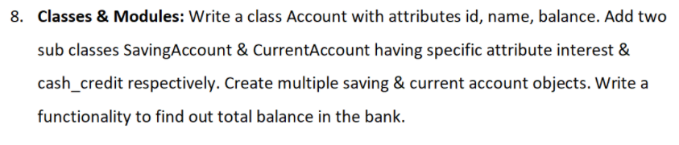

class Account{

constructor(id,name,balance)

{

this.id = id;

this.name = name;

this.balance = balance;

}

}

class Savings extends Account{

constructor(id,name,balance,interest)

{

super(id,name,balance);

this.interest = interest;

}

total_balance = () => {

this.balance += this.interest;

console.log(this.balance);

};

}

class Current extends Account{

constructor(id,name,balance,cashCredit)

{

super(id,name,balance);

this.cashCredit = cashCredit;

}

total_balance = () => {

this.balance += this.cashCredit;

console.log(this.balance);

};

}

let S_A = new Savings(123,"Kunal",3000,3);

let C_A = new Current(454, 'Ram', 300000,2500);

S_A.total_balance();

C_A.total_balance();