**JavaScript Assignment 1**

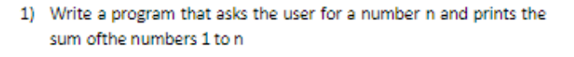

**function mySum(){**

**var userInput = prompt("Enter a number from sum ");**

**var myadd = 0;**

**for (i=1;i<=userInput;i++)**

**{**

**myadd +=i;**

**}**

**console.log("Sum of Number is : " + myadd);**

**document.getElementById("test").innerHTML= "Sum of Number is : " + myadd**

**}**



**function mySum(){**

**var userInput = prompt("Enter a number from sum ");**

**var myadd = 0;**

**for (i=1;i<=userInput;i++)**

**{**

**if (i%3==0 || i%5==0){**

**myadd +=i;**

**}**

**}**

**console.log("Sum of Number is : " + myadd);**

**document.getElementById("test").innerHTML= "Sum of Number is : " + myadd**

**}**

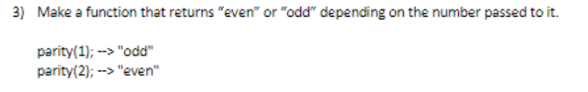

**function parity(){**

**var userInput = prompt("Enter a number for check even or odd ");**

**if (userInput % 2==0){**

**console.log(userInput + " Is a Even Number");**

**document.getElementById("test").innerHTML= userInput + " Is a Even Number"**

**}else{**

**console.log(userInput + " Is a Odd Number");**

**document.getElementById("test").innerHTML= userInput + " Is a Odd Number"**

**}**

**}**

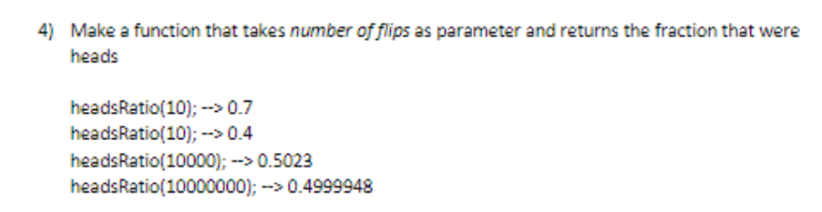

**function coinFlip(n) {**

**var head = 0;**

**for (i=0;i<n;i++)**

**{**

**x = Math.floor(Math.random() * 2 > 1) ? 'heads' : 'tails';**

**if (x=='heads'){**

**head++;**

**}**

**}**

**var frac = head/n;**

**console.log("HeadRatio is : " + frac);**

**document.getElementById('test').innerHTML="HeadRatio is : " + frac;**

**}**

**var userInput = prompt("Enter Number of Time a coin Flips")**

**coinFlip(userInput)**

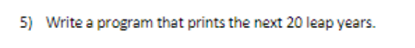

**function next_20_LeapYear(){**

**var leapYear = 2020;**

**for (i=1;i<=20;i++){**

**var leap_Year = leapYear + (i*4);**

**console.log(leap_Year);**

**document.getElementById("test").innerHTML=leap_Year;**

**}**

**}**

**next_20_LeapYear()**

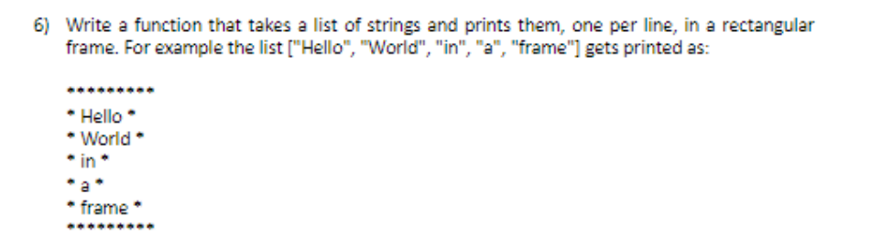

**function list_of_strings(String_list){**

**console.log("********")**

**for (i=0;i<String_list.length;i++){**

**console.log("*"+String_list[i]+"*")**

**}**

**console.log("********")**

**}**

**list_of_strings(["hello","world","in","a","frame"])**

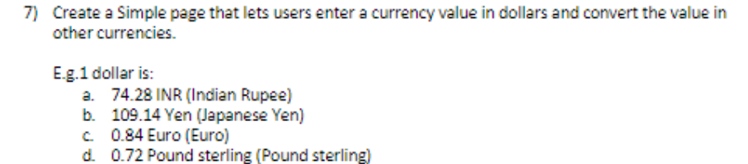

**function currancyConverter(n){**

**var indian_rupee = n*74.28;**

**var Japanese_yen = n*109.14;**

**var euro = n*0.84;**

**var pound_sterling = n*0.72;**

**var myMenu = document.getElementById("test");**

**myMenu.getElementsByTagName("p")[0].innerHTML=n + " Dollar in Indian Rupees is " + indian_rupee;**

**myMenu.getElementsByTagName("p")[1].innerHTML=n + " Dollar in Japanese_yen is " + Japanese_yen;**

**myMenu.getElementsByTagName("p")[2].innerHTML=n + " Dollar in euro is " + euro;**

**myMenu.getElementsByTagName("p")[3].innerHTML=n + " Dollar in pound_sterling is " + pound_sterling;**

**}**

**var dollar = prompt("Enter Dollar");**

**currancyConverter(dollar);**



**function arrayConcat(x,y){**

**var myArray = [];**

**for (i=0;i<x.length;i++)**

**{**

**myArray[i]=x[i];**

**}**

**for (j=0;j<y.length;j++)**

**{**

**myArray[x.length+j]=y[j];**

**}**

**console.log(myArray);**

**}**

**arrayConcat(['a','b','c'],[1,2,3])**

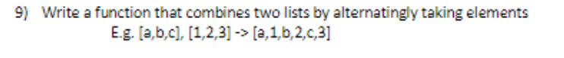

**function arrayConcat(x,y){**

**var myArray = [];**

**var len = x.length + y.length**

**var i=0;**

**var j=0;**

**for (k=0;k<len;k++)**

**{**

**if (k%2==0){**

**myArray[k]=x[i];**

**i++;**

**}else{**

**myArray[k]=y[j];**

**j++;**

**}**

**}**

**console.log(myArray);**

**}**

**arrayConcat(['a','b','c'],[1,2,3])**

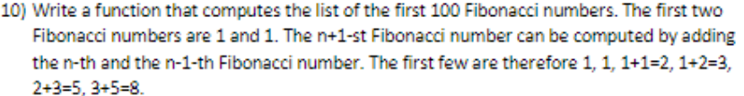

**function fibo(){**

**var a=0,b=1,sum_num ;**

**for(i=1;i<=100;i++)**

**{**

**console.log(a);**

**sum_num = a+b;**

**a=b;**

**b=sum_num;**

**}**

**}**

**fibo()**



**function reverse_array(myArray){**

**var len = myArray.length**

**for (i=0;i<len/2;i++){**

**a=myArray[i];**

**myArray[i]=myArray[len-i-1];**

**myArray[len-i-1]=a;**

**}**

**console.log(myArray)**

**}**

**reverse_array([12,5,67,23,23,4,3,56])**

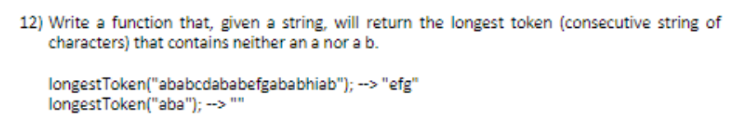

**function longestToken(string_input){**

**var max = 0, new_string = "",count=0,str = "";**

**for (i=0;i<string_input.length;i++){**

**if(string_input[i]!='a' && string_input[i]!='b')**

**{**

**new_string += string_input[i];**

**count++;**

**}**

**else{**

**if (max<count){**

**max=count;**

**count=0;**

**str=new_string;**

**new_string="";**

**}**

**}**

**}**

**console.log(str)**

**}**

**var string_input = prompt("Enter a string");**

**longestToken(string_input)**

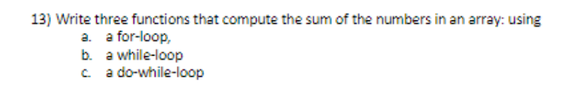

**function for_loop(myArray){**

**var myadd = 0;**

**for(i=0;i<myArray.length;i++){**

**myadd += myArray[i]**

**}**

**console.log("Using For Loop: " + myadd)**

**}**

**function while_loop(myArray){**

**var myadd = 0,i=0;**

**while(i<myArray.length){**

**myadd += myArray[i];**

**i++;**

**}**

**console.log("Using While Loop: " + myadd)**

**}**

**function do_while_loop(myArray){**

**var myadd = 0,i=0;**

**do{**

**myadd += myArray[i];**

**i++;**

**}while(i<myArray.length)**

**console.log("Using do While Loop: " + myadd)**

**}**

**var myArray = [2,5,8,2,5,6,10,23,45,22];**

**for_loop(myArray)**

**while_loop(myArray)**

**do_while_loop(myArray)**

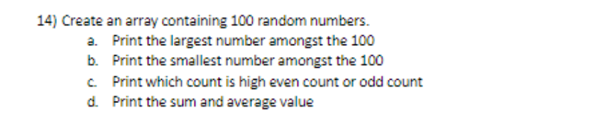

**function lagest_number(myArray){**

**sorting = myArray.sort();**

**console.log("Largest Number is: " + sorting[myArray.length-1]);**

**}**

**function smalest_number(myArray){**

**sorting = myArray.sort();**

**console.log("Smalest Number is: " + sorting[0]);**

**}**

**function highCount(myArray){**

**var evenArray = [];**

**var oddArray = [];**

**for (i=0;i<myArray.length;i++){**

**if (myArray[i]%2==0){**

**evenArray.push(myArray[i])**

**}else{**

**oddArray.push(myArray[i])**

**}**

**}**

**evencount = evenArray.length;**

**oddcount = oddArray.length;**

**if(evencount>oddcount){**

**console.log("Even number is high")**

**}else{**

**console.log("Odd Number is high")**

**}**

**}**

**function sum_average(myArray){**

**var sum=0,avg=0;**

**for(i=0;i<myArray.length;i++){**

**sum += myArray[i];**

**}**

**console.log("Sum is : " + sum);**

**console.log("Avg is : " + sum/myArray.length);**

**}**

**myArray = Array.from({length: 100}, () => Math.floor(Math.random() * 1000));**

**lagest_number(myArray)**

**smalest_number(myArray)**

**highCount(myArray)**

**sum_average(myArray)**

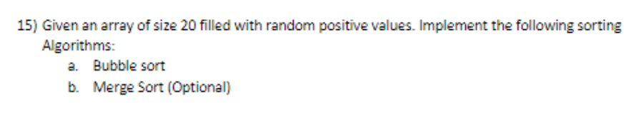

**function bubbleSort(myArray){**

**var temp=0;**

**for(i = 0; i < myArray.length; i++){**

**for(j = 0; j<( myArray.length - i -1 ); j++){**

**if(myArray[j] > myArray[j+1]){**

**temp = myArray[j]**

**myArray[j] = myArray[j + 1]**

**myArray[j+1] = temp**

**}**

**}**

**}**

**console.log(myArray);**

**}**

**var myArray = [34,45,12,99,36,2,10];**

**bubbleSort(myArray);**

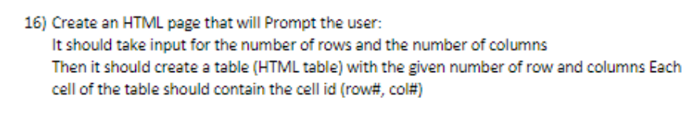

**function myTable(myRow,myCol){**

**var table = document.getElementById("mytable");**

**for (i=0;i<myRow;i++){**

**var row = table.insertRow(i);**

**for(j=0;j<myCol;j++){**

**var cell = row.insertCell(j);**

**cell.innerHTML = "Col "+(j+1);**

**}**

**}**

**}**

**var myRow =prompt("Enter number of rows");**

**var myCol =prompt("Enter number of columns");**

**myTable(myRow,myCol)**

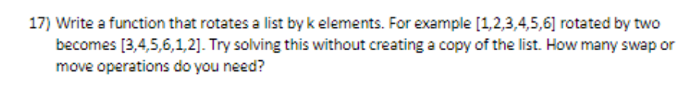

**function rotateElement(myArray,x){**

**for(i=0;i<x;i++)**

**{**

**var temp;**

**temp = myArray[0];**

**for (j=0;j<(myArray.length)-1;j++){**

**myArray[j]=myArray[j+1];**

**}**

**myArray[myArray.length-1]=temp;**

**}**

**document.write(myArray)**

**}**

**var myArray = [1,2,3,4,5,6,7];**

**rotateElement(myArray,2)**

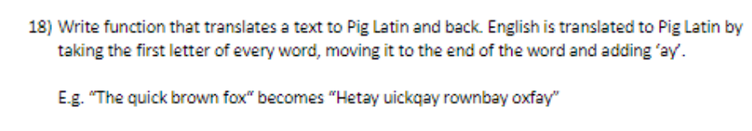

**function pigLatin(str){**

**var new_str = "",word=""**

**var myArray = str.split(" ");**

**for (i=0;i<myArray.length;i++){**

**var exeptfirst = myArray[i].slice(1,);**

**word = exeptfirst+myArray[i][0].toLocaleLowerCase()+"ay"**

**new_str = new_str+word+" ";**

**}**

**console.log(new_str)**

**}**

**pigLatin("The Quick brown fox")**

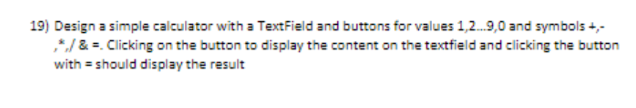

[**https://github.com/kunaalgupta06/Calculator_JS.git**](https://github.com/kunaalgupta06/Calculator_JS.git)