JavaScript Assignment 2

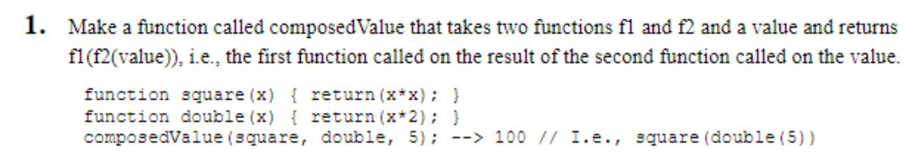

function composedValue(square,double,value){

var value_double = double(value);

var value_square = square(value_double);

return value_square;

}

function square(value){

return value * value;

}

function double(value){

return value * 2

}

var x = prompt("Enter a value");

var result = composedValue(square,double,x);

console.log(result)

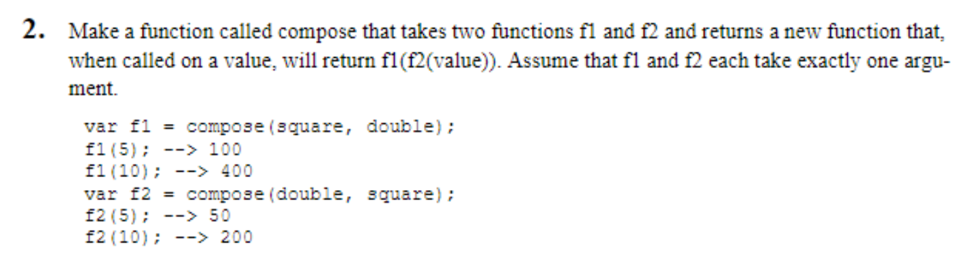

function composedValue(square,double,value){

var value_square = square(value);

var value_double = double(value_square);

return value_double;

}

function square(value){

return value * value;

}

function double(value){

return value * 2

}

var x = prompt("Enter a value");

var result = composedValue(square,double,x);

console.log(result)

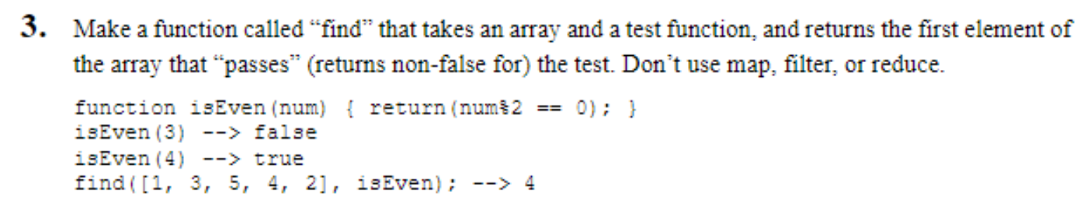

function find(arr,isEven){

for (i=0;i<arr.length;i++)

{

bool = isEven(arr[i])

if(bool){

console.log(arr[i])

break;

}

}

}

function isEven(value){

if (value % 2 == 0)

return true;

else

return false;

}

find([1,3,5,4,2],isEven)

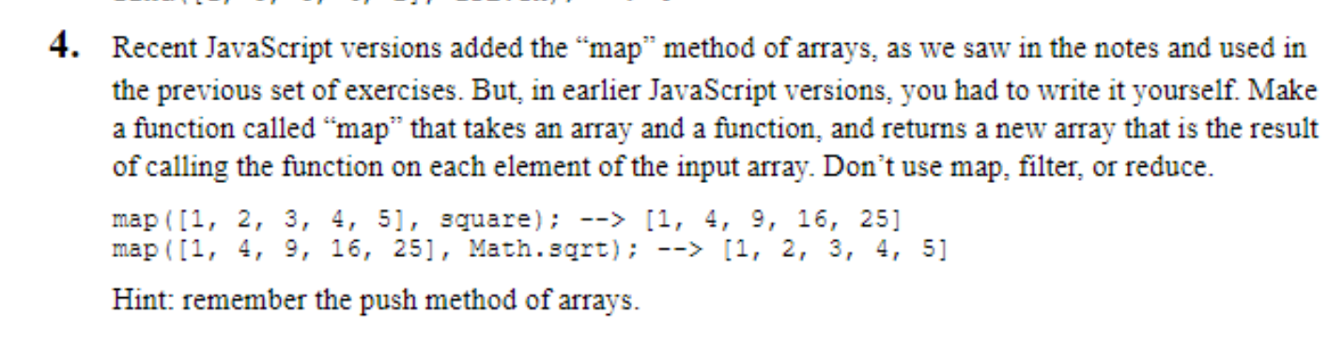

function map(arr,square){

myArr=[]

for(i=0;i<arr.length;i++)

{

number_square=square(arr[i])

myArr.push(number_square)

}

console.log(myArr)

}

function square(x){

return x*x;

}

map([1,2,3,4,5],square)

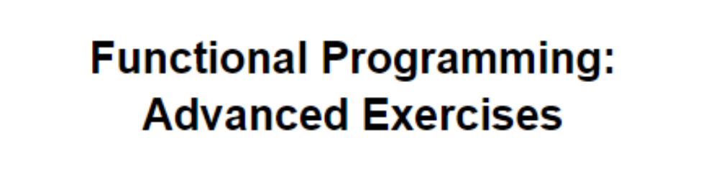

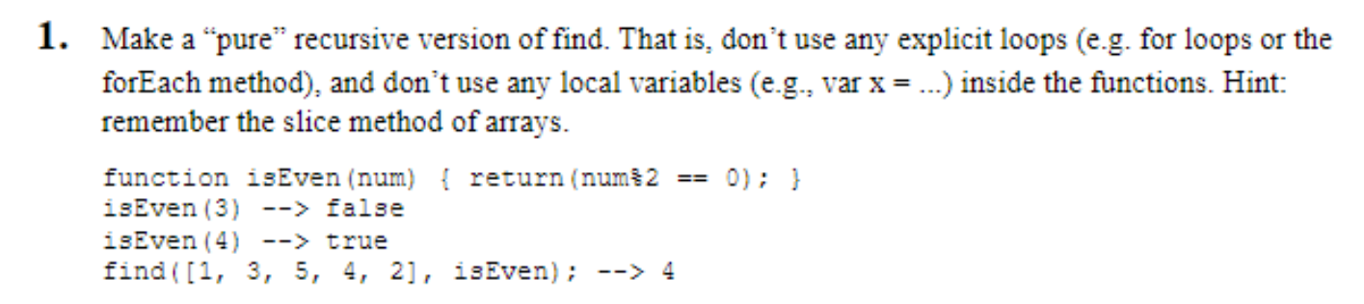

function find(arr,isEven){

x=isEven(arr[0])

if (x){

console.log(arr[0])

}

else{

find(arr.slice(1,),isEven)

}

}

function isEven(value){

if (value%2==0)

return true;

else return false;

}

find([1,3,6,5,4,2],isEven)

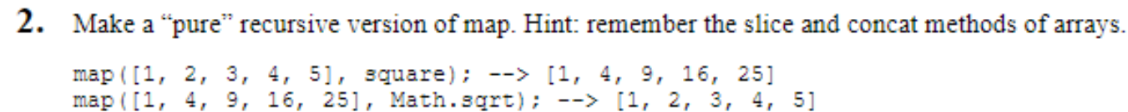

function maping(arr,square,myArr){

if (arr.length==0)

{

console.log(myArr)

return myArr;

}

var square_num = square(arr[0]);

myArr.push(square_num);

maping(arr.slice(1,),square,myArr);

}

function square(value){

return value * value;

}

var myArr=[];

maping([1,2,3,4,5],square,myArr);