**MongoDB_Assignment 2**

## create database

Connect to a running mongo instance, use a database named population and collection zipcode and import zip.json file

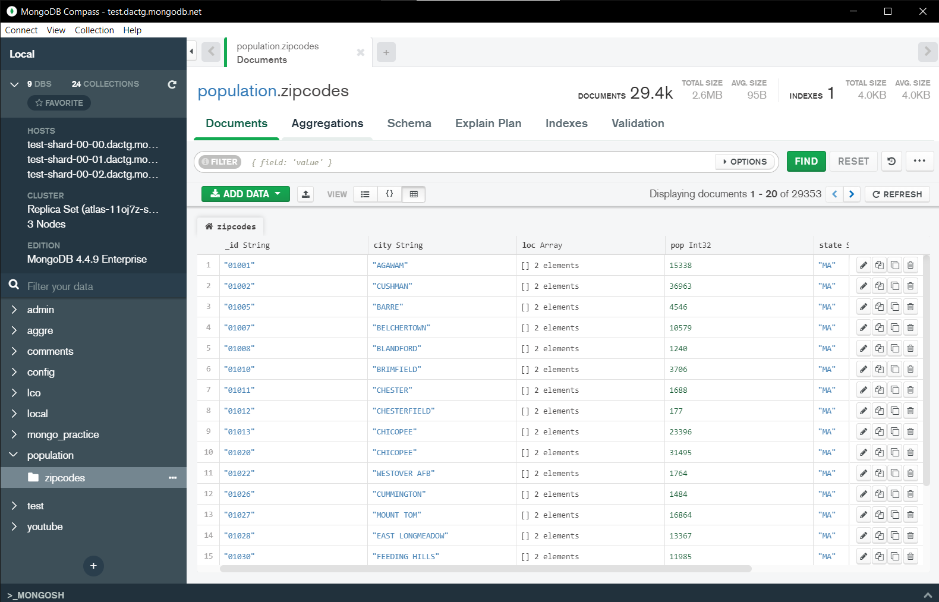.

**Atlanta Population**

1. Use db.zipcodes.find() to filter results where city is ATLANTA and state is GA.

* db.zipcodes.find({$and:[{city:"ATLANTA"},{state:"GA"}]})

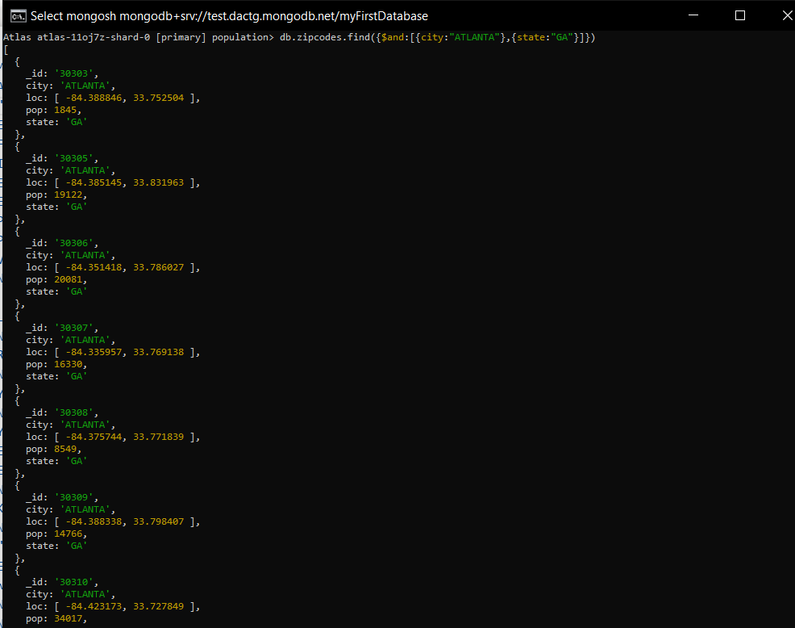

1. Use db.zipcodes.aggregate with $match to do the same as above.

* db.zipcodes.aggregate([ { $match: { $and: [{ city: 'ATLANTA' }, { state: "GA" }] } }])

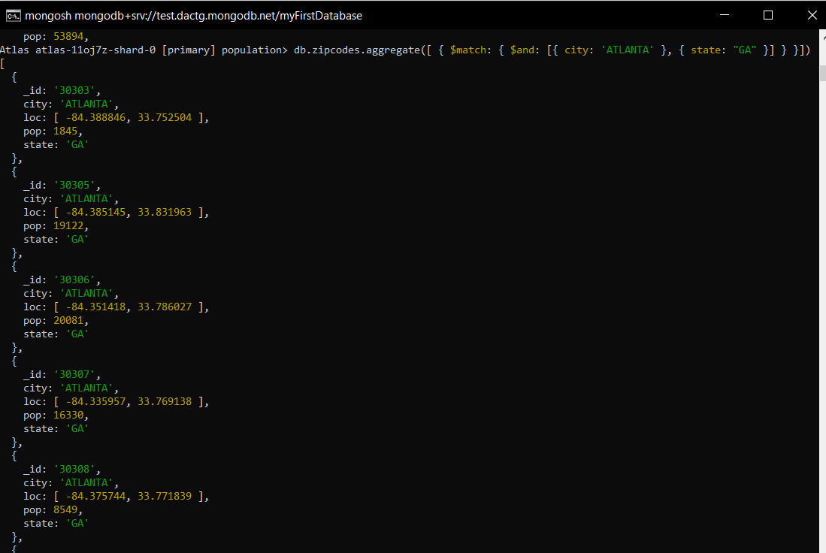

1. Use $group to count number of zipcodes in Atlanta.

* db.zipcodes.aggregate([{$match:{city:"ATLANTA"}},{$group:{_id:"$city",count:{$sum:1}}}])



1. Use $group to find total population in Atlanta.

* db.zipcodes.aggregate([{$match:{city:"ATLANTA"}},{$group:{_id:"$city",Total_Population:{$sum:"$pop"}}}])

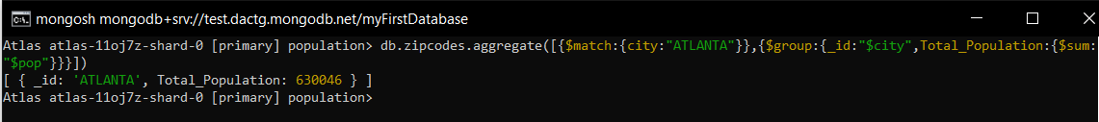

**Population by state**

1. Use aggregate to calculate total population of each state.

* db.zipcodes.aggregate([{$group:{_id:"$state",Total_population:{$sum:"$pop"}}}])

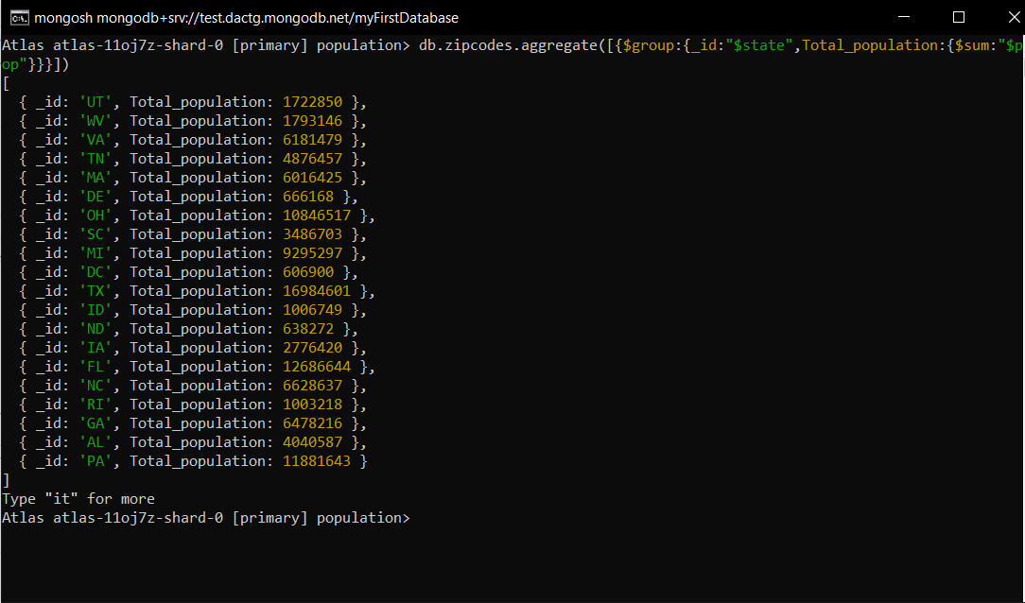

1. sort the result by population, highest first.

* db.zipcodes.aggregate([{$group:{_id:"$state",Total_population:{$sum:"$pop"}}}]).sort({Total_population:-1})

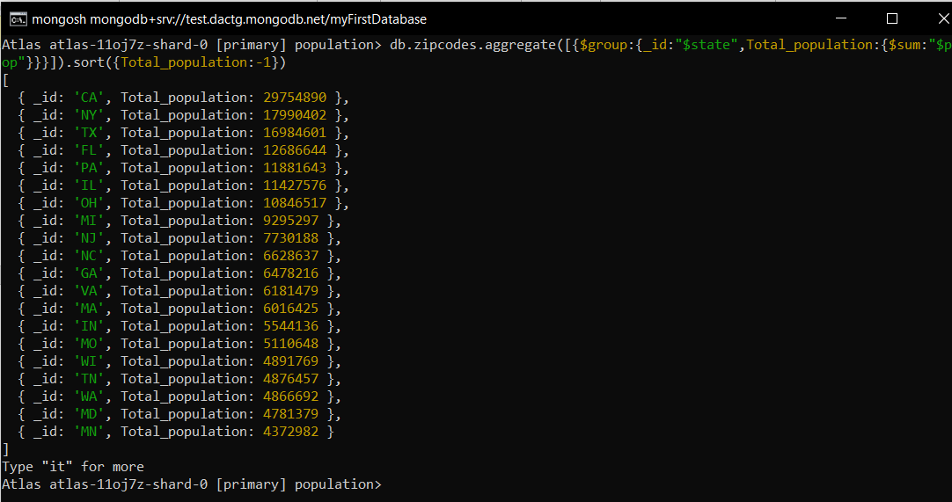

1. limits the results to just the first 3 results What are the top three state in population.

* db.zipcodes.aggregate([{$group:{_id:"$state",Total_population:{$sum:"$pop"}}},{$sort:{Total_population:-1}},{$limit:3}])

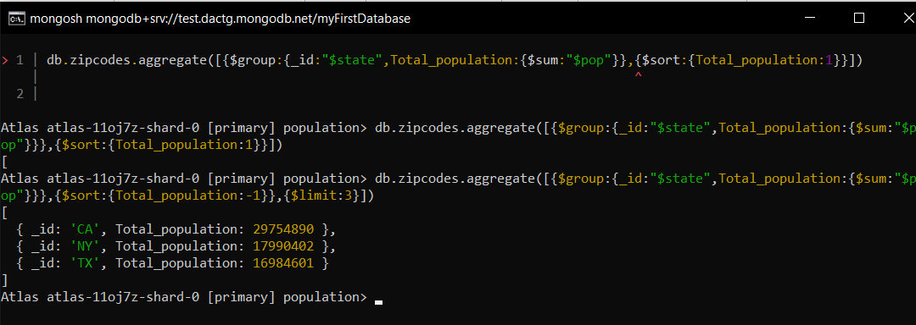

**Population by city**

1. Use aggregate to calculate total population of each state.

* db.zipcodes.aggregate([{$group:{_id:{city:"$city",state:"$state"},Total_population:{$sum:"$pop"}}}])

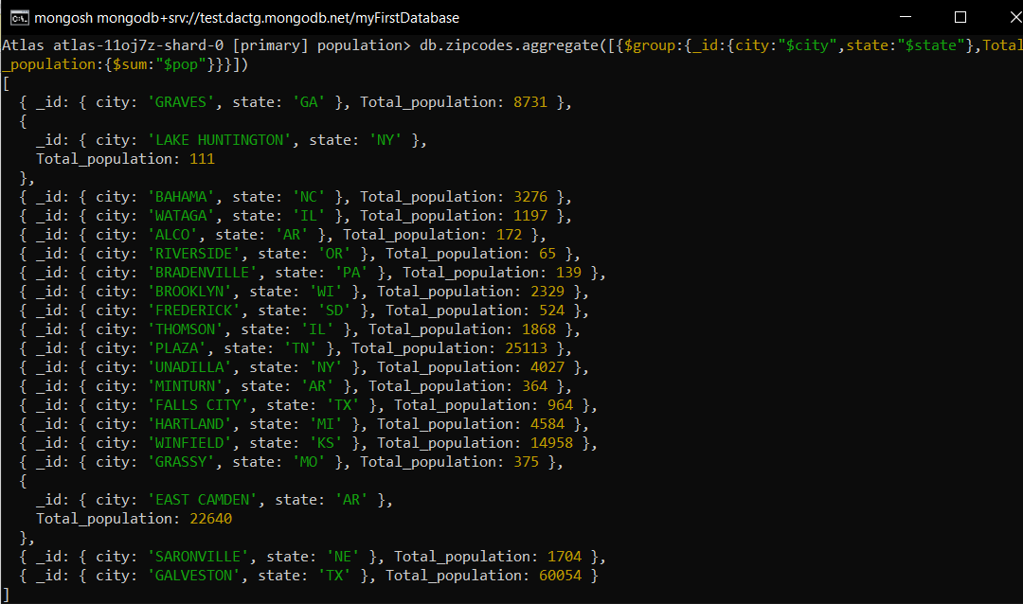

1. sort the result by population, highest first.

* db.zipcodes.aggregate([{$group:{_id:{city:"$city",state:"$state"},Total_population:{$sum:"$pop"}}},{$sort:{Total_population:-1}}])

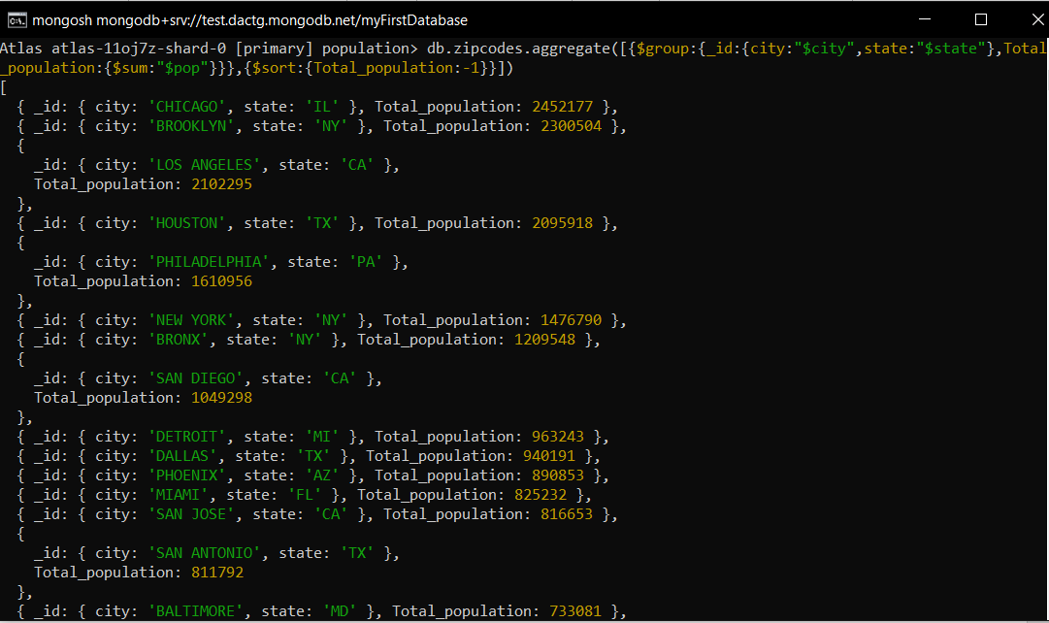

1. limits the results to just the first 3 results What are the top three cities in population.

* db.zipcodes.aggregate([{$group:{_id:{city:"$city",state:"$state"},Total_population:{$sum:"$pop"}}},{$sort:{Total_population:-1}},{$limit:3}])

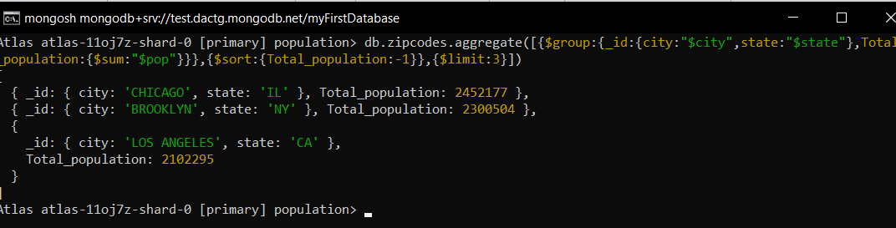

1. What are the top 3 cities in population in Texas.

* db.zipcodes.aggregate([{$match:{state:"TX"}},{$group:{_id:{city:"$city",state:"$state"},Total_population:{$sum:"$pop"}}},{$sort:{Total_population:-1}},{$limit:3}])

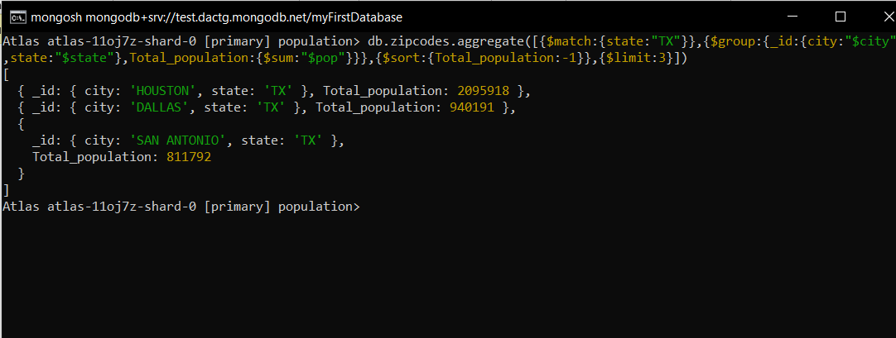

**Bonus**

1. write a query to get average city population for each state.

* db.zipcodes.aggregate([{$group:{_id:{state:"$state",city:"$city"},Avg_population:{$avg:"$pop"}}}])

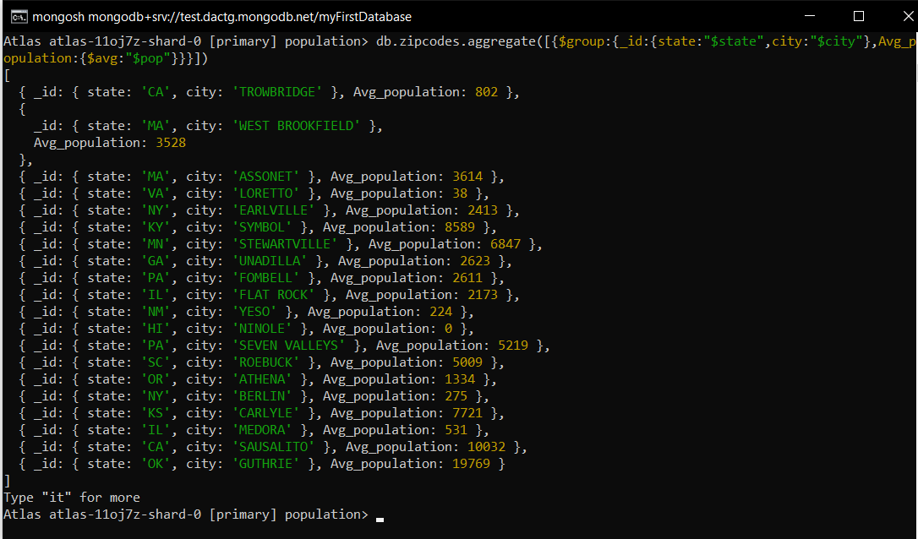

1. what are the top 3 state in terms of average city population.

* db.zipcodes.aggregate([{$group:{_id:{state:"$state",city:"$city"},Avg_population:{$avg:"$pop"}}},{$sort:{Avg_population:-1}},{$limit:3}])

