Typescript Assignments 3



var x;

var y;

var promise_1 = new Promise(function(resolve,reject)

{

if(true)

resolve(x=parseInt(prompt("Enter first value")));

else

reject(0);

});

var promise_2 = new Promise(function(resolve,reject)

{

if(true)

resolve(y =parseInt(prompt("Enter second value")));

else

reject(0);

});

Promise.all([promise_1, promise_2]).then(values =>{console.log(x + y);})

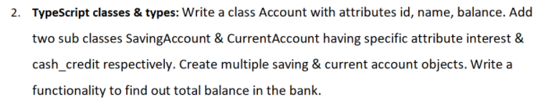

class Account{

constructor(id,name,balance)

{

this.id = id;

this.name = name;

this.balance = balance;

}

}

class Savings extends Account{

constructor(id,name,balance,interest)

{

super(id,name,balance);

this.interest = interest;

}

total_balance = () => {

this.balance += this.interest;

console.log(this.balance);

};

}

class Current extends Account{

constructor(id,name,balance,cashCredit)

{

super(id,name,balance);

this.cashCredit = cashCredit;

}

total_balance = () => {

this.balance += this.cashCredit;

console.log(this.balance);

};

}

let S_A = new Savings(123,"Kunal",3000,3);

let C_A = new Current(454, 'Ram', 300000,2500);

S_A.total_balance();

C_A.total_balance();

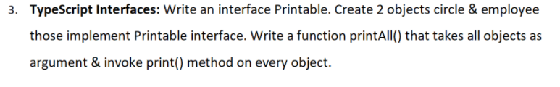

interface Printable{

radius?:Number;

fname?:string;

lname?:String;

};

let circle :Printable ={

radius : 5

};

let emp :Printable = {

fname: "Kunal",

lname:"Gupta"

};

function printAll(circle, emp){

console.log(circle.radius);

console.log(emp.fname,emp.lname);

}

printAll(circle,employee);