Submitted By:

KUNAL NAGPAL 12BCE0398

KARAN BABARIYA 12BCE0444

Online sudoku championship

Software Requirements Specification

In partial fulfilment of the requirements of

CSE326 Software engineering project

March 2015

Faculty Guide: Prof. Lydia Jane

Slot: B1 + TB1

**Table of** **Contents**

1 Introduction ............................................................................................................................................................... 2

1.1 Aim ............................................................................................................................................................... 2

1.2 Objective ............................................................................................................................................................... 2

1.3 Technology Used ............................................................................................................................................................….2

1.4 Tools Used ............................................................................................................................................................... 2

2 Overall Description ............................................................................................................................................................... 3

2.1 Product Perspective ............................................................................................................................................................... 3

2.2 Modules

……………………………….............................................................................................................................. 3

2.3 Process Model Identification: ............................................................................................................................................................... 4

2.4 Work Breakdown Structure ............................................................................................................................................................... 5

2.5 Scheduling ............................................................................................................................................................... 6

2.5.1 Pert Chart ............................................................................................................................................................... 6

2.5.2 Gantt Chart ............................................................................................................................................................... 6

2.5.3 Timeline Chart ............................................................................................................................................................... 7

2.6 Stakeholders

............................................................................................................................................................... 7

3 Specific Requirements

............................................................................................................................................................... 8

3.1 Use Case Diagram ............................................................................................................................................................... 8

3.2 Functional Requirements ............................................................................................................................................................... 9

3.3 Non-Functional Requirements

............................................................................................................................................................... 9

**1 Introduction**

* 1. **Aim:**

To develop and build an online platform that allows users to engage in competitive Sudoku gameplay.

* 1. **Objective:**

To allow users, both newcomers and veterans alike to experience the joy of Sudoku gameplay via a variety of gameplay modes. This is achieved via either a predefined collection of pre-generated Sudoku grids (as is the case with the non-practice game modes), or instantaneously generated grids.

* 1. **Technologies used:**

HTML5

CSS3

JavaScript

Node.Js

Git

MongoDB

* 1. **Tools used:**

JetBrains Webstorm

Git Plugin for Windows

Node package manager

1. **Overall description** 
   1. **Product perspective:**

Sudoku is a number placement game that is played on a nine by nine grid of cells, which are further arranged into 9 smaller boxes of three by three cells each, as shown in the figure:

|  |  |  |  |  |  |  |  |  |
| --- | --- | --- | --- | --- | --- | --- | --- | --- |
|  |  |  |  |  |  |  |  |  |
|  |  |  |  |  |  |  |  |  |
|  |  |  |  |  |  |  |  |  |
|  |  |  |  |  |  |  |  |  |
|  |  |  |  |  |  |  |  |  |
|  |  |  |  |  |  |  |  |  |
|  |  |  |  |  |  |  |  |  |
|  |  |  |  |  |  |  |  |  |
|  |  |  |  |  |  |  |  |  |

Referring the figure, it is possible to see that at the commencement of the game, the grid may have a few (but not all) of its 81 cells filled with numbers from one to nine. The objective of the game is to fill the remaining blank cells with numbers from one to nine such that there is exactly one instance of each number in each row, column, and three by three box.

Also, it is of considerable importance to note that each Sudoku grid has exactly one solution. Although guesswork will eventually result in the player reaching a solution, there is always a logical route to the placement of each number within the respective cells.

**2.2 Modules:**

**1.** **Guest user:**

Allows simple gameplay access, no statistical or archival functions, and no slots on the leader board.

**2.** **Registered user(s) management:**

Updating gameplay and other usage statistics after each match, security and protection management, calibrating leader board slots, allowing competitive gameplay.

**3. Social user(s) management:**

Same as 2, but with the added possibility of enhanced social interaction depending on the social platform of choice (One of Facebook, Twitter, GitHub, Google, and Linkedin).

**4. Online competitive gameplay:**

Allowing users to engage in real-time / semi real-time online competitive gameplay.

**5. Security:**

Blocking CSRF attempts, allowing non-social registered users to manage their account credentials on a periodic basis.

**2.3 Process model identification:**

**Waterfall Model**

The cascading from one phase to another, this model is known as the ‘waterfall model’ or software life cycle. The waterfall model is an example of a plan-driven process—in principle, you must plan and schedule all of the process activities before starting work on them.



Justification

* Considering the specification of each model we can conclude that the current project scenario falls under waterfall model as all the software specification are known as the final system is the static one which will not differ on any change of data.
* It is best suited for our scenario because if there are no uncertain requirement the overall project is small and essay phase will have specific deliverables.
* The final product is going to be stable and there are no ambiguous requirements.
* Ample resources with required expertise are available freely and our main focus is on performance measures and delivery rate.

**2.4 Work Breakdown Structure:**

Online Sudoku Championship

Rules Manipulation

Add/Delete users

Leader board Generation

Result Display

Score Calculator

Submission

Solve grid

Multiplayer feature

Enter the website

Authentication

Enter Login Credentials

Edit Details

Register the User

Registration

Gameplay

Guest Users

Full features access

Check validity

Limited access

Fill Reg. Form

Guest Players

Website Registration

Registered Users

Admin

**2.5 Scheduling**

**2.5.1 Pert Chart**

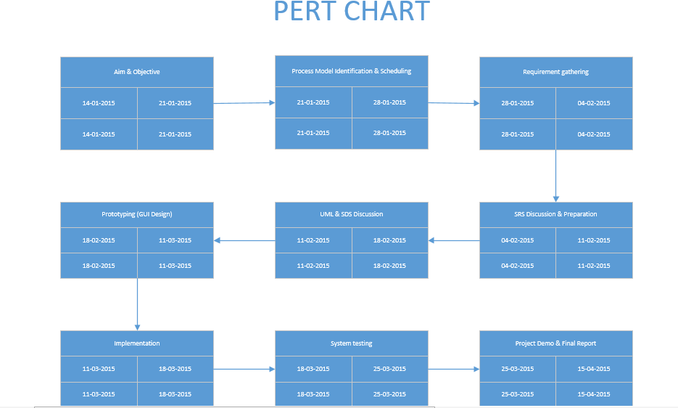

**2.5.2 Gantt Chart**

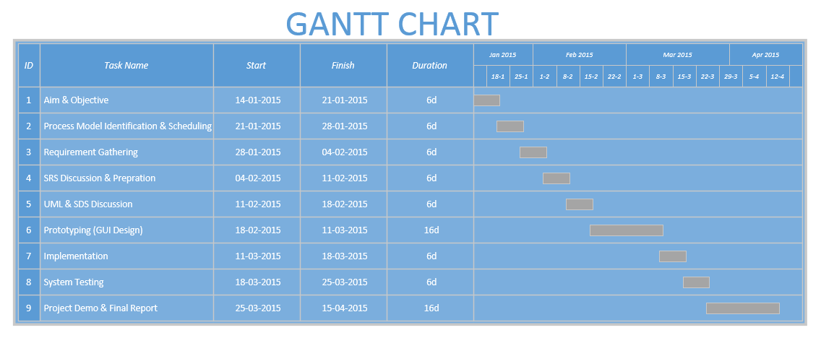

**2.5.3 Timeline Chart**

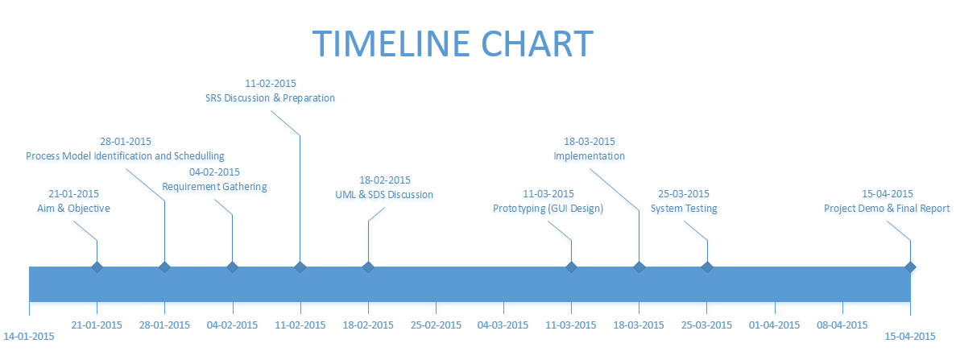

**2.6 Stakeholders**

**Admin (CIO):**

* Proper authentication at the time of registration.
* To add/delete users.
* To modify rules and regulations as per necessity.

**Guest Users:**

* Login as a guest user.
* Have access to only few features.
* Can play with full functionality upon registration.

**Registered Users (Website Registration):**

* Registration done directly on website.
* Proper credentials are to be provided.
* Can have full access to the game.
* Can check their leader board ranking.

**Registered Users (Social Networking Site Registration):**

* Registration done via social networking sites like Facebook, Twitter, Github, Linked In.
* Can have full access to all the functionalities.
* Can also check their leader board ranking.

**3 Specific Requirements**

**3.1 Use Case Diagram**



Guest Player Registered User



Virtual Server (Server) Social Networking Site User

**3.2 Functional Requirements:**  
  
 1) Professional look and feel, appropriate UI / UX integration.  
 2) User registration and guest play facility.  
 3) Random grid generator function, with pre-instated storage within the database.  
 4) In game hints, with player in-game surrender options.  
 5) Online competitive play, with the possibility of multiple game modes beside the pre-existing classic ones.  
 6) Leaderboard and statistical generation facility for individual users.  
 7) Advanced user record management system: Rudimentary CRUD operations, as well as security management.  
 8) Practice mode for beginner level players, challenge mode for experts who are familiar with the game.  
  
**3.3 Non-functional Requirements:**

1) Performance: The application performance metrics and indices should be independent of network characteristics,  
 within the limits of technical scope and possibility.  
 2) Scalability: The application should not fall into the spiral of throttling operations in the event of several  
 multiple users attempting access.  
 3) Usability: The application should not only serve those who are familiar with it's underlying concept, but also  
 attract more users toward it's universe of function.  
 4) Security: Lastly, user security should be given paramount importance, via the implementation of several checks  
 and such in order to thwart unauthorized access.