

Pineapple

UI Performance testing Document

**Tools** **2**

**Main Factors affecting performance** **2**

HTTP Requests 2

External style sheets 3

Avoiding redirects 3

HTTP 404 4

**Responsiveness** **4**

# 

# Tools

The tool used for benching marking was UI s Yslow provided by Yahoo. The tool is installed in the web browsers in the form of an extension making it easier to run tests on the respective pages of the application. It provides scores and reasons for its particular score results .

# 

# Main Factors affecting performance

#### HTTP Requests

Lower http requests result in pages loading faster on the client's computer. All the web pages of the application have been simplified to an extent so that loading times are short as possible.

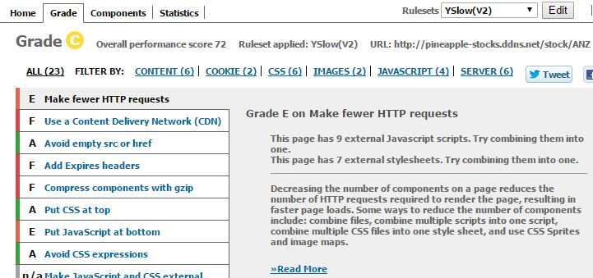

Score-E

Since the application requires certain scripts on its respective pages. This results in more isolated scripts.The score was heavily impacted by the use of inline css which is necessary as by the requirements.

#### External style sheets

The use of external style sheets allows the browser the cache

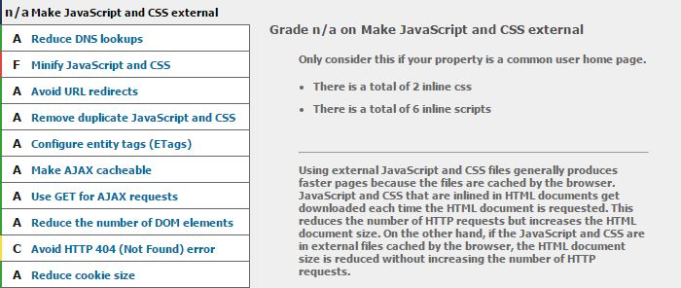

Score-N/A

The application was built using the front-end framework bootstrap. Inline css was used to style particular pages. Each page had its own set of elements, thus making inline css suitable.

#### 

#### Avoiding redirects

No external redirects are present in the application.Since no external redirects are present this reduces loading times.This also keeps the user interested and within the application. Use of http status codes 301 and 302 were excluded in building the application

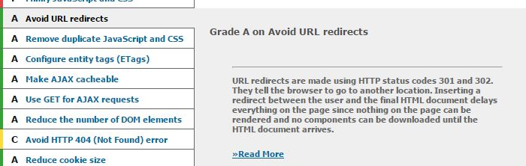

Score-A

#### The application scored an ideal A in the test clearly stating that

#### 

#### HTTP 404

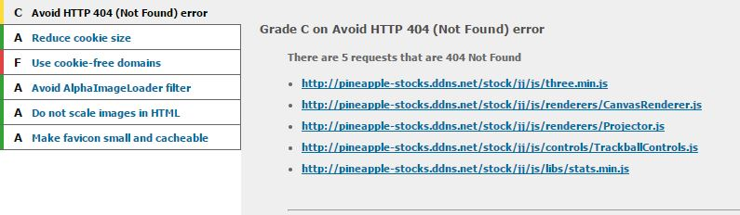

Score-C

The three js requests caused the score to drop down to c. The three js framework is used to provide an interactive background for the homepage.s

# Responsiveness

The website is responsive. The pages scale well. The website can be opened with a mobile, charts,graphs scale with changes in width and height. Since the application was built using bootstrap. Bootstrap makes the application design more intuitive mobile ready..