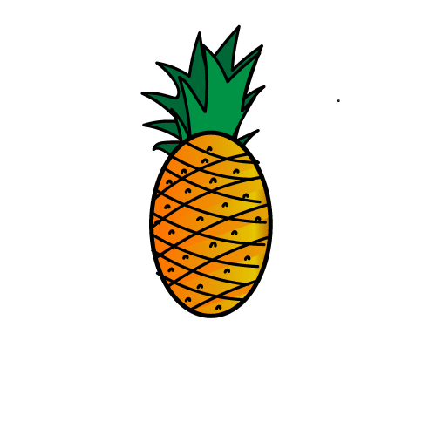

Pineapple

Style Guide

Table of Content

1. Preference
2. Colour
   1. primary colours
      1. Green
      2. Dark Blue
3. Images
4. Elements
   1. Button
   2. Form
      1. Form-input email
      2. Form-input password
      3. Form-input search
      4. Form option
      5. Form select
5. Fonts
   1. subheading
   2. heading
6. Table
   1. table
   2. Thead
7. Layouts
   1. container
   2. panel
   3. text-right
8. Footer
9. Navigation bar
   1. Navbar
   2. badge
10. Banner
11. Modal
12. Preface:

We included bootstrap style guide for responsive mobile toggling, fluid grid system to allow our template to scale properly in different devices. Our template uses predefined classes from bootstrap for easy layouts.

1. Colours:
   1. **Primary colour:**
      1. **Green**

* **class .bg**

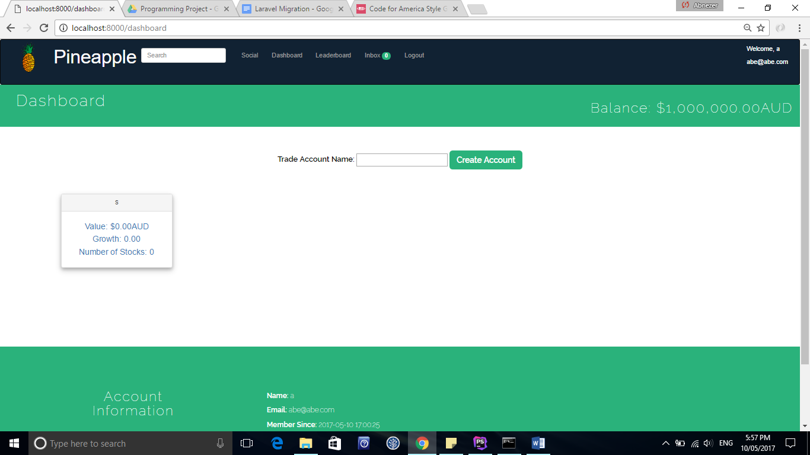

Background-colour: #2ab27b

We selected the colour green to match our logo design and symbolise money. The colour is not distracting on the user. Font that are place on top of this background are coloured white so the font is visible and readable.

* + 1. **Dark Blue**

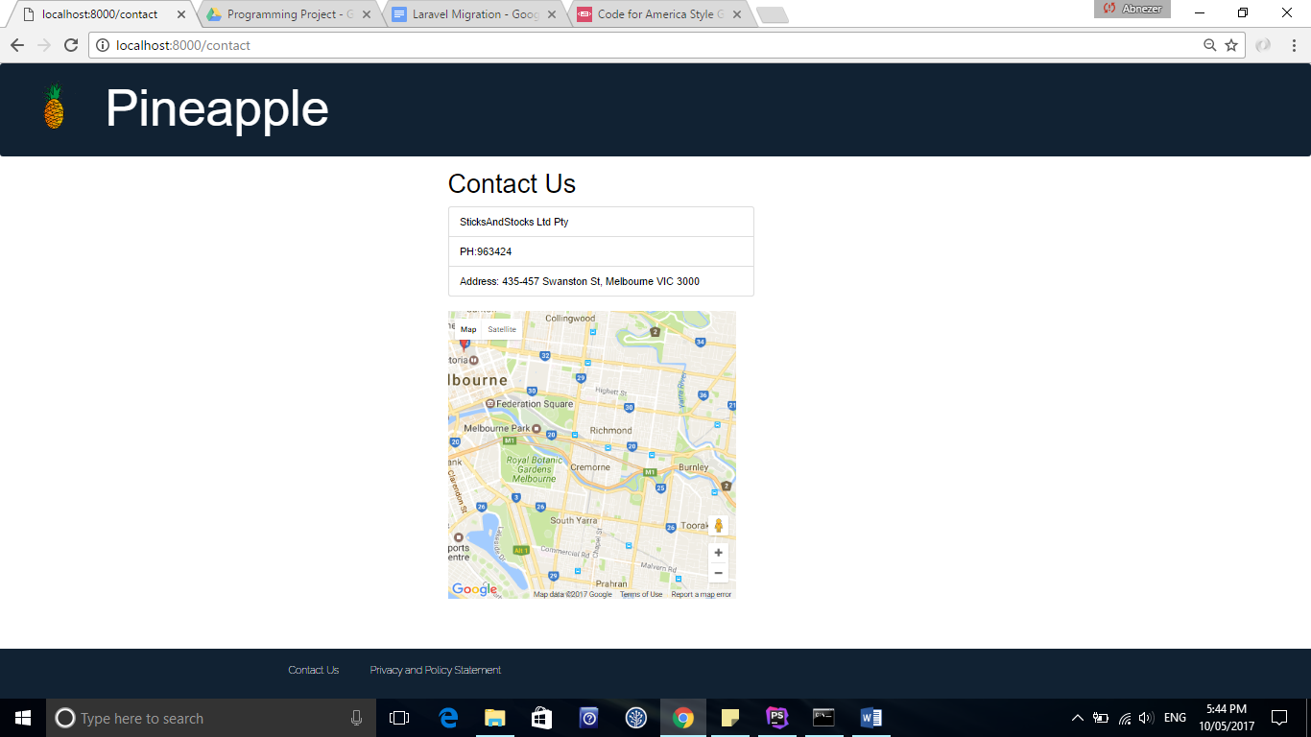

Background-colour: #123

The Dark Blue is used so that white coloured font can stand out. This colour is used for navigation bar and footer. This helps to insure that any font or links added on navigation and footer is visible and easy to read.

1. Images
   1. **Logo**:

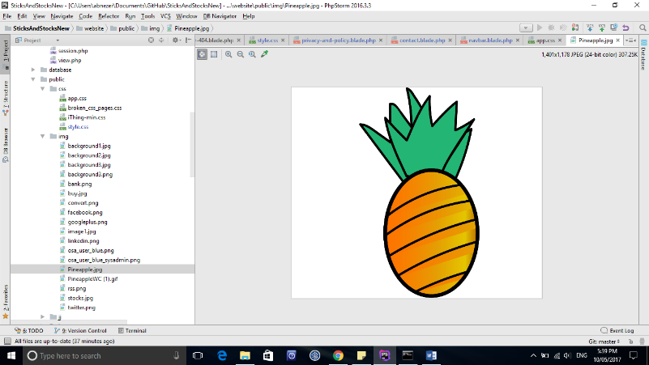

Height: 100px

Width: 100px

We used pineapple as a logo for our website. The pineapple colour green is used for the leafs and used in the website represent money that is used in share market stock game

1. Elements
   1. Button

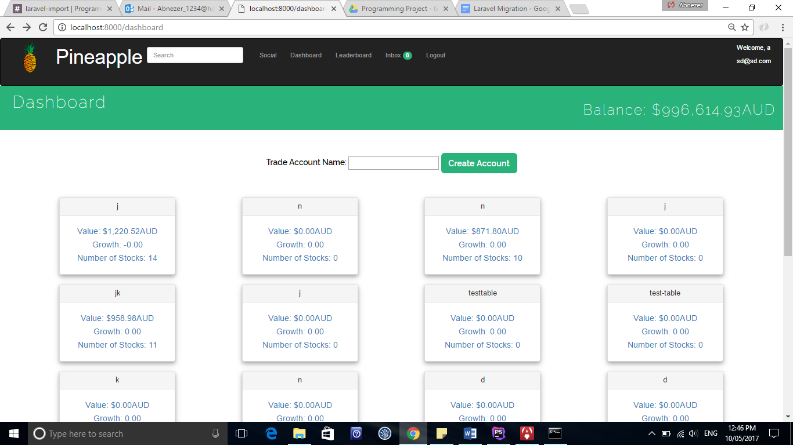

.Btn-xs Btn-sm btn-lg

All buttons that are visible on the website are coloured the green except sell button which is coloured orange. The font on the button is coloured white

Class button:

Background colour: #2ab27b

Font-colour: white

Text-align: centre

Cursor: pointer

Border-radius: 7px

# Form

* + 1. Form-input email

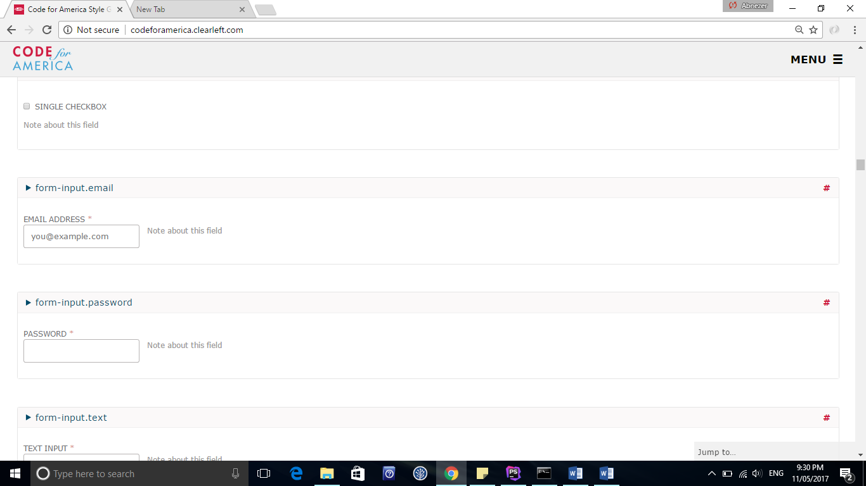

* + 1. Form-input password



* + 1. Form-input search

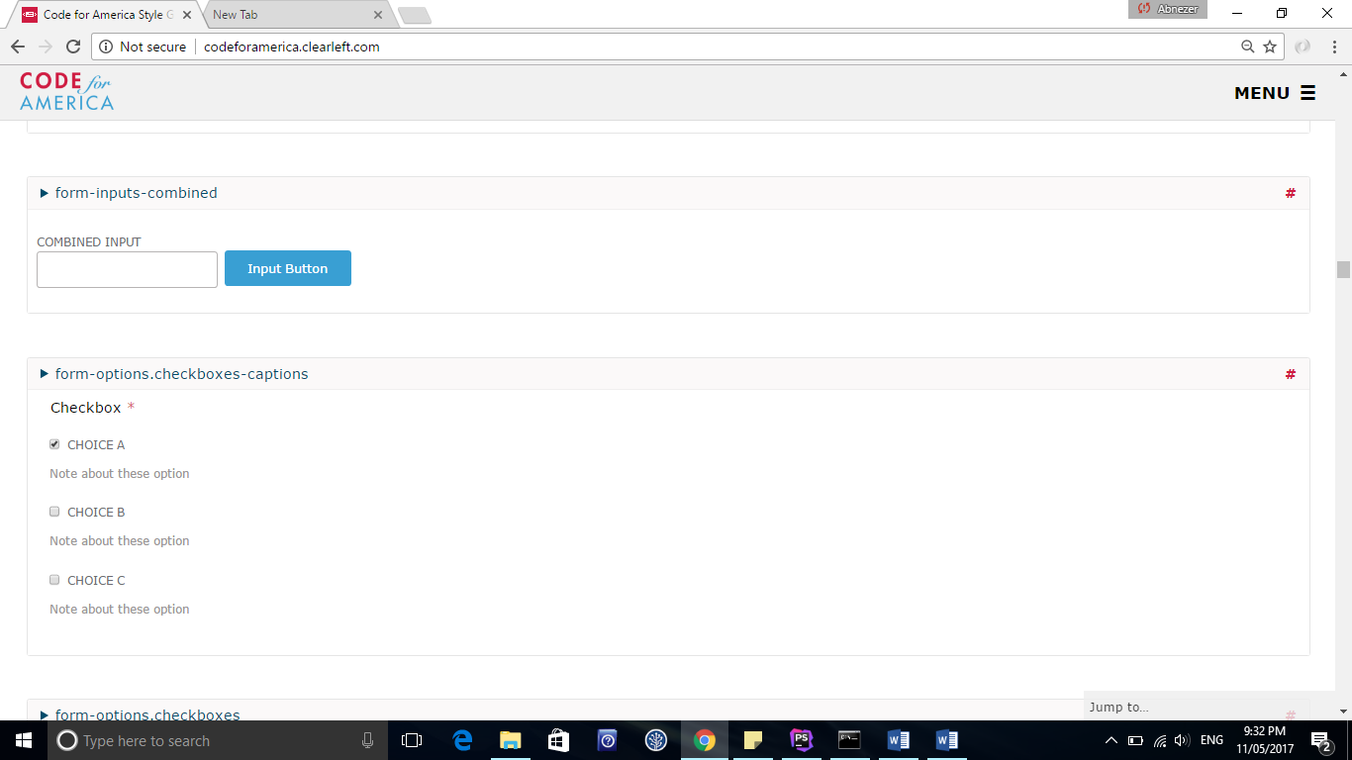

* + 1. Form option

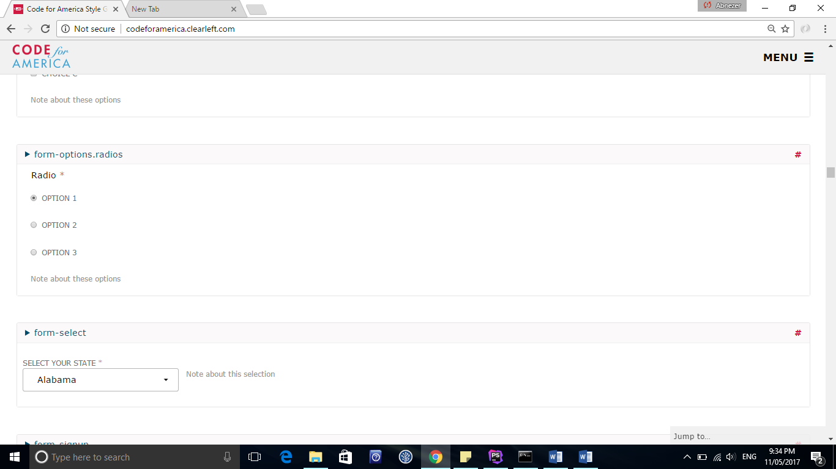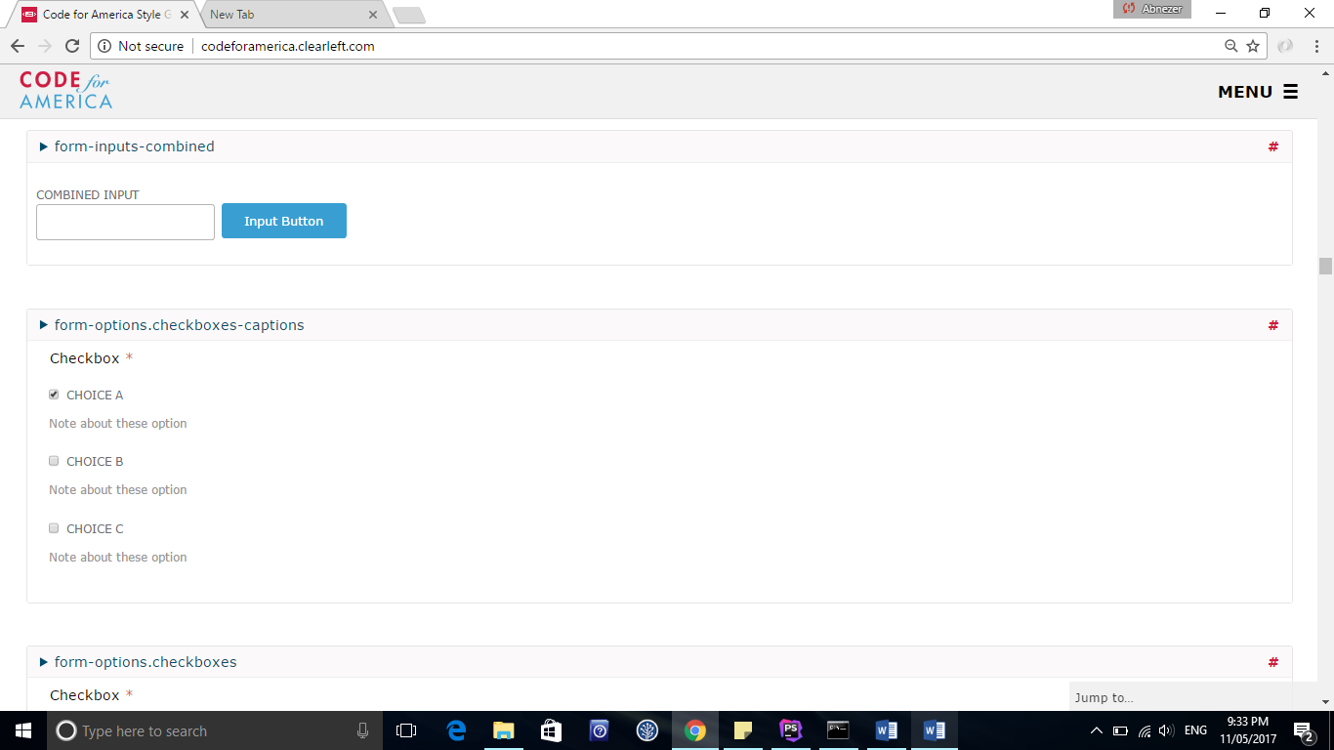

* + 1. Form select



1. Fonts:

Font-family: **"Helvetica Neue"**, **Helvetica**, **Arial**, **sans-serif**;

* 1. **.subheading**

Class subheading is used to style fonts and include hover feature so that the font stands out.

# Heading:

# H1: Pineapple

H1 are mainly used in heading and placed on top for each page to show the user the heading for each paragraph

## H2: Pineapple

H2 are used as subheading that are placed under heading to address content author or used to display dates.

<P> the tag p stands for paragraph which uses default styling

1. Table
   1. **.table**

Table class is used to style the table content

* 1. **.Thead**

This class sets the table headers with background colour to distingush table header from the rest of the columns

1. Layout

7.1 Container

Content-box class sets the content in the middle of the page with 10% padding on the right sides and 10% padding on the left side of the page.

Col-sm-1 col-sm-2

Col-md-2 col-sm-1 col-xs-offset-1

This grid layout is used to align the panel box so that the panel box is evenly spread out and centred on the page.

* 1. .**panel**

Panel class styles the font and aligns the text centred. The panels are placed evenly across the dashboard page

* 1. **.text-right**

Text-right class is used to stick text on the right hand side.

# Footer:

# .**footer**

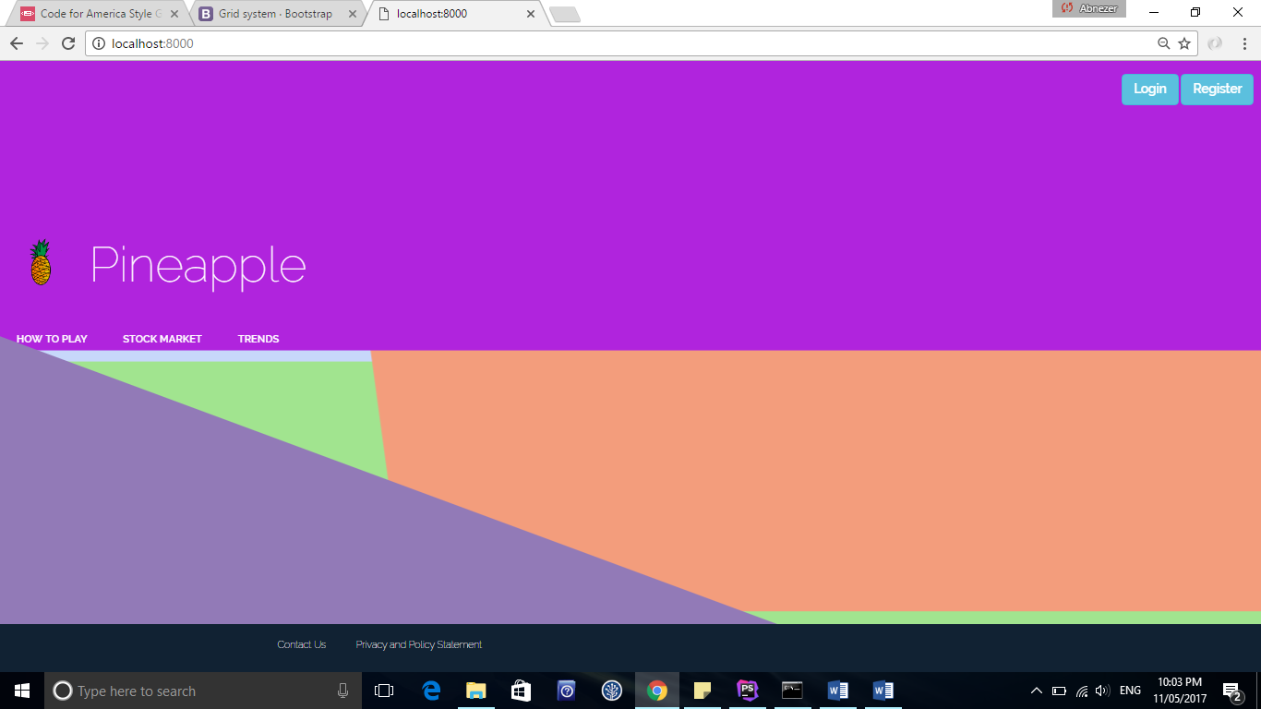

Footer class is used to style the font white

1. Navigation bar
   1. **.**navbar

The navbar class is used to style the fonts and the background .navbar-inverse highlights the text when user hovers the font and also changed the colour to black

# Badge:

The badge is used to show customers notification of messages the colour green to stand out and is visible for the user to see.

1. Banner

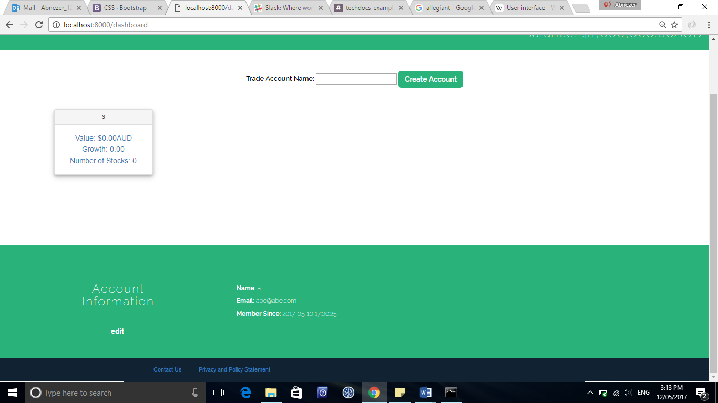

**.edit-info**

The class edit-info is used to style the font and sets the background colour green. The edit button is hidden but the font is visible when you user clicks the edit button and is able to edit his name and email.

1. Modal

11.1. **Buy/sell modal**

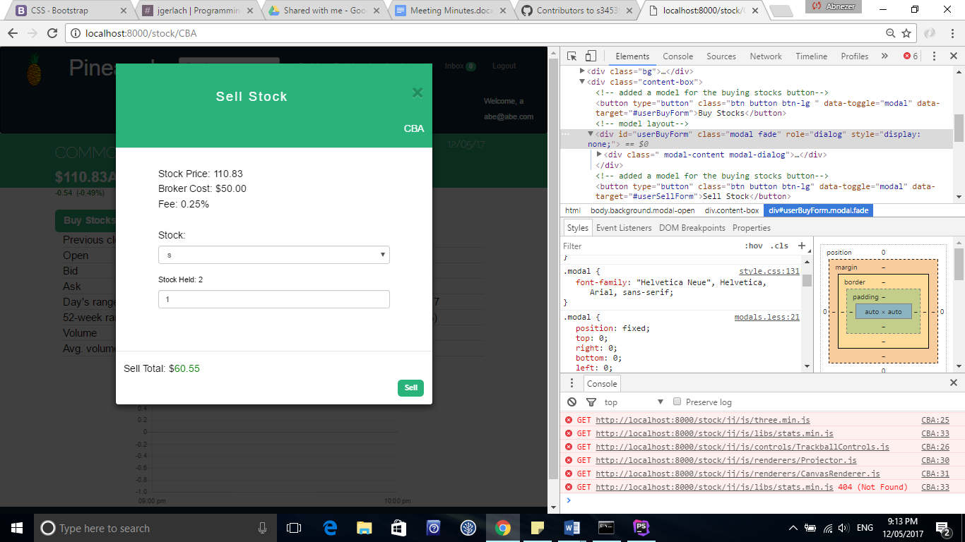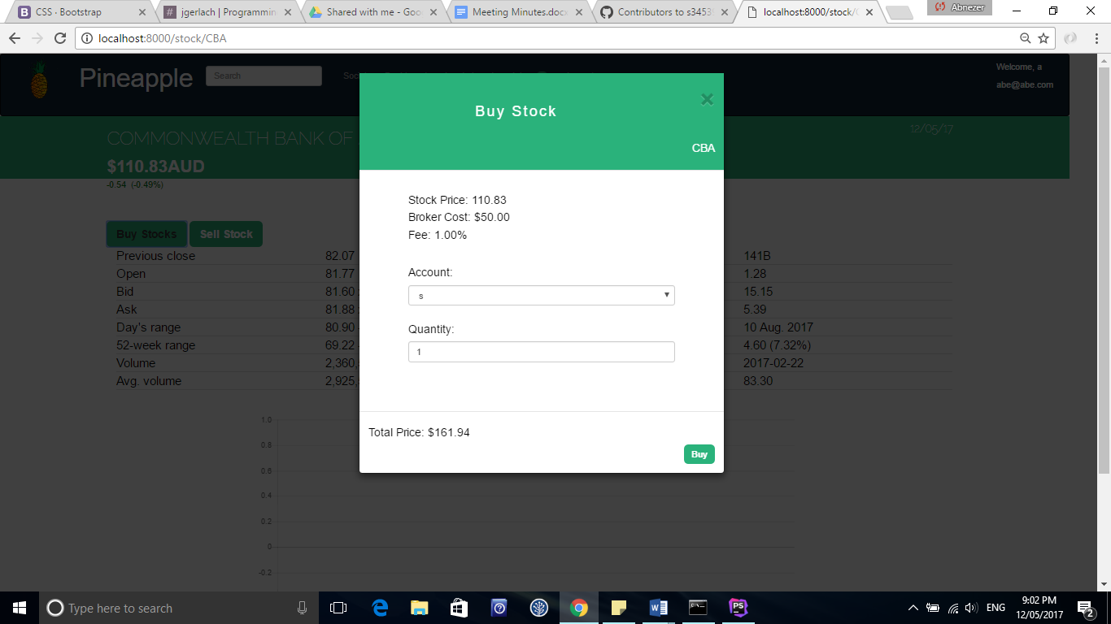

**12.2. .modal**

This modal class styles all the modal bodies with font and size and subheading class modifies the style of modal header.