AMITY UNIVERSITY GURUGRAM
Amity School of Engineering and Technology
Department of Artificial Intelligence
PROJECT-BASED LEARNING ASSIGNMENT
Fundamentals of Machine Learning (MLE2503)
Product Demand and Inventory Intelligence
Segmentation of the BigBasket Product Catalogue using Unsupervised Machine Learning
Problem Statement 1
Submitted by
Kunal
B.Tech (Artificial Intelligence and Machine Learning), Semester 5
Academic Session July–December 2026
October 2026

Contents
Abstract
1. Introduction
2. Literature and Methodological Background
3. Problem Statement and Objectives
4. Dataset Description
5. Methodology
6. Data Pre-processing
7. Exploratory Data Analysis
8. Model Development
9. Results and Evaluation
10. Business Interpretation and Recommendations
11. Limitations and Future Work
12. Conclusion
References
Appendix: Submission Contents and Reproducibility

Abstract
Retail organisations often plan inventory and promotions at the level of the product category, even though products within one category can behave very differently in price, discounting and customer response. This project investigates whether naturally occurring product groups can be discovered from catalogue data, and how those groups could guide stocking and promotional decisions.
The study uses the BigBasket product catalogue, which contains 27,555 listings from an Indian online grocery retailer. After removing 355 duplicate or unidentifiable records, 27,200 products were retained. Five behavioural features were engineered and standardised: price level, discount percentage, brand breadth, customer rating and an indicator of missing ratings. K-Means clustering, hierarchical clustering with Ward linkage and Gaussian mixture models were compared using the silhouette score, the Davies–Bouldin index and the Calinski–Harabasz index, and principal component analysis was used for visualisation.
K-Means with five clusters gave the best overall result (silhouette 0.286, Davies–Bouldin 1.27) and proved highly stable under resampling (Adjusted Rand Index of 0.98 or higher). The five segments are core everyday value products, promotion-driven products, premium full-price products with little review activity, low-rated products and large-brand discounted products with little review activity. Differentiated inventory and promotion strategies are proposed for each. Because the catalogue contains no sales, stock or return figures, demand is represented by proxies, and the recommendations should be validated against transaction data before implementation.
Keywords: product segmentation, K-Means, hierarchical clustering, PCA, retail analytics, inventory planning, silhouette score.

1. Introduction
Online grocery and general retail businesses manage tens of thousands of stock-keeping units. Each unit has its own price, rate of sale, level of promotion and customer reception. When planning decisions follow the product category alone, the same replenishment and promotion rules are applied to items that behave differently. The consequence is familiar: fast-moving items run out of stock while slow-moving items remain on the shelf, tie up capital and, for perishable goods, lose value.
Machine learning offers an alternative. Clustering algorithms can group products by their measured behaviour without a predefined label, and the resulting groups can be interpreted and managed as planning units. This report describes an end-to-end project that carries out such a segmentation on a real product catalogue, from problem formulation and data preparation through modelling and evaluation to business recommendations.

2. Literature and Methodological Background
This project relies on a small set of well-established methods, summarised below with their original sources.
- K-Means clustering. K-Means partitions observations into K groups by minimising the within-cluster sum of squared distances to the cluster centres (MacQueen, 1967). Its result depends on the initial centres, which the k-means++ seeding procedure improves by spreading the starting points (Arthur and Vassilvitskii, 2007). Because the method is based on Euclidean distance, features must be on comparable scales.
- Hierarchical clustering. Agglomerative clustering builds a tree of nested groups by repeatedly merging the closest pair. Ward's criterion merges the pair that causes the smallest increase in within-cluster variance (Ward, 1963). The tree is displayed as a dendrogram, and a cut at a chosen height yields a set of clusters.
- Gaussian mixture models. A mixture model describes the data as a combination of Gaussian distributions and assigns each point a probability of membership. It is a model-based alternative to K-Means and was included for comparison.
- Internal validation indices. The silhouette coefficient compares each point's distance to its own cluster with its distance to the nearest other cluster, and ranges from −1 to 1 (Rousseeuw, 1987). The Davies–Bouldin index averages the ratio of within-cluster scatter to between-cluster separation, so lower values indicate better clustering (Davies and Bouldin, 1979). The Calinski–Harabasz index is the ratio of between-cluster to within-cluster dispersion, where higher is better (Caliński and Harabasz, 1974).
- Elbow method. Within-cluster inertia is plotted against K, and the point where further clusters yield diminishing improvement is taken as a suitable K. The criterion is heuristic and is normally supported by other indices.
- Principal component analysis. PCA rotates the data onto orthogonal axes ordered by explained variance and is widely used for visualisation and dimensionality reduction (Jolliffe and Cadima, 2016).
- Comparing clusterings. The Adjusted Rand Index measures the agreement between two partitions, corrected for chance, and equals 1 for identical partitions (Hubert and Arabie, 1985). It is used here to compare solutions and to assess stability.
All computations were carried out with the scikit-learn library (Pedregosa et al., 2011).

3. Problem Statement and Objectives
A large retailer manages thousands of products whose sales frequency, price, inventory movement, discounts and returns differ markedly. Inventory decisions are currently category-based, which can cause stock-outs of fast-moving products and excess stock of slow-moving ones. Management requires a machine learning system that discovers groups of products with similar commercial behaviour and uses these groups for inventory and promotional planning.
The objectives of the project are:
- to identify naturally occurring product groups;
- to characterise fast-moving, slow-moving, premium, high-demand and promotion-driven products;
- to evaluate the quality of the discovered clusters with internal validation measures; and
- to support inventory and promotional decisions with segment-specific strategies.

4. Dataset Description
The BigBasket Products dataset, obtained from Kaggle, contains 27,555 product listings with ten attributes. Table 1 summarises the attributes.
Table 1. Attributes of the BigBasket dataset
Attribute | Type | Description
index | Integer | Row identifier (not used in the analysis)
product | Text | Product name
category | Categorical (11) | Top-level category, for example Beauty & Hygiene
sub_category | Categorical (90) | Second-level category
brand | Categorical (about 2,300) | Brand name
type | Categorical (426) | Product type within the sub-category
sale_price | Numeric (₹) | Selling price; mean 322.5, median 190, maximum 12,500
market_price | Numeric (₹) | Printed price; mean 382.1, median 220, maximum 12,500
rating | Numeric (1–5) | Customer rating; available for 18,929 listings, mean 3.94
description | Text | Product description

Important limitation. The file is a catalogue snapshot. It contains no units sold, stock levels or return figures, so sales velocity and inventory movement cannot be measured directly. The analysis therefore uses proxies: discount depth indicates dependence on promotion, the presence of ratings indicates review traction, brand size indicates breadth in the assortment, and price relative to peers indicates positioning. All interpretations should be read in this light.

5. Methodology
The project follows the standard stages of an unsupervised learning study: (1) loading and inspecting the data; (2) cleaning, imputation, feature engineering and outlier assessment; (3) encoding of categorical attributes; (4) a decision on data splitting; (5) standardisation; (6) clustering with K-Means, hierarchical methods and a Gaussian mixture, together with PCA; and (7) evaluation, profiling and business interpretation. Random seeds were fixed throughout, so every figure and table can be reproduced from the accompanying notebook.

6. Data Pre-processing

6.1 Missing, duplicate and inconsistent records
Table 2 summarises the data-quality review. Ratings are missing for 8,626 listings (31.3 per cent). The pattern is not random: Eggs, Meat and Fish and Fruits and Vegetables have no ratings at all, while Gourmet and World Food is missing 48.8 per cent and Snacks and Branded Foods only 12.3 per cent (Figure 1).
Table 2. Data-quality findings and treatment
Issue | Count | Treatment
Exact duplicate listings (ignoring the index) | 354 | Removed
Listing with no product name | 1 | Removed
Listing with no brand | 1 | Labelled "Unknown"
Missing descriptions | 115 | Replaced by an empty string
Missing ratings | 8,626 (31.3%) | Imputed; missing flag retained
Brand names with leading or trailing spaces | 1,625 | Standardised; case variants merged
Market price below sale price | 0 | None required
Zero or negative prices | 0 | None required

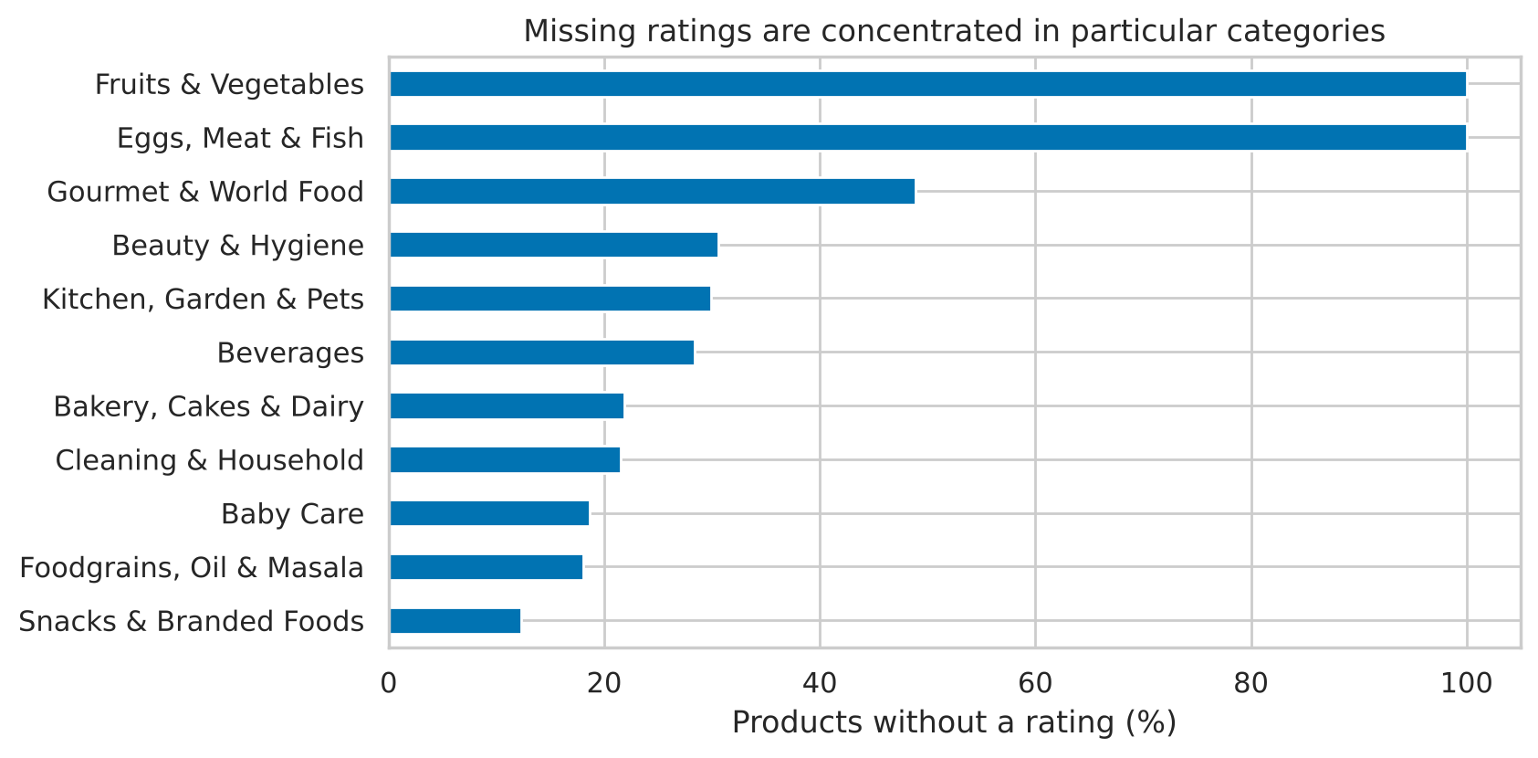
Figure 1. Percentage of products without a rating, by category
After cleaning, 27,200 products remained.

6.2 Imputation
A missing rating is informative: a product that no customer has rated has probably attracted little review activity. The absence was therefore retained as a binary indicator (rating_missing). The rating itself was imputed with the median rating of the product's sub-category, which keeps each product in line with comparable items. For the two categories with no ratings at all, the overall median of 4.1 was used. The median was preferred to the mean because ratings are concentrated at the upper end of the scale.

6.3 Feature engineering
Because sales data are absent, features were designed to describe observable commercial behaviour (Table 3). Right-skewed variables were log-transformed.
Table 3. Engineered features
Feature | Definition | Business meaning
discount_pct | (market price − sale price) / market price × 100 | Dependence on price promotion
log_price | log(1 + sale price) | Price level
price_index | Sale price / median price of the sub-category | Premium or economy position among peers
brand_size | Number of listings of the brand | Breadth and strength of the brand
type_size | Number of listings of the product type | Competition density
rating_imp, rating_missing | Imputed rating and its missing indicator | Customer feedback and review traction
desc_len | Words in the description | Richness of the listing

About 55.3 per cent of products carry some discount, with a mean discount of 11.8 per cent. The maximum discount is 83.7 per cent.

6.4 Outlier analysis
Outliers were identified with the 1.5 × IQR rule (Table 4). Between 7 and 9 per cent of the price, brand-size and type-size values fall outside the fences, and the distributions are strongly right-skewed (skewness above 5 for the price variables).
Table 4. Outlier summary (1.5 × IQR rule)
Variable | Outliers | Percent | Upper fence | Skewness
sale_price | 2,275 | 8.4 | 735.0 | 6.22
market_price | 2,100 | 7.7 | 912.5 | 5.83
discount_pct | 435 | 1.6 | 50.0 | 1.22
brand_size | 2,338 | 8.6 | 152.0 | 3.31
type_size | 1,987 | 7.3 | 462.5 | 3.14
price_index | 1,969 | 7.2 | 3.3 | 6.31

Decision: retain and transform. The extreme prices belong to genuine premium products, among them gas stoves, grooming appliances, imported perfumes, extra-virgin olive oil and bulk pet food, and are not data-entry errors. Deleting them would remove exactly the premium segment that management wants to identify. At the same time, leaving the skew untreated would let a small number of extreme values dominate the distance calculation. The log transform reduced the skewness of price, brand size, type size and price index to within ±0.2 while retaining every product (Figure 2). Discount percentage is bounded between 0 and 100, contains no impossible values and was left unchanged.
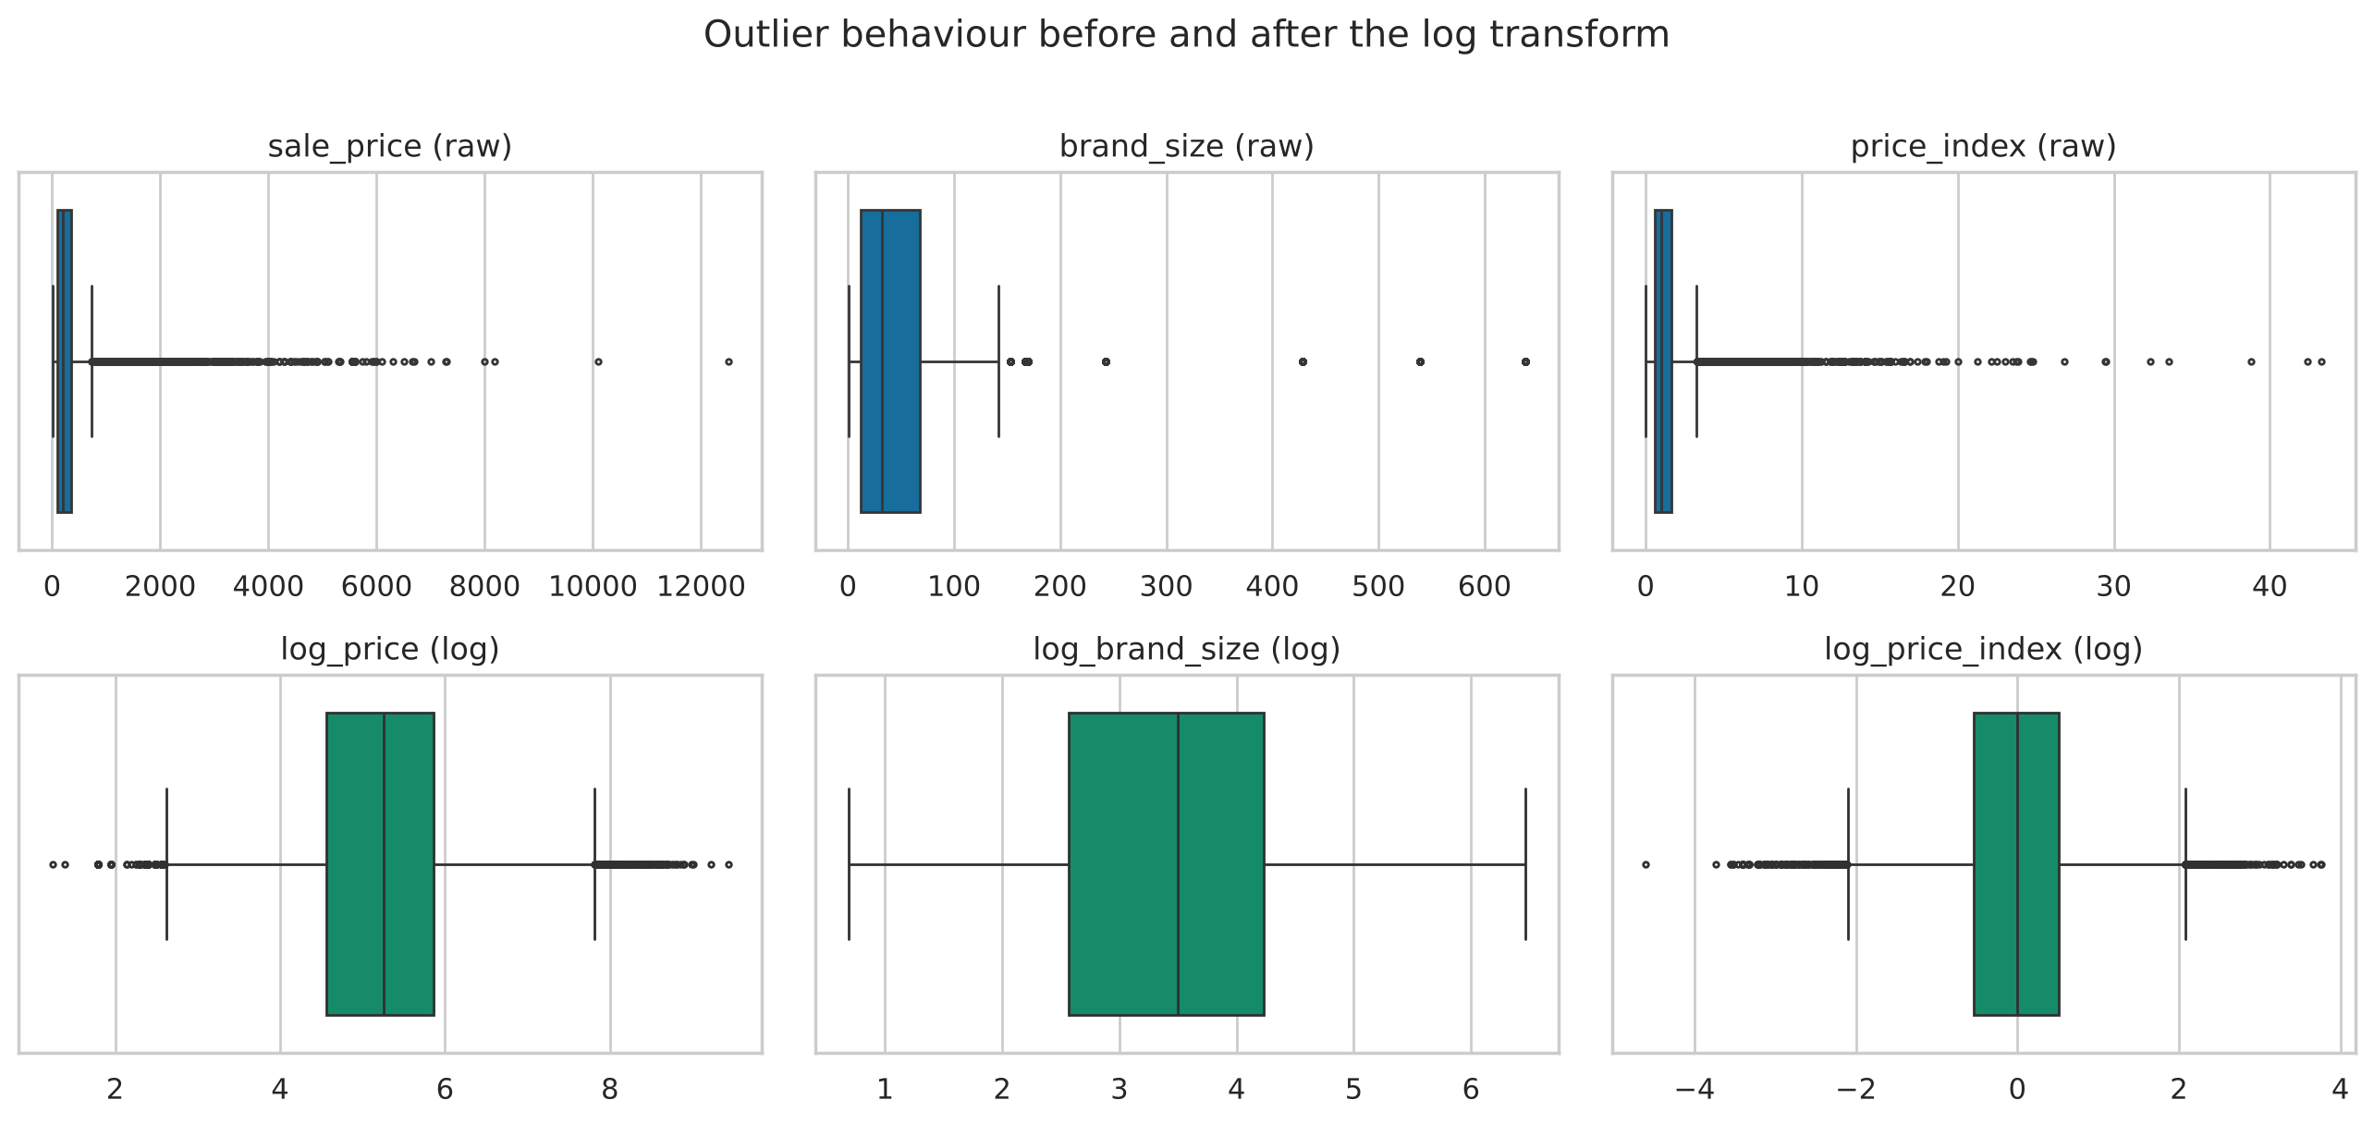
Figure 2. Box plots before (top) and after (bottom) the log transform

6.5 Encoding of categorical attributes
The encoding was chosen according to the number of categories (Table 5). Label encoding was deliberately avoided for nominal attributes, since distance-based algorithms would interpret the arbitrary numbers as magnitudes and create false similarity between unrelated categories.
Table 5. Encoding of categorical attributes
Attribute | Categories | Encoding | Justification
category | 11 | One-hot | Few values and no natural order; used in a comparison model and in profiling
sub_category | 90 | Relative-position features (price_index, type_size) | One-hot would add 90 sparse columns that dominate distances; the useful information is position within the sub-category
brand | 2,313 | Frequency (brand_size) | One-hot impractical; frequency measures how established a brand is
type | 426 | Frequency (type_size) | Same reasoning as for brand

6.6 Train–test split
A conventional train–test split was not used. Clustering is unsupervised: there is no target variable, hence no test accuracy that could be inflated by fitting on the same data. The aim is to describe the structure of the complete catalogue, and withholding products would only reduce the number segmented. The reliability of the segmentation was instead assessed by a hold-out assignment test and a bootstrap stability analysis (Section 9.5).

6.7 Standardisation and its effect
Distance-based clustering is sensitive to the scale of the variables. To demonstrate this, K-Means (K = 5) was fitted on the five selected features with and without standardisation. On the original scale, discount percentage accounts for 98.5 per cent of the total variance, while price, brand size, rating and the missing indicator together contribute 1.5 per cent. The unscaled clustering is therefore in effect a grouping on discount alone. Its agreement with the scaled clustering is low (Adjusted Rand Index 0.257), and its silhouette score of 0.619 is much higher than that of the scaled model (0.286), but the difference merely reflects the dominance of one variable and not better structure (Figure 3). All subsequent models use standardised features (zero mean, unit variance).
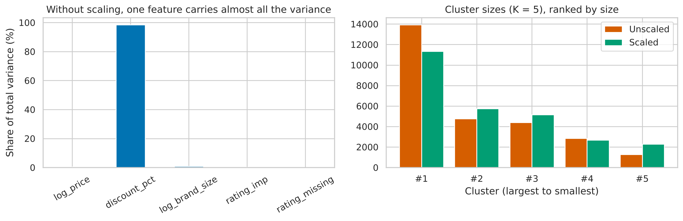
Figure 3. Effect of standardisation on variance share (left) and cluster sizes (right)

7. Exploratory Data Analysis
The catalogue is dominated by Beauty and Hygiene (7,683 products after cleaning), followed by Gourmet and World Food (4,677) and Kitchen, Garden and Pets (3,457). Sale prices are concentrated at low values, with a long tail of expensive items, and about 45 per cent of products are sold at the printed price (Figure 4).
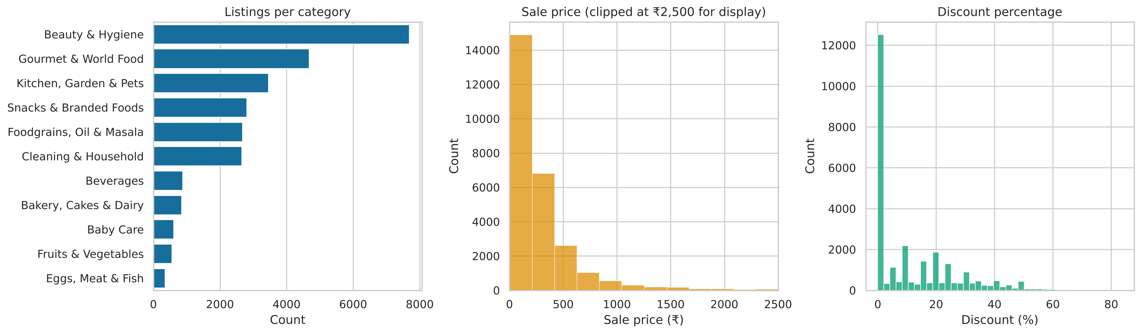
Figure 4. Listings per category, sale price distribution and discount distribution
Discounting differs sharply between categories (Figure 5). Kitchen, Garden and Pets (mean discount 22.6 per cent, 78 per cent of items discounted) and Fruits and Vegetables (21.3 per cent, 97 per cent discounted) are promoted heavily, while Baby Care (5.9 per cent), Snacks and Branded Foods (6.6 per cent) and Bakery, Cakes and Dairy (7.6 per cent) are mostly sold at the printed price. Category alone therefore captures part of the story, but a wide spread remains inside every category.
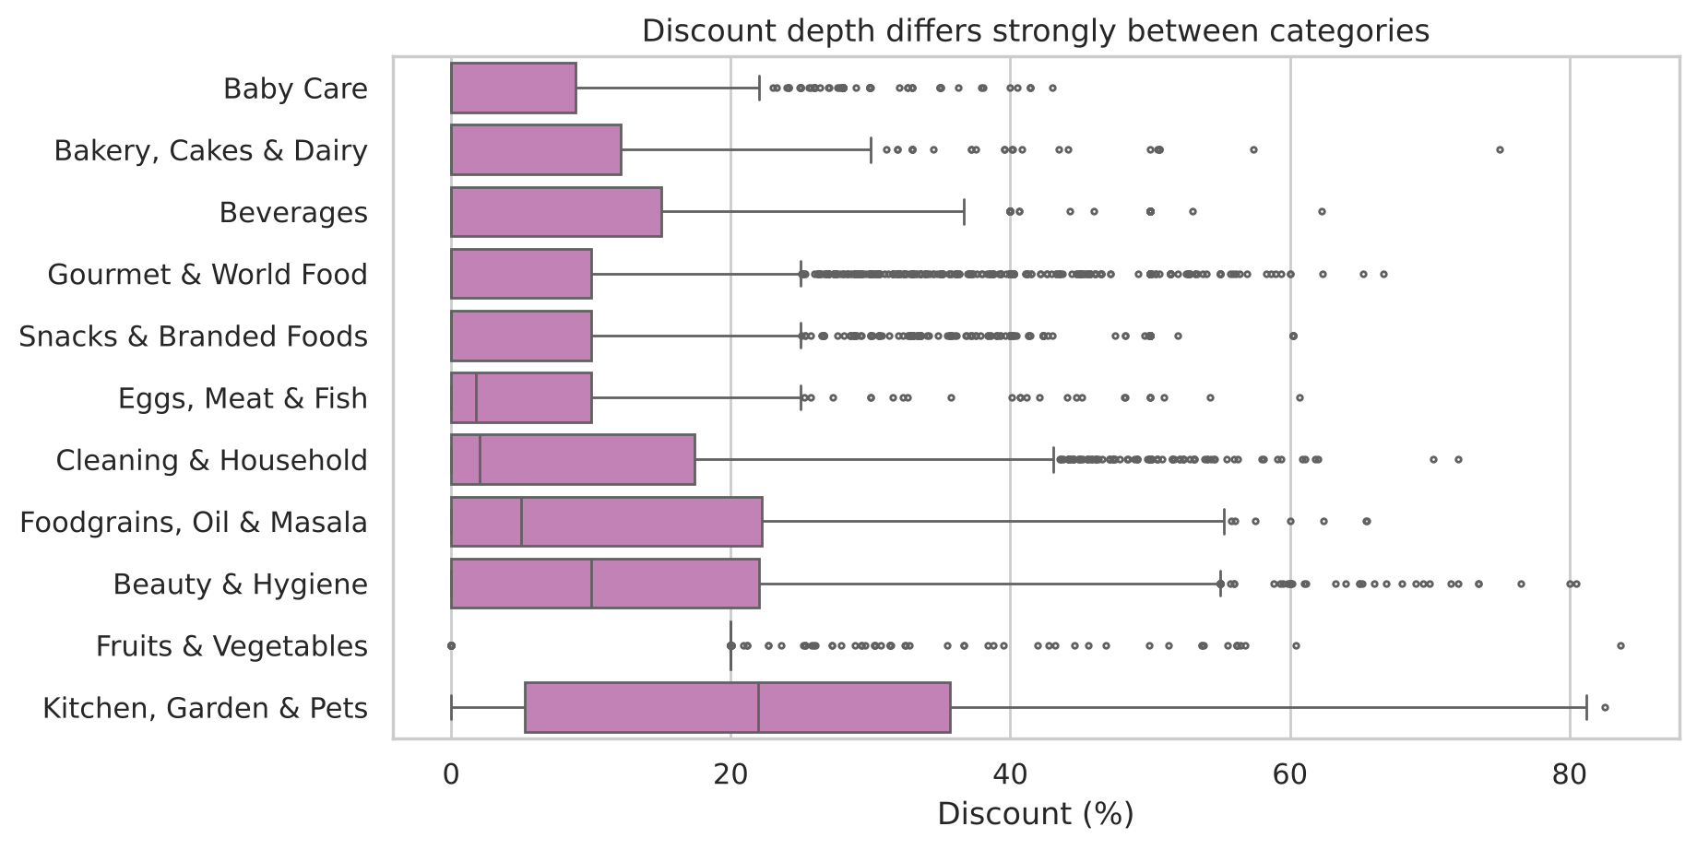
Figure 5. Discount percentage by category
Figure 6 shows the correlation between the engineered features. Log price and log price index are strongly correlated (0.81), so only log price is used in the main model to avoid giving price double weight. The missing-rating indicator is mildly associated with higher prices (0.19), which suggests that expensive items are slower to attract reviews.
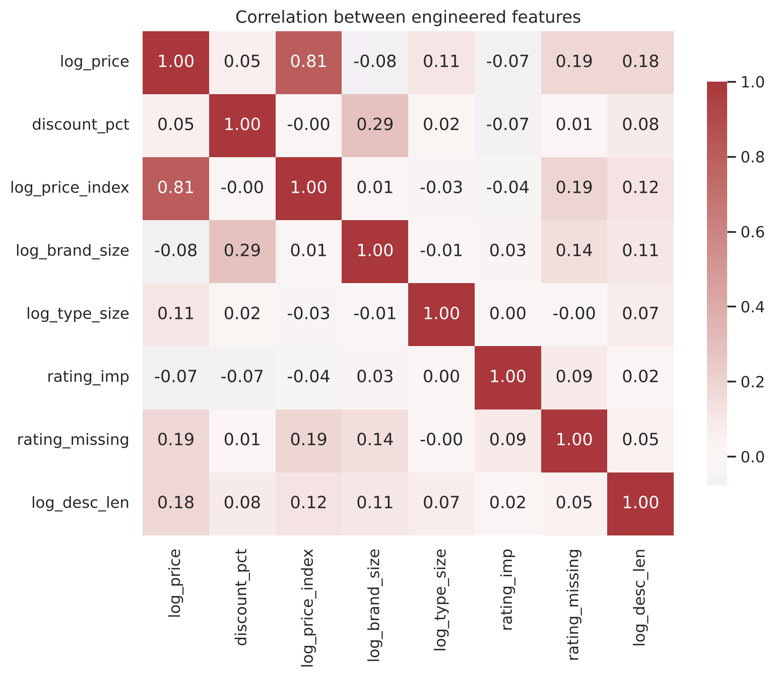
Figure 6. Correlation matrix of the engineered features

8. Model Development

8.1 Selection of features
The main model uses five features that describe different aspects of behaviour and are not strongly collinear: log price, discount percentage, log brand size, imputed rating and the missing-rating indicator. Several alternatives were tested with K-Means at K = 5 (Table 6, Figure 7).
Table 6. Comparison of feature sets (K-Means, K = 5)
Feature set | Features | Silhouette | Davies–Bouldin | Calinski–Harabasz
A: price + discount | 2 | 0.376 | 0.913 | 20,295
B: A + relative price | 3 | 0.323 | 0.999 | 15,836
C: all commercial features | 7 | 0.184 | 1.548 | 4,870
D: C + description length | 8 | 0.158 | 1.718 | 3,986
G: selected (main model) | 5 | 0.286 | 1.272 | 7,339
H: G + one-hot category | 16 | 0.216 | 1.460 | 3,094

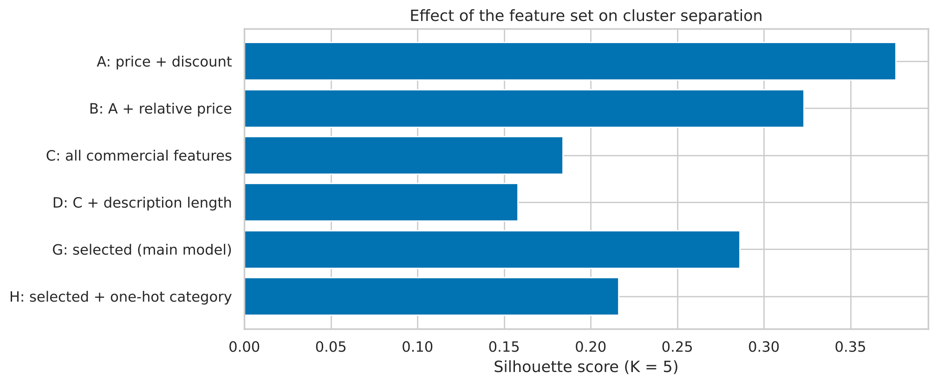
Figure 7. Silhouette score for each feature set
Set A reaches a higher silhouette score, but only because two variables are easy to separate; it cannot reflect customer feedback, review traction or brand strength, which are the signals needed to discuss demand. Adding further correlated variables (sets B, C and D) lowers the score because price-related columns are counted several times. Adding the one-hot category (set H) makes the result depend largely on category membership, which is the category-based planning that this project aims to improve on. Set G has the best indices among the sets that represent price, discount, brand and customer feedback together. Silhouette values are not strictly comparable across different feature spaces, so this comparison was treated as supporting evidence and read together with the interpretability of the segments.

8.2 K-Means and the choice of K
K-Means with k-means++ initialisation and ten restarts was run for K = 2 to 10 (Table 7, Figure 8). The silhouette score was estimated on a fixed random sample of 10,000 products, since the exact calculation requires a full distance matrix.
Table 7. K-Means results for K = 2 to 10
K | Inertia | Silhouette | Davies–Bouldin | Calinski–Harabasz
2 | 107,072 | 0.268 | 1.600 | 7,348
3 | 90,124 | 0.261 | 1.617 | 6,922
4 | 74,402 | 0.283 | 1.287 | 7,505
5 | 65,402 | 0.286 | 1.272 | 7,339
6 | 58,135 | 0.252 | 1.292 | 7,285
7 | 54,001 | 0.241 | 1.239 | 6,882
8 | 50,731 | 0.222 | 1.316 | 6,529
9 | 47,563 | 0.245 | 1.213 | 6,319
10 | 44,693 | 0.226 | 1.241 | 6,172

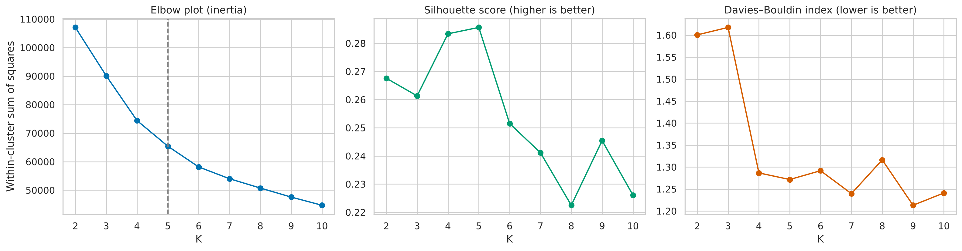
Figure 8. Elbow plot, silhouette score and Davies–Bouldin index for K = 2 to 10
The elbow criterion, defined as the largest perpendicular distance from the line joining the end points of the inertia curve, detects K = 5. The silhouette score is highest at K = 5 (0.286), with K = 4 very close (0.283), and falls for larger K. The Davies–Bouldin index is similar at K = 4 and K = 5 (1.29 and 1.27) and is slightly lower for some larger K, but only where the silhouette score has already declined and the segments become too fragmented to act upon. K = 5 was chosen because it agrees with the elbow and the silhouette peak, and because it separates the heavily discounted products into two commercially different groups that K = 4 would merge.

8.3 Hierarchical clustering and Gaussian mixture
Agglomerative clustering requires the full pairwise distance matrix, which for 27,200 products would occupy about 6 GB. The hierarchical methods were therefore run on a random sample of 6,000 products, and K-Means and the Gaussian mixture were refitted on the same sample so that all methods are compared on identical data. The Ward dendrogram (Figure 9) shows that the merge distance rises steeply over the last few merges, from about 50 to 100, which supports four to five groups.
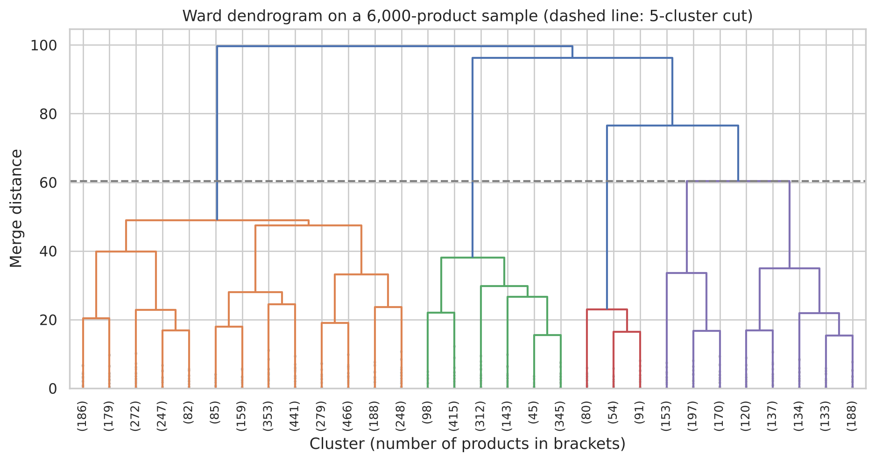
Figure 9. Ward dendrogram on a 6,000-product sample (dashed line: five-cluster cut)
Table 8. Comparison of clustering solutions on the 6,000-product sample
Solution | Silhouette | Davies–Bouldin | Calinski–Harabasz | Smallest / largest cluster
K-Means, K = 4 | 0.286 | 1.272 | 1,657 | 582 / 2,824
K-Means, K = 5 | 0.291 | 1.266 | 1,625 | 496 / 2,485
K-Means, K = 6 | 0.252 | 1.290 | 1,610 | 433 / 1,375
Ward, K = 4 | 0.265 | 1.316 | 1,408 | 225 / 3,185
Ward, K = 5 | 0.266 | 1.296 | 1,347 | 225 / 3,185
Average linkage, K = 5 | 0.236 | 0.940 | 160 | 1 / 5,823
Complete linkage, K = 5 | 0.174 | 1.590 | 828 | 264 / 3,803
Gaussian mixture, K = 4 | 0.163 | 1.858 | 1,070 | 899 / 2,311
Gaussian mixture, K = 5 | 0.114 | 2.174 | 905 | 899 / 1,811

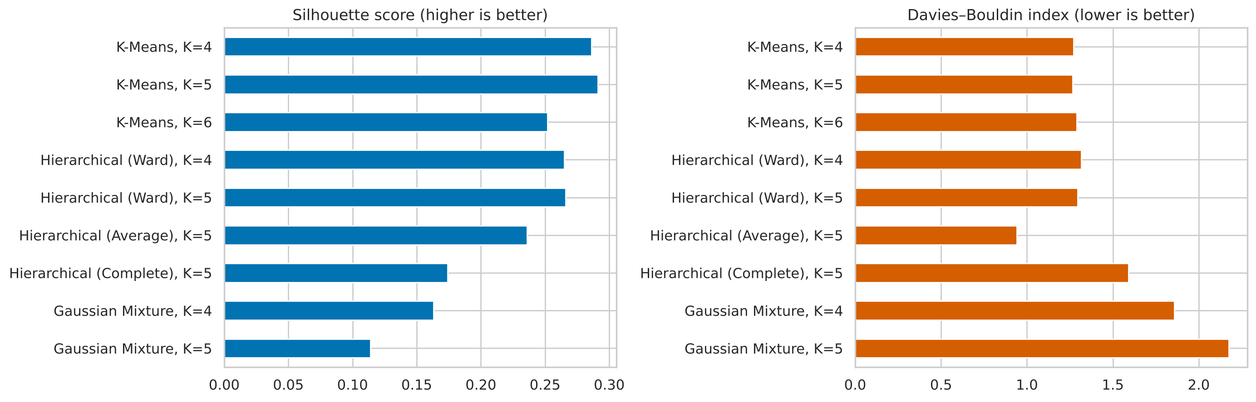
Figure 10. Silhouette score and Davies–Bouldin index of the candidate solutions
K-Means with K = 5 has the highest silhouette score and the lowest Davies–Bouldin index among the sensible candidates. Ward clustering is slightly weaker (silhouette about 0.27) and is a reasonable second choice. Average linkage reaches a low Davies–Bouldin value only by creating a degenerate cluster containing a single product, so its apparent quality is not useful. Complete linkage performs poorly. The Gaussian mixture has the weakest separation, probably because the binary missing-rating indicator does not follow a Gaussian distribution.

8.4 Principal component analysis
PCA of the standardised features shows that the variance is spread almost evenly: the five components explain 26.7, 23.2, 21.8, 16.0 and 12.3 per cent, and the first two together explain 49.9 per cent (Figure 11). The features therefore carry largely independent information, and reducing the dimensionality would discard useful signal. PCA was used only to visualise the clusters.
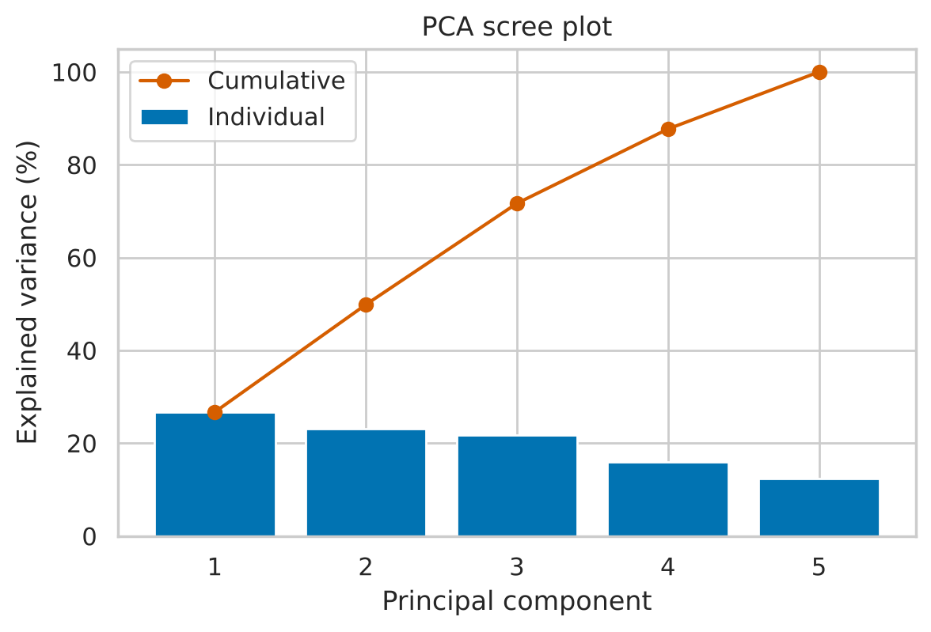
Figure 11. PCA scree plot

9. Results and Evaluation

9.1 Final model
The final model is K-Means with K = 5, fitted to the 27,200 standardised products with twenty restarts. Its internal quality is a silhouette score of 0.286, a Davies–Bouldin index of 1.27 and a Calinski–Harabasz index of 7,339. A silhouette near 0.29 indicates moderate and overlapping structure, which is expected for commercial attributes that vary continuously; the segments should therefore be used as planning groups and not as rigid classes. The clusters occupy distinct regions in the first two principal components but overlap near the centre (Figure 12), and their sizes are shown in Figure 13.
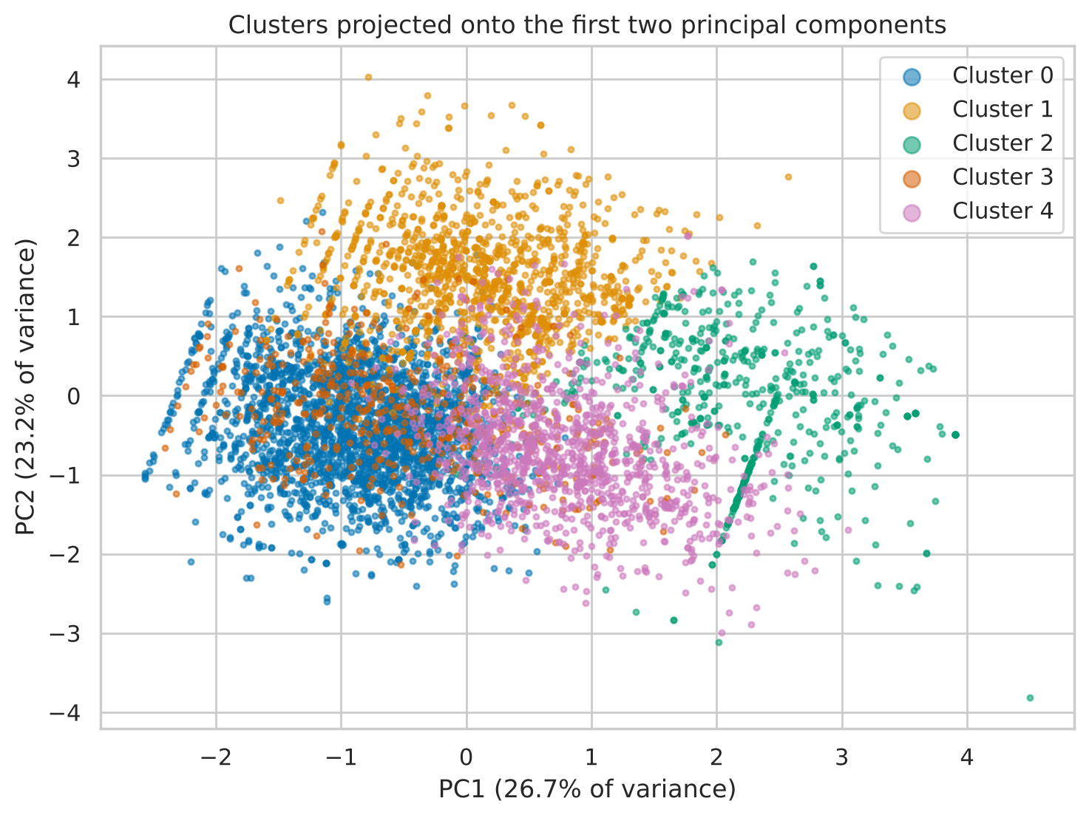
Figure 12. Clusters projected onto the first two principal components (6,000-product sample)
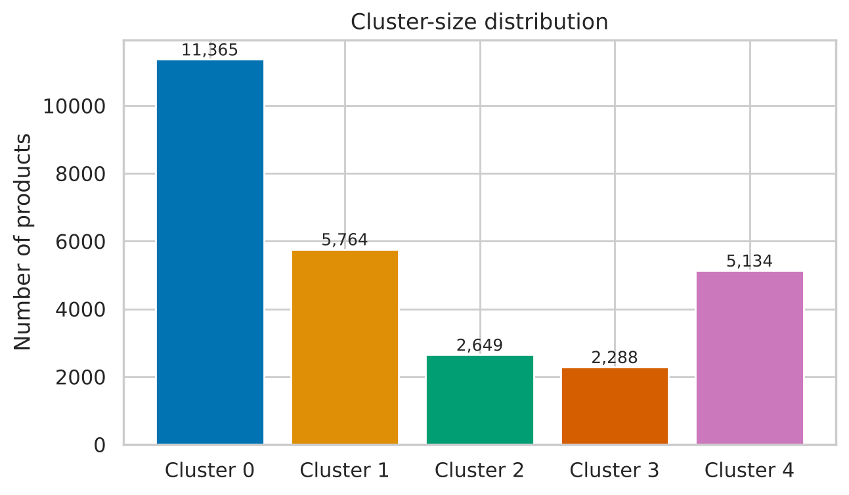
Figure 13. Cluster-size distribution

9.2 Cluster profiles
Table 9. Profile of the five segments
Segment | Products | Median price (₹) | Mean discount (%) | Median brand size | Share unrated | Mean rating
Core everyday value | 11,365 (41.8%) | 127.5 | 3.8 | 22 | 0% | 4.19
Premium full-price, low review traction | 5,764 (21.2%) | 300.0 | 4.9 | 19 | 100% | —*
Large-brand discounted, low review traction | 2,649 (9.7%) | 159.0 | 26.7 | 170 | 99% | —*
Low-rated, quality-risk | 2,288 (8.4%) | 297.3 | 10.6 | 24 | 0% | 2.44
Promotion-driven | 5,134 (18.9%) | 209.0 | 30.4 | 53 | 1% | 4.07
* Almost no products in these segments carry a rating, so the average of the few rated items is not meaningful.
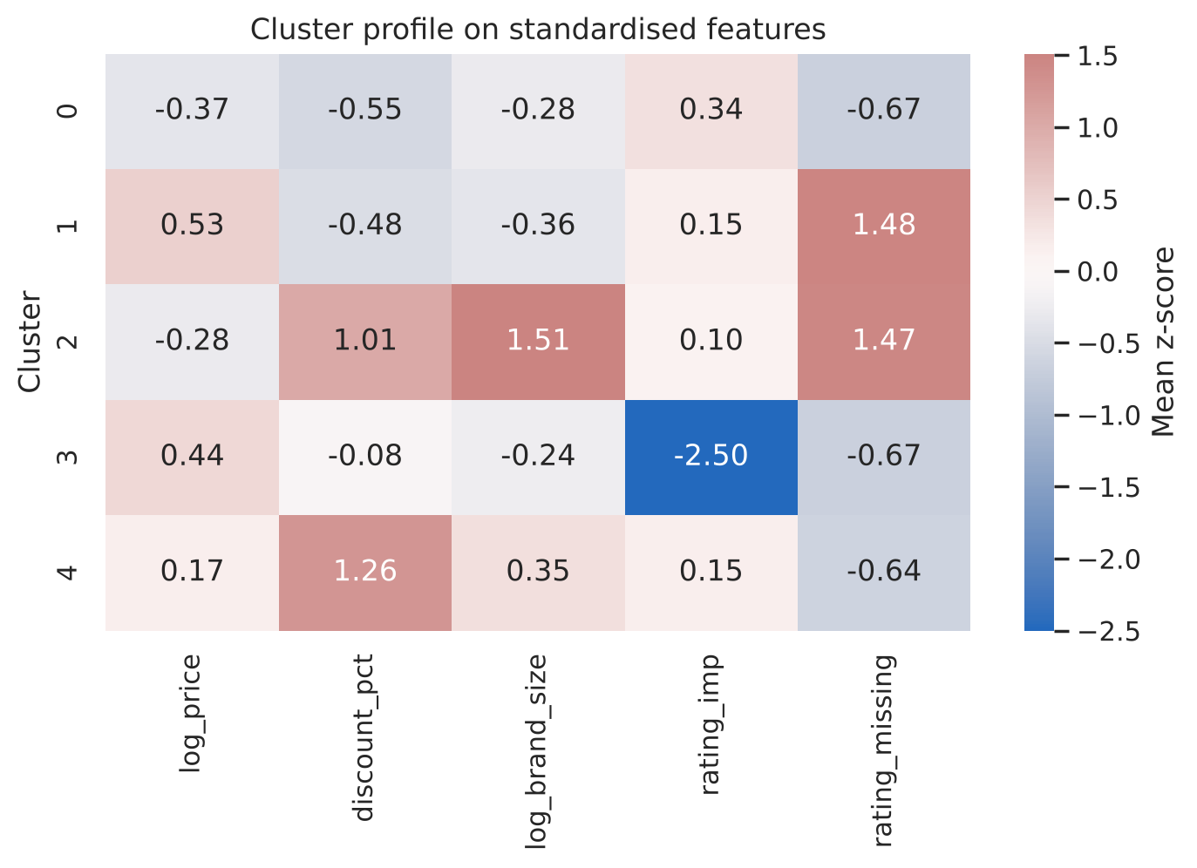
Figure 14. Mean standardised value of each feature in each cluster
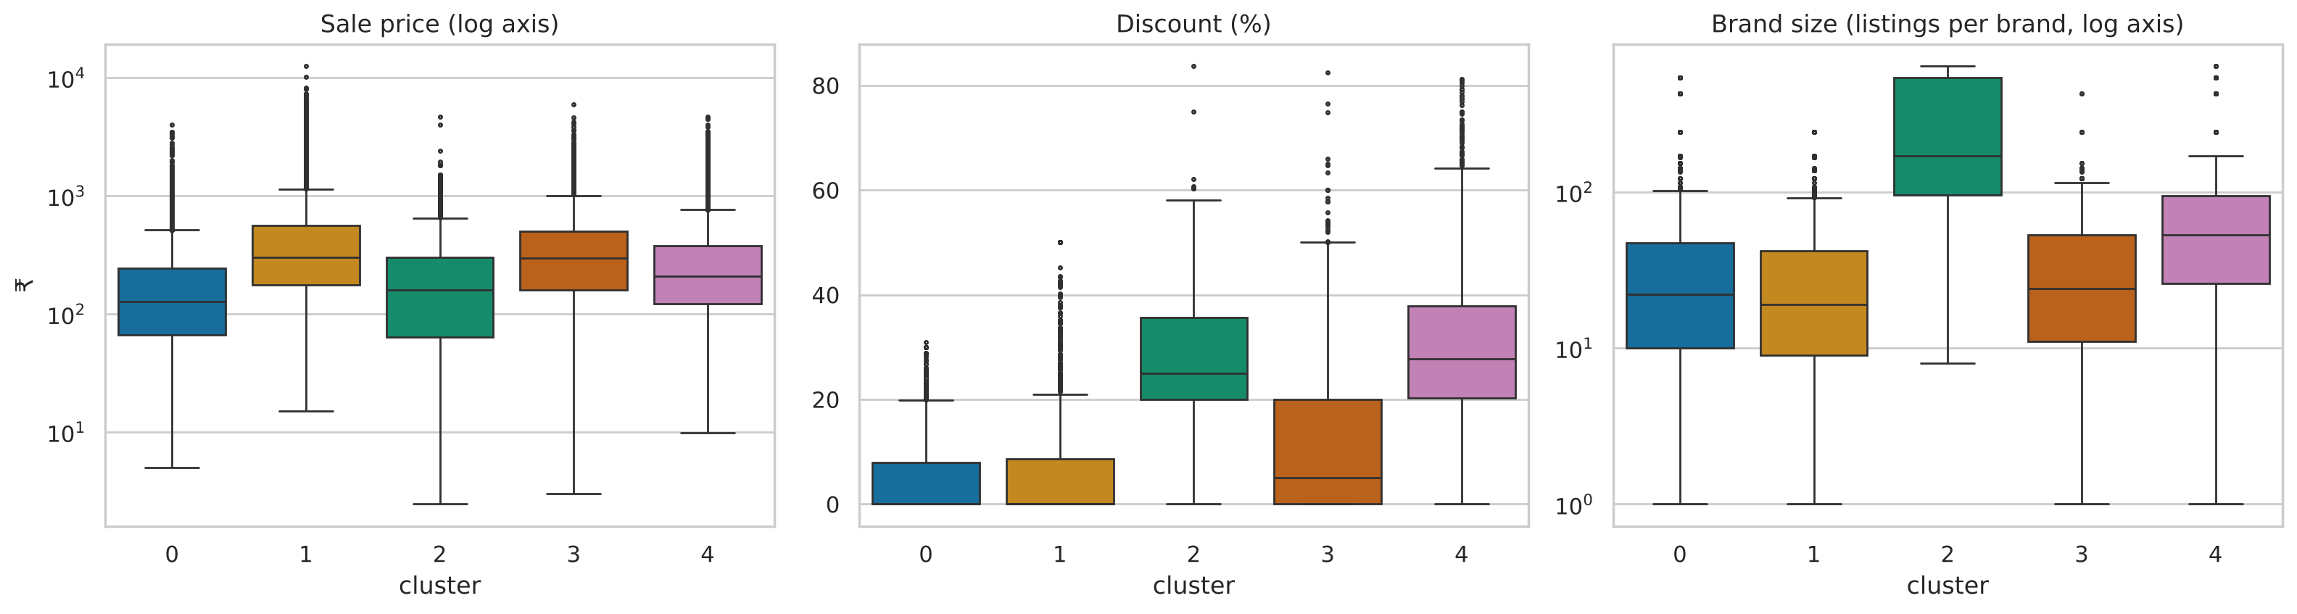
Figure 15. Price, discount and brand size by cluster
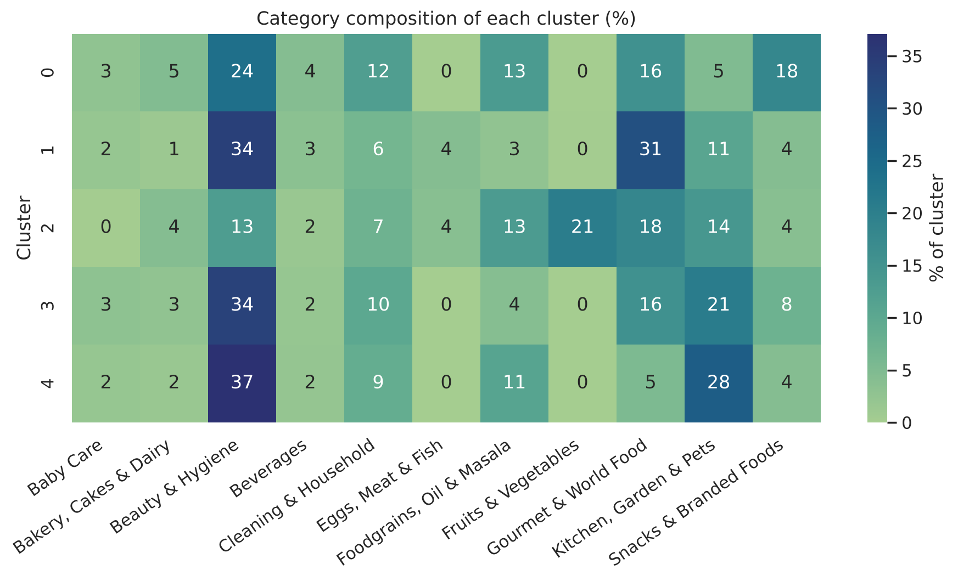
Figure 16. Category composition of each cluster (per cent of cluster)
Figure 16 shows that every segment spreads across several categories; the largest share in any segment never exceeds 37 per cent from a single category. A category-based plan would therefore treat products of different behaviour alike, which is the weakness of the present approach.

9.3 Description of the segments
- Core everyday value (41.8 per cent). The largest group has the lowest median price (₹127.5), little discounting (3.8 per cent on average), a good average rating (4.19) and reviews for every item. These are the probable fast-moving, high-demand staples.
- Promotion-driven (18.9 per cent). Every item is discounted, with an average discount of 30.4 per cent at a median price of ₹209. Demand for these products is probably tied to promotions.
- Premium full-price, low review traction (21.2 per cent). The median price is ₹300, discounts average under 5 per cent, and essentially none of the products is rated. These are premium items that probably sell slowly.
- Low-rated, quality-risk (8.4 per cent). The median price is ₹297 and the average rating only 2.44. Customer dissatisfaction is the defining characteristic.
- Large-brand discounted, low review traction (9.7 per cent). Products come from very broad brands (median 170 listings per brand), are discounted by 26.7 per cent on average and are almost never rated. Fresh produce is over-represented (21 per cent of the segment).

9.4 Which solution gives the most meaningful segmentation
K-Means with K = 5 is preferred on both statistical and business grounds. Statistically, it has the best silhouette and Davies–Bouldin values among the sensible candidates and the most balanced cluster sizes. From a business viewpoint, its five segments differ in ways that require different actions: they differ in price position, in promotion dependence, in customer satisfaction and in review traction. K = 4 merges the two heavily discounted groups, whereas K = 6 has a lower silhouette score (0.252) and splits the data into smaller, more fragmented groups. Ward clustering yields a similar structure but slightly weaker separation, and the Gaussian mixture does not suit the data.

9.5 Validation of stability
Two checks were made in place of a test-set evaluation. In the hold-out check, the scaler and K-Means were fitted on a random 80 per cent of the products, and the remaining 20 per cent were assigned to the nearest centroid; agreement with the full-data model was an Adjusted Rand Index (ARI) of 0.983. In the bootstrap check, K-Means was refitted on ten random 80 per cent subsamples; the mean ARI against the full-data labels was 0.987 (standard deviation 0.006, minimum 0.974). Values this close to 1 show that the same products are grouped together irrespective of the subset used, so the segmentation is stable.

10. Business Interpretation and Recommendations
The strategies below follow from the segment profiles. Since the data contain no sales or stock records, they should be treated as hypotheses to be confirmed against transaction data, and the first step in implementation should be to test each segment's actual sales velocity.
Table 10. Segment-specific inventory and promotion strategy
Segment | Commercial reading | Inventory and stocking | Promotion
Core everyday value | Probable fast-moving, high-demand staples | High safety stock and frequent replenishment; avoid stock-outs; negotiate volume terms with suppliers | Little need for discounts; use as traffic builders and bundle anchors
Promotion-driven | Demand tied to price promotion | Build stock ahead of campaigns and run it down afterwards; plan to the promotion calendar | Measure the sales uplift of each campaign; test shallower discounts
Premium full-price, low review traction | Premium, probable slow-moving | Minimal stock; replenish in small batches or on order; monitor ageing | Targeted rather than mass promotion; encourage reviews to build trust
Low-rated, quality-risk | Customer dissatisfaction | Reduce stock; review the supplier or quality before reordering | Do not discount to clear stock until quality is checked; consider delisting
Large-brand discounted, low review traction | Broad, low-priced assortment with little review activity | Keep lean stock; handle short shelf life carefully | Brand-level promotions rather than item-level offers

Three wider recommendations follow. First, replace uniform category rules by segment-specific replenishment and promotion rules, since every segment cuts across several categories. Second, review the discount policy for the promotion-driven segment, because a discount of about 30 per cent applied to every item in the segment is costly and should be justified by measured uplift. Third, give particular attention to the low-rated segment, where continued stocking and promotion may harm customer satisfaction.

11. Limitations and Future Work
- The data contain no units sold, stock levels or returns. "Fast-moving" and "slow-moving" are inferred from review traction, discount depth and brand breadth, which are indirect indicators. The segment strategies need validation against actual sales and inventory data.
- About 31 per cent of ratings are missing and two categories have none. Imputed ratings carry limited information, which is why a separate missing indicator was retained.
- The silhouette score of about 0.29 indicates overlapping segments. The clusters describe tendencies, not sharp boundaries.
- Hierarchical clustering was run on a random sample of 6,000 products because of memory limits.
- Future work should combine the catalogue with transaction data to build true demand features (units sold, sales velocity, stock turnover and return rate), add a time dimension to study seasonality, and test the strategies through controlled pilots.

12. Conclusion
This project showed that the BigBasket catalogue contains five commercially distinct groups of products that a category-based view does not reveal. K-Means clustering with K = 5 on standardised features gave the best internal quality among the models tested and was highly stable under resampling. Standardisation proved essential, since without it a single variable determined 98.5 per cent of the variance. Outliers were retained and log-transformed because they correspond to genuine premium products. The segments support differentiated inventory and promotion strategies, subject to the limitation that demand could be represented only by proxies. The same framework can be applied directly to richer retail data containing sales and stock figures.

References
[1] Arthur, D. and Vassilvitskii, S. (2007). k-means++: the advantages of careful seeding. Proceedings of the 18th Annual ACM-SIAM Symposium on Discrete Algorithms, 1027–1035.
[2] Caliński, T. and Harabasz, J. (1974). A dendrite method for cluster analysis. Communications in Statistics, 3(1), 1–27.
[3] Davies, D. L. and Bouldin, D. W. (1979). A cluster separation measure. IEEE Transactions on Pattern Analysis and Machine Intelligence, PAMI-1(2), 224–227.
[4] Hubert, L. and Arabie, P. (1985). Comparing partitions. Journal of Classification, 2, 193–218.
[5] Jolliffe, I. T. and Cadima, J. (2016). Principal component analysis: a review and recent developments. Philosophical Transactions of the Royal Society A, 374, 20150202.
[6] MacQueen, J. (1967). Some methods for classification and analysis of multivariate observations. Proceedings of the Fifth Berkeley Symposium on Mathematical Statistics and Probability, 1, 281–297.
[7] Pedregosa, F. et al. (2011). Scikit-learn: machine learning in Python. Journal of Machine Learning Research, 12, 2825–2830.
[8] Rousseeuw, P. J. (1987). Silhouettes: a graphical aid to the interpretation and validation of cluster analysis. Journal of Computational and Applied Mathematics, 20, 53–65.
[9] Ward, J. H. (1963). Hierarchical grouping to optimize an objective function. Journal of the American Statistical Association, 58(301), 236–244.
[10] BigBasket Products dataset, Kaggle. 27,555 product listings from an Indian online grocery retailer.

Appendix: Submission Contents and Reproducibility
The submission folder contains the following files.
- This report in PDF and Word format.
- Executed Python notebook (ipynb) with comments, and its PDF export.
- Sixteen plots in PNG format in the plots folder.
- The dataset (BigBasket Products.csv).
To reproduce the results, place the notebook and the dataset in the same folder and run all cells in order with Python 3, pandas, NumPy, scikit-learn, SciPy, matplotlib and seaborn installed. A fixed random seed (42) is used throughout.

