Chapter 1: Introduction
In current scenarios, due to rising environmental awareness and the demands of today's fast-paced world, there is a growing need for continuous learning and skill acquisition beyond traditional institutional boundaries. While many online platforms offer standardized courses, they often lack the personalized, local, and community-driven interaction required for hands-on expertise.

KnowsItAll acts as a remedy for this shortcoming by providing a peer-to-peer (P2P) skill-sharing platform where users can trade expertise, manage digital tokens, and build a verified reputation within their local community. By decentralizing the learning process, the platform empowers individuals to monetize their time and talent through a secure, localized marketplace.

  - Project Objectives
The primary objective of the KnowsItAll project is to develop a secure and efficient decentralized platform for local skill exchange.
- Secure Authentication: Implementing a JWT-based login functionality for added security and user profile management.
- Proximity Discovery: Developing a "Skill Radar" that identifies mentors and learners within a 5km radius using GPS technology.
- Transaction Integrity: Creating a "Trust Ledger" based on SHA-256 hashing to ensure an immutable history of every skill trade.
- Economic Hybridization: Providing a dual-mode system for both direct barter and "SkillToken" transactions to manage the trade of knowledge effectively.

  - Existing System and Need for the System
Existing System
Current learning landscapes are dominated by centralized platforms (MOOCs) or informal social media groups. These systems often require high monetary costs, lack physical/hands-on interaction, and offer no verifiable way to track a user's reputation outside of simple "likes" or star ratings.
Need for the System
There is a pressing need for a solution that combines local accessibility with high-tech security. KnowsItAll fulfils this need by integrating real-time location data with a blockchain-inspired ledger, ensuring that skill-sharing is not only accessible but also verifiable and safe.

Problem Statement

The "Double Coincidence of Wants" often hinders traditional barter (e.g., finding a carpenter who specifically wants to learn Python). Furthermore, the lack of professional documentation for informal learning makes it difficult for individuals to prove their skills to future employers. KnowsItAll solves these issues by introducing a token-based escrow system and a "Skill Passport" for verified micro-credentials.

  - Scope of the Work
The scope of KnowsItAll encompasses the design, development, and implementation of a secure, decentralized peer-to-peer (P2P) skill-sharing ecosystem. The project focuses on creating a reliable bridge between local expertise and the need for personalized learning.
1.3.1 Functional Scope
The functional scope defines the features available to the end-user to ensure a seamless "Learn and Earn" experience:
- User & Profile Management:
  - Secure registration and JWT-based authentication.
  - Dynamic "Skill Passport" profiles where users list their offered skills (Digital, Physical, or Hybrid) and proficiency levels.
- The Skill Radar (Geospatial Discovery):
  - Integration with Google Maps/Mapbox and the Android Fused Location API.
  - Real-time rendering of mentors and learners within a strict 5km radius.
- The Hybrid Trade Engine:
  - Development of a negotiation workflow for Direct Barter (Skill-for-Skill).
  - Implementation of a Token-based Trade system using an escrow mechanism to hold SkillTokens until session completion.
- Verification & Trust Ledger:
  - Dual-verification system: QR Code Handshake for physical meetups and Video Session Logging for remote trades.
  - A backend Trust Ledger that cryptographically links every completed transaction using SHA-256 hashing to prevent reputation fraud.
- Reporting & Credentials:
  - Automated generation of verified PDF certificates for every successfully completed "Swap," which serves as a micro-credential for the user's professional portfolio.
1.3.2 Technical Scope
The technical scope defines the technologies and architectural layers required to sustain the platform:
- Frontend (Mobile): A native Android application built using Jetpack Compose (for modern, reactive UI) and Kotlin. It will handle location services, QR scanning, and local data caching via Room DB.
- Backend (API Layer): A Spring Boot microservice architecture responsible for token economics, user authentication, and managing the state of swap transactions.
- Security & Encryption: Implementation of BCrypt for password hashing and SHA-256 for the chain-of-trust ledger.
- Persistence Layer: Use of PostgreSQL for relational data (users, skills, transactions) and PostGIS for optimized spatial queries (the 5km radar logic).
1.3.3 Out-of-Scope (Project Boundaries)
To maintain project focus and feasibility, the following are currently excluded from the initial version:
- Monetary Conversion: The platform does not support the conversion of SkillTokens into "Real-World" fiat currency (e.g., USD, INR) to avoid complex financial regulations.
- Global Marketplace: The system is strictly optimized for hyper-local (5km) or direct P2P interactions; it is not a global content-streaming platform like YouTube or Udemy.
- Dispute Arbitration: While the system provides a Trust Ledger for evidence, manual legal arbitration of failed physical trades is outside the software's scope.
1.3.4 Target Audience
The project is specifically scoped for:
- Semi-Urban Communities: Where formal training centers are scarce but local expertise is high.
- Students and Hobbyists: Looking to acquire new skills without the financial burden of traditional courses.
- Independent Artisans: Carpenters, coders, musicians, and artists looking to expand their network and trade their time.
  - Operating Environment: Hardware & Software
The operating environment of the KnowsItAll system defines the hardware and software requirements necessary for the development, deployment, and smooth functioning of both the mobile client and the backend server infrastructure.
Hardware Requirements
The system is designed to operate on modern mobile devices and standard server hardware. The minimum requirements are as follows:
For Development & Server Hosting:
- Processor: Intel Core i5 or higher (Recommended for handling Spring Boot services and Android Studio emulation).
- RAM: Minimum 8 GB (16 GB recommended for concurrent backend and mobile development).
- Storage: At least 40 GB of free disk space (to accommodate Android SDKs, PostgreSQL databases, and the local Trust Ledger).
- Internet Connectivity: High-speed connection required for real-time GPS synchronization, JWT authentication, and Jitsi/Agora video integration.
For End-Users (Mobile):
- Device: Android smartphone with GPS capabilities.
- RAM: Minimum 2 GB.
- Camera: Required for QR Code Handshake verification.
Software Requirements
The KnowsItAll application is developed using a robust technical stack to ensure the immutability of the Trust Ledger and the responsiveness of the Skill Radar.
- Operating System: Windows 10 or above / macOS / Linux (Ubuntu 20.04+).
- Backend Language: Java 17 (Spring Boot 3.x).
- Mobile Framework: Kotlin with Jetpack Compose (for modern UI rendering).
- Database: * PostgreSQL: For centralized cloud storage and relational mapping.
  - Room DB: For local, offline-first mobile data persistence.
- Security & Encryption: SHA-256 (for Ledger Hashing) and BCrypt (for password security).
- Development Tools (IDE): Android Studio Jellyfish+ (Frontend) and IntelliJ IDEA or VS Code (Backend).
- Version Control: Git and GitHub.
- APIs & Services: * Fused Location API: For hyper-local GPS tracking.
  - ZXing / ML Kit: For QR Code generation and scanning.
  - Technology Used
The KnowsItAll system is developed as a multi-platform ecosystem comprising a native mobile application and a robust backend server. It utilizes modern, industry-standard technologies to ensure high performance, cryptographic security for the Trust Ledger, and real-time responsiveness for the Skill Radar.
Programming Languages
- Kotlin: Kotlin is used as the primary language for the Android mobile application. Its concise syntax and null-safety features make it ideal for handling complex UI states and real-time GPS data.
- Java (Spring Boot): Java 17 is utilized on the backend to build a scalable RESTful API. It handles the core business logic, token escrow services, and the cryptographic hashing required for the Trust Ledger.
User Interface Technology
- Jetpack Compose: This modern toolkit is used to design the graphical user interface of the Android application. It allows for a reactive UI that updates seamlessly as the user moves through different geographical areas on the Skill Radar.
Database Technology
- PostgreSQL: A powerful relational database management system used to store persistent user profiles, skill catalogues, and the immutable transaction history of the Trust Ledger.
- Room Persistence Library: Used for local data caching on the Android device. This ensures that the application remains functional in "offline-first" scenarios common in semi-urban areas with spotty connectivity.
Security & Cryptography
- SHA-256 Hashing: Implemented to secure the Trust Ledger. Each transaction is linked to the previous one via a cryptographic hash, ensuring a tamper-proof record of all skill trades.
- JWT (JSON Web Tokens): Used for secure, stateless authentication between the mobile client and the backend server.
Development Tools
- Android Studio: The primary integrated development environment (IDE) used for building, debugging, and testing the Kotlin-based mobile application.
- IntelliJ IDEA: Used for backend development, providing extensive support for Spring Boot framework integration and database management.
- Git and GitHub: Used for source code version control, collaborative development, and maintaining the project’s documentation lifecycle.
Platforms Supported
- Mobile Environment: Android (SDK 24 and above).
- Backend Environment: Cloud-hosted or local server environments (Linux / Windows / macOS).

Chapter 2: Analysis and Design
2.1 Context Level Data Flow Diagram

2.1.1 0th Level DFD
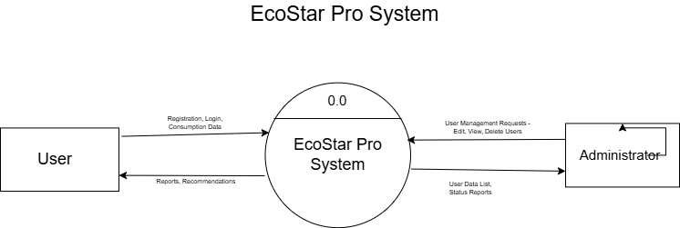

2.2.2 1st Level DFD
- Processes
            - User Authentication
            - Consumption Data Management
            - Profile Management
            - Analysis & Reports
            - Recommendations
            - User/Admin Management
            - Settings/Notification

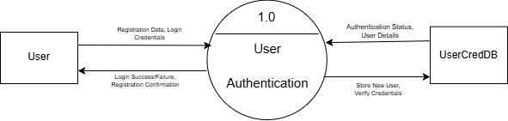

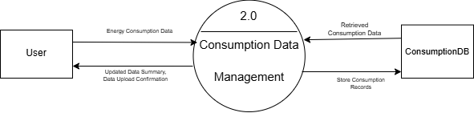

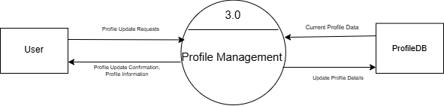

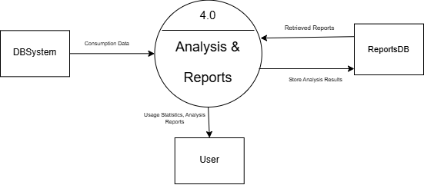
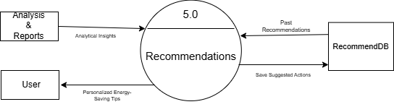

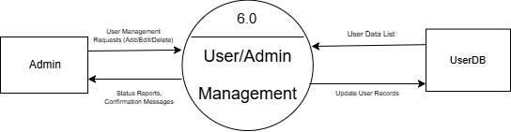

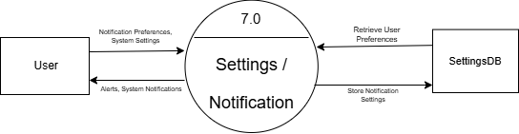

2.2 Entity Relationship Diagram
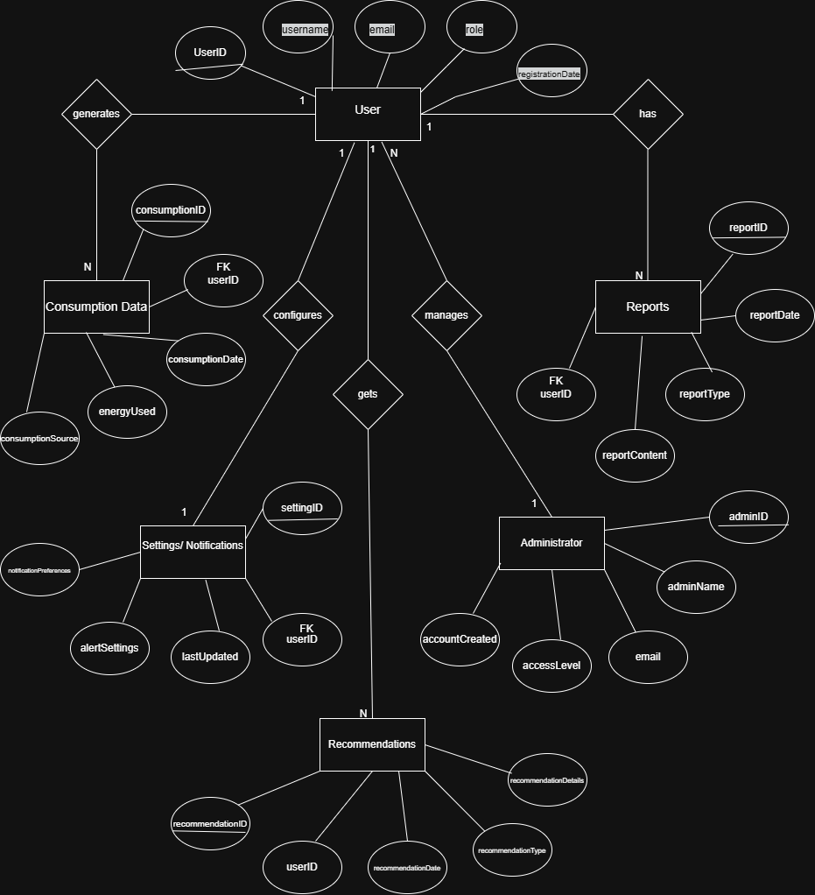

2.3 Data Dictionary
2.3.1 BarterSwap
Field Name | Data Type
exchangeType | ENUM
offeredSkillId | VARCHAR
swapID (FK) | INT
swapMatchScore | INT

2.3.2 Certificate Generator
Field Name | Data Type
digitalSeal | BLOB
outputFormat | VARCHAR
templatePath | VARCHAR

2.3.3 LedgerEntry
Field Name | Data Type
currentHash | VARCHAR
entryID (PK) | UUID
previousHash | VARCHAR
timestamp | DATETIME
transactionID (FK) | INT

2.3.4 Skill
Field Name | Data Type
category | VARCHAR
description | TEXT
proficiencyLevel | ENUM
skillID (PK) | VARCHAR
title | VARCHAR

2.3.5 Swap
Field Name | Data Type
escrowAmount | LONG
learnerID (FK) | VARCHAR
mentorID (FK) | VARCHAR
skillID (FK) | VARCHAR
status | ENUM
swapID (PK) | INT
type | ENUM

2.3.6 TokenSwap
Field Name | Data Type
escrowStatus | ENUM
platformFee | DOUBLE
swapID (FK) | INT
tokenAmount | DOUBLE

2.3.7 TrustLedger
Field Name | Data Type
currentHash | VARCHAR
entryID (PK) | INT
previousHash | VARCHAR

2.3.8 User
Field Name | Data Type
fullName | VARCHAR
latitude | DOUBLE
longitude | DOUBLE
tokenBal | LONG
trustScore | FLOAT
userID (PK) | VARCHAR

3.4 Class Diagram
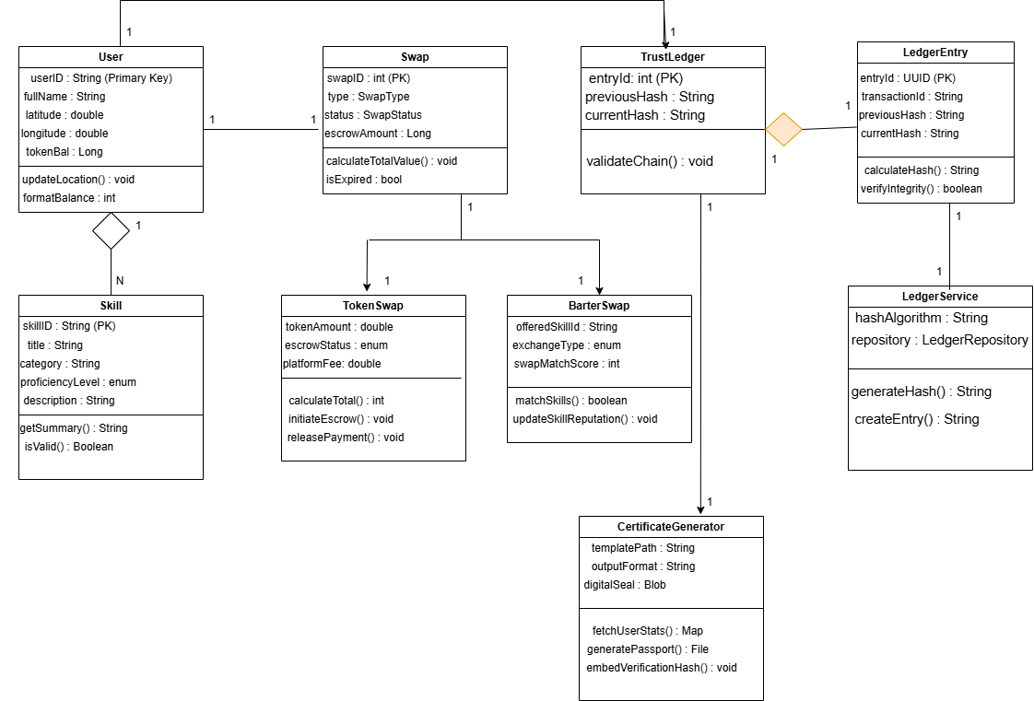

2.5 Use Case Diagrams
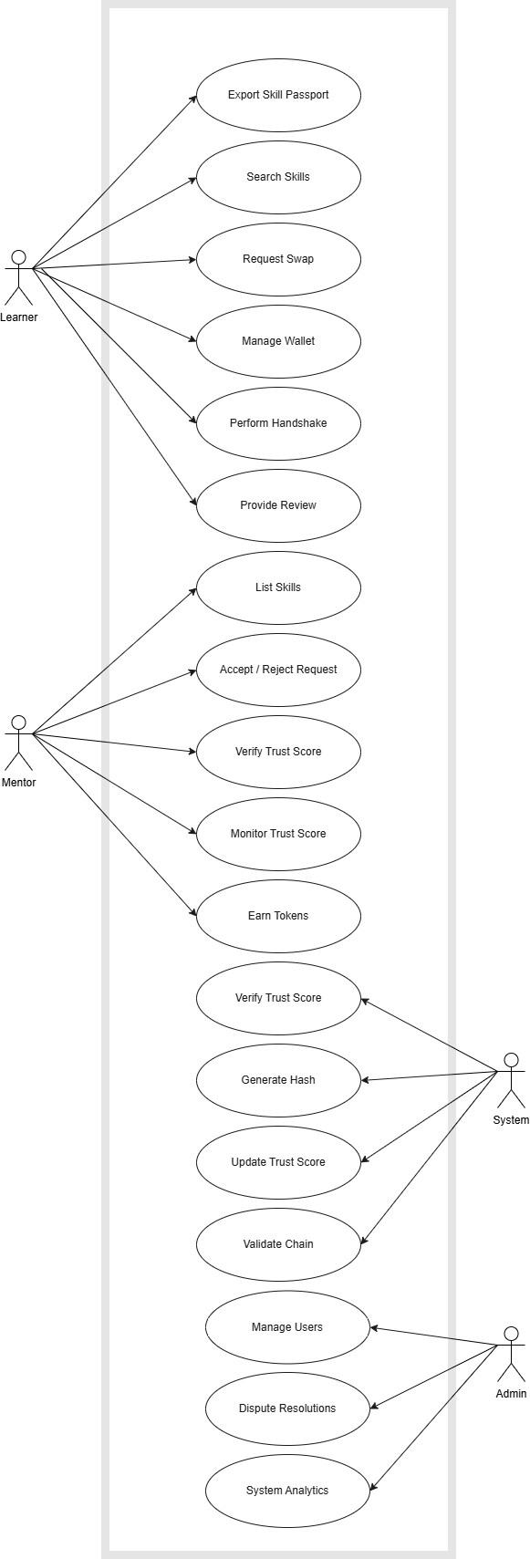
2.6 Activity Diagram
2.6.1 User
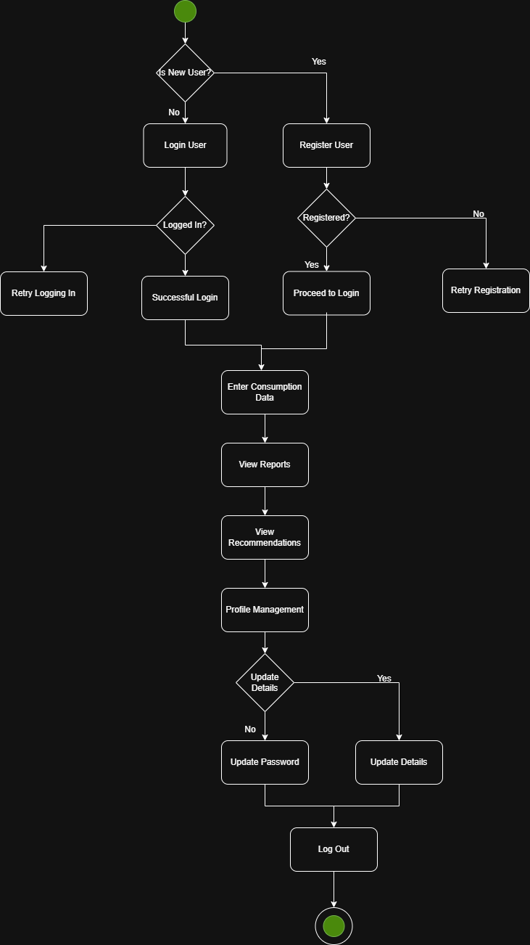

2.6.2 Admin
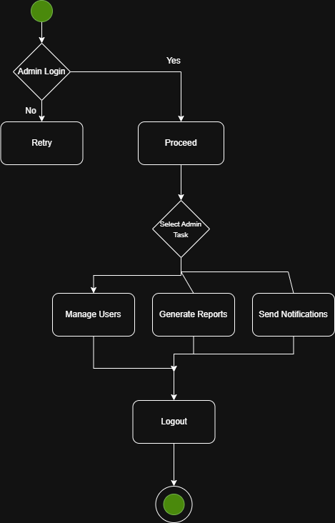

2.7 Package, Deployment and Component Diagram

2.7.1 Package Diagram
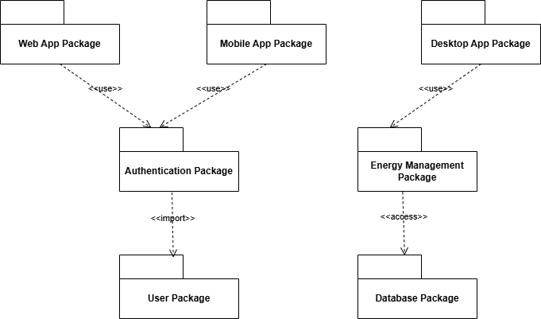
2.7.2 Deployment Diagram
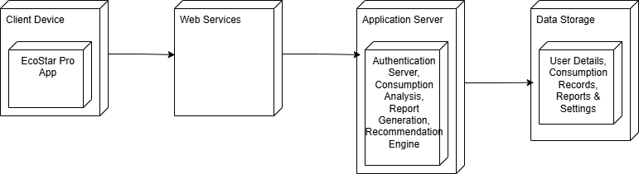

2.7.3 Component Diagram
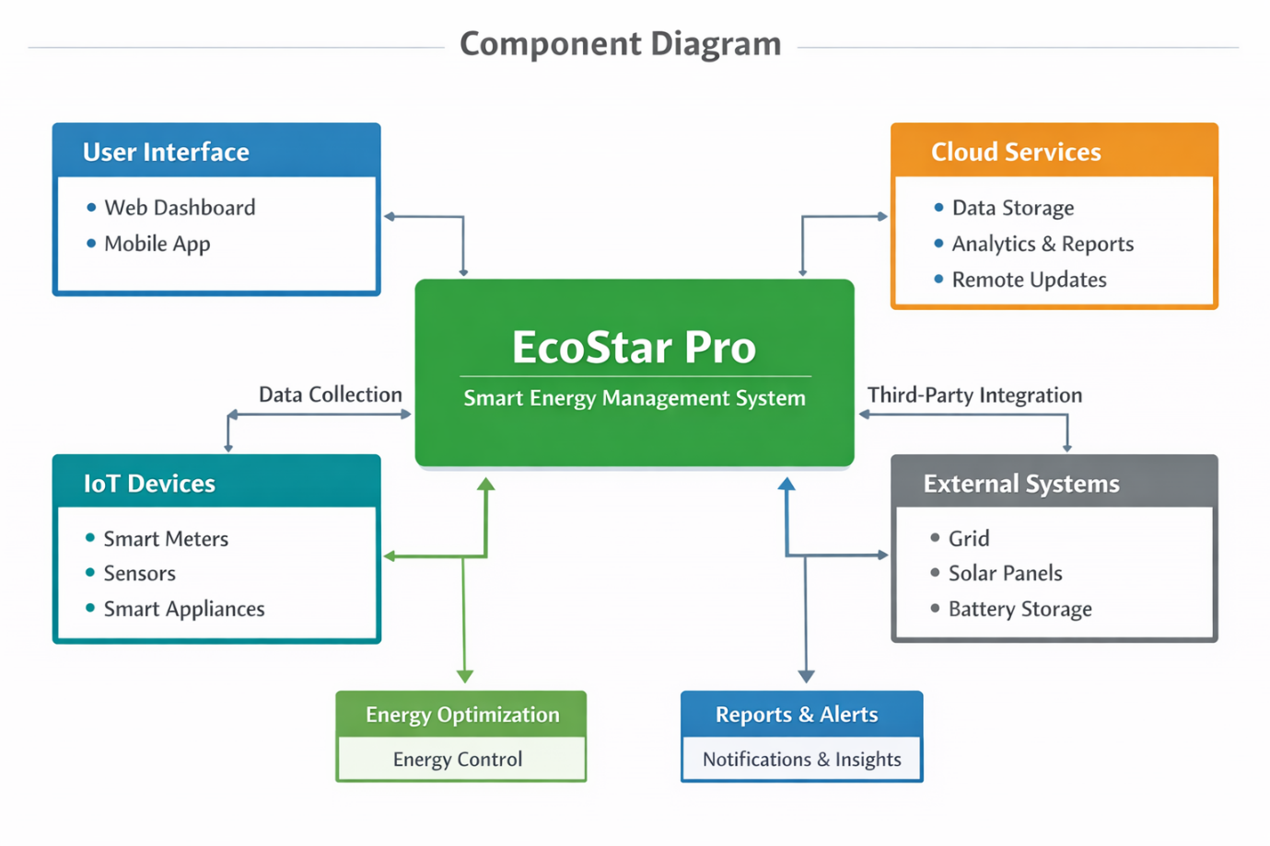

Chapter 3: Drawbacks and Limitations
While KnowsItAll provides a robust framework for decentralized learning, several technical and operational constraints must be acknowledged to ensure future optimization and realistic deployment.
1. Dependency on User Integrity and Data Accuracy
The effectiveness of the "Skill Passport" and the matching algorithm depends heavily on the accuracy of the data provided by users. While the Trust Ledger records transactions, the initial proficiency levels (Beginner to Expert) are self-proclaimed. Inaccurate self-assessment can lead to mismatched expectations between the Mentor and the Learner.
2. Limited Real-Time Proximity Accuracy
The "Skill Radar" relies on the Fused Location API and GPS hardware. In semi-urban areas with high-density buildings or poor satellite visibility, the 5km radius accuracy may fluctuate. This can result in users appearing on the radar who are actually outside the accessible range, or conversely, missing nearby mentors due to signal "drift."
3. Scalability Constraints of the Trust Ledger
The blockchain-inspired SHA-256 hashing ensures immutability, but as the transaction volume grows into the millions, the sequential nature of the hash-chain verification can lead to performance degradation. Without advanced indexing or sharding of the ledger, the backend may face latency issues during high-traffic periods.
4. Security and Privacy Risks
Handling real-time location data and personal skill histories raises significant privacy concerns. Even with JWT Authentication, the constant polling of a user's coordinates for the Skill Radar necessitates rigorous encryption and strict access controls to prevent unauthorized tracking or data breaches.
5. Connectivity Barriers in Semi-Urban Areas
The system requires a stable internet connection for JWT verification, token escrow, and the "QR Handshake." In regions with spotty 4G/5G connectivity, users may experience "Sync Failures" where a session is completed physically but cannot be recorded on the backend ledger immediately, leading to a temporary "state mismatch."
6. Rule-Based Matchmaking Limitations
Currently, the recommendation and discovery logic is primarily distance and category-based. The lack of advanced AI-driven matchmaking means the system cannot yet predict learning paths or suggest mentors based on complex behavioural patterns, restricting the level of personalization for diverse user needs.
7. Deployment Complexity of Native Features
Integrating native Android features like the Camera (for QR scanning), GPS (for the Radar), and Video APIs (for remote swaps) across various device manufacturers (OEMs) can lead to compatibility issues. Ensuring a consistent "look and feel" and performance across different Android versions requires extensive testing and specific environment setups.

Chapter 4: Proposed Enhancements
Following the structure of your reference report, here is the detailed Chapter 4: Proposed Enhancements for the KnowsItAll project. These points focus on transitioning the current MVP into a more intelligent, scalable, and globally accessible ecosystem.

Chapter 4: Proposed Enhancements
The current version of KnowsItAll provides a foundational framework for local skill sharing. To ensure long-term value and community growth, the following enhancements are proposed for future releases:
1. Integration with AI-Driven Matchmaking
Future versions can incorporate Machine Learning algorithms to analyze user learning patterns, search history, and proficiency gaps. This would enable the system to provide personalized "Learning Path" recommendations, suggesting mentors not just by distance, but by how well their teaching style matches the learner's previous successes.
2. Advanced Blockchain Integration for the Trust Ledger
While the current system uses a centralized cryptographic hash-chain, migrating the Trust Ledger to a decentralized blockchain (such as a private Ethereum sidechain or Hyperledger) would further enhance transparency. This would make the "Skill Passport" globally verifiable by third-party employers without relying on a central server.
3. Gamification and Community Incentives
To encourage consistent engagement, gamification elements such as "Mastery Badges," "Top Mentor" leaderboards, and streak rewards can be introduced. Users could earn special profile flairs or temporary "Boosts" on the Skill Radar by maintaining a high trust score and helping a diverse range of learners.
4. Augmented Reality (AR) Learning Aids
For physical skills (e.g., carpentry, mechanical repair, or plumbing), future updates could include AR overlays. A mentor could record a session where digital annotations appear over physical objects, which the learner can then view through their smartphone camera during the "Handshake" session to assist in hands-on tasks.
5. Multi-lingual and Local Dialect Support
To truly penetrate semi-urban and rural markets, KnowsItAll can be extended to support multiple regional languages and local dialects. Implementing a localized UI and voice-to-text features would ensure that users from diverse linguistic backgrounds can effectively navigate the Skill Radar and communicate with mentors.
6. Cloud-Based Analytics for Community Growth
Implementing advanced cloud-based analytics would allow the system to handle massive volumes of transaction data. This enhancement would provide administrators with "Knowledge Heatmaps," showing which skills are in high demand in specific regions, allowing for targeted community workshops or token incentives to fill those gaps.
7. Expanded "Skill Passport" Customization
Future updates may include customizable dashboard widgets and report formats, allowing users to tailor their Skill Passport for different use cases—such as a "Professional View" for job applications or a "Creative View" for social media sharing. This flexibility helps users focus on the most relevant insights related to their growth.

Chapter 5: Conclusion
KnowsItAll successfully addresses the growing need for a decentralized, user-friendly skill-sharing ecosystem that empowers individuals to discover, exchange, and verify expertise within their local communities. By leveraging Kotlin and Spring Boot, the system delivers a robust multi-platform solution that integrates hyper-local "Skill Radar" technology, secure token management, and a blockchain-inspired trust ledger into a single, cohesive platform.
Throughout the development process, key technical challenges, such as ensuring the mathematical immutability of the Trust Ledger, managing real-time GPS proximity constraints, and architecting a secure token escrow system, were identified and systematically addressed. Despite inherent limitations related to manual proficiency assessment and the dependency on mobile hardware accuracy, the project demonstrates substantial potential to democratize education and support the growth of the local gig economy.
Future enhancements, including the integration of AI-driven matchmaking, migration to a fully decentralized blockchain, and the implementation of Augmented Reality (AR) learning aids, will further increase the system’s efficacy and user engagement. These updates will transition the platform from a matching tool into a comprehensive, global knowledge-sharing infrastructure.
Overall, KnowsItAll lays a robust foundation for intelligent, community-driven applications that combine accessibility, cryptographic security, and actionable feedback to drive personal and professional growth. This project represents a significant step toward a sustainable "Knowledge Economy," empowering individuals to take control of their skill development through modern, technology-driven tools.

Chapter 7: Bibliography
- Botsman, R., & Rogers, R. (2010). What's Mine Is Yours: The Rise of Collaborative Consumption. HarperBusiness. (Foundational theory on P2P sharing economies).
- Nakamoto, S. (2008). Bitcoin: A Peer-to-Peer Electronic Cash System. (Basis for the cryptographic "Trust Ledger" and hashing logic).
- Goetz, B., et al. (2006). Java Concurrency in Practice. Addison-Wesley Professional. (Technical foundation for Spring Boot backend performance).
- JetBrains. (2024). Kotlin Programming Language Official Documentation. Retrieved from https://kotlinlang.org/docs/home.html
- Google Developers. (2024). Jetpack Compose Documentation: Build Better Apps Faster. Retrieved from https://developer.android.com/jetpack/compose
- Spring IO. (2024). Spring Boot Reference Guide. Retrieved from https://docs.spring.io/spring-boot/docs/current/reference/html/
- PostgreSQL Global Development Group. (2024). PostgreSQL 16 Documentation. Retrieved from https://www.postgresql.org/docs/16/index.html
- Google Cloud. (2024). Google Maps Platform: Places and Geolocation APIs. Retrieved from https://developers.google.com/maps/documentation
- OpenAI. (2024). ChatGPT-4 Technical Report. Retrieved from https://openai.com/research/gpt-4
- Philipp Lackner. (2024). Android Development with Kotlin & Jetpack Compose [Video Series]. YouTube. https://www.youtube.com/c/PhilippLackner
- Amigoscode. (2024). Spring Boot Full Stack Professional Tutorial [Video Series]. YouTube. https://www.youtube.com/c/amigoscode

Chapter 8: Annexure 1: User Sample Screens
8.1 Splash Screen
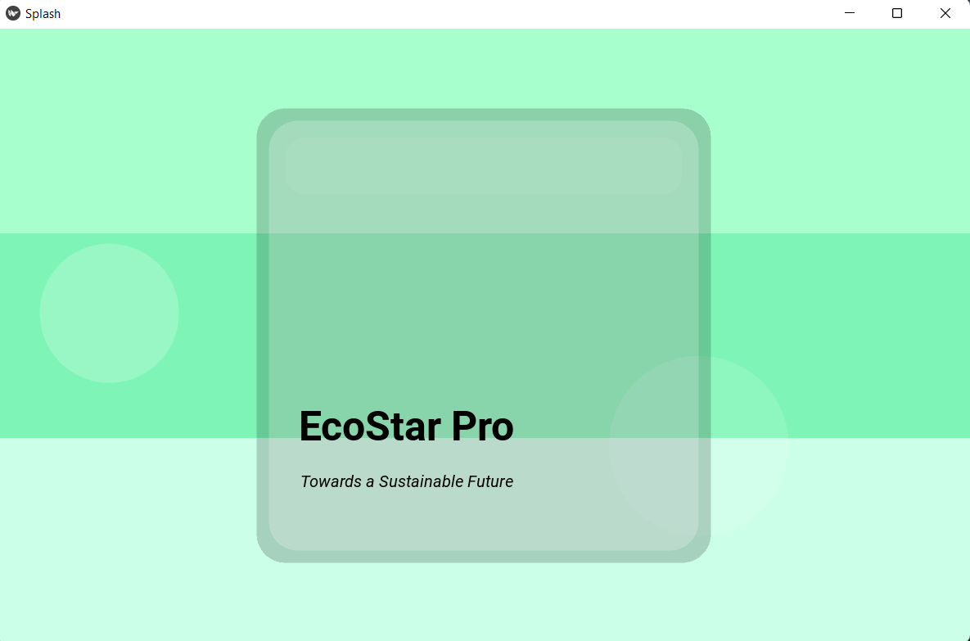

8.2 Login Screen (With Credentials)
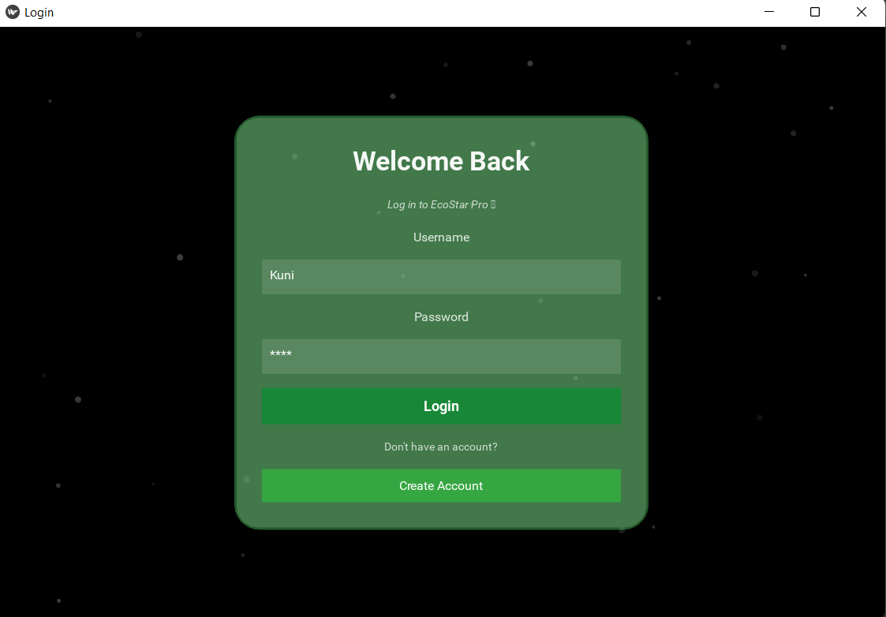
8.3 Register Screen (With Credentials)
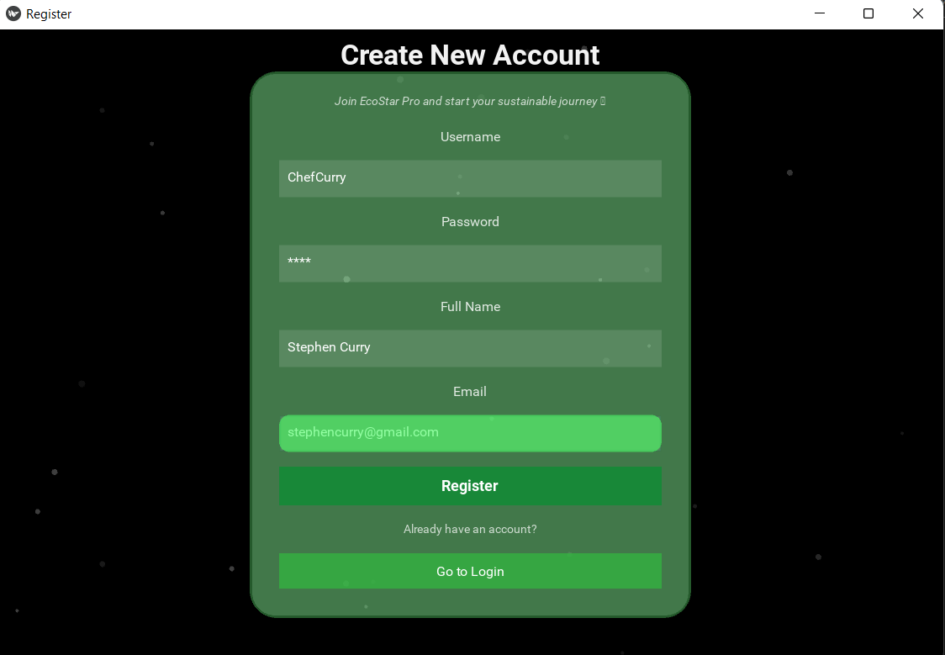
8.4 Home Page
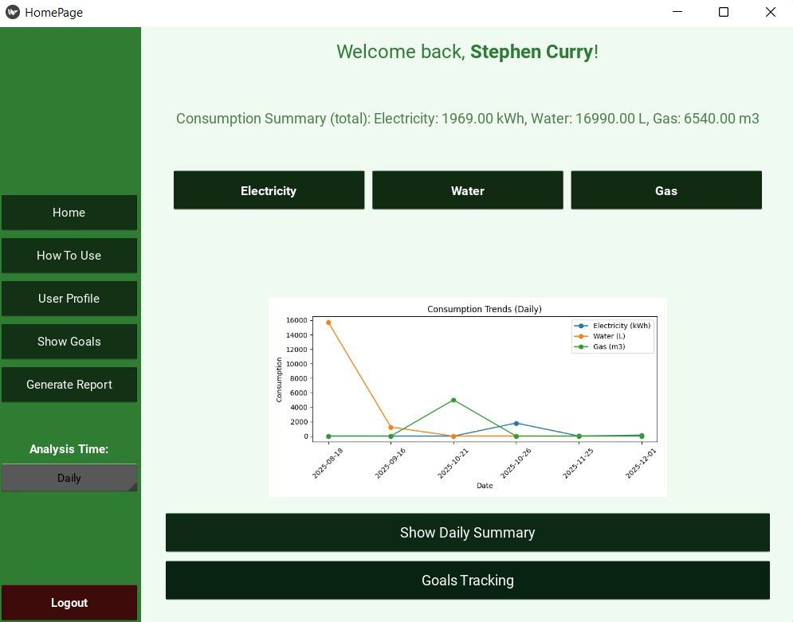

Data Entry:
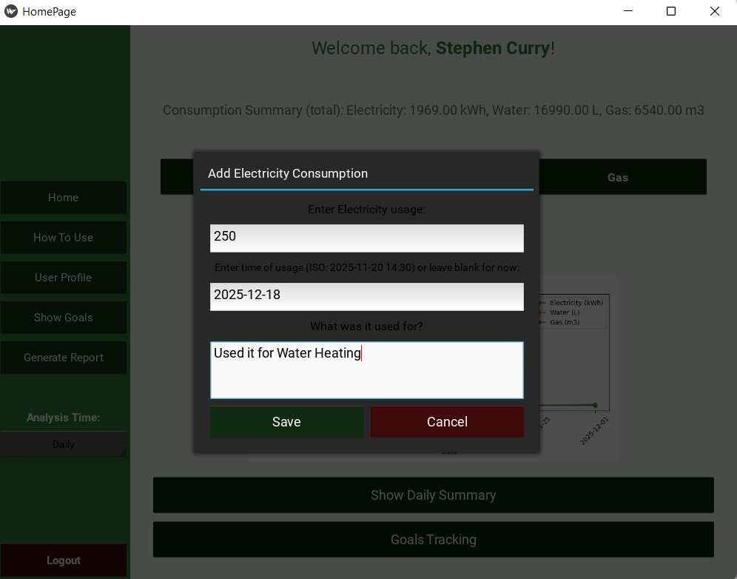
How to Use Page (User Manual):
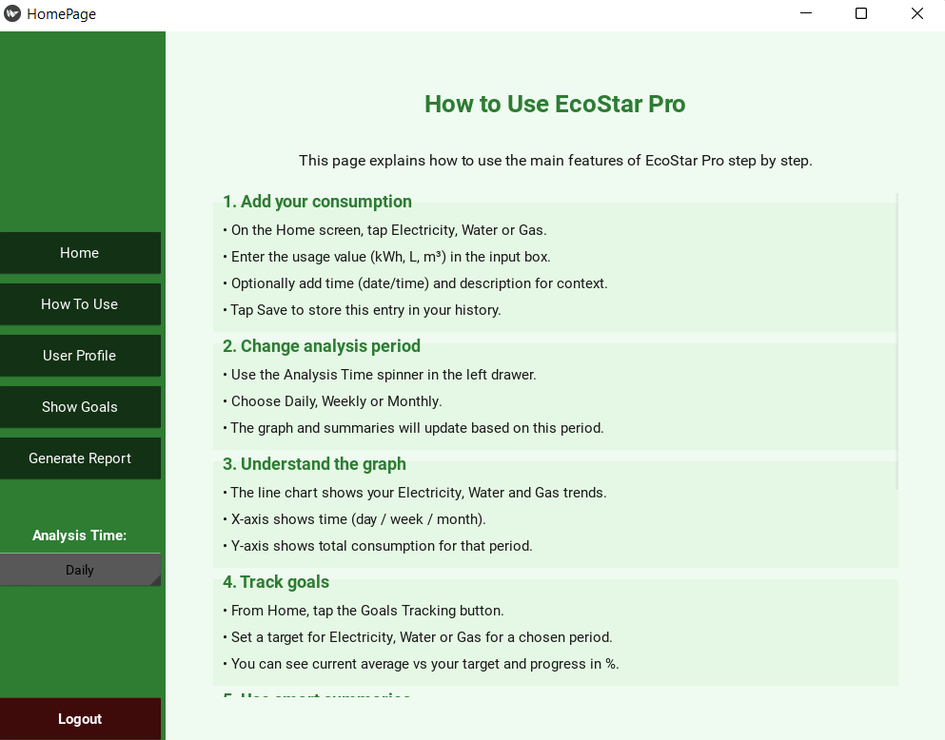

Usage Graph:
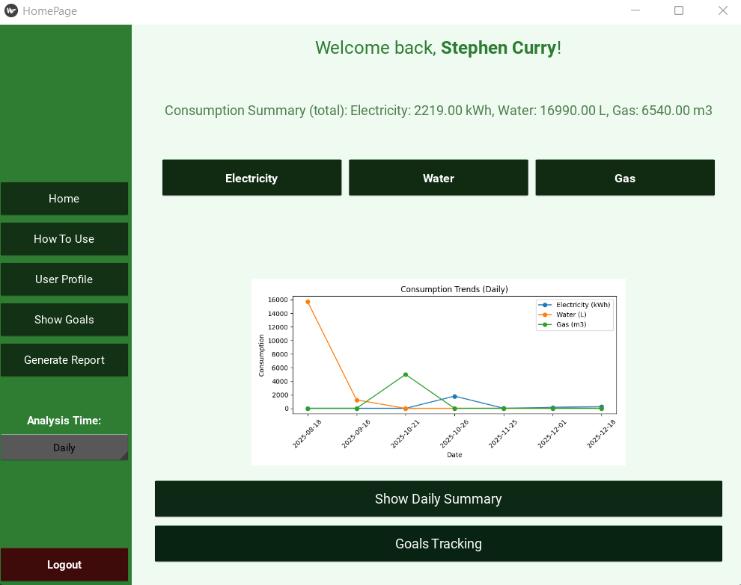
Daily Summary:
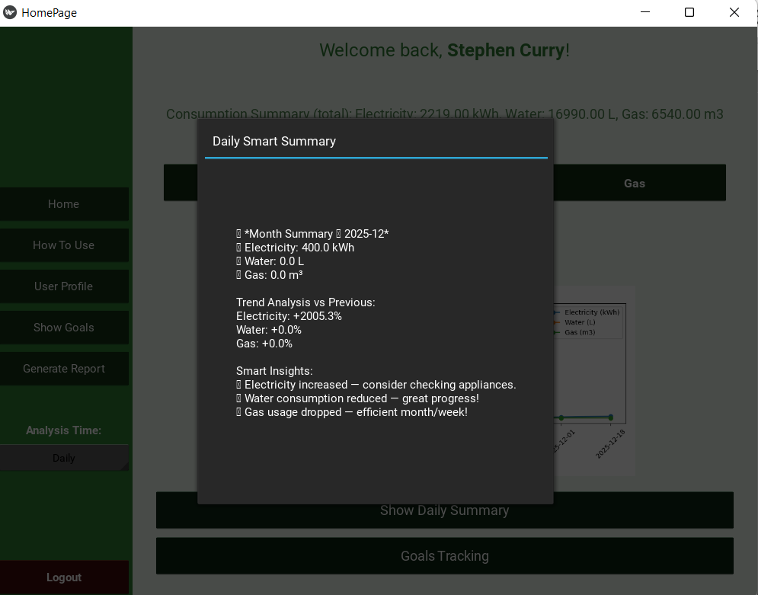

Goals Summary:
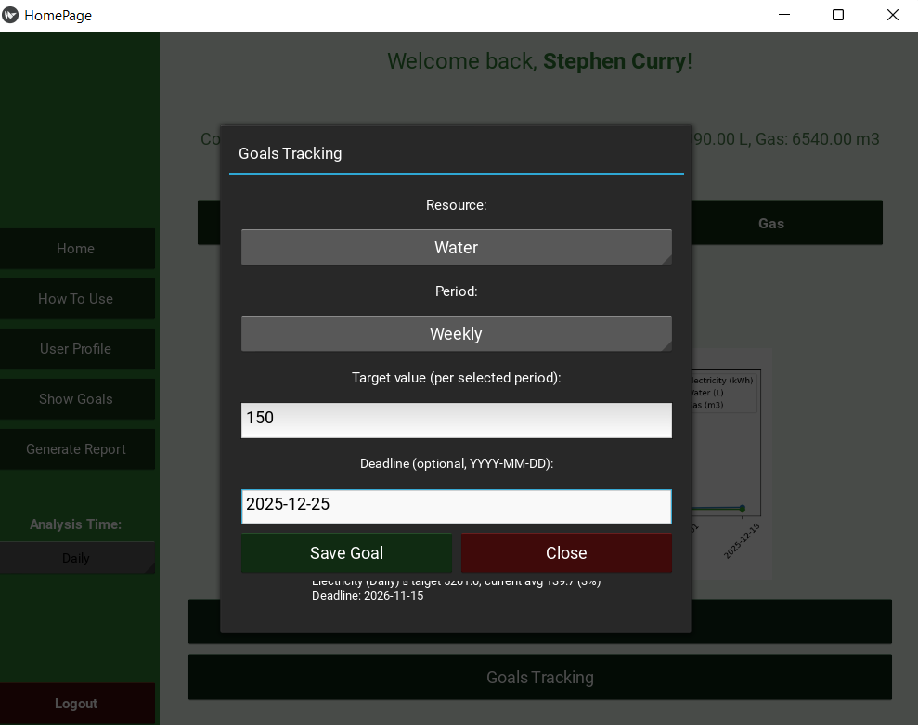
Goals Overview:
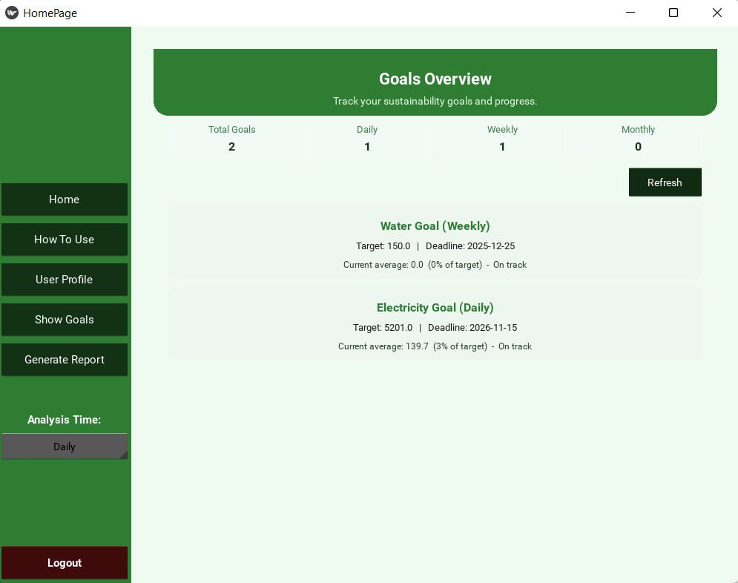

Report Generation:
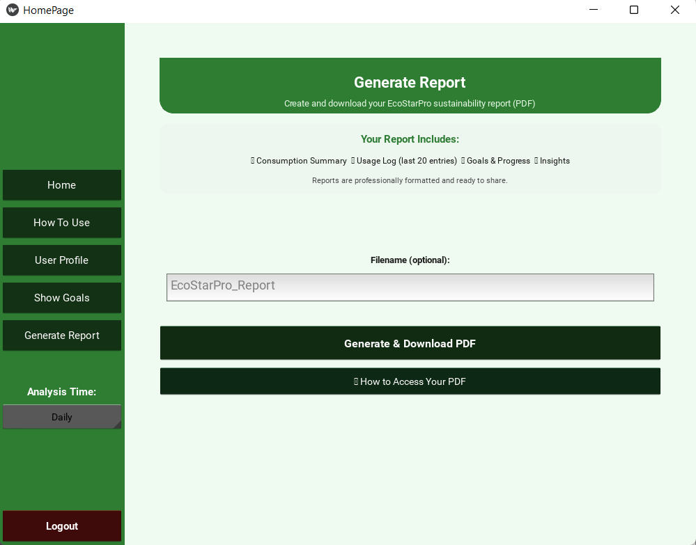

Annexure: Sample Program Code:
DB Creation
def ensure_users_table():
conn = sqlite3.connect(DB_PATH)
c = conn.cursor()
c.execute('''
CREATE TABLE IF NOT EXISTS users (
id INTEGER PRIMARY KEY AUTOINCREMENT,
username TEXT UNIQUE,
name TEXT,
email TEXT,
password_hash TEXT
)
''')
conn.commit()
conn.close()

ensure_users_table()

def create_consumption_table(db_path):
conn = sqlite3.connect(db_path)
c = conn.cursor()
c.execute('''
CREATE TABLE IF NOT EXISTS consumption (
id INTEGER PRIMARY KEY AUTOINCREMENT,
user_id INTEGER,
electricity REAL DEFAULT 0,
water REAL DEFAULT 0,
gas REAL DEFAULT 0,
entry_date TEXT DEFAULT (DATE('now')),
usage_time TEXT DEFAULT NULL,
usage_reason TEXT DEFAULT NULL
)
''')
conn.commit()
conn.close()
Goals Tracking:
def _fetch_goals(self):
conn = sqlite3.connect(self.db_path)
c = conn.cursor()
try:
c.execute("""
SELECT goal_type, target_value, period, deadline
FROM goals
WHERE user_id=?
ORDER BY created_at DESC
""", (self.user_id,))
rows = c.fetchall()
except Exception:
rows = []
conn.close()
return rows

def _compute_current_avg(self, goal_type, period):
conn = sqlite3.connect(self.db_path)
c = conn.cursor()

if period == "Daily":
group = "DATE(entry_date)"
lookback = "DATE('now', '-30 day')"
elif period == "Weekly":
group = "strftime('%Y-%W', entry_date)"
lookback = "DATE('now', '-90 day')"
else:
group = "strftime('%Y-%m', entry_date)"
lookback = "DATE('now', '-365 day')"

col = goal_type.lower()
try:
c.execute(f"""
SELECT AVG(s_val)
FROM (
SELECT {group} AS p, SUM({col}) AS s_val
FROM consumption
WHERE user_id=? AND DATE(entry_date) >= {lookback}
GROUP BY p
)
""", (self.user_id,))
row = c.fetchone()
except Exception:
row = (None,)
conn.close()
return row[0] or 0.0

def _build_summary_chip(self, title, value_text):
chip = BoxLayout(orientation='vertical',
padding=8,
spacing=3,
size_hint=(1, 1))
with chip.canvas.before:
Color(0.95, 0.98, 0.96, 1)
chip.bg = RoundedRectangle(radius=[10], pos=chip.pos, size=chip.size)
chip.bind(pos=lambda inst, val: setattr(chip.bg, 'pos', val),
size=lambda inst, val: setattr(chip.bg, 'size', val))

chip.add_widget(Label(
text=title,
font_size=13,
color=(0.25, 0.5, 0.3, 1),
size_hint=(1, None),
height=18
))
chip.add_widget(Label(
text=value_text,
font_size=16,
bold=True,
color=(0.1, 0.2, 0.1, 1),
size_hint=(1, None),
height=22
))
return chip

