--question 5.1 #should answer why

select * FROM (select permno, max(prc) as max_2010 FROM stocks2016.d2010 group by permno) as df

inner join

(select * FROM (select permno, max(prc) as max_2011 FROM stocks2016.d2011 group by permno) as diff) as final

on df.permno = final.permno;

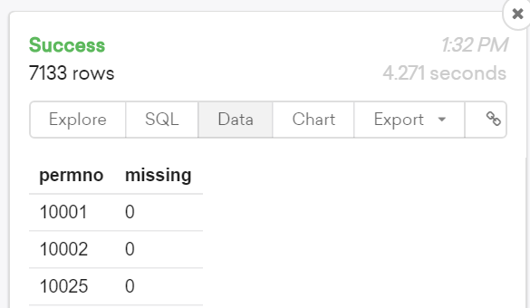

--question 5.2 #？？？

select * FROM (select permno as p FROM stocks2016.d2010) as df left join (select permno FROM stocks2016.d2011) as final on df.p = final.permno;

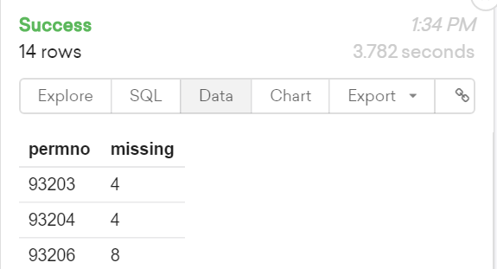

--question 5.3

select permno, max(retdate::timestamp) as last, min(retdate::timestamp) as first FROM stocks2016.d2010 group by permno;

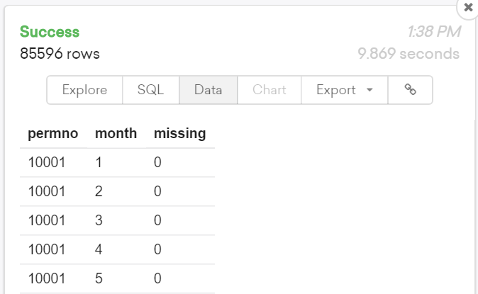

--question 5B4 shrout * prc

select LHS.SIC, LHS.marketValue/RHS.SumOfValue as percentage FROM

(select sum(shrout*prc) as marketValue, trunc(hsic/100) as SIC

FROM stocks2016.d2010

where retdate = '2010-01-11'

and prc is not null

and shrout is not null

and hsic is not null

group by SIC) as LHS

cross join

(select sum(marketValue) as SumOfValue FROM (select sum(shrout*prc) as marketValue, trunc(hsic/100) as SIC

FROM stocks2016.d2010

where retdate = '2010-01-11' group by SIC) as sin ) as RHS

ORDER BY percentage desc;

--the largest one is sic 28

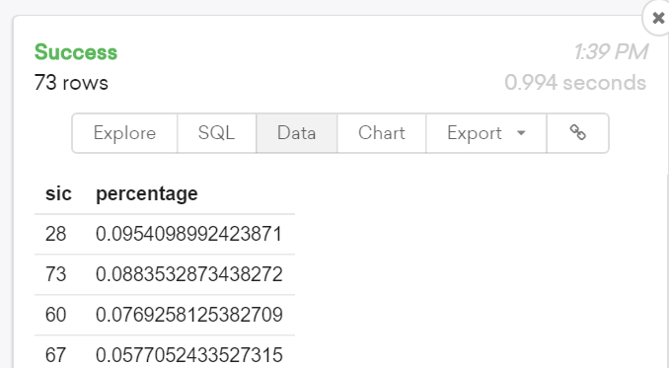

--question 5B5

select LHS.permno, RHS.FirPrice, RHS2.LasPrice FROM

(select permno, min(retdate) as FirstDay, max(retdate) as LastDay

FROM

stocks2016.d2010 group by permno) as LHS

left join

(select permno, retdate, prc as FirPrice FROM stocks2016.d2010) as RHS

on LHS.permno = RHS.permno and LHS.FirstDay = RHS.retdate

left join

(select permno, retdate, prc as LasPrice FROM stocks2016.d2010) as RHS2

ON LHS.permno = RHS2.permno AND LHS.LastDay = RHS2.retdate;

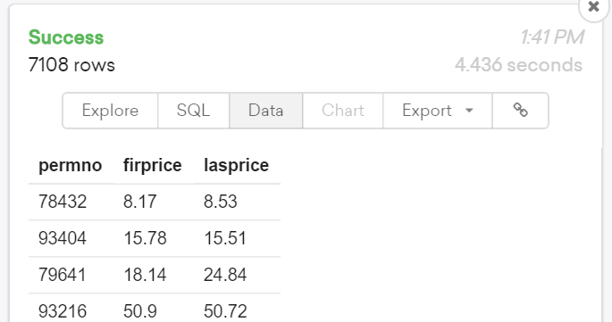

--question 5B6

select LHS.PlazeID, (RHS.later - LHS.origin)/LHS.origin as percentage

FROM

(select PlazeID, avg(ez) as origin

FROM

MTA where date_part('year',date)=2015 and

date_part('dow', date) = 1

group by PlazeID) as LHS

left join

(select PlazeID, avg(ez) as later

FROM

MTA where date_part('year', date) = 2016 and

date_part('dow',date)= 1

group by PlazeID) as RHS

on LHS.PlazeID = RHS.PlazeID;

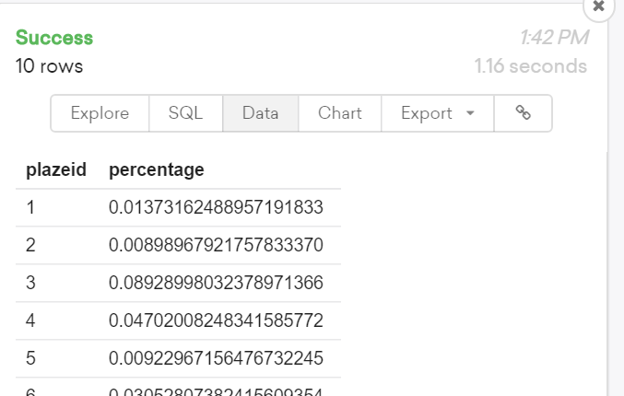

--question 5B7

select LHS.DOW, LHS.Ez2016/RHS2.sum2016 as percentage2016,

RHS3.Ez2015/RHS4.sum2015 as percentage2015 FROM

(select date_part('dow', date) as DOW,

sum(ez) as Ez2016 FROM MTA

where date_part('year',date) = 2016

and PlazeID = 1

group by DOW) as LHS

cross join

(select sum(ez) as sum2016 FROM MTA

where date_part('year', date)= 2016

and PlazeID =1) as RHS2

left join

(select date_part('dow',date) as DOW, sum(ez) as Ez2015 FROM MTA

where date_part('year',date) =2015

and PlazeID = 2

group by date_part('dow',date))

as RHS3 on LHS.DOW = RHS3.DOW

cross join

(select sum(ez) as sum2015 FROM MTA

where date_part('year',date) = 2015

and PlazeID = 2) as RHS4;

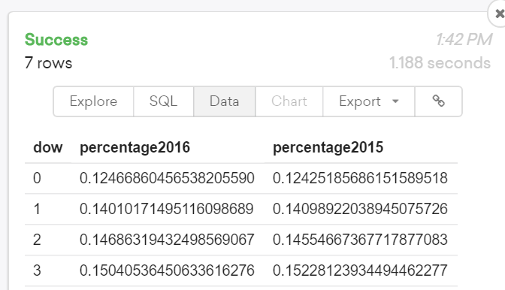

--question 5B8

select hour, max(ez) FROM MTA where PlazeID = 1 and Direction = 'O' group by hour;

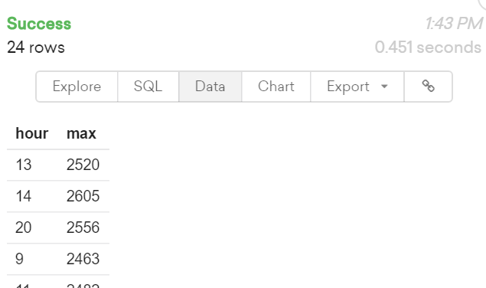

--question 5B9

select concat(date_part('dow',date), hour) as DowHour,

max(ez) FROM MTA where PlazeID =1 and Direction = 'O'

group by DowHour;

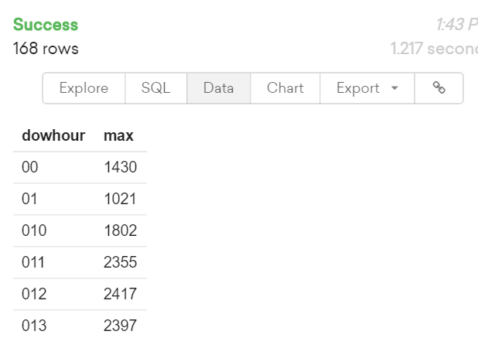

--question 5B10

select LHS.hour, LHS.MaxIn1, RHS.MinOut2, RHS2.Max3 FROM

(select hour, max(ez) as MaxIn1 FROM MTA

where PlazeID = 1 and Direction = 'I'

group by hour) as LHS

left join

(select hour, min(ez) as MinOut2 FROM MTA

where PlazeID = 2 and Direction = 'O'

group by hour) as RHS

on LHS.hour = RHS.hour

left join

(select hour, max(ez) as Max3 FROM MTA

where PlazeID = 3 group by hour) as RHS2

on LHS.hour = RHS2.hour;

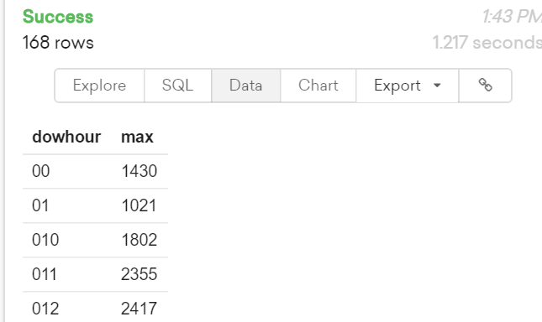

--question5b11

select LHS.hour, LHS.PlazeID,LHS.dow, case when RHS.Out = 0 then 0 else LHS.In/RHS.Out end as ratio

FROM

(select hour, PlazeID, date_part('dow',date) as dow, sum(case when Direction = 'I' then ez+Cash else 0 end) as In

FROM MTA group by hour, PlazeID,dow) as LHS

left join

(select hour, PlazeID, date_part('dow',date) as dow, sum(case when Direction = 'O' then ez+Cash else 0 end) as Out

FROM MTA group by hour, PlazeID,dow) as RHS

on LHS.hour = RHS.hour and LHS.PlazeID = RHS.PlazeID and LHS.dow = RHS.dow;

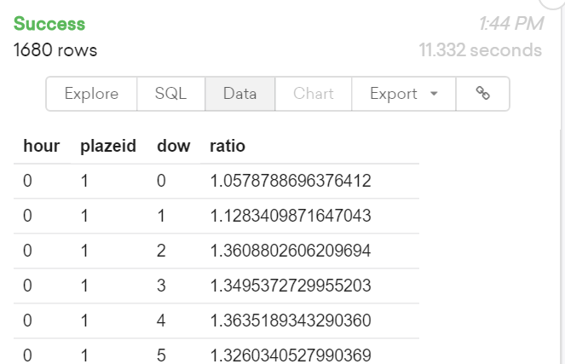

--question5b12

select LHS.hour, LHS.PlazeID,LHS.dow, case when RHS.Out = 0 then null else LHS.In/RHS.Out end as ratio2014,

case when RHS3.Out = 0 then null else RHS2.In/RHS3.Out end as ratio2015

FROM

(select hour, PlazeID, date_part('dow',date) as dow, sum(case when Direction = 'I' then ez+Cash else 0 end) as In

FROM MTA where date_part('year',date) = 2014 group by hour, PlazeID,dow) as LHS

left join

(select hour, PlazeID, date_part('dow',date) as dow, sum(case when Direction = 'O' then ez+Cash else 0 end) as Out

FROM MTA where date_part('year', date)=2014 group by hour, PlazeID,dow) as RHS

on LHS.hour = RHS.hour and LHS.PlazeID = RHS.PlazeID and LHS.dow = RHS.dow

left join

(select hour, PlazeID, date_part('dow',date) as dow, sum(case when Direction = 'I' then ez+Cash else 0 end) as In

FROM MTA where date_part('year',date) = 2015 group by hour, PlazeID,dow) as RHS2

on LHS.hour = RHS2.hour and LHS.PlazeID = RHS2.PlazeID and LHS.dow = RHS2.dow

left join

(select hour, PlazeID, date_part('dow',date) as dow, sum(case when Direction = 'O' then ez+Cash else 0 end) as Out

FROM MTA where date_part('year', date)=2015 group by hour, PlazeID,dow) as RHS3

on LHS.hour = RHS3.hour and LHS.PlazeID = RHS3.PlazeID and LHS.dow = RHS3.dow;

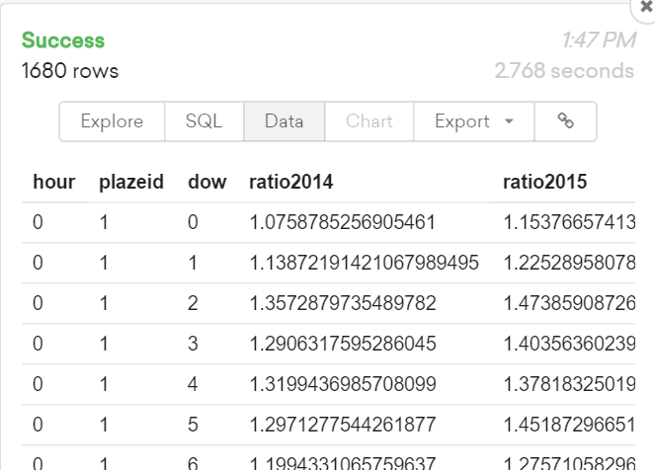

--question5b13

select LHS.hour, LHS.dow, case when RHS.Out = 0 then 0 else LHS.In/RHS.Out end as ratio

FROM

(select hour, date_part('dow',date) as dow, sum(ez) + sum(cash) as In

FROM MTA where date in (select date

FROM

(select date, sum(ez)+sum(cash) as total FROM MTA group by date) as a

where total in

(select max(total)

FROM (select date, sum(ez)+sum(cash) as total

FROM MTA

group by date) as b)) and Direction = 'I'

group by hour, dow) as LHS

left join

(select hour, date_part('dow',date) as dow, sum(ez) + sum(cash) as Out

FROM MTA

where date in (select date

FROM

(select date, sum(ez)+sum(cash) as total FROM MTA group by date) as a

where total in

(select max(total)

FROM (select date, sum(ez)+sum(cash) as total

FROM MTA

group by date) as b)) and Direction = 'O'

group by hour, dow) as RHS

on LHS.hour = RHS.hour and LHS.dow = RHS.dow;

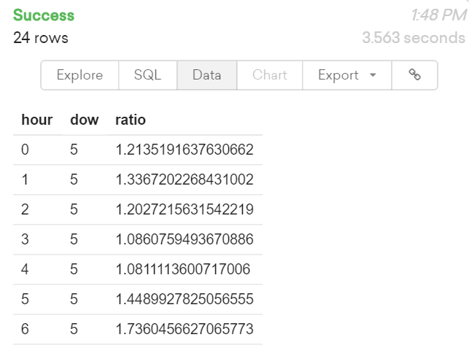

--question5b14

select permno, sum(index)-sum(exist) as missing FROM

(select LHS.permno, case when RHS3.data is null then 0 else 1 end as exist,

case when RHS.fullDay < RHS2.FirstDay then 0 else 1 end as index

FROM

(select distinct permno FROM stocks2016.d2010) as LHS

cross join

(select distinct retdate as fullDay FROM stocks2016.d2010) as RHS

left join

(select permno as stockName, retdate as data FROM stocks2016.d2010) as RHS3

on LHS.permno = RHS3.stockName and RHS.fullDay = RHS3.data

left join

(select permno, min(retdate) as FirstDay FROM stocks2016.d2010

group by permno) as RHS2

on LHS.permno = RHS2.permno) as whole

group by permno;

