Funnel Assignment

1.(a)

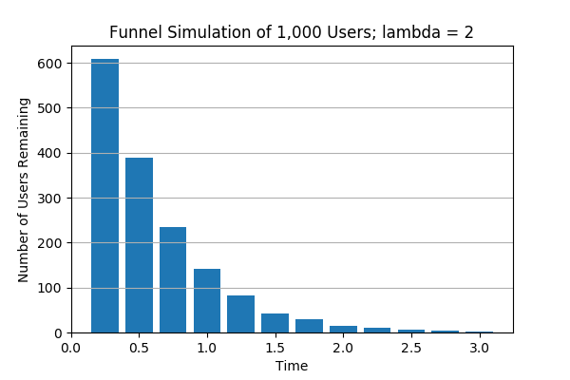

1.(b)

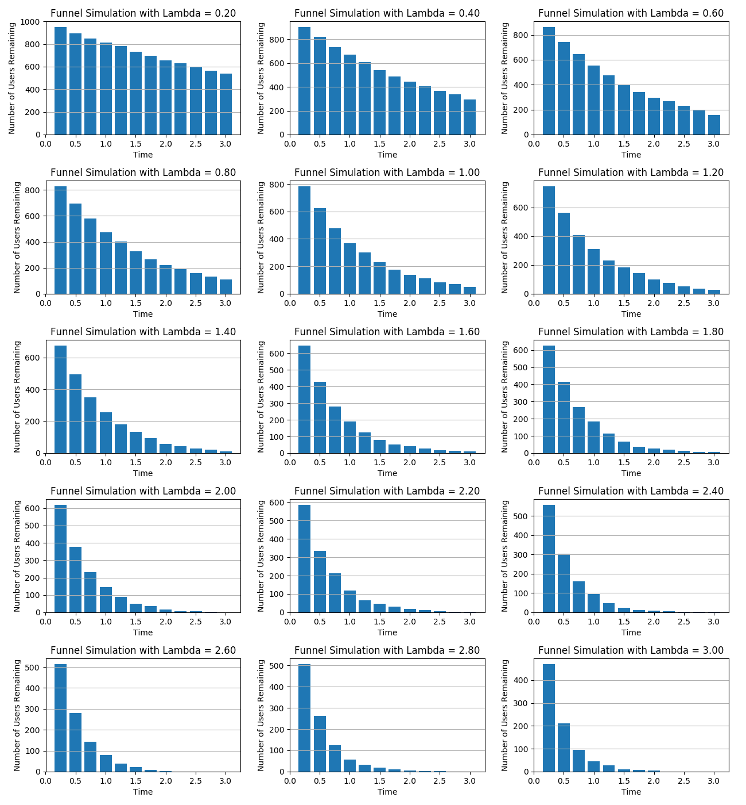

1.(c)

Survival time of a specified proportion of users is the total time spent by that proportion of users in the system (e.g. the sign-up pages of a website) before dropping out. E.g. survival time for 50% of the users is the time it takes for 50% of the users to drop out of the system. From the plots in (b), it appears that the survival time for any proportion of users drops down as lambda increases; i.e. lambda and survival time have an inverse relationship.

2.(a)

The output of EstLam1 is unbiased because exponential distribution is memory less, same as the simulated user quitting time.

2.(b)

The estimated lambda value is 0.994.

2.(c)

95% confidence interval for the estimated lambda is [ 0.974, 1.012]

2.(d)

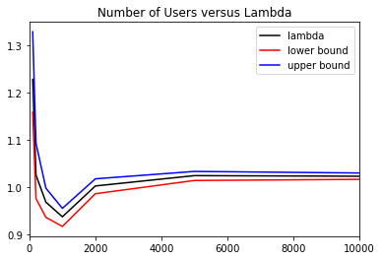

As number of users increases the 95% confidence interval decreases. This means when we simulate more user data, we become more confident about the lambda we are estimating.