Department of Computer Engineering, Ramdeobaba University Nagpur

Tools and Simulation

Title of the Experiment:
Impact of IoT Background Traffic on Real-Time Application Performance: A Smart Home Simulation Study

Submitted by:
Amar Shukla (A2_B2_27)
Kunal Nayak (A2_B4_53)
Mohit Agrawal (A2_B2_33)
Email id :
shuklaa_2@rbunagpur.in
24nayakk@rbunagpur.in
24agrawalm_1@rbunagpur.in

1. Aim / Objective
To simulate and analyze the performance degradation caused by IoT background traffic in smart home networks and measure its impact on real-time application performance such as video communication.

2. Theory / Conceptual Background
Smart homes contain numerous IoT devices that communicate with remote cloud servers using lightweight protocols such as MQTT or CoAP. This traffic is usually frequent and small-sized, but collectively it increases network load on the home gateway. Real-time applications such as video conferencing are highly sensitive to delay (latency) and variation in delay (jitter). In this experiment, we compare the difference in performance under two scenarios: a quiet network and a network overloaded with IoT traffic.

3. Software / Simulation Tool Used
Cisco Packet Tracer v8.x

4. Hardware / Software Requirements
Hardware Requirements:
- Processor: Intel i5 or above
- RAM: 8 GB or above
Software Requirements:
- Operating System: Windows 10 / Linux / macOS
- Simulation Tool: Cisco Packet Tracer v8.x

5. Procedure / Steps Performed
Figure 1: Flowchart of the simulation procedure.
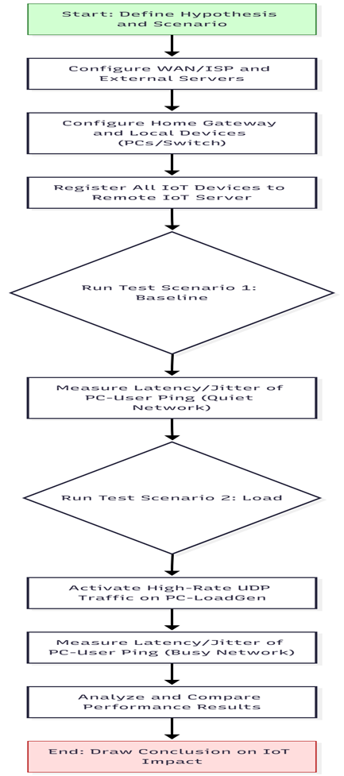

6. Simulation Diagram / Screenshot
Figure 2: Simulation network topology in Cisco Packet Tracer.
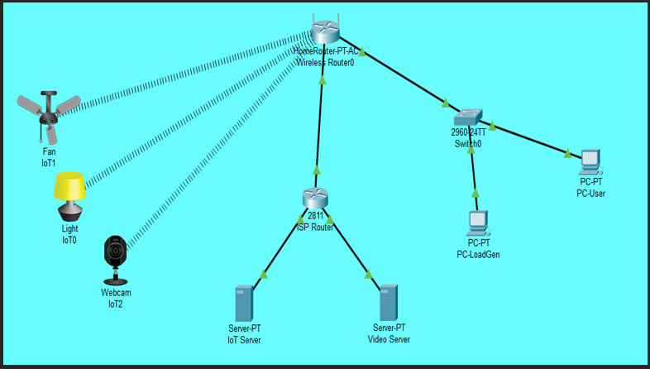

Configuration Screenshots: Figure 3: ISP Router static route configuration
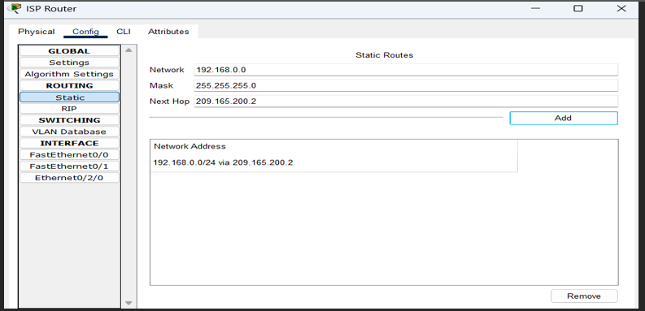

Figure 4: IoT Server service configuration
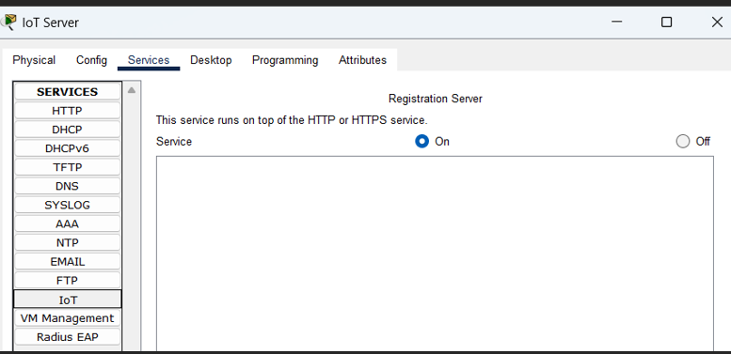
Figure 5: Video Server service configuration.
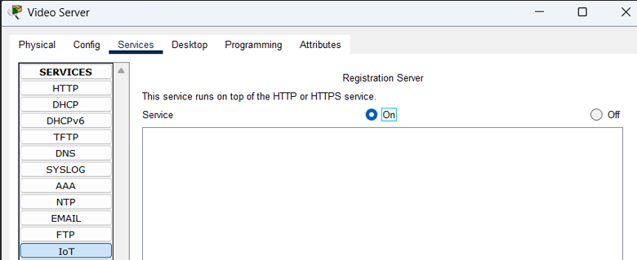

Figure 6: IoT device (IoT0) remote server configuration
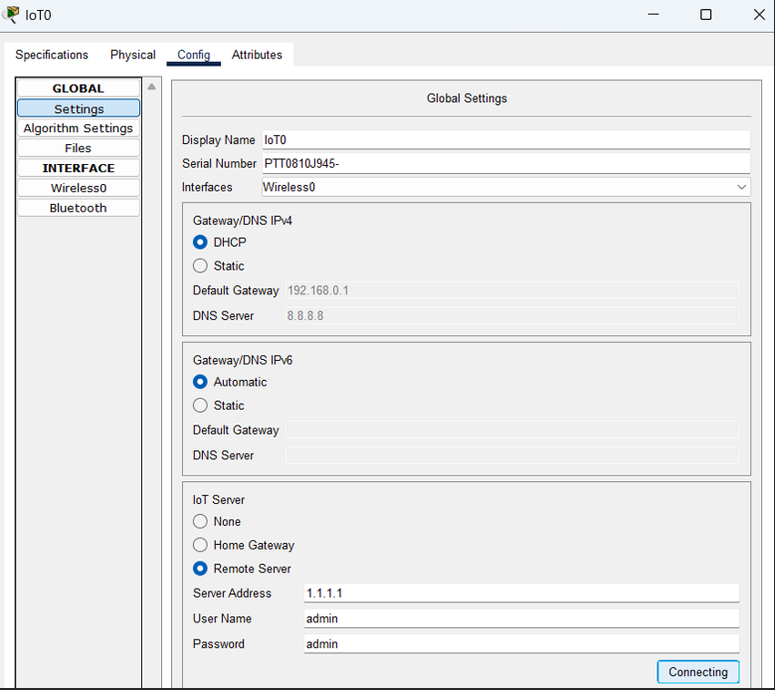
Figure 7: PC-LoadGen traffic generator settings.
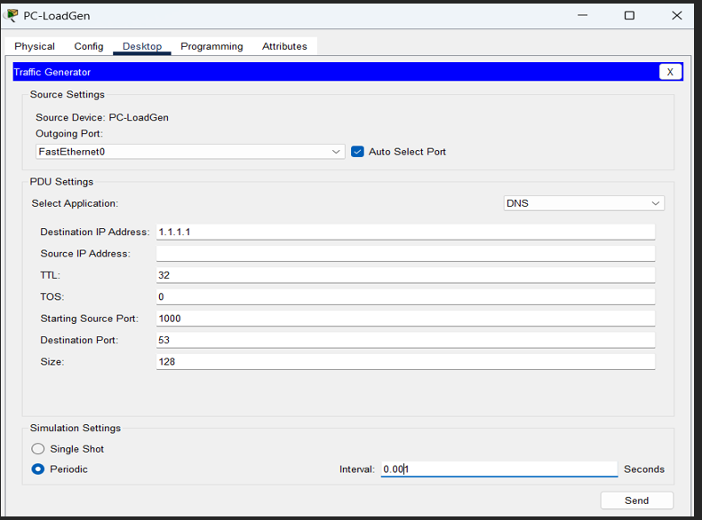

7. Observations

Scenario 1: Baseline (Quiet Network)
Latency: ~10.5 ms
Jitter: ~1 ms
No packet loss observed.
Network condition was stable and suitable for real-time communication.

Figure 8: Ping results for Scenario 1 (Baseline / Quiet Network).
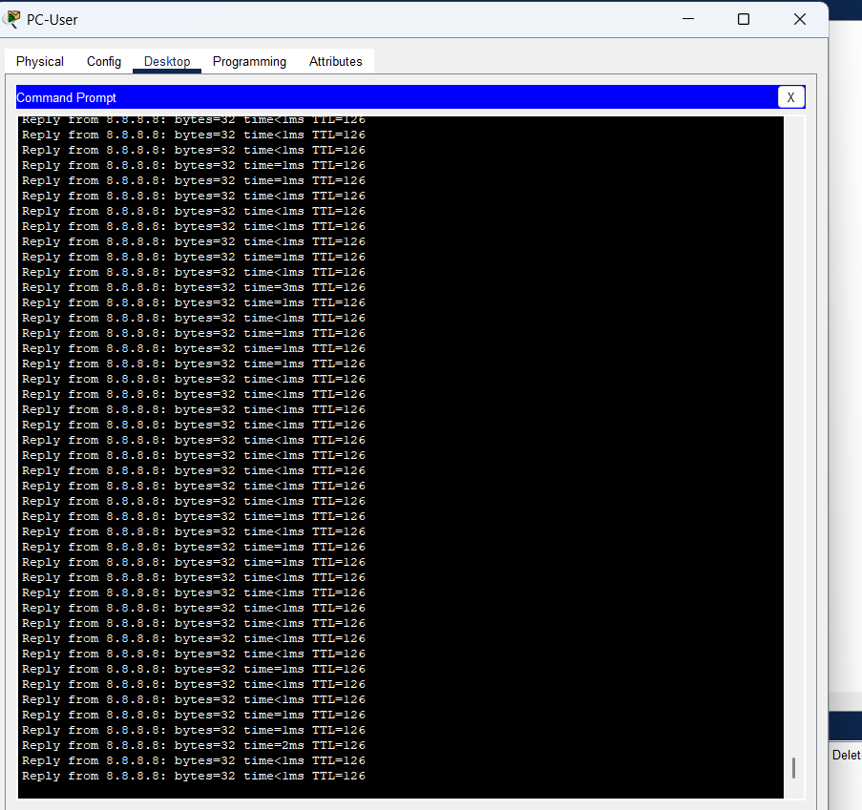

Scenario 2: Load (High IoT Traffic)
Latency: ~85.2 ms (high delay)
Jitter: >130 ms (extreme variation)
Packet loss present
Real-time application would experience lag, freezes, and poor audio/video quality.

Figure 9: Ping results for Scenario 2 (Load / High IoT Traffic).

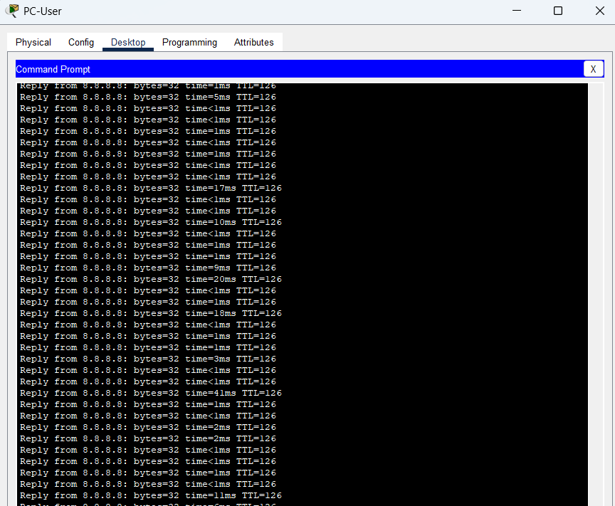

8. Result / Output
The experiment successfully demonstrated that heavy IoT background traffic severely impacts real-time applications. The performance difference between the baseline and load conditions highlights the need for traffic prioritization (QoS).

9. Conclusion
The Home Gateway becomes a bottleneck when IoT traffic increases. Without proper QoS configuration, real-time applications such as video conferencing experience performance degradation. QoS or traffic shaping is necessary to prioritize time-sensitive traffic over IoT background communication.

10. Viva Questions and Answers
Q1. What is the difference between latency and jitter?
Ans: Latency is the delay time it takes for data to travel from source to destination. Jitter is the variation in latency between packets, and it affects real-time applications like video calls.
Q2. Why does UDP traffic cause congestion faster than TCP?
Ans: UDP does not perform congestion control or retransmission. It keeps sending packets at a constant rate, which can overload network devices.
Q3. What is the role of the Home Gateway router in a smart home network?
Ans: The Home Gateway routes traffic between internal devices and the internet. It acts as the central hub for all communication.
Q4. How can QoS improve real-time communication performance?
Ans: QoS prioritizes time-sensitive packets, ensuring that video/audio traffic is forwarded before background traffic, reducing latency and jitter.
Q5. Why do IoT devices generate continuous traffic?
Ans: IoT devices frequently send sensor updates and status reports to remote servers, resulting in constant low-data but high-frequency traffic.

