Q 1) Grade Checker
Program:
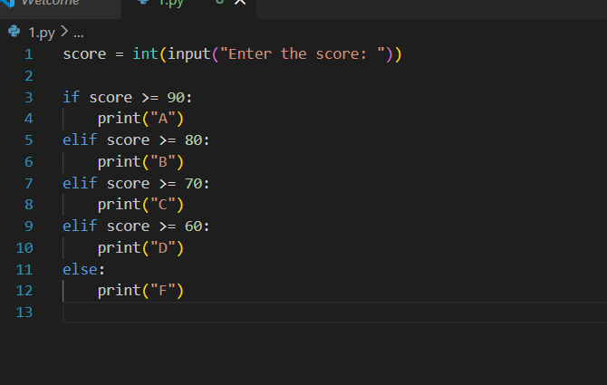
Output:
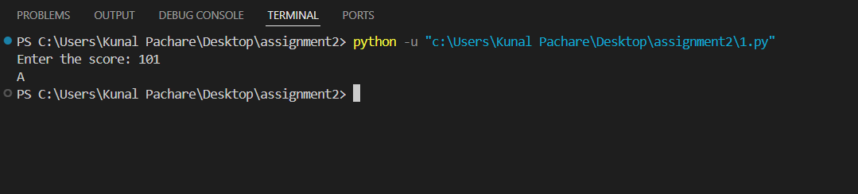
In this program I have take input from user i.e their score and print grade base on individuals score.
It demonstrate use of if-else statement very preciously. Thus helps to better understand flow of program easily.

Q 2) Student Grades
Program: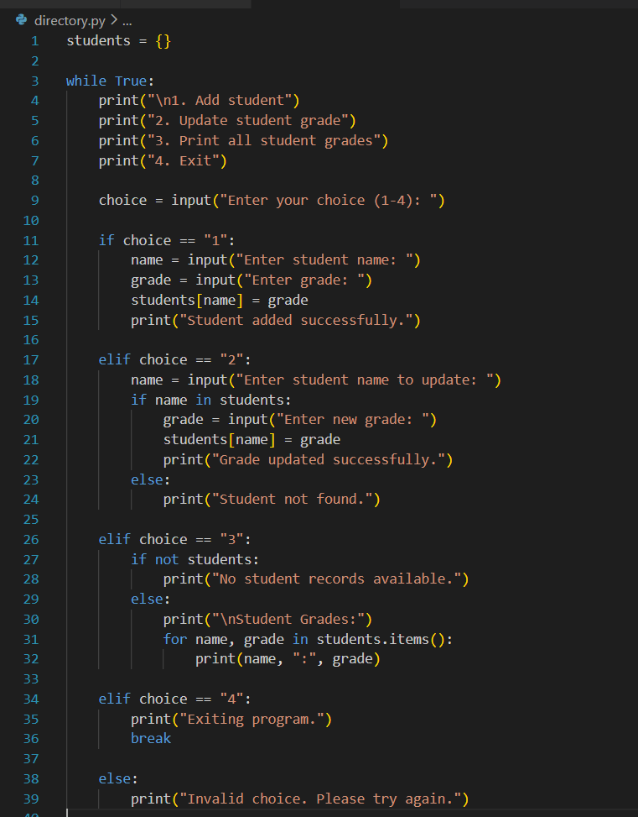

Output: 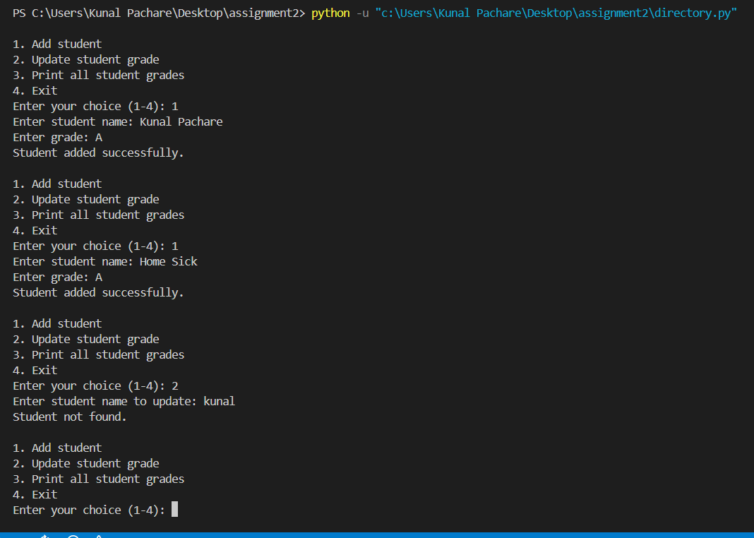
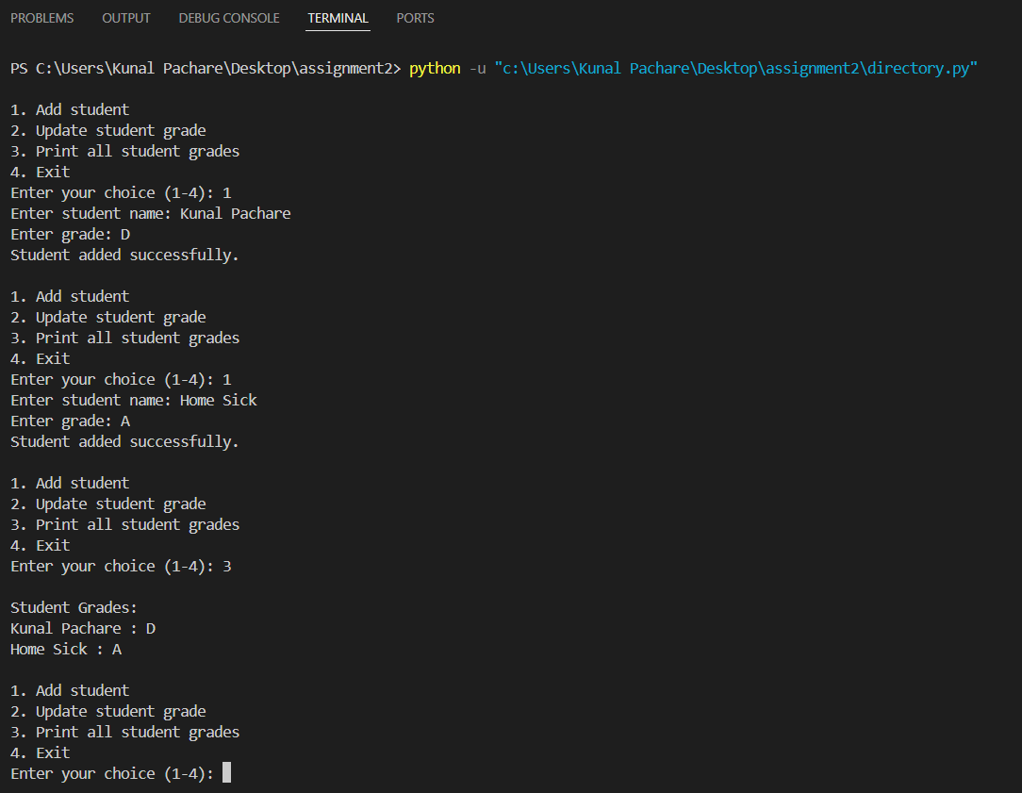
In this program I am taking constantly input from the user. I have provide them with options and their functions, users can add, update and view students. It helps to track the students records in the world.
If I have to talk about technical stuff of the program then, a dictionary is a built-in data structure used to store data in key–value pairs in python.

Q 3) .Write to a File
Program:
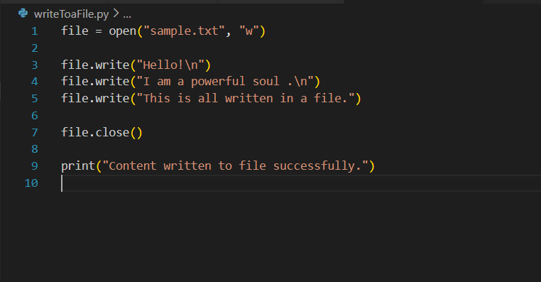
Output:
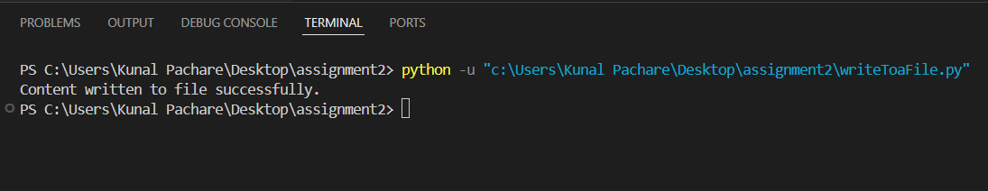
In this program I have create a ‘sample.txt’ file and write some content in it and close file. In the last I print a line which says I have done the task successfully.
Important thing to know:
File = open(“sample.txt”, “w)
This line first insure that if sample.txt if already present or not, if such file exits it erase its content. Otherwise it will create one.

Q 4) Read from a File
Program:
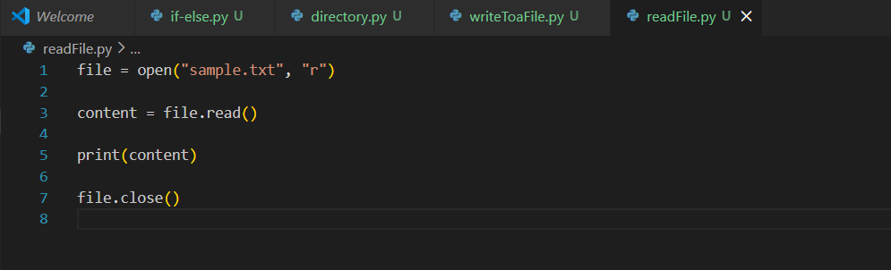
Output:
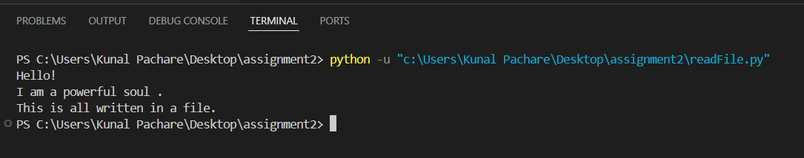
This program helps to read the content written inside the file. Its very helpful and easy to understand.

