Android APK
Static Analysis Report
Sample: app-debug.apk
Prepared as an educational reverse-engineering and static-analysis exercise

Analyst | Kunal Rajpurohit
Analysis date | 27-28 September 2026
Environment | Kali Linux (Live environment)
Analysis type | Static analysis / APK structure inspection
Scope | Offline inspection only; no dynamic execution or network behavior assessment

Note: Findings below are limited to what is directly supported by the captured static-analysis evidence. No claim of maliciousness is made.

1. Executive Summary
The Android package app-debug.apk was examined using common static-analysis techniques on Kali Linux. The sample was identified as a valid Android APK, hashed with SHA-256, inspected as a ZIP-compatible archive, extracted, and decoded with APKTool. The decoded output exposed the Android manifest, resources, Smali code, APKTool metadata, and signing-related META-INF files.
The available screenshots show a small debug-named APK with a file size of approximately 1.1 MB. APKTool metadata reports versionName 1.0, versionCode 1, minSdkVersion 19 and targetSdkVersion 23. The captured evidence does not by itself establish malicious behavior. A complete security assessment would also require focused manifest review, sensitive-string searches, code-path review, and ideally controlled dynamic analysis.

2. Objectives
- Confirm that the supplied sample is an Android APK and record basic metadata.
- Generate a cryptographic hash so the exact sample can be referenced consistently.
- Inspect the internal APK structure without executing the application.
- Decode resources and Dalvik bytecode into a form suitable for manual review.
- Document observations conservatively and separate confirmed facts from items requiring further analysis.

3. Tools and Commands Used
Tool / command | Purpose | Result
file app-debug.apk | Identify the file format | Recognized as an Android package (APK) containing AndroidManifest.xml.
ls -lh app-debug.apk | Record basic size/permissions | Sample shown at approximately 1.1 MB.
sha256sum app-debug.apk | Generate sample fingerprint | SHA-256 recorded for integrity/reference.
unzip -l app-debug.apk | List archive contents | Manifest, resources, classes.dex and META-INF entries observed.
unzip -q app-debug.apk -d apk_extraction | Extract APK archive | Core APK files extracted for inspection.
apktool d app-debug.apk -o apktool_output | Decode resources and bytecode | Readable resources, manifest and Smali structure produced.

4. Sample Identification
Filename: app-debug.apk
Observed size: approximately 1.1 MB
SHA-256: b47cc96e16bb2b9955a288caaefa54f07116c8d2be0ff6335b66ef2954f40334
The hash is useful as a unique fingerprint for this exact file. It does not indicate whether the APK is safe or malicious; it simply allows the analyzed sample to be identified and compared consistently.
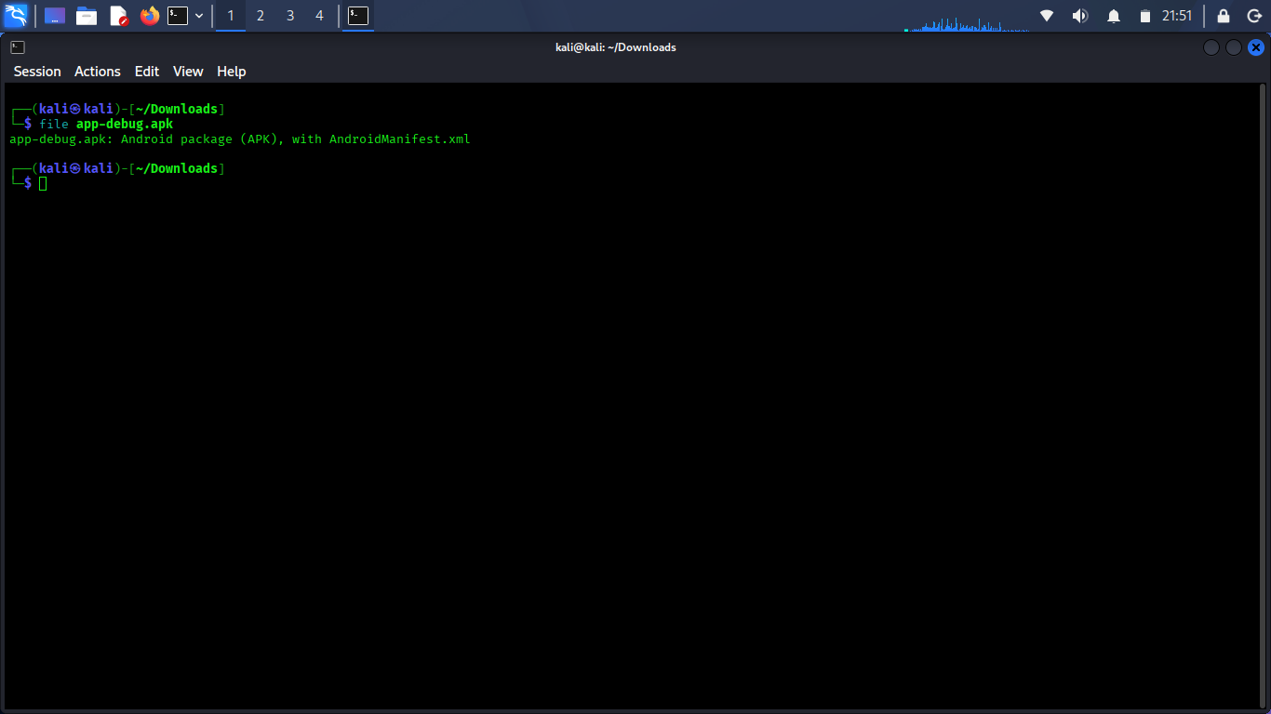
Figure 1. File-type identification of app-debug.apk.
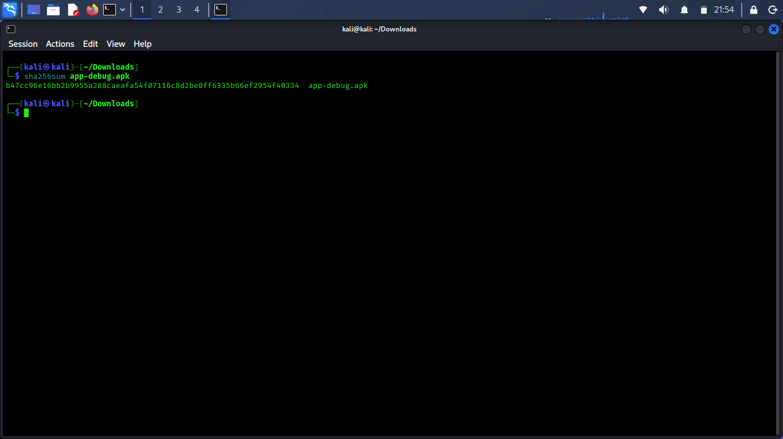
Figure 2. SHA-256 fingerprint generated for the APK.

5. APK Structure Inspection
Listing and extracting the APK confirmed the expected Android package structure. Important entries visible in the evidence include AndroidManifest.xml, classes.dex, resources.arsc, res/, and META-INF/. classes.dex contains compiled Dalvik/ART bytecode; resources.arsc and res/ hold compiled and packaged resources; META-INF contains signing-related metadata.
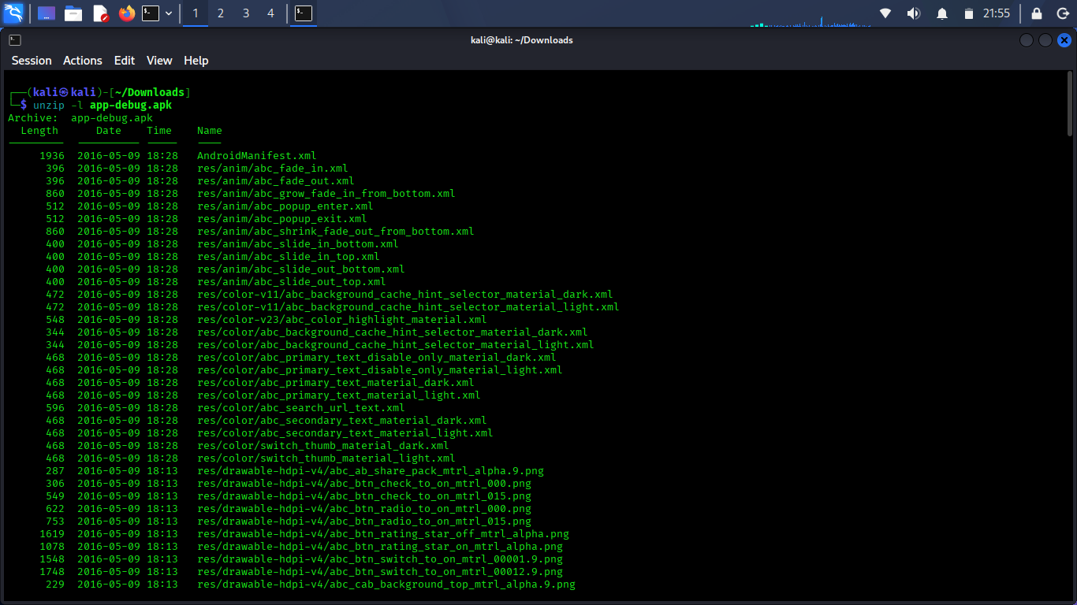
Figure 3. APK archive listing, including AndroidManifest.xml, classes.dex, resources and META-INF.
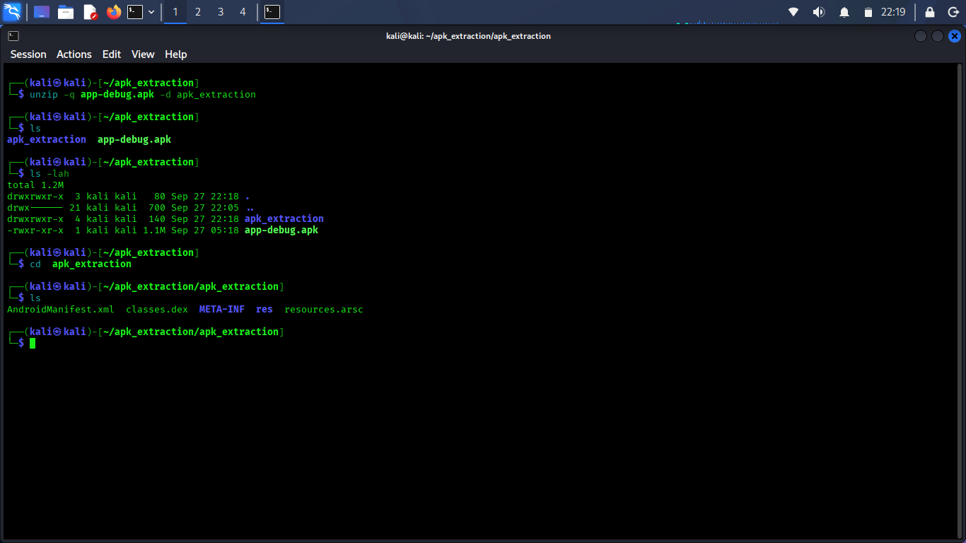
Figure 4. Extracted APK structure.

6. APKTool Decoding and Reverse-Engineering View
APKTool successfully decoded the sample. This step is useful because a raw APK is packaged for Android execution rather than convenient human review. APKTool reconstructs resources and disassembles DEX bytecode into Smali, allowing an analyst to inspect application components and implementation details without running the app.
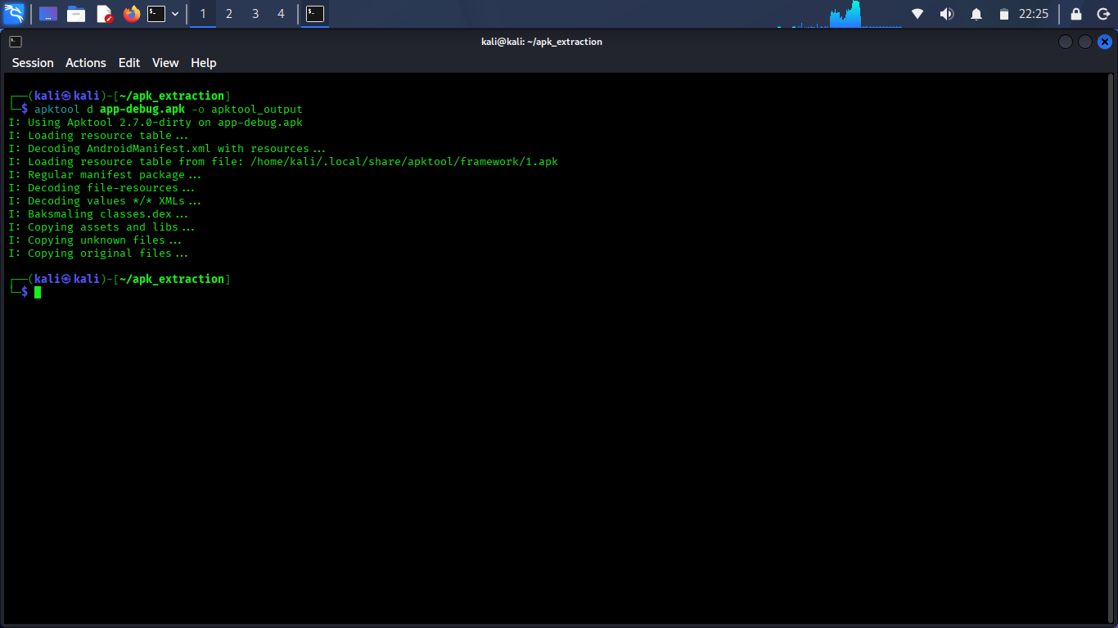
Figure 5. Successful APKTool decoding of app-debug.apk.

7. Metadata Observations
The captured apktool.yml provides build-related metadata. The evidence shows versionCode 1, versionName 1.0, minSdkVersion 19, and targetSdkVersion 23. These values describe compatibility/build targeting and are not, by themselves, vulnerabilities.
Field | Observed value
versionCode | 1
versionName | 1.0
minSdkVersion | 19
targetSdkVersion | 23
APKTool version shown | 2.7.0-dirty
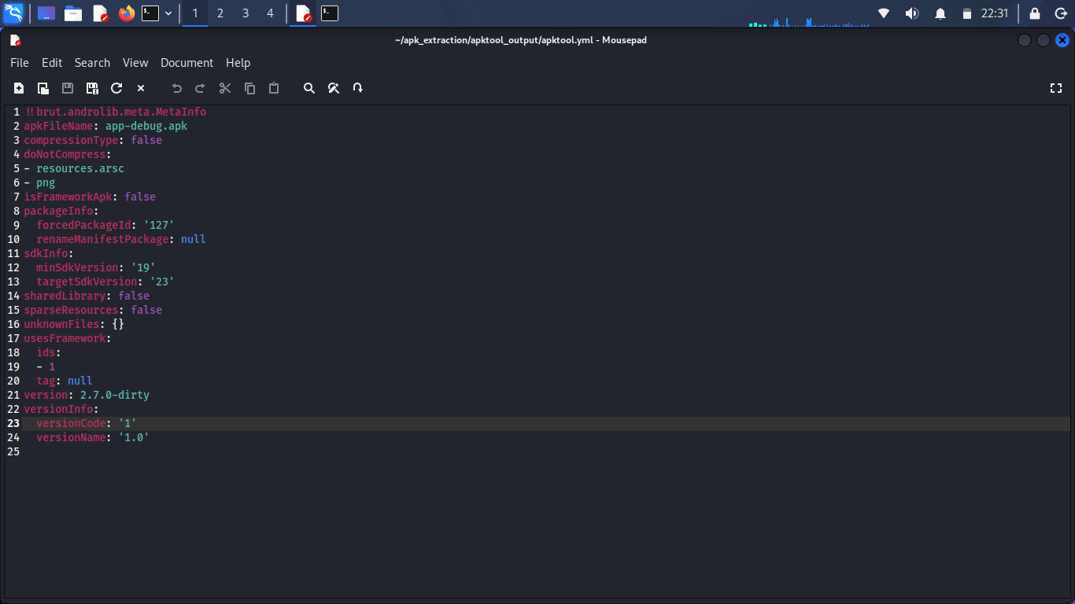
Figure 6. APKTool metadata captured from apktool.yml.

8. Signing Metadata
META-INF/CERT.SF was inspected. The file contains signature-manifest information and SHA-1 digest entries for packaged resources. Its presence indicates signing metadata exists in the APK. The screenshot alone does not establish signer identity, trustworthiness, or whether the certificate is production-grade; those questions require certificate-specific inspection.
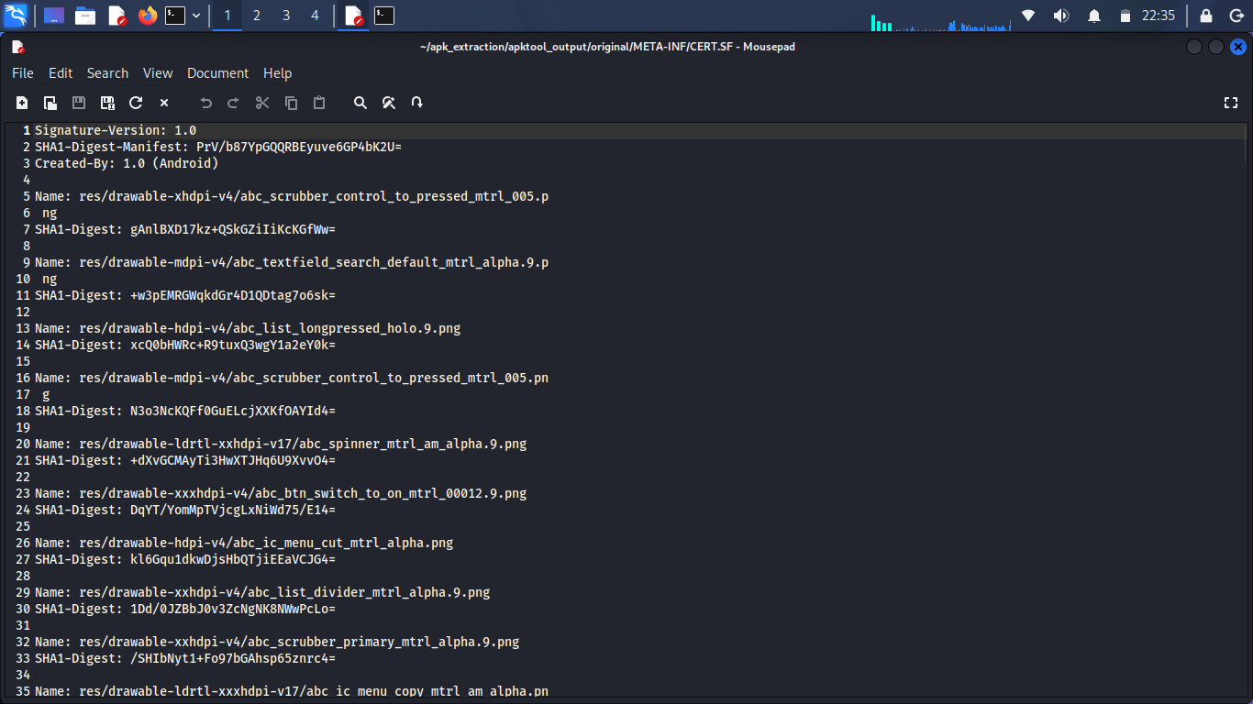
Figure 7. CERT.SF signature metadata within META-INF.

9. Smali Code Structure
The decoded Smali tree contains android/support/annotation classes such as NonNull, Nullable, RequiresPermission and related support-library annotations. These are common library/support components and should not be treated as suspicious simply because they appear in the APK. For application-specific behavior, the more relevant next step is to inspect the app's own package under the Smali tree rather than focusing on bundled support-library code.
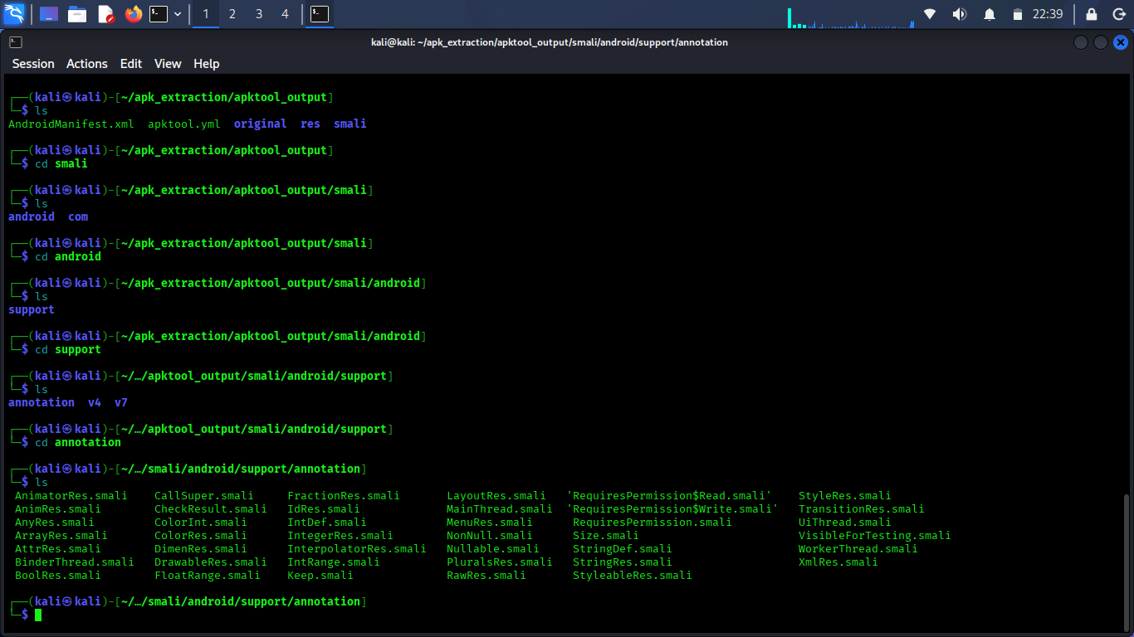
Figure 8. Smali support/annotation directory after decoding.

10. Findings and Interpretation
F-01 — APK structure successfully identified [Informational]
The sample is a readable Android APK and contains the expected core package components. This establishes that the file can be statically analyzed using standard Android reverse-engineering tools.
F-02 — Reproducible sample fingerprint recorded [Informational]
A SHA-256 digest was generated. This is useful for evidence handling and ensures future analysis refers to the same binary.
F-03 — Application targets an older Android API level [Observation]
APKTool metadata shows targetSdkVersion 23 and minSdkVersion 19. This is a build/compatibility observation. Whether it creates practical security exposure depends on the app's behavior, permissions, deployment environment and Android platform behavior, which were not assessed here.
F-04 — Signing metadata is present [Informational]
META-INF/CERT.SF and related signature files are present. Further certificate inspection would be needed to determine signer details and signing characteristics.
F-05 — Decompiled Smali is available for deeper review [Informational]
APKTool produced Smali code. The screenshot shown is primarily Android support-library annotation code; application-specific Smali should be reviewed separately for meaningful security findings.

11. What Was Not Established
No evidence in the supplied screenshots confirms malware, credential theft, data exfiltration, insecure network communication, hard-coded secrets, dangerous permissions, exported-component abuse, or other specific vulnerabilities. Those conclusions should not be made without additional evidence.

12. Recommended Next Analysis Steps
- Review the decoded AndroidManifest.xml for requested permissions, exported activities/services/receivers/providers, debuggable settings, backup settings and cleartext-traffic configuration.
- Search decoded resources and Smali for URLs, API endpoints, tokens, API keys, secrets and suspicious command strings.
- Identify the application's own package under smali/ and review its MainActivity and other application-specific classes rather than only bundled support-library code.
- Inspect the signing certificate with an Android signing/certificate inspection tool to record signer subject, issuer, validity and signature scheme information.
- If permitted by the assignment, perform dynamic analysis only in an isolated emulator/test environment and compare runtime behavior with the static findings.

13. Conclusion
The static-analysis workflow successfully established the APK's basic identity, fingerprint, internal package structure, decoded resources, build metadata, signature metadata and availability of Smali code for deeper inspection. Based only on the evidence captured in this exercise, the appropriate conclusion is that the sample is analyzable and several useful metadata points were recovered; there is not enough evidence to classify the application as malicious or benign. Further manifest, string, certificate and application-specific code review would be required for a stronger security assessment.

Appendix A — Evidence Selection
The report intentionally uses the clearest and most relevant screenshots rather than including every captured terminal view. Redundant screenshots were omitted so the evidence directly supports the documented analysis steps.

