Name: Kunal Tripathi
Roll No.: 23052331
Branch: CSE

Deep Learning Research Assistant Agent

1.Problem Statement
Academic researchers and students frequently find it difficult to locate precise, validated information about neural network topologies and optimisation techniques across large datasets in the quickly developing field of artificial intelligence. While normal LLMs are prone to hallucinations when queried about certain architectural features or specialised research publications, conventional search engines frequently yield results that are too general. When local information is inadequate, a system that combines a curated, validated academic knowledge base with the capacity to independently fact-check and retrieve real-time data from the internet is desperately needed.

2. Solution and Features

Solution Overview
A self-sufficient RAG (Retrieval-Augmented Generation) agent is the Deep Learning Research Assistant. It searches a high-density vector database of 25 fundamental deep learning topics using a "local-first" knowledge approach. In order to give the user the most recent research and citations, the agent automatically initiates an online search tool if it finds that the solution is not available in the local store.

Core Features
- Autonomous Routing:To determine whether to use conversation memory, explore the local knowledge base, or initiate a web search, the agent employs LangGraph logic.
- Self-Correction & Evaluation: To avoid hallucinations, an internal "Eval Node" compares each response's adherence to the retrieved context.
- Live Web Fallback: The agent automatically uses DuckDuckGo Search (via the ddgs library) to retrieve real-time updates when local data is not available.
- Interactive UI: With the help of a Streamlit interface, users can trace sources in real time and determine precisely which online result or research topic influenced the response.

3. Technical Stack
Component | Technology Used
Large Language Model | Llama 3.3-70B via Groq API (High-speed inference)
Orchestration | LangGraph (State management and agentic loops)
Vector Database | ChromaDB (Local high-performance vector storage)
Embeddings | Sentence-Transformers (all-MiniLM-L6-v2)
Frontend | Streamlit
Tools | DuckDuckGo Search API

4. Unique Points and Implementation

Unique Selling Points
- The "I Don't Know" Safety Valve:This agent is designed to detect knowledge gaps and switch to a tool-based search instead of hallucinating, in contrast to typical chatbots that make guesses.
- Hybrid Search Context: The system creates a link between textbook theory and contemporary business trends by combining local academic theory (such as ResNet bottlenecks and Swin Transformer window shifting) with real-time news.
- Stateful Memory: Complex, multi-turn technical discussions are possible without losing context thanks to the agent's sliding pane of conversation history.

Implementation Logic
The structure of the system is a directed acyclic graph (DAG). The Memory Node prepares the history upon receiving a query. The path is determined by the router node. In order to ensure academic rigour, the algorithm loops back to refine the response if the response Node fails the fidelity check of the Eval Node.

System Interface & Results

1.The UI Layout

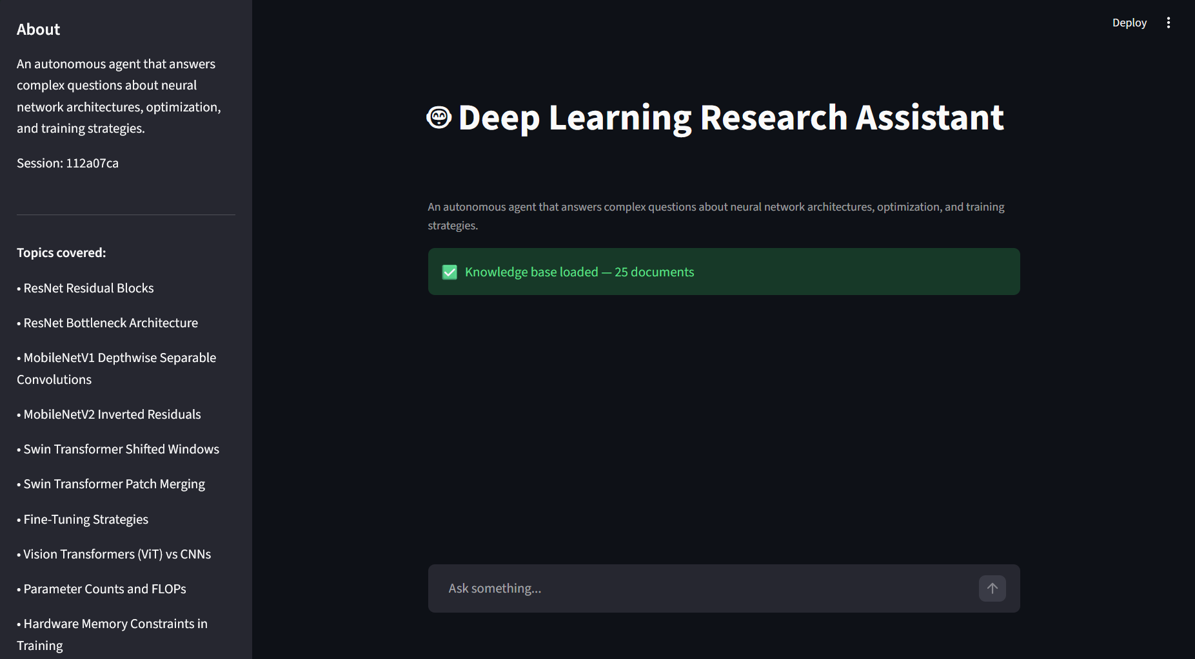

The main Streamlit screen showing the sidebar and the welcome message.

2.Local Knowledge Retrieval

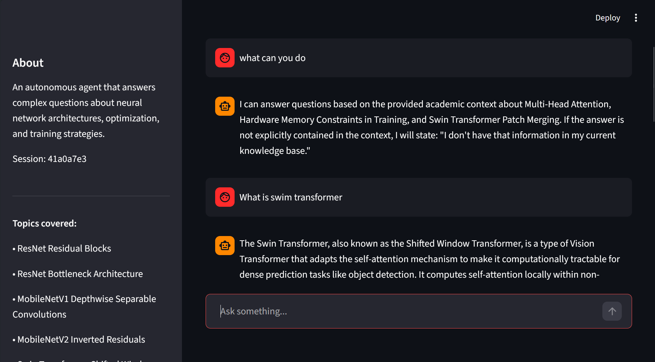

A question like "What is swin tranformer?" and the agent's response.

3.Autonomous Web Search
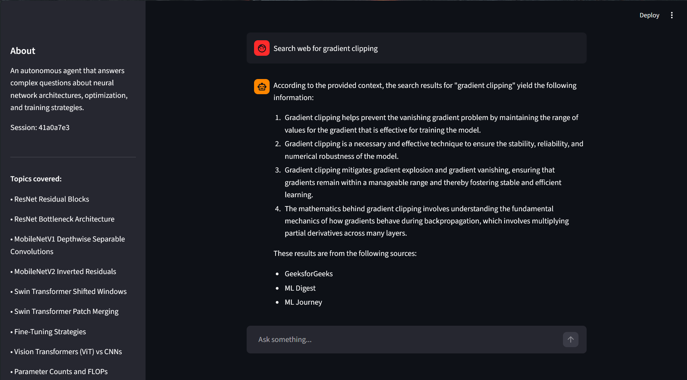

4.Out of Context Questions

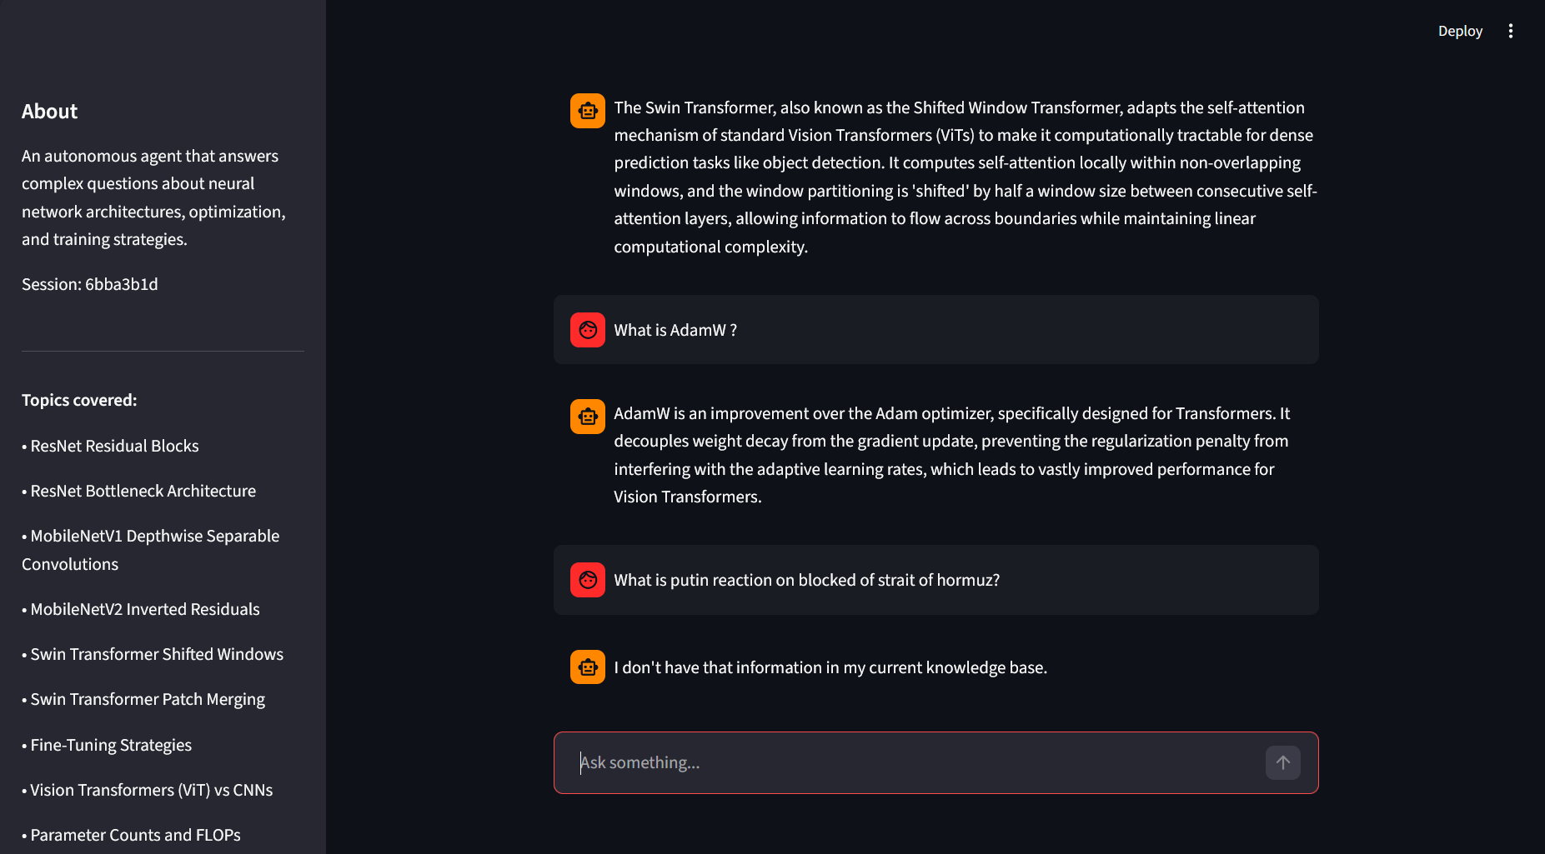
Saying I don’t have that information in my current kb if the question is out of context.

5. Future Improvements
- Multi-Modal Support: including the capability of directly analysing and elucidating architecture diagrams from research papers that are uploaded in PDF format.
- RAGAS Integration:automating the display of real-time performance measures (relevancy, fidelity) as a dashboard for the user.
- Expanded Knowledge Base:utilising a distributed ChromaDB instance to increase the local store's indexed paper count from 25 to more than 1,000.
- Fine-Tuned Embeddings: To increase retrieval accuracy for specialised AI concepts, a domain-specific embedding model was trained using the ArXiv dataset.

References
- LangGraph Documentation (Stateful Multi-Agent Orchestration)
- Groq Cloud Console (Llama 3.3 70B Versatile)
- ChromaDB Documentation (Vector Embeddings and Storage)

