**ORACLE CLIENT INSTALLATION**

1. Go to Ansible portal.

<https://automation-platform.oneadr.net/#/login>

1. Select Template option from Left side dashboard.

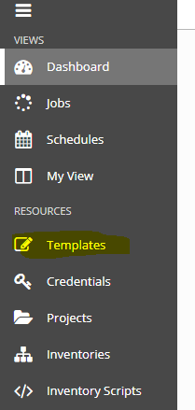

1. You can see client template name as [**50OI_ORACLE_CLIENT_INSTALL_CLIENT**](https://automation-platform.oneadr.net/#/templates/job_template/81?template_search=page_size%3A20%3Border_by%3Aname%3Btype%3Aworkflow_job_template%2Cjob_template)
2. Click on Arrow(highlighted) right side of template



1. Fill all the details like server name, oracle client version, environment, mail id.

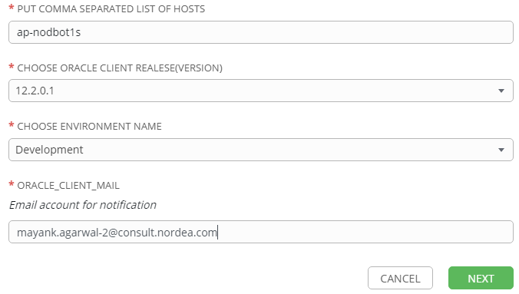

Click Next.

1. Verify the details on next screen and click on launch to start installation.

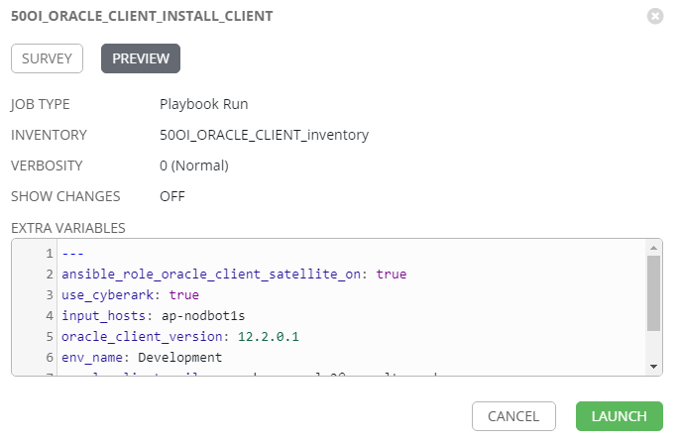

1. Note job id.



1. You will get notification on mail id on successful or failure. Same can be check from job logs on Ansible.