**Step 1: Visit Google Cloud Console**

**visit** [**https://console.cloud.google.com/**](https://console.cloud.google.com/)

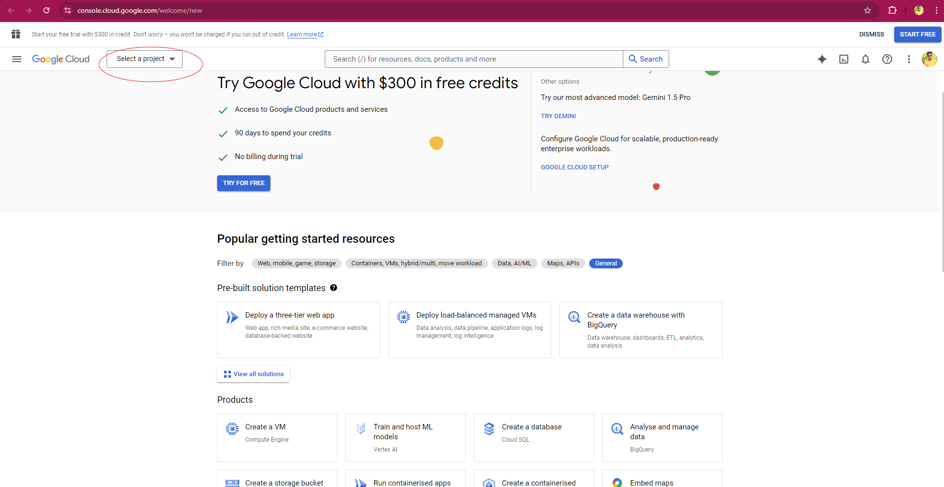

### Step 2: Create a New Project

* Click on **"Create Project"**.
* Enter a **project name** and click **"Create"**.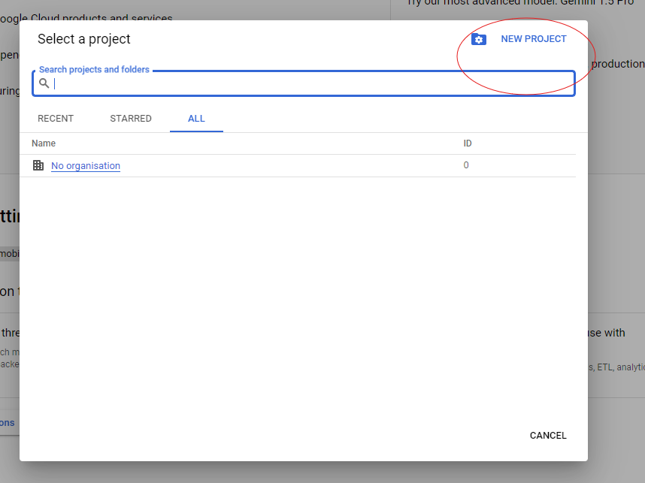

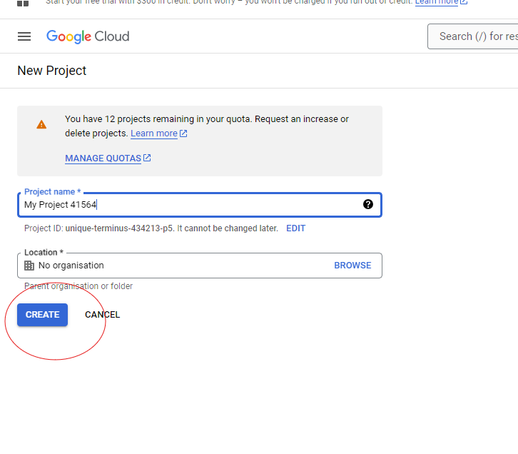

### Step 3: Access APIs & Services

* After creating the project, open the menu and select **"APIs & Services"**.

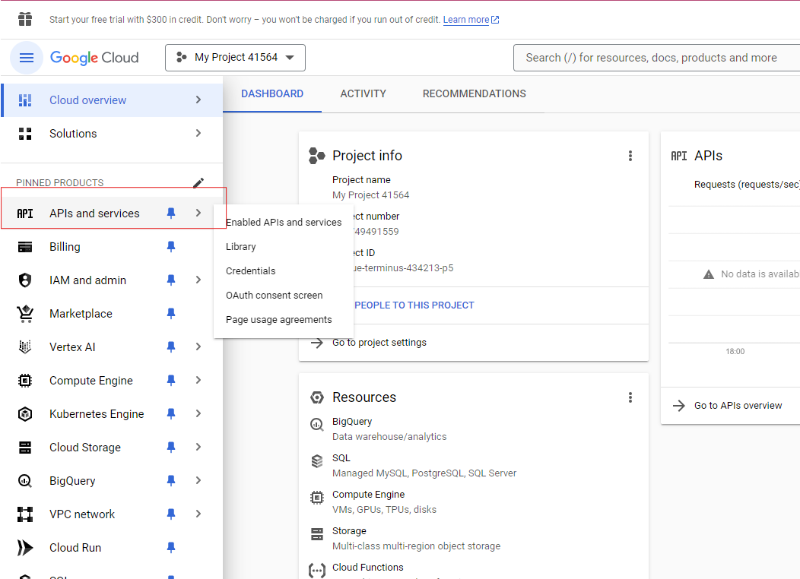

### Step 4: Enable Gmail API

* Click on **"Enable APIs and Services"**.
* Search for **"Gmail API"** and select it.
* Click on **"Enable"**.

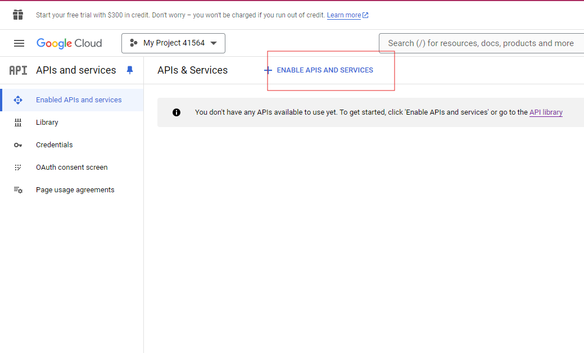

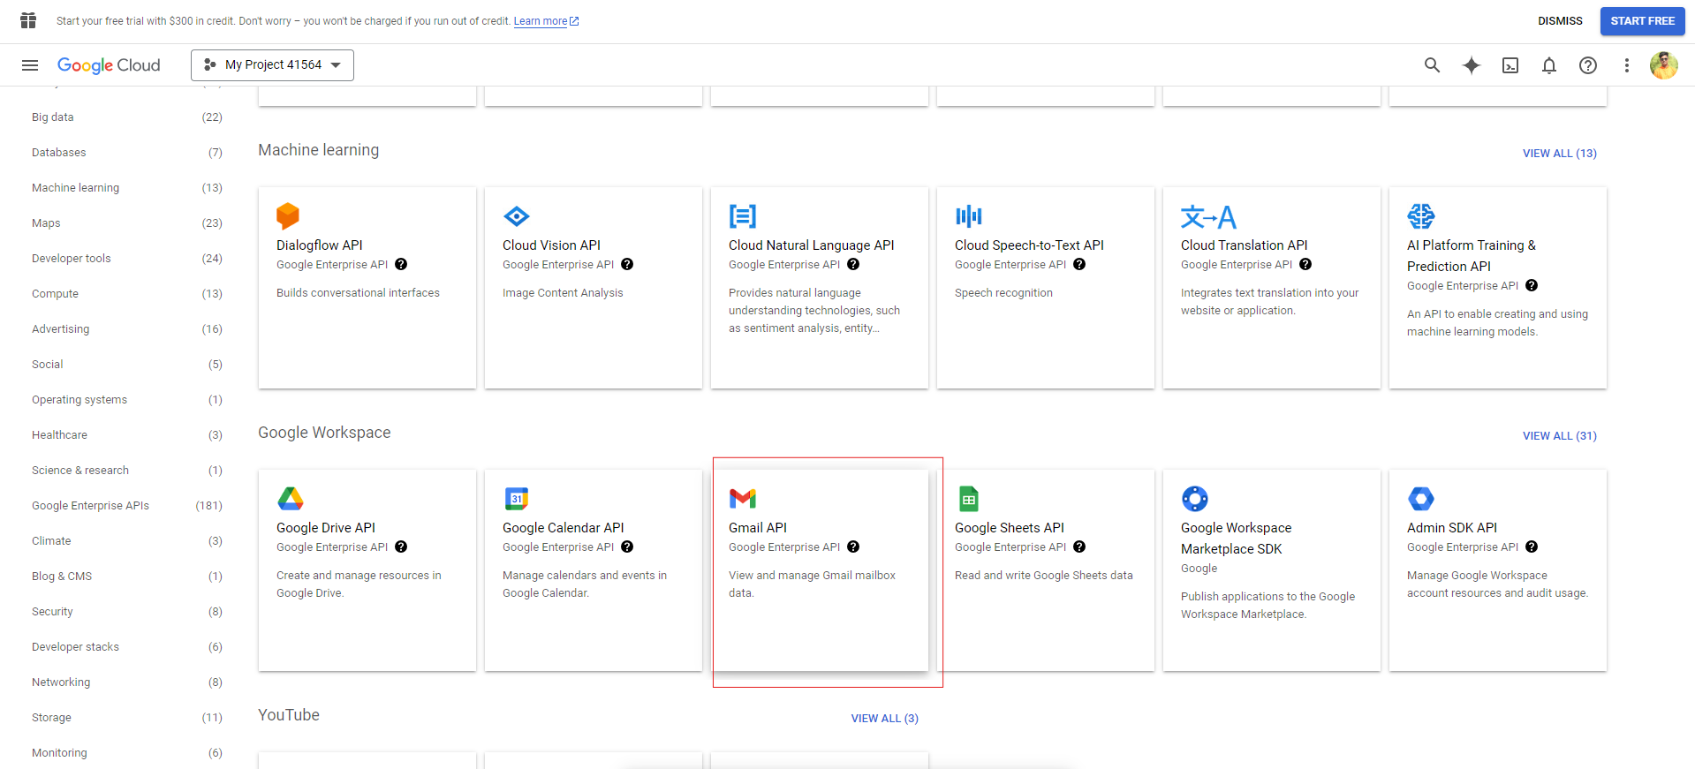

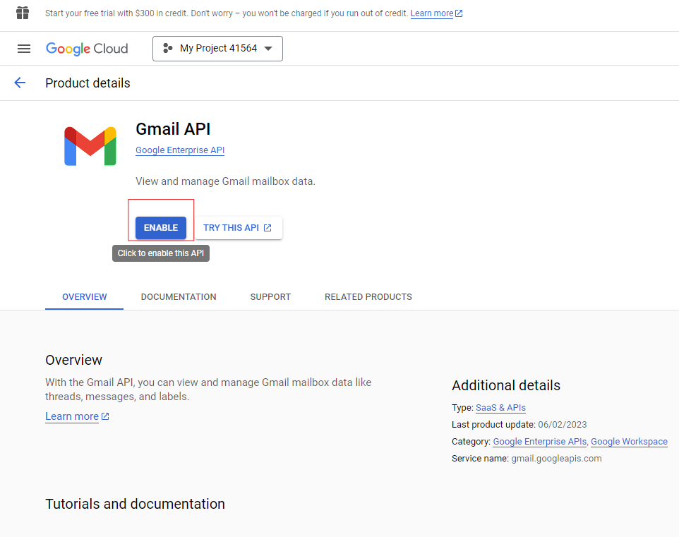

After enabling the Gmail API, GO to the Credentials section.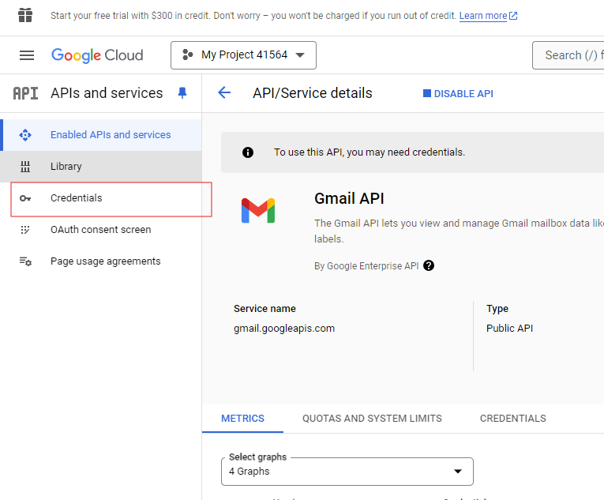

### Step 5: Set Up Credentials

* Go to the **Credentials** section.
* Click on **"Create Credentials"**.
* Select **"OAuth Client ID"**.

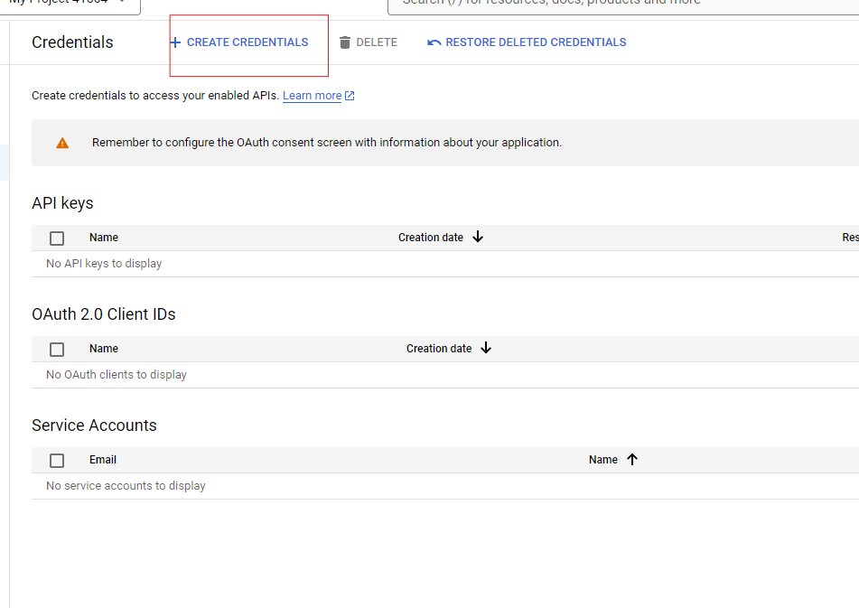

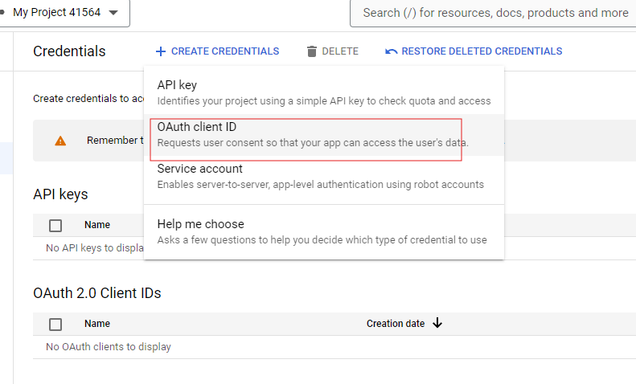

### Step 6: Configure OAuth Consent Screen

* Choose **"External"** as the user type and click **"Create"**.
* Fill in the **App name** and **Email address** (this will be used to send multiple emails).
* Provide **Developer contact information**, then click **"Save and Continue"**.

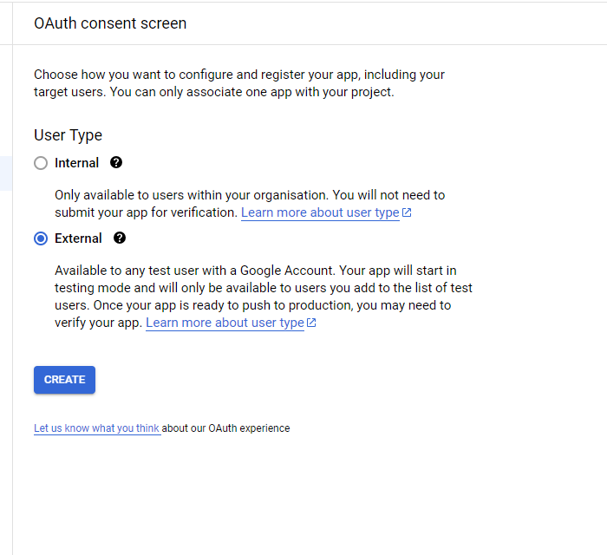

Step 11: Give the name of App, and email address from that email only you will send multiple emails at a time.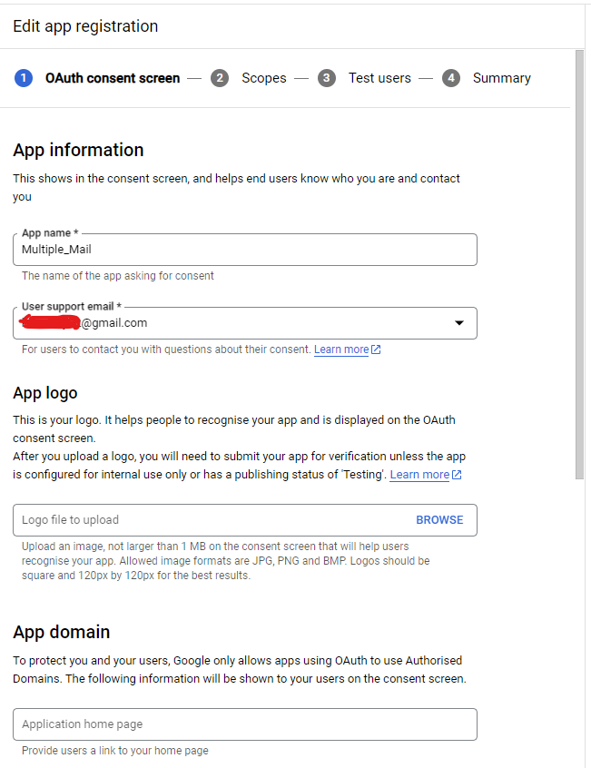

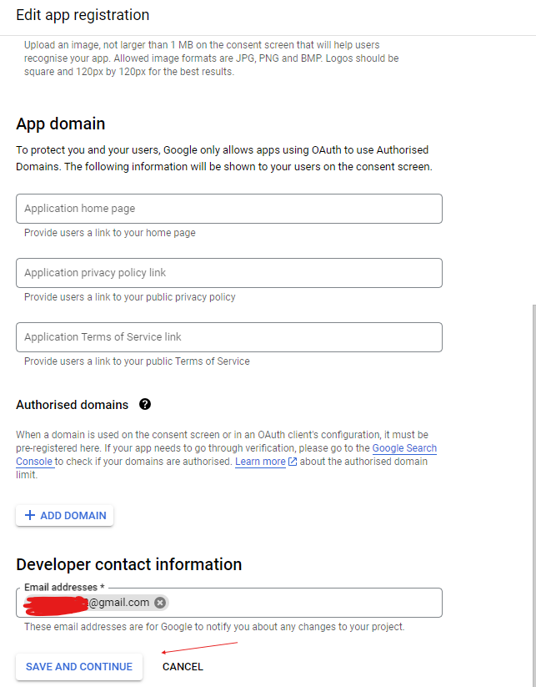

### Step 7: Add Scopes

* On the **OAuth Consent Screen**, go to **Scopes**.
* Click **"Add or Remove Scopes"**.
* Select the **"Manage Draft and Send Email"** option.
* Click **"Update"**, then **"Save and Continue"**.

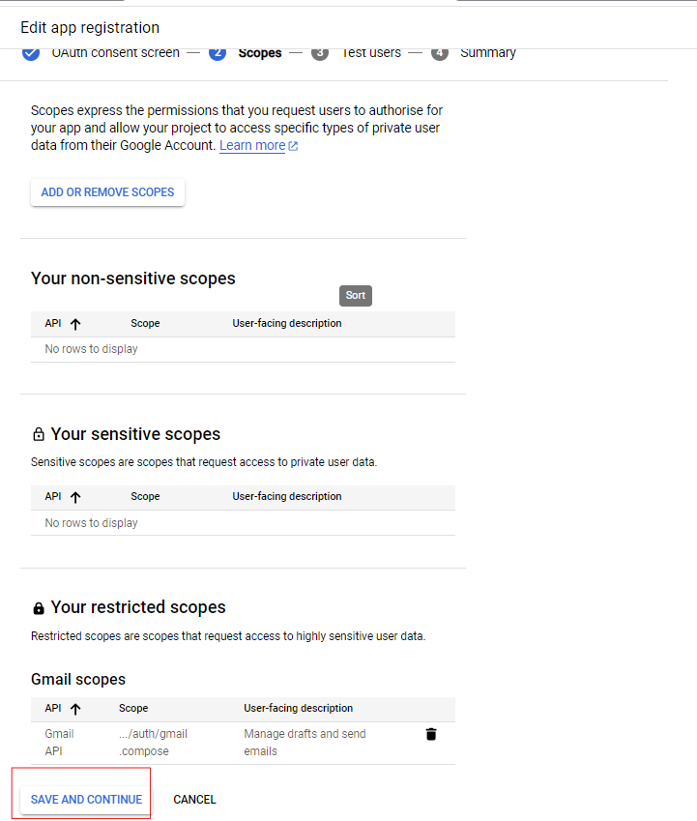

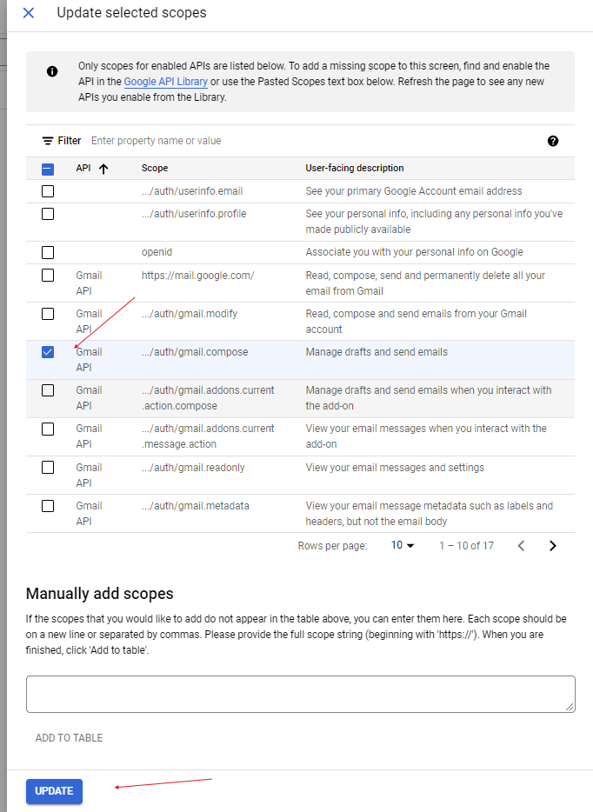

### Step 8: Add Test Users

* Navigate to the **Test Users** section.
* Click **"Add Users"** and add the email address that will be used to send emails.
* Click **"Save and Continue"**.

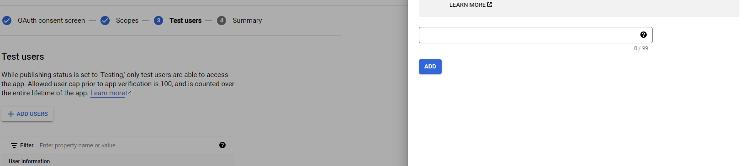

Step 15: Click on Back to Dashboard. Your OAuth Consent process is almost complete.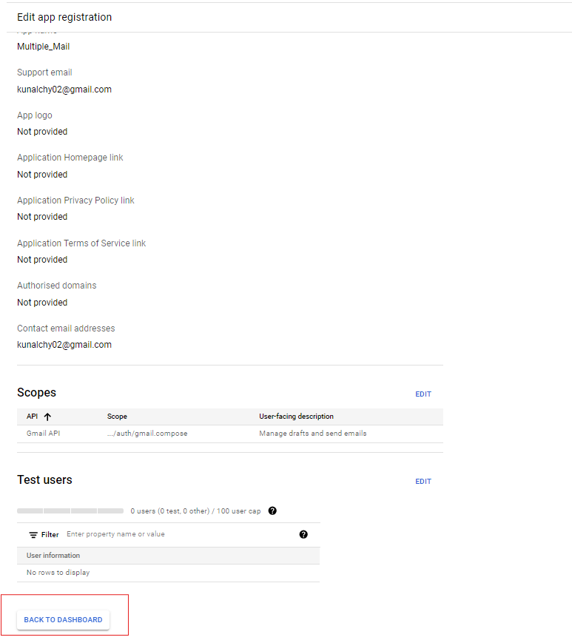

### Step 9: Publish the App

* Click on **"Back to Dashboard"**. Your OAuth Consent process is almost complete.
* Click **"Publish App"**.
* Click **"Prepare for Verification"**.
* Submit for verification by clicking **"Submit for verification"**.

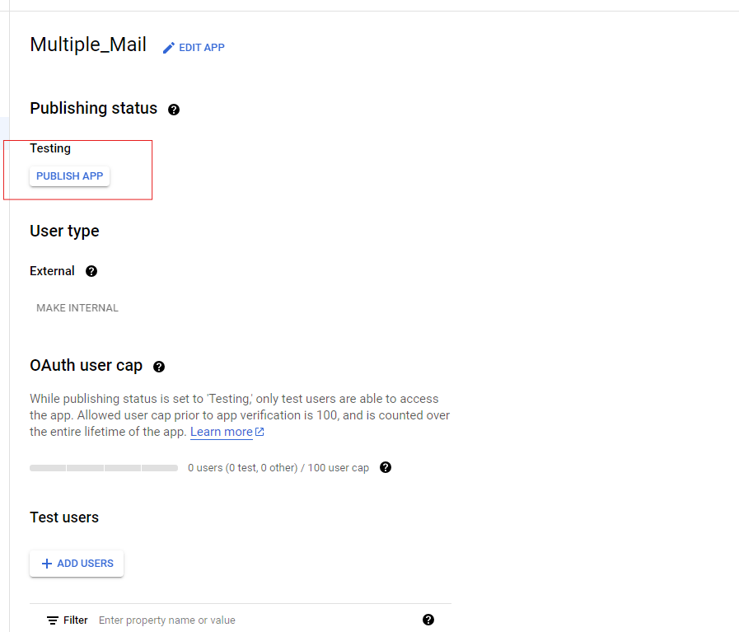

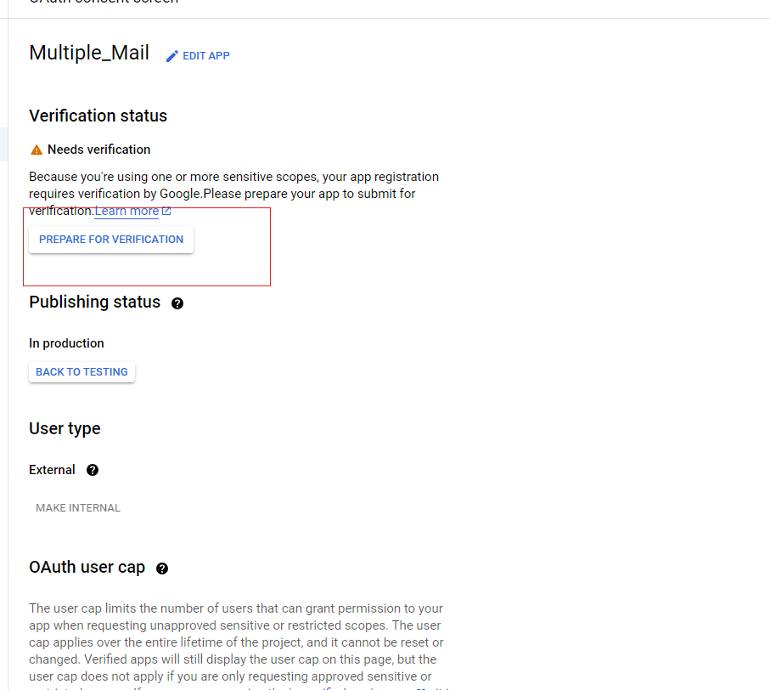

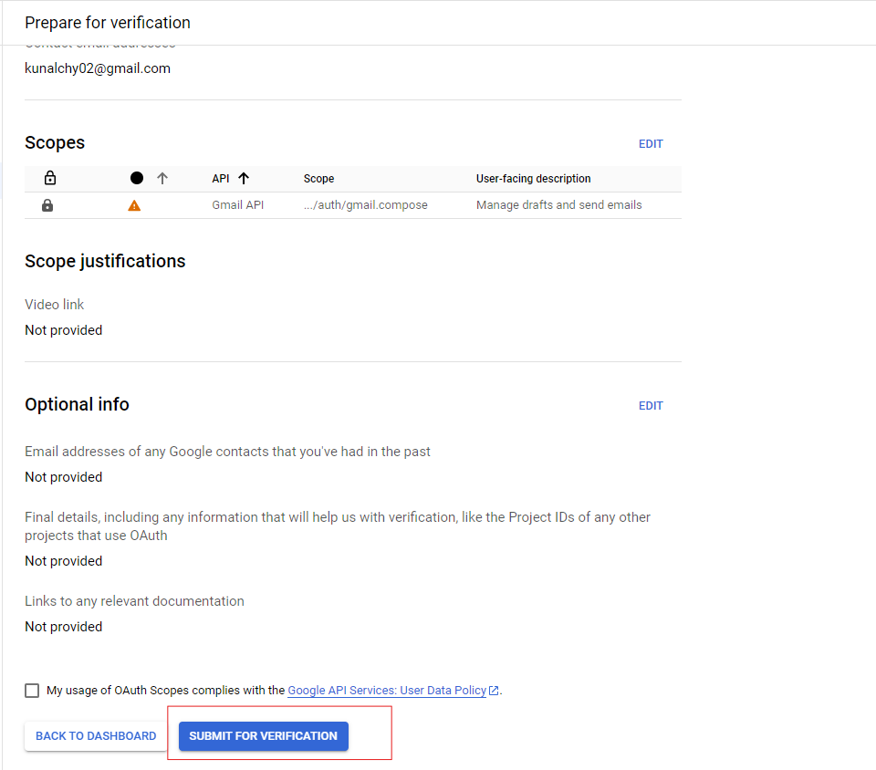

### Step 10: Generate OAuth Client ID

* Return to the **Credentials** section.
* Click on **"Create Credentials"** and select **"OAuth Client ID"**.
* Choose **"Desktop app"** as the Application type.
* Click **"Create"**.
* Download the generated **JSON** file (this will be needed for the next step).

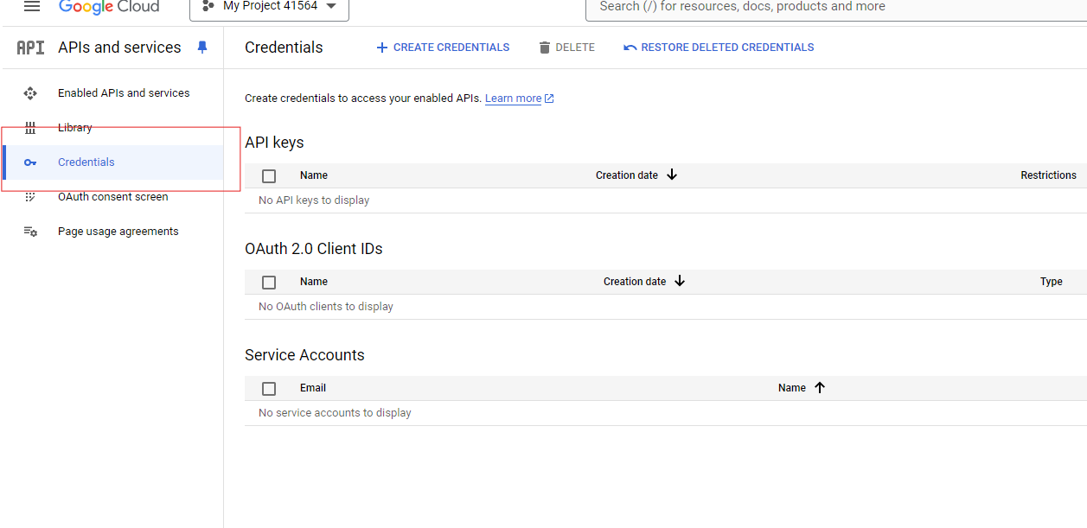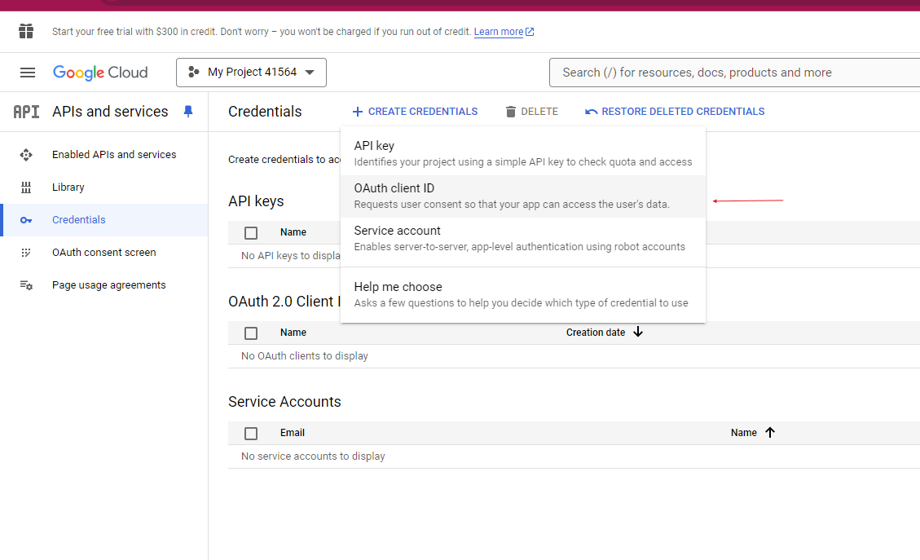

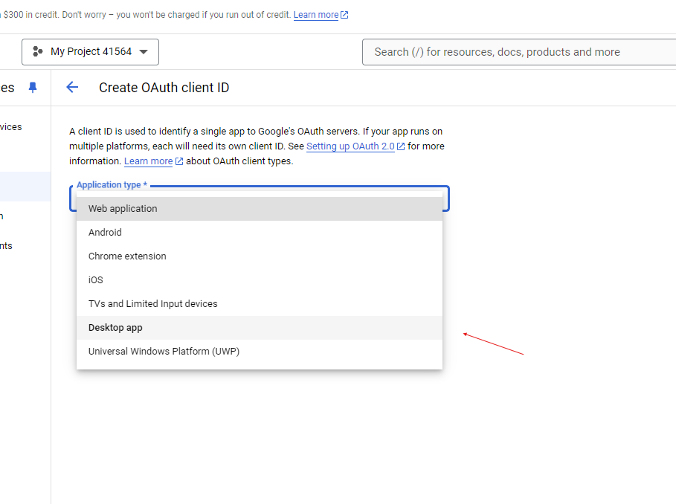

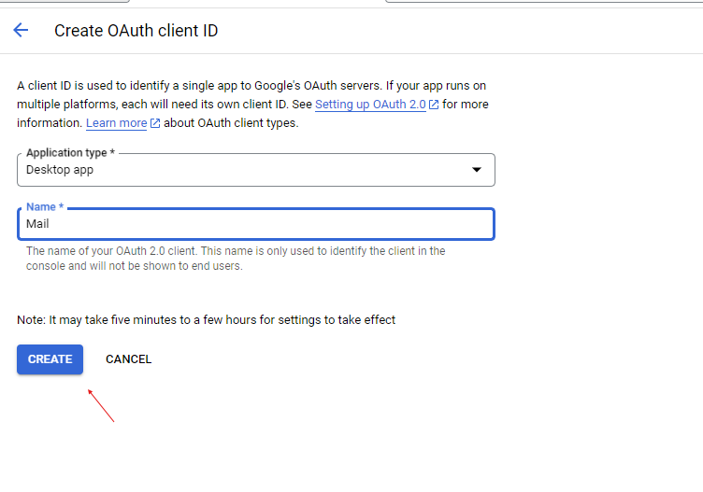

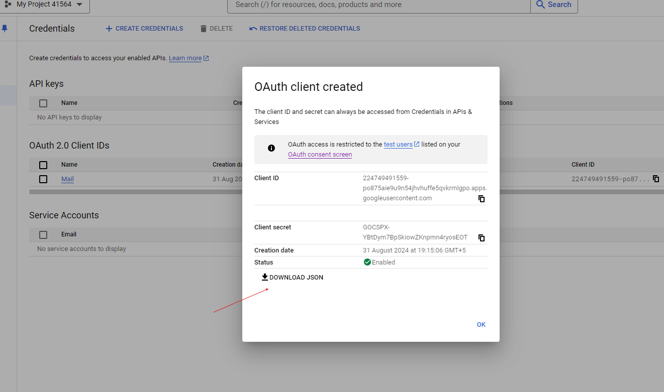

### Step 11: Run Authentication Code

* Make sure the JSON file is named **credentials.json**.
* Run your auth.py code.
* You will be redirected to a Google page to authenticate.
* After authentication, a **token.pickle** file will be generated, allowing you to send emails.

