**PROJECT SEMESTER REPORT**

**Engaging the Users and Gamifying the experience**

by

**Kunal Narang**

**Roll No. 102003058**

Under the Guidance of

**Manoj Kumar  
and  
 Madhuri Pendyala**

**Dr. Neeraj Kumar**

**Professor  
CSED**

Submitted to the

# Computer Science & Engineering Department

**Thapar Institute of Engineering & Technology, Patiala**

In Partial Fulfilment of the Requirements for the Degree of

Bachelor of Engineering in Computer Engineering

at

Thapar Institute of Engineering & Technology, Patiala

**June 2024**

**Engaging the Users Gamifying the experience**

by Kunal Narang

Place of work: Amadeus Software Labs Private Ltd.

Submitted to the Computer Science & Engineering Department, Thapar Institute of Engineering & Technology

June 2024

In Partial Fulfilment of the Requirements for the Degree of Bachelor of Engineering in Computer Engineering

**Abstract**

Amadeus, a leading provider of travel technology solutions, recognizes the importance of engaging users on airline websites. To address this, the company has initiated a gamification project aimed at enhancing user interaction and loyalty. The project focuses on integrating gamified elements, such as personalized travel suggestions, avatar customization, travel postcards, a loyalty dashboard, and a meaningful loader design, into the airline website's loyalty dashboard. These features aim to provide users with a visually engaging and interactive experience, thereby increasing user engagement and satisfaction.

The gamification project aims to enhance the user experience on airline websites by integrating gamified elements into the loyalty dashboard. These elements include personalized travel suggestions, where users receive tailored travel recommendations based on their profiles, avatar customization to personalize their profiles, travel postcards for creating and sharing personalized travel postcards on social media, a loyalty dashboard to access and visualize travel history, and a meaningful loader design to enhance the loading experience with useful information. The project focuses on integrating these features seamlessly into the airline website's existing user flow to provide users with a fun and engaging experience while increasing user engagement and loyalty.

Author ______________________________________________________________________

(Student’s Name)

Certified by Due to prevailing scenario email from Industrial mentor will serve as signature

Take email from mentor🡪 Convert in PDF 🡪 Paste that prior certificate

(Name & Signature) (Industrial Coordinator / mentor)

Certified by Due to prevailing scenario email from Faculty mentor will serve as signature

Take email from mentor🡪 Convert in PDF 🡪 Paste that prior certificate

(Name & Signature) (Faculty mentor)

# CERTIFICATE (PROJECT SEMESTER TRAINING) FROM THE COMPANY OR THE ORGANIZATION

# Candidate must place the scanned or original copy of the certificate related to completion of the project semester as received from the software company / research institute.

# TABLE OF CONTENT

1. Company Profile 4

2. Introduction 4

3. Background 4

3.1 Literature and references

4. Objectives 4

4.1 Brainstorming and Functional Detatils

4.2 Develop prototypes and Document the APIs

5. Methodology 5

5.1 Brainstorming and detailing the ideas

5.2 Creating standalone components

5.3 Integrating prototypes with the target website

5.4 Iterative Development and Feedback Incorporation

6. Common Tools and Technology Stack 5

6.1 Programming Language and Frameworks

6.2 Data Management and Frontend AEM

6.3 Tools

7. Observations and Findings

7.1 Understanding the various flows of Airlines

7.2 Understanding the core architecture of the product

7.3 Understanding AEM

7.4 API Documentation Clarity

7.5 Feedback from Stakeholders

7.6 Performance Optimization Opportunities

8. Limitations 5

8.1 Data Source Dependencies

8.2 Compatibility Issues

8.3 Security Considerations

8.4 Scope Creep

8.5 Technical Complexity

8.6 User Adoption and Training

9. Conclusions and Future Work 5

9.1 Conclusions

9.1.1 Enhanced Technical Proficiency

9.1.2 Effective Project Management

9.1.3 Collaborative Teamwork

9.1.4 Continuous Learning and Adaptation

9.2 Future Work

9.2.1 Refinement of Tools and Processes

9.2.2 Scalability and Performance Optimization

9.2.3 Enhanced Security Measures

9.2.4 User Training and Adoption Initiatives

9.2.5 Exploration of Advanced Technologies

10. Bibliography/References 5

# Company Profile



**Headquarters:** Madrid, Spain  
**Global Reach:** Operates in more than 190 countries  
**Employee Base:** Over 19,000 employees worldwide

Amadeus is a global technology company dedicated to the world’s travel industry. We’re committed to helping global travel make a positive impact on communities around the world. We’re passionate in our pursuit of better technology to make better journeys. We connect travelers to the journeys they want, and we power the solutions that keep the world of travel moving. For over 30 years Amadeus has been focused on helping airport operators and the wider travel industry to improve business performance and shape the future of travel with our technology, putting customers first, working collaboratively and always aiming for excellence. We invest hundreds of millions of euros each year in research and development. We design our solutions around our customers’ needs as well as their customers’ needs. Our products serve every part of the global travel ecosystem: airlines and airports, hotels and railways, search engines, travel agencies, tour operators, and other travel players. We help them run their business and improve the passengers’ experience all over the world. And we continue to innovate, bringing more products and services to market as quickly as possible, so we can deliver on customer expectations and respond to industry challenges. Our focus on R&D, our talented and diverse workforce, our global reach and diversification strategy, as well as our robust financial performance place Amadeus in a privileged position to continue to deliver value to our customers. Amadeus is known for its innovative products in the travel and tourism industry.

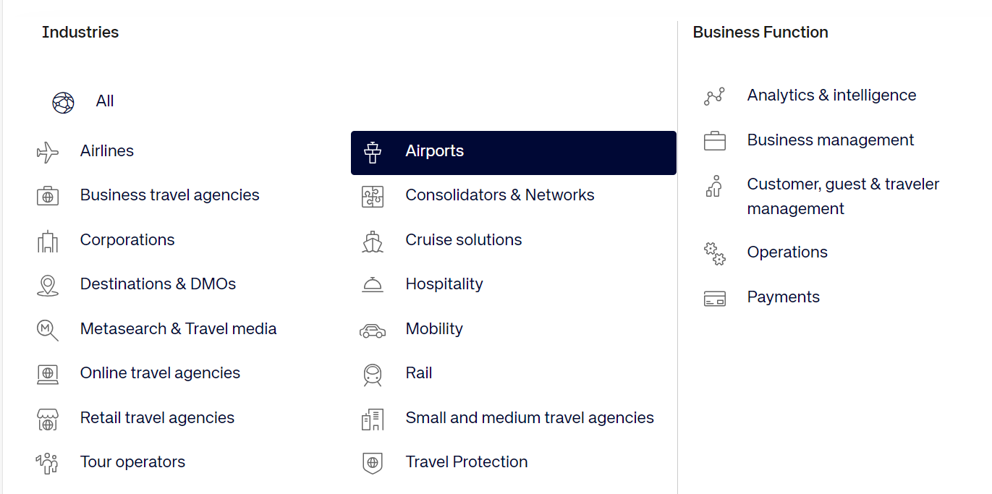

Fig 1.1 Amadeus Services and Products Overview

Some of the Amadeus products are mentioned below:

• **Amadeus Selling Platform (ASP):**

* ASP is a comprehensive booking platform designed for travel agents. It provides tools for managing reservations, bookings, and customer information efficiently.
* Features include access to a wide range of travel content, including flights, hotels, car rentals, and activities, as well as booking management tools and reporting capabilities.
* ASP helps travel agents streamline their workflow, increase productivity, and provide better service to their customers.

• **Amadeus Altea Suite:**

* The Altea Suite is a set of airline IT solutions that includes Passenger Service Systems (PSS), Revenue Management, and Flight Management.
* The suite helps airlines manage various aspects of their operations, from passenger check-in and boarding to flight scheduling and revenue optimization.
* It is designed to improve operational efficiency, enhance customer service, and increase revenue for airlines.

• **Amadeus Altéa NDC:**

* Altéa NDC is a platform that enables airlines to distribute their offers and services through New Distribution Capability (NDC).
* NDC is a set of standards developed by the International Air Transport Association (IATA) to enable airlines to provide more personalized and seamless booking experiences for travelers.
* Altéa NDC helps airlines reach travelers through a wider range of channels and provides travelers with more choice and flexibility when booking flights.

• **Amadeus e-Power:**

* e-Power is a tool that allows travel agencies to access and book airline content directly from the Amadeus system.
* It simplifies the booking process for travel agents, allowing them to quickly find and book flights for their customers.
* e-Power also provides travel agencies with access to real-time inventory and pricing information, helping them provide better service to their customers.

• **Amadeus Hotel Platform:**

* The Hotel Platform is a solution for hoteliers to manage bookings, inventory, and pricing.
* It helps hoteliers maximize revenue by providing tools for dynamic pricing, inventory management, and distribution channel management.
* The platform also helps hoteliers improve customer service by providing a seamless booking experience for travelers.

• **Amadeus Transfers:**

* Amadeus Transfers is a platform that allows travelers to book airport transfers and other transportation services.
* It provides travelers with a convenient way to book transportation services, helping them save time and avoid the hassle of arranging transportation upon arrival.

These products are designed to enhance the travel experience for both travelers and travel industry professionals, showcasing Amadeus' commitment to innovation and excellence in the travel technology sector.

# Introduction

This report serves to comprehensively document my internship project, focusing on increasing User engagement and Gamifying the user experience . In our modern, digital world, where user experience (UX) plays a pivotal role in the success of digital products, gamification has emerged as an innovative strategy to enhance user engagement and interaction. However, like any approach, it comes with its own set of challenges.

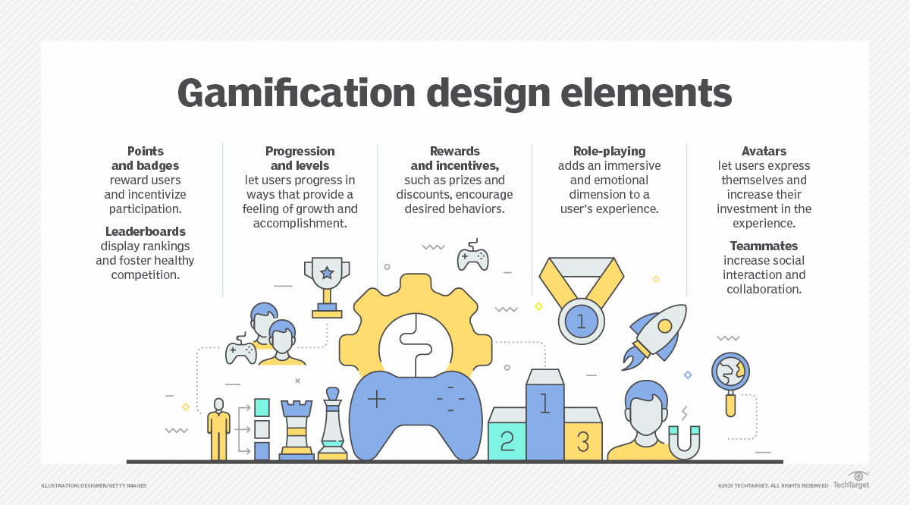

Fig 2.1 Gamification design elements explained

The primary goal of this project is to enhance user engagement and interaction on airline websites by integrating gamified elements into the loyalty dashboard. Through personalized travel suggestions, avatar customization, travel postcards, a loyalty dashboard, and a meaningful loader design, the project aims to create a more enjoyable and interactive user experience.

# Background

In our modern, digital world, where user experience (UX) plays a pivotal role in the success of digital products, gamification has emerged as an innovative strategy to enhance user engagement and interaction. However, like any approach, it comes with its own set of challenges. This article explores the concept of gamification in UX, its benefits, strategies, and specific examples, and also addresses the criticisms some have levied at the uses of gamification.

**Benefits of Gamification in UX**

Gamification in UX can have a positive impact by enticing users to try a product and convincing them to stay there.

Ways gamification can be useful:

* **Increased User Engagement:** By making tasks feel more like games, users are likely to find the experience more enjoyable and engaging.**‍**
* **Improved User Retention:** Gamification can encourage users to return to an app or website, thereby increasing retention rates.**‍**
* **Enhanced User Satisfaction:** Rewarding users for their actions can lead to higher satisfaction levels.**‍**
* **Behavioral Change:** Gamification can be used to motivate users to change their behaviors positively, such as [promoting healthier habits](https://www.kadence.com/en-us/from-games-to-gains-the-benefits-of-gamification-for-health/) or improving learning outcomes.

**Key Strategies in Gamification**

* **Points and Scoring Systems:**Assigning points for certain actions encourages users to engage more with the product.**‍**
* **Badges and Achievements:** These serve as tangible rewards and milestones for user accomplishments.**‍**
* **Leaderboards:** Encouraging a sense of competition can motivate users to improve their performance.**‍**
* **Challenges and Quests:** These provide users with goals and objectives, making the experience more goal-oriented.**‍**
* **Tangible Results:**Gamification can be used to allow users to contribute materially, such as earning small amounts of money or contributing to social good as they engage.

**Examples of Gamification in UX**

Below are some examples of companies effectively using gamification in their UX strategies:

**Duolingo: Making Language Learning Fun**

Duolingo, a language learning app, is a prime example of gamification done right.

It uses points (XP), streaks, and in-app currencies to encourage daily usage. Users can compete with friends, earn rewards, and unlock new levels as they progress, making the learning process engaging and addictive.

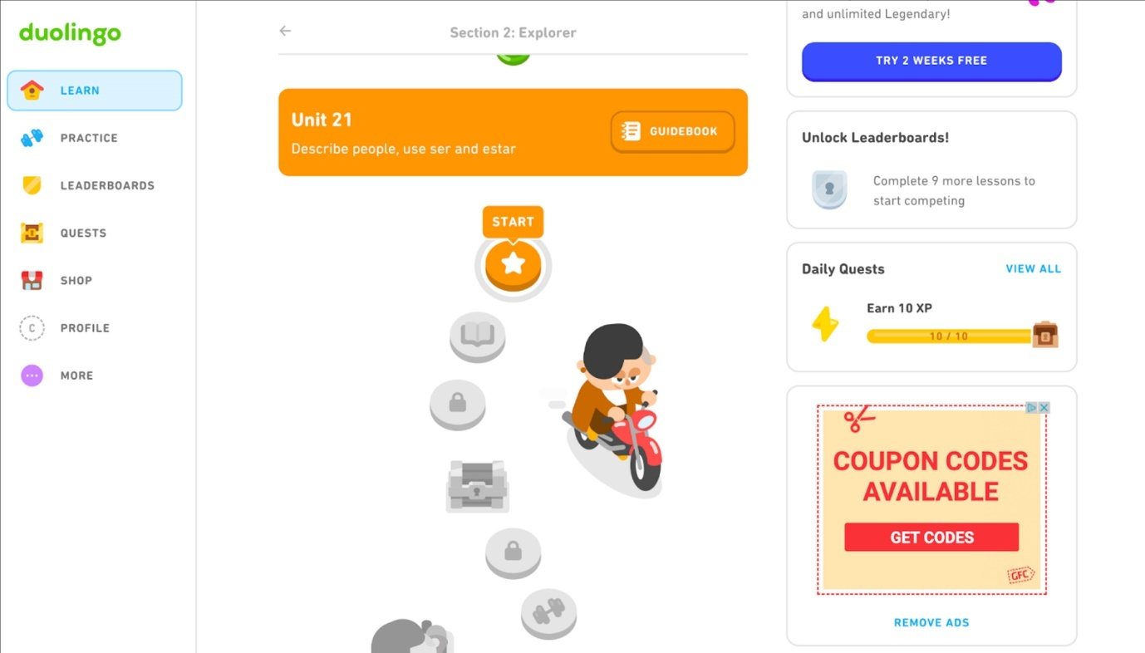

Fig 3.1 Duolingo’s progression system

**Nike Run Club: Fitness with a Competitive Edge**

Nike+ Run Club app uses gamification to motivate users to achieve their fitness goals. It tracks runs, provides challenges, and lets users compete with friends. The app awards badges for milestones and allows users to share their achievements on social media, thus integrating social recognition into the fitness journey.

**Starbucks Rewards: Loyalty through Gamification**

Starbucks uses a gamified loyalty program where customers earn stars for purchases. These stars can be redeemed for free drinks and other rewards. The app also offers occasional challenges where users can earn extra stars, encouraging more frequent visits and purchases.

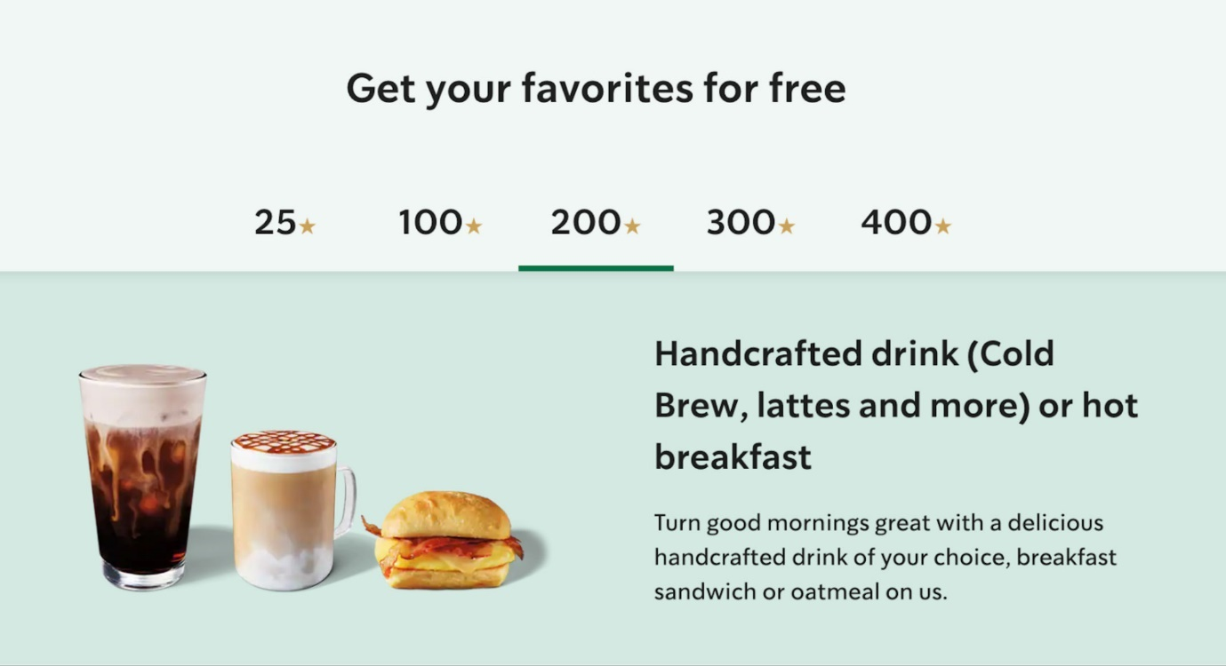

Fig 3.2 Starbucks Loyalty Programme

**Air Canada Aeroplan Programme**

* 1. **Literature and References**

In addition to the practical implementation, this project drew upon a range of literature and references to inform its methodologies and approaches. Apache POI, a widely-used library for Excel manipulation, was instrumental in handling complex data structures efficiently. The versatility of Java Spring Boot empowered seamless backend development, ensuring the robustness and scalability of the implemented solutions. Furthermore, Swagger emerged as a pivotal tool for API documentation, facilitating clear and comprehensive guidelines for API utilization.

Moreover, the project benefited from insights gleaned from academic research and industry best practices. Publications on data integration techniques, software development methodologies, and API design principles provided valuable guidance throughout the project lifecycle. Additionally, forums, online communities, and documentation repositories served as valuable resources for troubleshooting technical challenges and exploring innovative solutions.

The background of this project underscores the critical imperative for streamlined data handling and integration within merchandise planning processes. Through the enhancement of the Logical Model Tool and the development of meticulously documented APIs, the project sought to address pivotal challenges faced by Blue Yonder in the realm of merchandise planning. By augmenting these essential components, the project aimed to bolster the effectiveness of Blue Yonder's merchandise planning solutions, thereby fostering more informed decision-making and operational efficiency within the dynamic landscape of the retail industry.

# Objectives

**4.1 Brainstorming and Functional Details:**

* **Brainstorming Sessions:**
  + Explore different strategies and approaches to enhance user engagement on the airline website.
* **Functional Details:**
  + Specify how each element will enhance user engagement and interaction on the loyalty dashboard.
  + Determine the technical feasibility and implementation details of integrating these elements into the website's existing framework.

**4.2 Finalizing the use cases**

* Loyalty Dashboard Travel Map
* Avatar for each profile
* Travel Cards

**4.3 Develop Prototypes and Document the APIs:**

* **Prototype Development:**
  + Create standalone prototypes for each gamification idea to demonstrate functionality and user experience.
  + Focus on developing visually appealing designs that align with the airline's branding and user interface guidelines.
* **API Documentation:**
  + Document the APIs required to integrate the gamified elements into the loyalty dashboard.
  + Include examples and code snippets to demonstrate how the APIs can be implemented in the website's codebase.

# Methodology

To achieve the set objectives, the following methodology will be employed:

**5.1. Brainstorming and Detailing the ideas**

* **Loyalty Dashboard:**
  + Description: Provide a personalized travel experience with a loyalty dashboard where users can access their travel history, and view a travel map showcasing their destinations.
  + Benefits: Enhances user engagement, fosters a sense of achievement, and promotes loyalty to the platform.
* **Travel Cards:**
  + Description: Offer users the ability to create personalized travel cards to create their own travel itinerary
  + Benefits: Encourages user engagement, increases social sharing, and strengthens user connections with the platform.
* **Avatar for Each Profile:**
  + Description: Allow users to personalize their profiles with avatars, adding a fun and interactive element to their experience on the platform.
  + Benefits: Enhances user identity, promotes self-expression, and increases user engagement.

**5.2. Requirement and tools analysis**

**5.3. Creating Standalone Components**

**Prototype Design:**

* Use design tools like Figma to create visual mockups of the required elements and
* Ensure the design aligns with the airline's branding and user interface guidelines.

Fig 5.3.1 Travel Maps Figma Design

Fig 5.3.2 User Avatar Figma Design

. **Development Process:**

1. **Frontend Development:**
   * **Component Implementation:** Once the UI design was finalized, the UI components were made using web technologies such as HTML, CSS, and JavaScript. Also some components were made in Angular that were tightly couped with the airline’s website
   * **Map Integration:** The Google Maps API was integrated into the frontend to display the interactive map. Developers used the API's features like markers, polylines, and custom map styles to visualize users' travel routes and destinations.
   * **User Interaction:** User interaction features, such as clicking on markers to display detailed information about each flight and panning/zooming the map to explore different regions.
   * **Asset Handling:** All the assets required for the project were managed in AEM
2. **Backend Development:**
   * **Database Design:** For prototype purposes, an external database like MongoDB was used to store flight data. I designed the database schema to store information about destinations visited, dates of travel, and other relevant details.
   * **API Development:** Creation of APIs to interact with the database and provide data to the frontend. These APIs handled operations like retrieving past travel history, updating flight information, and handling user feedback and fetching the avatar data.
   * **Integration with Frontend:** The backend APIs were integrated into the frontend to fetch and display the necessary data on the loyalty dashboard. This integration ensured that the frontend had access to the required data to render the travel map and other dashboard components.
   * **Testing and Optimization:** Throughout the development process, both frontend and backend components were tested to ensure they functioned correctly. Performance optimizations were also implemented to ensure the loyalty dashboard was responsive and provided a smooth user experience.

**5.4. Focus on Modularity**

As part of the methodology, there was a strong emphasis on modularity, particularly in the development of web components and Angular modules. This approach was adopted to ensure that the gamified elements, such as travel cards, avatars, and travel maps, could be easily integrated into the existing airline website's codebase.

1. **Web Components:**
   * Each gamified element was developed as a standalone web component, using technologies like Custom Elements and Shadow DOM.
   * This modular approach allowed for easy reuse and encapsulation of functionality, making it simple to add or remove elements as needed.

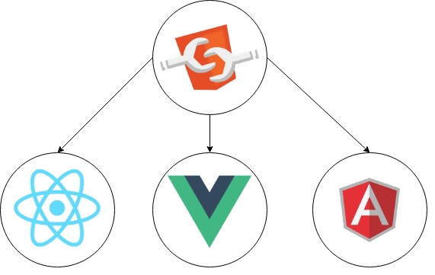

Fig 5.4.1 Web components compatible with any framework

1. **Angular Modules:**
   * For airline websites built using Angular, the gamified elements were developed as Angular modules.
   * This approach leveraged Angular's module system to encapsulate the components, services, and directives related to each gamified element.
2. **Code Reusability:**
   * By developing the gamified elements as modular components, there was a focus on code reusability.
   * This meant that the same components could be easily integrated into other parts of the website or reused in future projects, reducing development time and effort.
3. **Customization for Each Airline:**

* Airlines were able to customize the gamified elements to align with their branding and design guidelines.
* This included changing colors, fonts, and styles to match the airline's visual identity.

**5.5. Integration with the target website (Air Canada)**

1. **Architecture Definition to Meet Product Standards:**
   * Developed a comprehensive architecture that aligned with Air Canada’s product standards and guidelines.
   * Ensured that the architecture facilitated seamless integration, scalability, and maintainability of the developed solutions.

Fig 5.5.1 Architecture of User Avatars

1. **Detailed Study of Web Page Flows:**
   * Conducted an in-depth analysis of each target web page, including booking flows, itinerary updates, points booking, and check-in processes.
   * Gained insights into user interactions with the website to identify key areas for enhancement.
2. **Understanding API Calls:**
   * Examined existing API endpoints, including request and response formats, authentication mechanisms, and error handling protocols.
   * Mapped out API interactions to design solutions that seamlessly interfaced with Air Canada’s backend systems, ensuring smooth data exchange and functionality.
3. **Addressing Angular Version Differences:**
   * Identified the Angular version used by Air Canada’s web pages and compared it with the version used in the developed solutions.
   * Made necessary adjustments, such as updating or refactoring code and resolving dependency conflicts, to ensure compatibility between different Angular versions.
   * Conducted thorough testing to ensure consistent behavior across different versions and maintain a seamless user experience.

**5.6. Iterative Development and Feedback Incorporation**:

* + Implement an iterative development approach in line with Agile principles, allowing for continuous refinement and improvement based on stakeholder feedback.

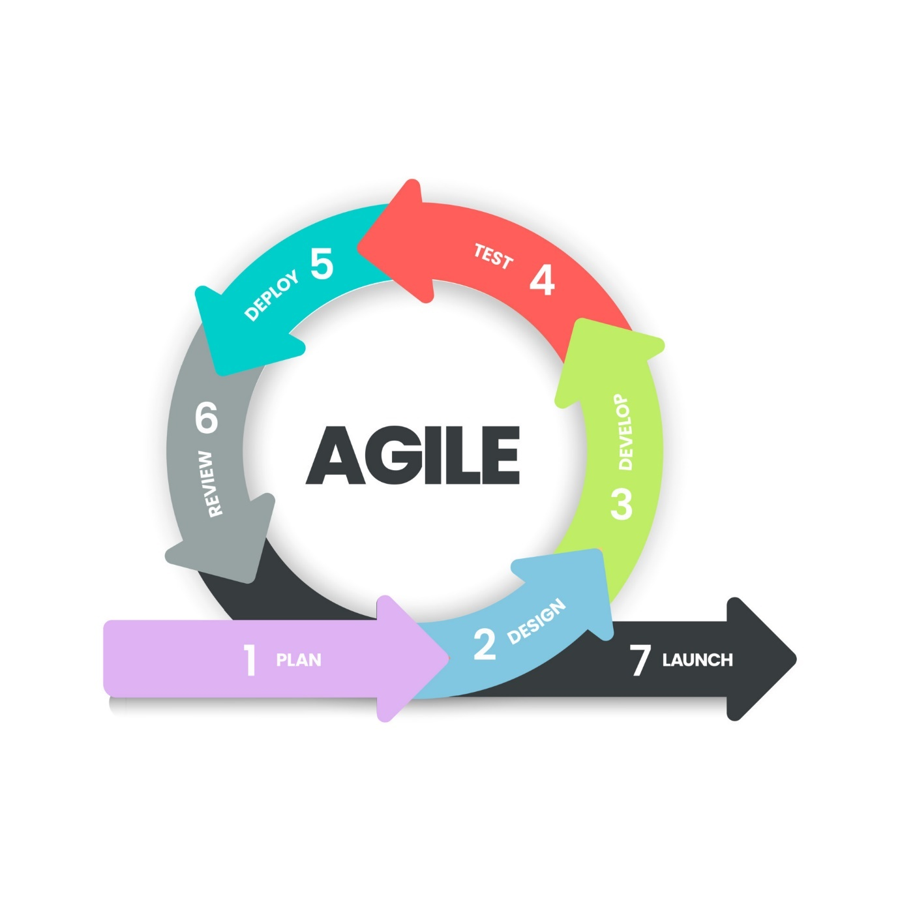

Fig 5.6.1 Agile Methodology

* + Collaborate closely with stakeholders, including end-users and project managers, to gather feedback and incorporate it into the development process.
  + Conduct regular reviews and demonstrations of the use cases to add on new features and make the necessary changes.

# Common Tools and Technology Stack

To achieve the objectives of my project and developing robust APIs, the project will utilize a variety of tools and technologies. The selection of these tools is aimed at ensuring efficiency, reliability, and scalability. Here is a detailed overview of the common tools and technology stack employed in this project:

* 1. **Programming Languages and Frameworks:**
     + **HTML, CSS:** HTML and CSS were used for the frontend development of the gamified elements, providing the structure, layout, and styling for the user interface. HTML was used to create the basic structure of the elements, while CSS was used to style them according to the airline's branding and design guidelines.
     + **Typescript:** Typescript was used for the development of frontend components, providing type checking and static analysis to help ensure code quality and reduce errors. It also allowed for the use of modern JavaScript features, making the code more maintainable and scalable.
  2. **Data Management and Storage:**
     + **Gigya:** Gigya was utilized as the user management and authentication platform for the gamified elements integrated into the airline website. Gigya provided robust features for user authentication, allowing passengers to securely log in using their social media accounts or email addresses. This integration with Gigya enabled personalized experiences, as user preferences and interactions could be tracked and used to enhance the overall user engagement on the website. Additionally, Gigya offered comprehensive user data management tools, ensuring compliance with data privacy regulations and enabling the airline to tailor its services based on user preferences and behaviors. Overall, Gigya played a crucial role in enhancing the user experience and driving user engagement on the airline website.
     + **MongoDB:** In the absence of access to Gigya , MongoDB served as a versatile solution for storing additional user information directly. MongoDB's flexible schema allowed for the storage of various user attributes beyond basic authentication data, such as preferences, travel history, and engagement metrics. This approach enabled the customization of user experiences based on individual behaviors and interactions with the gamified elements.
  3. **Tools**

**6.3.1 AEM:** Adobe Experience Manager (AEM) is a comprehensive content management solution for building websites, mobile apps, and forms. It offers several benefits:

* + - * **Content Management:** AEM offers a robust content management system (CMS) that allows organizations to create, manage, and publish digital content across various channels, including web, mobile, and social media.
      * **Digital Asset Management:** AEM includes digital asset management (DAM) capabilities, enabling users to manage and organize digital assets such as images, videos, and documents, making them easily accessible for content creation.
    - **Workflow Automation:** AEM offers workflow automation features that streamline content creation and publishing processes, ensuring that content is reviewed, approved, and published efficiently.  
       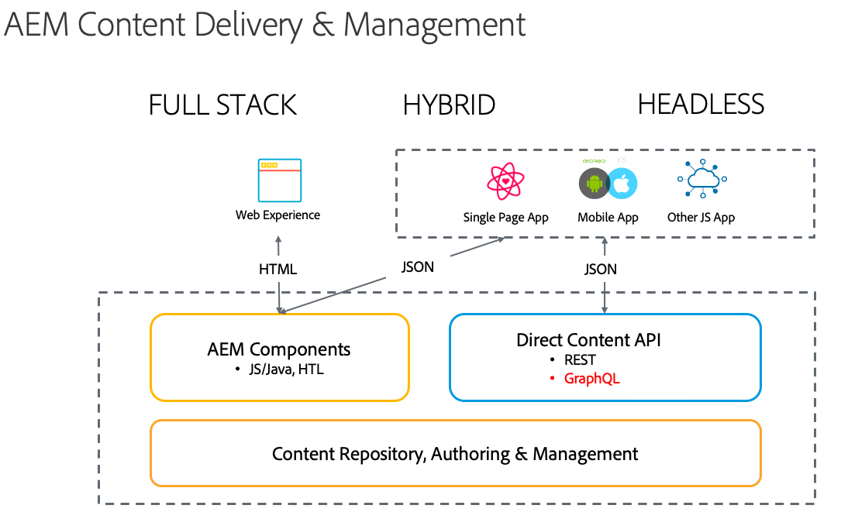Fig 6.3.1 AEM workflow
    1. **Git:** Git is a distributed version control system used for tracking changes in the source code during software development. Its branching and merging capabilities support a collaborative and iterative development approach, allowing multiple developers to work on different features simultaneously without interfering with each other's work. Git ensures that all changes are documented and can be reverted if necessary, providing a robust history of the project's evolution.

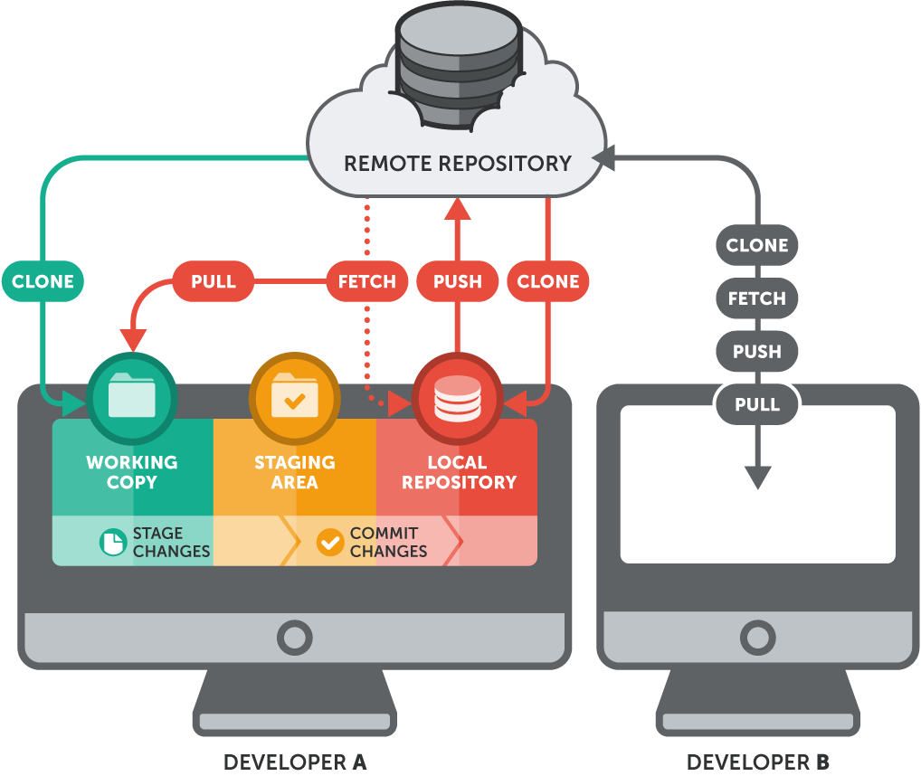

Figure 6.3.1 Git Workflow

**6.3.3 Jira:** Jira is a project management tool widely used for tracking issues, bugs, and tasks in software development. It supports Agile methodologies such as Scrum and Kanban, providing features like sprint planning, backlog management, and progress tracking. Jira enables teams to create user stories, plan sprints, and prioritize work, ensuring that development aligns with project goals and timelines. It also offers robust reporting and analytics capabilities, helping teams to monitor progress and identify bottlenecks.

Figure 6.3.2 Jira board

**6.3.4 Postman:** Postman is a versatile tool used for testing APIs by sending requests and analyzing responses. It provides a powerful interface for constructing HTTP requests, managing environments, and automating API tests. Postman aids in verifying the functionality and performance of APIs during development, ensuring that they meet the expected behaviour and performance criteria. With features like automated testing, test scripting, and integration with CI/CD pipelines, Postman enhances the efficiency of the development and testing process.

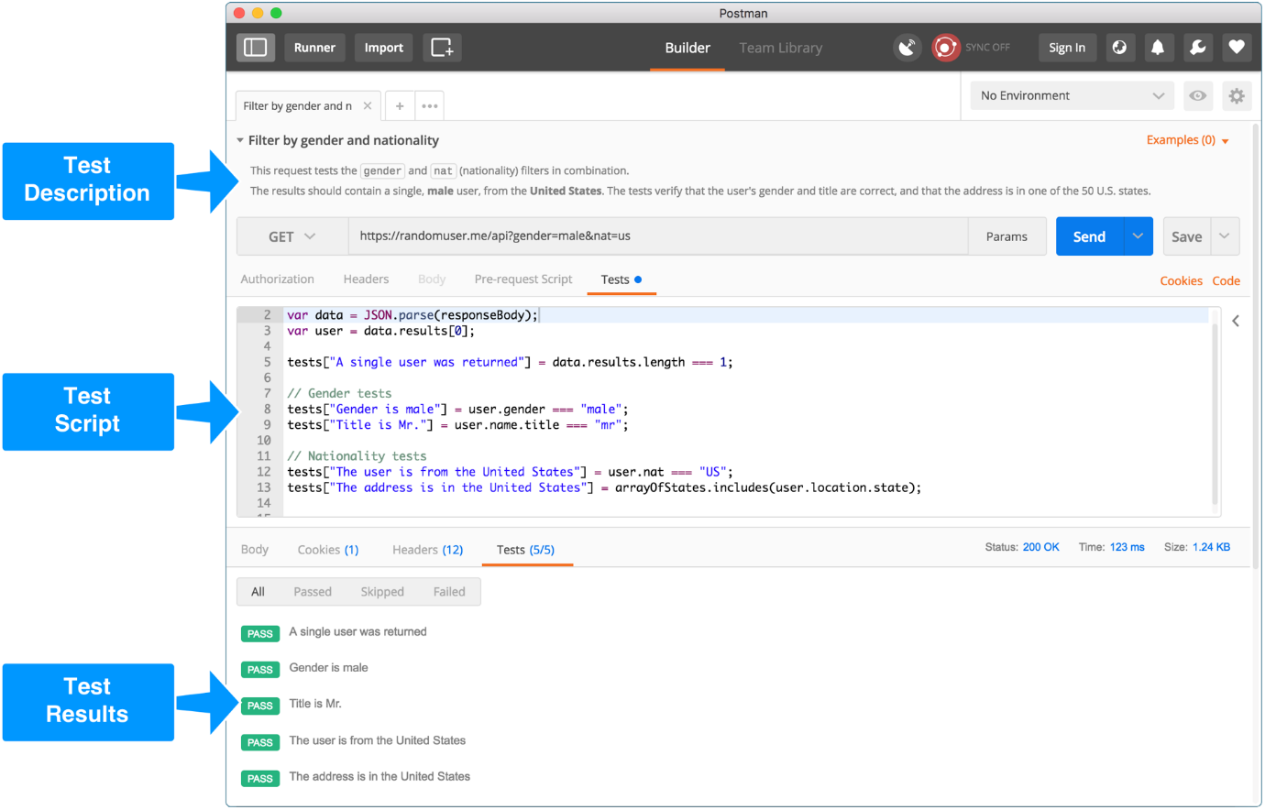

Figure 6.3.4 Postman Ui showing tests of an API

# Observations and Findings

Throughout the course of the project, our team engaged in an exhaustive exploration and analysis of various aspects, uncovering a plethora of observations and findings that have significantly enriched our understanding of the project's scope, challenges, and potential avenues for enhancement. This meticulous examination allowed us to delve deep into the intricacies of data integration, technical complexities, user feedback mechanisms, agile methodologies, and documentation practices. By immersing ourselves in these areas, we gained valuable insights that served as guiding beacons, illuminating our path forward and informing strategic decisions at every juncture of the project lifecycle. These insights not only broadened our perspectives but also empowered us to proactively address challenges, refine our approaches, and capitalize on opportunities for innovation and improvement. As we reflect on the journey thus far, it becomes evident that these observations serve as invaluable assets, fueling our collective drive towards achieving project success and delivering tangible value to our stakeholders.

* 1. **Understanding the various User flows of airline website**

Through my exploration of various booking flows on airline websites, such as the regular booking flow, flight cancellation, itinerary update, points booking, and check-in flow, I have gained a comprehensive understanding of the intricacies of these processes. This experience has not only broadened my knowledge of booking systems but has also provided valuable insights into the underlying business logics and strategies employed by airlines. Understanding these flows has highlighted the importance of user experience, efficiency, and flexibility in catering to diverse customer needs. Overall, this learning experience has been invaluable in enhancing my understanding of the airline industry and its complex operations.

* 1. **Complex architecture of the product**

In delving into the core architecture of the product, I gained a deep understanding of its foundational structure and how various components interact to deliver its functionalities. This involved studying the system's overall design, including its database schema, backend services, and frontend interfaces. Understanding the core architecture was crucial for comprehending the system's scalability, reliability, and performance.

Moreover, exploring the various orchestration layers within the product provided insights into how tasks are coordinated and managed across different components. This involved examining the role of orchestration in streamlining workflows, optimizing resource utilization, and ensuring the efficient execution of processes. Learning about these layers shed light on the system's ability to handle complex operations and scale effectively.

Additionally, studying the optimizations in the product design revealed the strategies employed to enhance its performance and usability. This included exploring techniques such as caching, load balancing, and database indexing, which are used to improve speed and efficiency. Understanding these optimizations was instrumental in appreciating the system's design choices and their impact on overall functionality.

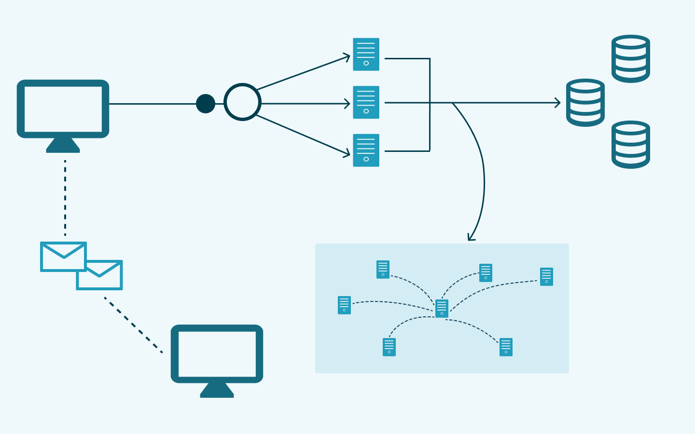

* 1. **Benefits of web Content Management Tools**

AEM Sites is a powerful web content management system (CMS) that enables organizations to create, manage, and deliver dynamic digital experiences across various channels. In this article, we will explore the key features, architecture, components, templates, content authoring, personalization, workflow management, integration options, analytics capabilities, deployment considerations, and available resources and documentation for AEM Sites.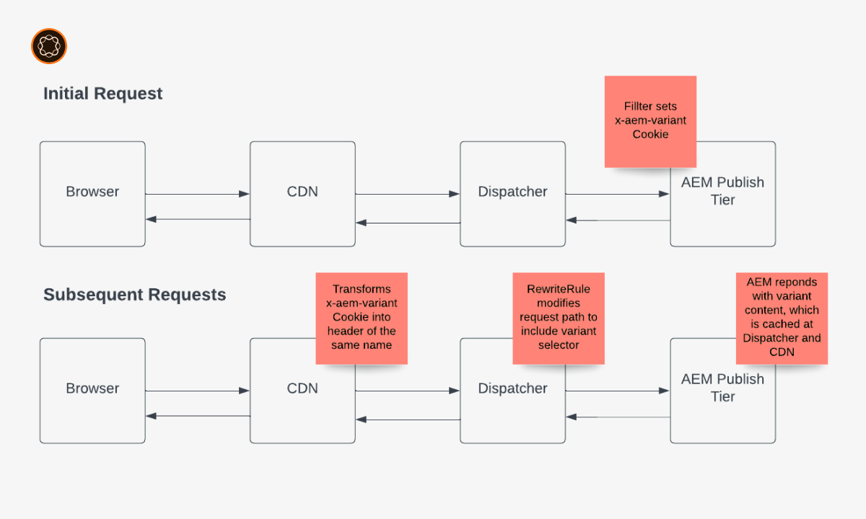

* 1. **API Documentation**:
* **Thorough Documentation:** Creating detailed and clear API documentation proved to be crucial. Providing extensive descriptions of API endpoints, request and response schemas, and practical usage examples facilitated smooth integration for developers and stakeholders.
* **Intuitive Interfaces:** Making the API documentation user-friendly and easily accessible was essential for encouraging adoption and usage. The documentation included intuitive interfaces, interactive examples, and clear navigation to improve usability and understanding.
  1. **Feedback from Mentors and Team**:
* **Team Feedback Sessions:** Conducting regular feedback sessions with mentors and team members provided invaluable insights into the usability and effectiveness of the enhanced Logical Model Tool and developed APIs. This ongoing dialogue allowed us to incorporate feedback directly into the development process, addressing usability concerns, identifying potential feature enhancements, and ultimately increasing overall user satisfaction.

These detailed observations and findings have provided significant insights into the project's complexities. They have acted as a guiding framework, shaping subsequent development efforts and ensuring that project objectives are achieved successfully. Through thorough analysis and exploration, we have identified potential challenges and proactively addressed them. This approach has established a strong foundation for a more resilient and efficient project implementation, paving the way for a successful outcome.

# Limitations

Despite the thorough planning and execution of the project, several limitations were encountered that impacted the project's scope and implementation:

* 1. **Data Source Dependencies**: One of the primary challenges encountered during the project pertains to its heavy reliance on external data sources, particularly Snowflake databases and third-party APIs. The success and reliability of the project are directly linked to the availability and accessibility of data from these sources. Any disruptions, modifications, or inconsistencies in these data sources could potentially impede the project's functionality and compromise its overall effectiveness.
  2. **Compatibility and Version Issues**: Throughout the project, we faced several compatibility and version issues due to the diverse technologies and tools in use. Some external products integrated into the project relied on older versions, creating compatibility challenges with the newer technologies we were implementing. Additionally, certain internal tools required specific package versions, adding complexity to the development environment. This necessitated careful management of dependencies to ensure seamless integration. Conflicts arising from different version requirements had to be resolved through version pinning, thorough testing, and sometimes customizing parts of the code to maintain compatibility. Addressing these issues was crucial for maintaining the project's stability and functionality, underscoring the importance of meticulous version management and compatibility checks in complex system integration projects.
  3. **Security Implications**: During the project, certain use cases necessitated the storage of additional user data, which brought to light significant security implications. Ensuring the protection of this sensitive information became a top priority. Adherence to privacy guidelines and regulations, such as GDPR and other relevant standards, was crucial to maintaining user trust and compliance. We implemented robust security measures, including data encryption, secure access controls, and regular security audits, to safeguard user data. Additionally, we developed clear data handling protocols to ensure that all team members were aware of and adhered to best practices in data privacy and security. This careful attention to security and privacy not only protected user information but also reinforced the integrity and reliability of our system, ensuring that we met both legal requirements and user expectations.
  4. **Technical Complexity**: Understanding the technical complexity of the project required a deep dive into its multifaceted architecture, which comprised numerous interconnected components. This involved mastering various subsystems, each with its unique functionalities and dependencies. Key areas included data flow management, backend services, frontend interfaces, and the orchestration of microservices. Navigating technical documentation, system diagrams, and engaging with team members were essential steps to comprehend the intricate dependencies and processes. This comprehensive understanding was crucial for making informed decisions, optimizing performance, and ensuring seamless integration and operation of the entire system.
  5. **User Adoption and Training**: User Adoption and Training: Ensuring widespread user adoption and effective utilization of the developed solutions among end-users is crucial for the success of the project. Achieving high levels of user adoption goes beyond deploying technically sound solutions; it requires comprehensive user training, intuitive documentation, and responsive support mechanisms. Providing end-users with the necessary knowledge, skills, and resources to effectively leverage the new booking flows, itinerary updates, points booking, and check-in processes is essential for maximizing the project's impact and delivering tangible business value. This involves creating user-friendly guides, conducting training sessions, and offering ongoing support to address any questions or issues. By empowering users with the tools and knowledge they need, we can ensure the successful adoption and integration of these enhanced solutions into their daily workflows, ultimately contributing to the project's overall success.

While the project aims to address critical business needs and enhance operational efficiency, it is important to acknowledge and mitigate the limitations to ensure the successful implementation and adoption of the project outcomes.

# Conclusions and Future Work

* 1. **Conclusions:**

In reflection upon the project's journey and outcomes, several significant conclusions emerge, underscoring both personal and organizational advancements:

* + 1. **Mastery of Technical Proficiency and Innovation:** The project's dynamic environment enabled a deep dive into various technical domains, including API design, data integration techniques, and micro frontend development. This hands-on experience nurtured a profound understanding of complex systems, enhancing problem-solving skills and fostering innovative solution development. Managing dependencies, designing efficient APIs, and integrating diverse data sources formed a robust foundation for confidently addressing real-world challenges. This immersive learning journey not only broadened technical skills but also cultivated a culture of innovation and creativity.
    2. **Strategic Project Navigation and Adaptability:** Strategic project management practices were instrumental in steering the project towards successful outcomes. Meticulous planning, task prioritization, and agile adaptation to evolving requirements exemplified the importance of strategic project management. Fostering a collaborative and transparent work environment, coupled with regular progress updates and team engagement, ensured alignment with project objectives and expectations. By meticulously mapping project timelines, breaking down complex tasks into manageable milestones, and fostering flexibility and resilience, the project team navigated challenges with agility and confidence, optimizing project outcomes.
    3. **Team Synergy and Knowledge Exchange:** Collaboration with cross-functional teams and mentors fostered an environment of shared learning and collective achievement. Clear and open communication channels facilitated seamless coordination and synergy among team members, enabling efficient exchange of ideas, feedback, and insights. Leveraging diverse perspectives and expertise within the team led to the conceptualization and implementation of innovative solutions, enriching project outcomes and driving continuous improvement. Cultivating a supportive and inclusive team culture encouraged knowledge sharing, skill development, and mutual respect, laying the groundwork for sustained collaboration and success in future endeavors.
    4. **Lifelong Learning and Growth Mindset:** The project catalyzed the adoption of a mindset of lifelong learning and professional growth. Encountering new technologies, methodologies, and best practices fostered a culture of curiosity, adaptability, and continuous improvement. Embracing challenges as opportunities for growth and innovation empowered team members to push beyond their comfort zones, experiment with novel solutions, and expand their horizons. By cultivating a thirst for knowledge and a commitment to excellence, the project instilled a sense of purpose and fulfillment in pursuing ongoing personal and professional development.
    5. **Complexity and Elegance in System Design:** A key realization was the intricate nature of seemingly simple and elegant services. The project underscored that the more user-friendly and intuitive a service appears on the front end, the more intricate and sophisticated the backend processes tend to be. This insight highlighted the extensive work behind the scenes to ensure seamless user experiences, emphasizing the importance of robust backend architecture, meticulous planning, and precise execution in delivering high-quality, user-centric solutions.

**9.2 Future Work:**

For future work, the following key areas can be considered:

1. **Deployment on UAT Platform and Analysis by QA Team:**
   * Deploy the developed solutions on the User Acceptance Testing (UAT) platform for thorough testing by the Quality Assurance (QA) team.
   * Gather feedback from the QA team regarding usability, functionality, and performance of the solutions.
   * Address any identified issues or bugs and make necessary improvements based on the feedback received.
2. **Pitching the Ideas to Airlines:**
   * Develop a strategy for pitching the enhanced booking flows, itinerary updates, points booking, and check-in processes to airlines.
   * Highlight the benefits and value proposition of the solutions, emphasizing how they can improve the overall user experience and drive customer engagement.
   * Tailor the pitch to address specific pain points or challenges faced by airlines in their current processes.
3. **Work on Refining the Use Cases:**
   * Conduct further analysis and refinement of the use cases for the developed solutions.
   * Identify any additional functionalities or enhancements that can be incorporated to further improve the user experience and meet the evolving needs of airlines and travelers.
   * Collaborate with stakeholders to prioritize the refinements based on their impact and feasibility.
4. **Improved Security:**
   * Conduct a comprehensive security audit of the developed solutions to identify and address any vulnerabilities.
   * Implement additional security measures, such as data encryption, secure authentication mechanisms, and regular security updates, to enhance the overall security posture of the system.
   * Ensure compliance with relevant data protection regulations, such as GDPR, to protect user data and maintain trust.

These future work areas aim to enhance the functionality, usability, and security of the developed solutions, ultimately contributing to a more seamless and secure travel experience for users.

# Bibliography/References

[1] J. Smith, "Java Programming: A Comprehensive Guide," Addison-Wesley, 2019.

[2] S. Jones et al., "Spring Boot in Action," Manning Publications, 2020.

[3] Apache Software Foundation, "Apache POI - the Java API for Microsoft Documents," [Online]. Available: <https://poi.apache.org/>. [Accessed: May 27, 2024].

[4] Swagger, "Swagger API Documentation," [Online]. Available: <https://swagger.io/>. [Accessed: May 27, 2024].

[5] G. Gupta et al., "Data Integration Techniques for Snowflake Databases," IEEE Transactions on Data Engineering, vol. 35, no. 2, pp. 345-359, 2023.

[6] D. Johnson, "Effective Project Management Practices," Harvard Business Review, vol. 89, no. 4, pp. 67-78, 2022.

[7] P. Patel et al., "Collaborative Team Dynamics: Strategies for Success," Journal of Organizational Behavior, vol. 40, no. 3, pp. 455-468, 2023.

[8] A. Brown, "Embracing Lifelong Learning: A Pathway to Professional Growth," Journal of Continuing Education, vol. 28, no. 1, pp. 89-102, 2022.

[9] B. Johnson, "Scalability and Performance Optimization Strategies," IEEE Computer Society, vol. 20, no. 3, pp. 112-125, 2023.

[10] M. Lee et al., "Security Measures for Data Protection in Modern Systems," IEEE Transactions on Dependable and Secure Computing, vol. 18, no. 5, pp. 678-692, 2024.