**AWS Cassandra Setup:**

**Steps to Create Instance:**

Choose **Launch Instance**.

**Step 1: Choose an Amazon Machine Image (AMI)**, find Ubuntu Server at the top of the list and choose **Select**.

Machine generated alternative text:
Step 1: Choose an Amazon Machine Image (AMI) 
EC2 Management Cons' X 
C) 
0 2008 - 2017, 
x 
us-west-2.consoIe.aws. 
amazon.com 
Services v 
Resource Groups 
/ec2/v2/home? region = us-west-2#LaunchlnstanceWizard: 
Bhanu 
Oregon 
Support 
1. Choose AMI 
2. Choose Instance Type 
3. Configure Instance 
4. Add Storage 
5. Add Tags 
6. Configure Security Group 
7. Review 
O Free tier only (j) 
Q Feedback English 
Ask me anything 
Red Hat 
Free tier eligible 
3 
SUSE Linux 
Free tier eligible 
Free tier eligible 
Windows 
Red Hat Enterprise Linux version 7.3 (HVM), EBS General Purpose (SSD) Volume Type 
Root device type: ebs Virtualization type: hvm 
SUSE Linux Enterprise Server 12 SP2 (HVM), SSD Volume Type - ami-e4a30084 
SUSE Linux Enterprise Server 12 Service Pack 2 (HVM), EBS General Purpose (SSD) Volume Type. Public Cloud, Advanced 
Systems Management, Web and Scripting, and Legacy modules enabled. 
Root device type: ebs Virtualization type: hvm 
Ubuntu Server 16.04 LTS (HVM), SSD Volume Type - ami-a58dOdc5 
Ubuntu Server 16.04 L TS (HVM),EBS General Purpose (SSD) Volume Type. Support available from Canonical 
Root device type: ebs Virtualization type: hvm 
Microsoft Windows Server 2016 Base - ami-6e833e0e 
Microsoft Windows 2016 Datacenter edition. [English] 
Cancel and Exit 
64-bit 
Select 
64-bit 
Select 
64-bit 
Select 
64-bit 
Amazon Web Services, Inc. or its affiliates. All rights reserved. 
Privacy Policy Terms of Use 
3:52 PM 
3/11/2017 —5 

**Step 2: Choose an Instance Type**, choose **Next: Configure Instance Details**

**We selected t2.large.**

Machine generated alternative text:
EC2 Management Cons' X 
- Q Mnagement Cansae 
CD a 
2017, Amazon Web Services, Inc. or its affiliates. All rights reserved. 
x 
us-west-2.consoIe.aws. 
amazon.com 
/ec2/v2/home? region = us-west-2#LaunchlnstanceWizard: 
Services v 
Resource Groups 
Bhanu 
Oregon 
1. Choose AMI 
2. Choose Instance Type 
3. Configure Instance 
4. Add Storage 
5. Add Tags 
6. Configure Security Group 
Step 2: Choose an Instance Type 
Currently selected: t2.large (Variable ECUs, 2 vCPUs, 
2.4 GHz, 
vCPUs 
2 
2 
4 
8 
Intel Xeon Family, 8 GiB memory, EBS only) 
7. Review 
EBS-Optimized 
0) 
Available 
o 
Family 
General purpose 
Type 
t2.nano 
t2.micro 
Free tier eli ible 
t2.small 
t2.medium 
t2.xlarge 
t2.2xlarge 
0) 
Memory (GiB) 
0.5 
1 
2 
4 
8 
16 
32 
Instance Storage (GB) 
0) 
EBS only 
EBS only 
EBS only 
EBS only 
EBS only 
EBS only 
EBS only 
Cancel 
0 2008 - 
Network Performance 
0) 
Low to Moderate 
Low to Moderate 
Low to Moderate 
Low to Moderate 
Low to Moderate 
Moderate 
Moderate 
Support 
IPv6 
Support 
Yes 
Yes 
Yes 
Yes 
Yes 
Yes 
Yes 
Previous 
Review and Launch 
Next: Configure Instance Details 
Q Feedback English 
Ask me anything 
Privacy Policy 
Terms of Use 
3:53 PM 
3/11/2017 

**Step 3: Configure Instance Details**, choose **Network**, and then choose the entry for your default VPC.

Machine generated alternative text:
Step 3: Configure Instance Details 
Configure the instance to suit your requirements. You can launch multiple instances from the same AMI, request Spot instances to take advantage of the lower pricing, assign an access 
management role to the instance, and more. 
EC2 Management Cons' X + 
C) 
us-west-2.consoIe.aws. 
/ec2/v2/home? region = us-west-2#LaunchlnstanceWizard: 
amazon.com 
Services 
Resource Groups v 
0 2008 - 2017, 
x 
Bhanu 
Oregon 
Support 
1. Choose AMI 
2. Choose Instance Type 
3. Configure Instance 
4. Add Storage 
5. Add Tags 
6. Configure Security Group 
7. Review 
Number of instances 
Purchasing option 
Network 
Subnet 
Auto-assign Public IP 
IAM role 
Shutdown behavior 
Enable termination protection 
Monitoring 
Q Feedback English 
Ask me anything 
Launch into Auto Scaling Group O) 
O) 
Request Spot instances 
Use subnet setting (Enable) 
Stop 
Protect against accidental termination 
Enable CloudWatch detailed monitoring 
Create new VPC 
Create new subnet 
Create new IAM role 
Cancel 
Previous 
Review and Launch 
Next: Add Storage 
Amazon Web Services, Inc. or its affiliates. All rights reserved. 
Privacy Policy Terms of Use 
3:53 PM 
3/11/2017 —5 

**Step 4:** For storage, we add **30GB**

Machine generated alternative text:
Step 4: Add Storage 
Your instance will be launched with the following storage device settings. You can attach additional EBS volumes and instance store volumes to your instance, or 
edit the settings of the root volume. You can also attach additional EBS volumes after launching an instance, but not instance store volumes. Learn more about 
storage options in Amazon EC2 
EC2 Management Cons' X + 
C) 
us-west-2.consoIe.aws. 
/ec2/v2/home? region = us-west-2#LaunchlnstanceWizard: 
amazon.com 
Services v 
Resource Groups v 
0 2008 - 2017, 
x 
Bhanu 
Oregon 
Support 
1. Choose AMI 
2. Choose Instance Type 
3. Configure Instance 
4. Add Storage 
5. Add Tags 
6. Configure Security Group 
7. Review 
0) 
Volume Type 
Root 
Add New Volume 
0) 
Device 
Idev/sdal 
Snapshot 
snap- 
O) 
Size (GiB) 
0) 
0) 
Volume Type 
0) 
1 oo / 3000 
Throughput 
0) 
(MB/s) 
090acef382b239622 
Free tier eligible customers can get up to 30 GB of EBS General Purpose (SSD) or Magnetic storage. Learn more about free usage tier eligibility and 
usage restrictions. 
Q Feedback English 
Ask me anything 
Cancel 
Previous 
Delete on 
Termination 
0) 
Review and Launch 
Encrypted 
0) 
Not Encrypted 
Next: Add Tags 
Amazon Web Services, Inc. or its affiliates. All rights reserved. 
Privacy Policy Terms of Use 
3:53 PM 
3/11/2017 —5 

**Step 5:**Add tags

Machine generated alternative text:
CD 
Services 
us-west-2.consoIe.aws. 
/ec2/v2/home? region = us-west-2#LaunchlnstanceWizard: 
amazon.com 
Resource Groups v 
Bhanu 
Oregon 
Support 
1. Choose AMI 
2. Choose Instance Type 
3. Configure Instance 
4. Add Storage 
5. Add Tags 
6. Configure Security Group 
7. Review 
step 5: Add Tags 
A tag consists of a case-sensitive key-value pair. For example, you could define a tag with key = Name and value = Webserver. Learn more about tagging your Amazon EC2 resources. 
Key 
Name 
(127 characters maximum) 
Value 
(255 characters maximum) 
Add another tag 
(Up to 50 tags maximum) 
Cancel 
Previous 
Review and Launch 
Next: Configure Security Group 
Q Feedback English 
Ask me anything 
0 2008 - 2017, 
Amazon Web Services, Inc. or its affiliates. All rights reserved. 
Privacy Policy Terms of Use 
3:53 PM 
3/11/2017 —5 

**Step 6:** Choose **Next: Configure Security Group**.

In this we opened all the inbound/outbound traffic by creating a new rule for All Traffic and accepting Source IP from anywhere.

Machine generated alternative text:
Step 6: Configure Security Group 
A security group is a set of firewall rules that control the traffic for your instance. On this page, you can add rules to allow specific traffic to reach your instance. For example, if you want to set up a 
web server and allow Internet traffic to reach your instance, add rules that allow unrestricted access to the HTTP and HTTPS ports. You can create a new security group or select from an existing 
one below. Learn more about Amazon EC2 security groups. 
Assign a security group: @Create a new security group 
OSelect an existing security group 
EC2 Management Cons' X + 
C) 
us-west-2.consoIe.aws. 
/ec2/v2/home? region = us-west-2#LaunchlnstanceWizard: 
amazon.com 
Services v 
Resource Groups v 
0 2008 - 2017, 
x 
Bhanu 
Oregon 
Support 
1. Choose AMI 
2. Choose Instance Type 
3. Configure Instance 
4. Add Storage 
5. Add Tags 
6. Configure Security Group 
7. Review 
Security group name: 
Description: 
launch-wizard-I 
launch-wizard- 
1 created 2017-03-1 ITI 
Type 
SSH 
All traffic 
Add Rule 
A Warning 
Q Feedback English 
Ask me anything 
Protocol (j) 
TCP 
All 
Port Range 
22 
o - 65535 
Source i 
Anywhere v 
Anywhere 
0.0.0.0/0, 
0.0.0.0/0, 
Cancel 
Previous 
Review and Launch 
Amazon Web Services, Inc. or its affiliates. All rights reserved. 
Privacy Policy Terms of Use 
3:54 PM 
3/11/2017 —5 

**Step 7:** Choose **launch.**

Machine generated alternative text:
Step 7: Review Instance Launch 
Please review your instance launch details. You can go back to edit changes for each section. Click Launch to assign a key pair to your instance and complete the launch process. 
EC2 Management Cons' X + 
CD a 
us-west-2.consoIe.aws. 
/ec2/v2/home? region = us-west-2#LaunchlnstanceWizard: 
amazon.com 
Services v 
Resource Groups v 
0 2008 - 2017, 
x 
Bhanu 
Oregon 
Support 
1. Choose AMI 
2. Choose Instance Type 
3. Configure Instance 
4. Add Storage 
5. Add Tags 
6. Configure Security Group 
7. Review 
A 
A 
Improve your instances' security. Your security group, launch-wizard-I , is open to the world. 
Your instances may be accessible from any IP address. We recommend that you update your security group rules to allow access from known IP addresses only. 
You can also open additional ports in your security group to facilitate access to the application or service you're running, e.g., HTTP (80) for web servers. Edit security groups 
x 
Your instance configuration is not eligible for the free usage tier 
To launch an instance that's eligible for the free usage tier, check your AMI selection, instance type, configuration options, or storage devices. Learn more about free usage tier 
eligibility and usage restrictions. 
AMI Details 
on s owme IS aga•n 
Edit AMI 
Free tier 
eligible 
Ubuntu Server 16.04 LTS (HVM), SSD Volume Type - ami-a58dOdc5 
Ubuntu Server 16.04 L TS (HVM),EBS General Purpose (SSD) Volume Type. Support available from Canonical (http://www.ubuntu.com/cloud/services). 
Root [)evice Type: ebs Virtualization type. hvm 
Cancel 
Previous 
Launch 
Q Feedback English 
Ask me anything 
Amazon Web Services, Inc. or its affiliates. All rights reserved. 
Privacy Policy Terms of Use 
3:54 PM 
3/11/2017 —5 

Create a new key pair and download it to your local desktop.

Machine generated alternative text:
EC2 Management Cons' X + 
C) 
us-west-2.consoIe.aws. 
/ec2/v2/home? region = us-west-2#LaunchlnstanceWizard: 
amazon.com 
services v Resource Groups v 
x 
Bhanu 
Oregon 
Support 
1. Choose AMI 
2. Choose Instance Type 
3. Configure Instance 
4. Add Storage 
5. Add Tags 
6. Configure Security Group 
7. Review 
Step 7: Review Instance 
Please review your instance launch detail 
Select an existing key pair or create a new key pair 
x 
A 
A 
Improve your instances' 
Your instances may be access 
You can also open additional 
Your instance configura 
To launch an instance that's el 
eligibility and usage restriction 
A key pair consists of a public key that AWS stores, and a private key file that you store. Together, 
they allow you to connect to your instance securely. For Windows AMIs, the private key file is required to 
obtain the password used to log into your instance. For Linux AMIs, the private key file allows you to 
securely SSH into your instance. 
Note: The selected key pair will be added to the set of keys authorized for this instance. Leam more 
about removing existing key pairs from a public AMI 
Create a new key pair 
Key pair name 
CassandraConfig3Node1 
Download Key Pair 
You have to download the private key file (*.pem file) before you can continue. Store 
it in a secure and accessible location. You will not be able to download the file 
again after its created. 
Launch Instances 
te the launch process. 
addresses only. 
ervers. Edit security groups 
x 
rn more about free usage tier 
on s ow me 
AMI Details 
IS aga•n 
Edit AMI 
Free tier 
eligible 
Ubuntu Server 16.04 L 
Ubuntu Server 16.04 CTS ( 
Root Device Type: ebs Virtual 
Cancel 
Previous 
Launch 
Q Feedback English 
Ask me anything 
CassandraConfig3Node1 .pem finished downloading. 
Open 
Open folder 
1 
View downloads 
Privacy Policy 
Terms of Use 
x 
3:55 PM 
3/11/2017 —5 

**Connecting to EC2 Instance:**

After creating of Ec2 instance, connect to it using Putty.

Before connecting using Putty, generate Private key using Putty Key Generator.

**Steps for creating Private Key:**

* Open Putty Key Generator.
* Click on conversions.
* Click on import
* Select the Key(.pem) created in AWS console.
* Click on save private key.

Machine generated alternative text:
PuTTY Key Generator 
File Key Conversions Help 
Key 
Public key for pasting into OpenSSH authorized keys file: 
ssh-rsa 
AAAA83NzaC1yc2EAAAADAQA3AAA3AQDpSHXbzOlHr79SUasVnnXv5LvP9LxN50iCDw97 
DDOMLdjzXIyL6pyWNVvRZxjm0DgMRn6TA2XpmvfGaq3cY0NDdxARr9VIvD008ZMuzCYI/rF 
+1bsw/wnuun3hqMYcau3ksanlLt5EQ81ZjRrF142syacN02StHHIGmUydS2U3QuRKzOoyJs v 
Key fingerprint 
Key comment 
Key passphrase: 
Confirm passphrase: 
Actions 
ssh-rsa 20489a:a6 Sa 3fSS e82f3c04 ea 743484 bb 3b Id 
imported-openssh-key 
Generate a public/private key pair 
Load an existing private key file 
Save public key 
Generate 
Load 
Save private key 
Save the generated key 
Parameters 
Type of key to generate: 
O SSH-I (RSA) 
@SSH-2 RSA 
O SSH-2 OSA 
Number of bits in a generated key: 

Machine generated alternative text:
PuTTY Configuration 
Category: 
A Terminal 
Keyboard 
Bell 
Features 
g Window 
Appearance 
Behaviour 
Translation 
Selection 
Colours 
g„Connection 
Data 
Proxy 
Telnet 
Rlogin 
g SSH 
Kex 
Cipher 
Auth 
TTY 
Xll 
Tunnels 
Bugs 
More bugs 
About 
Options controlling SSH authentication 
Bypass authentication entirely (SSH-2 only) 
Z] Display pre-authentication banner (SSH-2 only) 
Authentication methods 
Z] Attempt authentication using Pageant 
Attempt TIS or CryptoCard auth (SSH-I) 
Z] Attempt "keyboard-interactive" auth (SSH-2) 
Authentication parameters 
Allow agent forwarding 
Allow attempted changes of username in SSH-2 
Private key file for authenticatiom 
C Browse„ 
Open 
Cancel 

**Logging in Putty:**

* Open Putty.
* Enter the Public IP of Ec2 Instance in hostname.
* Click on Auth
* Browse the Private Key
* Click on Data under connections and enter the auto login username as ubuntu
* Click on Open

Machine generated alternative text:
ubuntu@i0-172-31-1-158: - 
Get cloud support with Ubuntu Advantage Cloud Guest: 
ht tp : //ww".l.ubuntu.com/business/services/cloud 
0 packages can be updated. 
0 updates are security updates. 
The programs included with the Ubuntu system are free software; 
the exact distribution terms for each program are described in the 
individual files in /usr/ share/doc/*/copyright. 
Ubuntu comes with ABSOLUTELY NO WARRANTY, to the extent permitted by 
applicable law. 
To run a command as adlninistrator (user "root") , 
See "man sudo root" for details. 
: S sudo passwd root 
Enter new UNIX password: 
Retype new UNIX password: 
passwd: password updated successfully 
use 
" sudo <command>" . 

**Making Instances Communicate:**

In the listen address mention the IP Address of all the Cassandra nodes so that they form one cluster.

Machine generated alternative text:
root@ip-172-31-l-158: 
GNU an 
commit log segment 
/etc/cassandra 
size in mb: 32 
# any class that implements the Seedprovider interface and has a 
# constructor that takes a Map<String, String> of parameters will do. 
seed provider: 
# Addresses of hosts that are deemed contact points. 
# Cassandra nodes use this list of hosts to find each other and learn 
# the topology of the ring. You must change this if you are running 
# multiple nodes! 
class name: org.apache.cassandra.locator.simpleseedprovider 
parameters : 
# seeds is actually a conuna—delimited list of addresses. 
# Ex: <ip3>" 
seeds : 
For workloads with more data than can fit in memory, Cassandra 's 
bottleneck will be reads that need to fetch data from 
disk. "concurrent reads" should be set to (16 * number of drives) in 
order to allow the operations to enqueue low enough in the stack 
that the OS and drives can reorder them. Same applies to 
"concurrent counter writes" , 
since counter writes read the current 
values before incrementing and writing them back. 
On the other hand, since writes are almost never 10 bound, the ideal 
number of "concurrent writes" is dependent on the number of cores in 
your system; (8 * number of cores) is a good rule of thumb. 
concurrent reads: 32 
concurrent writes: 32 
concurrent counter writes: 32 
Total memory to use for sstable—reading buffers. 
the smaller of 1/4 of heap or 512MB. 
file cache size in mb: 512 
Defaults to 
Total permitted memory to use for memtables. Cassandra will stop 
accepting writes when the limit is exceeded until a flush completes, 
and will trigger a flush based on memtable cleanup threshold 
If omitted, Cassandra will set both to 1/4 the size of the heap. 
memtable heap space in mb: 2048 
memtable offheap space in mb: 2048 
Ratio of occupied non—flushing memtable size to total permitted size 
that will trigger a flush of the largest memtable. Lager mct will 
mean larger flushes and hence less compaction, but also less concurrent 
flush activity which can make it difficult to keep your disks fed 
Get Help 
Exit 
Write Out 
Read File 
Where Is 
Replace 
Cut Text 
Uncut Text 
Justify 
To Spell 
Cur Pos 
Go To Line 
Prev 
Next 
Page 
Page 
First Line 
Last Line 
-a 
Wherels Next 
To Bracket 
Mark Text 
Copy Text 
o 
Ask me anything 
od 
Indent Text 
Unindent Text 
4:21 PM 
3/11/2017 —5 

Snapshot of Cassandra Cluster with 6 nodes:

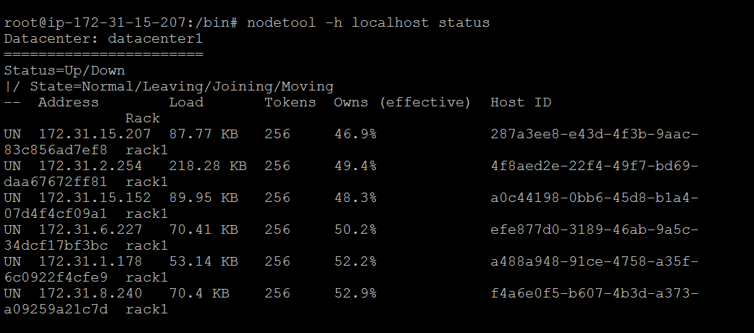

 In Security Groups open the inbound/outbound traffic.

Machine generated alternative text:
Step 6: Configure Security Group 
A security group is a set of firewall rules that control the traffic for your instance. On this page, you can add rules to allow specific traffic to reach your instance. For example, if you want to set up a 
web server and allow Internet traffic to reach your instance, add rules that allow unrestricted access to the HTTP and HTTPS ports. You can create a new security group or select from an existing 
one below. Learn more about Amazon EC2 security groups. 
Assign a security group: @Create a new security group 
OSelect an existing security group 
EC2 Management Cons' X + 
C) 
us-west-2.consoIe.aws. 
/ec2/v2/home? region = us-west-2#LaunchlnstanceWizard: 
amazon.com 
Services v 
Resource Groups v 
0 2008 - 2017, 
x 
Bhanu 
Oregon 
Support 
1. Choose AMI 
2. Choose Instance Type 
3. Configure Instance 
4. Add Storage 
5. Add Tags 
6. Configure Security Group 
7. Review 
Security group name: 
Description: 
launch-wizard-I 
launch-wizard- 
1 created 2017-03-1 ITI 
Type 
SSH 
All traffic 
Add Rule 
A Warning 
Q Feedback English 
Ask me anything 
Protocol (j) 
TCP 
All 
Port Range 
22 
o - 65535 
Source i 
Anywhere v 
Anywhere 
0.0.0.0/0, 
0.0.0.0/0, 
Cancel 
Previous 
Review and Launch 
Amazon Web Services, Inc. or its affiliates. All rights reserved. 
Privacy Policy Terms of Use 
3:54 PM 
3/11/2017 —5 

**VM Instance Specification:**

**Instance /CPU Type:** t2.large

**Number of Cores:** 2

**Memory Size: 30GB/dev/sda1**

**Price:** CPU credits/hours: 36 $0.094 per hour

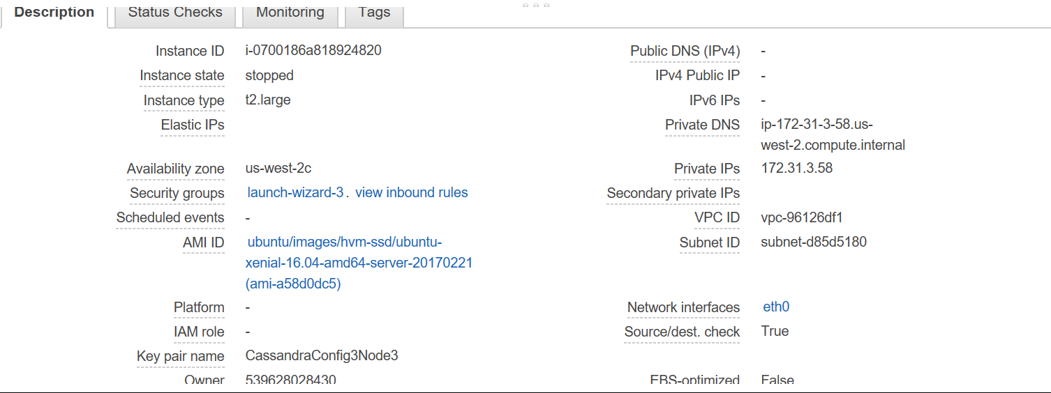

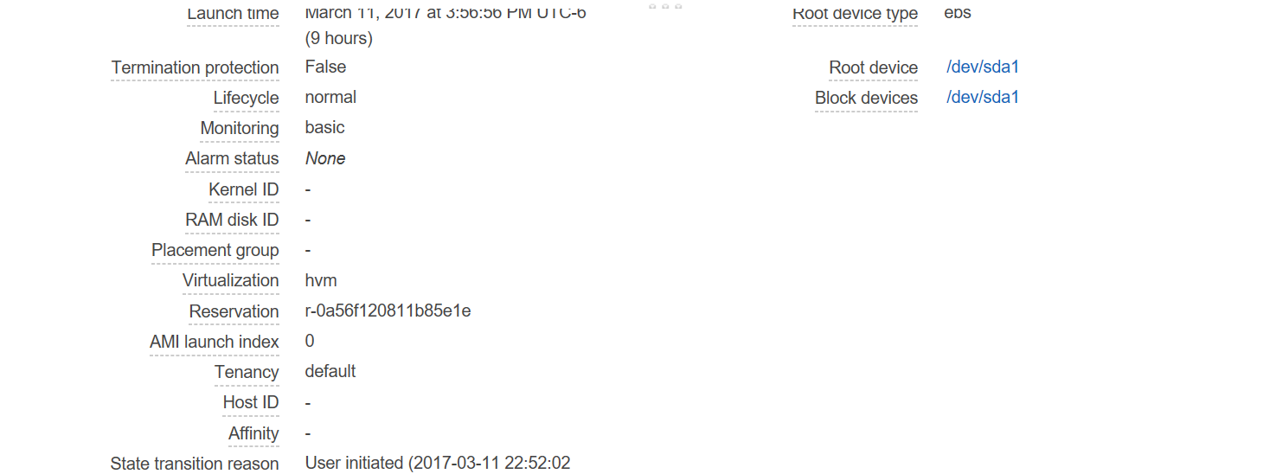

**Issues Faced:**

**Issue 1:**

Was unable to download Cassandra from the link provided in blog.

**Solution 1:**

Downloaded a newer version of Cassandra and got it running.

**Issue 2:**

Removing nodes on local host was time consuming and slow.

**Solution 2:**

Used command **nodetool removenode force hostID**