Assignment-2
Kunal Saini
2014053

Q1

a.
- Block Cipher : It is a deterministic and computable function of k-bit keys and n-bit (plaintext) blocks to n-bit (ciphertext) blocks.This means, when you encrypt the same plaintext block with the same key, you'll get the same result,this function is invertible also, i.e. with given the key and the ciphertext block we can also compute the plaintext by just following the reverse process that we used in encryption.To actually encrypt or decrypt a message (of any size) we first segment the message into blocks of n-bits and then used to encrypt eack of those n-bit bloks with a k-bit keys.

- Stream Cipher: It is a function which directly maps k-bit keys and arbitrary length plaintexts to same arbitrary length ciphertext, in such a way that prefixes of the plaintext map to prefixes of the ciphertext, i.e. we can compute the starting part of the ciphertext before the trailing part of the plaintext is known.If a part of the plaintext repeats, the corresponding ciphertext usually is not the same – different parts of the message will be encrypted in different ways.

Summarize :

BLOCK | STREAM
Operates on a fixed size block of plaintext | Encoding of each block depend on many previous;stateful encryption
Encryption is block by block | Encryption is byte by byte or bit by bit
Complex and slow | Simple and Fast

b.
Plaintext:“FOUNDATIONS TO COMPUTER SECURITY IS A COURSE AT IIITD”

- DES(Block Cipher)
Mode: ECB
Base64
key: 98123456
Cipher: u80PFJga6CxgV2vGV2rhpEmqFB4egv+5wzrxJylI2xz9SmtNjqo6QWED2hCN/BeB9eQA43CqTNA=

- One Time Pad (Stream Cipher)
Pad: akdfjkbnejjjmnknvkenvkjekjebvkjebvkbvjebvkjdd
Cipher: FYXSMKUVSWB CA PYZKEXRM CNGEAMUT SB E DJESNN EU DSRWG

Q2
Initial Basic Commands :
sudo ifconfig : To get my ip address that is 198.168.0.110 (wlan0)
sudo ufw enable : Activate the firewall
sudo ufw disable : Deactivate the firewall
lsb_release -a :Check Operating system Version

Operating System :
Distributor ID: Ubuntu
Description: Ubuntu 14.04.4 LTS
Release: 14.04
Codename: trusty

Screenshot when firewall is on :

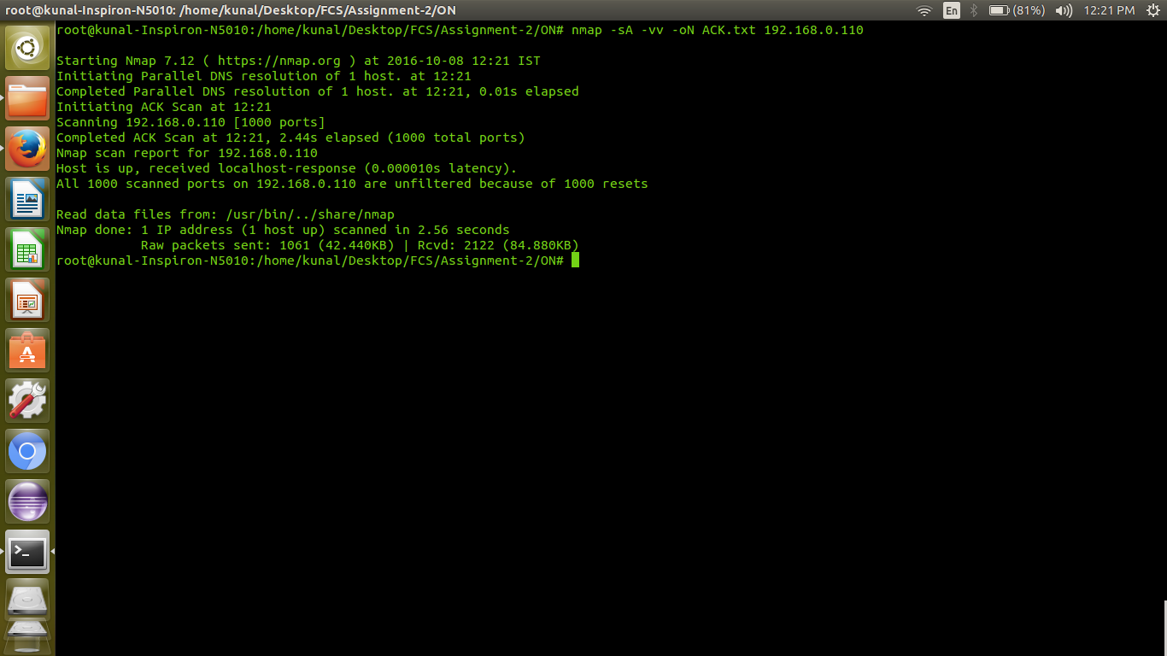
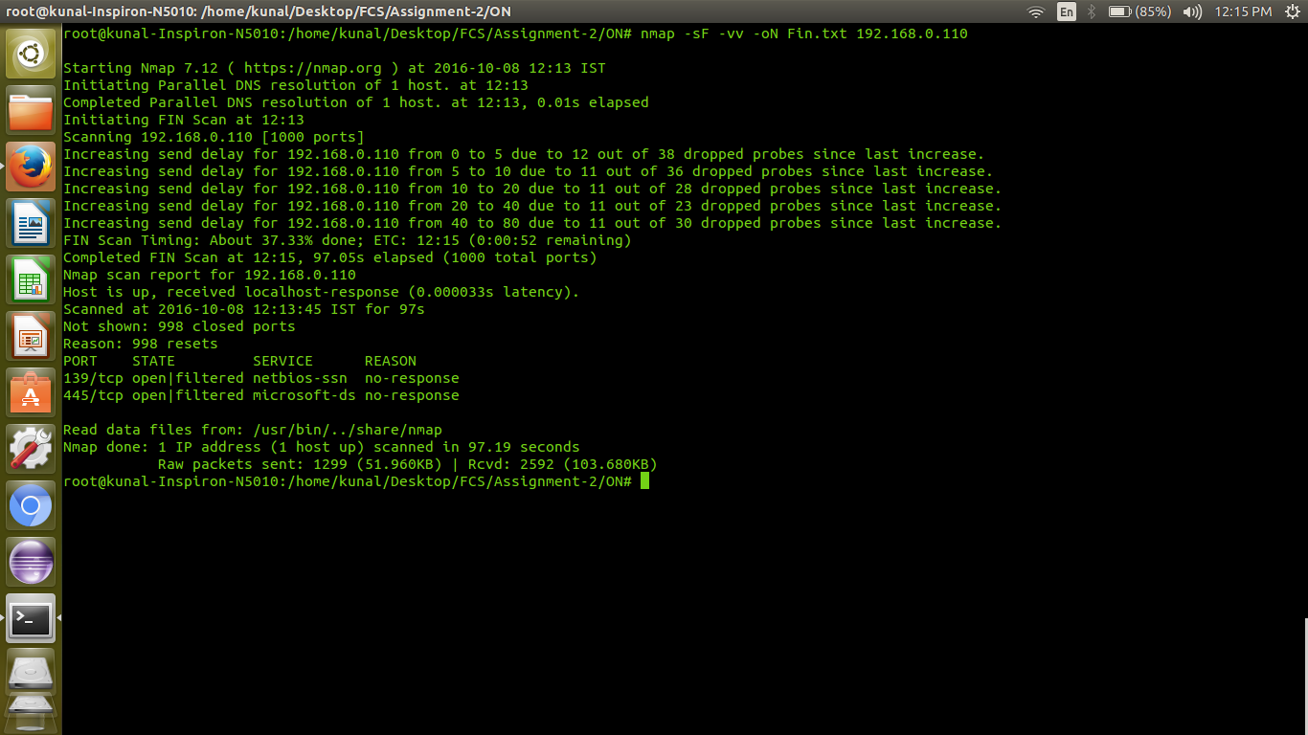
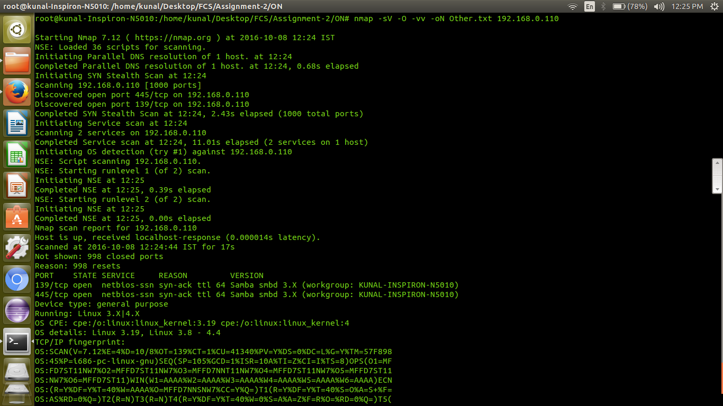
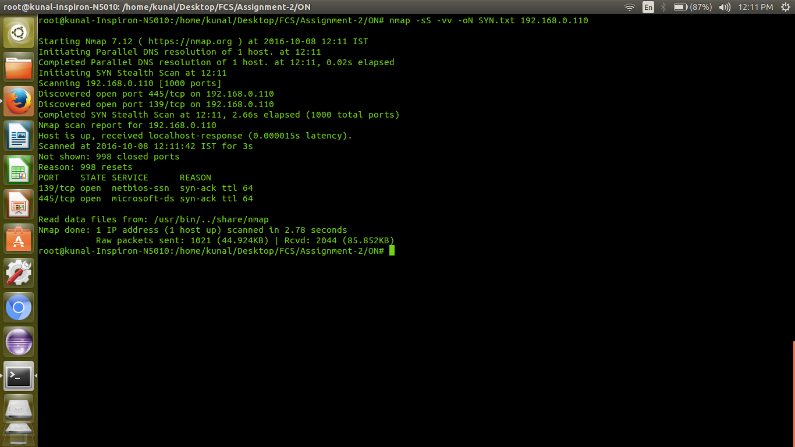

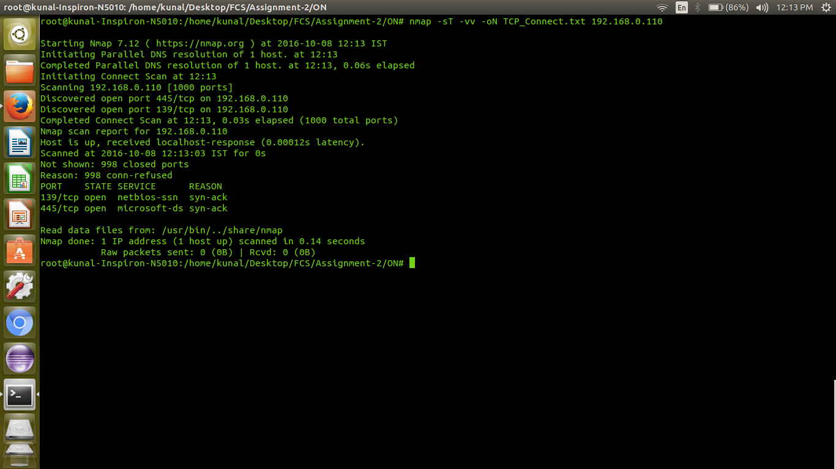
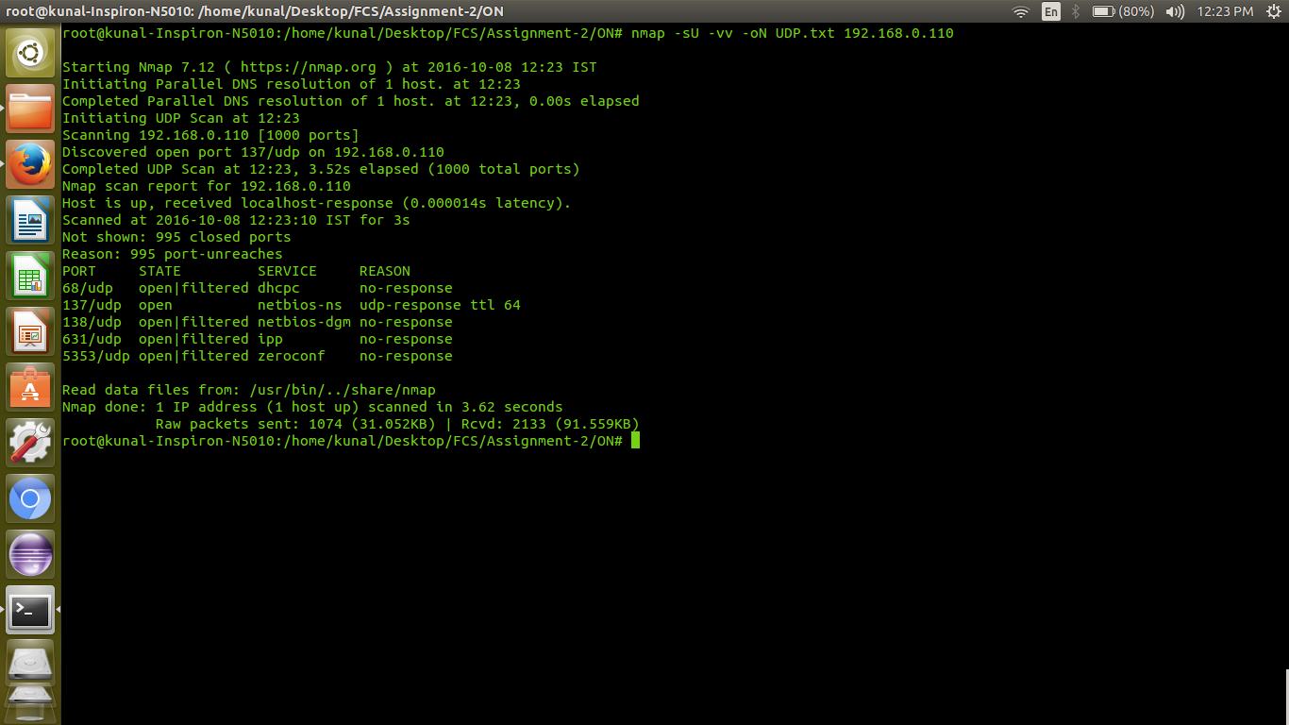

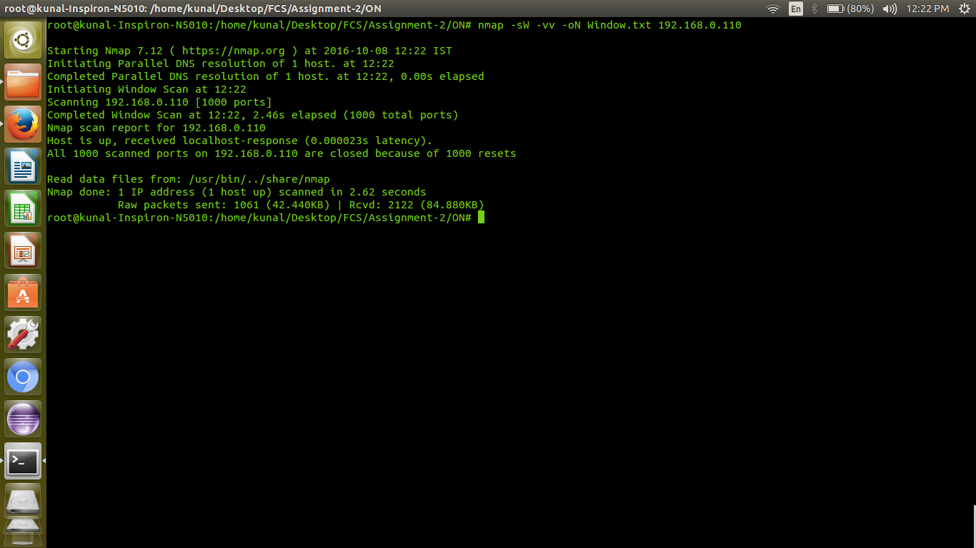
Screenshot when firewall is off :

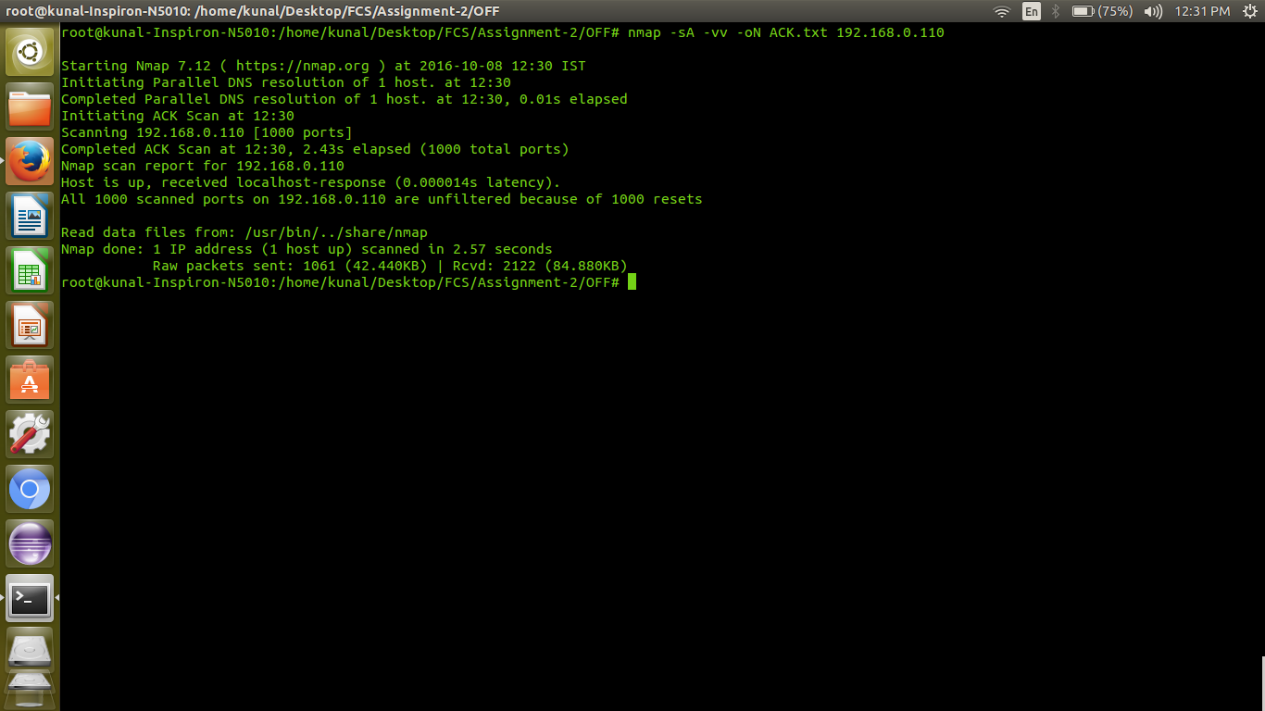

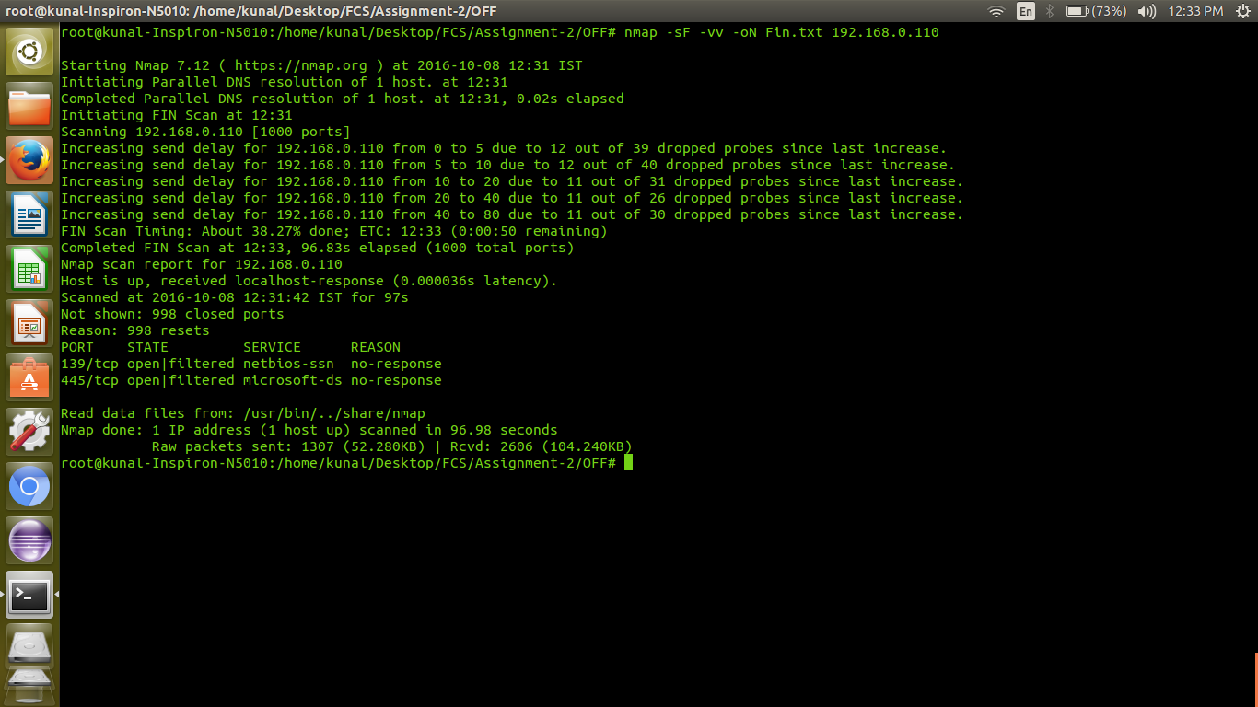
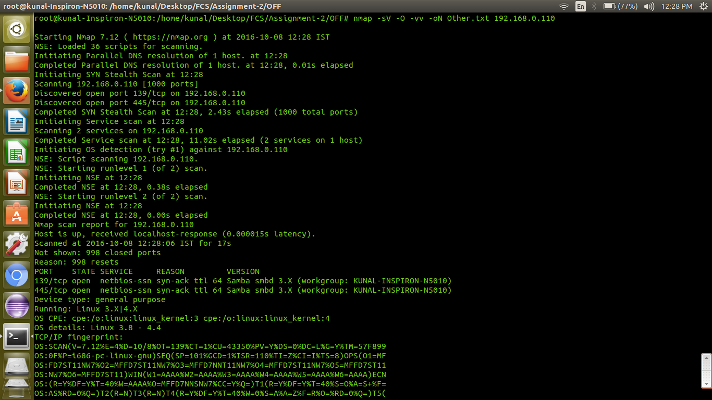

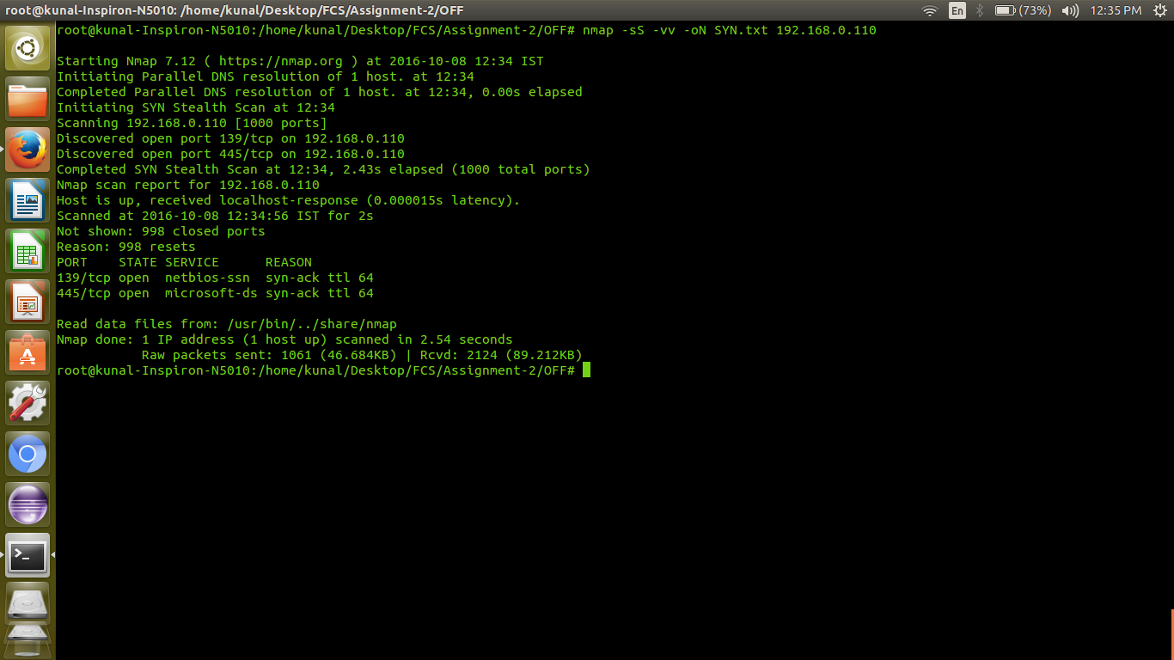

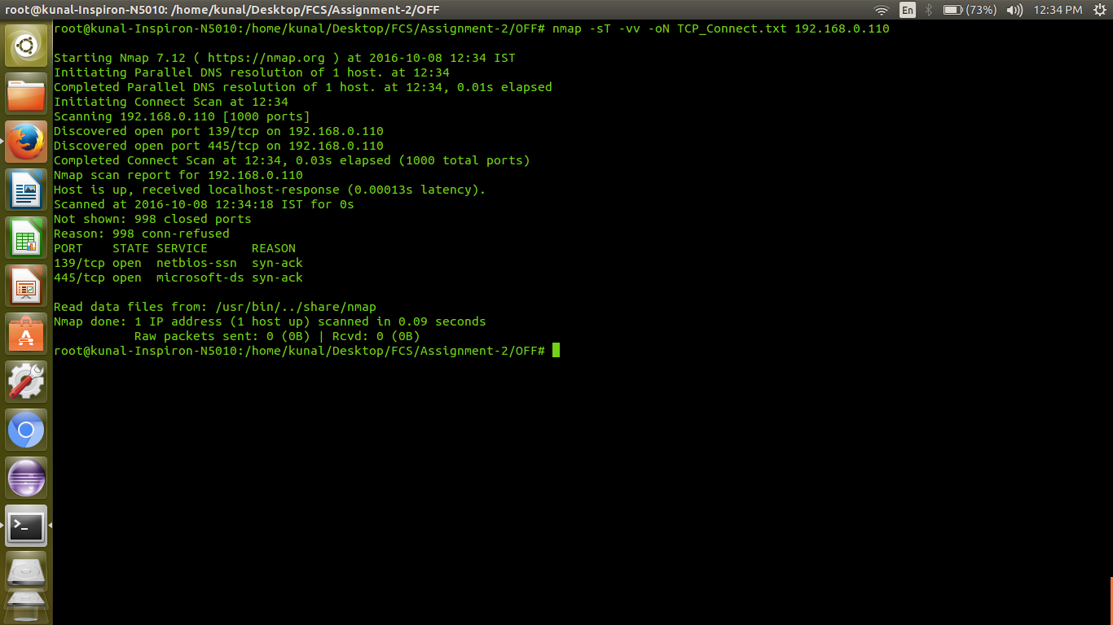

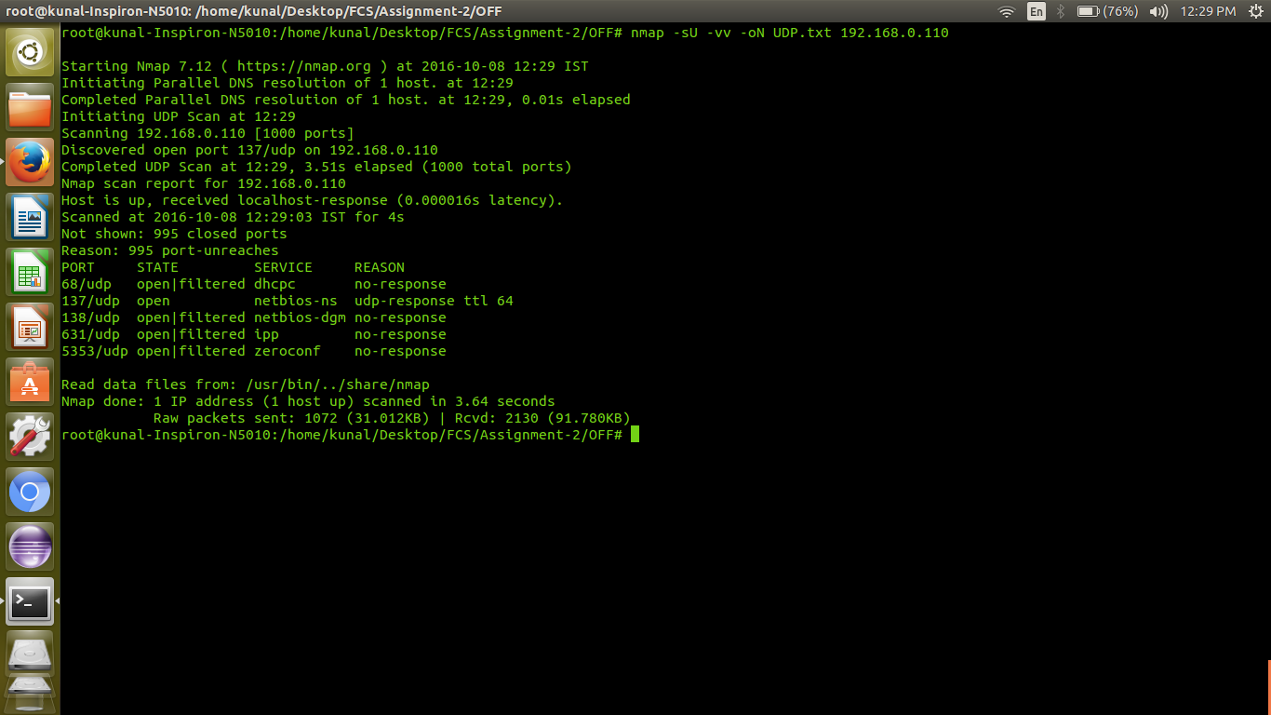

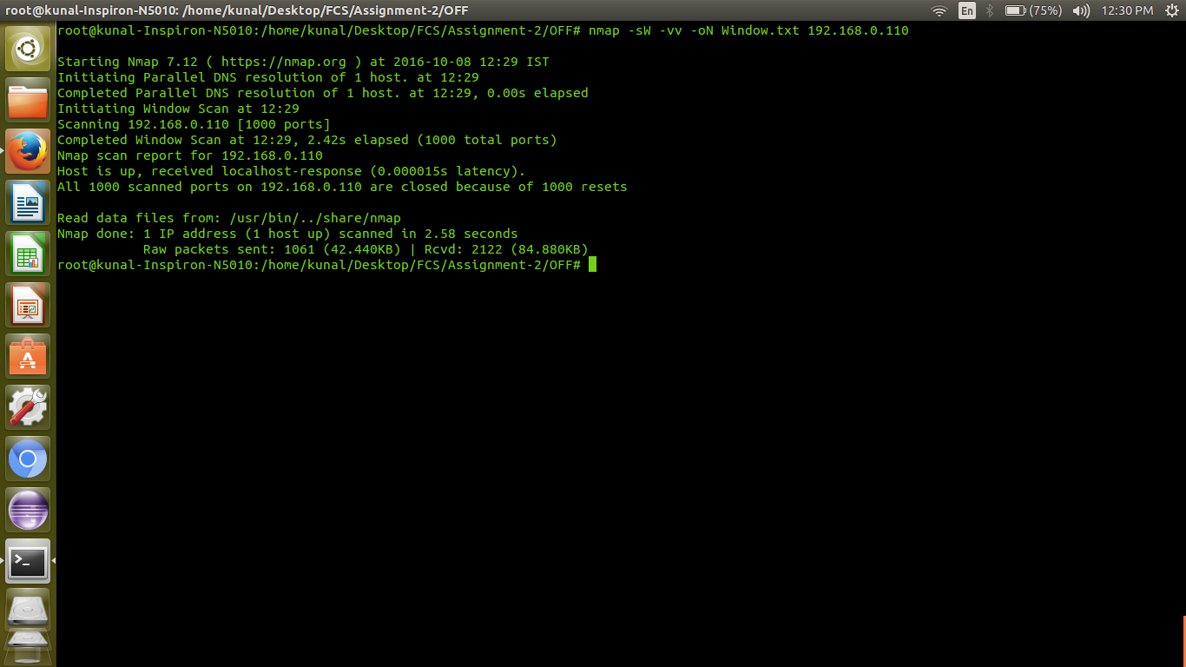

Q3
a. OpenSSL :- SSL/TLS(sucessor) => https which basically mean you are communicating with the server in a secure way; you send encrypted data that is safe from some body else that might be watching the traffic ,this secure link for communication is provided by SSL

Recently SSL introduced a new extension called Heart Beat Extension,it keep the TLS session open running with no data send by sending a request known as Heart Beat Request,which have a payload and the size of the payload,we can also use this to find the people with whomw we r communicating are there or not.

So Heartbleed Bug is due to this extension ; in this vernuability suppose an attacker send a heart beat request to the server that has a payload of one Byte but the size field says that the size of the packet is 65,536 Bytes ,so the payload only occupy a space of 1 Byte in the server ,but when it send the response it know that the size is 65,536 Bytes so it do send us our 1 Byte payload but along with it it also sends other 65,5346 Bytes ,now these bytes are nothing but the secured ingormation that is stored in the server and in this way attacker get access to this information.

b. STEPS AND SCREENSHOT(.txt file)

- Tested on www.google.com
- This website was found safe ; not vulnerable to Heartbleed Bug
- Command : nmap -d –script ssl-heartbleed –script-args vulns.showall -sV www.google.com
- Downloaded Heartbleed script as it was not present in the nmap and placed it in nmap script folder (ssl-heartbleed.nse)
Link :- https://svn.nmap.org/nmap/scripts/ssl-heartbleed.nse
- Also downloaded vuln.lua (liabrary to check vulnerability)
- Attached a file called HeartBleed.txt ,has the resul of the scan ,where “State: NOT VULNERABLE” shows that the website is safe from this bug.

Q4

Q5

Cipher Text:- \xc5\x81\x97~\xb4\x0b:U\x13^\x9c\xb2:\xedcC\xe5\n\xab\xb2\xbas\xbe/\r\xa8\x00'\x87\x91Ch\xb8\x060\xfb\xf8V\xf7)\x1d\xfb\x12\xe7\x16\xf0\x12\x1dQ\x99Gs`\xf5qZjQL\xe1\x1f\xfd\x90E

Plain Text:-
We are all in the gutter but some of us are looking at the stars

Keys:-
There was not only one key that gave this result but there were 256 keys that have the same result and they are in the attached result.txt file

CODE:-
language: Python

Liabraries:
Crypto.Cipher : For DES ;Decipher the Cipher text
enchant: For Dictionary word checking

Approach: Brute Force; tried to Decipher the Cipher text using all possible keys from 00000000 to 99999999 and whichever plain text has all words part of dictionary stored that into result.txt file and by luck they were all same so don't need to do any thing further

NOTE:- Code is in attached getkey1.py

