ksharm11_Assignment5__Question1_AND_2

Kunal Sharma

07/11/2021

1.The Hope Valley Health Care Association owns and operates six nursing homes in adjoining states. An evaluation of their efficiency has been undertaken using two inputs and two outputs. The inputs are staffing labor (measured in average hours per day) and the cost of supplies (in thousands of dollars per day). The outputs are the number of patient-days reimbursed by third-party sources and the number of patient-days reimbursed privately. A summary of performance data is shown in the table below.

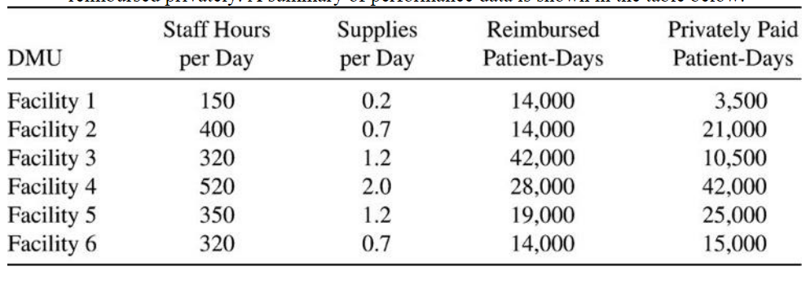

Questions

1)Formulate and perform DEA analysis under all DEA assumptions of FDH, CRS, VRS, IRS, DRS, and FRH.

2)Determine the Peers and Lambdas under each of the above assumptions

3)Summarize your results in a tabular format

4)Compare and contrast the above results

library(lpSolveAPI)

DMU_Facility_1 <- read.lp("DMU_Facility_1.lp")  
solve(DMU_Facility_1)

## [1] 0

get.objective(DMU_Facility_1)

## [1] 1

get.constraints(DMU_Facility_1)

## [1] 0.000000 -1.853448 0.000000 -2.931034 -1.798030 -1.439655 1.000000

get.variables(DMU_Facility_1)

## [1] 7.142857e-05 0.000000e+00 5.172414e-03 1.120690e+00

#The solution for the this DMU gives us an optimal solution.

DMU_Facility_2 <- read.lp("DMU_Facility_2.lp")  
solve(DMU_Facility_2)

## [1] 0

get.objective(DMU_Facility_2)

## [1] 1

get.constraints(DMU_Facility_2)

## [1] -0.16819572 0.00000000 -0.71100917 0.00000000 -0.06181739 -0.17562254  
## [7] 1.00000000

get.variables(DMU_Facility_2)

## [1] 0.000000e+00 4.761905e-05 1.376147e-03 6.422018e-01

#The solution for the this DMU gives us an optimal solution.

DMU_Facility_3 <- read.lp("DMU_Facility_3.lp")  
solve(DMU_Facility_3)

## [1] 0

get.objective(DMU_Facility_3)

## [1] 1

get.constraints(DMU_Facility_3)

## [1] 0.0000000 -0.6178161 0.0000000 -0.9770115 -0.5993432 -0.4798851 1.0000000

get.variables(DMU_Facility_3)

## [1] 2.380952e-05 0.000000e+00 1.724138e-03 3.735632e-01

#The solution for the this DMU gives us an optimal solution.

DMU_Facility_4 <- read.lp("DMU_Facility_4.lp")  
solve(DMU_Facility_4)

## [1] 0

get.objective(DMU_Facility_4)

## [1] 1

get.constraints(DMU_Facility_4)

## [1] -0.08409786 0.00000000 -0.35550459 0.00000000 -0.03090869 -0.08781127  
## [7] 1.00000000

get.variables(DMU_Facility_4)

## [1] 0.000000e+00 2.380952e-05 6.880734e-04 3.211009e-01

#The solution for the this DMU gives us an optimal solution.

DMU_Facility_5 <- read.lp("DMU_Facility_5.lp")  
solve(DMU_Facility_5)

## [1] 0

get.objective(DMU_Facility_5)

## [1] 0.9774987

get.constraints(DMU_Facility_5)

## [1] 0.00000000 0.00000000 -0.16483516 0.00000000 -0.02250131 -0.09419152  
## [7] 1.00000000

get.variables(DMU_Facility_5)

## [1] 0.0000115123 0.0000303506 0.0010989011 0.5128205128

#The solution for the this DMU gives us an optimal solution.

DMU_Facility_6 <- read.lp("DMU_Facility_6.lp")  
solve(DMU_Facility_6)

## [1] 0

get.objective(DMU_Facility_6)

## [1] 0.8674521

get.constraints(DMU_Facility_6)

## [1] 0.00000000 0.00000000 -0.23195876 0.00000000 -0.03166421 -0.13254786  
## [7] 1.00000000

get.variables(DMU_Facility_6)

## [1] 1.620029e-05 4.270987e-05 1.546392e-03 7.216495e-01

#The solution for the this DMU does not give us an optimal solution.

library(Benchmarking)

input <- matrix(c(150, 400, 320, 520, 350, 320, 0.2, 0.7, 1.2, 2.0, 1.2, 0.7), ncol = 2)  
colnames(input) <- c("Staff Hours per Day", "Supplies per Day")  
input

## Staff Hours per Day Supplies per Day  
## [1,] 150 0.2  
## [2,] 400 0.7  
## [3,] 320 1.2  
## [4,] 520 2.0  
## [5,] 350 1.2  
## [6,] 320 0.7

output <- matrix(c(14000, 14000, 42000, 28000, 19000, 14000, 3500, 21000,10500, 42000, 25000, 15000), ncol = 2)  
  
colnames(output) <- c("Reimbured Patient-Days", "Privately Paid Patient-Days")  
output

## Reimbured Patient-Days Privately Paid Patient-Days  
## [1,] 14000 3500  
## [2,] 14000 21000  
## [3,] 42000 10500  
## [4,] 28000 42000  
## [5,] 19000 25000  
## [6,] 14000 15000

CRS_DMU <- dea(input,output, RTS = "crs")  
CRS_DMU

## [1] 1.0000 1.0000 1.0000 1.0000 0.9775 0.8675

#Solution of the CRS of DMU.

lambda(CRS_DMU)

## L1 L2 L3 L4  
## [1,] 1.0000000 0.00000000 0 0.0000000  
## [2,] 0.0000000 1.00000000 0 0.0000000  
## [3,] 0.0000000 0.00000000 1 0.0000000  
## [4,] 0.0000000 0.00000000 0 1.0000000  
## [5,] 0.2000000 0.08048142 0 0.5383307  
## [6,] 0.3428571 0.39499264 0 0.1310751

The Lambda value of the CRS is as above.

peers(CRS_DMU)

## peer1 peer2 peer3  
## [1,] 1 NA NA  
## [2,] 2 NA NA  
## [3,] 3 NA NA  
## [4,] 4 NA NA  
## [5,] 1 2 4  
## [6,] 1 2 4

The peers of CRS is as above.

FDH_DMU <- dea(input,output, RTS = "fdh")  
FDH_DMU

## [1] 1 1 1 1 1 1

Solution of the FDH of DMU.

peers(FDH_DMU)

## peer1  
## [1,] 1  
## [2,] 2  
## [3,] 3  
## [4,] 4  
## [5,] 5  
## [6,] 6

The peers of FDH is as above.

lambda(FDH_DMU)

## L1 L2 L3 L4 L5 L6  
## [1,] 1 0 0 0 0 0  
## [2,] 0 1 0 0 0 0  
## [3,] 0 0 1 0 0 0  
## [4,] 0 0 0 1 0 0  
## [5,] 0 0 0 0 1 0  
## [6,] 0 0 0 0 0 1

The Lambda value of the FDH is as above

VRS_DMU <- dea(input,output, RTS = "vrs")  
VRS_DMU

## [1] 1.0000 1.0000 1.0000 1.0000 1.0000 0.8963

#Solution of the VRS of DMU.

peers(VRS_DMU)

## peer1 peer2 peer3  
## [1,] 1 NA NA  
## [2,] 2 NA NA  
## [3,] 3 NA NA  
## [4,] 4 NA NA  
## [5,] 5 NA NA  
## [6,] 1 2 5

The peers of VRS is as above.

lambda(VRS_DMU)

## L1 L2 L3 L4 L5  
## [1,] 1.0000000 0.0000000 0 0 0.0000000  
## [2,] 0.0000000 1.0000000 0 0 0.0000000  
## [3,] 0.0000000 0.0000000 1 0 0.0000000  
## [4,] 0.0000000 0.0000000 0 1 0.0000000  
## [5,] 0.0000000 0.0000000 0 0 1.0000000  
## [6,] 0.4014399 0.3422606 0 0 0.2562995

The Lambda value of the VRS is as above.

IRS_DMU <- dea(input,output, RTS = "irs")  
IRS_DMU

## [1] 1.0000 1.0000 1.0000 1.0000 1.0000 0.8963

#Solution of the IRS of DMU.

peers(IRS_DMU)

## peer1 peer2 peer3  
## [1,] 1 NA NA  
## [2,] 2 NA NA  
## [3,] 3 NA NA  
## [4,] 4 NA NA  
## [5,] 5 NA NA  
## [6,] 1 2 5

The peers of IRS is as above.

lambda(IRS_DMU)

## L1 L2 L3 L4 L5  
## [1,] 1.0000000 0.0000000 0 0 0.0000000  
## [2,] 0.0000000 1.0000000 0 0 0.0000000  
## [3,] 0.0000000 0.0000000 1 0 0.0000000  
## [4,] 0.0000000 0.0000000 0 1 0.0000000  
## [5,] 0.0000000 0.0000000 0 0 1.0000000  
## [6,] 0.4014399 0.3422606 0 0 0.2562995

The Lambda value of the IRS is as above.

DRS_DMU <- dea(input,output, RTS = "drs")  
DRS_DMU

## [1] 1.0000 1.0000 1.0000 1.0000 0.9775 0.8675

#Solution of the DRS of DMU.

peers(DRS_DMU)

## peer1 peer2 peer3  
## [1,] 1 NA NA  
## [2,] 2 NA NA  
## [3,] 3 NA NA  
## [4,] 4 NA NA  
## [5,] 1 2 4  
## [6,] 1 2 4

The peers of DRS is as above.

lambda(DRS_DMU)

## L1 L2 L3 L4  
## [1,] 1.0000000 0.00000000 0 0.0000000  
## [2,] 0.0000000 1.00000000 0 0.0000000  
## [3,] 0.0000000 0.00000000 1 0.0000000  
## [4,] 0.0000000 0.00000000 0 1.0000000  
## [5,] 0.2000000 0.08048142 0 0.5383307  
## [6,] 0.3428571 0.39499264 0 0.1310751

The Lambda value of the DRS is as above.

FRH_DMU <- dea(input,output, RTS = "add")  
FRH_DMU

## [1] 1 1 1 1 1 1

#Solution of the FRS of DMU.

peers(FRH_DMU)

## peer1  
## [1,] 1  
## [2,] 2  
## [3,] 3  
## [4,] 4  
## [5,] 5  
## [6,] 6

The peers of FRS is as above.

lambda(FRH_DMU)

## L1 L2 L3 L4 L5 L6  
## [1,] 1 0 0 0 0 0  
## [2,] 0 1 0 0 0 0  
## [3,] 0 0 1 0 0 0  
## [4,] 0 0 0 1 0 0  
## [5,] 0 0 0 0 1 0  
## [6,] 0 0 0 0 0 1

The Lambda value of the FRS is as above. #The tabular representation of the all DMU RTS.

Col_Names <- c("", "FDH_DMU", "CRS_DMU", "VRS_DMU", "IRS_DMU", "DRS_DMU", "FRH_DMU")  
Row_Names <- c("Facility 1", "Facility 2", "Facility 3", "Facility 4", "Facility 5", "Facility 6")  
Tabular_Output <- as.data.frame(cbind(Row_Names, FDH_DMU$eff, CRS_DMU$eff, VRS_DMU$eff, IRS_DMU$eff, DRS_DMU$eff, FRH_DMU$eff))  
colnames(Tabular_Output)<- Col_Names  
Tabular_Output

## FDH_DMU CRS_DMU VRS_DMU IRS_DMU  
## 1 Facility 1 1 1 1 1  
## 2 Facility 2 1 1 1 1  
## 3 Facility 3 1 1 1 1  
## 4 Facility 4 1 1 1 1  
## 5 Facility 5 1 0.977498691784406 1 1  
## 6 Facility 6 1 0.867452135493373 0.896328293736501 0.896328293736501  
## DRS_DMU FRH_DMU  
## 1 1 1  
## 2 1 1  
## 3 1 1  
## 4 1 1  
## 5 0.977498691784406 1  
## 6 0.867452135493373 1

Here, we can see that the DMU’s CRS and DRS values are efficient, since they can give us the ideal solution for the DMU with the most accuracy. As a result, we can state that the CRS and DRS values can assist us in determining the DMU effectively.

We obtained the same value by solving the DMU alone as we did by solving the CRS and the DRS.

#Therefore, the Facilites 1, 2, 3 and 4 are the efficient facilities to go with as Facilites 5 and 6 are not so efficient.

2.The Research and Development Division of the Emaxcorp Corporation has developed three new products. A decision now needs to be made on which mix of these products should be produced. Management wants primary consideration given to three factors: total profit, stability in the workforce, and achieving an increase in the company’s earnings next year from the $75 million achieved this year. In particular, using the units given in the following table, they want to

Maximize Z = P -6C -3D, where

P = total (discounted) profit over the life of the new products,

C = change (in either direction) in the current level of employment,

D = decrease (if any) in next year’s earnings from the current year’s level.

The amount of any increase in earnings does not enter into Z, because management is concerned primarily with just achieving some increase to keep the stockholders happy. (It has mixed feelings about a large increase that then would be difficult to surpass in subsequent years.)

The impact of each of the new products (per unit rate of production) on each of these factors is shown in the following table:

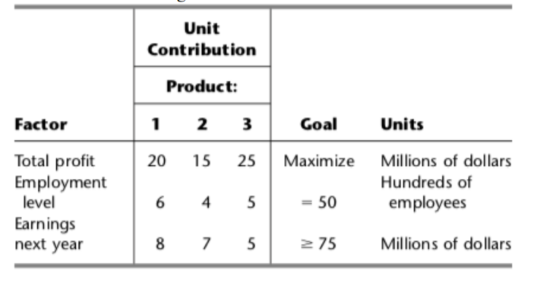

Questions

1)Define y1+and y1-, respectively, as the amount over (if any) and the amount under (if any) the employment level goal. Define y2+and y2-in the same way for the goal regarding earnings next year. Define x1, x2, and x3as the production rates of Products 1, 2, and 3, respectively. With these definitions, use the goal programming technique to express y1+, y1-, y2+and y2-algebraically in terms of x1, x2, and x3. Also express P in terms of x1, x2, and x3.

2)Express management’s objective function in terms of x1, x2, x3, y1+, y1-, y2+and y2-.

3)Formulate and solve the linear programming model. What are your findings?

##solution: Let the Xi = the new proucts. i = 1, 2, 3.

y1 = Amount of employment level goal  
y1 = y1p - y1m  
y1p = amount over employment level goal  
y1m = amount under employment level goal.  
y2= earnings next year  
y2p = earnings increase next year  
y2m = earnings decrease next year

Hence,

Max = P - 6C - 3D

P = 20 x1 + 15 x2 + 25 x3 C = y1p - y1m D = y2p - y1m

but increase can be ignored thus, D = y1m

Emaxcorp <- read.lp("Emaxcorp.lp")  
  
solve(Emaxcorp)

## [1] 0

get.objective(Emaxcorp)

## [1] 225

get.constraints(Emaxcorp)

## [1] 0 50 75

get.variables(Emaxcorp)

## [1] 0 0 15 25 0 0 0

##Using the simplex method, we obtained at the best solution with the most profit, z = 225. Using x3 = 15 and x1 and x2 = 0, y1p = 25, y1m and y2m = 0. The number of employees has increased by 25 in hundreds.

Emaxcorp <- read.lp("Emaxcorp_FirstStage.lp")  
  
solve(Emaxcorp)

## [1] 0

get.objective(Emaxcorp)

## [1] 250

get.constraints(Emaxcorp)

## [1] 50 75

get.variables(Emaxcorp)

## [1] 0 0 10 0 0 25 0

##Our initial aim is to maximize profit with z = 250, product 3 chosen x3 = 10, and earnings reduced by 25.

Emaxcorp <- read.lp("Emaxcorp_SecondStage.lp")  
solve(Emaxcorp)

## [1] 0

get.objective(Emaxcorp)

## [1] 208.3333

get.constraints(Emaxcorp)

## [1] 0 50 75

get.variables(Emaxcorp)

## [1] 0.000000 8.333333 3.333333 0.000000 0.000000

##Our next profit target is z = 208.33, x2 = 8.3333, x3 = 3.3333, and no employee level changes.

Emaxcorp <- read.lp("Emaxcorp_Streamline.lp")  
  
solve(Emaxcorp)

## [1] 0

get.objective(Emaxcorp)

## [1] 291.6667

get.constraints(Emaxcorp)

## [1] 0 50 75

get.variables(Emaxcorp)

## [1] 0.000000 0.000000 11.666667 8.333333 0.000000 16.666667 0.000000

##As a result, the total maximum profit will be 291.6667 million dollors. Product 3 is chosen with 11.666667 units, an increase in employment target leavel with 8.33333 employees, and a drop in earnings of 16.66667.