ksharm11_Assignment6_Question1_AND_2

Kunal Sharma

20/11/2021

1. Consider the following activity-on-arc project network, where the 12 arcs (arrows) represent the 12 activities (tasks) that must be performed to complete the project and the network displays the order in which the activities need to be performed. The number next to each arc (arrow) is the time required for the corresponding activity. Consider the problem of finding the longest path (the largest total time) through this network from start (node 1) to finish (node 9), since the longest path is the critical path.

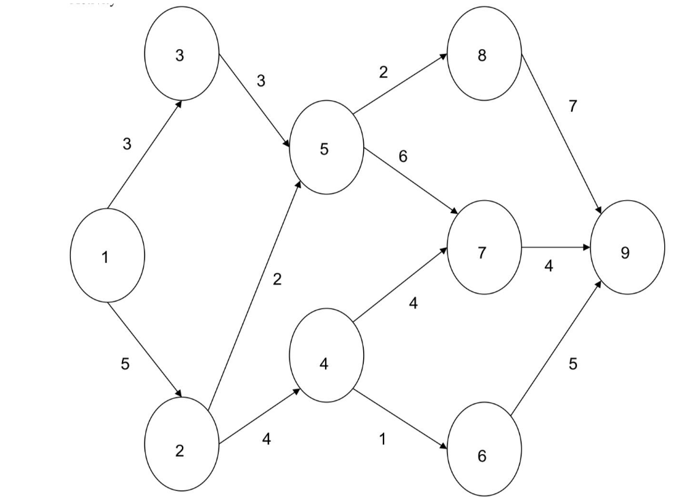

Formulate and solve the binary integer programming (BIP) model for this problemusing library lpsolveor equivalent in R.

library(lpSolveAPI)  
Object1<- read.lp("Diagramtolp.lp")  
solve(Object1)

## [1] 0

get.objective(Object1)

## [1] 17

get.variables(Object1)

## [1] 1 0 0 1 0 0 0 1 0 0 1 0

get.constraints(Object1)

## [1] 1 0 0 0 0 0 0 0 1

###After Running the LP formulation on LP solver, the critical path is:

###From node 1 -> 2 -> 5 -> 7 -> 9

###Hence therefore, the duration of the project will be 17 unit time

1. Selecting an Investment PortfolioAn investment manager wants to determine an opti-mal portfolio for a wealthy client. The fund has $2.5 million to invest, and its objective is to maximize total dollar return from both growth and dividends over the course of the coming year. The client has researched eight high-tech companies and wants the portfolio to consist of shares in these firms only. Three of the firms (S1 –S3) are primarily software companies, three (H1–H3) are primarily hardware companies, and two (C1–C2) are internet consulting companies. The client has stipulated that no more than 40 percent of the investment be allocated to any one of these three sectors. To assure diversification, at least $100,000 must be invested in each of the eight stocks. Moreover, the number of shares invested in any stock must be a multiple of 1000.

The table below gives estimates from the investment company’s database relating to these stocks. These estimates include the price per share, the projected annual growth rate in the share price, and the anticipated annual dividend payment per share.

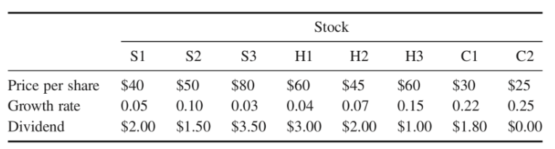

1)Determine the maximum return on the portfolio. What is the optimal number of shares to buy for each of the stocks? What is the corresponding dollar amount invested in each stock?

2)Comparethesolutioninwhichthereisnointegerrestrictiononthenumberofshares invested. By how much (in percentage terms) do the integer restrictions alter the value of the optimal objective function? By how much (in percentage terms) do they alter the optimal investment quantities?

We can caluclate the effective function cost by: Price per share * Growth Rate + Dividend So we can create the Max objective function using the same

### solving the LP with the integer restriction

Stock_Investment <- read.lp("Stock_Investment.lp")  
  
set.type(Stock_Investment,c(1:8),type = "integer")  
  
solve(Stock_Investment)

## [1] 0

get.objective(Stock_Investment)

## [1] 487145.2

get.variables(Stock_Investment)

## [1] 2500 6000 1250 1667 2223 13332 30000 4000

get.constraints(Stock_Investment)

## [1] 2499975 500000 999975 1000000

###Now solving the LP without integer restriction

Real_Stock_Investment<- read.lp("Stock_Investment.lp")  
  
solve(Real_Stock_Investment)

## [1] 0

get.objective(Real_Stock_Investment)

## [1] 487152.8

get.variables(Real_Stock_Investment)

## [1] 2500.000 6000.000 1250.000 1666.667 2222.222 13333.333 30000.000  
## [8] 4000.000

get.constraints(Real_Stock_Investment)

## [1] 2500000 500000 1000000 1000000

##The ideal goal solution function value varies by 0.0015601097988854 %. And the recommended investment amounts varied by 0.01 %.