**Prediction of viewer Interest In  
 shows on Netflix In Particular Country**

**Summary**

I have gathered the data to analyze the shows on Netflix based on the Movies and TV series online i.e., and the evaluating the content by rating of the users.

**Progress Report**

I am having some trouble converting the data to ARFF format, but I am almost finished with the data analysis. For data preprocessing, I checked the data for any missing values or incorrect data, then used Python to convert the data to the correct format.

Currently, I have created a visualization of the data for further insight and analysis.

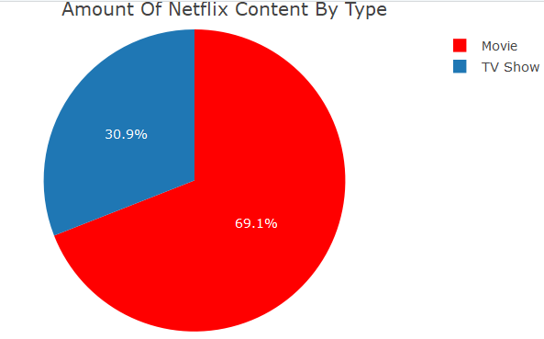 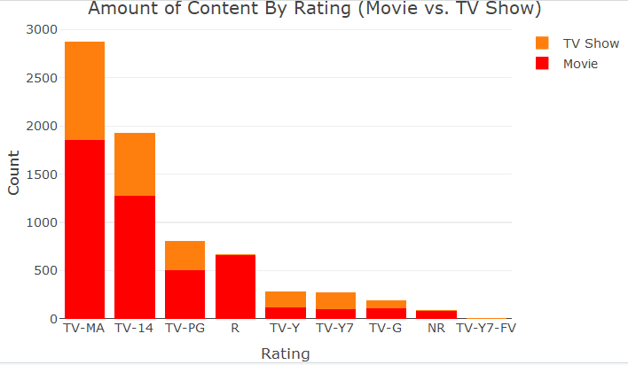

Furthermore, I am heading down the path where I am selecting attributes for the target variable criteria and then using visualization to extract the solution with high accuracy.

Imported the gathered data in the WEKA by converting the data in the ARFF format.

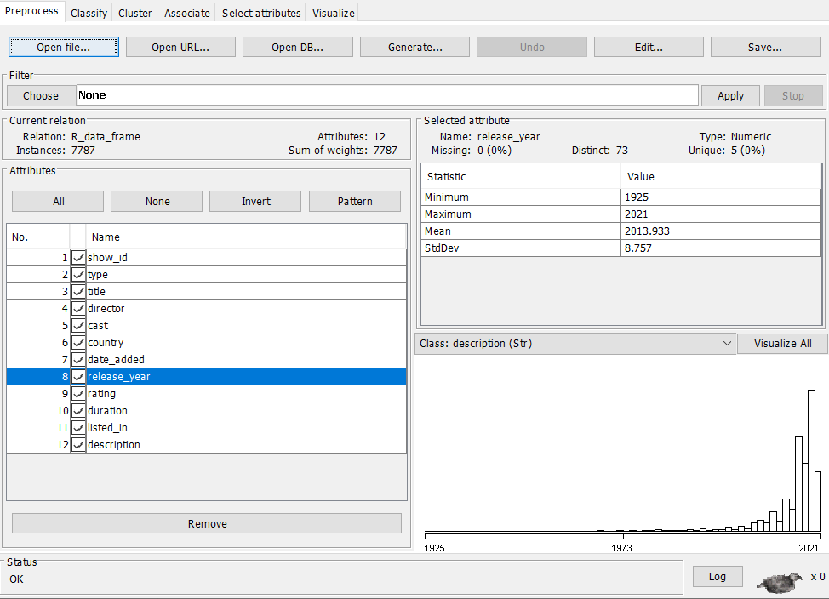

**Dataset** [**https://www.kaggle.com/shivamb/netflix-shows?select=netflix_titles.csv**](https://www.kaggle.com/shivamb/netflix-shows?select=netflix_titles.csv)