Server

# ======================================================================
# UDP FILE TRANSFER - SERVER (RECEIVER SIDE)
# Protocol : UDP (SOCK_DGRAM) -> connectionless, reliability is
# added manually using sequence numbers + ACK
# Made by : Kunal
# Run order : 1) udp_server.py 2) udp_client.py
# ======================================================================

import socket
import os
import struct

AUTHOR = "Kunal" # Watermark (change here if needed)

# ---------------------------- CONFIGURATION ---------------------------
HOST = "0.0.0.0" # Listen on all network interfaces
PORT = 5000 # UDP port number
BUFFER_SIZE = 2048 # Max datagram size we accept
SAVE_DIR = "received_files" # Folder where files will be stored
os.makedirs(SAVE_DIR, exist_ok=True)

def banner(title):
"""Prints the watermark banner (shows in output)."""
print("=" * 58)
print(f" {title}")
print(f" Protocol : UDP | Made by : {AUTHOR}")
print("=" * 58)

banner("UDP FILE RECEIVER (SERVER)")

# Step 1: Create a UDP socket (SOCK_DGRAM = UDP)
server = socket.socket(socket.AF_INET, socket.SOCK_DGRAM)

# Step 2: Bind socket to IP + port (no listen()/accept() in UDP)
server.bind((HOST, PORT))

# Timeout lets Ctrl+C work on Windows (recvfrom otherwise blocks forever)
server.settimeout(1.0)

print(f"[{AUTHOR}] UDP Server started")
print(f"[{AUTHOR}] Listening on port {PORT}...")
print(f"[{AUTHOR}] Files will be saved in: {SAVE_DIR}")
print("[INFO] Press Ctrl+C to stop the server.\n")

current_file = None # File object currently being written
current_filename = None
expected_sequence = 0 # Next packet number we expect
client_address = None # Only accept data from this client

try:
while True:
# Step 3: Receive a datagram (returns data + sender address)
try:
data, address = server.recvfrom(BUFFER_SIZE)
except socket.timeout:
continue # Nothing received, keep waiting
except ConnectionResetError:
continue # Windows quirk (error 10054), ignore

if len(data) < 4: # Packet must have 4-byte header
continue

# Step 4: Split packet -> 4-byte sequence number + payload
sequence = struct.unpack("!I", data[:4])[0]
payload = data[4:]

# ---- Sequence 0 = filename packet ----
if sequence == 0:
filename = os.path.basename(payload.decode("utf-8"))

if not filename:
continue

if current_file:
current_file.close()

current_filename = filename
client_address = address
filepath = os.path.join(SAVE_DIR, current_filename)

current_file = open(filepath, "wb")
expected_sequence = 1

print(f"\n[{AUTHOR}] Receiving: {current_filename} from {address}")

# Step 5: Send ACK for packet 0
server.sendto(struct.pack("!I", 0), address)
continue

# Ignore data if no file is open or sender is a different client
if current_file is None or address != client_address:
continue

# ---- Sequence >= 1 = file data packets ----
if sequence == expected_sequence:
if payload == b"FILE_END": # End-of-file marker
current_file.close()
current_file = None
print(f"[{AUTHOR}] Successfully received: {current_filename}")
current_filename = None
else:
current_file.write(payload) # Save chunk to disk
expected_sequence += 1

# Step 6: Send ACK for the last accepted sequence
ack_sequence = expected_sequence - 1

if payload == b"FILE_END" and current_file is None:
ack_sequence = sequence

server.sendto(struct.pack("!I", ack_sequence), address)

except KeyboardInterrupt:
print(f"\n[{AUTHOR}] Server stopped by user.")

finally:
if current_file:
current_file.close()
server.close() # Step 7: Close the socket
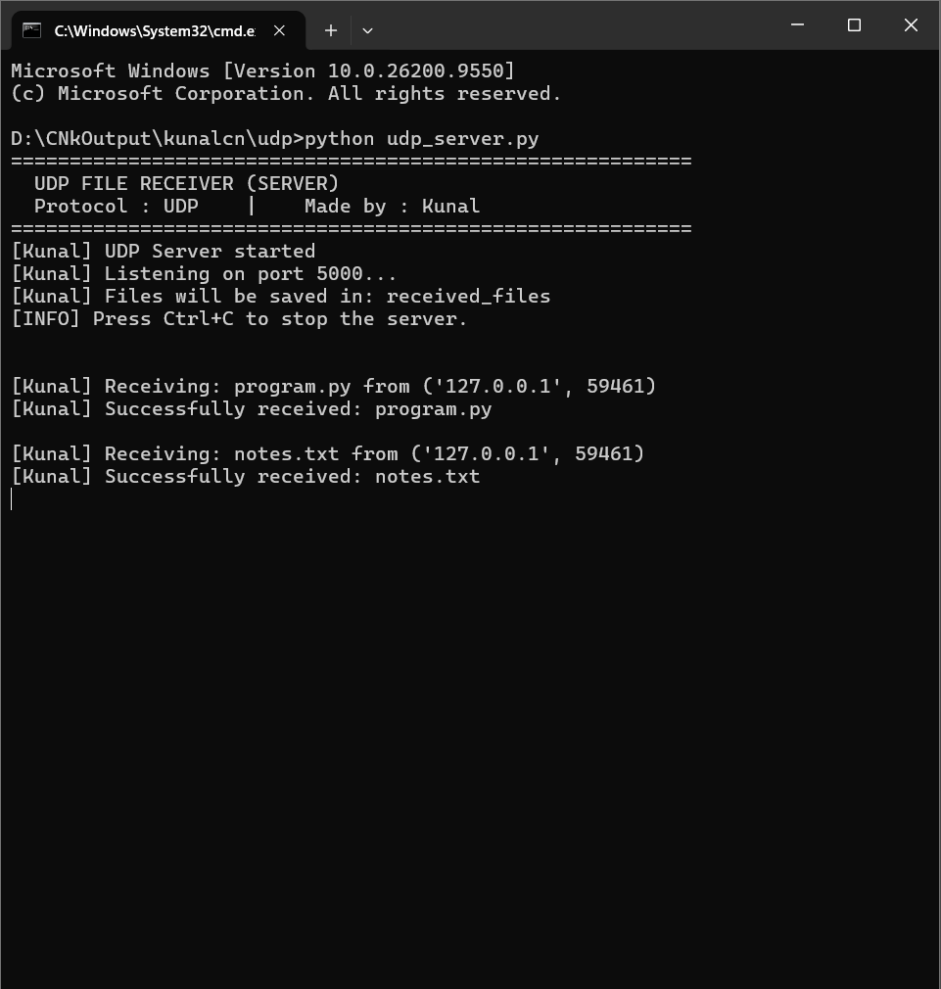

Client

# ======================================================================
# UDP FILE TRANSFER - CLIENT (SENDER SIDE)
# Protocol : UDP (SOCK_DGRAM) -> Stop-and-Wait reliability
# (send packet -> wait for ACK -> retry on timeout)
# Made by : Kunal
# Run order : 1) udp_server.py 2) udp_client.py
# ======================================================================

import socket
import os
import struct
import time

AUTHOR = "Kunal" # Watermark (change here if needed)

# ---------------------------- CONFIGURATION ---------------------------
SERVER_IP = "127.0.0.1" # Server address (localhost)
SERVER_PORT = 5000 # Must match server port
CHUNK_SIZE = 1024 # Bytes of file data per packet
TIMEOUT = 2 # Seconds to wait for ACK
MAX_RETRIES = 10 # Resend attempts before giving up

# Files to send (keep them in the same folder as this script)
files = [
"program.py",
"notes.txt"
]

def banner(title):
"""Prints the watermark banner (shows in output)."""
print("=" * 58)
print(f" {title}")
print(f" Protocol : UDP | Made by : {AUTHOR}")
print("=" * 58)

banner("UDP FILE SENDER (CLIENT)")

# Step 1: Create a UDP socket (no connect() needed in UDP)
client = socket.socket(socket.AF_INET, socket.SOCK_DGRAM)
client.settimeout(TIMEOUT)

# Display server information
print(f"[{AUTHOR}] Server IP address : {SERVER_IP}")
print(f"[{AUTHOR}] Port number : {SERVER_PORT}")

def send_packet(sequence, payload):
"""Sends one packet and waits for its ACK. Returns True if ACKed."""
# Packet format = [4-byte sequence number][payload]
packet = struct.pack("!I", sequence) + payload

for attempt in range(MAX_RETRIES):
# Step 2: Send the datagram
client.sendto(packet, (SERVER_IP, SERVER_PORT))

try:
# Step 3: Wait for ACK from server
response, _ = client.recvfrom(1024)

if len(response) < 4:
continue

ack = struct.unpack("!I", response[:4])[0]

if ack == sequence: # Correct ACK received
return True

except socket.timeout:
print(f"[{AUTHOR}] Timeout, retrying packet {sequence}...")
except ConnectionResetError:
# Windows error 10054: server is not running
print(f"[{AUTHOR}] Server not reachable, retrying packet {sequence}...")
time.sleep(0.5)

return False # All retries failed

def send_file(filepath):
if not os.path.isfile(filepath):
print(f"[{AUTHOR}] File not found: {filepath}")
return

filename = os.path.basename(filepath)
print(f"\n[{AUTHOR}] Sending file: {filename}")

# Packet 0 = filename
if not send_packet(0, filename.encode("utf-8")):
print(f"[{AUTHOR}] Failed to send filename.")
return

sequence = 1

# Packets 1..N = file data, CHUNK_SIZE bytes at a time
with open(filepath, "rb") as file:
while True:
chunk = file.read(CHUNK_SIZE)

if not chunk: # End of file reached
break

if not send_packet(sequence, chunk):
print(f"[{AUTHOR}] Transfer failed: {filename}")
return

sequence += 1

# Last packet = end-of-file marker
if send_packet(sequence, b"FILE_END"):
print(f"[{AUTHOR}] Successfully sent: {filename}")
else:
print(f"[{AUTHOR}] Failed to finish sending: {filename}")

for filepath in files:
send_file(filepath)

client.close() # Step 4: Close the socket
print(f"\n[{AUTHOR}] All done. Check the 'received_files' folder.")
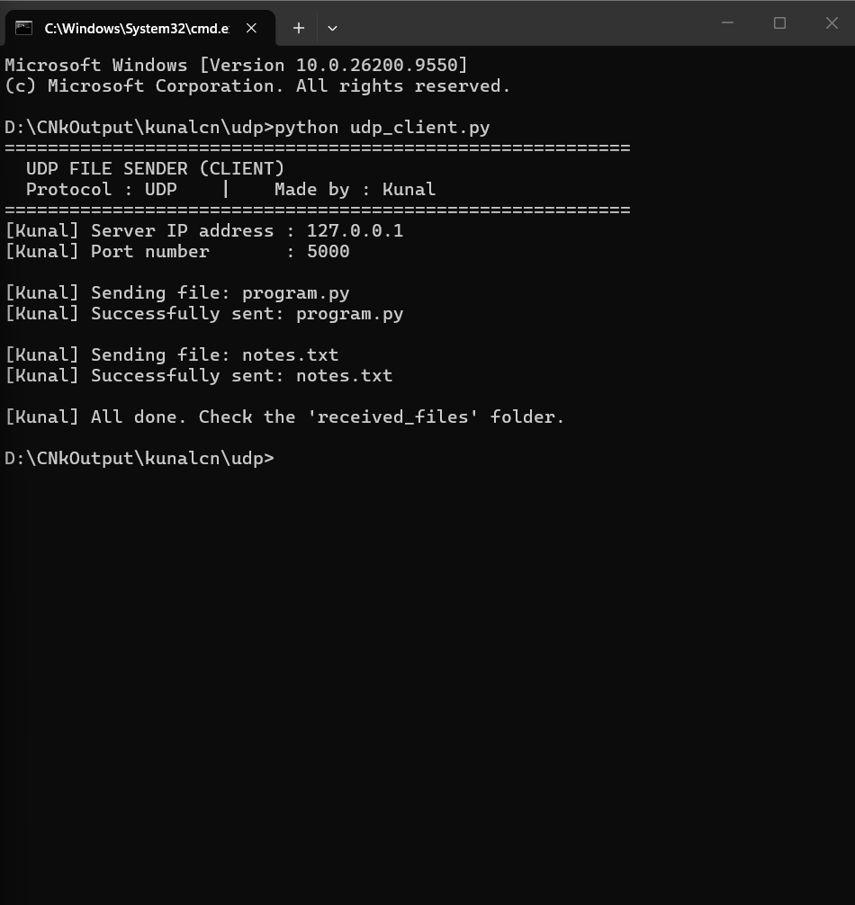

Received files
