/*
* Assignment 5 (Group A): Sliding Window Protocol - GO-BACK-N (peer to peer, UDP)
* Student : Kunal Chaudhari
* College : Modern Education Society's Wadia College of Engineering, Pune
*
* Run receiver first: java GoBackN receiver
* Then the sender : java GoBackN sender
*/
import java.net.*;
import java.nio.charset.StandardCharsets;
import java.text.SimpleDateFormat;
import java.util.Date;

public class GoBackN {
static final String OWNER = "Kunal Chaudhari"; // watermark
static final int PORT = 9876;
static final int TOTAL = 10; // total frames to send
static final int WINDOW = 4; // sender window size (N)
static final int TIMEOUT_MS = 2000; // sender timeout
static final int LOST_FRAME = 2; // receiver "loses" this frame once

static void log(String role, String msg) {
String t = new SimpleDateFormat("HH:mm:ss.SSS").format(new Date());
System.out.println("[" + OWNER + "] [" + t + "] [" + role + "] " + msg);
}

static void banner(String title) {
System.out.println("==================================================");
System.out.println(" " + title);
System.out.println(" Performed by: " + OWNER);
System.out.println(" Date: " + new Date());
System.out.println("==================================================");
}

static void send(DatagramSocket s, String msg, InetAddress a, int p) throws Exception {
byte[] b = msg.getBytes(StandardCharsets.UTF_8);
s.send(new DatagramPacket(b, b.length, a, p));
}

static void sender() throws Exception {
banner("GO-BACK-N SENDER (window N = " + WINDOW + ", frames = " + TOTAL + ")");
DatagramSocket s = new DatagramSocket();
s.setSoTimeout(TIMEOUT_MS);
InetAddress addr = InetAddress.getByName("127.0.0.1");
int base = 0, next = 0;

while (base < TOTAL) {
while (next < base + WINDOW && next < TOTAL) {
send(s, "DATA|" + next + "|Frame-" + next + "|" + OWNER, addr, PORT);
log("SENDER", "Sent frame " + next + " window=[" + base + ".." +
Math.min(base + WINDOW - 1, TOTAL - 1) + "]");
next++;
}
try {
byte[] buf = new byte[1024];
DatagramPacket p = new DatagramPacket(buf, buf.length);
s.receive(p);
String[] f = new String(p.getData(), 0, p.getLength(), StandardCharsets.UTF_8).split("\\|");
int ack = Integer.parseInt(f[1]);
log("SENDER", "Received ACK " + ack);
if (ack >= base) base = ack + 1; // cumulative ACK slides the window
} catch (SocketTimeoutException e) {
log("SENDER", "*** TIMEOUT *** Going back to frame " + base + " and resending the window");
next = base; // GO BACK N
}
}
log("SENDER", "All " + TOTAL + " frames sent and acknowledged. DONE.");
s.close();
}

static void receiver() throws Exception {
banner("GO-BACK-N RECEIVER");
DatagramSocket s = new DatagramSocket(PORT);
int expected = 0;
boolean dropped = false;
log("RECEIVER", "Waiting for frames on port " + PORT + " ...");

while (expected < TOTAL) {
byte[] buf = new byte[1024];
DatagramPacket p = new DatagramPacket(buf, buf.length);
s.receive(p);
String[] f = new String(p.getData(), 0, p.getLength(), StandardCharsets.UTF_8).split("\\|");
int seq = Integer.parseInt(f[1]);

if (seq == LOST_FRAME && !dropped) {
dropped = true;
log("RECEIVER", "*** Frame " + seq + " LOST (simulated error) ***");
continue;
}
if (seq == expected) {
log("RECEIVER", "Frame " + seq + " received in order -> delivered. Sending ACK " + seq);
send(s, "ACK|" + seq + "|" + OWNER, p.getAddress(), p.getPort());
expected++;
} else {
log("RECEIVER", "Frame " + seq + " out of order (expected " + expected + ") -> DISCARDED");
if (expected > 0) send(s, "ACK|" + (expected - 1) + "|" + OWNER, p.getAddress(), p.getPort());
}
}
log("RECEIVER", "All " + TOTAL + " frames received in order. DONE.");
s.close();
}

public static void main(String[] args) throws Exception {
if (args.length != 1) { System.out.println("Usage: java GoBackN sender|receiver"); return; }
if (args[0].equalsIgnoreCase("receiver")) receiver(); else sender();
}
}

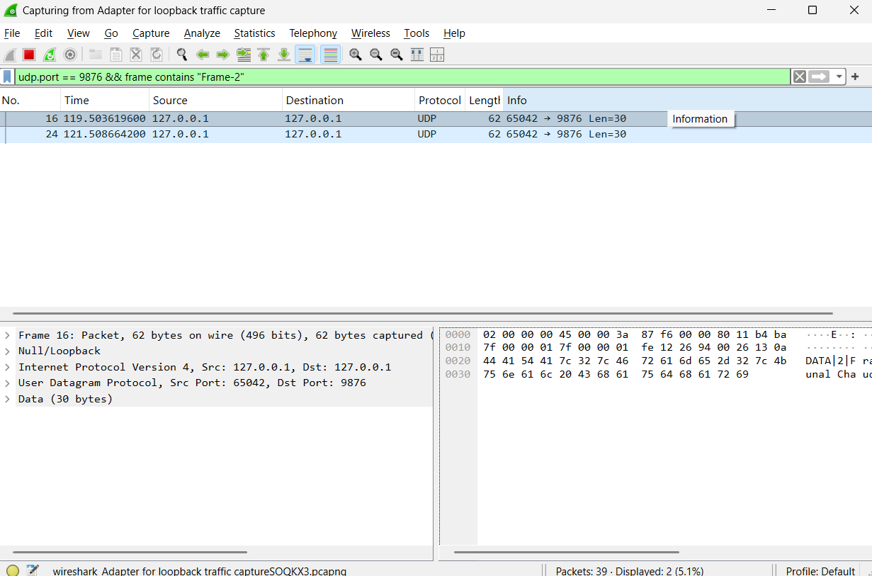

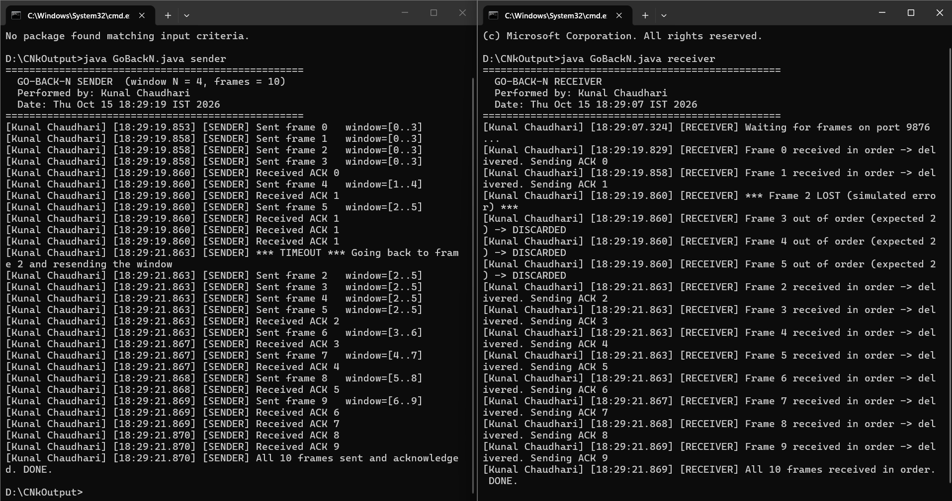

/*
* Assignment 5 (Group A): Sliding Window Protocol - SELECTIVE REPEAT (peer to peer, UDP)
* Student : Kunal Chaudhari
* College : Modern Education Society's Wadia College of Engineering, Pune
*
* Run receiver first: java SelectiveRepeat receiver
* Then the sender : java SelectiveRepeat sender
*/
import java.net.*;
import java.nio.charset.StandardCharsets;
import java.text.SimpleDateFormat;
import java.util.Date;

public class SelectiveRepeat {
static final String OWNER = "Kunal Chaudhari"; // watermark
static final int PORT = 9877;
static final int TOTAL = 10;
static final int WINDOW = 4;
static final int TIMEOUT_MS = 2000;
static final int LOST_FRAME = 2;

static void log(String role, String msg) {
String t = new SimpleDateFormat("HH:mm:ss.SSS").format(new Date());
System.out.println("[" + OWNER + "] [" + t + "] [" + role + "] " + msg);
}

static void banner(String title) {
System.out.println("==================================================");
System.out.println(" " + title);
System.out.println(" Performed by: " + OWNER);
System.out.println(" Date: " + new Date());
System.out.println("==================================================");
}

static void send(DatagramSocket s, String msg, InetAddress a, int p) throws Exception {
byte[] b = msg.getBytes(StandardCharsets.UTF_8);
s.send(new DatagramPacket(b, b.length, a, p));
}

static void sender() throws Exception {
banner("SELECTIVE REPEAT SENDER (window N = " + WINDOW + ", frames = " + TOTAL + ")");
DatagramSocket s = new DatagramSocket();
s.setSoTimeout(200);
InetAddress addr = InetAddress.getByName("127.0.0.1");
boolean[] sent = new boolean[TOTAL], acked = new boolean[TOTAL];
long[] sentAt = new long[TOTAL];
int base = 0;

while (base < TOTAL) {
long now = System.currentTimeMillis();
for (int i = base; i < base + WINDOW && i < TOTAL; i++) {
if (!sent[i]) {
send(s, "DATA|" + i + "|Frame-" + i + "|" + OWNER, addr, PORT);
sent[i] = true; sentAt[i] = now;
log("SENDER", "Sent frame " + i + " window=[" + base + ".." +
Math.min(base + WINDOW - 1, TOTAL - 1) + "]");
} else if (!acked[i] && now - sentAt[i] >= TIMEOUT_MS) {
log("SENDER", "*** TIMEOUT for frame " + i + " *** Resending ONLY frame " + i);
send(s, "DATA|" + i + "|Frame-" + i + "|" + OWNER, addr, PORT);
sentAt[i] = now;
}
}
try {
byte[] buf = new byte[1024];
DatagramPacket p = new DatagramPacket(buf, buf.length);
s.receive(p);
String[] f = new String(p.getData(), 0, p.getLength(), StandardCharsets.UTF_8).split("\\|");
int ack = Integer.parseInt(f[1]);
log("SENDER", "Received ACK " + ack);
if (ack >= 0 && ack < TOTAL) acked[ack] = true;
while (base < TOTAL && acked[base]) base++; // slide window
} catch (SocketTimeoutException e) { /* check timers again */ }
}
log("SENDER", "All " + TOTAL + " frames sent and acknowledged. DONE.");
s.close();
}

static void receiver() throws Exception {
banner("SELECTIVE REPEAT RECEIVER");
DatagramSocket s = new DatagramSocket(PORT);
String[] buffer = new String[TOTAL];
int rcvBase = 0;
boolean dropped = false;
log("RECEIVER", "Waiting for frames on port " + PORT + " ...");

while (rcvBase < TOTAL) {
byte[] buf = new byte[1024];
DatagramPacket p = new DatagramPacket(buf, buf.length);
s.receive(p);
String[] f = new String(p.getData(), 0, p.getLength(), StandardCharsets.UTF_8).split("\\|");
int seq = Integer.parseInt(f[1]);

if (seq == LOST_FRAME && !dropped) {
dropped = true;
log("RECEIVER", "*** Frame " + seq + " LOST (simulated error) ***");
continue;
}
if (seq >= rcvBase && seq < rcvBase + WINDOW) {
if (buffer[seq] == null) {
buffer[seq] = f[2];
log("RECEIVER", "Frame " + seq + " received and BUFFERED. Sending ACK " + seq);
}
send(s, "ACK|" + seq + "|" + OWNER, p.getAddress(), p.getPort());
while (rcvBase < TOTAL && buffer[rcvBase] != null) {
log("RECEIVER", "Delivered frame " + rcvBase + " to application (in order)");
rcvBase++;
}
} else if (seq < rcvBase) {
send(s, "ACK|" + seq + "|" + OWNER, p.getAddress(), p.getPort());
}
}
log("RECEIVER", "All " + TOTAL + " frames received. DONE.");
s.close();
}

public static void main(String[] args) throws Exception {
if (args.length != 1) { System.out.println("Usage: java SelectiveRepeat sender|receiver"); return; }
if (args[0].equalsIgnoreCase("receiver")) receiver(); else sender();
}
}

