Program 1: Hostname to IP Address
Name: Kunal Chaudhari
# Name: Kunal Chaudhari
# Program 1: Hostname to IP Address

import socket

hostname = input("Enter Host Name: ")

try:
ip = socket.gethostbyname(hostname)
print("Name: Kunal Chaudhari")
print("IP Address:", ip)

except socket.gaierror:
print("Invalid Host Name.")

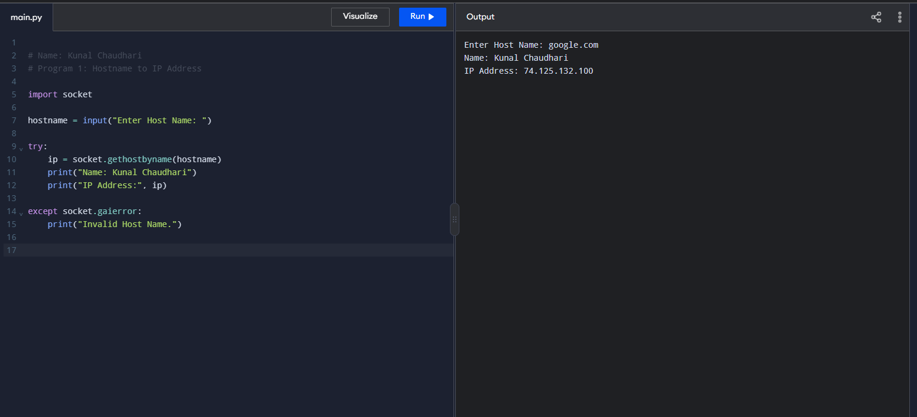

Program 2: IP Address to Hostname
Name: Kunal Chaudhari
# Name: Kunal Chaudhari
# Program 2: IP Address to Hostname

import socket

ip = input("Enter IP Address: ")

try:
hostname = socket.gethostbyaddr(ip)[0]
print("Name: Kunal Chaudhari")
print("Host Name:", hostname)

except socket.herror:
print("Host name not found.")

except socket.error:
print("Invalid IP Address.")

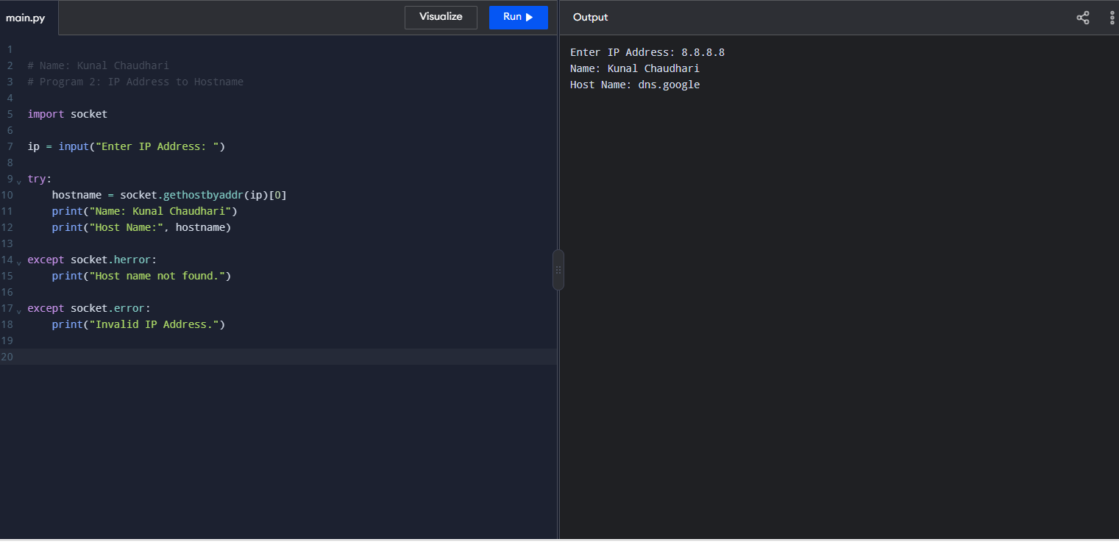

Program 3: Multiple IP Addresses for a Hostname
Name: Kunal Chaudhari
# Name: Kunal Chaudhari
# Program 3: Multiple IP Addresses

import socket

hostname = input("Enter Host Name: ")

try:
name, aliases, ip_addresses = socket.gethostbyname_ex(hostname)

print("Name: Kunal Chaudhari")
print("Host Name:", name)
print("IP Addresses:")

for ip in ip_addresses:
print(ip)

except socket.gaierror:
print("Invalid Host Name.")

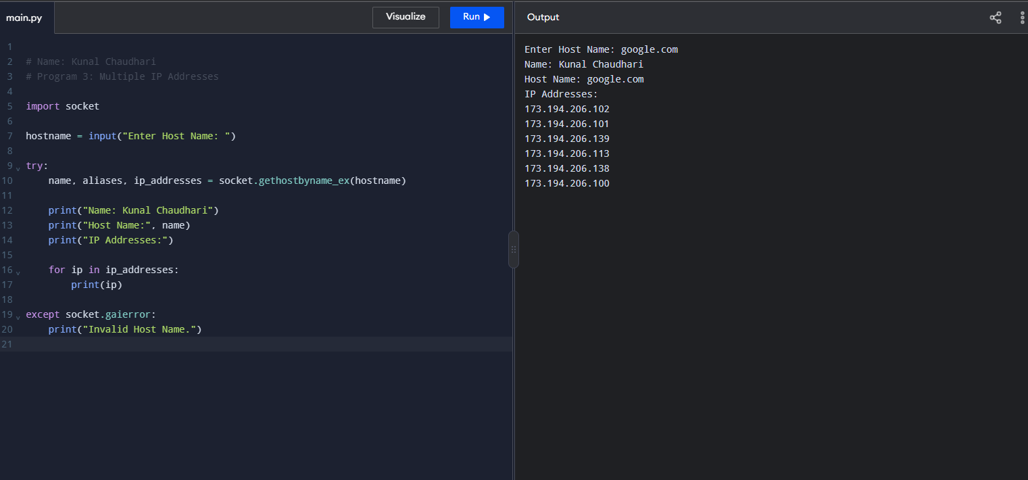

Program 4: Multiple IP Addresses to Domain Name
Name: Kunal Chaudhari
# Name: Kunal Chaudhari
# Program 4: Multiple IP Addresses to Domain Name

import socket

def get_domain(ip):
try:
hostname = socket.gethostbyaddr(ip)[0]
parts = hostname.split('.')

if len(parts) >= 2:
domain = ".".join(parts[-2:])
else:
domain = hostname

return hostname, domain

except socket.herror:
return "Not found", "No domain found"

except socket.error:
return "Invalid IP", "No domain found"

ip1 = input("Enter first IP: ")
ip2 = input("Enter second IP: ")

print("Name: Kunal Chaudhari")

for ip in [ip1, ip2]:
hostname, domain = get_domain(ip)

print("\nIP Address:", ip)
print("Hostname:", hos

