Server

# ======================================================================
# TCP MULTI-SERVICE - SERVER SIDE
# Services : 1) Chat / Hello 2) File Transfer 3) Calculator
# Protocol : TCP (SOCK_STREAM) -> connection-oriented, reliable
# Made by : Kunal
# Run order : 1) tcp_server.py 2) tcp_client.py
# ======================================================================
# Command format received from client (one line, fields split by '|'):
# MSG|<text> -> chat message / hello
# FILE|<filename>|<size> -> followed by <size> raw bytes
# CALC|<num1>|<op>|<num2> -> calculator request
# EXIT -> close connection
# ======================================================================

import socket
import os

AUTHOR = "Kunal" # Watermark (change here if needed)

# ---------------------------- CONFIGURATION ---------------------------
HOST = "127.0.0.1" # Localhost
PORT = 5000 # TCP port number
SAVE_DIR = "received_files_tcp" # Folder for received files
os.makedirs(SAVE_DIR, exist_ok=True)

def banner(title):
"""Prints the watermark banner (shows in output)."""
print("=" * 58)
print(f" {title}")
print(f" Protocol : TCP | Made by : {AUTHOR}")
print("=" * 58)

def calculate(a, op, b):
"""Calculator service: returns the result as a string."""
try:
a = float(a)
b = float(b)

if op == "+":
r = a + b
elif op == "-":
r = a - b
elif op == "*":
r = a * b
elif op == "/":
if b == 0:
return "Error: division by zero"
r = a / b
elif op == "%":
if b == 0:
return "Error: division by zero"
r = a % b
elif op == "**":
r = a ** b
else:
return "Error: invalid operator"

# Show 15 instead of 15.0
if r == int(r):
r = int(r)
return f"{a:g} {op} {b:g} = {r}"

except (ValueError, OverflowError):
return "Error: invalid numbers"

def handle_client(conn, addr):
"""Serves one connected client until it sends EXIT."""
# Binary mode so we can mix text commands and raw file bytes
reader = conn.makefile("rb")
writer = conn.makefile("wb")

def send_line(text):
writer.write((text + "\n").encode("utf-8"))
writer.flush()

# Application-level acknowledgment sent right after connection
send_line(f"ACK: Connection established with {AUTHOR}'s server on port {PORT}")
print(f"[{AUTHOR}] Acknowledgment sent to client.\n")

for raw in reader:
text = raw.decode("utf-8").rstrip("\r\n")
cmd = text.split("|", 1)[0].upper()

# ---------------- Service 1: Chat / Hello ----------------
if cmd == "MSG":
message = text.split("|", 1)[1] if "|" in text else ""
print(f"[Chat] Client: {message}")

if message.lower() == "hi client":
reply = "hi welcome " + AUTHOR
elif message.lower() == "hello":
reply = "Hello from server! - " + AUTHOR
else:
reply = "Server received: " + message

print(f"[Chat] Server: {reply}")
send_line(reply)

# ---------------- Service 2: File Transfer ----------------
elif cmd == "FILE":
_, filename, size = text.split("|")
filename = os.path.basename(filename) # safety: no paths
size = int(size)
print(f"[File] Receiving '{filename}' ({size} bytes)...")

remaining = size
with open(os.path.join(SAVE_DIR, filename), "wb") as f:
while remaining > 0:
chunk = reader.read(min(4096, remaining))
if not chunk:
break
f.write(chunk)
remaining -= len(chunk)

if remaining == 0:
print(f"[File] Successfully received: {filename}")
send_line(f"OK File '{filename}' received ({size} bytes) - {AUTHOR}")
else:
print("[File] Transfer incomplete!")
send_line("ERROR File transfer incomplete")

# ---------------- Service 3: Calculator ----------------
elif cmd == "CALC":
_, a, op, b = text.split("|")
result = calculate(a, op, b)
print(f"[Calc] {a} {op} {b} -> {result}")
send_line(result)

# ---------------- Exit ----------------
elif cmd == "EXIT":
send_line("Goodbye! - " + AUTHOR)
break

else:
send_line("Error: unknown command")

banner("TCP SERVER")

try:
# Step 1: Create a TCP socket (SOCK_STREAM = TCP)
serverSocket = socket.socket(socket.AF_INET, socket.SOCK_STREAM)

# Allow quick restart on the same port
serverSocket.setsockopt(socket.SOL_SOCKET, socket.SO_REUSEADDR, 1)

# Step 2: Bind socket to IP + port
serverSocket.bind((HOST, PORT))

# Step 3: Start listening
serverSocket.listen(1)

# Timeout so Ctrl+C works on Windows
serverSocket.settimeout(1.0)

print(f"[{AUTHOR}] Server IP address : {HOST}")
print(f"[{AUTHOR}] Port number : {PORT}")
print(f"[{AUTHOR}] TCP Server started, waiting for client...")
print(f"[{AUTHOR}] Files will be saved in: {SAVE_DIR}")
print("[INFO] Press Ctrl+C to stop the server.\n")

while True:
# Step 4: Accept connection
try:
socketClient, address = serverSocket.accept()
except socket.timeout:
continue

# TCP 3-way handshake (performed by the OS before accept() returns)
print("-" * 58)
print(f"[{AUTHOR}] ---- 3-WAY HANDSHAKE ----")
print(f"[Step 1] SYN received from client {address}")
print(f"[Step 2] SYN-ACK sent to client {address}")
print(f"[Step 3] ACK received from client {address}")
print(f"[{AUTHOR}] CONNECTION ESTABLISHED with {address[0]}:{address[1]}")
print("-" * 58)

# Step 5: Serve the client (chat / file / calculator)
with socketClient:
handle_client(socketClient, address)

print("-" * 58)
print(f"[{AUTHOR}] ---- CONNECTION CLOSED ----")
print(f"[{AUTHOR}] FIN/ACK exchanged, client {address} disconnected.")
print(f"[{AUTHOR}] Waiting for next client...\n")

except KeyboardInterrupt:
print(f"\n[{AUTHOR}] Server stopped by user.")

except OSError as e:
print("Server error:", e)

finally:
serverSocket.close() # Step 6: Close the server socket
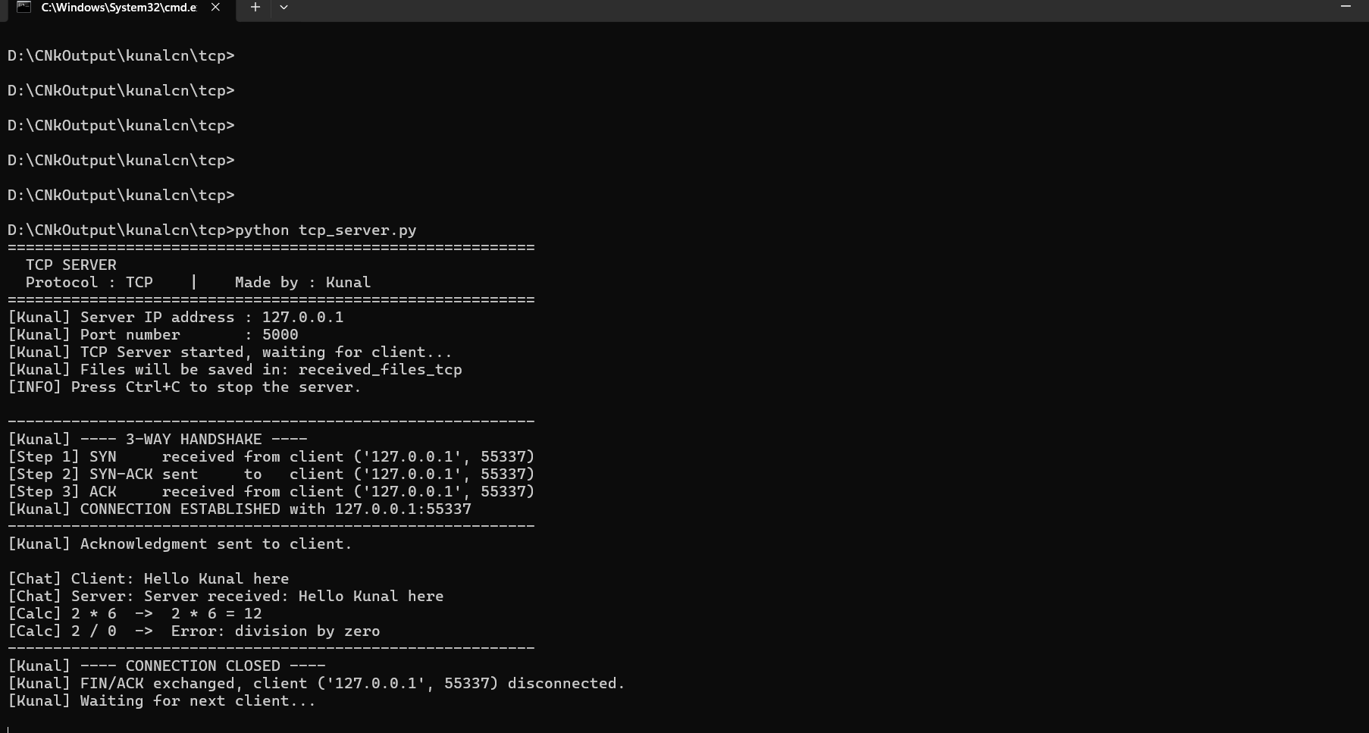

Client
# ======================================================================
# TCP MULTI-SERVICE - CLIENT SIDE
# Services : 1) Chat / Hello 2) File Transfer 3) Calculator
# Protocol : TCP (SOCK_STREAM) -> 3-way handshake via connect()
# Made by : Kunal
# Run order : 1) tcp_server.py 2) tcp_client.py
# ======================================================================

import socket
import os

AUTHOR = "Kunal" # Watermark (change here if needed)

# ---------------------------- CONFIGURATION ---------------------------
SERVER_IP = "127.0.0.1" # Server address (localhost)
SERVER_PORT = 5000 # Must match server port

def banner(title):
"""Prints the watermark banner (shows in output)."""
print("=" * 58)
print(f" {title}")
print(f" Protocol : TCP | Made by : {AUTHOR}")
print("=" * 58)

banner("TCP CLIENT")

try:
# Step 1: Create a TCP socket
clientSocket = socket.socket(socket.AF_INET, socket.SOCK_STREAM)

print(f"[{AUTHOR}] Server IP address : {SERVER_IP}")
print(f"[{AUTHOR}] Port number : {SERVER_PORT}")

# Step 2: Connect to server (3-way handshake happens here)
print("-" * 58)
print(f"[{AUTHOR}] ---- 3-WAY HANDSHAKE ----")
print(f"[Step 1] Client -> Server : SYN (connection request)")
clientSocket.connect((SERVER_IP, SERVER_PORT)) # OS does SYN, SYN-ACK, ACK
print(f"[Step 2] Server -> Client : SYN-ACK received")
print(f"[Step 3] Client -> Server : ACK sent")

local_ip, local_port = clientSocket.getsockname()
print(f"[{AUTHOR}] CONNECTION ESTABLISHED")
print(f"[{AUTHOR}] Client : {local_ip}:{local_port} <--> Server : {SERVER_IP}:{SERVER_PORT}")
print("-" * 58)

with clientSocket:
# Binary mode: text commands + raw file bytes
reader = clientSocket.makefile("rb")
writer = clientSocket.makefile("wb")

def send_line(text):
"""Sends one command line to the server."""
writer.write((text + "\n").encode("utf-8"))
writer.flush()

def get_reply():
"""Reads one reply line from the server."""
reply = reader.readline()
if reply == b"":
return None
return reply.decode("utf-8").rstrip("\r\n")

# Wait for the server's acknowledgment message
print(f"[{AUTHOR}] Server says:", get_reply())

while True:
print("\n------------- MENU (by " + AUTHOR + ") -------------")
print(" 1. Chat / Hello message")
print(" 2. File transfer")
print(" 3. Calculator")
print(" 4. Exit")
choice = input("Enter choice (1-4): ").strip()

# ---------------- Service 1: Chat / Hello ----------------
if choice == "1":
message = input("Enter message (try 'hello' or 'hi client'): ")
send_line("MSG|" + message)

# ---------------- Service 2: File Transfer ----------------
elif choice == "2":
filepath = input("Enter file name to send: ").strip()

if not os.path.isfile(filepath):
print("File not found:", filepath)
continue

size = os.path.getsize(filepath)
filename = os.path.basename(filepath)

# Header first, then the raw file bytes
send_line(f"FILE|{filename}|{size}")
with open(filepath, "rb") as f:
while True:
chunk = f.read(4096)
if not chunk:
break
writer.write(chunk)
writer.flush()
print(f"[{AUTHOR}] Sent {filename} ({size} bytes)")

# ---------------- Service 3: Calculator ----------------
elif choice == "3":
a = input("Enter first number : ").strip()
op = input("Enter operator (+ - * / % **): ").strip()
b = input("Enter second number: ").strip()
send_line(f"CALC|{a}|{op}|{b}")

# ---------------- Exit ----------------
elif choice == "4":
send_line("EXIT")
print("Server reply:", get_reply())
break

else:
print("Invalid choice, try again.")
continue

# Step 3: Print the server's reply
reply = get_reply()
if reply is None:
print("Server disconnected.")
break
print("Server reply:", reply)

print("-" * 58)
print(f"[{AUTHOR}] ---- CONNECTION CLOSED ----")
print(f"[{AUTHOR}] FIN/ACK exchanged, connection terminated.")

except OSError as e:
print("Connection error:", e)

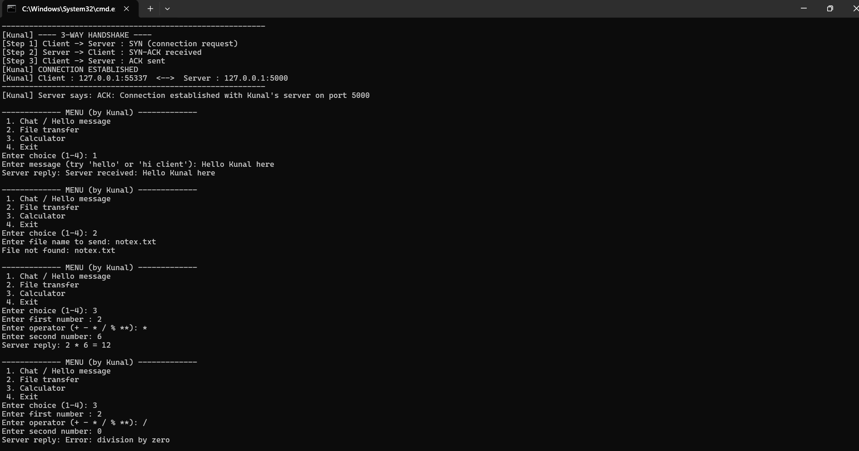

Received file
