**ATMANIRBHAR FARMER**

1. **Introduction** 
   1. **Purpose**

To create a native os application for existing as well as new small-scale farmers, which will help them in every possible way by providing genuine information and guidelines for effective, low-cost, good quality farming. It will help make the farmer more independent with dependence on the right sources.

* 1. **Overview**

India has a very huge and developing agricultural sector that employs a large number of people from village as well as semi urban areas. There is a growing need for guidance for farmers as in case of any unwanted circumstances, the farmers become helpless and aren’t always aware of how and who to turn to for guidance. ATMANIRBHAR FARMER is a native-os application for the new and existing farmers, that’ll provide a platform for small-scale farmers to learn about the various information, guidelines, helplines etc. for daily farming or about who to turn to in case of undesirable circumstances. Every year many farmers commit suicide in many parts of the country due serious problems and depts. We have developed this site to try to prevent such cases from happening. If we are able to save even one life by providing them with the right info and guiding them properly, we’ll realize that we did an amazing job.

* 1. **Scope of the system**

The project aims at providing and efficient interface to get the latest information about farming and related fields. The basic idea involved in the project is to create a guide like system that will help in giving all the latest information related to farming. Keeping track of all pricings of the crops as well as providing information about the better approach to farming. Each user will be registered in the database and will be provided with username and password, with which they can access all kinds of information related to farming. The system also provides suggestions on what to do and what not to do while farming so as to create better results. In order to maintain a good quality quality service system to the customers, the native os application- also keeps track latest buyers and sellers so that the user can get in contact with them easily.

**EXISTING FUNCTIONALITIES IN THE APP**

* **Login**: Existing users can login into their accounts with their existing usernames and passwords.
* **Registration**: Users who are new to the site can sign up with a new username and password.
* **Crop Prices:** The current MSP (minimum support price) of each crop has been entered into the website for references.
* **Soil related information**: State wise information of soil fertility has been provided for study.
* **Irrigation related information**: Irrigation is a major issue in places of draught affected areas. We will provide alternatives for such circumstances.
* **Helplines**: All the helpline numbers of govt. organizations as well as their sites that have been built to aid the farmers have been mentioned.
* **Location based weather information:** Depending upon where the farmer lives, he will be able to latest weather forecast in the app.
* **Irrigation related info:** There are numerous irrigation methods, we’ll help the farmer on deciding the best suited methods for his area.
* **Buying and Selling Guidelines:** To make users aware of their choices, facilities and options available we have provided guidelines that’ll help prevent the user from getting into scams or frauds.
* **Do’s and Don’ts:** In order to prevent any kinds of mishaps or undesirable circumstances, some things should be known prior to the process. After studying all the circumstances, we have provided information about what is to be done and what’s not to be done to have a smoother experience in farming.

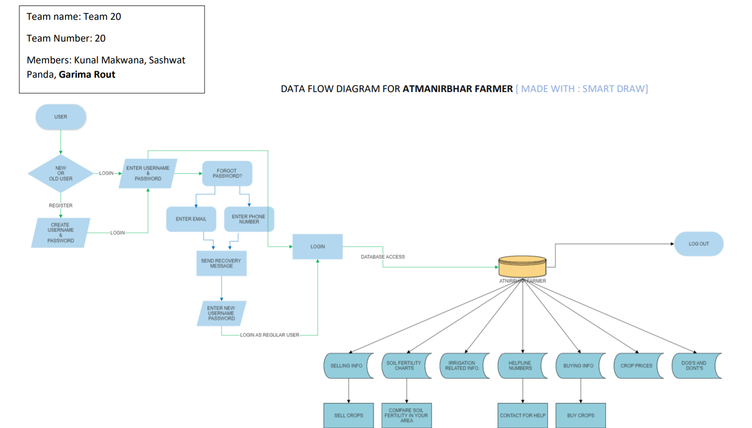

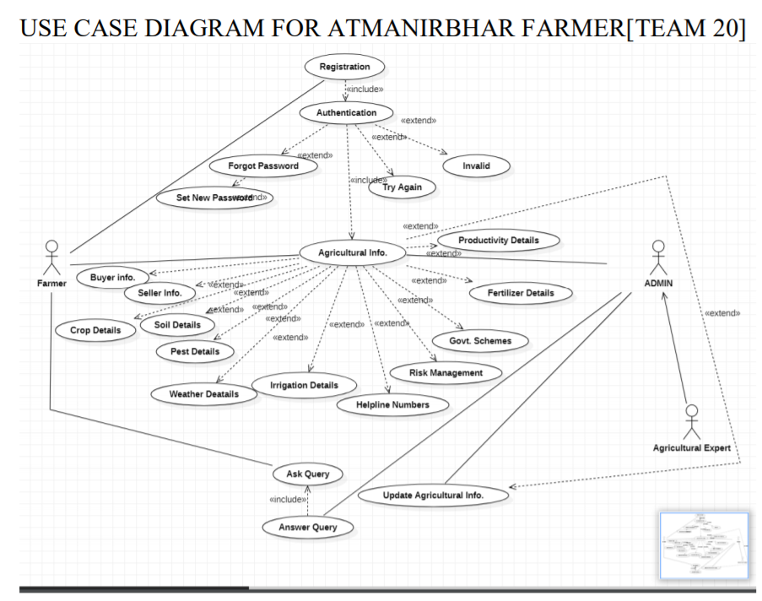

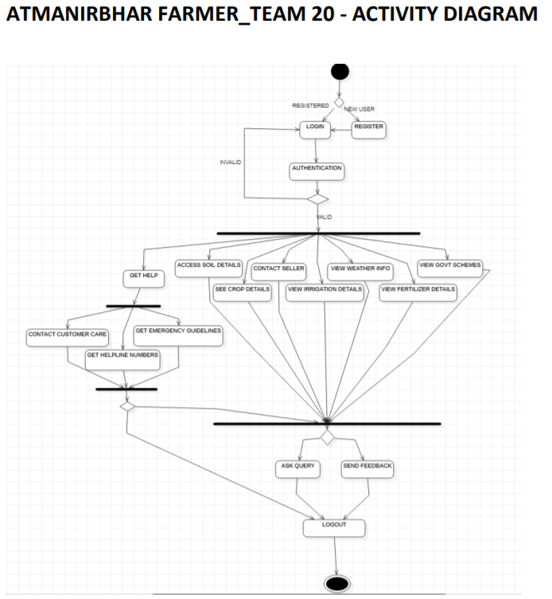

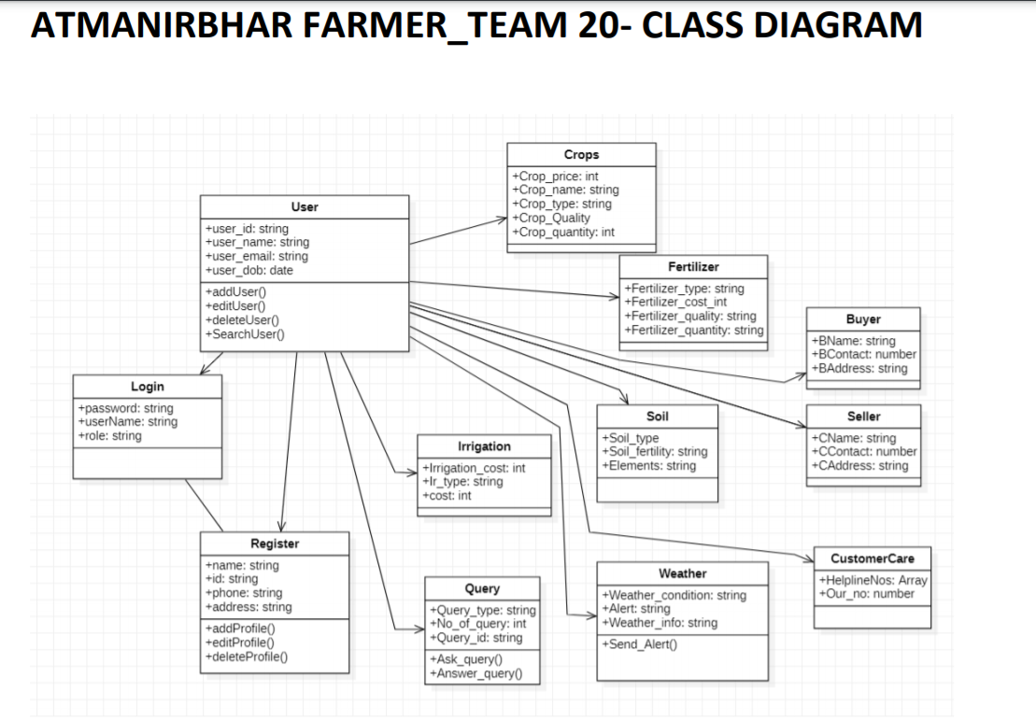

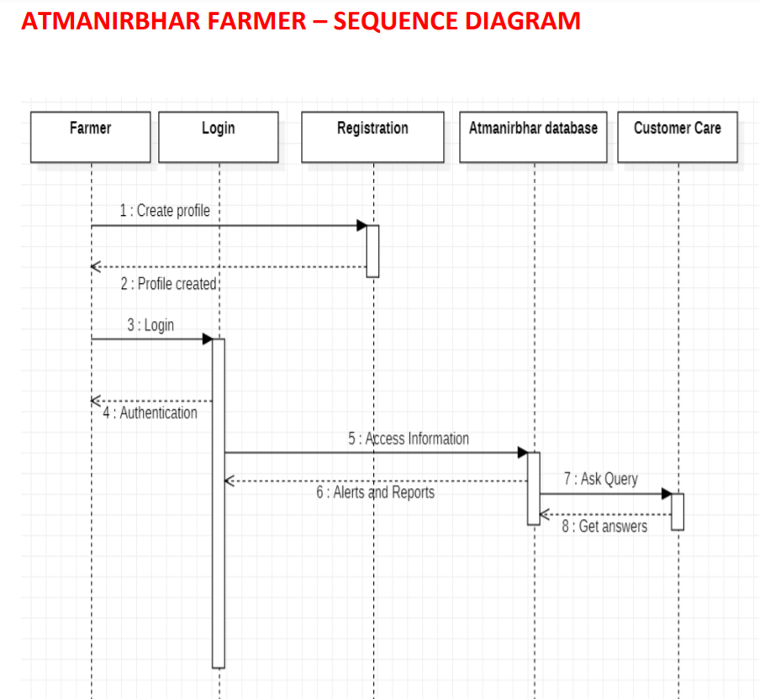

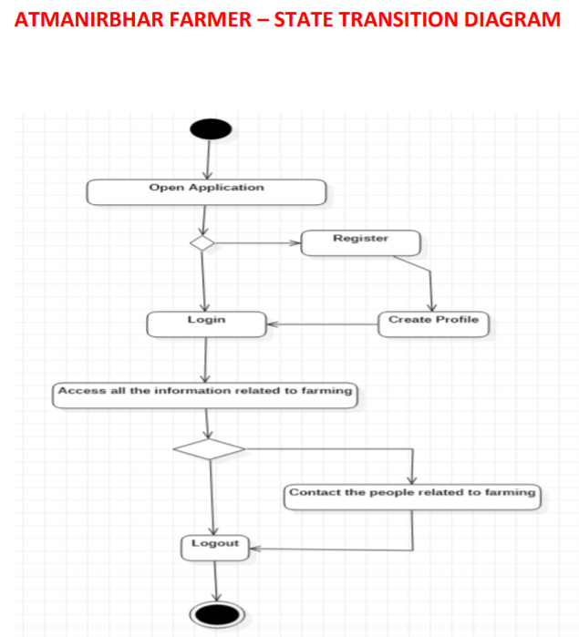

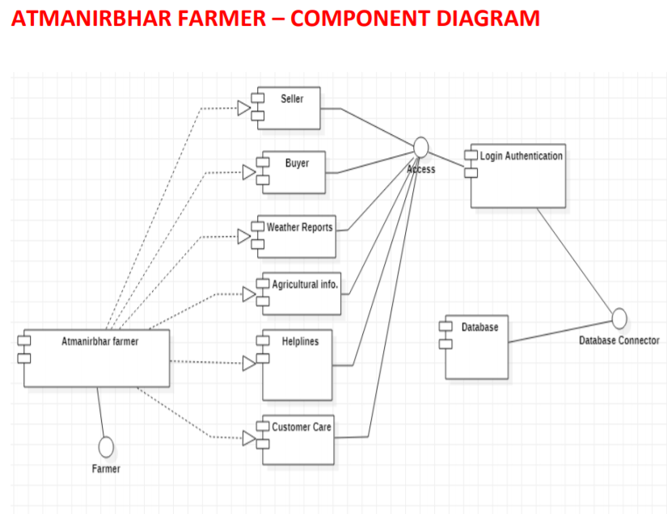

**ATMANIRBHAR FARMER – DEPLOYMENT DIAGRAM**

