Assignment-1: Connect and disconnect with login Access

* What happens when you login a non-existent users or username?
  + Provide Screenshot and What you understand, explain in short brief?

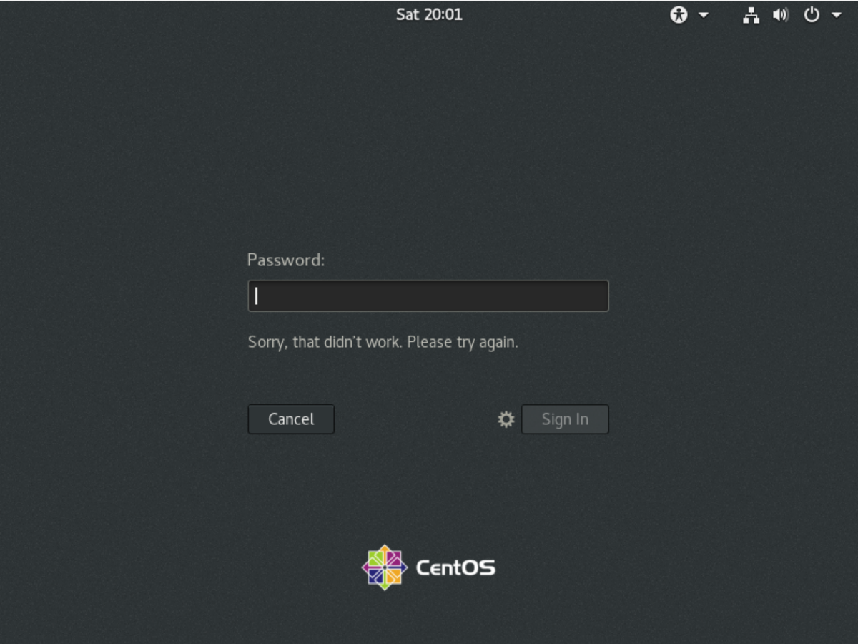

• When we try to login with non-existent users or username, we get rejected from login to machine. Because the OS won’t be able to detect the username which was not set up earlier while installing it.

Assignment-2: Password changing

• Login into your account and then change password?

• Change your password into ***IneuR0n#42*** and hit the **Enter** key

• Explain what happen and give screenshot?

○ Have changed the password to ***IneuR0n#42*** and hit entered, the password change was successful due to the complexity of the it. The password has Upper case, lower case, special characters and numbers. It has all characters which makes the password stronger.

Changing password to ***IneuR0n#42*** (below Screenshot)

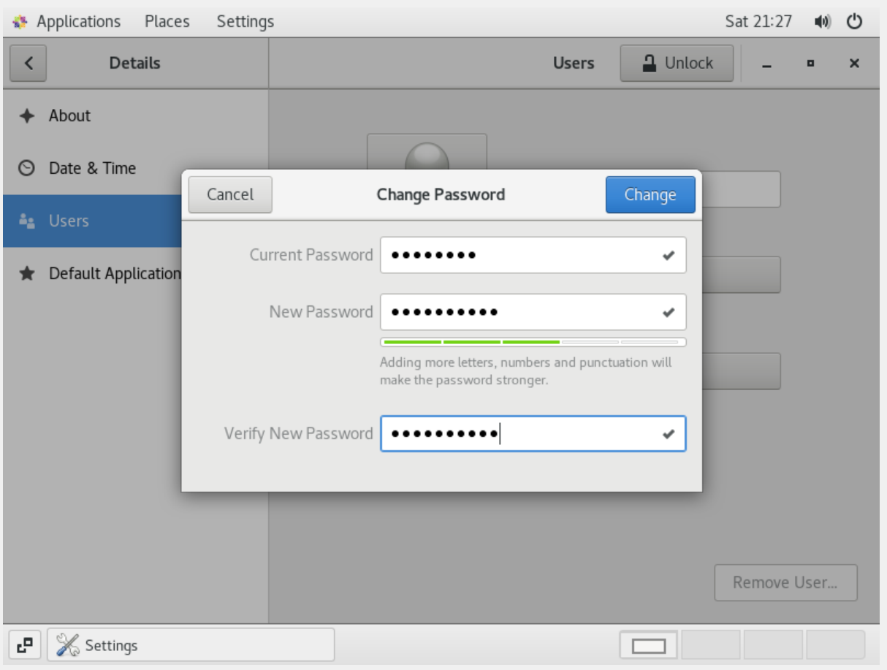

Successfully changes the password (below Screenshot)

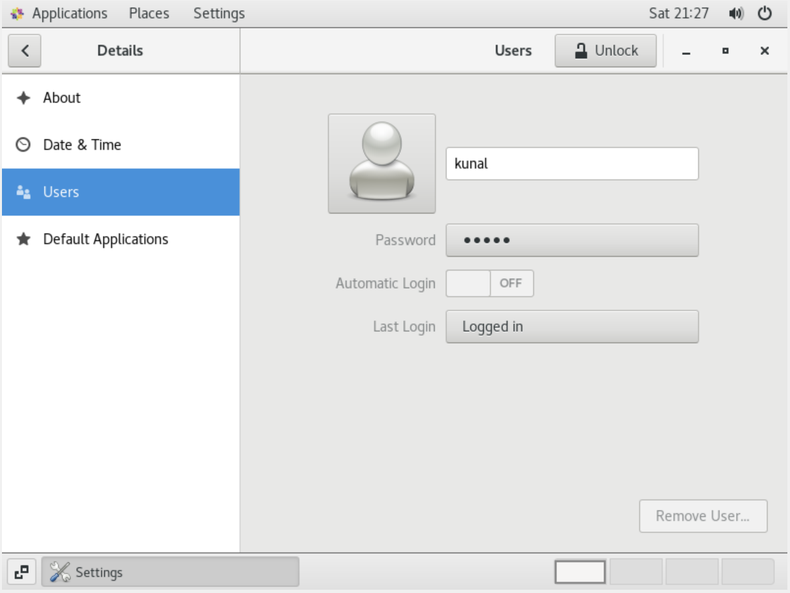

• Try again to change password but use like password ***1234*** or ***abcd***

• Explain what happen and give screenshot?

○ Tried changing password to **1234** or **abcd** but it didn’t work as the password was weak and easily recognisable which will lead to security breach.

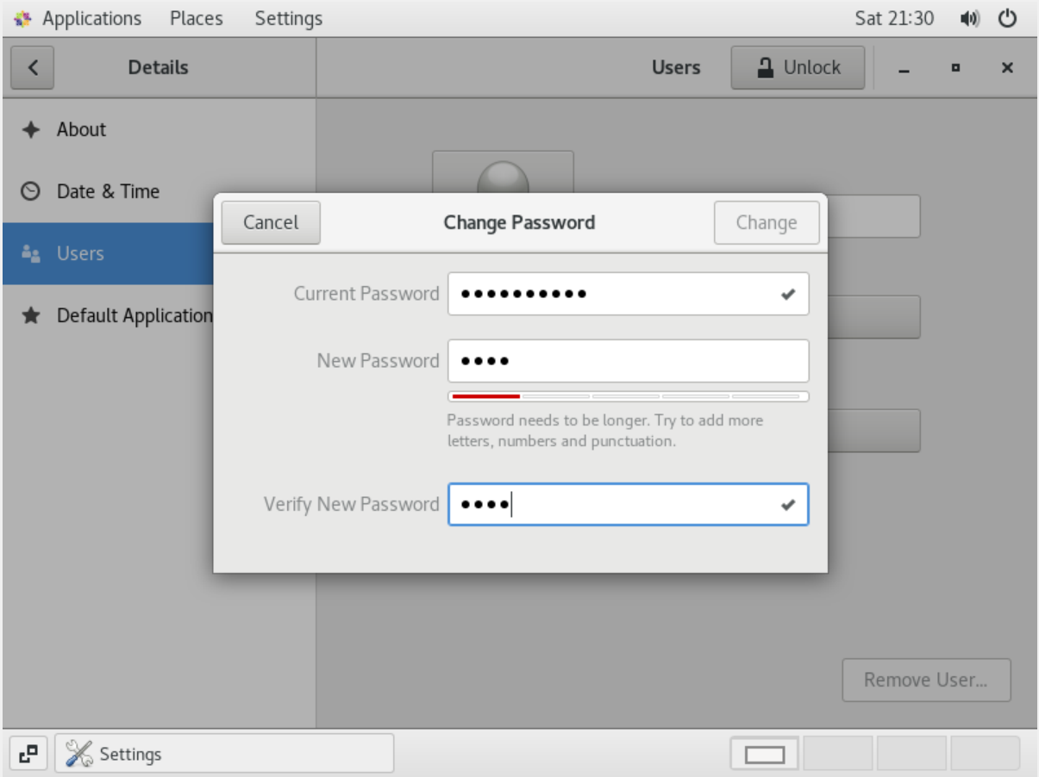

• Try again to change password but now don’t use any password just hit **Enter** key

• Explain what happen and give screenshot?

○ Tried hitting Enter with blank password nothing happened.

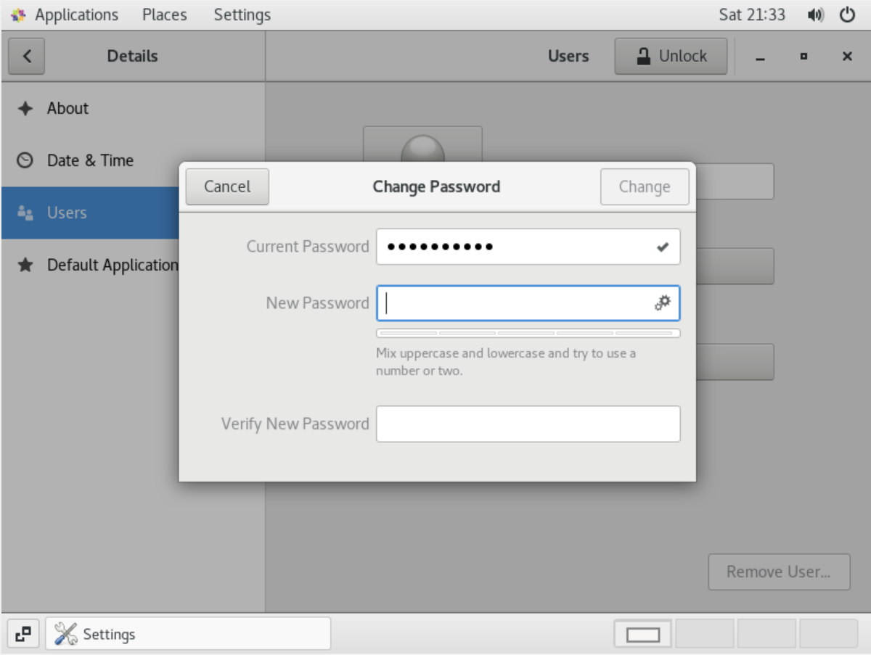

Assignment-3: Working with Directories

• Enter the command cd / and then ls and then hit Enter key

• Take screenshot and explain what output we got?

○ After entering the cd / command I went into root directory and in my root directory I have multiple sub-directories which is there in the below screenshot.

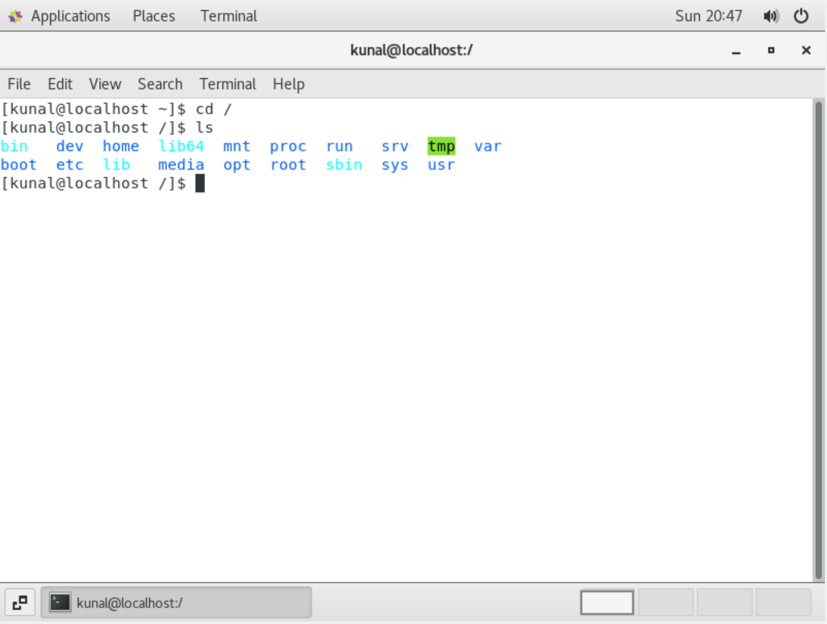

• Enter the command now cd /home and then hit Enter key

• Do ls, provide screenshot and explain what is /home directory used for?

○ /home directory is used to store personal user data/files and user details of the system.

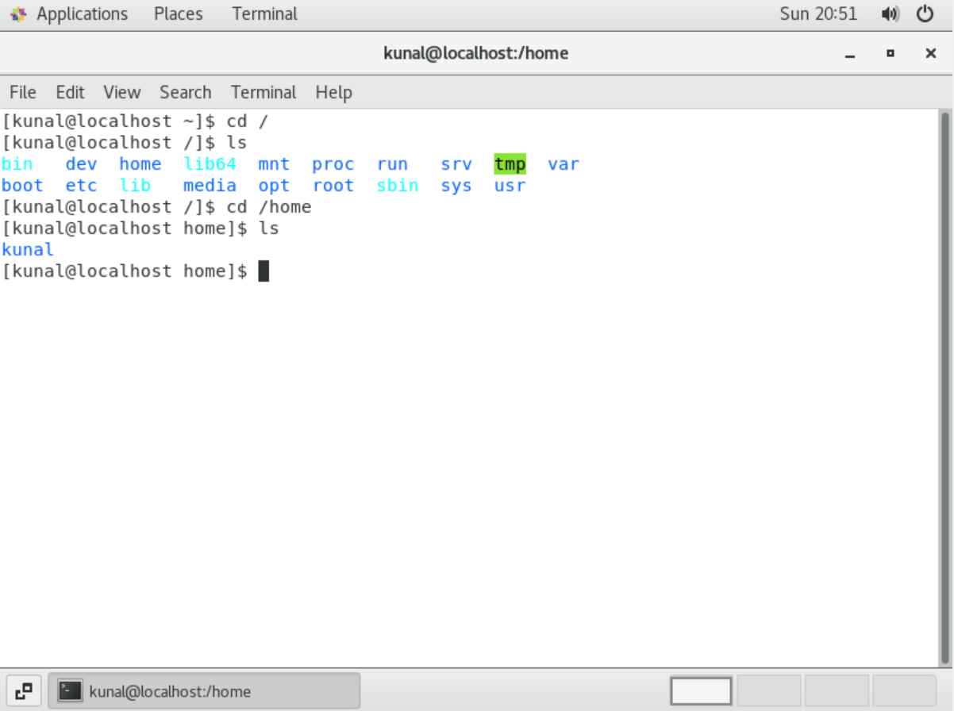

• Enter cd .. and hit Enter key [ Note: here we have space after cd then use double dot]

• Check what happen and give screenshot?

○ After hitting cd .. I went back to previous directory from present working directory.

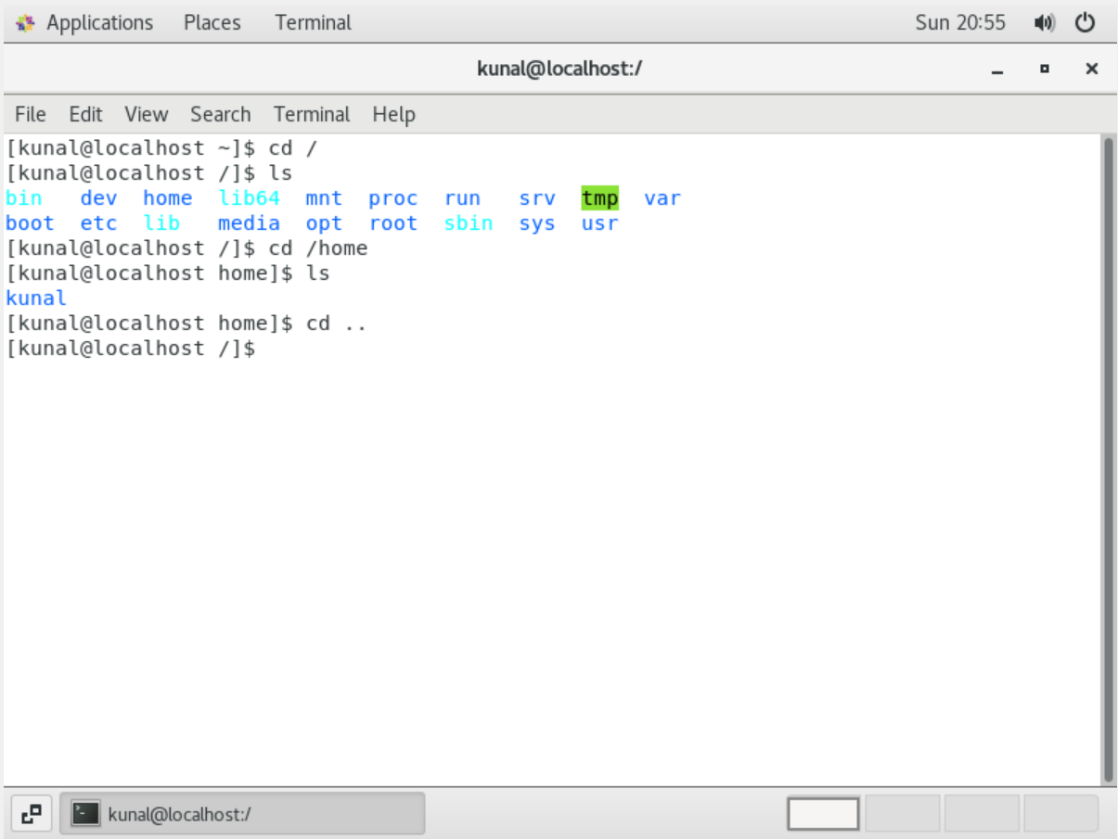

• Now enter cd /var/www/html and then type cd and hit Enter key

• Explain what happen and give screenshot?

○ After entering the command got an error as no such file or directory because there is no directory is created for this file. We have to install external package for this directory to be created.

After entering cd command, I went back to my home directory from root directory (from / to ~)

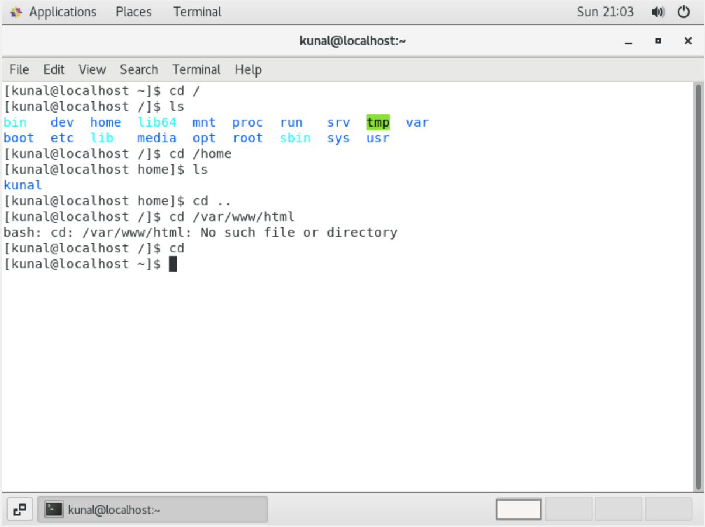

• Now type cd /root and then hit Enter key

• Do ls, check any output we have on screen if yes then take screenshot?

○ After entering cd /root I got permission denied because I don’t have the permissions of root user.

I need to use sudo command to execute for root user.

After entering ls command I was shown the sub-directories under home directory.

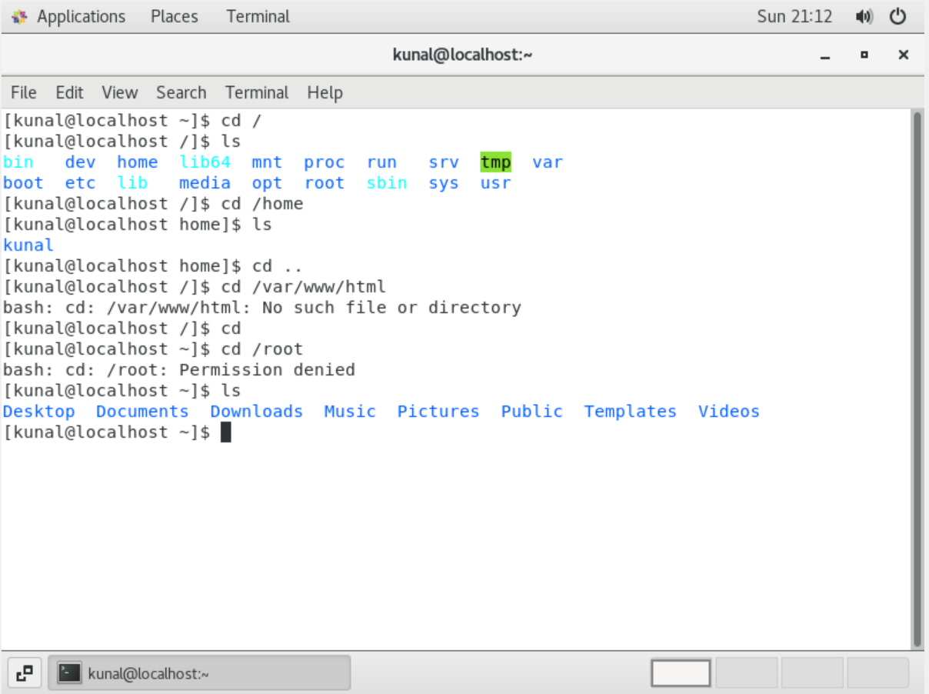

Assignment-4: Working with File Listing

• Go to cd /etc and type ls

• Take screenshot and explain what files you have seeing?

• Take screenshot and explain what different output you found compare to previous command you used?

○ After entering cd /etc I am able to see many configuration files and system files.

This directory contains system information such as passwords, users and installation files also.

○ The difference I can see is the number of files are huge compared to other directories.

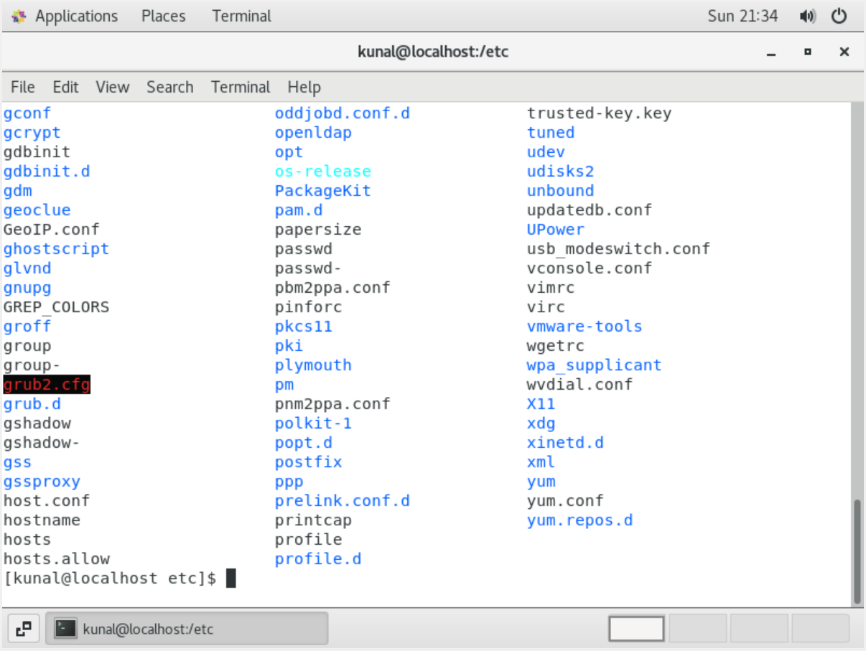

• Then type ls -al and hit Enter key

• Take screenshot and explain what new file or directory you found?

○ After typing ls -al I can see lists of all files along with directories within the /etc directory

As well as I can see the **1)** total count of the files in the /etc directory **2)** permissions given to each file and directory **3)** Count of files in each directory **4)** owner of the file **5)** size of the file **6)** time and date of creation **7)** name of the file.

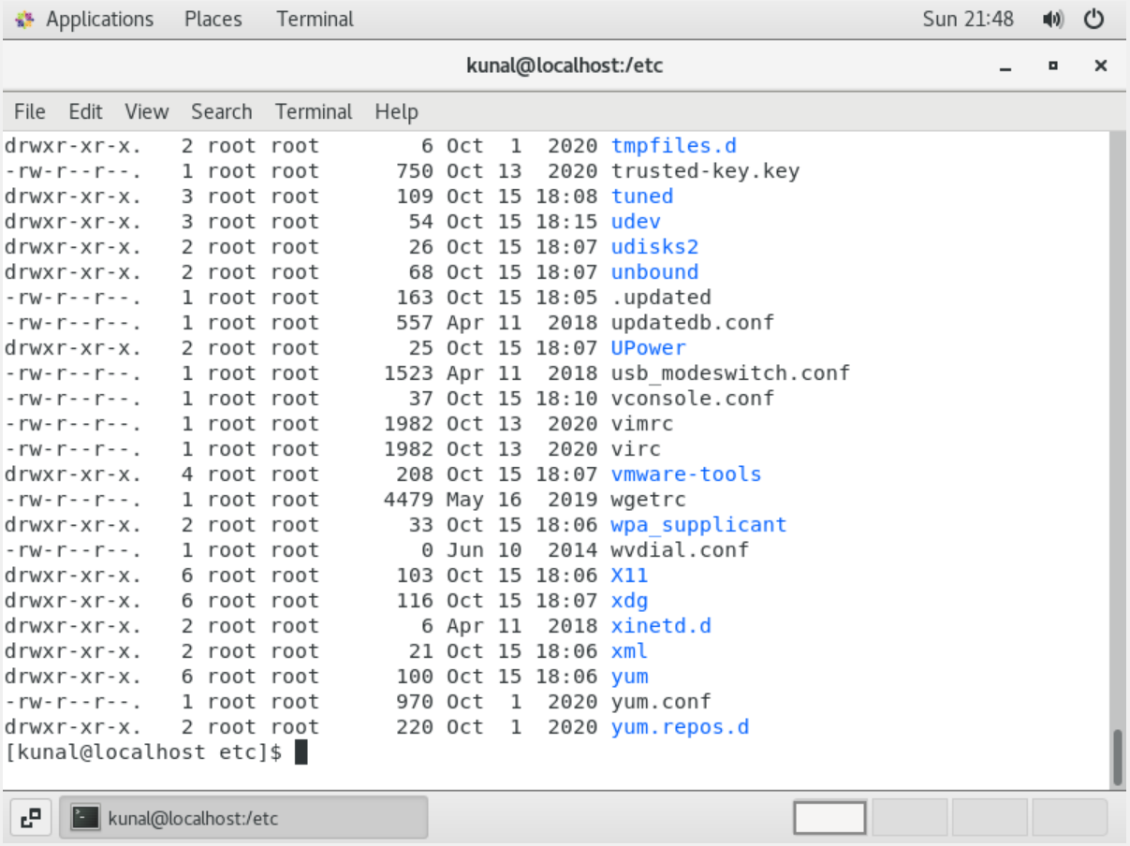

• Then use ls -i and hit Enter key

• Now see what different output its shows and take screenshot?

○ After entering ls -i command I got inode index number of each file.

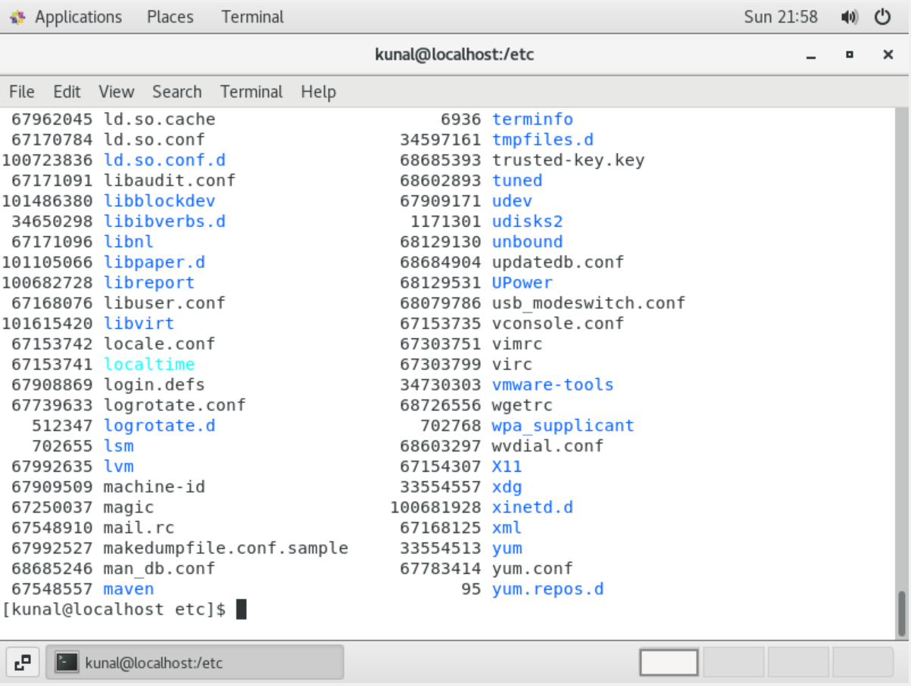

• Then use ls –help and see other options about ls command

• Explore it and try with other attribute we can use with ls command

○ After entering ls –help I got the list of arguments I can use with ls command to specific purposes.

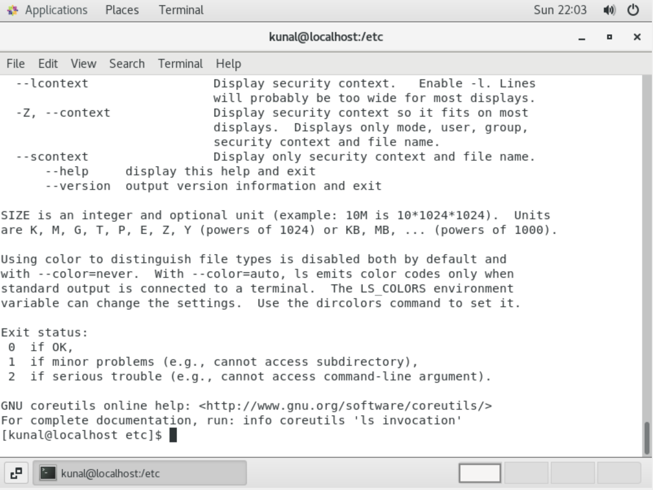

Assignment-5: Know where you are and where you working

*Here we use* ***pwd, cd and ls*** *as combine task to understand where you working on terminal and how you can switch from one directory to another one.*

• Open terminal after restart the linux

• Check which location you working, type pwd and take screenshot

○ Opened the terminal after restarting the linux and I was in home directory.

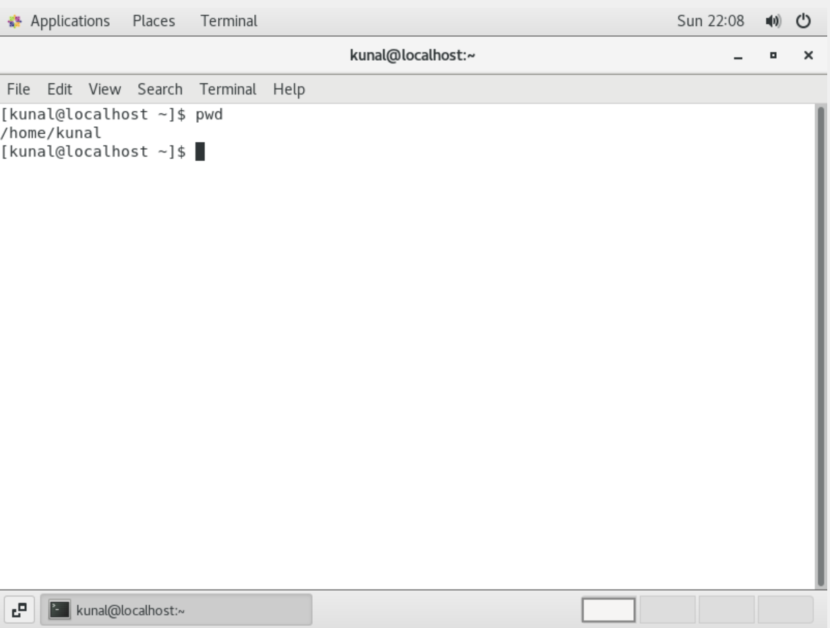

• Now use cd /var and hit Enter key

• Do ls, and see what output comes, give screenshot?

○ After entering cd /var I changed my directory to var and enter ls command to list all files and directories under /var

