Linux Basic Commands Assignment

1.Create a file like nano file1.txt

o Edit some data and then save the file

● new file file1.txt is created

2. Now we will copy date from file1 to new file2

o cp file1.txt file2.txt

o Then see the output of file2.txt, cat file2.txt

o Give screenshot

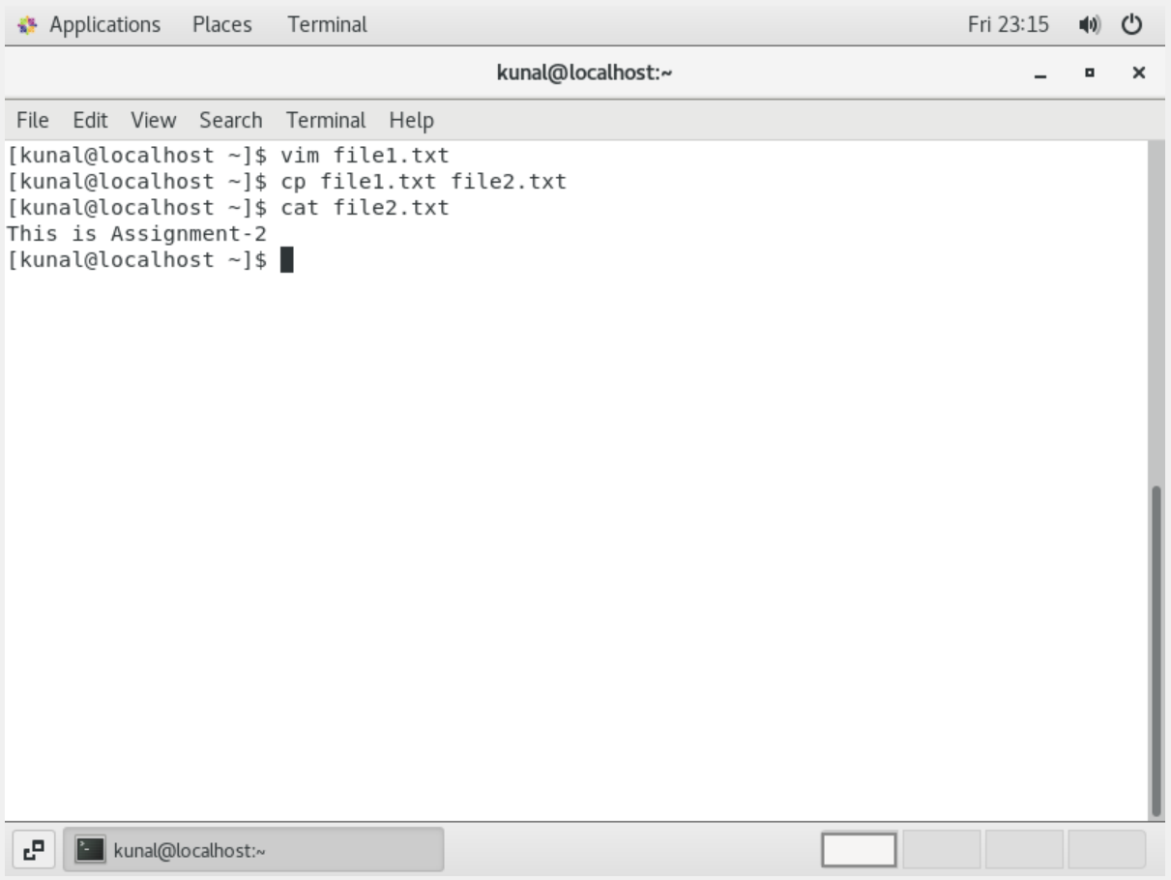

3. Now we will move the file2.txt to new folder /home

o mv file2.txt /home

o Then go to home directory and check ls, file exits or not?

o Given screenshot

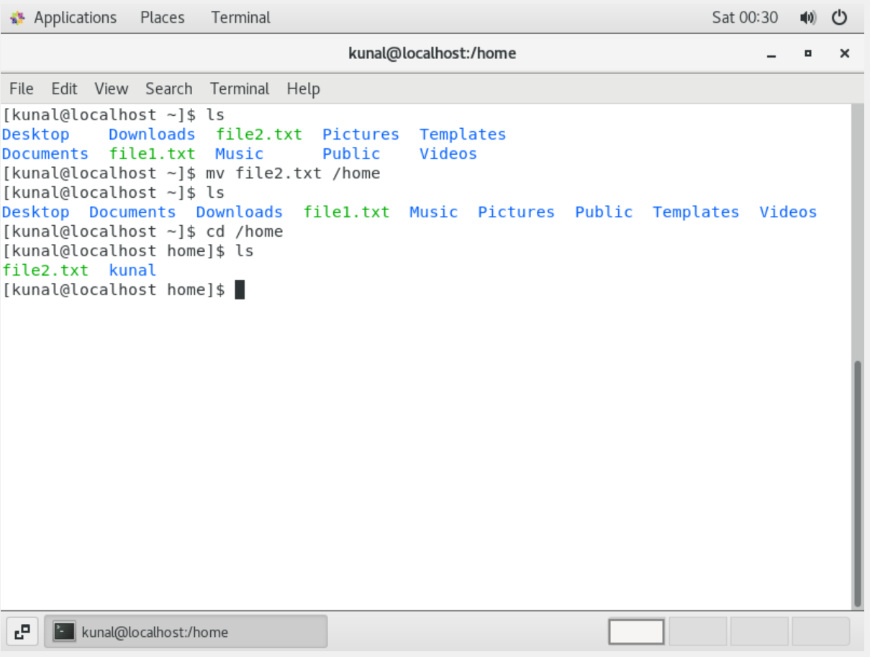

4. Then we create a new file3.txt and file4.txt in home directory and add

content in it.

o Now do echo “Hello I am newline” > file3.txt and provide the

output of file3.txt

o Now do echo “Hello I am newline” >> file4.txt and provide the

output of file4.txt

o Tell the different between both step you follow and the reason

behind it.

● By putting > we are overriding the existing file. Where as by putting >> we are adding new data to the file.

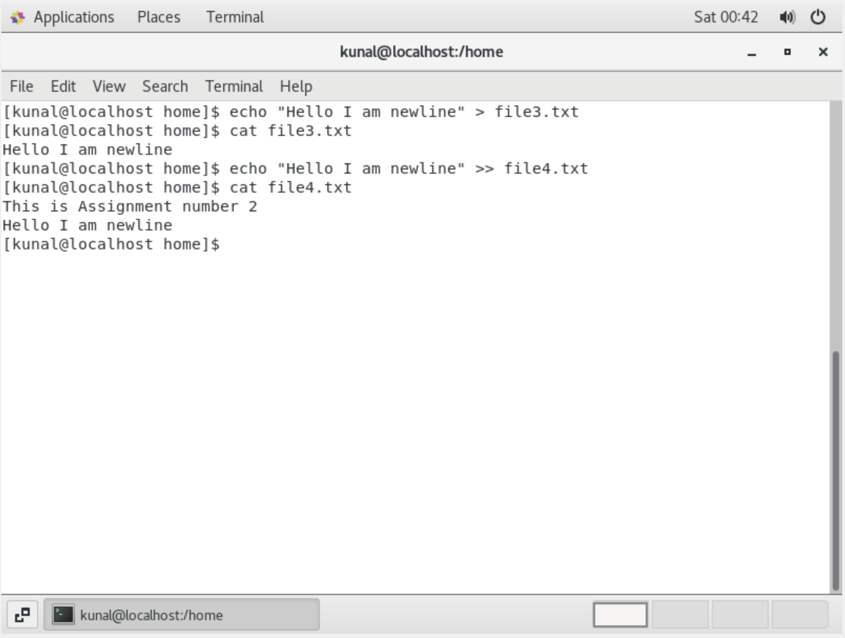

5. For remove a file or directory you can use the below two commands

o To delete a file – rm <any_filename>

o To delete a directory -rmdir<any_directoryname>

● All the three files are removed using rm command and new folder is created and deleted by using mkdir and rmdir commands respectively.

