**Sheru**

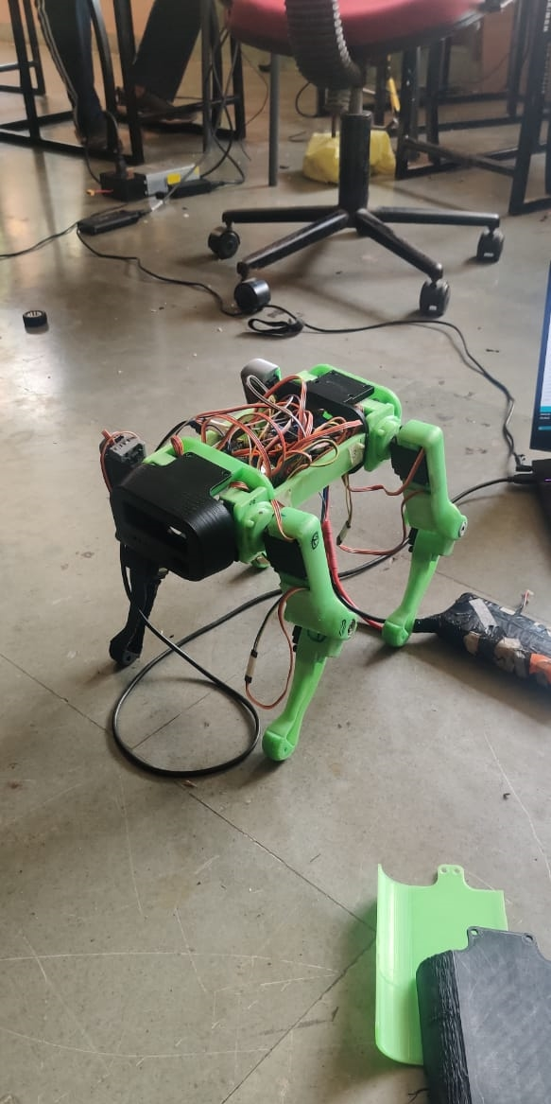

**Team Members**:

Abhishek Borse (Coding)

Kunal Awari (Coding)

Sumeet Jadhav (Electronics)

**Components Used:**

Arduino Uno

Servo Motors (12)

PCA9685

**Libraries Used:**

Adafruit_PWMServoDriver.h

**Description**

It is a 4 legged robot that runs on 12 servos (3 per leg) which are controlled by a PCA9685 motor driver that can control upto 16 servo motors simultaneously. Currently it is in the development stage.In the future we plan to add an accelerometer and a gyroscope.