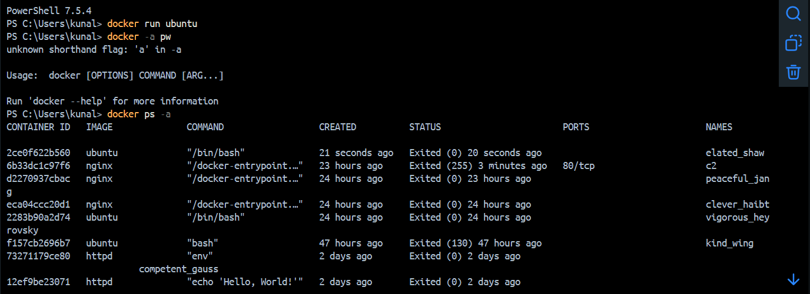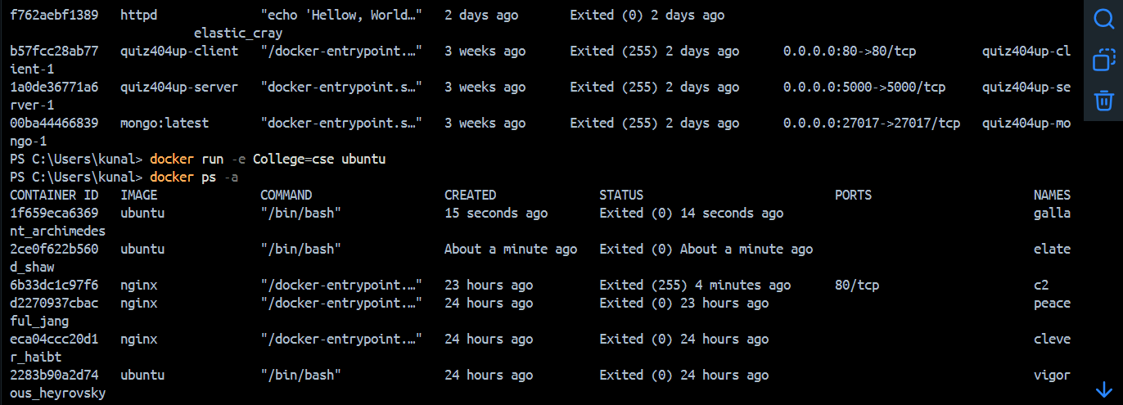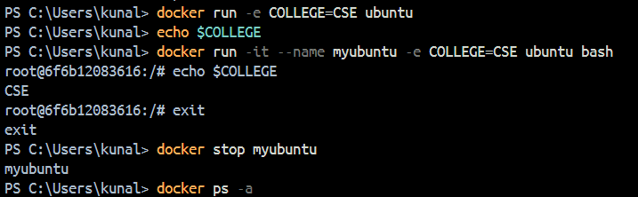

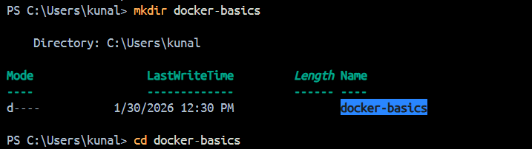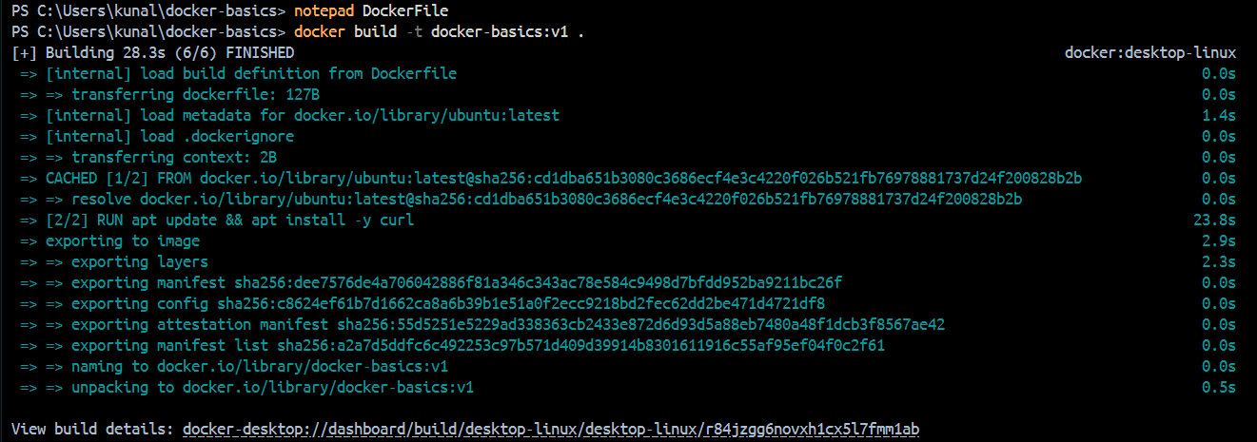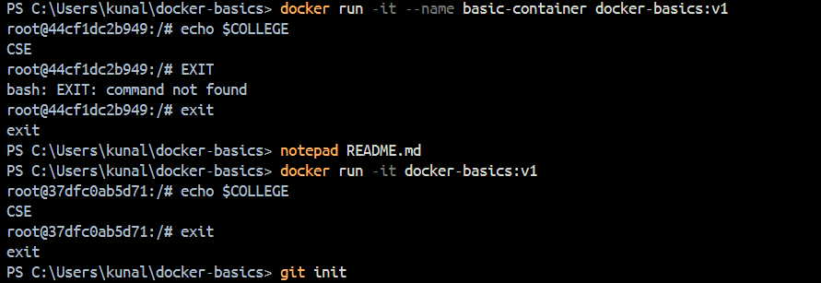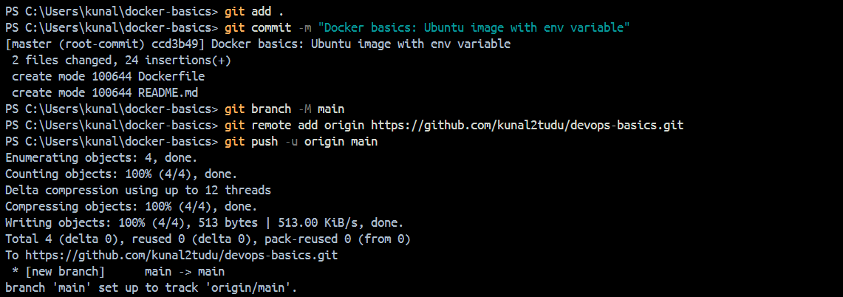

2/5/26

PowerShell 7.5.4
PS C:\Users\kunal> mkdirdocker-volume
mkdirdocker-volume: The term 'mkdirdocker-volume' is not recognized as a name of a cmdlet, function, script file, or executable program.
Check the spelling of the name, or if a path was included, verify that the path is correct and try again.
PS C:\Users\kunal> mkdir docker-volume

Directory: C:\Users\kunal

Mode LastWriteTime Length Name
---- ------------- ------ ----
d---- 2/5/2026 12:19 PM docker-volume

PS C:\Users\kunal> ls

Directory: C:\Users\kunal

Mode LastWriteTime Length Name
---- ------------- ------ ----
d---- 7/17/2025 9:12 AM .anaconda
d---- 12/15/2025 3:22 PM .antigravity
d---- 1/27/2026 12:50 PM .cagent
d---- 2/5/2026 11:40 AM .codex
d---- 7/17/2025 12:01 PM .conda
d---- 1/27/2026 12:50 PM .config
d---- 7/17/2025 9:12 AM .continuum
d---- 2/5/2026 12:09 PM .docker
d---- 12/15/2025 4:00 PM .gemini
d---- 7/17/2025 9:17 AM .ipython
d---- 2/11/2025 3:14 AM .jdks
d---- 8/30/2025 11:30 AM .m2
d---- 7/17/2025 9:17 AM .matplotlib
d---- 2/21/2025 12:14 AM .ms-ad
d---- 4/9/2025 3:56 PM .redhat
d---- 7/17/2025 12:01 PM .spyder-py3
d---- 8/30/2025 1:09 PM .sts4
d---- 12/18/2025 12:09 PM .VirtualBox
d---- 2/10/2025 3:39 PM .vscode
d---- 7/17/2025 9:14 AM anaconda3
d---- 12/30/2025 6:15 PM ansel
d-r-- 4/30/2025 2:19 AM Contacts
d---- 11/28/2025 1:19 PM DEVOPS
d---- 1/30/2026 12:46 PM docker-basics
d---- 2/5/2026 12:19 PM docker-volume
d---- 2/9/2025 6:17 PM Documents
dar-- 2/5/2026 11:28 AM Downloads
d---- 5/5/2025 3:53 PM end
d-r-- 2/9/2025 6:14 PM Favorites
d---- 11/14/2025 1:30 PM git-branches-demo
d---- 3/27/2025 10:48 AM IdeaProjects
d---- 2/11/2025 3:16 AM IdeaSnapshots
d-r-- 2/9/2025 6:14 PM Links
d---- 12/12/2025 1:36 PM MAVEN
d---- 12/12/2025 1:51 PM MAVEN12
d-r-- 1/20/2026 10:46 PM Music
d---- 11/6/2025 1:50 PM myProject
d---- 2/10/2025 2:18 PM New folder
d---- 2/28/2025 3:51 PM New folder (2)
d---- 4/11/2025 3:20 PM node_modules
lar-- 7/11/2025 12:31 PM OneDrive
d---- 12/12/2025 3:16 PM Postman
d---- 11/29/2025 1:48 PM ProjectLab
d---- 12/5/2025 1:27 PM rebase-demo
d-r-- 4/30/2025 12:56 AM Saved Games
d-r-- 2/9/2025 6:31 PM Searches
d---- 12/2/2025 1:52 PM stash-demo
d---- 4/11/2025 1:18 PM venv
d-r-- 1/20/2026 10:48 PM Videos
d---- 4/14/2025 12:08 AM website
-a--- 12/5/2025 1:53 PM 5422 .bash_history
-a--- 7/17/2025 9:12 AM 25 .condarc
-a--- 11/15/2025 1:16 PM 51 .gitconfig
-a--- 12/15/2025 3:46 PM 14 .gitignore
-a--- 12/5/2025 1:34 PM 20 .lesshst
-a--- 11/6/2025 1:45 PM 990 .viminfo
-a--- 4/19/2025 12:01 AM 67340 ca2.pdf
-a--- 11/15/2025 1:47 PM 20 demo.txt
-a--- 11/14/2025 1:45 PM 37 Devops.txt
-a--- 11/28/2025 1:21 PM 23 file1.txt
-a--- 11/28/2025 1:31 PM 16 file2.txt
-a--- 11/28/2025 1:30 PM 15 file3.txt
-a--- 4/9/2025 4:02 PM 119 Kun.java
-a--- 4/11/2025 3:20 PM 30768 package-lock.json
-a--- 4/11/2025 3:20 PM 114 package.json
-a--- 12/10/2025 4:41 PM 368957208 postgresql_18.exe
-a--- 4/2/2025 4:46 PM 176225 website.zip

PS C:\Users\kunal> cd docker-volume
PS C:\Users\kunal\docker-volume> ls
PS C:\Users\kunal\docker-volume> cat >> hostfile.txt

cmdlet Get-Content at command pipeline position 1
Supply values for the following parameters:
Path[0]:
PS C:\Users\kunal\docker-volume> echo Hello from HOST machine > ^C
PS C:\Users\kunal\docker-volume> echo Hello from HOST machine > C:\Users\kunal\docker-volume\hostfile.txt
PS C:\Users\kunal\docker-volume> ls

Directory: C:\Users\kunal\docker-volume

Mode LastWriteTime Length Name
---- ------------- ------ ----
-a--- 2/5/2026 12:24 PM 28 hostfile.txt

PS C:\Users\kunal\docker-volume> echo hostfile.txt
hostfile.txt
PS C:\Users\kunal\docker-volume> touch hostfile.txt
touch: The term 'touch' is not recognized as a name of a cmdlet, function, script file, or executable program.
Check the spelling of the name, or if a path was included, verify that the path is correct and try again.
PS C:\Users\kunal\docker-volume> cat >> hostfile.txt

cmdlet Get-Content at command pipeline position 1
Supply values for the following parameters:
Path[0]: Hello this is Host file
Path[1]:
PS C:\Users\kunal\docker-volume> cat >> hostfile.txt

cmdlet Get-Content at command pipeline position 1
Supply values for the following parameters:
Path[0]:
PS C:\Users\kunal\docker-volume> docker run -it --name cv3 -v C:\docker-volume-demo:/data ubuntu bash
root@b16abe2469f1:/# ls
bin boot data dev etc home lib lib64 media mnt opt proc root run sbin srv sys tmp usr var
root@b16abe2469f1:/# cd data
root@b16abe2469f1:/data# cat hostfile.txt
cat: hostfile.txt: No such file or directory
root@b16abe2469f1:/data# ^C
root@b16abe2469f1:/data#
exit
PS C:\Users\kunal\docker-volume> "^C
PS C:\Users\kunal\docker-volume> ls

Directory: C:\Users\kunal\docker-volume

Mode LastWriteTime Length Name
---- ------------- ------ ----
-a--- 2/5/2026 12:24 PM 28 hostfile.txt

PS C:\Users\kunal\docker-volume> docker run -it --name cv3 -v C:\docker-volume-demo:/data ubuntu bash
docker: Error response from daemon: Conflict. The container name "/cv3" is already in use by container "b16abe2469f157c5e695f6e06f6ab22d803cef08f48febea7f94c1b09810e86e". You have to remove (or rename) that container to be able to reuse that name.

Run 'docker run --help' for more information
PS C:\Users\kunal\docker-volume> docker run -it --name cv4 -v C:\docker-volume-demo:/data ubuntu bash
root@fbdb37079908:/# ls
bin boot data dev etc home lib lib64 media mnt opt proc root run sbin srv sys tmp usr var
root@fbdb37079908:/# cd data
root@fbdb37079908:/data# ls
root@fbdb37079908:/data#
exit
PS C:\Users\kunal\docker-volume> echo Hello from HOST machine > C:\Users\kunal\docker-volume\hostfile.txt
PS C:\Users\kunal\docker-volume> ^C
PS C:\Users\kunal\docker-volume> ls

Directory: C:\Users\kunal\docker-volume

Mode LastWriteTime Length Name
---- ------------- ------ ----
-a--- 2/5/2026 12:31 PM 28 hostfile.txt

PS C:\Users\kunal\docker-volume> docker run -it --name cv4 -v C:\docker-volume:/data ubuntu bash
docker: Error response from daemon: Conflict. The container name "/cv4" is already in use by container "fbdb370799088aadde2295158e2e13b8eb9a5376a4c3bd05e11e37c19ee50691". You have to remove (or rename) that container to be able to reuse that name.

Run 'docker run --help' for more information
PS C:\Users\kunal\docker-volume> docker run -it --name cv5 -v C:\docker-volume:/data ubuntu bash
root@125141edd6b1:/# cd data
root@125141edd6b1:/data# ls
root@125141edd6b1:/data# cat hostfile.txt
cat: hostfile.txt: No such file or directory
root@125141edd6b1:/data# ^C
root@125141edd6b1:/data# ^C
root@125141edd6b1:/data#
exit
PS C:\Users\kunal\docker-volume> docker run -it --name cv6 -v C:\User\kunal\docker-volume:/data ubuntu bash
root@52cfcd213714:/# ls
bin boot data dev etc home lib lib64 media mnt opt proc root run sbin srv sys tmp usr var
root@52cfcd213714:/# cd data
root@52cfcd213714:/data# ls
root@52cfcd213714:/data#
exit
PS C:\Users\kunal\docker-volume> docker run -it --name cv7 -v C:\Users\kunal\docker-volume:/data ubuntu bash
root@94d2f91ada3b:/# cd data
root@94d2f91ada3b:/data# ls
hostfile.txt
root@94d2f91ada3b:/data# cat hostfile.txt
Hello
from
HOST
machine
root@94d2f91ada3b:/data# echo "Modified inside container">> /data/hostfile.txt
root@94d2f91ada3b:/data# cat hostfile.txt
Hello
from
HOST
machine
Modified inside container
root@94d2f91ada3b:/data#
exit
PS C:\Users\kunal\docker-volume> docker volume create studentdata
studentdata
PS C:\Users\kunal\docker-volume> ls

Directory: C:\Users\kunal\docker-volume

Mode LastWriteTime Length Name
---- ------------- ------ ----
-a--- 2/5/2026 12:39 PM 54 hostfile.txt

PS C:\Users\kunal\docker-volume> docker run -it --name student1 -v ^C
PS C:\Users\kunal\docker-volume> docker run -it --name student1 ^
>> -v studentdata:/student ^
>> ubuntu bash
>>
docker: invalid reference format

Run 'docker run --help' for more information
-v:
Line |
2 | -v studentdata:/student ^
| ~~
| The term '-v' is not recognized as a name of a cmdlet, function, script file, or executable program.
Check the spelling of the name, or if a path was included, verify that the path is correct and try again.
ubuntu:
Line |
3 | ubuntu bash
| ~~~~~~
| The term 'ubuntu' is not recognized as a name of a cmdlet, function, script file, or executable program.
Check the spelling of the name, or if a path was included, verify that the path is correct and try again.
PS C:\Users\kunal\docker-volume> docker run -it --name student1 -v studentdata:/student ubuntu bash
root@087240899fd5:/# ls
bin boot dev etc home lib lib64 media mnt opt proc root run sbin srv student sys tmp usr var
root@087240899fd5:/# cd /student
root@087240899fd5:/student# echo "Hello from student1">notes.txt
root@087240899fd5:/student# ls
notes.txt
root@087240899fd5:/student# cat notes.txt
Hello from student1
root@087240899fd5:/student#
exit
PS C:\Users\kunal\docker-volume> docker rm student1
student1
PS C:\Users\kunal\docker-volume> docker run -it --name student2 -v studentdata:/student ubuntu bash
root@a1832df18d81:/# cd
root@a1832df18d81:~# ls
root@a1832df18d81:~#
exit
PS C:\Users\kunal\docker-volume> docker run -it --name student2 -v studentdata:/student ubuntu bash
docker: Error response from daemon: Conflict. The container name "/student2" is already in use by container "a1832df18d81f8fac158bc9a8816b86319ef823c3caec07f01e941851106385f". You have to remove (or rename) that container to be able to reuse that name.

Run 'docker run --help' for more information
PS C:\Users\kunal\docker-volume> docker rm student2
student2
PS C:\Users\kunal\docker-volume> docker run -it --name student2 -v studentdata:/student ubuntu bash
root@08376b716755:/# ls
bin boot dev etc home lib lib64 media mnt opt proc root run sbin srv student sys tmp usr var
root@08376b716755:/# cd /student
root@08376b716755:/student# cat notes.txt
Hello from student1
root@08376b716755:/student#

