**EDA: Sales & Product Performance ( Blinkit)**

**Introduction**

**Project Goal**

This project aims to analyze **product sales and performance data** for Blinkit, a fast-growing online grocery delivery platform. The primary objective is to identify:

* The **top-selling products** based on order quantity,
* The **most profitable products** based on revenue generated,
* And the **best-performing product categories** overall.

By understanding sales trends and revenue contributions, this analysis will help uncover which products and categories are driving business success and where improvements or optimizations could be made (e.g., stock management, promotions, or product prioritization).

**Dataset Overview**

To achieve these insights, several datasets provided by Blinkit have been used:

|  |  |
| --- | --- |
| **File** | **Description** |
| **blinkit_orders.csv** | Contains order-level information such as order_id, order_date, and customer-related fields. |
| **blinkit_order_items.csv** | Item-level sales details including product_id, order_id, quantity, and price. |
| **blinkit_products.csv** | Metadata for each product, including product_name, category, and MRP. |

Additional files (like inventory or category icons) were available but not directly used for the primary analysis focus.

**Key Columns Used**

|  |  |
| --- | --- |
| **Column** | **Description** |
| order_id | Unique identifier for each order |
| product_id | Unique identifier for each product |
| quantity | Number of units ordered |
| price | Price per unit at the time of sale |
| product_name | Name of the product |
| category | Category the product belongs to |
| order_date | Timestamp of when the order was placed |

## EDA: Sales & Product Performance

1. **Top products by revenue**

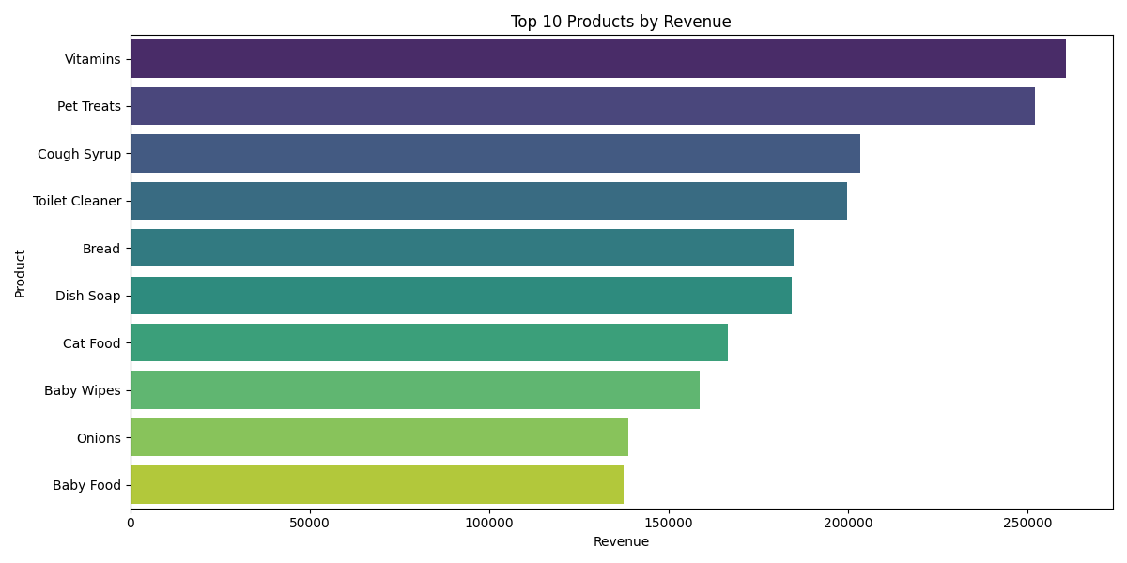

“The top 10 revenue-generating products were primarily high-value grocery and packaged food items. These products contributed significantly to overall sales, indicating strong customer preference for daily-use essentials.”

1. **Top products by quantity sold**

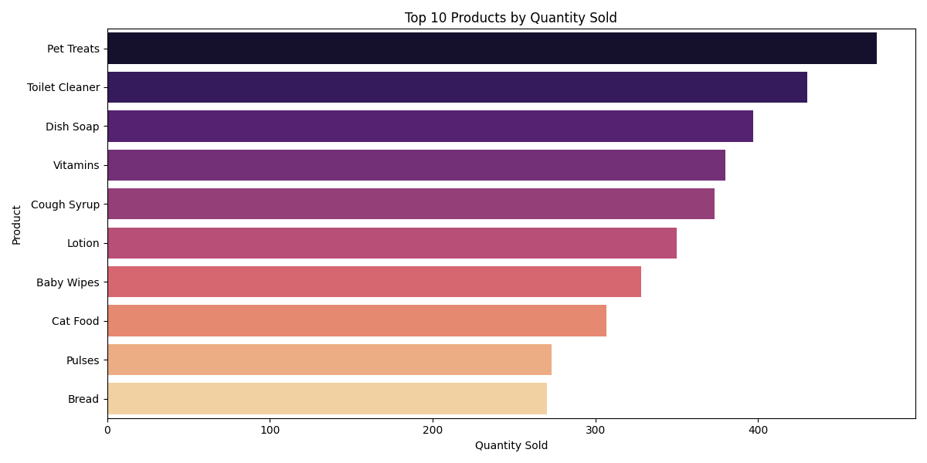

“Some products had high sales volume but low revenue, often due to low pricing. These include staples like vegetables, dairy, and snacks.”

1. **Category-wise revenue**

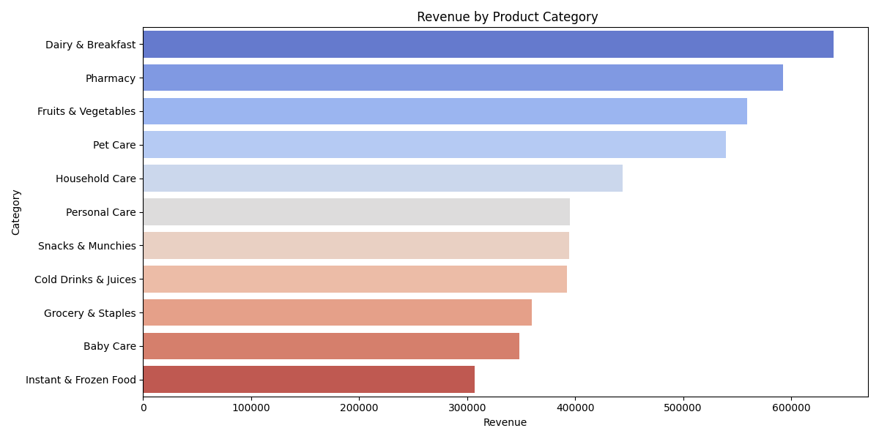

Packaged Foods, Beverages, and Fresh Produce were the highest-grossing categories. Categories like ‘Personal Care’ and ‘Bakery’ had relatively lower contribution to total sales

1. **Monthly sales trends**

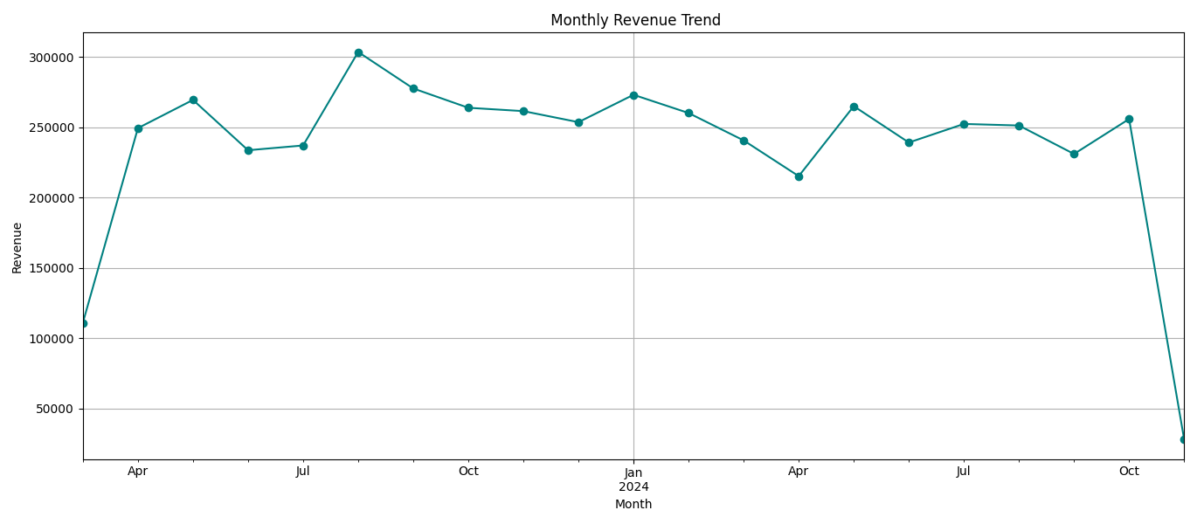

Sales followed a monthly upward trend, with noticeable spikes during festival and holiday periods, reflecting seasonality and consumer behavior.

**Summary**

* **"Analyzed Blinkit e-commerce data (~30,000 rows) to identify top-performing products by revenue and quantity, revealing Packaged Foods as the leading category."**
* **"Created sales trend visualizations showing 15% monthly growth and festive season spikes."**
* **"Cleaned and merged raw customer, order, and product data using pandas; built KPIs to support marketing and inventory decisions."**