node –v

java –version

npm install -g appium -> appium install hoga

npm install -g appium-doctor -> appium doctor install hoga

npm install @wdio/appium-service --save-dev –> install karna need hai

npm install appium --save-dev ->install karna need hai

appium -v se version check but ps1 file delete kar lena

appium client and server folder create in vscode

npm install -g appium@next kare for appium server cmd wala install ke liye

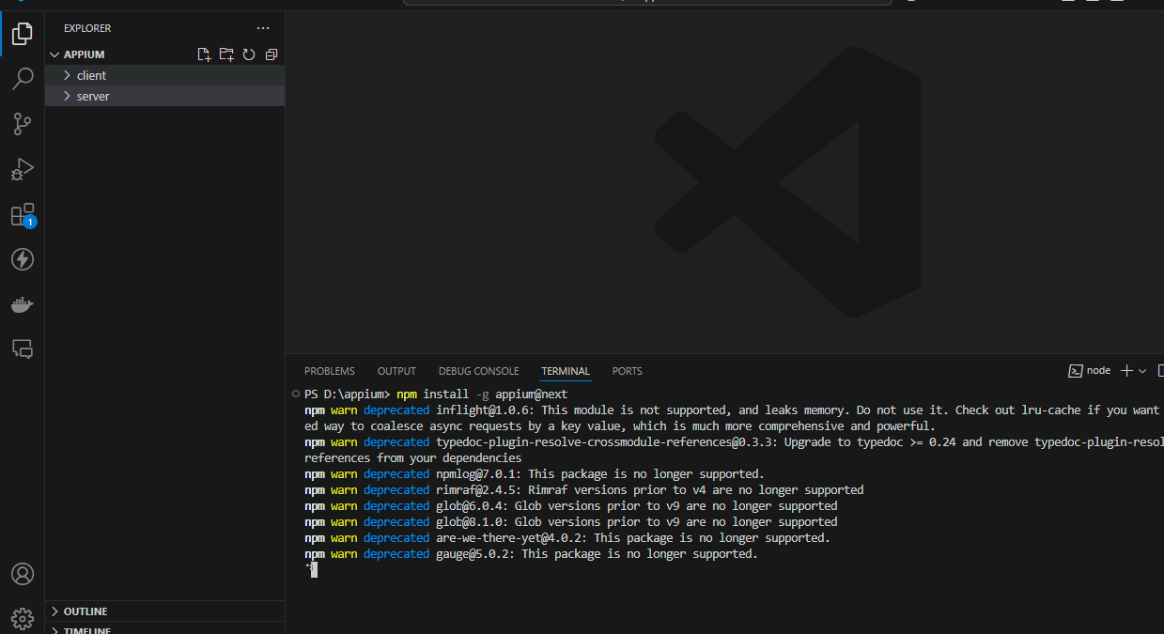

appium-doctor->for check kya hai kya nahi

appium driver list-> driver check for appium

appium driver install uiautomator2->driver install ke liye

appium ->isse Appium server start hoga

apk info red wala and Appium settings apk(jo simple ho add na ho usmay) download kar lena mobile mai chrome github debug apk after only enable karna hai background mai run ho jaayega.

appium desktop client download karenge jo ke appium server ka gui version hai

<https://github.com/appium/appium-desktop/releases/tag/v1.8.2> github par jaaye after appium-desktop-setup-1.8.2.exe download kar le

appium inspector-><https://github.com/appium/appium-inspector/releases> par jaaye

Appium-Inspector-windows-2024.3.1-x64.exe download kar le

usb cable connect and usb deubggin on kar lena

server folder run appium

client folder run npm init wdio .

:---------------------------------------------------------------------------------

y

y

E2E Testing - of Web or Mobile Applications

On my local machine

Mobile - native, hybrid and mobile web apps, on Android or iOS

using UiAutomator2 (https://www.npmjs.com/package/appium-uiautomator2-driver)

Mocha (https://mochajs.org/)

no

n

spec

wait-for

n

appium

y (after todha time lenge depencies install hone mai so patiance rakhna) after three dependcies install hogi after appium-installar n kar dena

:-------------------------------------------------------------------------------------------------------

ek root par app/android folder mai apk daale jiske testing karni hai kyoki yeh appium server push karega mobile or emulator mai testing ke liye

developer options mai verify app over usb ko close kare

developer options mai disable permission monitoring on kar deh

**note:-**

**appium inspector client hai and appium desktop server hai direct ui base work**

**folder client mai npx wdio client run karta hai aur server mai appium server run karta hai**

**so appium cmd server chalaaye and appium inspector use kare for ui after direct npx wdio use kare ,appium desktop use nahi karna hai**

wdio.config.js mai:-

 services: [

    [

      "appium",

      {

        args: {

          address: "localhost",

          port: 4723

, // Change the port to your desired value

        },

        logPath: "./",

      },

    ],

  ],

  specs: ["./test/specs/*.js"],

capabilities: [

    {

      // capabilities for local Appium web tests on an Android Emulator

      platformName:"Android",

      "appium:platformVersion":"12",

      "appium:deviceName":"narzo 30 Pro 5G",

      "appium:app":"C:\\appium\\app\\android\\base.apk",

      "appium:automationName":"UiAutomator2",

      "appium:appPackage":"com.google.android.calculator",

      "appium:appActivity":"com.android.calculator2.Calculator",

    },

  ],

**--------------------------------------------------**

**appium inspector ke sath direct work ke liye apk install already app after recording and code use in code mai using appium cmd server and appium-inspector**

Appium inspector mai:-

{

"platformName": "Android",

"appium:platformVersion": "14",

"appium:deviceName": "realme C61",

"appium:udid": "0D54627128201712",

"appium:noReset": true,

"automationName": "UiAutomator2"

}

-------------------------------------------------------------------

**Code mai apk and testing code chalega appium cmd server and npx wdio client**

capabilities: [

    {

      // capabilities for local Appium web tests on an Android Emulator

      platformName:"Android",

      "appium:platformVersion":"12",

      "appium:deviceName":"narzo 30 Pro 5G",

      "appium:app":"C:\\appium\\app\\android\\base.apk",

      "appium:automationName":"UiAutomator2",

      "appium:appPackage":"com.google.android.calculator",

      "appium:appActivity":"com.android.calculator2.Calculator",

    },

  ],

Apk info say package and mainactivy use kare

After mainly appium inspector say code create karke vscode mai daalkar automation use karna