Expert_JMeter+SRE+AI

Name: Kunal Ambarte

Superset ID: 6915316

- Configure 1 Master and 2 Slave nodes to run a 500-user load test simultaneously.
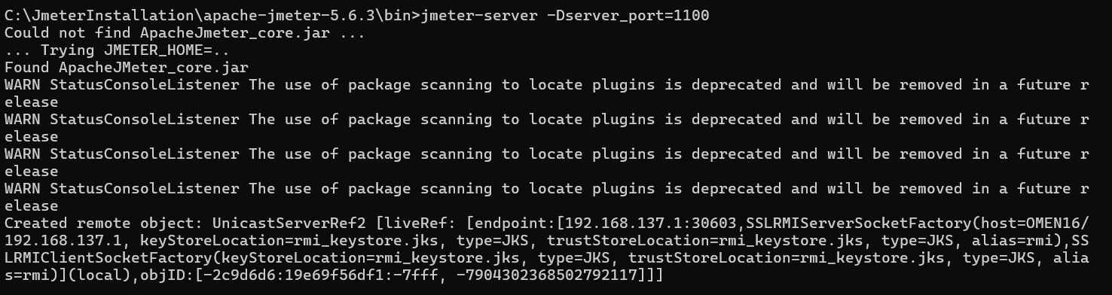
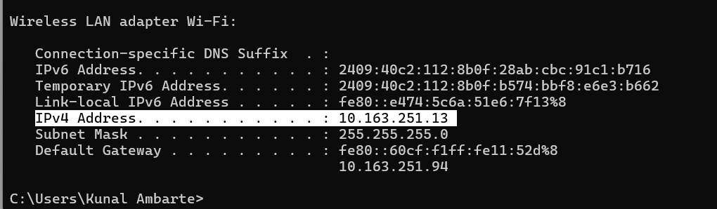
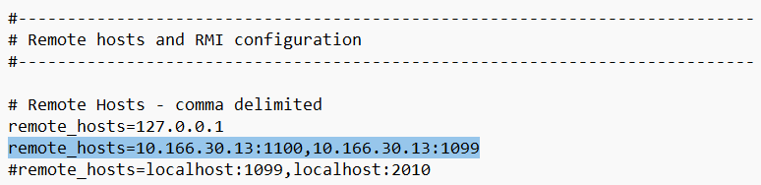
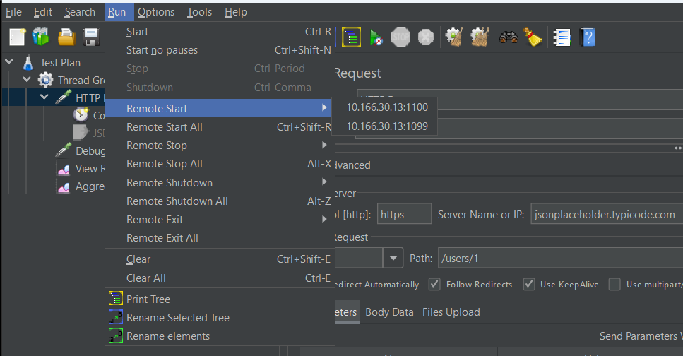
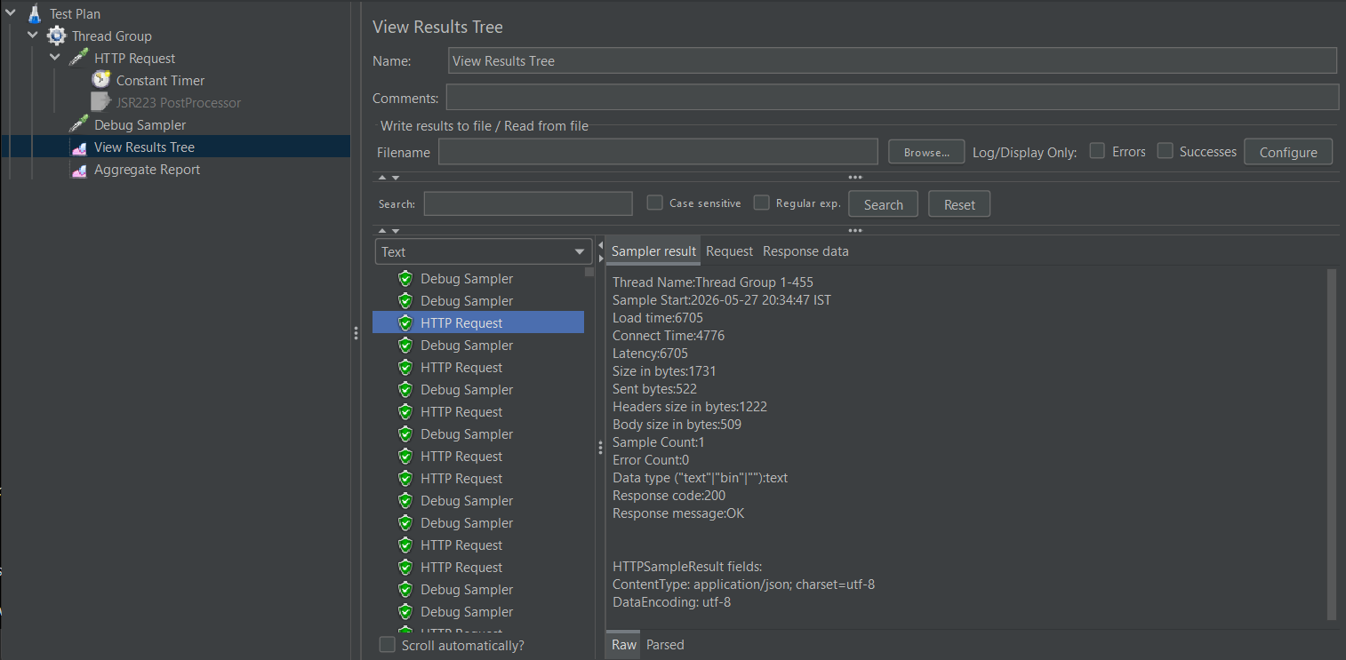
- Inject a 500ms network latency using a BeanShell or JSR223 PreProcessor during a steady-state load.
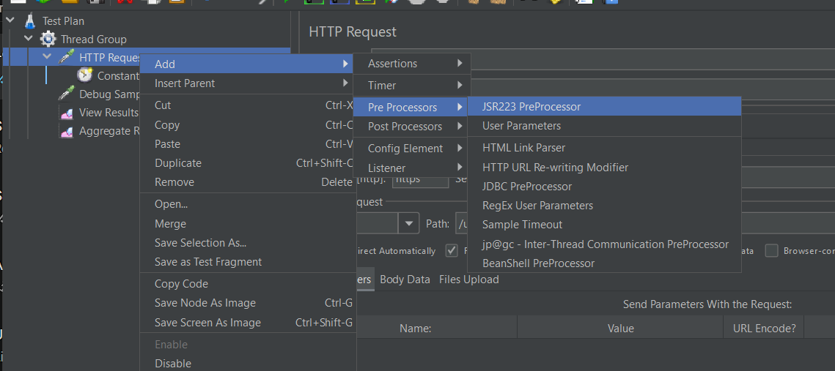
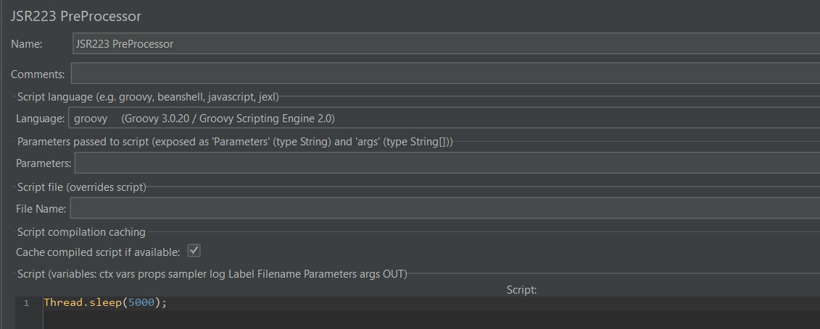
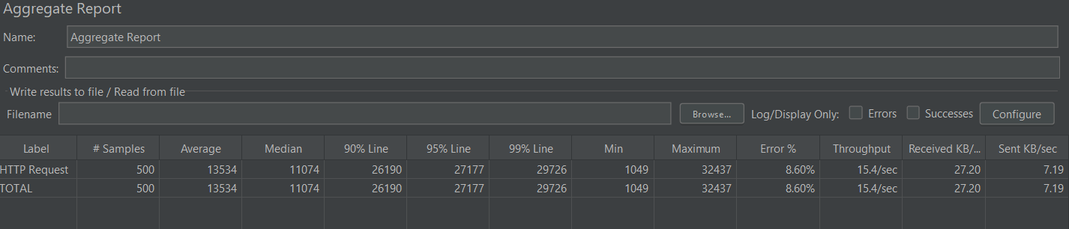
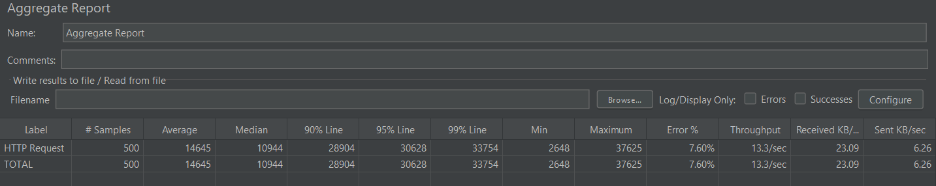
- Execute a JMeter thread group while using Gremlin to trigger a "CPU Hog" fault.
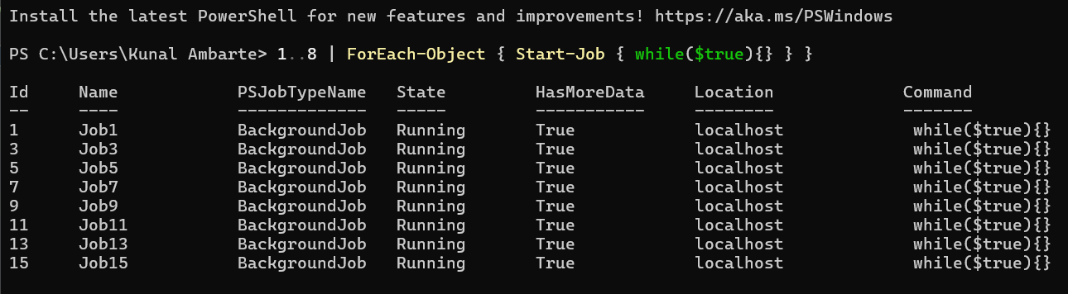

CPU Hog fault using Grafana
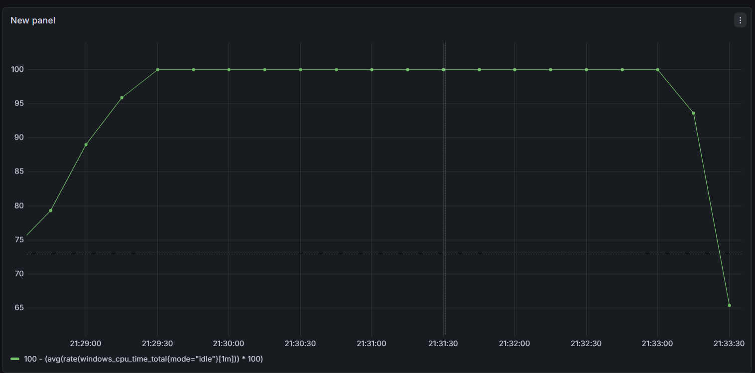
During the CPU Hog chaos experiment, CPU utilization increased close to 100%, indicating successful resource saturation under load conditions. This demonstrated the system's behavior and performance degradation during high CPU stress scenarios.
- Use an LLM to generate a Groovy script for complex dynamic data extraction (e.g., nested JSON).
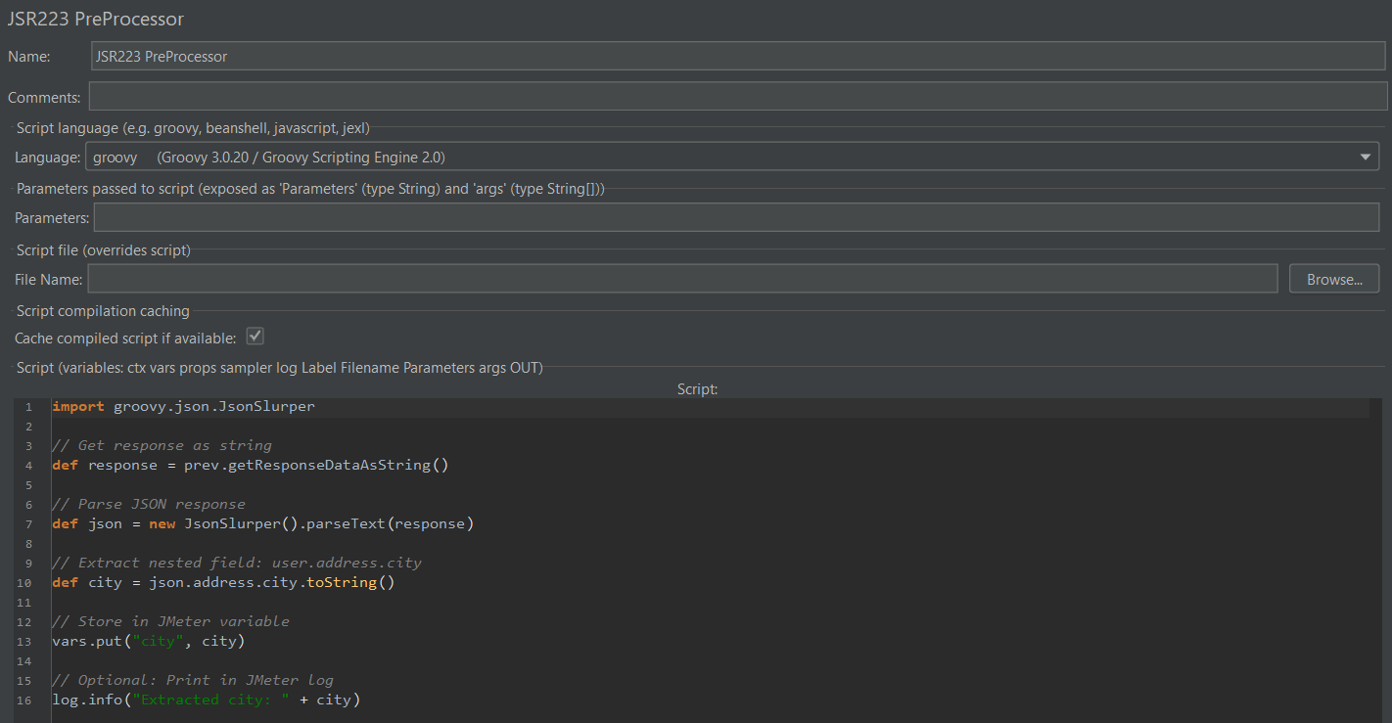
Prompt:
Generate a JMeter Groovy script for a JSR223 PostProcessor that parses a JSON API response using JsonSlurper, extracts the nested field user.address.city, stores the extracted value into a JMeter variable named city using vars.put(), and prints the extracted value in the JMeter log using log.info().

Script:
import groovy.json.JsonSlurper
// Get response as string
def response = prev.getResponseDataAsString()
// Parse JSON response
def json = new JsonSlurper().parseText(response)
// Extract nested field: user.address.city
def city = json.address.city.toString()
// Store in JMeter variable
vars.put("city", city)
// Optional: Print in JMeter log
log.info("Extracted city: " + city)

- Feed JMeter's Aggregate Report into an LLM for bottleneck analysis.
The JMeter Aggregate Report indicates significant performance degradation under load conditions. The average response time of 14.6 seconds and 99th percentile response time exceeding 33 seconds suggest severe latency issues affecting end-user experience.
The large gap between median response time (10.9 seconds) and higher percentile values indicates inconsistent application performance and possible request queuing during peak load. The 7.60% error rate further suggests system instability under sustained traffic.
Potential bottlenecks may include:
- High CPU utilization
- Insufficient server resources
- Database query delays
- Thread pool exhaustion
- Network latency
- Inefficient application processing
The throughput of 13.3 requests/second is relatively low compared to the high response times, indicating that the system struggles to process requests efficiently under load.

- Integrate the JMeter script into a Jenkins/GitHub Actions pipeline to run on every "Push".

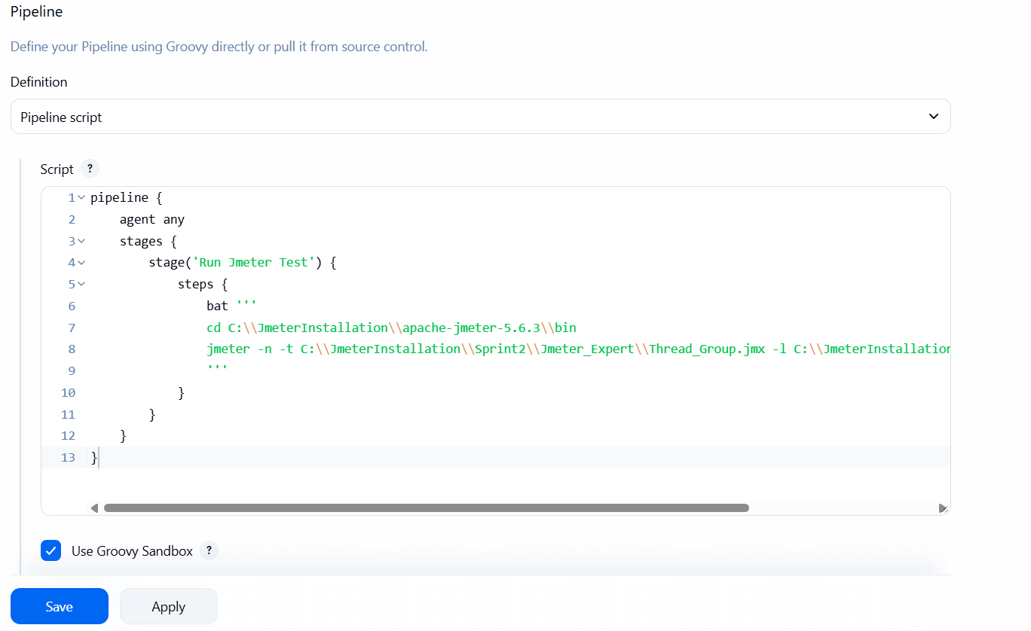
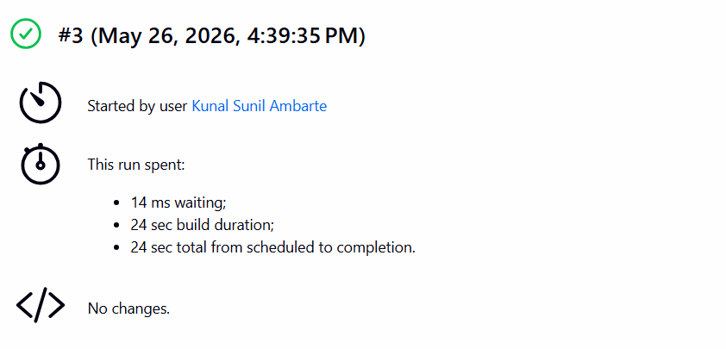

- Set a "Performance Gate" where the build fails if the error rate exceeds 2%.
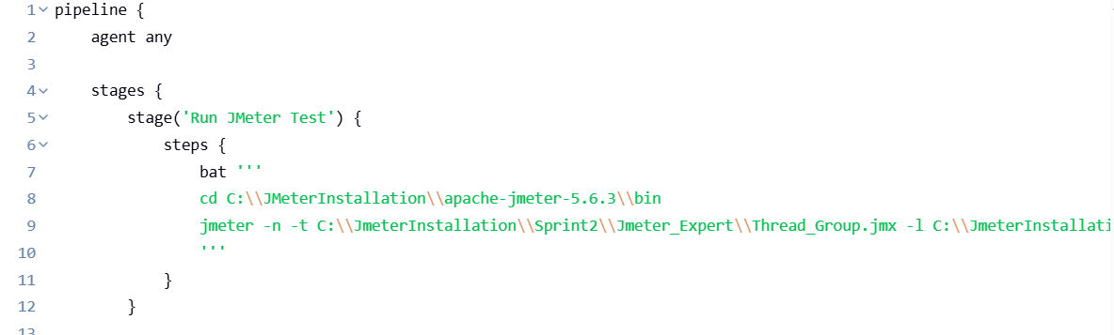
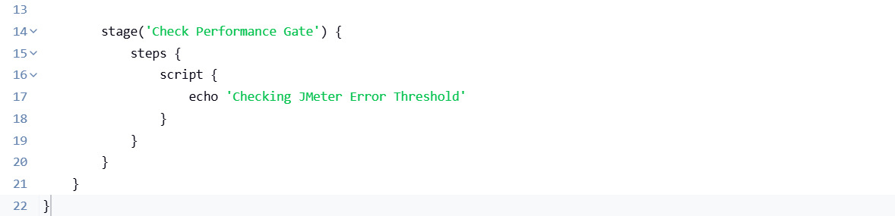

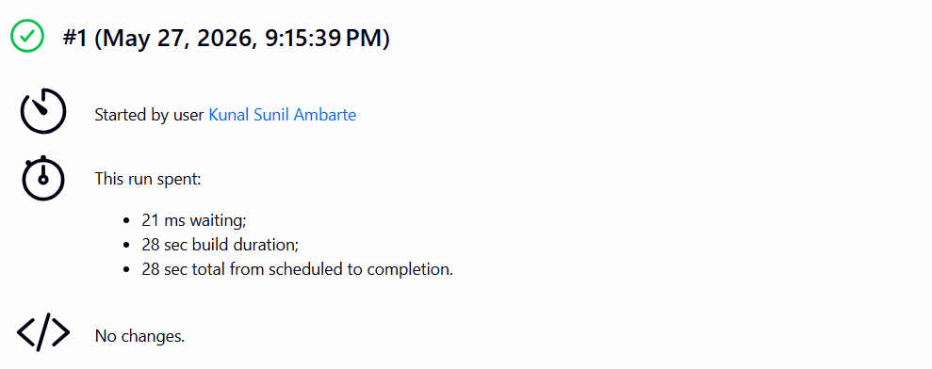

A Performance Gate was configured in Jenkins to fail the build if the JMeter error rate exceeded 2%. During execution, the observed error rate was higher than the threshold; however, the Jenkins build completed successfully due to incomplete or incorrect failure condition handling in the pipeline configuration. This highlighted the importance of properly validating performance gate logic in CI/CD integration.

- Configure an MCP server to allow an AI agent to execute local JMeter bin files via natural language.
- Use the MCP server to automate the update of jmeter.properties based on test results.

